Method for extracting and analyzing dosimetric data from Hitachi-type DICOM reports

Mouhamed GUEYE
TIC4Dev University Alioune Diop of Bambey
University Alioune Diop of Bambey
Bambey, Senegal
mouhamed3.gueye@uadb.edu.sn
Abdou Khadre DIOP
TIC Department
University Alioune Diop of Bambey
Bambey, Senegal
abdoukhadre.diop@uadb.edu.sn
Sada ANNE
TIC4Dev University Alioune Diop of Bambey
University Alioune Diop of Bambey
Bambey, Senegal
sada.anne@uadb.edu.sn
Magatte DIAGNE
Oncology and Radiotherapy Department
Ahmadoul Khadim Hospital in Touba
Touba, Senegal
blindiagne@gmail.com
Fallou SEYE
TIC4Dev University Alioune Diop of Bambey
University Alioune Diop of Bambey
Bambey, Senegal
fallou.seye@uadb.edu.sn
Amadou Dahirou GUEYE
MIM Department STA
University Amadou Mahtar Mbow
Dakar, Senegal
dahirou.gueye@uam.edu.sn

Abstract—Currently, data from Hitachi machines Digital Imaging and Communications in Medicine (DICOM) reports is used manually, which is time-consuming and error-prone. This limits the effectiveness of the analyses needed to manage radiation doses and improve medical practices. This paper therefore proposes an automated solution for the rapid and reliable extraction of key information, including CTDI (Computed Tomography Dose Index) and PDL (Product of Dose Length) indices, to facilitate the determination of Diagnostic Reference Levels (DRL). The methodology combines several steps: collecting real data from Picture Archiving and Communication System (PACS) reports; studying the structure of DICOM reports; developing an extraction algorithm in Python; and visualising the results via a web interface. The solution's architecture is based on the Django framework for data processing and Angular for the interactive presentation of results. The results obtained demonstrate the effectiveness of the platform in automating the extraction and analysis of DICOM data, significantly reducing processing time while providing healthcare professionals with clear, intuitive visualisation. This solution represents a significant advance in radiation dose management, transitioning from manual processes to an automated system that is faster and aligns with international radiation protection recommendations.
Keywords—DICOM, DICOM SR, DRL

Introduction
Rapid technological development is transforming many fields, including medicine. The integration of data management and analysis systems is significantly improving both patient care and the management of medical equipment [1]. In particular, medical imaging is an area where the growing volume of data requires specialised tools for effective exploitation. The Digital Imaging and Communications in Medicine(DICOM) format has become the international standard for the storage and exchange of medical images [2]. It offers a wealth of information that can be analysed to improve diagnostics and optimise device performance.
This paper addresses the specific challenges of extracting and analysing data from Hitachi machine DICOM reports, which are essential for diagnostic analysis and informed decision-making [3]. Automatic extraction of this data would increase clinical efficiency and facilitate predictive equipment maintenance, thereby reducing operating costs and improving quality of care [4, 5].
Our study is part of an initiative to create a dosimetric reference model for the whole country. The use of X-rays in diagnostic examinations has been introduced in modern medicine, and they play a key role in diagnosing patients. These doses must be standardised. Excess or deficiency can have harmful consequences for the patient. An outdated method was previously used to perform this task. However, technological advances mean that we can now achieve more in less time.
In this paper, we will start by outlining the structure of DICOM files and explaining the algorithm used to search for essential data. We will then define the extraction functions and data visualisation via an intuitive web interface. This approach, which is based on advanced data extraction techniques, demonstrates the impact of automation on the management of information flows in medical imaging [6, 7]. The rest of this document is organised as follows: Section 1 presents related work; Section 2 describes the adopted methodology; Section 3 highlights the obtained results; and Section 4 concludes the document.

Related work
The process of extracting data from DICOM reports generated by Hitachi Machine is of paramount importance in the optimisation of medical image processing and analysis. The structuring and leveraging of this data by healthcare professionals has the potential to enhance patient record management, refine diagnoses, and facilitate integration with artificial intelligence (AI) systems. This approach has been shown to automatically identify anomalies, thereby facilitating the acceleration of radiology workflows and ensuring more efficient and accurate patient care. The extant literature has focused on these aspects. Klein et al. [8] conducted an examination of the limited external reproducibility of Medical Record Review (MRR) and its impact on its utilisation for hospital benchmarking. The study examined the consistency of assessments conducted by two independent committees and concluded that, while MRR is beneficial in detecting general patient safety issues, its lack of external reproducibility restricts its application in the comparison of healthcare facilities. In their seminal paper, Naciri et al. [9] propose a methodology and translator for the integration of management data from ERP(Enterprise Resource Planning) software into Hitachi's (Global Performance Management) GPM data warehouse. The proposed methodology involves the conversion of Excel files into a structured model, with the aim of facilitating data sharing and visualisation. Jadu FM et al. [10] optimised a cone beam computed tomography (CBCT) sialography protocol by maximising the signal-to-noise ratio (SDNR) while taking radiation dose into account. The study utilised Hitachi Medical Systems CB MercuRay to assess the efficacy of varying combinations of kVp and mA on an iodine-containing imaging phantom. The findings indicate that the optimal compromise between image quality and effective dose is achieved by utilising a setting of 80 kVp and 10 mA. In the study by Liu et al. [11], the performance of CEUS (Contrast-Enhanced Ultrasound) and DSA (Digital Subtraction Angiography) for the diagnosis of internal carotid artery stenosis was compared. The study utilised a Hitachi Preirus ultrasound scanner. The findings indicate that CEUS is a non-invasive, accurate, and well-tolerated technique with performance comparable to or even superior to DSA. These findings serve to reinforce the value of utilising Hitachi machines for the acquisition and analysis of medical data, particularly in the context of DICOM report extraction and processing. In their study, Tamam et al. [12] examined the rise in radiation doses in digital mammography in the United Kingdom, which was found to be associated with increased compressed breast thickness. The impact of physiological changes in patients on the evolution of the doses used was highlighted. National Institute for Health and Care Excellence (NICE) provides a review of software designed for the monitoring of radiation doses in medical imaging procedures involving ionising radiation [13]. The technology under discussion presents eight technologies capable of automatically collecting, analysing, and reporting patient radiation exposure, thereby improving image quality while minimising doses. The study emphasises the benefits, costs and limitations of these tools, highlighting their potential to optimise patient safety and meet regulatory requirements. Mackenzie A. et al. [14] conducted an examination of the challenges and successes of extracting metadata from DICOM-formatted medical images for audit and research purposes. It highlights obstacles related to picture archiving and communication system (PACS) limitations, security, and data governance issues, while proposing solutions such as retrospective extraction, the use of structured reports, and secure research environments.

Methodology
In the present study, a solution was developed for extracting the information required to perform the analysis based on Excel files used to determine dose indices for HITASHI devices. The results are displayed via a web interface. The following steps were taken in order to complete the work:
• The data collection process was made possible by a partnership with Dantec Hospital, leading to the retrieval of 100 PACS reports.
• Study of the report structure: Dicom reports have a
variety of structures. Each manufacturer can choose how to store this data in the reports.
• Development of the extraction algorithm: Using Python, we were able to develop an algorithm to extract the information needed for analysis.
• Visualization of the results: The results of the analysis are presented in a more intuitive way via a web interface.
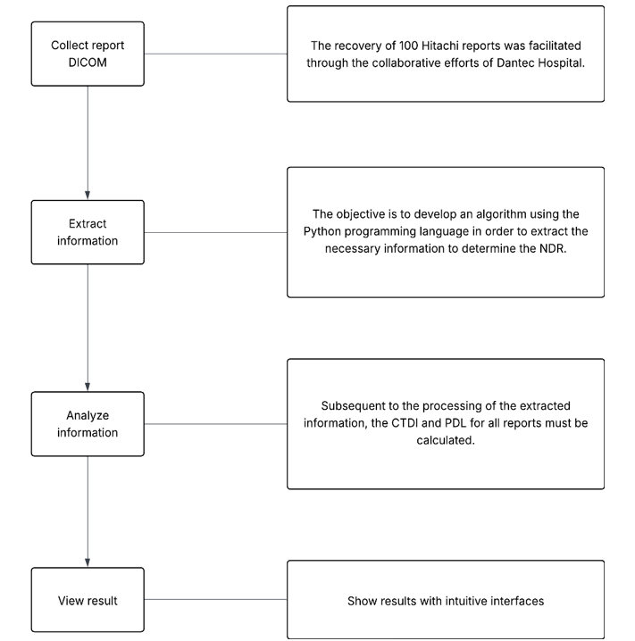
Fig. 1. Methodology for extracting and analyzing data from Hitashi-type DICOM reports

Structure of Hitachi-type DICOM reports

Information needed to conduct the study
We had to extract the information that medical physicists need for proper analysis in order to reduce radiation doses. This information was retrieved from Excel files, as shown in Fig.1. The mandatory information is the computed tomography dose index (CTDI) and diagnostic reference level (DRL) dose indices.
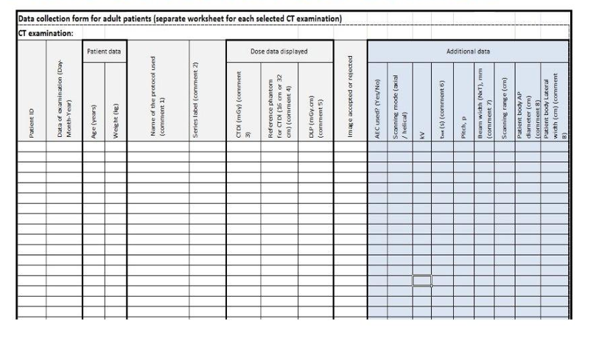
Fig. 2. Data required for analysis
After extraction, using the Excel file, they performed calculations to determine the CTDI and overall DRL for all parts, as well as for each individual part (Fig. 3).

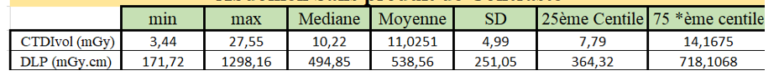

Fig. 3. Results of CTDI and DRL for the abdomen

Hitachi DICOM report
DICOM SR(Structured Report) is a standard used in medical imaging to structure and exchange structured reports on medical examinations. It is an extension of the DICOM format, which is the standard commonly used for storing, transmitting, and managing medical images, such as X-rays, CT scans, and ultrasounds. In addition, it is a solution for retrieving imaging metadata tags through structured DICOM reports that can contain metadata for specific purposes. There are a variety of reports, however, only the DICOM Structured Radiation Dose Report (RSDR) is commonly used in imaging. RSDRs have the advantage of containing additional exposure-related information, but without any image data, allowing for faster transfer. In addition, RSDRs provide non-exclusive access to examination and exposure data, capturing detailed information about each X-ray irradiation event (a fluoroscopy or series of acquisitions).
The use of structured reports also has the potential to further standardize the reporting and storage of clinical reports and results, but has not been widely adopted. This is a problem because within the same organization, different records are stored on different software systems. There is often no easy way to link them. Like DICOM, RDSR consists of tags and values. The value can be a simple element or a sequential element.
To extract simple elements, you can use the field identifier, for example dataset.PatientName, or the hexadecimal tag (dataset.get((0x0010, 0x1010)).value). For sequential elements, the previous operation (extracting a simple element) provides an array containing elements, and these elements may contain other elements, and so on. To do this, since we have an example dataset and we also have an example of the expected result, we used the keyboard shortcut “CTRL+F” to search the dataset for the location of the result in order to obtain the correct index to locate the result. An example is: dataset.get((0x0040,0xa730))[9].get((0x0040,0xa730))[1].get((0x0040,0xa168))[0].get((0x0008, 0x0104)).value.

Data extraction and analysis

Data extraction function

The data extraction file (see Fig. 1) comprises four sections: patient information (ID, first name, last name, gender, weight, date); protocol information (protocol name, series); dosimetric information (CTDI, PDL); and additional information (KV or kilovoltage, pitch, total columns, etc.), as illustrated in Fig. 4, 5, 6 and 7, respectively. In the present approach, it was deemed necessary to divide each part into extraction functions:

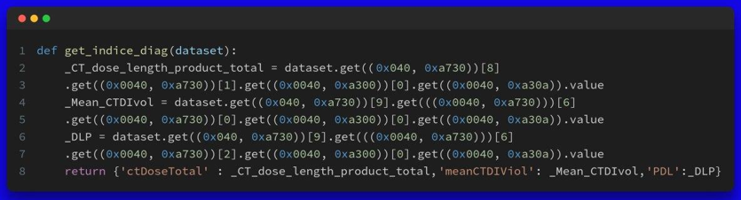

Fig. 4. Information about the device

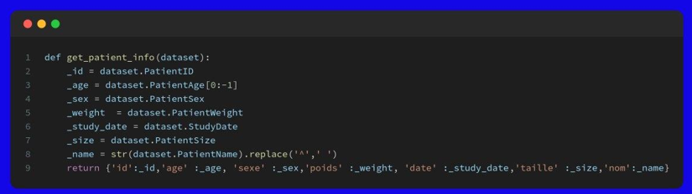

Fig. 5. Patient information
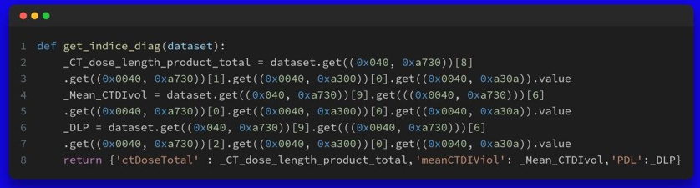
Fig. 6. Dose index information
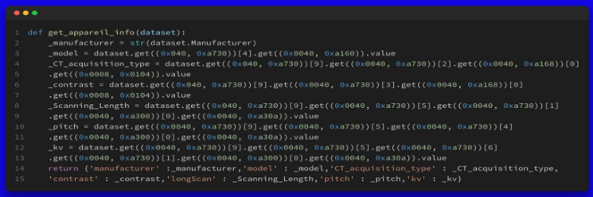
Fig. 7. Additional information

Data analysis

The aim of the study is to determine the DRL for the hospital by optimizing data extraction and analysis. The International Commission on Radiological Protection (ICRP) first introduced the concept of diagnostic reference levels in 1996, in its Publication 73, “Radiation Protection and Safety in Medicine” (ICRP, 1996). Given the diversity of interpretation and implementation of these levels between countries and sectors of activity (radiology, nuclear medicine, etc.), ICRP Committee 3 decided to revisit this issue in 2000 and proposed a new document (International Commission on Radiological Protection (ICRP), 2001), currently under discussion, intended to supplement the initial recommendations of Publication 73. The European Commission recommends (European Commission, 1999) an empirical method, based on actual medical practices, to gradually reduce the doses delivered to patients. This is the statistical method known as the 75th percentile, which has already been implemented by several European countries, including the United Kingdom, for the past 20 years (National Radiological Protection Board (NRPB), 1999). The reference level adopted is the 75th percentile of the distribution of doses measured for a given procedure, across a large number of patients in a large number of centers, representative of radiological practice in a country.

To accurately assess the radiation dose, two key parameters are extracted: the CTDI (1), (2) and the DRL (3). The weighted CTDI, denoted (CTDI)_w, is calculated using the following formula: weighted computed tomography dose index

${CTDI}_{w}=\frac{1}{3}{CTDI}_{\text{center }}+\frac{2}{3}{CTDI}_{\text{periphery }}$ (1)

Next, the volumetric CTDI is obtained by taking into account the pitch (ratio between the table advance and the beam width):

${CTDI}_{vol}=\frac{{CTDI}_{w}}{\text{ Pitch }}$ (2)

The Product Length (PL) is given by:

$DLP={CTDI}_{vol}×L$ (3)

with L being the scanning length in inches.

Presentation of results

With Django, we were able to integrate Python processing and communicate with Angular via the Rest API to present the results on a user-friendly interface:
To determine the NDR, a study can be conducted. Once logged in, each doctor will see a list of the studies they have had to perform, as shown in Fig. 7.

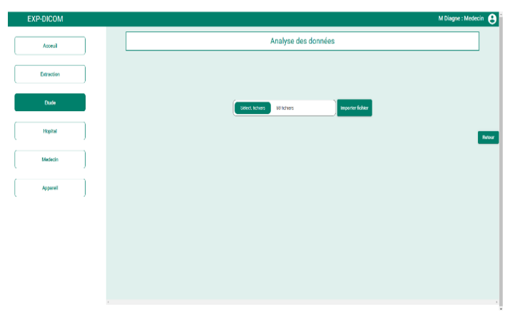
Fig. 8. Upload the files

The following pages show details of settings such as attributes to extract and correction of missing values after downloading the files and clicking the import button in Fig. 10.

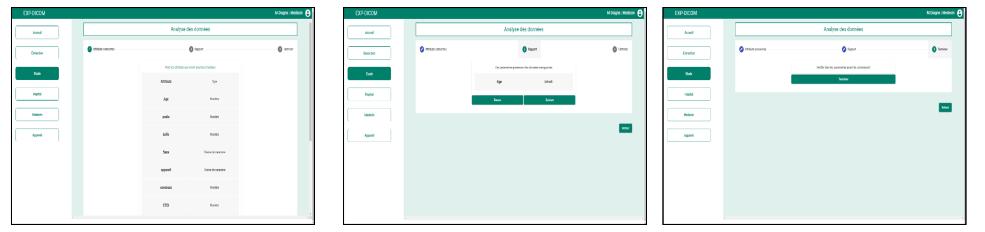

Fig. 9. Information to extract, Default value, Finish the setup

After validating the parameter, a list of reports is displayed (Fig. 13). You can view the details of each extracted file by clicking on the icon in the action section. The results are grouped together as shown in the Fig. (Fig. 2).

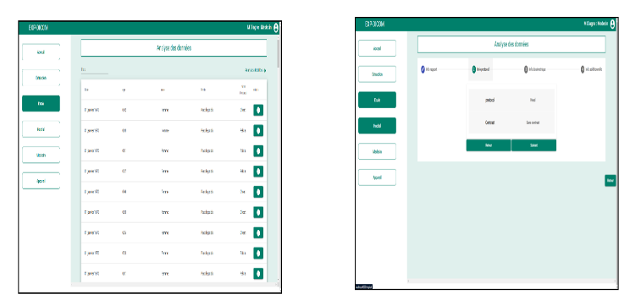

Fig. 10. Patient information, Protocol information

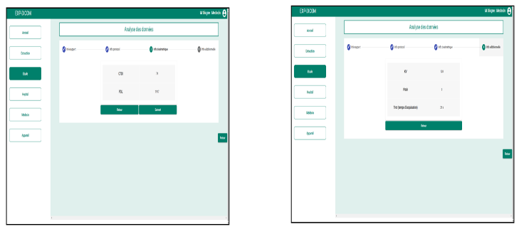

Fig. 11. Dosimetric information, Additional information

From the list, you can also proceed to the analysis by clicking on the detailed analysis link in Fig. 14. This allows you to choose between the two types of analysis available: statistical or general.
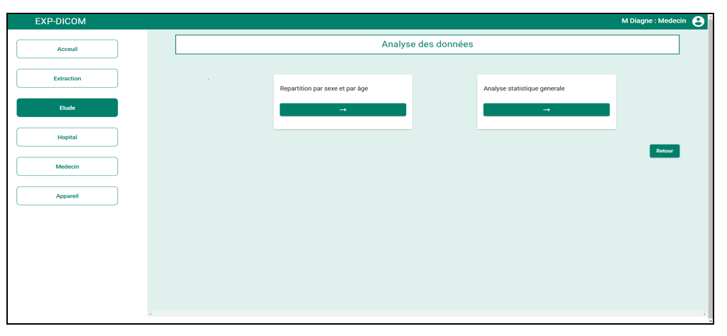
Fig 12 : Types of analysis

The statistical analysis as indicated in our reference document provides the distribution by age and gender for the study conducted on X patients.

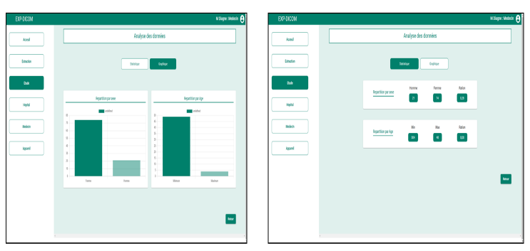
Fig 13 : Analysis by gender and age (graph), Analysis by gender and age (statistical)

For the overall statistical analysis (the other tab in Fig. 19), we determined the statistical distribution as indicated in the reference file. Thus, we can see the CTDI and DRL of the study corresponding to the 75th percentile.

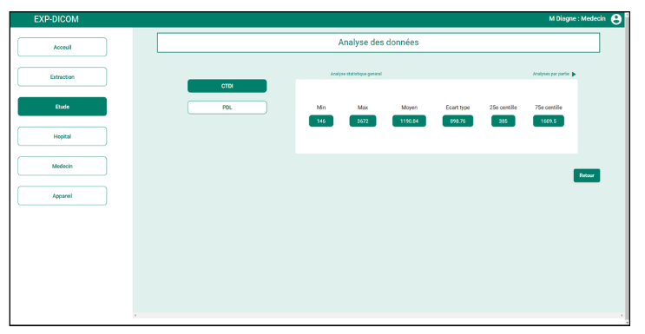
Fig. 14. Comprehensive statistical analysis

Furthermore, we can determine the statistical analysis for each part by clicking on the link “analysis by part” in Fig. 12:
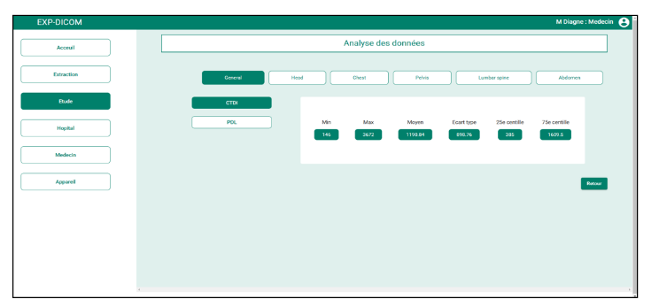
Fig. 15. Statistical analysis by part

In order to define diagnostic reference levels based on the data collected, we applied a statistical method based on the 75th percentile.
NDR is defined as follows:

$NDR=P_{75}(X)$ (4)

where X represents the set of CTDI or DRL values measured for the same type of examination. The NDR corresponds to the value below which 75% of the observed data lies, in accordance with the recommendations of the European Commission.

Conclusion and perspectives

The extraction and analysis of data contained in DICOM reports, particularly RDSR reports from Hitachi devices, represent a significant advance in the intelligent management of radiation doses in medical imaging. This work is part of a drive to modernize medical practices in Senegal, where taking diagnostic reference levels into account is becoming crucial for patient safety and optimizing device performance.
Thanks to a methodical approach combining the collection of real data, a detailed understanding of the DICOM structure, and the development of robust extraction algorithms, we have been able to implement an automated solution that effectively replaces the old manual methods, which were time-consuming and prone to error. This solution, based on an ergonomic web interface and powered by Python processing via Django, not only accurately extracts critical parameters such as CTDI and DRL, but also generates clear visualizations for quick and informed decision-making.
The time savings are remarkable: a task that previously took an estimated two to three months can now be completed in a matter of minutes. Beyond its technical performance, this platform is a tool for standardizing practices, proactively monitoring exposure, and assisting with compliance with international recommendations such as those of the ICRP or the European Commission.
In short, this work paves the way for more efficient, safer, and more integrated management of radiological examinations. It lays the foundation for a future where data intelligence will not only improve the quality of care, but also ensure radiological safety on a national scale. This model could eventually be extended to other equipment and medical centers and potentially integrated into broader clinical decision support systems based on artificial intelligence and medical data science.

References

- G Smith, J., et al. "Advancements in Health Data Management." Journal of Medical Technology, 2020.
- "Digital Imaging and Communications in Medicine (DICOM) Standards." Medical Imaging Standards Organization, 2019.
- Brown, L., et al. "Data Extraction from Medical Imaging Reports." IEEE Transactions on Biomedical Engineering, 2021.
- Lin, K., & Zhou, Y. "Predictive Maintenance in Medical Imaging Equipment." Health Informatics Journal, 2018.
- Allen, R., et al. "Automation and Efficiency in Clinical Data Processing." Healthcare Technology Letters, 2020.
- Chen, X., et al. "Data Mining Techniques for Medical Imaging Data Analysis." International Journal of Data Science and Analytics, 2022.
- Yang, S., et al. "Automated Systems in Healthcare Data Management." Journal of Applied Clinical Informatics, 2019.
- Klein, D. O., Rennenberg, R., Gans, R., Enting, R., Koopmans, R., & Prins, M. H. (2019). Limited external reproducibility restricts the use of medical record review for benchmarking. BMJ Open Quality, 8(1), e000564. https://doi.org/10.1136/bmjoq-2018-000564
- Naciri S., Cheikhrouhou N., Pouly M., Glardon R. ERP data sharing framework using the Generic Product Model (GPM). Expert Systems with Applications, vol. 38, no. 2, 2011. DOI: 10.1016/j.eswa.2010.05.013.
- Jadu FM, Hill ML, Yaffe MJ, Lam EW. Optimization of exposure parameters for cone beam computed tomography sialography. Dentomaxillofac Radiol. 2011 Sep;40(6):362-8. doi: 10.1259/dmfr/81159071. PMID: 21831976; PMCID: PMC3520345.
- Liu R, Yan Z, Zhang G, Ding Z, Li Y, Jiang Z. Comparison of digital subtraction angiography and contrast-enhanced ultrasound in assessment of carotid stenosis. Afr Health Sci. 2020 Mar;20(1):509-514. doi: 10.4314/ahs.v20i1.57. PMID: 33402939; PMCID: PMC7750059.
- N. Tamam, H. Salah, M. Rabbaa, M. Abuljoud, A. Sulieman, M. Alkhorayef, and D. A. Bradley, "Evaluation of patients radiation dose during mammography imaging procedure," Radiation Physics and Chemistry, vol. 188, p. 109680, 2021. DOI: 10.1016/j.radphyschem.2021.109680.
- NICE, Radiation dose monitoring software for medical imaging with ionising radiation, Medtech Innovation Briefing, 31 oct. 2017. [En ligne]. Disponible sur : www.nice.org.uk/guidance/mib127.
- Mackenzie A, Lewis E, Loveland J. Successes and challenges in extracting information from DICOM image databases for audit and research. Br J Radiol. 2023 Nov;96(1151):20230104. doi: 10.1259/bjr.20230104. Epub 2023 Sep 12. PMID: 37698251; PMCID: PMC10607388.

