Study of the Effects of Aerosols and Dust on Surface Solar Radiation and Solar Energy Potential

Mohammad Jafar Mokarram
School of Electronic Engineering and Intelligent Manufacturing
Anhui Xinhua University
Hefei, China
mjmokarram@axhu.edu.cn
Mohamed Hafez
Faculty of Engineering FEQS
INTI International University
Nilai, Malaysia
Faculty of Management, Shinawatra University, Pathum Thani, Thailand, mohdahmed.hafez@newinti.edu.my
Xuan Yang
Shandong Engineering Research Center of New Energy Materials and Devices, Weifang University of Science and Technology, Weifang, China, yangxuan@wfust.edu.cn
Hani Attar
Faculty of Engineering
Zarqa Univeristy
Jordan
Hattar@zu.edu.jo

Abstract—The deserts of South Asia have high potential for solar energy generation due to their low latitude and almost cloudless summers. Using satellite data from MIDAS climatology and cloud information from CM SAF, this study investigates the effects of aerosols, dust, and surface shortwave radiation downward (SSRD) during 2004–2023. It also assesses their impact on solar power generation facilities. The results show that dust aerosol concentrations and total aerosols are positively but weakly correlated with SSRD and DIR (R² between 0.02 and 0.048). Between 2016 and 2024, the average Aerosol Optical Depth (AOD) decreased in countries such as Pakistan (from 0.53 to 0.11) and Afghanistan (from 0.25 to 0.1), while it increased in the Syrian Arab Republic (from 0.07 to 0.21). The Global horizontal irradiance (GHI) and direct normal irradiance (DNI) also increased in some areas such as the Paracel Islands and decreased in Pakistan and Aksai Chin. These changes affect the efficiency of solar energy systems and require attention in the design of facilities.
Keywords—Aerosols, dust, surface solar radiation, solar energy, optical depth, Asian deserts.

Introduction
Climate change is one of the greatest global challenges of the 21st century. These changes are caused by the increase in greenhouse gas concentrations due to human activities, especially the combustion of fossil fuels [1], [2], [3]. Industrial activities are one of the main sources of greenhouse gas emissions, and global energy demand is constantly increasing [4], [5]. This increase in demand has intensified the consumption of fossil fuels and increased greenhouse gas emissions [6], [7], [8]. The transition to renewable energies, especially solar energy, is a strategic solution to reduce emissions and combat climate change [9], [10]. It is regarded as a clean energy technology that significantly participates in energy development and developing countries progress [11], [12], [13]. Photovoltaic technologies, with continuous improvements, have great potential for producing clean energy. The Paris Agreement has committed countries to reduce greenhouse gas emissions and increase the share of renewable energy [14], [15], [16].
The desert regions of South Asia have high potential for solar energy due to their low latitude and arid climate with abundant radiation. These regions, with their high average Global horizontal irradiance (GHI), offer significant opportunities for the development of solar installations [17], [18]. Climatic factors such as aerosols, dust and clouds have a significant impact on surface shortwave radiation downward (SSRD) and these variables are critical for optimal photovoltaic (PV) performance [19], [20]. Aerosols and desert dust reduce the radiation received by panels by scattering and absorbing sunlight [21], [22], [23]. These particles also reduce efficiency by depositing on panels [24], [25]. Aerosols, by acting as cloud condensation nuclei, affect the optical properties and lifetime of clouds, increasing the complexity of climate effects [26], [27]. In the deserts of South Asia, the low cloud cover in summer makes aerosols and dust the main determinants of radiation levels [21], [28], [29]. Satellite data such as MIDAS and CM SAF have enabled detailed analysis of climate impacts. These data are essential for modeling SSRD and predicting the performance of solar installations [30].
Many of these studies have been limited to local analyses and have not comprehensively examined long-term satellite data. Some studies in Africa and the Middle East have used satellite data to analyze aerosol changes but have focused less on the direct impact on solar installations. The present study uses MIDAS and CM SAF data to analyze aerosol and solar radiation changes between 2004 and 2023. This study investigated the correlation between aerosols and radiation variables SSRD. The main objective of this paper is to investigate the effects of dust aerosols on surface solar radiation and solar panel efficiency in the deserts of South Asia. This study uses satellite data to analyze the temporal and spatial variations of Dust Aerosol Optical Depth (AOD) and its impact on GHI and direct normal irradiance (DNI). The effects of dust deposition on panels and efficiency reduction are also investigated. Future work can explore the integration of solar forecasting models with cross-sector energy management frameworks [31]. Additionally, advanced signal processing and waveform optimization techniques can be used to improve methods for monitoring atmospheric aerosols and dust using remote sensing technologies [32], [33].

Data
This study uses satellite data to investigate the effects of aerosols, dust, and clouds on SSRD from 2004 to 2023. aerosol optical depth at 550 nm (AOD550) data is extracted from MIDAS and MODIS. Cloud and radiative variables data are obtained from CM SAF. Statistical analyses are performed with Python and the NumPy, Pandas, and Matplotlib libraries. The statistical data from 2016 and 2024 examine the changes in AOD550, GHI, and DNI in regions such as Pakistan, Afghanistan, and the Paracel Islands.

methodology

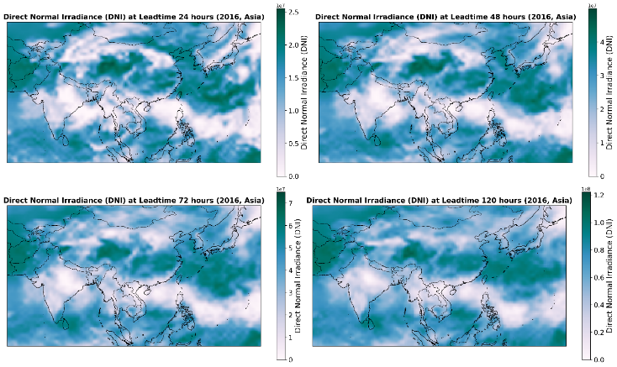
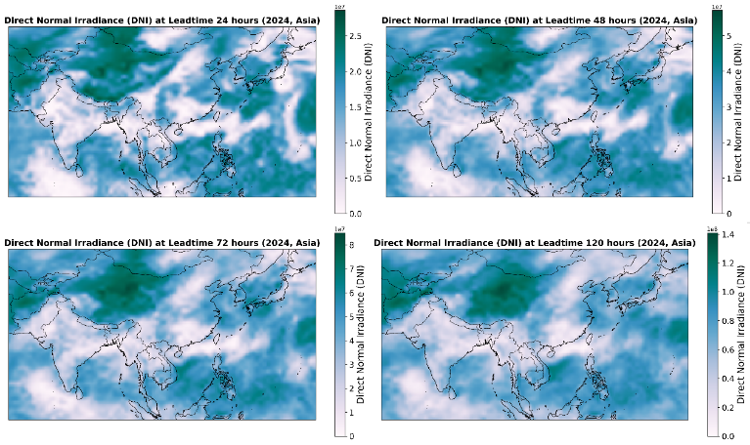
Statistical Analysis

Analyses were performed using Python (version 3.8) and the NumPy, Pandas, and Matplotlib libraries. Box plots were created to analyze the distribution of variables AOD550, AOD550, GHI, and DNI.

Regression Analysis
Simple linear regression was used to explore the relationship between aerosols and radiation variables. The regression formulations are as follows:
SSRD = β₀ + β₁ × AOD550 + ε
DNI = β₀ + β₁ × AOD550 + ε
SSRD = β₀ + β₁ × AOD550 + ε
DNI = β₀ + β₁ × AOD550 + ε
where SSRD represents surface solar radiation, DNI is direct normal irradiance, AOD550 is the dust aerosol optical depth at 550 nm, AOD550 is the total aerosol optical depth at 550 nm, β₀ is the intercept, β₁ is the coefficient for the independent variable, and ε is the error term.

results

Spatial Distribution of DNI and Dust
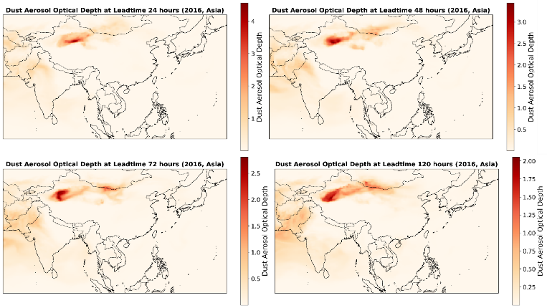
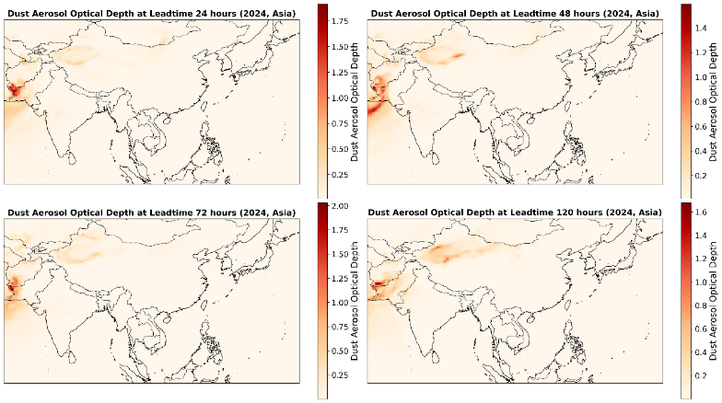
The dust concentration is shown in Fig. 1. The highest dust levels are observed in northeastern China. The results also indicate the presence of dust in parts of East Asia. Dust in these areas significantly affects solar radiation and energy production.
Fig. 2 shows the DNI zoning maps for different Asian regions. Many regions in the study area have high solar radiation. The spatial variations indicate that in 2024, Northeast China will offer favorable conditions for solar panel installation.

Changes AOD
Analysis of AOD data from 2016 to 2024 shows significant changes in dust concentrations across Asian countries. In Pakistan, the average AOD550 decreased from 0.53 in 2016 to 0.11 in 2024, representing a decrease of 0.42 units. This decrease may be due to changes in weather patterns or a decrease in local dust-generating activities. In Afghanistan, the average decreased from 0.25 to 0.1, representing a decrease of 0.15 units. Turkmenistan experienced a similar trend, with the average decreasing from 0.22 to 0.1. In contrast, the Syrian Arab Republic saw an increase in the average AOD550 from 0.07 to 0.21, representing an increase of 0.14 units. This increase may be due to more intense dust events or changes in dust transport pathways from desert areas. Azerbaijan also experienced a significant decrease, with the median decreasing from 0.18 to 0.02 (Fig. 3).

Changes in Aerosol Optical Depth (AOD550)
AOD550 shows different trends in Asia. Hong Kong had a median increase from 0.1 to 0.38, an increase of 0.28 points. Macau showed an increase from 0.09 to 0.33, an increase of 0.24 points. Azerbaijan experienced a median decrease from 0.46 to 0.18, a decrease of 0.29 points. Armenia also experienced a decrease from 0.39 to 0.13, a decrease of 0.26 points. Georgia recorded a median decrease from 0.42 to 0.08, a decrease of 0.34 points. These changes reflect the influence of local and regional aerosol sources (Fig. 3).

Changes in Global Horizontal Irradiance (GHI)
GHI showed diverse changes across Asian regions. In the Paracel Islands, the average GHI increased by about 70 percent. Vietnam experienced a similar increase of about 80 percent. In contrast, Pakistan experienced a significant decrease of about 33 percent. Aksai Chin showed a similar downward trend of about 33 percent. These changes can affect PV system efficiency, especially in areas with significant radiation reduction (Fig. 3).

Changes in Direct Normal Irradiance (DNI)
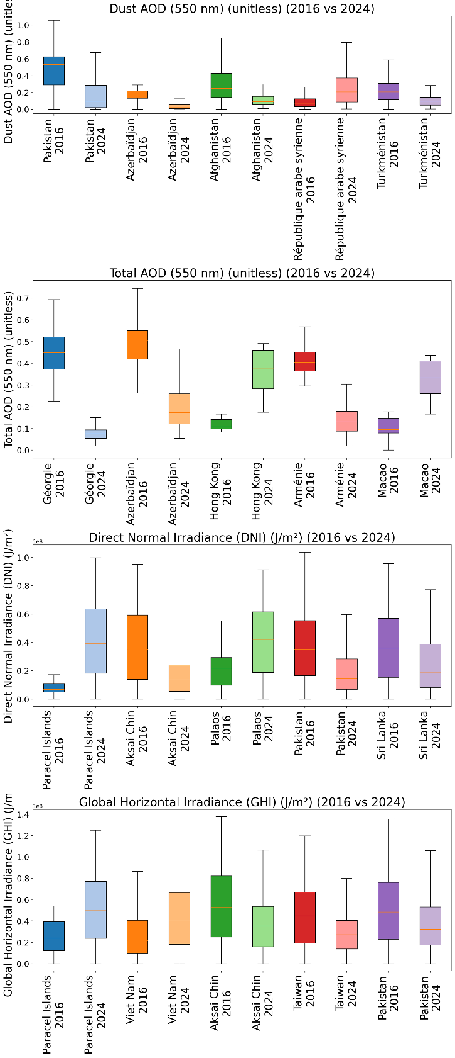
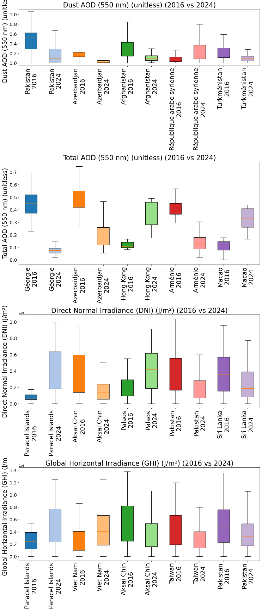
DNI showed contrasting patterns across regions. In the Paracel Islands and Palau, the average DNI increased by approximately fourfold and twofold, respectively. These results indicate a significant improvement in direct irradiance. In contrast, Pakistan and Sri Lanka experienced a decrease of approximately 50–60%. China also saw a significant decrease of approximately 60%. These trends highlight the impact of atmospheric conditions and aerosol changes on CSP system efficiency (Fig. 3).

Regression Analysis
Simple linear regression models were applied to examine the relationship between aerosol indices (AOD550 and AOD550) and radiation variables (SSRD and DNI). The results indicate a positive but weak relationship between aerosol indices and radiation variables. This indicates that an increase in aerosol concentration is associated with a slight increase in radiation values. However, the low coefficients of determination (R²) indicate that other factors, such as cloud cover, humidity, and local atmospheric variations, play a more important role in determining solar radiation. These findings, derived from MIDAS and CM SAF satellite data, emphasize the limited but significant role of aerosols in the variation of solar installation efficiency (Fig. 3).
Impact on Solar Energy Production

The observed changes in AOD550, GHI and DNI directly affect solar energy generation. The decrease in GHI and DNI in regions such as Pakistan and China indicates a decrease in the potential of PV and CSP systems. This decrease may be due to dust accumulation on the panels or attenuation of radiation by aerosols. In contrast, the increase in GHI and DNI in the Paracel Islands indicates an improvement in conditions for solar energy generation. The increase in AOD550 in Hong Kong may be due to urban pollution, which reduces the efficiency of solar panels. These results highlight the importance of regular maintenance of panels and consideration of weather conditions in the design of solar installations..

conclusion
The present study showed that aerosols and dust have a significant impact on SSRD and DIR in the deserts of South Asia. The statistical correlations obtained were weak. Long-term changes in AOD550 were observed in different regions of the region. These changes have brought about different patterns of increasing or decreasing solar radiation. Significant reductions in dust in countries such as Pakistan and Afghanistan have been accompanied by relative improvements in solar radiation conditions. Increased dust in areas such as Syria and Hong Kong could pose new challenges for solar energy generation.
The results of GHI and DNI changes showed that some areas, especially the Paracel Islands and Vietnam, have enjoyed increased solar radiation. Areas such as Pakistan, Aksai Chin have experienced significant radiation reductions. These climatic and spatial variations affect the efficiency of PV systems. These issues should be considered in the design, siting, and maintenance of solar installations. Finally, this study emphasizes the importance of using long-term satellite data. Comprehensive analysis of aerosol and dust effects is essential. These analyses will enable the formulation of strategies to optimize solar energy generation. The findings indicate the need to develop solar radiation forecasting models based on local climate and air quality data. These models can enable sustainable and effective exploitation of solar resources in South Asia.

References
[1] T. Tsoutsos, N. Frantzeskaki, and V. Gekas, “Environmental impacts from the solar energy technologies,” Energy Policy, vol. 33, pp. 289–296, 2005, doi: 10.1016/S0301-4215(03)00241-6.
[2] M. Kenisarin and K. Mahkamov, “Solar energy storage using phase change materials,” Renewable and Sustainable Energy Reviews, vol. 11, no. 9, pp. 1913–1965, Dec. 2007, doi: 10.1016/J.RSER.2006.05.005.
[3] M. Mokarram, M. J. Mokarram, M. Gitizadeh, T. Niknam, and J. Aghaei, “A novel optimal placing of solar farms utilizing multi-criteria decision-making (MCDA) and feature selection,” J Clean Prod, vol. 261, p. 121098, 2020.
[4] A. O. M. Maka and J. M. Alabid, “Solar energy technology and its roles in sustainable development,” Clean Energy, vol. 6, no. 3, pp. 476–483, 2022.
[5] A. M. Omer, “The energy crisis, the role of renewable and global warming,” Greener Journal of Environment Management and Public Safety, vol. 1, no. 1, pp. 7–38, 2012.
[6] W. S. Ebhota and T.-C. Jen, “Fossil fuels environmental challenges and the role of solar photovoltaic technology advances in fast tracking hybrid renewable energy system,” International Journal of Precision Engineering and Manufacturing-Green Technology, vol. 7, no. 1, pp. 97–117, 2020.
[7] E. Kabir, P. Kumar, S. Kumar, A. A. Adelodun, and K.-H. Kim, “Solar energy: Potential and future prospects,” Renewable and Sustainable Energy Reviews, vol. 82, pp. 894–900, 2018.
[8] M. Mokarram, M. J. Mokarram, and A. Najafi, “Thermal power plants pollution assessment based on deep neural networks, remote sensing, and GIS: A real case study in Iran,” Mar Pollut Bull, vol. 192, p. 115069, 2023.
[9] P. A. Owusu and S. Asumadu-Sarkodie, “A review of renewable energy sources, sustainability issues and climate change mitigation,” Cogent Eng, vol. 3, no. 1, p. 1167990, 2016.
[10] M. Mokarram, M. J. Mokarram, M. R. Khosravi, A. Saber, and A. Rahideh, “Determination of the optimal location for constructing solar photovoltaic farms based on multi-criteria decision system and Dempster–Shafer theory,” Sci Rep, vol. 10, no. 1, p. 8200, 2020.
[11] S. Dhivya and S. Prakash, “Power Quality Assessment in Grid-Connected Solar PV Systems Using Deep Learning Techniques,” Journal of Applied Data Sciences, vol. 6, no. 2, pp. 1192–1208, 2025.
[12] H. Attar, A. Alahmer, G. Borowski, and S. Alsaqoor, “Comprehensive review of advancements, challenges, design, and environmental impact in floating photovoltaic systems.,” Ecological Engineering & Environmental Technology (EEET), vol. 26, no. 2, 2025.
[13] A. Amer et al., “Floating photovoltaics: assessing the potential, advantages, and challenges of harnessing solar energy on water bodies,” Journal of Ecological Engineering, vol. 24, no. 10, pp. 324–339, Oct. 2023, doi: 10.12911/22998993/170917.
[14] M. Elkelawy, W. M El-Ashmawy, and S. M. Ahmed, “State of the art in concentrated solar power: latest technological advancements and innovations in efficiency and energy storage,” Pharos Engineering Science Journal, vol. 1, no. 1, pp. 17–28, 2024.
[15] T. Wilberforce, A. Baroutaji, Z. El Hassan, J. Thompson, B. Soudan, and A. G. Olabi, “Prospects and challenges of concentrated solar photovoltaics and enhanced geothermal energy technologies,” Science of The Total Environment, vol. 659, pp. 851–861, 2019.
[16] A. Amer et al., “Floating photovoltaics: assessing the potential, advantages, and challenges of harnessing solar energy on water bodies,” Journal of Ecological Engineering, vol. 24, no. 10, pp. 324–339, 2023.
[17] M. Jahangiri, O. Nematollahi, E. Heidari Sooreshjani, and A. Heidari Sooreshjani, “Investigating the current state of solar energy use in countries with strong radiation potential in asia using GIS software, a review,” Journal of Solar Energy Research, vol. 5, no. 3, pp. 477–497, 2020.
[18] M. Mokarram, J. Aghaei, M. J. Mokarram, G. P. Mendes, and B. Mohammadi‐Ivatloo, “Geographic information system‐based prediction of solar power plant production using deep neural networks,” IET Renewable Power Generation, vol. 17, no. 10, pp. 2663–2678, 2023.
[19] M. Boujoudar et al., “Impact of dust accumulation on PV and CSP systems: Experimental analysis and simulation insights in semi-arid climate,” Solar Energy, vol. 296, p. 113602, 2025.
[20] M. S. G. Casagrande et al., “Numerical assessment of downward incoming solar irradiance in smoke influenced regions—A case study in brazilian amazon and cerrado,” Remote Sens (Basel), vol. 13, no. 22, p. 4527, 2021.
[21] J. Huang, T. Wang, W. Wang, Z. Li, and H. Yan, “Climate effects of dust aerosols over East Asian arid and semiarid regions,” Journal of Geophysical Research: Atmospheres, vol. 119, no. 19, pp. 11–398, 2014.
[22] S. Mostamandi, A. Ukhov, J. Engelbrecht, I. Shevchenko, S. Osipov, and G. Stenchikov, “Fine and coarse dust effects on radiative forcing, mass deposition, and solar devices over the Middle East,” Journal of Geophysical Research: Atmospheres, vol. 128, no. 22, p. e2023JD039479, 2023.
[23] K. Ansari and S. Ramachandran, “Radiative effects of absorbing aerosol types over South Asia,” Science of the Total Environment, vol. 858, p. 159969, 2023.
[24] S. Fan, Y. Wang, S. Cao, T. Sun, and P. Liu, “A novel method for analyzing the effect of dust accumulation on energy efficiency loss in photovoltaic (PV) system,” Energy, vol. 234, p. 121112, 2021.
[25] H. Yang and H. Wang, “Numerical simulation of the dust particles deposition on solar photovoltaic panels and its effect on power generation efficiency,” Renew Energy, vol. 201, pp. 1111–1126, 2022.
[26] Y. Shao et al., “Dust cycle: An emerging core theme in Earth system science,” Aeolian Res, vol. 2, no. 4, pp. 181–204, 2011.
[27] P. Kumar, I. N. Sokolik, and A. Nenes, “Measurements of cloud condensation nuclei activity and droplet activation kinetics of fresh unprocessed regional dust samples and minerals,” Atmos Chem Phys, vol. 11, no. 7, pp. 3527–3541, 2011.
[28] Y. Gu, Y. Xue, F. De Sales, and K.-N. Liou, “A GCM investigation of dust aerosol impact on the regional climate of North Africa and South/East Asia,” Clim Dyn, vol. 46, no. 7, pp. 2353–2370, 2016.
[29] A. Asutosh, S. K. Pandey, V. Vinoj, R. Ramisetty, and N. Mittal, “Assessment of recent changes in dust over South Asia using RegCM4 regional climate model,” Remote Sens (Basel), vol. 13, no. 21, p. 4309, 2021.
[30] D. A. Bachour and E. Fernández Sánchez, Measuring and estimating solar direct normal Irradiance using LIDAR, solar station and satellite data in qatar. Universitat Autònoma de Barcelona, 2015.
[31] N. Gholipoor et al., “A Review on the Cross-Sector Resource Management Framework for Electric Vehicles Integration: Challenges, Solutions, Key-Enabling Technologies, and Future Directions,” IEEE Open Journal of Intelligent Transportation Systems, vol. 6, pp. 1084–1120, 2025, doi: 10.1109/OJITS.2025.3593437.
[32] Z. Asadsangabi, R. Mohseni, and S. Samadi, “Optimizing the OFDM radar waveform for LATT using WAF criteria in smart cities,” EURASIP Journal on Wireless Communications and Networking 2025 2025:1, vol. 2025, no. 1, pp. 90-, Oct. 2025, doi: 10.1186/S13638-025-02525-1.
[33] F. Aghaei, M. Uysal, R. C. De Lamare, and L. T. N. Landau, “Vehicular MMW Communication: Channel Characterization Based on Ray Tracing Study,” Proceedings of the International Symposium on Wireless Communication Systems, 2024, doi: 10.1109/ISWCS61526.2024.10639124.

