Evaluating the Impact of Photovoltaic Power Plants on Land Surface Temperature Using Remote Sensing Techniques in Asian Regions

Roksana Zarychta
Department of Geodesy, Cartography and Spatial Management; Institute of Law, Economics and Administration; University of the National Education Commission, Krakow; Podcho, Roksana.zarychta@gmail.com
Zhiqing Bai
School of Electronic Engineering and Intelligent Manufacturing
Anhui Xinhua University
Hefei, China, baizhiqing@axhu.edu.cn
Hani Attar
Faculty of Engineering
Zarqa Univeristy
Jordan
Hattar@zu.edu.jo
Xuan Yang
Shandong Engineering Research Center of New Energy Materials and Devices, Weifang University of Science and Technology, Weifang, China, yangxuan@wfust.edu.cn
Mohammad Jafar Mokarram
School of Electronic Engineering and Intelligent Manufacturing
Anhui Xinhua University
Hefei, China
mjmokarram@axhu.edu.cn
Mohamed Hafez
Faculty of Engineering FEQS
INTI International University
Nilai, Malaysia
Faculty of Management, Shinawatra University, Pathum Thani, Thailand, mohdahmed.hafez@newinti.edu.my

Abstract—This study assesses the effects of photovoltaic (PV) power plants on land surface temperature (LST) using remote sensing techniques. The main objective is to investigate the impact of the construction of these power plants on the environment, especially in Asian regions. For this purpose, MODIS thermal infrared satellite images from 2003 and 2023 were used to analyze temperature changes in large PV power plants. The results show that the installation of PV power plants significantly reduced the average daily LST. The cooling rate depends on the plant's capacity: -0.32°C for the daily average, -0.48°C for daytime, and -0.14°C for nighttime per terawatt-hour. Also, night-time cooling is correlated with geographical factors such as latitude, altitude, annual mean temperature, precipitation, and solar radiation. These results indicate the dependence of temperature effects on regional conditions, climate and vegetation. Statistical analysis from 2016 to 2024 in Asian countries such as Tajikistan, Ukraine, Kyrgyzstan, Kazakhstan and Pakistan shows an average temperature increase of 2 m (up to 6.27 degrees in Tajikistan). While in Kazakhstan and Pakistan there is an observed decrease (up to 3.92 degrees). Global horizontal irradiance (GHI) increased in the Paracel Islands and Vietnam (up to 20 million J/m²), but decreased in Aksai, China.
Keywords—Photovoltaic power plant, land surface temperature, remote sensing, climate change, sustainable energy management.

Introduction
As one of the most abundant and cleanest renewable energy sources, solar energy plays a key role in reducing dependence on fossil fuels and reducing greenhouse gas emissions [1], [2], [3], [4], [5]. With the advancement of photovoltaic (PV) technologies, the direct conversion of sunlight into electricity has become possible, and solar power plants have become economically competitive with traditional power plants [1], [2], [3]. It is regarded as a clean energy technology that significantly participates in energy development and developing countries progress [4], [5], [6]. Solar power plants have become economically competitive with traditional power plants [7]. According to the International Energy Agency (IEA), the global installed capacity of PV has increased from about 100 MW in 1992 to more than 700 GW in 2023 [8].
This rapid expansion has not only contributed to reducing carbon emissions [9], [10], but also has had direct impacts on local and regional climate through changes in the Earth’s surface energy balance [11]. The widespread installation of PV panels can affect the land surface temperature (LST) due to changes in albedo (surface reflectance) and reduced absorption of solar energy [12]. These temperature changes can help improve climate conditions in arid regions or reduce urban heat island effects [13]. However, the precise effects of these power plants on surface temperature and energy balance still need to be investigated more thoroughly, especially at large geographical scales.
Remote sensing, as a powerful tool for monitoring environmental changes at large scales, has enabled the detailed study of land surface temperature [14], [15], [16], [17], [18]. Unlike point-based measurements of air temperature by meteorological stations, which may be affected by surface heterogeneity or sensor installation height, remote sensing using satellite data such as MODIS provides comprehensive information with wide spatial coverage [19], [20]. This technology enables accurate LST mapping and allows researchers to investigate the effects of PV power plants on surface temperature at high resolution. Previous studies have shown that remote sensing data, such as MODIS thermal bands, can be used to analyze temperature changes in different regions with high accuracy [21], [22]. However, the application of these techniques to large-scale photovoltaic power plants has received less attention. While this method can provide valuable information about the environmental impacts of these power plants,
Photovoltaic power plants can have cooling effects on surface temperatures by changing the albedo of the land surface and reducing the absorption of solar radiation [23], [24]. Studies have shown that in urban areas, rooftop PV panels can reduce daily air temperatures by between 0.2 and 0.8 °C. However, conflicting results have been reported for large-scale PV power plants. Some studies point to cooling effects. While other studies have reported temperature increases in arid regions [25], [26].
These differences can depend on factors such as geographical location, climatic conditions, and vegetation cover of the area. For example, in arid regions, PV panels can reduce surface temperatures by reducing albedo and increasing solar reflectance. While in humid regions, different effects may be observed. These complexities require more detailed investigation using extensive data and advanced methods such as remote sensing.
The aim of this study is to investigate the effects of photovoltaic power plants on land surface temperature using MODIS thermal infrared remote sensing data from 2003 and 2023. This research seeks to answer the following questions:
(1) What is the impact of installing PV power plants on land surface temperature during the day, night, and daily average?
(2) Are these temperature effects dependent on geographical factors such as latitude, altitude, or weather conditions such as precipitation and solar radiation?
By analyzing data from several large PV power plants in Asia and using cloud computing platforms such as Google Earth Engine, this study seeks to provide new insights into the environmental impacts of this technology. These findings can contribute to sustainable energy policymaking and environmental impact management. Future investigations should also explore the integration of PV plants within broader smart energy systems including cross-sector frameworks for managing EV-grid interactions [27] and leverage advanced sensing and communication techniques, such as OFDM radar waveform optimization [28] and MMW channel characterization for vehicular networks [29], to enhance the spatial and temporal resolution of climate and environmental impact assessments.

Data
To assess the impacts of PV plants on LST, Terra-MODIS satellite remote sensing data were used. MODIS thermal band data (product MYD11A1) with a spatial resolution of 1 km and daily temporal resolution were extracted for the years 2003 and 2023. These data monitored LST changes at 23 large PV plants in Asia. In addition, environmental variables such as 2-meter temperature, dew point, GHI, net solar surface insolation, and clear-sky direct insolation were extracted for the years 2016 and 2024 from ERA5-Land data. Data analysis was performed using Python (Pandas, NumPy, and Matplotlib libraries) and the Google Earth Engine platform. The study area included both dry and wet regions of Asia, allowing for the analysis of geographical and climatic effects. These data were used to identify cooling patterns and solar radiation changes at PV power plants.

methodology

Solar Radiation Calculation
GHI and surface solar radiation (SSR) were calculated using ERA5-Land data. GHI was defined as the sum of surface shortwave radiation downward (SSRD), while SSR was obtained from the difference between SSRD and reflected SSR [30]. The following formulations were used to calculate these variables:
$GHI=SSRD$ (1)
$SSR=SSRD-SSR_{reflected}$ (2)
Key inputs included solar zenith angle (SZA), aerosol optical depth (AOD) from CAMS, and TCC. For cloudy conditions, the effects of water cloud optical thickness (WCOT) and ice cloud optical thickness (ICOT) were simulated in the wavelength range of 285 to 2700 nm.

Statistical Analysis
To examine the distribution of temperature and radiation variables, boxplots were generated using the Matplotlib library. These plots display the minimum, first quartile (Q₁), median (Q₂), third quartile (Q₃), and maximum values ​​of 2-meter temperature, dew point, GHI, and SSR for different regions in 2016 and 2024.

Regression Modeling
To investigate the relationship between LST and environmental factors (latitude, altitude, precipitation, solar radiation, and vegetation), linear and polynomial regression models were used. The linear regression model was defined as follows:
$LST=β_{0}+β_{1}X_{1}+β_{2}X_{2}+⋯+β_{n}X_{n}+ϵ$ (3)
where $X_{i}$represents independent variables (e.g., GHI, elevation, or precipitation), and $ϵ$is the error term. For nonlinear relationships, a second-degree polynomial regression was applied:
$LST=β_{0}+β_{1}X+β_{2}X^{2}+ϵ$ (4)
These models were implemented using the Scikit-learn library in Python. Correlation between variables was assessed using the Pearson correlation coefficient ($R$).

Cooling Effect Analysis
The cooling effect of PV plants on LST was investigated by comparing MODIS data in the years before and after the installation of the plants (2003 and 2023). The reduction in daytime (0.81°C) and nighttime (0.24°C) temperatures was calculated using the difference in LST means:
$ΔLST=LST_{2003}-LST_{2023}$ (5)
The cooling rate per plant capacity (terawatt-hour) was calculated as:
$\text{Cooling Rate}=\frac{ΔLST}{\text{Capacity (TWh)}}$ (6)

Results

Temperature Changes
Analysis of boxplots of 2-meter temperatures (in Kelvin) in Asian countries including Tajikistan, Kazakhstan, Pakistan and Ukraine between 2016 and 2024 shows significant changes in temperature patterns. In Tajikistan, the median 2-meter temperature increased from 283.35 in 2016 to 289.62 in 2024. These results indicate a temperature increase of 6.27 degrees. Ukraine also saw a temperature increase, with the median temperature increasing from 297.30 in 2016 to 302.66 in 2024, an increase of 5.36 degrees. In contrast, Kazakhstan and Pakistan experienced a decrease in temperature. In Kazakhstan, the median temperature decreased from 302.83 to 298.91, a decrease of 3.92 degrees. In Pakistan, the median temperature decreased from 307.57 to 303.90, a decrease of 3.67 degrees. These differences indicate the different impacts of PV power plants on surface temperatures in different regions of Asia and are likely to depend on the geographical and climatic conditions of each region.

Global Horizontal Irradiation (GHI) Changes
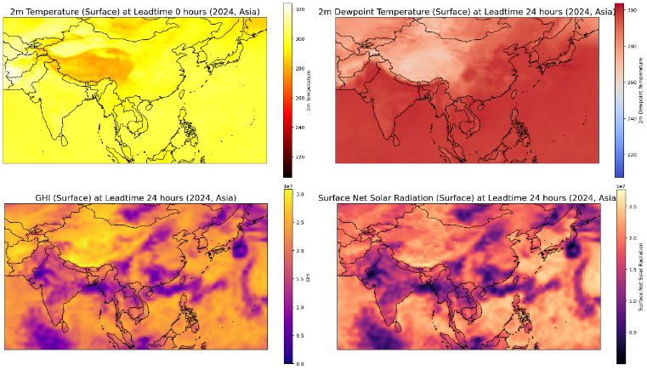
GHI was analyzed in the Asian regions including the Paracel Islands, Vietnam, Taiwan, Aksai Chin. In the Paracel Islands, the median GHI increased from 28,959,744 J/m² in 2016 to 49,492,992 J/m² in 2024, an increase of 20,533,248 J/m². Vietnam also saw a significant increase, with the median GHI increasing from 23,230,464 J/m² to 41,183,232 J/m², an increase of 17,952,768 J/m². In the Kuril Islands, the median GHI increased from 14,992,384 J/m² to 30,171,136 J/m², equivalent to a growth of 15,178,752 J/m². In contrast, Taiwan and Mainland China experienced a decrease in GHI. In Mainland China, the median GHI decreased from 52,165,632 J/m² to 35,999,744 J/m², equivalent to a decrease of 16,165,888 J/m². These changes could be related to differences in cloud cover or surface albedo caused by the installation of PV panels.

Surface Solar Radiation (SSR) Changes
SSR was also examined in the same Asian regions. In the Paracel Islands, the median SSR increased from 27,418,624 J/m² in 2016 to 47,224,836 J/m² in 2024, representing a growth of 19,806,212 J/m². Vietnam had an increase of 15,294,980 J/m², with the median SSR increasing from 19,863,552 J/m² to 35,158,532 J/m². In the Kuril Islands, the median SSR increased from 14,144,512 J/m² to 28,431,362 J/m², representing a growth of 14,286,850 J/m². China also saw a decrease of 13,503,486 J/m², with the median SSR falling from 38,370,304 J/m² to 24,866,818 J/m². These patterns indicate the varying impacts of PV panel installation on the surface energy balance in different regions.

Clear-Sky Direct Radiation and Top-of-Atmosphere (TOA) Radiation Changes
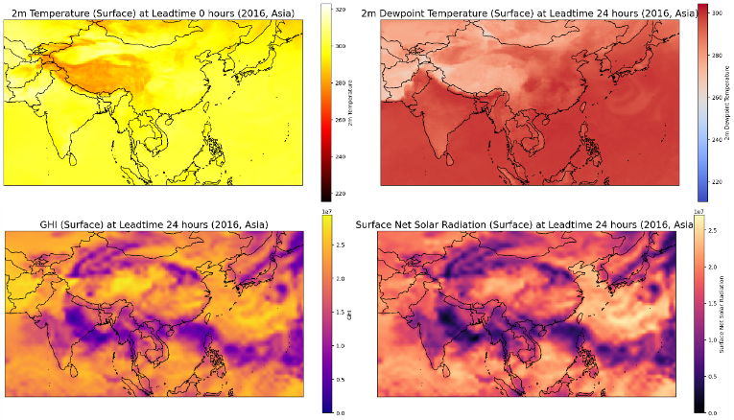
Clear sky direct radiation was studied in Asian countries such as Turkey, Georgia, Kazakhstan and Cyprus. In Turkey, the median clear sky direct radiation increased from 52,219,392 J/m² in 2016 to 56,427,520 J/m² in 2024, representing an increase of 4,208,128 J/m². In Georgia, the median increased from 50,144,768 J/m² to 54,292,480 J/m², representing an increase of 4,147,712 J/m². Kazakhstan also saw an increase of 3,181,568 J/m², with the median increasing from 46,616,576 J/m² to 49,798,144 J/m². In Cyprus, the median increased from 50,557,952 J/m² to 54,198,272 J/m², representing an increase of 3,640,320 J/m². In contrast, the upper atmosphere radiation in the regions of Cyprus, Aksai Chin, North Korea, Pakistan and Jammu and Kashmir showed a slight decrease. For example, in Pakistan, the median TOA decreased from 75,881,472 J/m² to 75,609,088 J/m², representing a decrease of 272,384 J/m². These decreases may be related to climate change or local effects of PV plants (Figs. 1 and 2).

Regression Analysis
Linear and second-degree polynomial regression models were used to examine relationships between climatic and radiation variables. Results showed a positive but relatively weak relationship between 2-meter temperature and GHI. The polynomial model performed slightly better than the linear model, with a marginally higher coefficient of determination (R²). The relationship between 2-meter temperature and surface SSR followed a similar trend, but with even weaker correlation. For dew point , a negative correlation was observed with both GHI and SSR, indicating that increased relative humidity (reflected by higher dew point) was associated with reduced radiation. In all cases, R² values were low, suggesting a weak but climatically significant dependence between variables. These patterns indicate that solar radiation changes are influenced by a combination of atmospheric, humidity, and surface characteristics. Simple linear or second-degree models cannot fully explain these changes (Fig. 3).

conclusion
Using remote sensing techniques, the impact of PV power plants on LST and related climate parameters in different Asian regions was investigated. The results show that the installation of PV power plants generally has a cooling effect on the land surface, especially in reducing the average daily (by 0.81 °C) and nighttime (0.24 °C) temperatures. The intensity of this cooling effect is directly related to the power plant capacity and is influenced by geographical and climatic factors such as latitude, altitude, rainfall, solar radiation and vegetation. Data analysis showed that temperature and radiation changes differ between different regions; such that some countries such as Tajikistan and Ukraine experienced a significant increase in temperature.
While a decrease in temperature was observed in Kazakhstan and Pakistan. Also, changes in dew point, GHI and net SSR indicate regional impacts and diverse climate changes. These changes can be caused by differences in geographical, climatic and plant structure conditions. These findings emphasize the importance of using remote sensing data to monitor and assess the environmental impacts of PV plants. These results indicate that the selection of a suitable location for the construction of solar power plants should be done by considering climatic and geographical conditions. This approach can help optimize solar energy production, reduce negative environmental impacts and strengthen sustainable energy management at the regional and global levels.

References
[1] J. Phillips, “Determining the sustainability of large-scale photovoltaic solar power plants,” Renew. Sustain. Energy Rev., vol. 27, pp. 435–444, Nov. 2013, doi: 10.1016/J.RSER.2013.07.003.
[2] J. Phillips, “Determining the sustainability of large-scale photovoltaic solar power plants,” Renew. Sustain. Energy Rev., vol. 27, pp. 435–444, Nov. 2013, doi: 10.1016/J.RSER.2013.07.003.
[3] M. Mokarram, J. Aghaei, M. J. Mokarram, G. P. Mendes, and B. Mohammadi‐Ivatloo, “Geographic information system‐based prediction of solar power plant production using deep neural networks,” IET Renew. Power Gener., vol. 17, no. 10, pp. 2663–2678, 2023.
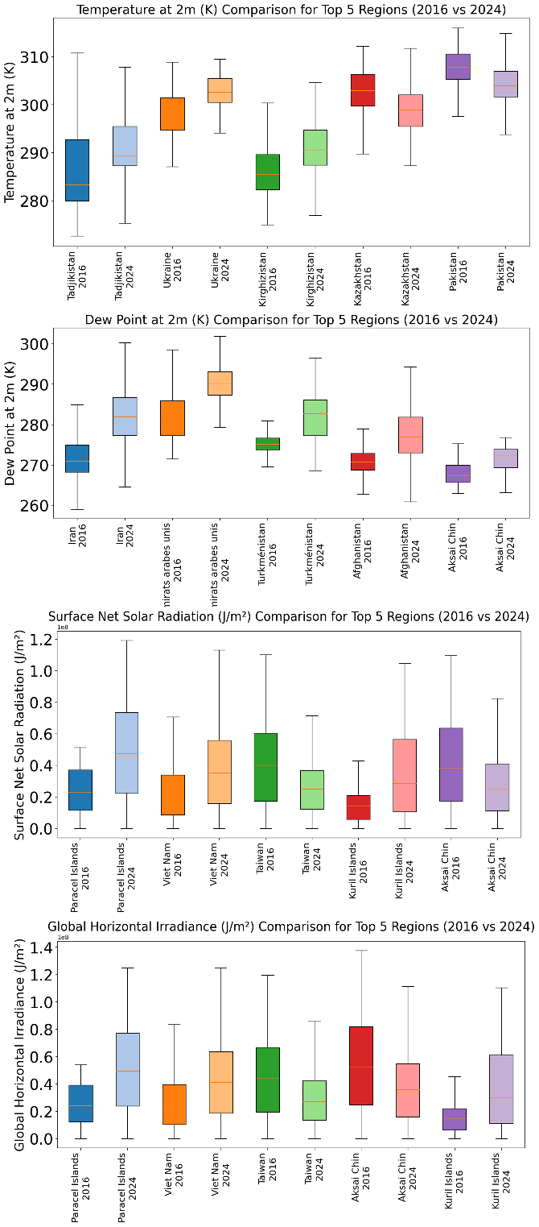
[4] S. Dhivya and S. Prakash, “Power Quality Assessment in Grid-Connected Solar PV Systems Using Deep Learning Techniques,” J. Appl. Data Sci., vol. 6, no. 2, pp. 1192–1208, 2025.
[5] H. Attar, A. Alahmer, G. Borowski, and S. Alsaqoor, “Comprehensive review of advancements, challenges, design, and environmental impact in floating photovoltaic systems.,” Ecol. Eng. Environ. Technol., vol. 26, no. 2, 2025.
[6] P. Aragonés-Beltrán, F. Chaparro-González, J.-P. Pastor-Ferrando, and A. Pla-Rubio, “An AHP (Analytic Hierarchy Process)/ANP (Analytic Network Process)-based multi-criteria decision approach for the selection of solar-thermal power plant investment projects,” Energy, vol. 66, pp. 222–238, Mar. 2014, doi: 10.1016/J.ENERGY.2013.12.016.
[7] M. D. S. Hossain, A. Wadi Al-Fatlawi, L. Kumar, Y. R. Fang, and M. E. H. Assad, “Solar PV high-penetration scenario: an overview of the global PV power status and future growth,” Energy Syst., pp. 1–57, 2024.
[8] S. A. Halasah, D. Pearlmutter, and D. Feuermann, “Field installation versus local integration of photovoltaic systems and their effect on energy evaluation metrics,” Energy Policy, vol. 52, pp. 462–471, Jan. 2013, doi: 10.1016/J.ENPOL.2012.09.063.
[9] S. J. Quan, Q. Li, G. Augenbroe, J. Brown, and P. P.-J. Yang, “A GIS-based Energy Balance Modeling System for Urban Solar Buildings,” Energy Procedia, vol. 75, pp. 2946–2952, Aug. 2015, doi: 10.1016/J.EGYPRO.2015.07.598.
[10] N. Sarmiento, S. Belmonte, P. Dellicompagni, J. Franco, K. Escalante, and J. Sarmiento, “A solar irradiation GIS as decision support tool for the Province of Salta, Argentina,” Renew. Energy, vol. 132, pp. 68–80, Mar. 2019, doi: 10.1016/J.RENENE.2018.07.081.
[11] A. Zameer, F. Jaffar, F. Shahid, M. Muneeb, R. Khan, and R. Nasir, “Short-term solar energy forecasting: Integrated computational intelligence of LSTMs and GRU,” PLoS One, vol. 18, no. 10, p. e0285410, 2023.
[12] G. A. Barron-Gafford, R. L. Minor, N. A. Allen, A. D. Cronin, A. E. Brooks, and M. A. Pavao-Zuckerman, “The Photovoltaic Heat Island Effect: Larger solar power plants increase local temperatures,” Sci. Rep., vol. 6, no. 1, p. 35070, 2016.
[13] M. Mokarram and F. Aminzadeh, “GIS-based multicriteria land suitability evaluation using ordered weight averaging with fuzzy quantifier: a case study in Shavur Plain, Iran,” Int. Arch. Photogramm. Remote Sens. Spat. Inf. Sci., vol. 38, no. 2, pp. 508–512, 2010.
[14] F. Taripanah, A. Ranjbar, A. Vali, and M. Mokarram, “Classification of landforms using topographic location index and assessment of their actual Soil Erosion Risk in mountainous areas (Case study: Kharestan watershed),” Iran. J. Remote Sens. GIS, vol. 15, no. 2, pp. 17–36, 2023.
[15] H. Lu and M. Mokarram, “Forecasting climate change effects on Saline Lakes through advanced remote sensing and deep learning,” Sci. Total Environ., vol. 980, p. 179582, 2025.
[16] A. Tahooni, A. A. Kakroodi, and M. Kiavarz, “Monitoring of land surface albedo and its impact on land surface temperature (LST) using time series of remote sensing data,” Ecol. Inform., vol. 75, p. 102118, 2023.
[17] M. Mokarram, M. J. Mokarram, and A. Najafi, “Thermal power plants pollution assessment based on deep neural networks, remote sensing, and GIS: A real case study in Iran,” Mar. Pollut. Bull., vol. 192, p. 115069, 2023.
[18] Z. Zhang, A. Arshad, C. Zhang, S. Hussain, and W. Li, “Unprecedented Temporary Reduction in Global Air Pollution Associated with COVID-19 Forced Confinement: A Continental and City Scale Analysis,” Remote Sens. 2020, Vol. 12, Page 2420, vol. 12, no. 15, p. 2420, Jul. 2020, doi: 10.3390/RS12152420.
[19] J. E. Nichol, M. Bilal, A. M. Ali, and Z. Qiu, “Air Pollution Scenario over China during COVID-19,” Remote Sens. 2020, Vol. 12, Page 2100, vol. 12, no. 13, p. 2100, Jun. 2020, doi: 10.3390/RS12132100.
[20] S. M. Jaber, “On the relationship between normalized difference vegetation index and land surface temperature: MODIS-based analysis in a semi-arid to arid environment,” Geocarto Int., vol. 36, no. 10, pp. 1117–1135, 2021.
[21] F. Xie and H. Fan, “Deriving drought indices from MODIS vegetation indices (NDVI/EVI) and Land Surface Temperature (LST): Is data reconstruction necessary?,” Int. J. Appl. earth Obs. Geoinf., vol. 101, p. 102352, 2021.
[22] S. Wei et al., “Small reduction in land surface albedo due to solar panel expansion worldwide,” Commun. Earth Environ., vol. 5, no. 1, p. 474, 2024.
[23] X. Zhang et al., “Review of land surface albedo: variance characteristics, climate effect and management strategy,” Remote Sens., vol. 14, no. 6, p. 1382, 2022.
[24] M. Mehdi, N. Ammari, A. A. Merrouni, A. Benazzouz, and M. Dahmani, “Experimental investigation on the effect of wind as a natural cooling agent for photovoltaic power plants in desert locations,” Case Stud. Therm. Eng., vol. 47, p. 103038, 2023.
[25] A. Ataman and N. Arslanoğlu, “Investigation of the cooling effect of wind on rooftop PV power plants,” Case Stud. Therm. Eng., vol. 63, p. 105295, 2024.
[26] V. Teixeira-Branco, “Evaluación de modelos numéricos globales para la predicción de la radiación solar global en el sureste de Sudamérica,” 2023.

