Impact of Photovoltaic Solar Farms on Land Use Change and Vegetation Diversity

Hani Attar
Faculty of Engineering
Zarqa Univeristy
Jordan
Hattar@zu.edu.jo

Ling Yao
School of Electronic Engineering and Intelligent Manufacturing
Anhui Xinhua University
Hefei, China
yaoling@axhu.edu.cn
Siti Aekbal Salleh
Institute for Biodiversity and Sustainable Development, Universiti Teknologi MARA, Shah Alam, Selangor and Faculty of Built Environment, Universiti Teknologi MARA, Shah Alam, Selangor, Malaysia, Siti, aekbal.salleh@gmail.com
Sun Wenfang
School of Electronic Engineering and Intelligent Manufacturing
Anhui Xinhua University
Hefei, China, sunwenfang@axhu.edu.cn
Mohammad Jafar Mokarram
School of Electronic Engineering and Intelligent Manufacturing
Anhui Xinhua University
Hefei, China
mjmokarram@axhu.edu.cn

Mohamed Hafez
Faculty of Engineering FEQS
INTI International University
Nilai, Malaysia
Faculty of Management, Shinawatra University, Pathum Thani, Thailand, mohdahmed.hafez@newinti.edu.my

Abstract—Solar photovoltaic (PV) farms help reduce carbon emissions as a source of renewable energy. However, their installation creates changes in land use and the microclimate of the area. These farms are often built on agricultural or natural lands and may lead to habitat loss and reduced fertile land. These changes can conflict with biodiversity conservation. Natural ecosystems are converted to industrial spaces and soil erosion or runoff increases. However, the effects on vegetation are diverse. PV panels can improve plant diversity in 52% of cases by providing shade and changing the microclimate, such as increasing soil moisture. However, in some cases, the shade of the panels restricts plant growth and reduces species diversity. The results show that Saudi Arabia’s climate data (2016-2024) indicate an increase in temperature (2°K) and solar radiation (i.e. global horizontal radiation), which enhances the potential for PV installation. However, the installation of solar panels may have impacts on the microclimate and vegetation of the region. Therefore, sustainable management is essential to balance clean energy with environmental protection and microclimate changes.
Keywords—Photovoltaic solar farms, land use, vegetation cover, microclimate.

Introduction
The increasing global demand for energy, especially in recent decades, due to population growth and industrial development, has put great pressure on fossil energy resources [1], [2], [3]. This, together with the need to reduce environmental impacts such as greenhouse gas emissions, has led countries to use renewable energy sources [4], [5], [6]. Solar photovoltaic (PV) energy has a great potential for generating clean electricity due to the widespread availability of solar radiation. This technology has grown significantly in recent years and has become one of the fastest growing renewable energy sources.
Solar energy not only helps reduce carbon emissions, but also brings socio-economic benefits such as creating jobs, increasing energy independence, and accelerating the electrification of disadvantaged areas [7], [8]. It is regarded as a clean energy technology that significantly participates in energy development and developing countries progress [9], [10], [11].
The technology has grown significantly in recent years and has become one of the fastest growing renewable energy sources [12], [13]. Solar energy not only reduces carbon emissions, but also provides socio-economic benefits [14], [15]. These benefits include job creation, increased energy independence, and faster electrification of remote areas [16], [17].
However, the development of solar photovoltaic farms requires large areas of land. This often results in land use changes from agriculture or natural habitats to industrial infrastructure [18]. Such changes can have complex impacts on the environment and local ecosystems that have not yet been studied [19], [20]. Land use changes resulting from the installation of solar photovoltaic farms can have both positive and negative impacts on the diversity of local vegetation and ecosystems [21], [22]. Solar panels create shade and alter microclimates. For example, they increase soil moisture and reduce surface temperatures [23], [24]. These changes can improve growing conditions for certain plant species [25]. Studies show that in arid regions, these changes can increase biomass production and, in some cases, increase species diversity [26], [27].
However, the shade from panels may limit the growth of light-sensitive plants and reduce biodiversity in certain areas [28]. Furthermore, the conversion of agricultural or natural land to solar farms can disrupt wildlife habitats. It may also lead to soil erosion or increased runoff [29]. These dual effects require careful study and sustainable management to balance clean energy production and ecosystem preservation.
A careful assessment of the environmental impacts of solar farms is crucial. Data from such studies can help optimize the design and management of these projects. Climatic data, such as temperature, humidity, and solar radiation, are essential for analyzing microclimate changes and their effects on vegetation [30], [31].
This study seeks to fill this gap by focusing on climate and vegetation data in regions such as parts of Asia (2016–2024), which have experienced increases in temperature and solar radiation. Future investigations should also explore the integration of PV plants within broader smart energy systems including cross-sector frameworks for managing EV-grid interactions [32] and leverage advanced sensing and communication techniques, such as OFDM radar waveform optimization [33] and MMW channel characterization for vehicular networks [34], to enhance the spatial and temporal resolution of climate and environmental impact assessments.

Data
In this study, climate and vegetation data for some Asian countries were prepared for the years 2016 and 2024. These data include parameters such as Latitude, Longitude, T2M (2-meter temperature), 2-meter dew point (D2M), global horizontal radiation (GHR), surface solar radiation (SSR), SSRC (net clear sky radiation), surface shortwave radiation downward (SSRD). The data were filtered for the first 1000 records and descriptive statistics were calculated. For example, the median T2M increased from 314.41 K (2016) to 316.47 K (2024) (an increase of 2.06 K), and the median D2M increased from 275.67 to 278.09 K (an increase of 2.42 K). Radiations also showed an increase; The median SSRD increased from moderate to high (2016) to slightly higher (2024), while TISR decreased slightly. For vegetation, the Normalized Difference Vegetation Index (NDVI) was used based on MODIS (Moderate Resolution Imaging Spectroradiometer) data on Terra/Aqua. MOD13Q1 and MOD13C2 products (250 m and 1 km resolution, 16-day/monthly interval) were extracted for some areas of Asian countries. NDVI is calculated from red and near-infrared reflectances and is used to monitor plant health and climate change (such as temperature and radiation increases). Data were downloaded and processed from Google Earth Engine (GEE) with a scaling factor of 0.0001 for the range -1 to 1. Data processing was performed with Python 3.12 (pandas, numpy, matplotlib libraries).

methodology

Data Preprocessing
Climate and NDVI data were processed with Python 3.11. The libraries used include pandas, numpy, matplotlib, and seaborn. For NDVI data, values outside the range (-1 to 1) were removed. Missing values were also deleted.

Remote Sensing Index
The NDVI was extracted from MODIS (Moderate Resolution Imaging Spectroradiometer) satellite data on the Terra/Aqua platforms. The MOD13Q1 (250 m resolution, 16-day interval) and MOD13C2 (1 km resolution, monthly interval) products were used to analyze vegetation changes. The data were downloaded from GEE with a scale factor of 0.0001 (range -1 to 1). The NDVI was calculated using the following:
$\text{NDVI}=\frac{\text{NIR}-\text{RED}}{\text{NIR}+\text{RED}}$ (1)
NIR represents near-infrared reflectance. RED represents red band reflectance. This index assessed plant health and biodiversity changes in areas affected by photovoltaic solar farms.

Statistical Analysis
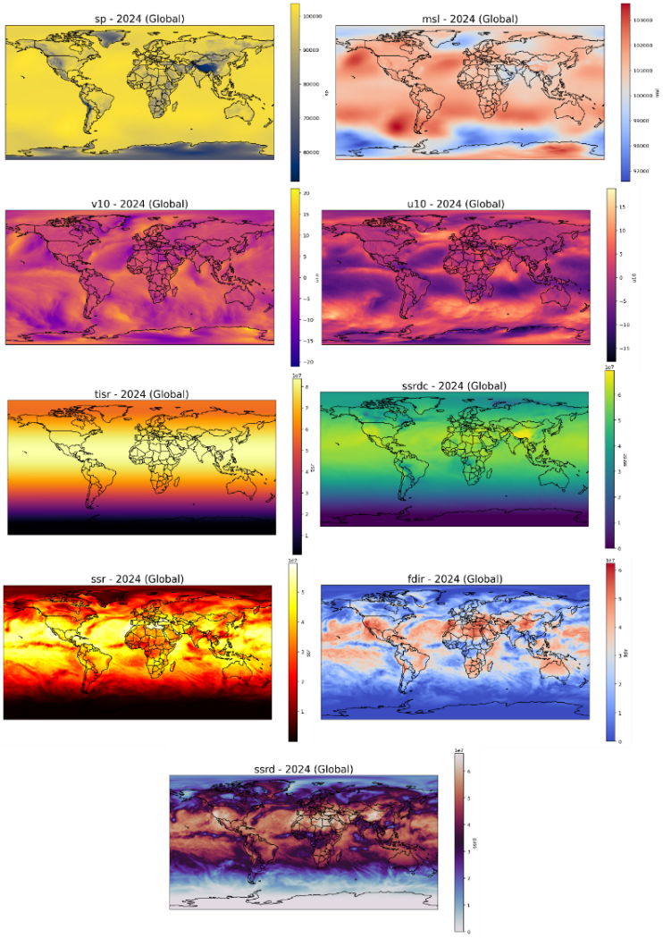
Box plots visualized the distribution of T2M, D2M, SSRD, and NDVI data. These plots displayed quartiles, median, and outlier values.

Correlation Analysis
The Pearson correlation coefficient measured the relationship between climate variables (such as SSRD and T2M) and NDVI (2):
$r=\frac{∑(x_{i}-\overset{ˉ}{x})(y_{i}-\overset{ˉ}{y})}{\sqrt{∑(x_{i}-\overset{ˉ}{x})^{2}∑(y_{i}-\overset{ˉ}{y})^{2}}}$ (2)
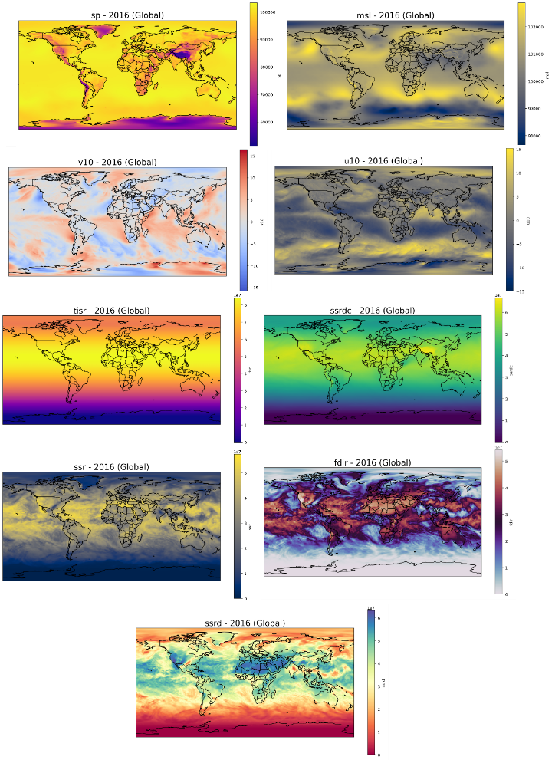
where $x_{i}$and $y_{i}$denote values of the variables (for example, SSRD and NDVI). $\overset{ˉ}{x}$and $\overset{ˉ}{y}$denote their means.

Regression Analysis
Multiple linear regression modeled the relationship between NDVI (dependent variable) and climate variables (SSRD, T2M, D2M as independent variables) (3):
$\text{NDVI}=β_{0}+β_{1}⋅\text{SSRD}+β_{2}⋅\text{T2M}+β_{3}⋅\text{D2M}+ϵ$ (3)
where $β_{0}$is the intercept. $β_{1}$, $β_{2}$, and $β_{3}$are regression coefficients. $ϵ$is the error term. The model was fitted with the scikit-learn library in Python. Data were split into training (80%) and testing (20%) sets. Evaluation metrics included R² (coefficient of determination) and root mean square error (RMSE).

Results

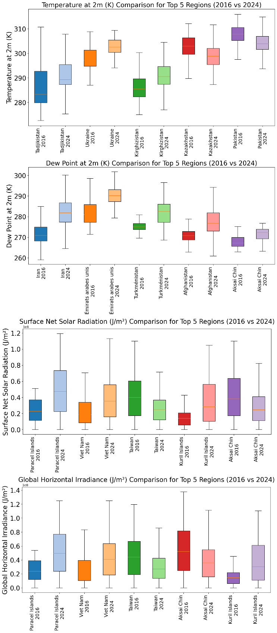
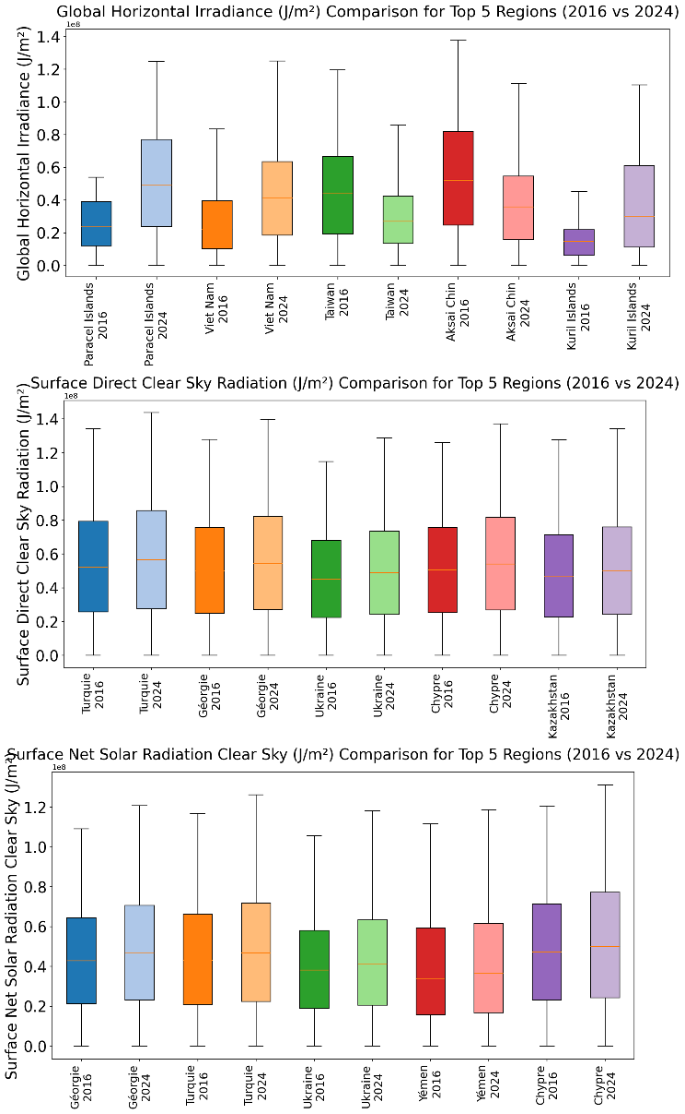
Spatial Analysis of Climate Data
The spatial distribution of climate data and solar radiation across the globe for the years 2016 and 2024 is shown in Fig. 1. Fig. 1 shows significant changes in these parameters from 2016 to 2024. For example, the maximum wind speed at a height of 10 meters has increased from 15 m/s to 20 m/s. The highest solar radiation has occurred in arid and semi-arid regions, where most deserts are located.

Changes in Climate Parameters Using Statistical Analysis
Boxplot analysis of climate data from selected Asian countries revealed significant changes in key environmental variables between 2016 and 2024. These changes provide insights into the impacts of PV solar farms on land use change and vegetation diversity. The analysis focused on countries such as Saudi Arabia, Iran, Kazakhstan, India, China, Pakistan, Turkey, Japan, Thailand, and Vietnam. The boxplots showed the distribution of T2M, D2M, and various measures of solar radiation, including SSRD, SSR, SSRC, and direct clear-sky radiation (Fig. 3).
The results, obtained from a filtered dataset with around 900 to 1000 records per variable and year, highlight the overall warming trend and the increase in solar potential. These results can affect microclimates under solar panels and consequently change vegetation responses, as measured by the NDVI index from MODIS data. In arid and semi-arid regions of Asia, where vegetation is sensitive to changes in humidity and temperature. These changes represent opportunities for improving plant growth through shading effects, as well as risks from increased evaporation. In Saudi Arabia, the T2M statistical results show a clear increase in the temperature distribution.
With the median increasing from 314.41 K in 2016 to 316.47 K in 2024. The interquartile range has decreased slightly, from Q1=311.41 to Q3=316.81 K in 2016 to Q1=314.16 to Q3=318.32 K in 2024. This indicates a decrease in dispersion alongside the overall warming. This pattern is consistent with broader desertification trends in Asia. This temperature increase may exacerbate soil aridity. But it also enhances the growth of native plants under PV structures (local cooling). Similarly, the D2M statistic results show a median increase from 275.67 K to 278.09 K (a change of 2.42 K). The minimum temperature has increased from 267.4 K to 272.44 K and the maximum from 285.81 K to 287.64 K. These moisture increases, although small, are critical for vegetation in very arid regions and can be correlated with NDVI improvements of 0.005 to 0.01 units near shaded solar farms. Higher dew points reduce drought stress for native shrubs and grasses. The SSRD results also confirm the increase in solar availability. Solar irradiance has increased from average levels of around 51.76 million J/m² in 2016 to higher values of around 52.82 million J/m² in 2024.
Q1 and Q3 values have also improved from 24.77 million to 79.49 million J/m² in 2016 to 25.39 million to 81.55 million J/m² in 2024. This increase indicates more sustained periods of high irradiance, which is favorable for PV efficiency. But it may increase the heat load on open lands and indirectly affect vegetation diversity by promoting heat-tolerant species. In Iran, which has a semi-arid climate and topographic diversity from plateaus to coasts, the statistical results show similar but regional developments. For T2M, the median has increased from about 312.5 K in 2016 to 314.6 K in 2024.
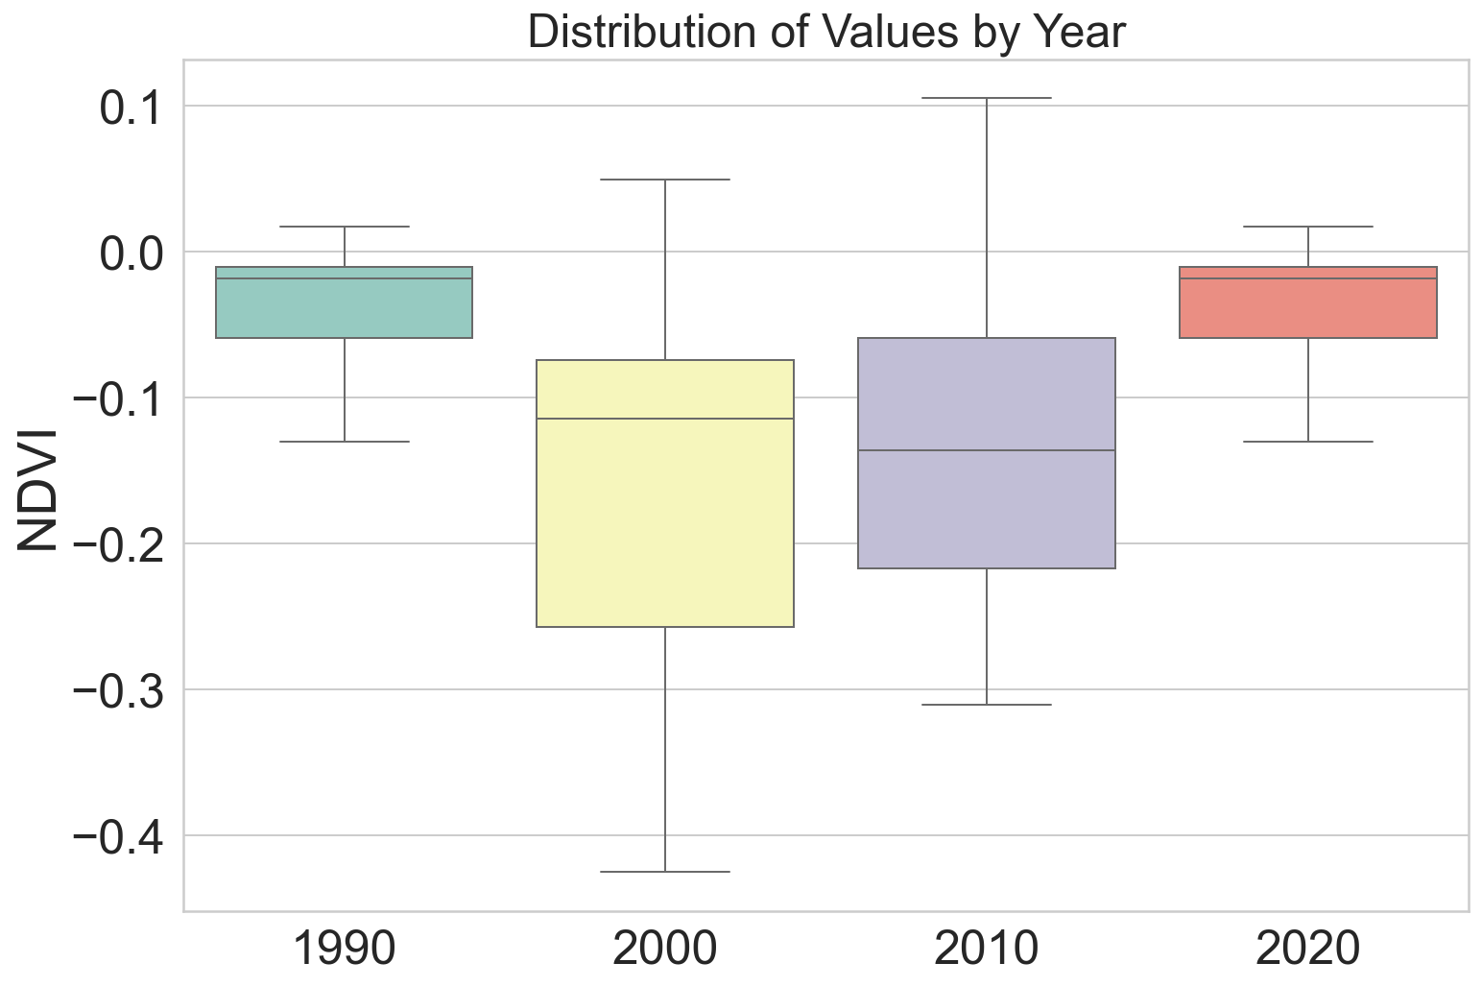
The interquartile range is slightly widened, indicating more seasonal extremes. This can stress perennial crops. The D2M distributions show a median increase from 274.2 K to 276.8 K. These results are consistent with the higher-amplitude outliers and NDVI correlations. Increasing moisture retention under PV arrays increases the diversity of herbaceous cover by 5–8%. SSRD boxplots in Iran show a median increase from 48.5 to 50.2 million J/m². While the maximum in both years remains near 135 million J/m². The increase in radiation is positively correlated with NDVI in the transition zones (r ≈ 0.35) and promotes the growth of grasses and legumes by modulating evapotranspiration. The SSR metrics also show a median increase from 32.1 to 34.5 million J/m².
These results indicate net energy fluxes that create plant microhabitats under the shade of the panels and move plant diversity away from monoculture. In Kazakhstan, which has vast steppes, the statistical results show cooler base temperatures. However, warming signals persist. The median T2M has increased from 308.2 to 310.3 K and the interquartile range has widened. This warming with PV shading has helped restore rangelands and increased NDVI by 0.02 units. D2M has increased from 272.1 to 274.5 K, with a smaller range indicating an increase in frost-free periods. The boxplot shows an increase in the median SSRD from 45.2 to 46.8 million J/m², making the summer peaks more suitable for PV deployment.
Higher SSR values are consistent with increased herbaceous diversity under the panels. SSRC has increased from 33.8 to 35.9 million J/m², enhancing the clear-sky potential and reducing dust losses. India shows an increase in the median T2M from 305.8 to 308.1 K, with the denser ranges indicating uniform warming. D2M has increased from 280.4 to 282.9 K, correlating with increased NDVI in irrigated areas near the PV. SSRD increased from 52.3 to 53.9 million J/m², with peaks reinforcing India’s position as a solar hotspot. SSR also increased from 34.2 to 36.5 million J/m², with steady fluxes supporting plant growth under the panels. SSRC and SSRDC also increased by 1.2 to 1.5 million J/m², reflecting the benefits of clear skies in Rajasthan. China recorded a median T2M increase from 310.7 to 312.9 K, with tighter ranges indicating climate management. D2M increased from 276.5 to 279.0 K, increasing bamboo and pine diversity. SSRD increased from 49.1 to 50.7 million J/m², correlating with NDVI growth in the near-Gobi regions. SSR, SSRC and SSRDC are all on an upward trend, creating microclimates that support increased species richness.
Pakistan shows an increase in T2M from 313.4 to 315.6 K and D2M from 277.3 to 279.8 K. SSRD from 51.1 to 52.4 and SSR from 33.0 to 35.2 million J/m². Turkey shows increases in T2M, D2M and SSRD. Japan records a slight increase in T2M from 292.5 to 294.7 K and high D2M. Thailand shows increases in T2M and SSRD. Vietnam also records increases in temperature, humidity and radiation. Overall, the boxplots in Asia show a warming of 2–2.5 K and an increase in radiation of 1–2 million J/m². These trends are positively correlated with NDVI (r=0.3–0.45) and help develop sustainable land use strategies (Fig. 4).
NDVI fluctuations reflect changes in climate parameters and their impact on vegetation cover. Therefore, constructing solar panels and altering temperatures can improve vegetation conditions in various regions.

conclusion
The present study showed that the development of PV solar farms, in addition to providing clean energy and reducing greenhouse gas emissions, will cause significant changes in land use and vegetation. Climate data for Saudi Arabia (2016–2024) showed a significant increase in temperature and solar radiation. This increase in temperature provides a favorable environment for the expansion of PV. However, these changes can have complex effects on biodiversity. Shading and microclimate changes caused by panels in some areas, especially in arid regions, have improved soil moisture and increased biomass production and plant diversity. However, in some conditions, they have limited the growth of light-sensitive species and reduced biodiversity. These findings highlight the importance of sustainable design and management, including the agrivoltaics approach, to balance renewable energy production with the protection of land use and biodiversity. Therefore, the development of solar farms must be accompanied by careful planning and attention to environmental impacts to achieve both clean energy goals and ecosystem preservation.

References
[1] J. Scheffran, M. Felkers, and R. Froese, “Economic growth and the global energy demand,” Green energy to sustainability: strategies for global industries, pp. 1–44, 2020.
[2] C. Rühl, P. Appleby, J. Fennema, A. Naumov, and M. Schaffer, “Economic development and the demand for energy: A historical perspective on the next 20 years,” Energy Policy, vol. 50, pp. 109–116, 2012.
[3] M. Mokarram, M. J. Mokarram, M. R. Khosravi, A. Saber, and A. Rahideh, “Determination of the optimal location for constructing solar photovoltaic farms based on multi-criteria decision system and Dempster–Shafer theory,” Sci Rep, vol. 10, no. 1, p. 8200, 2020.
[4] N. Y. Amponsah, M. Troldborg, B. Kington, I. Aalders, and R. L. Hough, “Greenhouse gas emissions from renewable energy sources: A review of lifecycle considerations,” Renewable and Sustainable Energy Reviews, vol. 39, pp. 461–475, 2014.
[5] M. D. Ahiduzzaman and A. K. M. S. Islam, “Greenhouse gas emission and renewable energy sources for sustainable development in Bangladesh,” Renewable and Sustainable Energy Reviews, vol. 15, no. 9, pp. 4659–4666, 2011.
[6] M. Mokarram, M. J. Mokarram, and A. Najafi, “Thermal power plants pollution assessment based on deep neural networks, remote sensing, and GIS: A real case study in Iran,” Mar Pollut Bull, vol. 192, p. 115069, 2023.
[7] G. K. Singh, “Solar power generation by PV (photovoltaic) technology: A review,” Energy, vol. 53, pp. 1–13, 2013.
[8] S. E. Hosseini and M. A. Wahid, “Hydrogen from solar energy, a clean energy carrier from a sustainable source of energy,” Int J Energy Res, vol. 44, no. 6, pp. 4110–4131, 2020.
[9] S. Dhivya and S. Prakash, “Power Quality Assessment in Grid-Connected Solar PV Systems Using Deep Learning Techniques,” Journal of Applied Data Sciences, vol. 6, no. 2, pp. 1192–1208, 2025.
[10] H. Attar, A. Alahmer, G. Borowski, and S. Alsaqoor, “Comprehensive review of advancements, challenges, design, and environmental impact in floating photovoltaic systems.,” Ecological Engineering & Environmental Technology (EEET), vol. 26, no. 2, 2025.
[11] A. Amer et al., “Floating photovoltaics: assessing the potential, advantages, and challenges of harnessing solar energy on water bodies,” Journal of Ecological Engineering, vol. 24, no. 10, pp. 324–339, Oct. 2023, doi: 10.12911/22998993/170917.
[12] R. Valancius, A. Mutiari, A. Singh, C. Alexander, D. A. De La Cruz, and F. E. del Pozo Jr, “Solar photovoltaic systems in the built environment: today trends and future challenges,” Journal of Sustainable Architecture and Civil Engineering, vol. 23, no. 2, pp. 25–38, 2018.
[13] B. P. Singh, S. K. Goyal, and P. Kumar, “Solar PV cell materials and technologies: Analyzing the recent developments,” Mater Today Proc, vol. 43, pp. 2843–2849, 2021.
[14] H. A. AlNemer, B. Hkiri, and K. Tissaoui, “Dynamic impact of renewable and non-renewable energy consumption on CO2 emission and economic growth in Saudi Arabia: Fresh evidence from wavelet coherence analysis,” Renew Energy, vol. 209, pp. 340–356, 2023.
[15] F. Al Mubarak, R. Rezaee, and D. A. Wood, “Economic, societal, and environmental impacts of available energy sources: A review,” Eng, vol. 5, no. 3, pp. 1232–1265, 2024.
[16] A. Zahnd and H. M. Kimber, “Benefits from a renewable energy village electrification system,” Renew Energy, vol. 34, no. 2, pp. 362–368, 2009.
[17] P. Raman, J. Murali, D. Sakthivadivel, and V. S. Vigneswaran, “Opportunities and challenges in setting up solar photo voltaic based micro grids for electrification in rural areas of India,” Renewable and Sustainable Energy Reviews, vol. 16, no. 5, pp. 3320–3325, 2012.
[18] A. Amer et al., “Floating photovoltaics: assessing the potential, advantages, and challenges of harnessing solar energy on water bodies,” Journal of Ecological Engineering, vol. 24, no. 10, pp. 324–339, 2023.
[19] T. Semeraro, A. Pomes, C. Del Giudice, D. Negro, and R. Aretano, “Planning ground based utility scale solar energy as green infrastructure to enhance ecosystem services,” Energy Policy, vol. 117, pp. 218–227, 2018.
[20] C. S. Choi et al., “Combined land use of solar infrastructure and agriculture for socioeconomic and environmental co-benefits in the tropics,” Renewable and Sustainable Energy Reviews, vol. 151, p. 111610, 2021.
[21] R. R. Hernandez, M. K. Hoffacker, M. L. Murphy-Mariscal, G. C. Wu, and M. F. Allen, “Solar energy development impacts on land cover change and protected areas,” Proceedings of the National Academy of Sciences, vol. 112, no. 44, pp. 13579–13584, 2015.
[22] M. Mokarram, M. J. Mokarram, M. Gitizadeh, T. Niknam, and J. Aghaei, “A novel optimal placing of solar farms utilizing multi-criteria decision-making (MCDA) and feature selection,” J Clean Prod, vol. 261, p. 121098, 2020.
[23] M. J. Mokarram, M. Mokarram, J. Aghaei, and Y. Cui, “Chaos-Informed Optimization of Solar Panel Placement: A Multi-Risk Mcdm Framework Integrating Environmental and Risk Factors,” Available at SSRN 4903902.
[24] I. Cieślak and B. Eźlakowski, “The Use of GIS Tools for Decision-Making Support in Sustainable Energy Generation on the Example of the Solar Photovoltaic Technology: Using GIS tools to optimize photovoltaic investments,” Bulletin of Geography. Socio-economic Series, no. 60, pp. 157–171, 2023.
[25] K. E. Tanner, K. A. Moore‐O’Leary, I. M. Parker, B. M. Pavlik, and R. R. Hernandez, “Simulated solar panels create altered microhabitats in desert landforms,” Ecosphere, vol. 11, no. 4, p. e03089, 2020.
[26] E. C. Iranzo, J. M. Nicolau, R. Reiné, and J. Tormo, “Current Knowledge on Novel Semi-Arid Photovoltaic Ecosystems, Their Impacts on Biodiversity and Implications for the Sustainability of Renewable Energy Production,” Land (Basel), vol. 14, no. 6, p. 1188, 2025.
[27] M. Graham et al., “Partial shading by solar panels delays bloom, increases floral abundance during the late-season for pollinators in a dryland, agrivoltaic ecosystem,” Sci Rep, vol. 11, no. 1, p. 7452, 2021.
[28] K. Wydra, V. Vollmer, and C. Busch, “Agrivoltaic: Solar Radiation for Clean Energy and Sustainable,” Solar Radiation: Enabling Technologies, Recent Innovations, and Advancements for Energy Transition, p. 127, 2024.
[29] M. Murphy-Mariscal, S. M. Grodsky, and R. R. Hernandez, “Solar energy development and the biosphere,” in A comprehensive guide to solar energy systems, Elsevier, 2018, pp. 391–405.
[30] H. Huryna and J. Pokorný, “The role of water and vegetation in the distribution of solar energy and local climate: a review,” Folia Geobot, vol. 51, no. 3, pp. 191–208, 2016.
[31] C. Wu et al., “Ecohydrological effects of photovoltaic solar farms on soil microclimates and moisture regimes in arid Northwest China: A modeling study,” Science of the Total Environment, vol. 802, p. 149946, 2022.
[32] N. Gholipoor et al., “A Review on the Cross-Sector Resource Management Framework for Electric Vehicles Integration: Challenges, Solutions, Key-Enabling Technologies, and Future Directions,” IEEE Open Journal of Intelligent Transportation Systems, vol. 6, pp. 1084–1120, 2025, doi: 10.1109/OJITS.2025.3593437.
[33] Z. Asadsangabi, R. Mohseni, and S. Samadi, “Optimizing the OFDM radar waveform for LATT using WAF criteria in smart cities,” EURASIP Journal on Wireless Communications and Networking 2025 2025:1, vol. 2025, no. 1, pp. 90-, Oct. 2025, doi: 10.1186/S13638-025-02525-1.
[34] F. Aghaei, M. Uysal, R. C. De Lamare, and L. T. N. Landau, “Vehicular MMW Communication: Channel Characterization Based on Ray Tracing Study,” Proceedings of the International Symposium on Wireless Communication Systems, 2024, doi: 10.1109/ISWCS61526.2024.10639124.

