Identification and Separation of Solar Panels in South Asia Using Semantic Segmentation and Scale Optimization with the MRS Algorithm

Mohammad Jafar Mokarram
School of Electronic Engineering and Intelligent Manufacturing
Anhui Xinhua University
Hefei, China
mjmokarram@axhu.edu.cn
Mohamed Hafez
Faculty of Engineering FEQS
INTI International University
Nilai, Malaysia
Faculty of Management, Shinawatra University, Pathum Thani, Thailand, mohdahmed.hafez@newinti.edu.my
Liu Yuan
School of Electronic Engineering and Intelligent Manufacturing, Anhui Xinhua University, Hefei, China
liuyuanji@shu.edu.cn
Hani Attar
Faculty of Engineering
Zarqa Univeristy
Jordan
Hattar@zu.edu.jo

Abstract—Solar energy, as one of the most promising renewable resources in tropical regions with abundant solar radiation but insufficient utilization such as Southeast Asia, plays a key role in combating electricity shortage and pollution caused by fossil fuels. The aim of this research is to identify and segment photovoltaic solar panels in this region using semantic segmentation and mosaicking approach for processing large satellite images. The main focus is to select the best scales in the Multiresolution segmentation (MRS) to improve the accuracy of panel segmentation and investigation. The methodology involves applying scales of 10, 20, 30, 50, 100 and 200 in the MSR algorithm for image classification. For evaluation, key indicators such as PSE (Precision Segmentation Error), Noise-to-Signal Ratio (NSR) and Edge Discrepancy (ED) are used. The results show that medium scales such as 100 m provide the best performance for panel separation (with a minimum ED of about 0.3). While larger scales (such as 200 m or more) are more suitable for grouping panels and estimating energy production. Given the rapid growth of solar energy in South Asia, this approach allows for rapid mapping, energy production estimation, and optimal resource management. The results emphasize that the choice of scale depends on the purpose of the analysis (individual or group) and regional characteristics, and can contribute to sustainable energy policies.
Keywords—Solar energy, photovoltaic panels, semantic segmentation, MRS algorithm, PSE, NSR, ED.

Introduction
Solar energy, as one of the most prominent renewable energy sources, plays a pivotal role in the drive towards sustainable development, especially in regions with abundant solar radiation such as South Asia [1]. These regions have significant potential for solar energy exploitation due to their geographical location close to the equator and access to high solar radiation [2], [3], [4]. Solar photovoltaic (PV) panels offer a clean, silent and low-cost solution by directly converting sunlight into electricity. It is regarded as clean energy technology that significantly participates in energy development and developing countries progress [5], [6], [7].
Despite the advantages of reliability, high availability and low environmental impact, challenges such as high initial cost and dependence on weather conditions remain barriers to the expansion of this technology. The dramatic growth in installed solar capacity in recent decades, particularly from 1992 to 2020, reflects technological advances and the decline in the cost of manufacturing photovoltaic panels [8]. This has strengthened the potential of solar energy as an alternative to traditional energy sources [9], [10]. In South Asia, as energy demand grows due to population growth and technological development, solar energy can serve as a complement to existing sources such as hydroelectricity [11], [12], [13], [14].
This is particularly important in a context where climate change threatens to reduce rainfall and threaten hydroelectricity generation. The importance of remote sensing in managing and monitoring solar energy infrastructure is undeniable. As the number of solar photovoltaic power plants increases in South Asia, the need for efficient methods to identify, map, and monitor these facilities is increasingly felt. Traditional inspection methods, such as field surveys, are time-consuming, costly, and require specialized manpower, which poses significant limitations given the large scale and geographical dispersion of these power plants in semi-arid regions. Remote sensing, particularly using satellite imagery such as Sentinel-2, allows for periodic and automated monitoring [15], [16].
Remote sensing is used as a key tool in assessing construction progress, estimating energy production, and managing energy resources [17], [18]. Recent advances in deep learning technology, especially in semantic segmentation, have enabled the processing of large and complex images with high accuracy. This plays an important role in identifying solar panels and separating them from other environmental features [19], [20]. These methods, using convolutional neural networks (CNN), have the ability to analyze multidimensional arrays and provide an effective alternative to manual methods [19], [21].
Choosing the appropriate scale in semantic segmentation processes is one of the determining factors in the accuracy and efficiency of solar panel identification. Multiscale algorithms such as the Multiresolution segmentation (MRS) algorithm, by adjusting different scales, allow for more accurate separation of geographical and infrastructure features such as solar panels [22], [23]. The choice of the optimal scale depends on several factors, including the size of the panels, their dispersion, and the environmental characteristics of the area. Studies have shown that medium scales (e.g., 100 m) are more suitable for identifying individual panels, while larger scales (e.g., 200 m or more) are more efficient for group analysis and energy generation estimation [24], [25].
Evaluation indices such as Precision Segmentation Error (PSE), Noise-to-Signal Ratio (NSR), and Edge Discrepancy (ED) are key tools for determining the optimal scale. In these indices, lower values indicate higher accuracy in segmentation [26]. The use of a mosaicking approach, along with semantic segmentation, allows processing large satellite images while preserving detail. This approach is especially crucial in the vast areas of South Asia.
Previous studies on solar panel detection have mainly focused on urban areas and high-resolution imagery, but mapping large-scale solar power plants remains challenging [27]. For example, research conducted in Europe and the United States has shown that deep learning methods can detect solar panels with high accuracy in urban environments, but their application in rural or semi-arid areas has been less explored. In South Asia, where solar power plants are widely distributed and geographically diverse, there is a growing need for automated and scalable methods to monitor the development of these facilities [28].
Given the importance of the topic, the main objective of this paper is to select the best scales for segmenting and surveying photovoltaic solar panels in South Asia using the MRS algorithm and mosaicking approach. This study aims to develop an automated method for detecting and monitoring solar power plants using Sentinel-2 satellite imagery (Figure 1). This method enables rapid mapping, energy generation estimation, and optimal resource management.
Given the rapid growth of solar energy in the region and the need for effective policies for energy security, this research can help improve regulatory processes and decision-making related to sustainable development. The study also seeks to provide a scalable framework that can be used not only for South Asia but also for other regions with similar conditions [20].

Data
Sentinel-2 satellite images with a spatial resolution of 10 m were used to identify and segment solar photovoltaic panels in South Asia. These images were selected due to their free availability, wide coverage, and spectral information suitable for remote sensing analyses. The study period spans from 2020 to 2023, which covers a period of rapid growth in solar power installations in the region. The study areas include semi-arid areas of South Asia with high solar radiation that are suitable for the installation of photovoltaic panels. Data analysis was performed using eCognition 64 software, which allows the implementation of a MRS algorithm. Scales of 10, 20, 30, 50, 100, and 200 m were tested for panel segmentation. Weights of 0.7 for spectral information and 0.3 for shape, along with weights of 0.4 for compactness and smoothness, were applied. PSE, NSR, and ED indices were used to evaluate the segmentation accuracy. A mosaicking approach was applied to process large satellite images to enable efficient analysis of large areas.
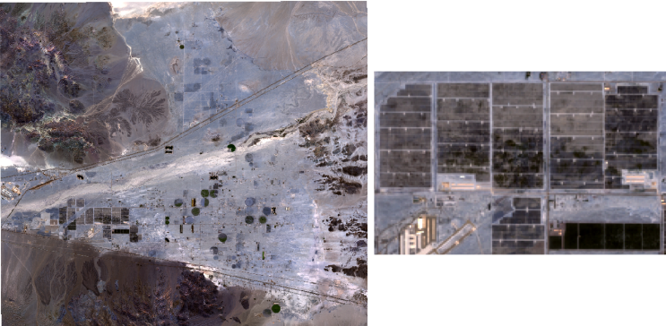
Figure 1. An example of the solar panels studied

methodology

MRS Method
The MRS was used to separate PV from other features based on a fractal network evolution approach. This algorithm, by optimizing the homogeneity of objects in the image, is influenced by three key parameters: scale (determining the maximum heterogeneity in sections), compactness (weighting the smoothness of boundaries), and shape (weighting the color and geometry). The overall homogeneity is calculated by combining the spectral and geometric variations between objects (Δh_{color} and Δh_{shape}) and the associated weighting. Also, the compactness and smoothness criteria of the boundary are adjusted with specific coefficients (w_{compactness} and w_{smoothness}).
$h=w_{\text{color}}⋅Δh_{\text{color}}+w_{\text{shape}}⋅Δh_{\text{shape}}$ (1)where $w_{\text{color}}+w_{\text{shape}}=1$.
$\text{Compactness}=w_{\text{compactness}}⋅\frac{\text{Perimeter}}{\sqrt{\text{Area}}}$ (2)$\text{Smoothness}=w_{\text{smoothness}}⋅\frac{\text{Perimeter}}{\text{Bounding Box Perimeter}}$ (3)
To evaluate segmentation accuracy, three metrics were applied: NSR to measure the match between segmented and reference regions, PSE to assess segmentation potential error, and Edge Discrepancy (ED²) to gauge the closeness of segmentation to the reference region. The formulation for ED² is provided below:
$ED^{2}=\sqrt{\sum_{i=1}^{m}{{(\frac{\text{Area}(S_{i})}{\text{Area}(R)}-1)}^{2}}+\sum_{i=1}^{v}{((x_{i}-y_{i})^{2})}}$ (4)
where $\text{Area}(S_{i})$is the area of the segmented region, $\text{Area}(R)$is the area of the reference region, $m$is the number of reference segments, $v$is the number of segmented regions, and $x_{i}$and $y_{i}$are the coordinates of segmented and reference regions, respectively.

Results

Optimal Scale Selection for Solar Panel Segmentation
Analysis of data obtained from Sentinel-2 satellite images in selected regions of South Asia shows a significant impact of scale selection on the accuracy of segmentation of photovoltaic solar panels using the MRS algorithm.
The scales tested included 10, 20, 30, 50, 100 and 200 m, which were processed using eCognition 64 software (Figure 2).

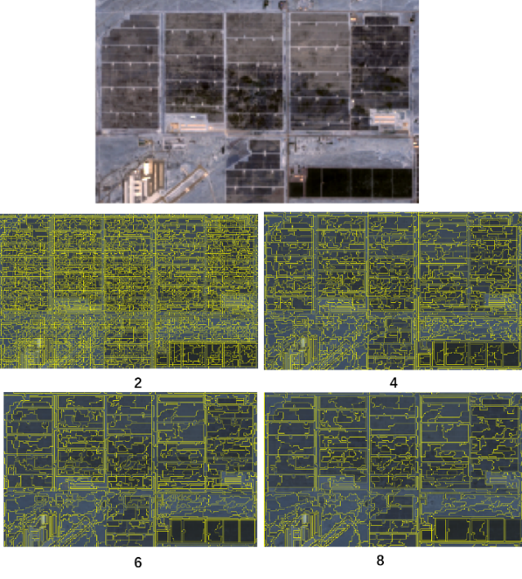
Figure 2. Different scales for separating various groups of solar panels
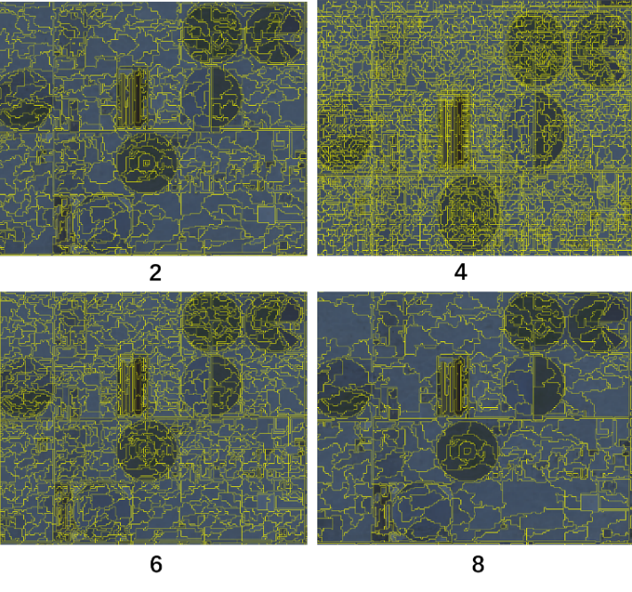
To evaluate the performance of the algorithm, three key metrics were used: PSE, NSR and ED. These metrics provide a measure of the overall segmentation error, noise-to-signal ratio and ED, respectively. The parameter weights in the MRS algorithm were adjusted by assigning 0.7 to spectral information and 0.3 to shape, along with weights of 0.4 for compactness and smoothness, to give more emphasis to the spectral features of the images. The results showed that the 100-meter scale consistently provided the best performance for distinguishing individual solar panels in the semi-arid regions of South Asia, including areas in India, Pakistan, and Bangladesh. At this scale, the ED index reached its minimum value, around 0.3 (Figure 3).

Analysis of Larger Scales for Panel Grouping
For the analysis of solar panel clusters, in larger and more dispersed power plants, larger scales such as 200 m were investigated. These scales were more suitable for identifying cluster patterns and estimating the total area of solar power plants over larger areas, especially in areas with lower panel densities. At this scale, the ED index still showed acceptable values (0.35). While the PSE and NSR indices also increased slightly with increasing scale due to the reduction in spatial detail. These observations indicate that larger scales, although less accurate for resolving individual panel details, are more efficient for general mapping purposes and estimating energy production at a regional scale. The study areas in South Asia, particularly in the Indian states of Rajasthan and Gujarat, demonstrated the success of this scale in identifying cluster structures. The use of a mosaicking approach in processing larger images helped improve the efficiency of analysis at this scale due to the possibility of faster and more integrated processing of satellite data (Figure 4).

Impact of Parameter Weighting and Scale Sensitivity
The MRS algorithm settings, in particular the higher weighting of spectral information (0.7) compared to the figure (0.3), had a significant impact on the resolution accuracy. These settings allowed the algorithm to more accurately identify the spectral features of solar panels in the near-infrared and visible bands of Sentinel-2 images. However, the analysis showed that the MRS method is sensitive to the choice of scale. Very small scales (such as 10 and 20 m) produced higher values of the PSE and NSR indices (about 0.5 and 0.6, respectively) due to high noise and over-resolution of details. These scales were not suitable for areas with high panel densities or complex environmental features, such as urban areas with mixed land uses. In contrast, medium scales such as 100 m provided a good balance between accuracy and noise reduction. These results were confirmed by a decrease in the ED index to 0.3 and low values of PSE and NSR.

Performance Comparison Across South Asian Regions
The results showed slight differences in the optimal scale across different regions of South Asia, including the semi-arid regions of India, Pakistan, and Bangladesh. In areas with high solar radiation and low vegetation density, such as the Thar Desert in India, the 100 m scale consistently performed better. However, in areas with greater environmental complexity, such as areas close to urban areas in Bangladesh, the 50 m scale sometimes performed better in terms of PSE (around 0.25) due to the need for higher resolution. These differences indicate the influence of environmental characteristics on the choice of scale and highlight the need to tune the MRS algorithm parameters for each region. The results show that the 100 m scale was confirmed as a general choice for most regions of South Asia. Given the balance between accuracy and processing efficiency, it is suitable for mapping and monitoring solar power plants.

Energy Management with Solar Power Plant Identification
The results of this study have significant practical applications for the management and monitoring of solar power plants in South Asia. Accurate identification of solar panels at optimal scales enables rapid mapping and estimation of energy production. The 6-meter scale for segmentation of individual panels and the 8-meter scale for cluster analysis allow decision-makers to assess the geographical distribution of solar power plants with high accuracy. This is particularly important in countries such as India, which has seen significant growth in solar capacity in recent years. The use of Sentinel-2 imagery and eCognition 64 software allows for automated and scalable implementation of this method, significantly reducing the cost of field inspections. The results also provide a framework for future research in other Asian regions with similar conditions. As shown in Figure 4, larger scales resulted in segmentation of coarser features without fine details.
This study used different combinations for image segmentation using the MRS algorithm. As shown in Figure 4, the features are separated by increasing the scale more generally and without details. Considering that the input data for segmentation was Sentinel 2 images, combinations such as using main bands with different resolutions (10 and 20 m), main bands only with a resolution of 20 m or 10 m, using L2A bands as input data for the model were used. At this stage, it was tried to set the color weight to 0.7 and the shape weight to 0.3 because more priority was given to spectral information than to shape features. The compactness and softness weights in the shape were each set to 0.4. In the early stages, it was determined that the best starting scale was 50 m and the step size was 100 m to find the optimal scale parameter.

Conclusion
The use of the MRS algorithm combined with the mosaicking approach provides an effective and scalable method for identifying and segmenting photovoltaic solar panels in South Asia. The results showed that the selection of the optimal scale plays a key role in improving the segmentation accuracy; in particular, the 100-meter scale with the minimum ED index value (about 0.3) provided the best performance for identifying individual panels. While larger scales such as 200 meters were more suitable for group analysis and energy generation estimation at the regional scale. In addition, a higher weighting of spectral information (0.7) compared to shape (0.3) increased the accuracy and efficiency of segmentation, highlighting the sensitivity of the algorithm to scale.
These findings indicate that the selection of the appropriate scale should be made according to the purpose of the analysis—individual or group—and the geographical and environmental characteristics of the region. Given the rapid growth of solar power plant installation capacity in South Asia, this method can provide a powerful tool for rapid mapping, monitoring plant development, and estimating energy production, and play an effective role in sustainable energy policy decisions. In addition to its application in South Asia, this analytical framework has the potential to be expanded and used in other regions with similar conditions. Future studies can also explore the integration of multi-sensor data to enhance the accuracy of solar panel detection in complex environments [29]

References
[1] M. J. Mokarram, R. Rashiditabar, M. Gitizadeh, and J. Aghaei, “Net-load forecasting of renewable energy systems using multi-input LSTM fuzzy and discrete wavelet transform,” Energy, vol. 275, p. 127425, 2023.
[2] J. L. Monteith, “Solar radiation and productivity in tropical ecosystems,” Journal of applied ecology, vol. 9, no. 3, pp. 747–766, 1972.
[3] W. H. Quinn and W. V Burt, “Weather and solar radiation reception in the equatorial trough,” J Appl Meteorol Climatol, vol. 6, no. 6, pp. 988–993, 1967.
[4] M. Mokarram, J. Aghaei, M. J. Mokarram, G. P. Mendes, and B. Mohammadi‐Ivatloo, “Geographic information system‐based prediction of solar power plant production using deep neural networks,” IET Renewable Power Generation, vol. 17, no. 10, pp. 2663–2678, 2023.
[5] M. Mokarram, M. J. Mokarram, M. R. Khosravi, A. Saber, and A. Rahideh, “Determination of the optimal location for constructing solar photovoltaic farms based on multi-criteria decision system and Dempster–Shafer theory,” Sci Rep, vol. 10, no. 1, p. 8200, 2020.
[6] A. Amer et al., “Floating photovoltaics: assessing the potential, advantages, and challenges of harnessing solar energy on water bodies,” Journal of Ecological Engineering, vol. 24, no. 10, pp. 324–339, Oct. 2023, doi: 10.12911/22998993/170917.
[7] H. Attar, A. Alahmer, G. Borowski, and S. Alsaqoor, “Comprehensive review of advancements, challenges, design, and environmental impact in floating photovoltaic systems,” Ecological Engineering & Environmental Technology, vol. 26, no. 2, pp. 301–322, 2025, doi: 10.12912/27197050/199520.
[8] N. Gholipoor et al., “A Review on the Cross-Sector Resource Management Framework for Electric Vehicles Integration: Challenges, Solutions, Key-Enabling Technologies, and Future Directions,” IEEE Open Journal of Intelligent Transportation Systems, vol. 6, pp. 1084–1120, 2025, doi: 10.1109/OJITS.2025.3593437.
[9] O. O. Apeh, E. L. Meyer, and O. K. Overen, “Contributions of solar photovoltaic systems to environmental and socioeconomic aspects of national development—A review,” Energies (Basel), vol. 15, no. 16, p. 5963, 2022.
[10] A. N. Celik, T. Muneer, and P. Clarke, “A review of installed solar photovoltaic and thermal collector capacities in relation to solar potential for the EU-15,” Renew Energy, vol. 34, no. 3, pp. 849–856, 2009.
[11] K. Calvert, J. M. Pearce, and W. E. Mabee, “Toward renewable energy geo-information infrastructures: Applications of GIScience and remote sensing that build institutional capacity,” Renewable and sustainable energy reviews, vol. 18, pp. 416–429, 2013.
[12] A. Kaczmarek and J. Blachowski, “Remote Sensing Perspective on Monitoring and Predicting Underground Energy Sources Storage Environmental Impacts: Literature Review,” Remote Sens (Basel), vol. 17, no. 15, p. 2628, 2025.
[13] A. Leibrand, N. Sadoff, T. Maslak, and A. Thomas, “Using earth observations to help developing countries improve access to reliable, sustainable, and modern energy,” Front Environ Sci, vol. 7, p. 123, 2019.
[14] M. Mokarram, M. J. Mokarram, and A. Najafi, “Thermal power plants pollution assessment based on deep neural networks, remote sensing, and GIS: A real case study in Iran,” Mar Pollut Bull, vol. 192, p. 115069, 2023.
[15] J. Segarra, M. L. Buchaillot, J. L. Araus, and S. C. Kefauver, “Remote sensing for precision agriculture: Sentinel-2 improved features and applications,” Agronomy, vol. 10, no. 5, p. 641, 2020.
[16] D. Phiri, M. Simwanda, S. Salekin, V. R. Nyirenda, Y. Murayama, and M. Ranagalage, “Sentinel-2 data for land cover/use mapping: A review,” Remote Sens (Basel), vol. 12, no. 14, p. 2291, 2020.
[17] A. Hammer et al., “Solar energy assessment using remote sensing technologies,” Remote Sens Environ, vol. 86, no. 3, pp. 423–432, 2003.
[18] L. Kumar, P. Sinha, S. Taylor, and A. F. Alqurashi, “Review of the use of remote sensing for biomass estimation to support renewable energy generation,” J Appl Remote Sens, vol. 9, no. 1, p. 97696, 2015.
[19] R. Ravishankar, E. AlMahmoud, A. Habib, and O. L. de Weck, “Capacity estimation of solar farms using deep learning on high-resolution satellite imagery,” Remote Sens (Basel), vol. 15, no. 1, p. 210, 2022.
[20] T. Sun, M. Shan, X. Rong, and X. Yang, “Estimating the spatial distribution of solar photovoltaic power generation potential on different types of rural rooftops using a deep learning network applied to satellite images,” Appl Energy, vol. 315, p. 119025, 2022.
[21] B. Austin-Gabriel, C. N. Monsalve, and A. S. Varde, “Power plant detection for energy estimation using GIS with remote sensing, CNN & vision transformers,” arXiv preprint arXiv:2412.04986, 2024.
[22] H. Lu and M. Mokarram, “Fusion of deep neural networks and infrared wave analysis for climate pattern prediction and shifting sand hazard Assessment,” International Journal of Applied Earth Observation and Geoinformation, vol. 141, p. 104649, 2025.
[23] I. Hassan et al., “Weighted overlay based land suitability analysis of agriculture land in Azad Jammu and Kashmir using GIS and AHP.,” Pak J Agric Sci, vol. 57, no. 6, 2020.
[24] Z. Zou, X. Zhou, P. Yang, J. Liu, and W. Yang, “Data-Model Complexity Trade-Off in UAV-Acquired Ultra-High-Resolution Remote Sensing: Empirical Study on Photovoltaic Panel Segmentation,” Drones, vol. 9, no. 9, p. 619, 2025.
[25] C. Eisank, M. Smith, and J. Hillier, “Assessment of multiresolution segmentation for delimiting drumlins in digital elevation models,” Geomorphology, vol. 214, pp. 452–464, 2014.
[26] C. Witharana and D. L. Civco, “Optimizing multi-resolution segmentation scale using empirical methods: Exploring the sensitivity of the supervised discrepancy measure Euclidean distance 2 (ED2),” ISPRS Journal of Photogrammetry and Remote Sensing, vol. 87, pp. 108–121, 2014.
[27] M. Ihsan, D. Suwardhi, E. Widyaningrum, I. Meilano, and N. S. Amelia, “Multi-Resolution Region Merging (MRRM): A Novel Post-Processing Framework to Mitigate Fragmentation in SAM-Based Geospatial Segmentation of Rural Buildings,” IEEE Access, 2025.
[28] S. Khadka, “Potential of Solar Energy in South Asia: Current Challenges and Opportunities,” energy, vol. 2, no. 1, 2023.
[29] Z. Asadsangabi, R. Mohseni, and S. Samadi, “Optimizing the OFDM radar waveform for LATT using WAF criteria in smart cities,” EURASIP Journal on Wireless Communications and Networking 2025 2025:1, vol. 2025, no. 1, pp. 90-, Oct. 2025, doi: 10.1186/S13638-025-02525-1.

