Machine Learning-Based Prediction and Classification of Bovine Diseases Using Physiological and Environmental Indicators
Gurmeet Kaur¹  Department of Computer Science & Engineering, University Institute of Engineering, Chandigarh University, Punjab, India  grmtkaur76@gmail.com | Yogesh kumar²  Computer Science, School of Technology  Pandit Deendayal Energy University  Gandhinagar, India  yogesh.Kumar@sot.pdpu.ac.in |  | Hani Attar³  Faculty of Engineering,  Zarqa Univeristy, Jordan.  Hattar@zu.edu.jo |  | Mohamed Hafez⁴  Faculty of Engineering FEQS, INTI International University, Nilai, Malaysia  Faculty of Management, Shinawatra University, Pathum Thani, Thailand. mohdahmed.hafez@newinti.edu.my
Parvathaneni Naga Srinivasu⁵  Amrita School of Computing, Amrita Vishwa Vidyapeetham, Amaravati, India  parvathanenins@gmail.com |  | Muhammad Umair Manzoor⁶  School of Engineering  RMIT University, Melbourne, Australia  muhammad.umair.manzoor@rmit.edu.au |  | Muhammad Fazal Ijaz⁷  Centre for Artificial Intelligence Research and Optimization (AIRO),  Design and Creative Technology, Torrens University Australia, Melbourne, Victoria, Australia  muhammadfazal.ijaz@torrens.edu.au

Abstract: Animal health is integral to food security, rural livelihoods, and economic sustainability, particularly in developing nations like India where cattle form the backbone of the livestock sector. However, traditional methods of diagnosing bovine diseases are often time-consuming, resource-intensive, and inaccessible to small-scale farmers. This paper proposes a data-driven approach using machine learning (ML) models for the early prediction and classification of cattle diseases based on physiological and environmental indicators. We applied a structured preprocessing pipeline to ensure data integrity and consistency to a numerical dataset capturing features such as body temperature, heart rate, saliva pH, and more. Multiple classifiers including Linear Discriminant Analysis (LDA), Gaussian Naïve Bayes, Decision Trees, K-Nearest Neighbors (KNN), Linear SVM, and Logistic Regression were evaluated on accuracy, log-loss, and class-wise performance metrics. Results indicate that probabilistic models such as LDA and Gaussian Naïve Bayes outperform others, achieving high accuracy (>98%) and robust generalization across disease types. The study demonstrates the feasibility and effectiveness of intelligent disease prediction systems in livestock health monitoring and provides insights into the most reliable ML models for real-world deployment.

Keywords: Cattle Disease Prediction, Machine Learning, Animal Health Monitoring, Gaussian Naïve Bayes, Physiological Indicators, Early Diagnosis Systems

- INTRODUCTION

Animal health is a major global concern for animal disease outbreaks, climate change, and the food crisis. In India, animal husbandry plays a dominant role in the rural economies by contributing 30.23% of the agriculture GVA and 5.5% to the national economy. Being by far the largest milk producer in the world, animal husbandry runs on nutrition, employment, and rural development [1]. Taking just the numbers in millions: Bovine 303.76, sheep 74.26, goats 148.88, pigs 9.06, birds 851.81 million: this livestock sector has been characterized by the running of subsistence and large-scale farms, women empowerment, food security strengthening, and increased exports. An efficient livestock sector, because of all these reasons, epitomizes economic and agricultural agricultural and economic stability [2]. However, the challenges to secure cattle productivity and health are escalating due to many infectious and non-infectious diseases such as FMD, LSD, Brucellosis, and Mastitis. These diseases typically reduce production, increase mortality, and lead to various economic losses [3]. Insufficient diagnosis facilities, sparse veterinary activity, and insufficient surveillance in the developing world worsen the situation. In essence, the situation calls for the real-time monitoring of problems in animals related to human health. Overall, there is reason to support the observation of animal health surveillance inversely as concordance to real food security, itself within livelihood and global health [4].
Indeed, traditional methods of diagnosis by veterinarians, lab tests, and visual observations may provide reliable diagnoses but they are time-consuming and not always cost-effective and sometimes not readily available to smallholder farmers [5]. Thus, the incorporation of the latest computational approaches offers a way for identifying new ways to improve livestock health monitoring. These machine-learning methods examine large databases, learn hidden patterns within characteristics, and hence can predict diseases with impressive accuracy, helping veterinarians and farmers make decisions or automatically make decisions, respectively [6]. This shows that data-driven systems can improve monitoring and decision-making in different areas. In the same way, intelligent control frameworks can optimize performance through predictive maintenance and adaptive energy management [7], and these ideas can also be used in livestock health systems to support real-time monitoring and reduce losses.
In this paper, we propose a data-driven computational approach for the prediction of various cattle diseases encompassing data preprocessing, feature engineering, training, and evaluation. The accuracy, entropy loss, and classification report are computed using various machine learning models for a robust validation of the predictive performance. The results demonstrate that ML-based classifiers can reliably support early disease detection in the livestock domain, expanding into improvement of animal welfare, reduction in economic losses, and enhancement of food security.
A. Key Contributions: This paper provides the following major contributions:
- A structured machine-learning framework to predict cattle diseases using physiological and environmental indicators.
- A robust preprocessing pipeline with median/mode imputation, one-hot encoding, and a unified scikit-learn transformation workflow to ensure consistent training and inference.
- Feature-level insights showing the diagnostic value of indicators such as temperature, pulse rate, and saliva pH, supported by visualization and correlation analysis.
- Guidelines for real-world deployment, emphasizing lightweight and interpretable ML models suitable for farm-level health monitoring systems.

- RELATED WORK
Since the last decades, AI and ML has been very much merged with health monitoring for animals, mostly toward predicting and diagnosing cattle diseases. The application of ensemble and deep learning frameworks toward disease-wise diagnosis is among the emerging trends. Mallikarjun et al. (2025) [8] proposed another stacking ensemble approach that used capsule networks for spatial representations and extreme learning machines for high-dimensional data. With Random Forest classifiers on the secondary level, the system was able to achieve 98.3% accuracy in diagnosing Lumpy Skin Disease (LSD), therefore underscoring the usefulness of hybrid frameworks to increase diagnosis accuracy. Madhanakumar et al. (2025) [9] further studied the LSD detection technique, and this time with comparison between classic CNN and DenseNet architectures, with DenseNet achieving 96% accuracy while CNN secured an 89%. Moving further, Genemo et al. (2023) [10] developed a ten-layered CNN using color histograms for lesion segmentation and combined it with an Extreme Learning Machine classifier, giving a slightly lower classification accuracy of 90.12% but emphasizing segmentation-driven enhancement of features for better generalization. Besides disease-specific examinations, wider frameworks of multi-disease identification were conceptualized by Rony et al., (2021) [11]. They developed a deep learning-based classification system for detecting various external diseases that exclusively affect cattle, i.e., Lumpy Skin Disease, Foot and Mouth Disease, Infectious Bovine Keratoconjunctivitis, using CNN variants (InceptionV3, VGG16). Cihan et al., (2024), proposed an innovative diagnostic system for the assessment of CVD in dairy cattle using retinal images beyond skin diseases [12]. Of these models, the ResNet101 was the best model envisioning an accuracy of 96.1% and an F1-score of 96.4% as an indication that image-based diagnostics are indeed a lucrative alternative to conventional clinical parameters. Lately, IoT-enabled health monitoring systems have been promising areas. Kaur et al. (2025) developed an IoT-based smart neck collar to constantly monitor cattle using sensors for temperature, pulse, and activity level [13]. Data with respect to 150 cows from across Punjab were subjected to machine learning models of Random Forest and Decision Trees with 92% and 91% accuracy, respectively. High level researchers such as Swain et al. [14] identified five crucial parameters of cattle cases from nearly 2,000 samples alongside Random Forest, with 88% accuracy serving as the main strength in facing differences in features and complex feature interactions. Further, event-based disease prediction has emerged as another important area of research. Nadeem et al. (2024) [15] did a study on estrus, acidosis, mastitis, lameness, and calving detection and compared to multiple models including Random Forest, XGBoost, Logistic Regression, and Single Perceptron. Random Forest achieved the best results with 98.25% accuracy, 100% recall, and 97% precision, proving the viability of data-driven solutions for timely detection of critical bovine events and ensuring improved dairy productivity.
- METHODOLOGY

In this section, Figure 1 illustrates the overall pipeline of the proposed machine learning-based framework for cattle disease prediction.

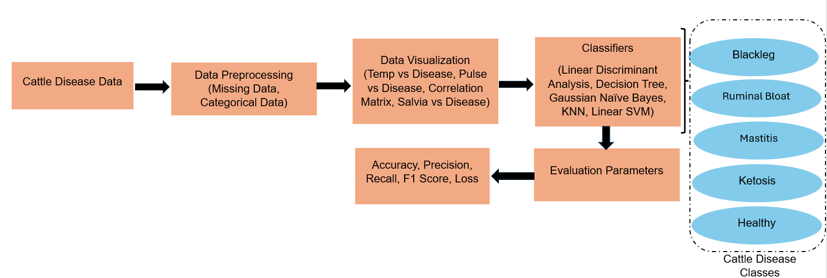
Figure 1: End-to-End Workflow for Cattle Disease Prediction Using Machine Learning

  - Dataset Description: The Cattle Disease Dataset is a numerical, tabular dataset designed for classifying cattle health status, supporting early disease detection and decision-making. The dataset contains many observations (i.e. individual cattle instances), along with a set of numerical input variables (features) that describe different measurable or recorded attributes of those cattle. The outcome (target) is a class label identifying whether a given animal is healthy or diseased (or possibly different categories of disease) [16]. Table 1 explains the key health features (or columns) in the dataset.
Table 1: Description of the cattle disease features
Feature | Description
Disease Label (Target) | Tells if the cow is healthy or sick
Body Temperature | The cow’s internal temperature
Heart Rate | How fast the heart is beating
Breathing Rate | Number of breaths per minute
Age | How old the cow is
Weight | Body weight of the cow
Food Intake | How much the cow is eating
Water Intake | How much water the cow drinks
Activity Level | How much the cow moves
Environmental Temperature | Temperature of the cow’s surroundings
  - Data Preprocessing: A structured and mathematically grounded preprocessing pipeline was put into practice to ensure the integrity and reliability of the datasets for machine learning assignments. Let the dataset be denoted by $X∈R^{n×d}$, where $n$ represents the number of samples and $d$ the number of features, with the corresponding target vector $y∈R^{n}$ extracted as the final column of the dataset. The feature matrix $X$ was divided into two disjoint subsets: numerical features $X_{\text{num}}$ and categorical features $X_{\text{cat}}$, such that $X=\left[X_{\text{num}} ∥ X_{\text{cat}}\right]$. To address missing data, different imputation strategies were applied. For each numerical feature $x_{j}∈X_{\text{num}}$, missing entries were filled using the median value, represented mathematically as $\left.x_{j}^{(i)}←\text{median}\left(x_{j}\right)\right.$ for all missing $x_{j}^{(i)}$. Similarly, for categorical features $c_{k}∈X_{\text{cat}}$, missing values were imputed using the mode, defined as $\left.c_{k}^{(i)}←\text{mode}\left(c_{k}\right)\right.$. After imputation, categorical variables were transformed using one-hot encoding. For a categorical feature with $m$ distinct categories, the transformation maps $c_{k}∈\left\{v_{1},v_{2},...,v_{m}\right\}$ to a binary vector $\text{OHE}\left(c_{k}\right)∈{\left\{0,1\right\}}^{m}$, where only one element is active per observation, i.e., $\sum_{i=1}^{m}{\text{OHE}}{\left(c_{k}\right)}_{i}=1$. This transformation pipeline was encapsulated into a scikit-learn Pipeline object $\left.P=T→M\right.$, where $M$ is the machine learning model (e.g., Random Forest). This approach ensured that all preprocessing steps were consistently applied during both training and inference phases, thereby enhancing the reproducibility, robustness, and predictive performance of the model for cattle disease classification.
  - Data Visualization: In the boxplot of Figure 2, saliva pH varies significantly with cattle diseases and is thus a valid noninvasive diagnostic tool. Healthy cattle have nearly neutral pH (7.4–7.6). Blackleg and mastitis bring the pH down and cause mild acidosis (7.2–7.5), whereas ruminal bloat shows a moderate acidification during digestive troubles (6.7–7.0). Saliva pH may thus emerge as a sensitive detector for metabolic and infectious stress in cattle in cooperation with parameters such as temperature and heart rate.
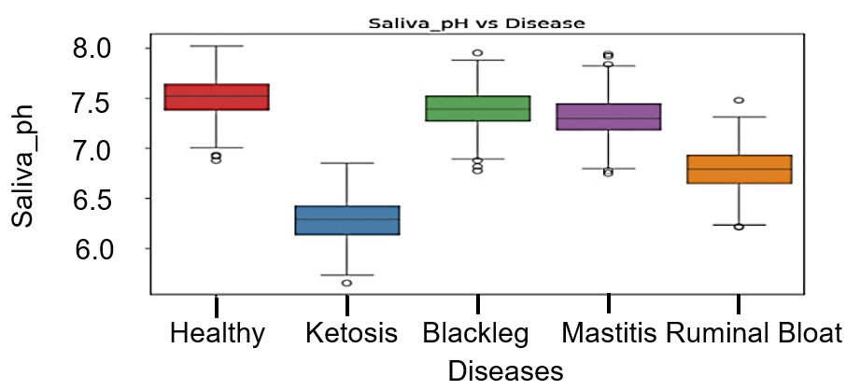
Fig 2: Saliva pH Across Different Cattle Disease Conditions

Likewise, Figure 3 shows that pulse rate varies across cattle diseases and can help differentiate between them. Healthy and ketosis cases have stable pulse rates around 60–70 BPM, indicating minimal cardiovascular stress. On the contrary, blackleg, mastitis, and bloating cause significant increases, with blackleg in the ballpark of an increase over 110 beats per minute owing to the intense infection and fever. Mastitis and ruminal bloat also increase the pulse rate to the 95- to 105-beats-per-minute and the 90-to 100-beats-per-minute ranges, respectively, due to inflammation and circulatory congestion. Consequently, the pulse rate has some value as an indication of infectious or inflammatory problems in cattle.
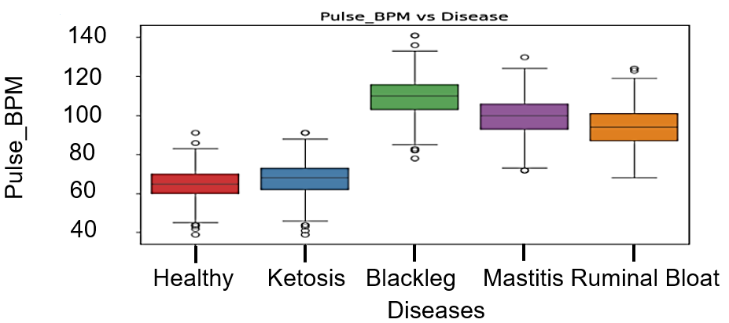
Fig 3: Pulse_BPM Across Different Cattle Disease Conditions
In Figure 4, varying with type of disease, variation of body temperature implies varied anaphylactic response and catabolic stresses. Cows with ketosis and cows without maintaining temperature within a normal range from 38-39°C, whereas in case of ketosis, the prognosis does not include a high fever. Contrary to that, blackleg pathogens can fire off fever above 41°C due to severe bacterial infection and immune up-regulation, while mastitis modestly raises a body temperature around 40°C from inflamed source, while the rumen bloat will induce a small elevation in temperature from stress and effects. Furthermore, on closer observation (Figure 5), the correlation heatmap demonstrates which linear correlations among numerous numerical features exist in the context of bovine health variances. For example, a positive strong correlation (0.83) develops between body temperature and pulse rate, which indicates that higher temperature is always going along with a high heart rate. Saliva pH positively correlates to some extent with temperature (0.42) and with pulse (0.27), implying some relationship might be there with metabolic activity. Gas sensor readings (MQ_Gas), on the other hand, correlate negatively with temperature (–0.36) and saliva pH (–0.78); hence higher volatile gas levels give off lower body temperatures and more acidic saliva. The accelerometer and gyroscope data are almost totally uncorrelated with the physiological observations, as can be observed; the data hint that they are capturing independent kinds of information.

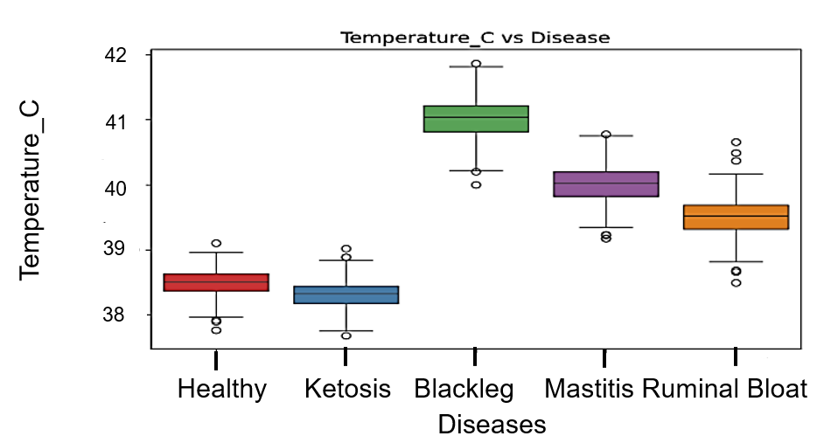
Fig 4: Temperature Across Different Cattle Disease Conditions
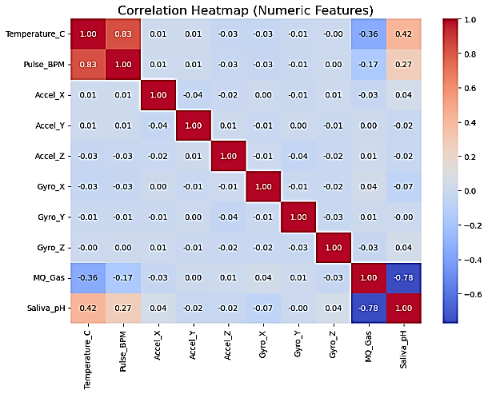
Fig 5: Correlation Heatmap
  - Classifiers: In cattle disease prediction and classification, a variety of supervised learning models can be employed to capture the relationship between observable symptoms and the underlying disease classes. Table 2 defines the values of the hyperparameters set while applying these classifiers.
Table 2: Hyperparameters used for the applied classifiers
Model | Hyperparameters
LDA | solver = svd (default), no shrinkage
GNB | var_smoothing = 1e-9
Decision Tree | criterion = entropy, max_depth = None, min_samples_split = 2
KNN | n_neighbors = 7, metric = Euclidean distance
Linear SVM | C = 1.0, max_iter = 1000, loss = hinge
Logistic Regression | solver = lbfgs, max_iter = 1000, C = 1.0, penalty = l2
LDA assumes that the features follow a normal distribution and that different disease classes share a common covariance structure. It projects the input space onto a discriminant axis that maximizes class separability [17]. For each class $C_{k}$, the discriminant function is expressed as
$$δ_{k}(x)=x^{T}Σ^{-1}μ_{k}-\frac{1}{2}μ_{k}^{T}Σ^{-1}μ_{k}+lnP\left(C_{k}\right)$$ | (1)
where $Σ$ is the shared covariance matrix, $μ_{k}$ is the mean vector of class $k$, and $P\left(C_{k}\right)$ is the prior probability of class $k$. The predicted disease corresponds to the class with the highest discriminant score. Unlike LDA, a Decision Tree uses a recursive partitioning approach that splits features into regions to create interpretable decision rules for cattle disease classification [18]. At each split, a measure such as entropy is used to evaluate impurity, defined as
$$H(S)=-\sum_{i=1}^{n}{p_{i}}\log_{2}p_{i}$$ | (2)
where $p_{i}$ is the proportion of samples belonging to class $i$. The optimal feature for splitting maximizes information gain, given by
IG(S,A)=H(S)-v∈Values(A)​∣Sv∣∣S∣HSv | (3)
This method mirrors rule-based reasoning, making it suitable for veterinarians seeking an interpretable model. Another probabilistic approach is the Naive Bayes classifier, particularly Gaussian Naive Bayes (GNB), which assumes that symptoms are conditionally independent given the disease class [19]. Using Bayes’ theorem, the posterior probability is computed as
$$P\left(C_{k}∣X\right)=\frac{P\left(X∣C_{k}\right)P\left(C_{k}\right)}{P(X)}$$ | (4)
For continuous features, the likelihood is modeled using the Gaussian distribution:
$$P\left(x_{j}∣C_{k}\right)=\frac{1}{\sqrt{2πσ_{kj}^{2}}}exp\left(-\frac{{\left(x_{j}-μ_{kj}\right)}^{2}}{2σ_{kj}^{2}}\right)$$ | (5)
where $μ_{kj}$ and $σ_{kj}$ denote the mean and variance of feature $j$ for class $k$. The disease is predicted by selecting the class with the maximum posterior probability. In contrast, the K-Nearest Neighbors (KNN) algorithm is a non-parametric method that classifies a new case by comparing it with the most similar past cases [19]. For a given sample, the Euclidean distance is commonly used:
$$d\left(x,x_{i}\right)=\sqrt{\sum_{j=1}^{n}{{\left(x_{j}-x_{ij}\right)}^{2}}}$$ | (6)
The predicted disease corresponds to the majority class among the $k$ nearest neighbors:
$$\hat{y}=arg\max_{c}\sum_{i=1}^{k}{I}\left(y_{i}=c\right)$$ | (7)
where $I$ is the indicator function. While intuitive, KNN can be sensitive to noisy features and performs poorly with high-dimensional data. A more discriminative approach is the Linear Support Vector Machine (Linear SVM), which constructs a hyperplane that maximizes
the margin between disease classes. The decision function is defined as
$$f(x)=w^{T}x+b$$ | (8)
By maximizing the margin, Linear SVM achieves robust classification when the diseases are linearly separable in the feature space. Finally, machine learning regression has been applied to predict disease severity. Such regression-based frameworks can extract meaningful relationships from complex inputs, supporting their adaptation to other domains such as Parkinson disease detection that require real-time monitoring and decision support [20]. Logistic Regression provides a probabilistic framework for binary and multiclass cattle disease prediction [21]. It models the probability of a disease as a logistic function of the input features:
$$P(y=1∣x)=\frac{1}{1+e^{-(w^{T}x+b)}}$$ | (9)
The parameters $w$ and $b$ are estimated by maximizing the likelihood or equivalently minimizing the cross-entropy loss:
$$L(w,b)=-\sum_{i=1}^{m}{\left[y_{i}log{\hat{y}}_{i}+\left(1-y_{i}\right)log\left(1-{\hat{y}}_{i}\right)\right]}$$ | (10)
- RESULTS
This section sets out the experimental results evaluating the performances of the proposed models and analysing the most significant trends across different evaluation metrics.
Table 3: Comparison of Machine Learning Models for Cattle Disease Classification
Model | Accuracy | Log-Loss (Entropy)
LDA | 0.9817 | 0.0427
Decision Tree | 0.9733 | 0.9612
Gaussian Naive Bayes | 0.9833 | 0.0423
KNN (k=7) | 0.2383 | 6.3373
Linear SVM (LinearSVC) | 0.8067 | N/A
Logistic Regression | 0.6250 | 0.7840
There is a comparative evaluation in Table 3 of a variety of classification models based on claims for accuracy and log-loss. Accuracy is the percentage of correctly classified instances, whereas log-loss measures the quality of the predicted probability distributions: lower values indicate better calibration. From the comparison, probabilistic models like Linear Discriminant Analysis (LDA) and Gaussian Naïve Bayes emerged as the best-performing models among high accuracy classification which possesses probability estimates that are well-calibrated. This is followed by decision-tree models, which have power in classification. However, this power is compromised by poor probability calibration, as aptly described in high values in log-loss. On the other hand, KNN for the present configuration is not nearly as good. This further indicates a far-fetched possibility of the model being applied to this dataset. Linear SVM shows much weaker feedback in terms of likelihood but does not predict probability estimate at all, whereas logistic regression is quite low. These weaken the chances of capturing the decision boundaries of the dataset.
As depicted in Figure 6, a comparison of the mean precision, recall, and F1-score of different models reveal that LDA, Decision Tree, and Naïve Bayes or Gaussian NB had the same high-performance nature, and that the three scores were nearly at the maximum performance threshold. Gaussian Naïve Bayes and LDA seem to be slightly better in terms of consistency of performance, given the compromise made by KNN (when using k=7), which barely resembles 0.2 across all three metrics, indirectly indicating a poor ability to separate different classes of a dataset. Linear SVM shows medium performance across other three criteria and scores slightly high, hinging upon 0.75–0.85 of precision, recall, and F1.
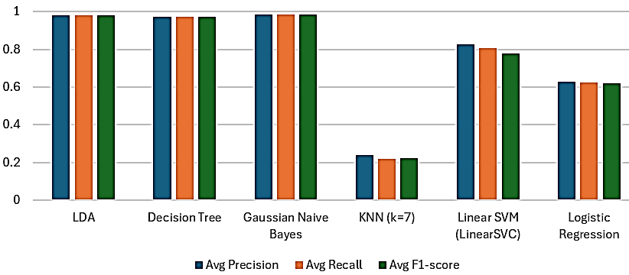
Figure 6: Analysis of classifiers for different metrics
This suggests that Linear SVM can separate classes good enough; however, they generally could not surpass the robustness of optimal-performing models. Logistic Regression being lower scores, averaging 0.6 for all metrics, indicates little ability for classification. It shows that Naïve Bayes and LDA, which are probabilistic models, are most favorable choices for this dataset; comparably, KNN and Logistic Regression are not suitable for this dataset due to their poorer average performance.
Table 4: Examination of classifiers for different classes of cattle diseases
Model | Class | Precision | Recall | F1-score
LDA | Blackleg | 0.9580 | 0.9500 | 0.9540
LDA | Healthy | 1.0000 | 1.0000 | 1.0000
LDA | Ketosis | 1.0000 | 1.0000 | 1.0000
LDA | Mastitis | 0.9504 | 0.9583 | 0.9544
LDA | Ruminal Bloat | 1.0000 | 1.0000 | 1.0000
Decision Tree | Blackleg | 0.9421 | 0.9500 | 0.9461
Decision Tree | Healthy | 1.0000 | 1.0000 | 1.0000
Decision Tree | Ketosis | 0.9836 | 1.0000 | 0.9917
Decision Tree | Mastitis | 0.9492 | 0.9333 | 0.9412
Decision Tree | Ruminal Bloat | 0.9916 | 0.9833 | 0.9874
Gaussian Naive Bayes | Blackleg | 0.9664 | 0.9583 | 0.9623
Gaussian Naive Bayes | Healthy | 1.0000 | 1.0000 | 1.0000
Gaussian Naive Bayes | Ketosis | 0.9917 | 1.0000 | 0.9959
Gaussian Naive Bayes | Mastitis | 0.9587 | 0.9667 | 0.9627
Gaussian Naive Bayes | Ruminal Bloat | 1.0000 | 0.9917 | 0.9958
KNN (k=7) | Blackleg | 0.2359 | 0.3833 | 0.2921
KNN (k=7) | Healthy | 0.2331 | 0.2583 | 0.2451
KNN (k=7) | Ketosis | 0.2170 | 0.1917 | 0.2035
KNN (k=7) | Mastitis | 0.2581 | 0.2000 | 0.2254
KNN (k=7) | Ruminal Bloat | 0.2603 | 0.1583 | 0.1969
Linear SVM | Blackleg | 0.5979 | 0.9417 | 0.7314
Linear SVM | Healthy | 0.8613 | 0.9833 | 0.9183
Linear SVM | Ketosis | 0.9487 | 0.9250 | 0.9367
Linear SVM | Mastitis | 0.8000 | 0.2333 | 0.3613
Linear SVM | Ruminal Bloat | 0.9344 | 0.9500 | 0.9421
Logistic Regression | Blackleg | 0.5769 | 0.7500 | 0.6522
Logistic Regression | Healthy | 0.8065 | 0.6250 | 0.7042
Logistic Regression | Ketosis | 0.7105 | 0.6750 | 0.6923
Logistic Regression | Mastitis | 0.4271 | 0.3417 | 0.3796
Logistic Regression | Ruminal Bloat | 0.6241 | 0.7333 | 0.6743
Table 4 illustrates a class-wise performance comparison of multiple classification models using precision, recall, and F1-score as evaluation metrics. The findings strongly indicate that the use of probabilistic models like LDA and Gaussian Naïve Bayes has always been associated with high precision and recall resulting in even distribution and robust F1-scores as a by-product. These models can classify the healthy cases with utmost accuracy and at the same time, they are able to locate the disease classes of ketosis, mastitis, and ruminal bloat almost perfectly, thus revealing their powerful generalization ability.
The decision tree is also on par with others, especially in recognizing ketosis and bloating of the rumen, but it does not show the same level of stability as LDA and Naïve Bayes in dealing with mastitis and blackleg. On the other hand, the KNN model with k=7 scores very poorly in all the classes, which is evident from its extremely low precision, recall, and F1-scores, thus proving its unsuitability for this dataset. Linear SVM is a moderate performer, strong for some classes like ketosis and ruminal bloat, but very weak in mastitis detection where it totally collapses in terms of recall. Logistic regression is rather inconsistent; it shows moderate effectiveness for some classes but in general it fails to find the right equilibrium between precision and recall, especially in the case of mastitis.

- CONCLUSION
In this paper, a machine learning paradigm were introduced for timely disease identification in cattle. The proposed models to examine were Linear Discriminant Analysis and Gaussian Naïve Bayes; both ranked best accuracy when contrasted with the other probabilistic classifiers, which were even ranked high on disease detection. The disease inferences were much stronger using physiological features such as body temperature, heart rate, and saliva pH. Limitations included that the features were completely numerical, the diseases were predetermined, and the study had no external validation, which was an impediment to generalizability. Future works should include use of multimodal data (e.g., images, IoT sensors), extensions of disease coverage, and samples from different geographic areas. Additionally, real-time deployments on mobile/edge platforms should be considered by active collaboration with veterinary professionals to establish a foundation for the development of livestock health-monitoring systems, scalable and practical alike.

REFERENCES

- YEAR END REVIEW 2024: DEPARTMENT OF ANIMAL HUSBANDRY AND DAIRYING. www.pib.gov.in/PressReleasePage.aspx?PRID=2086052.
- Hagiwara, Takayuki. “Securing Veterinary Health to Ensure a Safer Future for All | Hindustan Times.” Hindustan Times, 24 Apr. 2025.
- Tulu, Dereje. "Bovine brucellosis: epidemiology, public health implications, and status of brucellosis in Ethiopia." Veterinary Medicine: Research and Reports (2022): 21-30.
- Kumar, HB Chethan, et al. "Animal disease surveillance: Its importance & present status in India." Indian Journal of Medical Research 153.3 (2021): 299-310.
- Neculai-Valeanu, Andra-Sabina, Catalina Sanduleanu, and Ioana Porosnicu. "From tradition to precision: leveraging digital tools to improve cattle health and welfare." Frontiers in Veterinary Science 12 (2025): 1549512.
- Dineva, Kristina, and Tatiana Atanasova. "Health status classification for cows using machine learning and data management on AWS cloud." Animals 13.20 (2023): 3254.
- Goh, Ren Xiang, et al. "AI Based Control System for Electric Vehicles with Predictive Maintenance and Adaptive Energy Management." 2025 21st IEEE International Colloquium on Signal Processing & Its Applications (CSPA). IEEE, 2025.
- Mallikarjun, Goddeti, and V. A. Narayana. "The strategic utilization of machine learning insights to optimize the management of skin health in cattle." Multimedia Tools and Applications 84.6 (2025): 3369-3403.
- Madhanakumar, S. R. "Lumpy skin disease prediction using machine learning." 2024 2nd International Conference on Intelligent Data Communication Technologies and Internet of Things (IDCIoT). IEEE, 2024.
- Genemo, Musa. "Detecting high-risk area for lumpy skin disease in cattle using deep learning feature." Advances in Artificial Intelligence Research 3.1 (2023): 27-35.
- Rony, Md, Dola Barai, and Zahid Hasan. "Cattle external disease classification using deep learning techniques." 2021 12th International Conference on Computing Communication and Networking Technologies (ICCCNT). IEEE, 2021.
- Cihan, Pınar, et al. "AI-aided cardiovascular disease diagnosis in cattle from retinal images: Machine learning vs. deep learning models." Computers and Electronics in Agriculture 226 (2024): 109391.
- Kaur, Devinder, and Amandeep Kaur Virk. "Smart neck collar: IoT-based disease detection and health monitoring for dairy cows." Discover Internet of Things 5.1 (2025): 12.
- Swain, Satyaprakash, et al. "Smart livestock management: integrating IoT for cattle health diagnosis and disease prediction through machine learning." Indonesian Journal of Electrical Engineering and Computer Science 34.2 (2024): 1192-1203.
- Nadeem, Ghalib, and Muhammad Irfan Anis. "Investigation of bovine disease and events through machine learning models." Pakistan Journal of Agricultural Research 37.2 (2024): 102-114.
- “Cattle Disease Dataset (Numerical).” Kaggle, 22 Aug. 2025, www.kaggle.com/datasets/avik09/cattle-disease-dataset-numerical.
- Grace, G. Hannah, et al. "Classification of Livestock Diseases Using Machine Learning Algorithms." How Machine Learning is Innovating Today's World: A Concise Technical Guide (2024): 127-138.
- Lowie, Thomas, et al. "Decision tree analysis for pathogen identification based on circumstantial factors in outbreaks of bovine respiratory disease in calves." Preventive Veterinary Medicine 196 (2021): 105469.
- Damayunita, Aina, Rifqi Syamsul Fuadi, and Christina Juliane. "Comparative analysis of Naive Bayes, K-Nearest Neighbors (KNN), and Support Vector Machine (SVM) algorithms for classification of heart disease patients." Jurnal Online Informatika 7.2 (2022): 219-225.
- Hamzehei, Sahand, et al. "Predicting the total Unified Parkinson’s Disease Rating Scale (UPDRS) based on ML techniques and cloud-based update." Journal of Cloud Computing 12.1 (2023): 12
- Nur, Zakaria Mohamed, et al. "Leveraging Supervised Learning Algorithms for Automated and Accurate Cattle Disease Diagnosis in Livestock Farming in Somalia." International Conference on Artificial Intelligence and Smart Energy. Cham: Springer Nature Switzerland, 2025.

