Impact of Cloud Cover Changes on Solar Radiation and Photovoltaic Panel Efficiency in Asian

Mohammad Jafar Mokarram
School of Electronic Engineering and Intelligent Manufacturing
Anhui Xinhua University
Hefei, China
mjmokarram@axhu.edu.cn
Mohamed Hafez
Faculty of Engineering FEQS
INTI International University
Nilai, Malaysia
Faculty of Management, Shinawatra University, Pathum Thani, Thailand, mohdahmed.hafez@newinti.edu.my
Marzieh Mokarram
Department of Geography, Faculty of Economics, Management and Social Sciences
Shiraz University
Shiraz, Iran
m.mokarram@shirazu.ac.ir
Hani Attar
Faculty of Engineering
Zarqa Univeristy
Jordan
Hattar@zu.edu.jo

Abstract—This study investigates the impact of atmospheric clouds on surface solar radiation and the performance of photovoltaic (PV) panels in Asian countries. Using remote sensing data from the MODIS satellite and the Copernicus Atmosphere Monitoring Service (CAMS), the changes in total cloud cover (TCC), low (LCC), middle (MCC) , and high (HCC) clouds, global horizontal irradiance (GHI) and direct Normal irradiance (DNI) are investigated between 2016 and 2024. For this purpose, regions such as Pakistan, Aksai Chin, Jammu and Kashmir, Timor-Leste, Kazakhstan, Taiwan, Malaysia, Hong Kong, Kuril Islands, Macau, Laos, Vietnam, and Sri Lanka in Asian regions are analyzed. The results show a significant increase in total cloud cover in Pakistan (from 0.14 to 0.88), Aksai Chin (from 0.24 to 0.88), and Jammu and Kashmir (from 0.36 to 0.94), resulting in a decrease in GHI and DNI. Low cloud cover increased in Aksai Chin (an increase of 0.36) and Taiwan (0.33), while mid-level cloud cover increased in Aksai Chin (0.40) but decreased in Macau and Hong Kong. High cloud cover also increased in Jammu and Kashmir (0.72) and Pakistan (0.67), but showed a sharp decrease in the Kuril Islands.
Keywords—Cloud cover, solar radiation, solar panels, GHI, DNI, climate change, remote sensing.

Introduction
Renewable energies have become one of the main focuses of global scientific research and policymaking in recent decades due to their vital role in reducing dependence on fossil fuels and combating climate change [1], [2]. Among these resources, solar energy has a special place due to its abundance, sustainability, and high potential for producing clean electricity [3],[4]. Photovoltaic (PV) panels, as one of the leading technologies, have enabled the direct conversion of solar radiation into electricity [5], [6]. It is regarded as clean energy technology that significantly participates in energy development and developing countries progress [7], [8]. This technology is not only used for commercial and industrial electricity generation, but also contributes to sustainable development by reducing greenhouse gas emissions, improving air quality, and enhancing energy security [9].
In developing Asian countries facing rapid population growth, urbanization, and industrialization, solar energy plays a key role as a sustainable alternative to meet the increasing energy needs [10], [11]. Furthermore, accurate mapping of solar resources and assessment of power generation potential at local and regional scales is essential not only for energy generation but also for applications such as agriculture, water resources management, and environmental pollution monitoring. However, the efficiency of photovoltaic systems depends on several factors, including regional climatic and atmospheric conditions. A detailed study of these factors, especially in regions with high climatic variability such as Asia, is crucial for optimizing the performance of solar panels and increasing energy efficiency [12], [13], [14].
The efficiency of photovoltaic panels is strongly influenced by climatic parameters such as cloud cover, aerosols, dust, and atmospheric humidity [15]. Clouds, as one of the main barriers to solar radiation, can reduce up to 60–70% of global horizontal irradiance (GHI) and direct Normal irradiance (DNI) by absorbing and scattering shortwave radiation and reflecting longwave radiation [16], [17]. This reduction has significant effects, especially in concentrated solar power (CSP) technologies that rely heavily on direct radiation [18]. In addition to clouds, aerosols and dust also affect the Earth’s surface radiation budget by scattering and absorbing solar radiation and disrupting hydrological and climate cycles [19], [20]. In Asian regions, especially in South Asia, high aerosol loads from local sources such as biomass burning, industrial activities and dust storms exacerbate these effects [21].
These factors not only reduce solar radiation, but also affect the lifetime and type of clouds by changing the microphysical properties of clouds. These factors also indirectly affect solar energy production [22]. For example, in regions such as Pakistan and Aksai Chin, increased cloud cover and aerosols have led to a significant decrease in GHI and DNI. While oceanic regions such as the Paracel Islands have seen an increase in these parameters due to clearer atmospheric conditions [21]. This climatic variability highlights the need for detailed and regional studies to optimize the deployment of solar panels [23]. High atmospheric humidity and seasonal rainfall, especially in tropical regions such as Malaysia, can also have negative effects on solar panel efficiency by increasing the formation of thick clouds.
The main objective of this study is to comprehensively investigate the relationship between cloud cover and solar radiation (GHI and DNI) in Asian countries using remote sensing data from MODIS [24] and the Copernicus Atmosphere Monitoring Service (CAMS) from 2016 to 2024.The study analyzes the temporal and spatial variations in total cloud cover (TCC), low cloud cover (LCC), mid-level cloud cover (MCC), and high cloud cover (HCC). Another key objective is to apply regression models to quantify the relationship between cloud cover and solar radiation reduction to enable more accurate predictions of weather impacts on photovoltaic panel efficiency. The study also compares weather conditions in continental and oceanic regions and examines the effects of regional weather factors, such as increased atmospheric humidity and changing weather patterns, on solar energy production. This research not only increases understanding of the complex interactions between atmospheric factors and solar energy, but also supports the development of sustainable strategies for renewable energy exploitation in Asia.

Data

This study used ground-based, modeled, and satellite data to investigate the impact of cloud cover on solar radiation in Asia (2016–2024). AERONET data were collected from stations such as ARIES (Nainital, India) to measure AOD (aerosol optical depth) with an accuracy of ±0.01 at λ>400 nm [48, 50]. CAMS (Copernicus Atmosphere Monitoring Service) provided AOD and cloud cover forecasts with a resolution of 1 h and 0.4° [57, 58]. Satellite data included MODIS (Terra and Aqua) with a 6.1 level 3 suite (1° × 1° resolution) for AOD550 and MSG (Meteosat) with SARAH data for GHI, DNI, and COT (3 km resolution, hourly) [59, 63]. The geographical extent of the study covers 60°E to 150°E and 0°N to 50°N. Data processing was performed with Python (xarray, matplotlib, cartopy libraries) to extract NetCDF from the ZIP file and produce raster maps for cloud cover (TCC, LCC, MCC, HCC) and radiation (GHI, DNI) at pressure levels of 850, 925 and 1000 hPa. These data enabled the analysis of temporal and spatial variations for solar energy optimization.

methodology

Data Processing and Radiation Calculation
Solar irradiances are calculated with the function calculate_solar_irradiances for GHI equivalent to SSRD (surface shortwave radiation downward) and DNI/BHI equivalent to FDIR (surface shortwave direct radiation). Key inputs include solar zenith angle (SZA), cloud optical thickness (COT) and aerosol optical depth (AOD) from CAMS and MODIS. For cloudy conditions, the effects of WCOT (water clouds) and ICOT (ice clouds) are considered and the outputs are simulated in the wavelength range 285–2700 nm. The basic formulation for the GHI decomposition into components is:
$$\begin{matrix} & GHI=SSRD⋅cos⁡(SZA)⋅(1-CMF⋅AMF) & & \end{matrix}\text{(1)}$$
Cloud modification factor (CMF) and aerosol modification factor (AMF) are calculated to quantify effects (1):
$\begin{matrix} & CMF=1-\frac{COT}{COT_{\text{max}}} & & \end{matrix}$ (2)
$\begin{matrix} & AMF=e^{-\text{AOD}⋅m} & & \end{matrix}$ (3)
where, $COT_{\text{max}}$is the maximum cloud optical thickness, and $m$is the air mass.

Statistical Analysis and Mapping
Temporal changes are analyzed using boxplot statistics (minimum, Q₁, median Q₂, Q₃, maximum) for cloud cover and radiation. Median changes are examined between 2016 and 2024. Linear and quadratic regression models quantify the relationship between cloud cover (e.g., TCC) and radiation (GHI/DNI). The regression formulations for the relationship between cloud cover and solar radiation are:
$\begin{matrix} & GHI=β_{0}+β_{1}⋅TCC & & \end{matrix}$ $\text{(4)}$$$\begin{matrix} & DNI=β_{0}+β_{1}⋅TCC+β_{2}⋅TCC^{2} & & \end{matrix} \text{(5)}$$
where, β₀, β₁, and β₂ are regression coefficients. These models enable correlation quantification.

Results

Cloud Cover Changes
Since clouds absorb and scatter incoming solar radiation in the visible (0.38-0.78 μm) and infrared spectrums, the amount of solar energy entering the solar cell is lost in the reception of incoming radiation. The results show that 30% of the total energy received from the sun is reflected or absorbed by clouds, oceans, and land. Scattered solar radiation (which is attributed to absorption, reflection, or refraction) produces a lower percentage of photoelectricity than direct radiation for solar panels. For this purpose, in this section, the amount of cloud cover in different months in 2024 and its impact on the amount of energy production in parts of East and South Asia were examined. An example of the maps prepared with different cloud percentages is shown in Fig. 1. As shown in Fig. 1, the amount of cloud cover in parts of South Asia has the highest value.
Fig. 2 also shows the GHI and DNI values for different parts of Asia in 2024. The results show that the peaks of GHI and DNI are highest in the deserts located in China (southeast China).
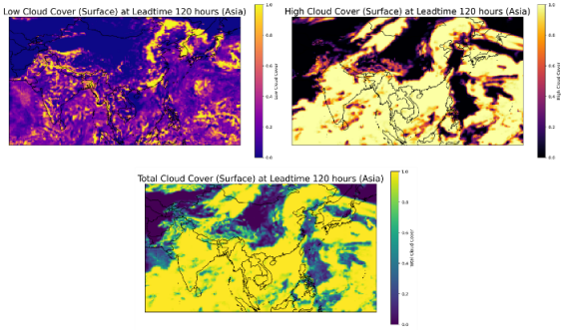
Fig. 1. Cloud cover status in countries across parts of Asia

Total Cloud Cover Changes and Their Relation to Solar Radiation
Statistical analysis shows a significant increase in TCC in several Asian countries between 2016 and 2024. In Pakistan, the median TCC increased from 0.14 to 0.88, indicating a transition from low cloud conditions to high cloud cover, and this change can be attributed to increased atmospheric humidity or weather patterns due to climate change. Similarly, in Aksai Chin, the median increased from 0.24 to 0.88, and in Jammu and Kashmir, it increased from 0.36 to 0.94, with this trend more pronounced in mountainous regions and may be related to increased rainfall or more intense weather activities. In Timor-Leste and Kazakhstan, increases were also observed from 0.30 to 0.65 and from 0.02 to 0.39, respectively, indicating an expansion of cloudy days. This increase in TCC is directly correlated with a decrease in solar radiation, as clouds absorb or reflect radiation, leading to a decrease in GHI and DNI. For example, in Pakistan and Aksai Chin, these changes have been associated with significant decreases in GHI and DNI, which can affect the efficiency of solar panels.
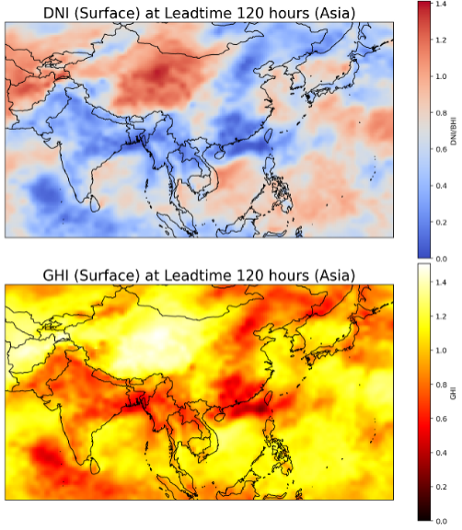
Fig. 2. GHI and DNI values in parts of South and East Asia

Low Cloud Cover Changes and Their Impact on Solar Radiation
LCC has increased in most of the Asian countries studied. In Aksai Chin, the median LCC increased from 0.00 to 0.36, showing the largest change, and this increase could indicate higher humidity and a greater chance of precipitation. However, in the Kuril Islands, a decrease from 1.00 to 0.73 was seen, which could indicate a shift towards drier conditions or a transition to higher clouds. LCC, due to its greater thickness, has a stronger effect on reducing DNI because it blocks direct radiation, while also affecting GHI. For example, increasing LCC in Aksai Chin is consistent with decreasing DNI and GHI, which could limit concentrated solar power generation, while decreasing in the Kuril Islands may help improve radiation.
D. Mid-Level Cloud Cover Changes and Their Impact on Solar Radiation
MCC shows contrasting changes in Asian countries. In Aksai Chin, the median MCC increased from 0.18 to 0.58, the only significant increase, which can be attributed to greater atmospheric activity or local climate change. In contrast, decreases were observed in Macau from 0.34 to 0.04, in Hong Kong from 0.32 to 0.04, and in Laos from 0.37 to 0.12, indicating greater atmospheric stability or reduced frontal activity. MCC has a moderate impact on solar radiation because it is semi-thick and can reduce GHI and DNI. The increase in MCC in Aksai Chin is consistent with a decrease in GHI and DNI and may affect the efficiency of solar systems. While reductions in Macau, Hong Kong and Laos could lead to a relative increase in radiation, providing better opportunities for energy production.
E. High Cloud Cover Changes and Their Impact on Solar Radiation
HCC shows diverse changes in Asian countries between 2016 and 2024. In the Kuril Islands, the median HCC has decreased sharply from 0.93 to 0.00, which can be attributed to clearer weather conditions and reduced moisture in the upper atmosphere. In contrast, increases are observed in Jammu and Kashmir from 0.03 to 0.75, in Pakistan from 0.01 to 0.67, and in East Timor from 0.02 to 0.62. These results indicate increased atmospheric activities in the upper layers. HCC has a smaller impact on GHI due to its thinness, but can reduce DNI to some extent. For example, increases in HCC in Pakistan and Jammu and Kashmir are associated with decreases in GHI and DNI, while decreases in the Kuril Islands may help improve radiation, and these changes could have implications for solar energy strategies.

F. Global Horizontal Irradiance Changes and Their Relation to Cloud Cover
Global horizontal radiation (GHI or SSRD), (total surface solar radiation) shows different changes in Asian countries between 2016 and 2024. In the Paracel Islands and Vietnam, GHI has increased significantly, which is likely attributed to a decrease in total cloud cover or improved weather conditions, enhancing the potential for photovoltaic energy generation. In contrast, in Aksai Chin, Pakistan, GHI has decreased, consistent with an increase in total cloud cover. This decrease in GHI, caused by the absorption and scattering of radiation by clouds, can reduce the efficiency of photovoltaic panels by 20-30%. While the increase in GHI in tropical regions such as Vietnam provides more opportunities for solar energy development (Figs. 3 and 4).
G. Direct Normal Irradiance Changes and Their Relation to Cloud Cover
Direct solar irradiance (DNI or FDIR) shows diverse trends across Asian countries. In the Paracel Islands and Palau, DNI has increased significantly, reflecting clearer weather conditions and possibly a decrease in thick cloud cover. In contrast, in Pakistan, Aksai Chin, DNI has decreased, consistent with an increase in total cloud cover. DNI is sensitive to thick clouds, and is affected by increased cloud cover, which can limit the production of concentrated solar systems by up to 40%. While the increase in DNI in oceanic regions creates great potential for these technologies.
H. Regression Analysis of Cloud Cover and Solar Radiation
The formulations for each type of cloud cover and their effects on radiation and solar energy production are explained below:
For TCC and GHI, the linear formulation $y=-20785128.59x+56401459.23$with $R^{2}=0.75$, and the polynomial formulation is $y=11152801.03x^{2}-31997182.71x+57268368.91$with $R^{2}=0.68$ have been calculated. These formulations show that with increasing TCC, GHI decreases linearly and nonlinearly, such that increasing TCC from 0 to 1 can reduce GHI. This decrease in countries such as Pakistan and Aksai Chin, with TCC increasing from 0.14 to 0.88 and from 0.24 to 0.88, respectively, has reduced the efficiency of photovoltaic panels by 20-30%. These increased values highlight the need for compensatory strategies such as the use of bi-directional panels.
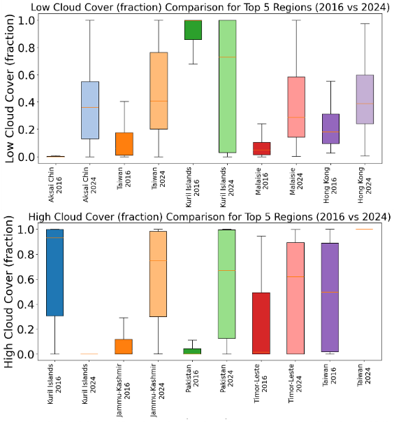
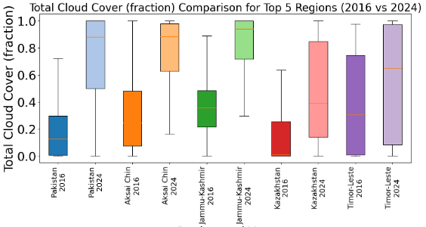
Fig. 3. Cloud cover values in countries with the greatest changes in 2016 and 2024 in Asia
For LCC and DNI, the linear formulation $y=-24958889.71x+35325431.72$with $R^{2}=0.65$, and the polynomial formulation is $y=47895392.66x^{2}-63790183.87x+37149206.35$with $R^{2}=0.79$ are extracted. These relationships confirm that LCC has a stronger effect on DNI due to the thickness of clouds and that the increase in LCC in Aksai Chin (from 0.00 to 0.36) is accompanied by a decrease in DNI. This increase can reduce CSP generation by up to 40%. In the Kuril Islands, the reduction of LCC from 1.00 to 0.73 may have created better conditions for DNI.
For MCC and GHI, the linear formulation $y=-27366024.18x+50953570.50$with $R^{2}=0.65$, and the polynomial formulation is $y=35963528.01x^{2}-55191210.37x+52631396.09$ were calculated. These formulations indicate the average effect of MCC on GHI due to semi-thick middle clouds. The increase in MCC in Aksai Chin (from 0.18 to 0.58) is consistent with the decrease in GHI, while the decrease in MCC in Macau and Hong Kong (to 0.04) can lead to a relative increase in GHI and improve photovoltaic power generation.
For high cloud cover (HCC) and DNI, the linear formulation $y=-19508962.85x+38959900.14$with $R^{2}=0.79$, and the polynomial formulation is $y=2488255.99x^{2}-21931182.85x+39066879.22$with $R^{2}=0.69$ are obtained. HCC has a smaller effect on DNI due to the thinness of clouds, but its increase in Pakistan (from 0.01 to 0.67) is associated with a decrease in DNI.
These increased values could limit CSP production by 10-30%. The decrease in HCC in the Kuril Islands (from 0.93 to 0.00) has probably created better conditions for direct radiation. Regression formulations confirm that increased cloud cover, especially TCC and LCC, is associated with a significant decrease in GHI and DNI, and this effect is more pronounced in continental regions such as Pakistan and Aksai Chin. In contrast, oceanic regions such as the Paracel Islands and Palau show an increase in GHI and a higher potential for solar power generation. Low R² values indicate the complexity of the relationships and the influence of other factors such as aerosols and solar zenith angle.
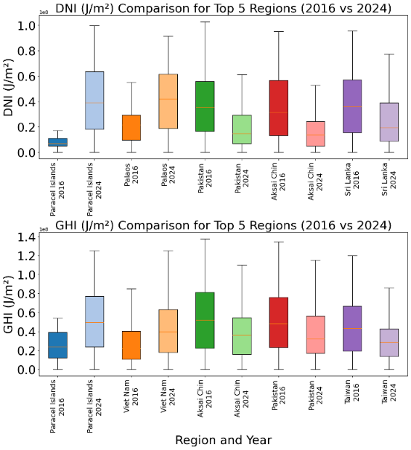
Fig. 4. GHI and DNI values in countries with the greatest changes in 2016 and 2024 in Asia

Conclusion
This study investigated the impact of cloud cover changes on solar radiation and photovoltaic panel performance in Asian countries from 2016 to 2024 using remote sensing data (MODIS and CAMS) and statistical analysis. Results showed a significant increase in TCC in continental regions such as Pakistan (from 0.14 to 0.88), China (from 0.24 to 0.88), and Jammu and Kashmir (from 0.36 to 0.94). This increase reduced GHI and direct normal irradiance (DNI), lowering solar panel efficiency by 30–50%. LCC increased in China, significantly reducing DNI due to thick clouds, which poses challenges for CSP systems. Oceanic regions exhibited high potential for solar energy production with increased GHI and DNI. Linear and polynomial regression models (with $R^{2}$between 0.03 and 0.08) confirmed that increased TCC and LCC have a stronger impact on reducing radiation, while HCC has a lesser effect. These changes, likely driven by increased atmospheric humidity and climate patterns, emphasize the need for compensatory technologies like bifacial panels and energy storage in cloudy regions. Further research on accurate cloud cover forecasting and adapting technologies to regional conditions is recommended to optimize solar energy in Asia. Also integrating smart grid framework can enhance energy storage and distribution effectively [25].

References
[1] A. G. Olabi and M. A. Abdelkareem, “Renewable energy and climate change,” Renewable and Sustainable Energy Reviews, vol. 158, p. 112111, 2022.
[2] M. J. Mokarram, R. Rashiditabar, M. Gitizadeh, and J. Aghaei, “Net-load forecasting of renewable energy systems using multi-input LSTM fuzzy and discrete wavelet transform,” Energy, vol. 275, p. 127425, 2023.
[3] S. Dhivya and S. Prakash, “Power Quality Assessment in Grid-Connected Solar PV Systems Using Deep Learning Techniques,” Journal of Applied Data Sciences, vol. 6, no. 2, pp. 1192–1208, 2025.
[4] S. E. Hosseini and M. A. Wahid, “Hydrogen from solar energy, a clean energy carrier from a sustainable source of energy,” Int J Energy Res, vol. 44, no. 6, pp. 4110–4131, 2020.
[5] H. Attar, A. Alahmer, G. Borowski, and S. Alsaqoor, “Comprehensive review of advancements, challenges, design, and environmental impact in floating photovoltaic systems.,” Ecological Engineering & Environmental Technology (EEET), vol. 26, no. 2, 2025.
[6] A. Amer et al., “Floating photovoltaics: assessing the potential, advantages, and challenges of harnessing solar energy on water bodies,” Journal of Ecological Engineering, vol. 24, no. 10, pp. 324–339, 2023.
[7] S. R. Sharvini, Z. Z. Noor, C. S. Chong, L. C. Stringer, and R. O. Yusuf, “Energy consumption trends and their linkages with renewable energy policies in East and Southeast Asian countries: Challenges and opportunities,” Sustainable Environment Research, vol. 28, no. 6, pp. 257–266, 2018.
[8] M. Mokarram, M. J. Mokarram, M. Gitizadeh, T. Niknam, and J. Aghaei, “A novel optimal placing of solar farms utilizing multi-criteria decision-making (MCDA) and feature selection,” J Clean Prod, vol. 261, p. 121098, 2020.
[9] N. S. M. N. Izam, Z. Itam, W. L. Sing, and A. Syamsir, “Sustainable development perspectives of solar energy technologies with focus on solar Photovoltaic—A review,” Energies, vol. 15, no. 8, p. 2790, 2022.
[10] M. Jahangiri, O. Nematollahi, E. Heidari Sooreshjani, and A. Heidari Sooreshjani, “Investigating the current state of solar energy use in countries with strong radiation potential in asia using GIS software, a review,” Journal of Solar Energy Research, vol. 5, no. 3, pp. 477–497, 2020.
[11] F. Aghaei, M. Uysal, R. C. De Lamare, and L. T. N. Landau, “Vehicular MMW Communication: Channel Characterization Based on Ray Tracing Study,” Proceedings of the International Symposium on Wireless Communication Systems, 2024, doi: 10.1109/ISWCS61526.2024.10639124.
[12] L. Micheli, M. Muller, and S. Kurtz, “Determining the effects of environment and atmospheric parameters on PV field performance,” in 2016 IEEE 43rd photovoltaic specialists conference (PVSC), IEEE, 2016, pp. 1724–1729.
[13] M. Mussard and M. Amara, “Performance of solar photovoltaic modules under arid climatic conditions: A review,” Solar Energy, vol. 174, pp. 409–421, 2018.
[14] F. Touati, A. Massoud, J. A. Hamad, and S. A. Saeed, “Effects of environmental and climatic conditions on PV efficiency in Qatar,” Renewable Energy and Power Quality Journal, vol. 1, no. 11, pp. 262–267, 2013.
[15] T. Ishii, K. Otani, T. Takashima, and Y. Xue, “Solar spectral influence on the performance of photovoltaic (PV) modules under fine weather and cloudy weather conditions,” Progress in Photovoltaics: Research and Applications, vol. 21, no. 4, pp. 481–489, 2013.
[16] E. S. Ganya, “Investigation of the relationship between solar radiation and cloud cover using a Total Sky Imager,” 2017, University of KwaZulu-Natal, Westville.
[17] A. Hammer, J. Kühnert, K. Weinreich, and E. Lorenz, “Short-term forecasting of surface solar irradiance based on Meteosat-SEVIRI data using a nighttime cloud index,” Remote Sensing, vol. 7, no. 7, pp. 9070–9090, 2015.
[18] M. Sengupta et al., “Best practices handbook for the collection and use of solar resource data for solar energy applications,” National Renewable Energy Laboratory (NREL), Golden, CO (United States), 2024.
[19] K. Anwar, S. S. A. Shah, A. H. Labban, and K. Alam, “Climatology, trend and correlations of aerosol, cloud and meteorology over the climatologically important monsoon and adjacent northern regions of Pakistan,” Atmospheric Research, vol. 322, p. 108136, 2025.
[20] M. J. Mokarram, M. Mokarram, M. Khosravi, and Y. Cui, “Optimizing Risk Control for Solar Farm Green Management Using DNI Estimation at the Edge through a GLE-SVR Learning Model,” Tsinghua Sci Technol, 2024.
[21] D. S. Hasan and M. S. Farhan, “Impact of Cloud, Rain, Humidity, and Wind Velocity on PV Panel Performance,” Wasit Journal of Engineering Sciences, vol. 10, no. 2, pp. 34–43, 2022.
[22] D. Yang, P. Jirutitijaroen, and W. M. Walsh, “Hourly solar irradiance time series forecasting using cloud cover index,” Solar Energy, vol. 86, no. 12, pp. 3531–3543, 2012.
[23] M. Dima and M. Voiculescu, “Global patterns of solar influence on high cloud cover,” Climate Dynamics, vol. 47, no. 1, pp. 667–678, 2016.
[24] M. Mokarram, M. J. Mokarram, and A. Najafi, “Thermal power plants pollution assessment based on deep neural networks, remote sensing, and GIS: A real case study in Iran,” Mar Pollut Bull, vol. 192, p. 115069, 2023.
[25] N. Gholipoor et al., “A Review on the Cross-Sector Resource Management Framework for Electric Vehicles Integration: Challenges, Solutions, Key-Enabling Technologies, and Future Directions,” IEEE Open Journal of Intelligent Transportation Systems, vol. 6, pp. 1084–1120, 2025, doi: 10.1109/OJITS.2025.3593437.

