A Hybrid Technique for Breast Cancer Detection with Efficient Imbalance Removal and Classification using ShuffleNetV2 Architecture

Debaleena Datta
Dept. of Computer Science & Applications
Techno Main Saltlake
Kolkata, India
leenadatta1907@gmail.com

Zakaria Che Muda Prof. Ir Dr
Professor, Faculty of Engineering and Quantity Surveying INTI-IU University Nilai, Malaysia zakaria.chemuda@newinti.edu.my
Uddalok Sen
Dept. of Information Technology
MCKV Institute of Enginnering
Howrah, India
uddaloksen81@gmail.com

Abey Jose
School of Allied Health
University of Limerick, Ireland
abey.jose@ul.ie

Hani Attar
Faculty of Engineering
Zarqa Univeristy, Jordan
Hattar@zu.edu.jo

Muhammad Fazal Ijaz
Centre for Artificial Intelligence Research and Optimization (AIRO) Design and Creative Technology
Torrens University Australia,
muhammadfazal.ijaz@torrens.edu.au

Abstract— For researchers to improve treatment efficacy and reduce mortality rates, early identification of breast cancer is crucial assisted by computer-aided diagnostic (CAD) tools. In recent times, deep CNN-based deep transfer learning (TL) methods have emerged as the most state-of-the-art approach. In this paper, we propose a computer aided methodology named deep hybrid AS-RF-ShuffNetV2 which addresses three major challenges of the base technology: data imbalance, extraction of feature set, and classification. Three steps make up the entire work: (1) Adaptive synthetic minority oversampling (ADASYN) is used to oversample malignant images (minority) in order to improve the feature space; (2) Random Forest (RF) splits are used to extract selective features from the balanced dataset; and (3) ShuffleNetV2, an efficient deep TL model, uses a channel split block with dual convolutional branch, a decisive channel attention block, and a channel shuffle block for interbranch information exchange, to classify the final features into two target classes. Our model is assessed by the metrics precision, recall, and f-score using INBreast dataset. The accuracy and AUC score achieved by our model are 92.68% and 0.86. The strength and consistency of the suggested method in correctly identifying breast cancer classes are demonstrated by thorough testing versus existing contemporary approaches, which concludes that our model poses superiority due to its intricate structure involving attention architecture.
Keywords— Breast Cancer, INBreast Dataset, Imbalance, Hybrid CNN network, ShuffleNetV2.

Introduction
Recent data indicates that breast cancer (BC) is one of the most prevalent diseases worldwide, primarily affecting women. It is typified by the growth of aberrant cells in the breast tissues that proliferate out of control [1]. The cancer burden is predicted to rise by almost 60% over the next 20 years, further taxing medical systems, communities, and people. According to the Breast Cancer Organization [2], 12.5% of all new cancer cases annually are BC, which grows especially in women. Since localized-stage diagnoses greatly improve treatment efficacy and patient prognosis, early diagnosis of BC is essential for increasing survival rates. Traditional screening methods like mammography, however, have inherent drawbacks, especially when dealing with thick breast tissue, where a lower contrast level may make it difficult to see the tumour [3]. Furthermore, a significant problem that frequently leads to needless biopsies, raised patient anxiety, and higher healthcare expenses is the high frequency of false positives and false negatives. These drawbacks underscore the pressing need for more sophisticated and trustworthy diagnostic techniques that can increase detection precision while reducing diagnostic errors [4]. There is a body of research which focuses on genetic organization of the cancer cells to identify its type [5]. A computer-aided design tool (CAD) is the most practical way to handle such evident problems that must be resolved as soon as possible in current day of advanced technology. These systems give radiologists quick, dependable, and affordable assistance, increasing diagnosis accuracy. It also results in improving human health by decreasing the health risks and improving the life expectancies significantly. The detection of BC has been further transformed by the incorporation of various convolutional neural network (CNN) architecture approaches into CAD systems. Transfer learning (TL) techniques based on CNN structures, nowadays, are the most effective addition to any CAD architecture. Medical imagery datasets can be used to refine models that have already been trained on large-scale datasets, such as ImageNet, to reach high accuracy with less computational effort and training time. It is also favourable for highly imbalanced datasets. The issues of biasness towards the majority class of general deep learning models are resolved through efficient TL models as they use a pretrained model. This benefits in stabilizing gradients that would otherwise be dominated by majority class, resulting in less errors and high robustness [6] and in improving human health by decreasing the health risks and improving the life expectancies significantly [7].
In this paper, we build a deep hybrid classification model for a highly imbalanced INBreast dataset which has benign images as majority samples, and malignant images as minority samples. The work is three-fold: (1) oversampling of malignant images (minority) using Adaptive synthetic minority oversampling (ADASYN) which enhances the feature space; (2) The selective features extracted from the balanced dataset using the Random Forest (RF) splits; (3) The final features are classified into two target classes by efficient deep TL model ShuffleNetV2 with a channel split (CS) block and a decisive channel attention (CA) block. The efficiency of our deep hybrid AS-RF-ShuffNetV2 model is evaluated by comparing its performance with the contemporary state-of-art CNN-based TL architectures. Our proposed study provides the following contributions:
- Focuses on a small dataset with challenges of imbalance due to less data for malignant instances. Use of ADASYN enhances the difference between major and minor class images.
- Intricate feature extraction from the augmented training dataset using RF with efficient existing feature splitting.
- The features are thoroughly refined using the CS and the classification accuracy is checked by the block of CA of the ShuffleNetV2.
The remainder of this paper is organized as follows: The relevant literature on the categorization of breast cancer is reviewed in Section II. The model's design, including its layers, components, and the reasoning behind architectural decisions, is thoroughly explained in Section III, which also describes our methodological approach. The findings of the suggested method are shown in Section IV, where they are contrasted with those of alternative methods based on a number of different criteria. Section V provides the conclusion and the future direction of this work.

previous research
Breast cancer persists as one of the most common malignancies in the world, and successful treatment depends on early identification. The CAD for such critical diseases is the paramount requirement of the hour. In order to automate the diagnosing process, DL approaches, in particular, CNN-based TL networks have drawn a lot of interest and have been used frequently in the past few years. The following Table I represents the most recent related literary works that had been published using the various TL-architectures.
- Summarization of latest literatures
Sl. No | Year & Ref | Contribution | Observations
1 | 2024  [8] | Two CNN-based models, ConvNeXT-small and EfficientNetV2-S, are employed for identification after preprocessing raw images from the RSNA Screening Mammography BC dataset, with 93% accuracy. | This work does not cover the imbalance prospect of the BC data and also the complex features of the dataset.
2 | 2024  [9] | The work provides an astounding accuracy of 97%, the CNN-based AlexNet framework, which was trained on the BUS-2 ultrasound dataset, has shown exceptional performance in BC categorization. | The work lacks in addressing the data augmentation of the existing dataset and a comparison with other relevant models.
3 | 2024  [10] | This work has focused greatly on denoising the CBIS-DDSM dataset and apply geometrical data augmentation. It uses basic CNN-based VGG16  and VGG19 with 70-72% accuracy. | This work uses the most basic models with lower accuracy and preprocessing techniques require refinement.
4 | 2024  [11] | In this work, two CNN models, InceptionV3 and DenseNet201 are trained on minimally processed BreaKHis dataset, the feature set of which is carefully generated, resulting in approximately 99% accuracy for both models. | The dataset requires more preprocessing and more inclusion of non-overfitting input features.
5 | 2024  [12] | This work proposes ResNet50V2 as the CNN-based model to classify the BreaKHis dataset, with nominal geometrical augmentation and 88% accuracy. | The work provides scopes to improve data preprocessing and inculcate efficiency of the model.
6 | 2024  [13] | MobileNetV3Large is proposed in this study to categorize the BreaKHis dataset, while the features are learned using ImageNet structure of CNN. The accuracy achieved is 76%. | The study applies general rotations and flips to augment data, and the features are not so detailed, providing a scope of advancement.
7 | 2025  [14] | This study puts up a comparison between DenseNet121 and ResNet152 on the Mammographic Image Analysis Society (MIAS) database with 94-95% accuracy by both TL architectures. | This study does not provide any modification to the base CNN-structures and neglected proper data augmentation.
8 | 2025  [15] | This study uses a hybrid CNN model comprising a preliminary block using MobileNet and a succeeding multi-branch ShuffleNet structure for training the architecture. The accuracy achieved on BreakHis dataset is more than 99%. | This study does not deliver any details for the preprocessing of the dataset, and it invokes the idea of hybridizing several strategies to achieve desired outcome.
These literary works depict the extensive and insightful exploration on CNN-based TL models, that acts as motivation for us to opt for this research.

proposed methodology

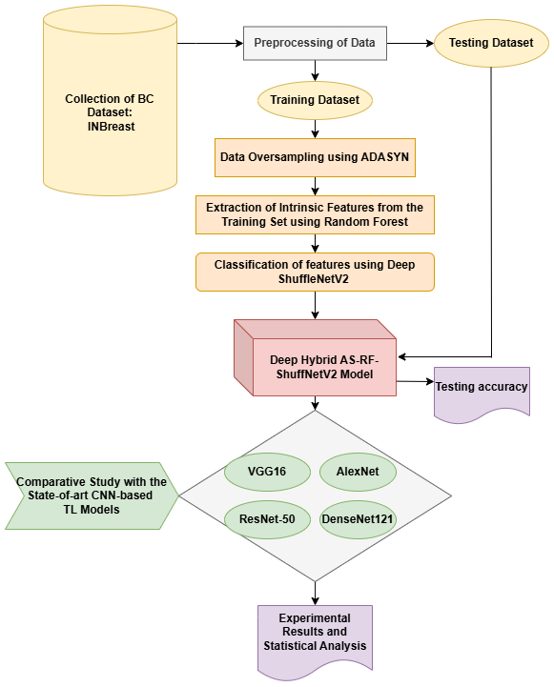Fig. 1. The Workflow diagram of the Proposed hybrid technique
CNN-based TL models are being extensive explored in various research aspects, especially for CADs which aim for classification using the embedded features in the imagery database. The objective of our study is construct an efficient hybrid model to resolve the imbalance issue of a small dataset, as well as efficiently classify the malignant and benign lesions from the BC dataset. The entire work direction of the proposed methodology is briefed diagrammatically in Fig. 1. The primary step is to collect a suitable BC database. Data is first pre-processed by resizing and normalizing the data. Then the dataset is split into training and testing sets. The training set is further processed to augment imagery data using oversampling, the augmented data is thus forwarded to a feature extractor technique. Then the selected featured are being passed to the CNN-architecture for the final categorical outcome. Our hybrid deep model is then evaluated on the testing set using metrics and on a comparative basis with other relevant contemporary models.

Dataset Description
This study uses the publicly available BC dataset INBreast. It is a prominent public collection of Full-Field Digital Mammograms (FFDM) used for breast cancer diagnosis. It features high-resolution images with detailed annotations, including pixel contours for lesions, making it a key benchmark for computer vision research. It includes 115 cases with 410 images of 14-bit grayscale at a resolution of 3328×4084 or 2560×3328 pixels (depending on breast size and compression plate). It includes detailed BI-RADS (Breast Imaging-Reporting and Data System) assessment factors (1-6) and precise XML contours for abnormalities. Bi-RADS 1-3 represents 310 Benign or Normal out of which 220 are benign; Bi-RADS 4-6 represents 100 Abnormal out of which 49 are confirmed Malignant. The following Fig. 2 delivers the samples of fully normal, benign and malignant image samples from the dataset.
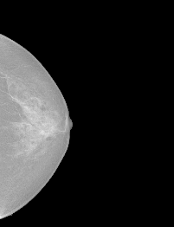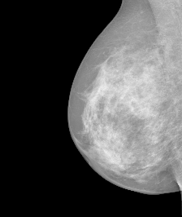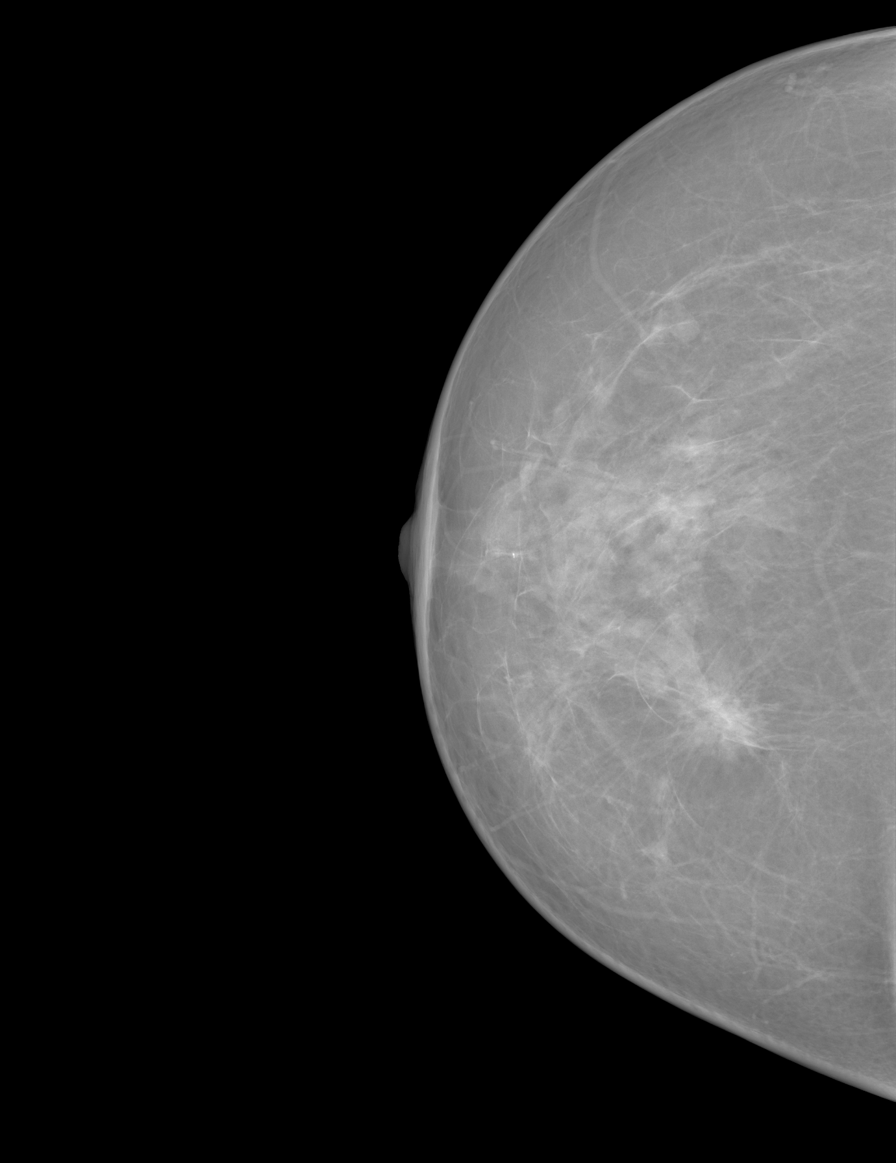
(a) (b) (c)
- The sample images form INBreast dataset: (a) Fully normal, (b) Benign, (c) Malignant

Data Preprocessing and Splitting
We use the DICOM format to store breast pictures is first converted into accessible forms as PNG, TIFF, or NumPy arrays. Then we extract the important metadata, including view (CC/MLO), laterality (L/R), and BI-RADS density. In order to preserve consistency, we scale the photos to 224*224 resolution. Lastly, the image date's region of interest is determined.
We split the entire dataset into two consecutive sets using a 4:1 train-test split ratio following the successful preprocessing. As a result, we obtain a training set of 328 images and a testing set of 82 images.

Training Data Oversampling
The imbalance between the malignant (minor class) and benign (major class) is a prominent issue which further leads to biasness of the classifier towards the majority. To address this issue, we chose ADASYN, an efficient technique that is assisted to oversample the minor class of the training set, to restore the balance in the dataset. The original training Feature shape was (328, 50176). After using ADASYN, resampled training Feature shape becomes (560, 50176).

Feature Extraction using Random Forest
The resampled feature vectors are initially treated by RF, which functions as a robust primary feature extractor. Using decision trees, Random Forests divide our feature space into intricate, nonlinear areas. The leaf assignments capture nonlinear feature interactions since each leaf node reflects a distinct mix of input features. We obtain a new, high-dimensional binary vector by noting which leaf node a sample falls into across all trees. This vector summarizes the decision boundaries that the forest found by acting as a learnt embedding of the data. Instead of using raw input variables as inputs to ShuffleNetV2, the generated embeddings are enhanced with discriminative features.

The Proposed Model: Hybrid AS-RF-ShuffNetV2
The final part of our hybrid model is to incorporate the layers of ShuffeleNetV2 to train the entire hybrid model using refined feature set obtained from RF. To facilitate feature discrimination and inter-channel dependency modelling, the improved ShuffleNetV2 design incorporates a channel split (CS) mechanism and a channel attention (CA) block. The block diagram of the ShuffleNetV2 unit is shown in Fig. 3.
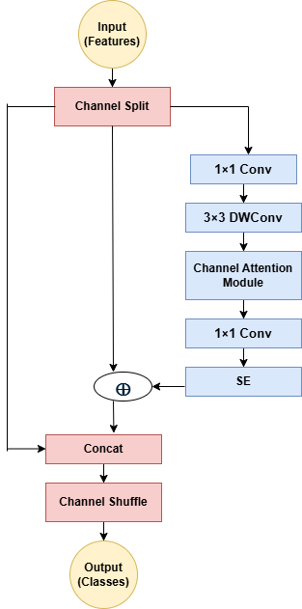
- The Block Diagram of the ShuffleNetV2 Architecture

Channel Split (CS) and Dual-Branch Design: Suppose, for a given inpout feature map X ∈ ℝ^{C×H×W}, the feature channels are evenly divided into two branches:
X₁, X₂ = Split (X) (1)
Branch 1, the Identity branch passes features directly for gradient flow and computational efficiency. Branch 2, the Computation branch Processes X2​ through sequential convolutions:
- 1×1 pointwise convolution that reduces channel mixing expense
- 3×3 depth-wise convolution that captures spatial context
- Channel Attention module, which reweights channels based on importance.

Channel Attention Block: The attention block uses a squeeze-and-excitation (SE) mechanism to boost informative channels and inhibit redundant ones:
s=σ(W₂​δ(W₁​GAP(X₂​))) (2)
where GAP denotes global average pooling, δ is ReLU, and σ is sigmoid activation. The rescaled feature is obtained as X₂′=s⊙X₂

Channel Shuffle and Concatenation: After attention modulation, both branches are concatenated and shuffled to encourage inter-branch information exchange:

Y = Shuffle ([X₁, X₂′]) (3)

The output Y is then passed to the next stage.
High representational power and little computing overhead are guaranteed by this architecture. The design is ideal for lightweight medical imaging models like breast cancer detection since the channel split and shuffle preserve efficiency while the channel attention enhances feature selectivity.

results and discussion
The objective of this study is to evaluate the performance of our proposed hybrid model AS-RF-ShuffNetV2 against the INBreast data. This section emphasises on evaluating the various performance metrics based on the test dataset, also recording the same for other contemporary CNN architectures which has been used for the same purpose in the previous studies. Based on these statistics, a thorough comparative study is generated.

Experimental Setting
The TorchVision, NumPy, and PyTorch libraries are used to create the experimental pipeline. To train the model, the input photos are zero-padded with a batch size of 64. An Nvidia GeForce RTX 3050 GPU and 64GB RAM can do 30 epochs in about 15 minutes. With a batch size of 128, the model is trained across 100 epochs. Every ten epochs, the starting learning rate of 0.01 is reduced by 30%. The stochastic gradient descent (SGD) optimizer is used to update the parameters with a momentum of 0.9 and a weight decay of 5×10-4. The hyperparameters β and α are set at 5×10-4 and 0.1, respectively. T, the distillation temperature, is set to 3.0.

Performance Metrics (PM) for Evaluation
To enable comparisons, we utilize the following PMs, incorporating False Positives (FP), False Negatives (FN), True Positives (TP), and True Negatives (TN), as noted down in Table II.
- List of Performance Metrics
Metric Name | Formula | Details
Precision (P) | $$\frac{TP}{TP+FP}$$ | It is a measure of a classifier's ability to accurately anticipate favourable outcomes.
Recall (R) | $$\frac{TP}{TP+FN}$$ | It quantifies the percentage of true positive observations that were accurately predicted, indicating a classifier's performance.
F1-Score (F1) | $$\frac{2×P×R}{P+R}$$ | It is the ensemble average of recall and precision.
Accuracy (Acc) | $$\frac{TP+TN}{TP+FP+TN+FN}$$ | It is the measure of a model's ability to accurately forecast true and false classifications.
Moreover, the ROC-AUC score is a single number that summarizes the classifier's performance over all possible classification levels. The score determines the classifier's capacity to distinguish between positive and negative classifications.

Experimental Outcome and Comparative Analysis
Our proposed model AS-RF-ShuffNetV2 is a hybrid architecture that addresses three major issues of any CAD system: data imbalance, feature extraction and efficient categorization of INBreast BC data. The performance of the model is based on the test dataset, which comprises 20% random images from the original dataset. It is measured through the above-mentioned PMs and the ROC curves are plotted. This subsection additionally offers a detailed statistical record on the comparison of the PMs of our model with the benchmark CNN-TL architectures: VGG16, AlexNet, ResNet50 and DenseNet121, which is thoroughly depicted conjugately in Table III and Table IV. The aforementioned models are also treated the same way, i.e., preprocessed in the same way, then oversampled by ADASYN and feature extracted by RF. The purpose behind this is to make a fair comparison between our model and other models with a clarified judgement. The expected outcome classes are benign (0) and malignant (1).
Table III is a class-wise (0 and 1) discrimination between the precision (P), Recall (R), and F1-score (F1) of all models, including ours. It indicates a clear contradiction between the sample classes in the testing set. Class 0 (Benign) has consistent results across all models, however, AS-RF-ShuffNetV2 performs better than the others. On the other hand, for class 1 (Malignant), the rate of false positives are way too higher, affected by sheer imbalance causing inaccurate metric values. Nevertheless, AS-RF-ShuffNetV2 pulls up the performance by improving the PMs, as shown in the last column of the table.
- Statistics for precision (P), Recall (R), and F1-score (F1) of all models
Models → | VGG16 |  | AlexNet |  | ResNet-50 |  | DenseNet-121 |  | AS-RF-ShuffNetV2
PMs ↓ | Ben (0) | Mal (1) | Ben (0) | Mal (1) | Ben (0) | Mal (1) | Ben (0) | Mal (1) | Ben (0) | Mal (1)
P | 0.86 | 0.00 | 0.88 | 0.00 | 0.86 | 0.00 | 0.89 | 1.00 | 0.92 | 1.00
R | 0.99 | 0.00 | 1.00 | 0.09 | 0.99 | 0.00 | 1.00 | 0.18 | 1.00 | 0.45
F1 | 0.92 | 0.00 | 0.93 | 0.17 | 0.92 | 0.00 | 0.94 | 0.31 | 0.96 | 0.62
Table IV represents the overall accuracy and AUC score of all models based on raw the test dataset, i.e., 82 images. Our model achieves the highest accuracy among all models, viz., 92.68% and 0.86, which proves that model is efficient enough.
- Statistics for overall accuracy and auc-score of all models
 | VGG16 | AlexNet | ResNet-50 | DenseNet  -121 | AS-RF-ShuffleNetV2
Overall Acc% | 85.37 | 87.80 | 85.37 | 89.02 | 92.68
AUC Score | 0.65 | 0.58 | 0.71 | 0.79 | 0.86
The confusion matrices and ROC curves are shown in Fig. 4 and Fig. 5 for AS-RF-ShuffNetV2 and the other chosen models for a better visual experience. In our study, TP is obtained by the number of samples which are malignant and correctly predicted by the model. Similarly, TN represents correctly predicted benign samples, FP represents incorrect predictions of malignant samples, and FN represents incorrect predictions of benign samples.
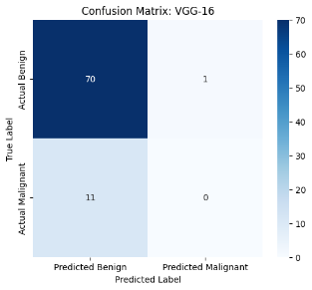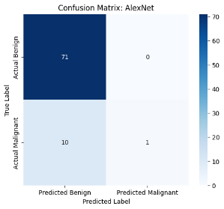
(a) (b)
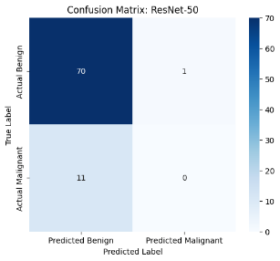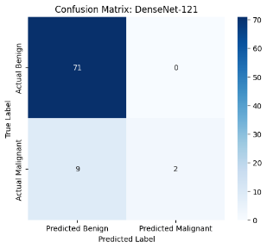
(c) (d)
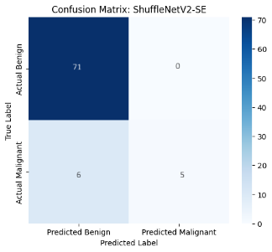
(e)
- The Confusion Mtarices obtained from the CNN-based models for the The test dataset: (a) VGG16, (b) AlexNet, (c) ResNet-50, (d) DenseNet-121, (e) AS-RF-ShuffNetV2
Fig. 4 shows that, the FP and the FNs suffer due to the lack of balance between the benign and the malignant samples. Although, our model has 6 FNs, but it correctly classifies 5 sample of positive malignant class.
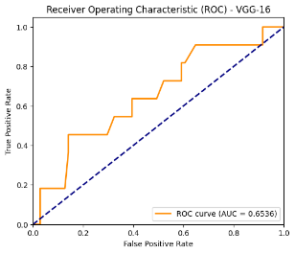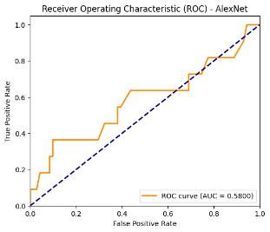
(a) (b)
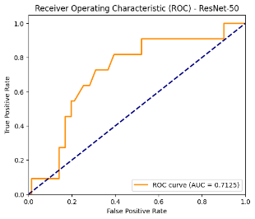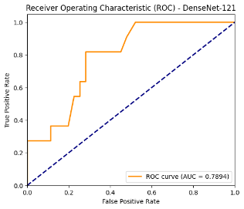
(c) (d)
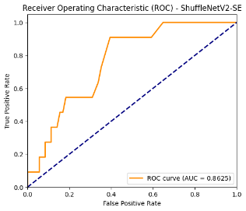
(e)
- The ROC Curves obtained from the CNN-based models for the The test dataset: (a) VGG16, (b) AlexNet, (c) ResNet-50, (d) DenseNet-121, (e) AS-RF-ShuffNetV2
Fig. 5 shows that, the ROC curve of our models outperforms the same for the other models.

Overall Discussion
Using the INBreast dataset, the experimental results show that the suggested AS-RF-ShuffleNetV2 hybrid architecture successfully tackles the crucial issues of CAD in breast cancer identification. The architecture of the model incorporates ShuffleNetV2 as the lightweight deep backbone, Random Forest (RF) for feature extraction, and Adaptive Synthetic Sampling (ADASYN) for oversampling. This combination improves generalization performance on small medical datasets and allows for better learning from minority malignant cases.
The precision, recall, and F1-score of the suggested approach and benchmark CNN architectures (VGG16, AlexNet, ResNet-50, and DenseNet-121) are compared class-wise in Table III. The findings demonstrate that although all models continuously perform well for benign instances (Class 0), data imbalance causes their sensitivity to drastically decrease for malignant cases (Class 1). But for malignant samples, AS-RF-ShuffleNetV2 significantly increases recall and F1-score (0.45 and 0.62, respectively), suggesting better lesion discriminating and a lower false-negative rate—a crucial component in medical diagnosis.
Among the assessed models and AS-RF-ShuffleNetV2, the confusion matrices show clear patterns in classification behavior. For the benign class, all models perform well, correctly identifying nearly all benign instances (≈70-71 true positives) with very few false positives (≤1). On the other hand, the more clinically important task of malignant class detection exhibits significant variation. With 0 true positives and 11 false negatives, VGG-16 and ResNet-50 were unable to identify any malignant samples, demonstrating a strong bias in favor of the majority benign class. While DenseNet-121 found two cancerous cases, indicating somewhat improved sensitivity but still inadequate generalization to minority data, AlexNet only slightly improved with one malignant case properly identified. The suggested AS-RF-ShuffleNetV2 model, on the other hand, produced a more balanced result with five malignant cases correctly categorized and only six misclassified, significantly increasing recall without sacrificing benign detection (71 true negatives, 0 false positives). This increase is consistent with the ROC curve and AUC analysis, where the suggested model outperformed the baseline CNNs (AUC ≈ 0.58–0.79) in terms of discriminatory power across thresholds, achieving the maximum AUC = 0.86. Integrating ADASYN oversampling, Random Forest feature selection, and ShuffleNetV2's lightweight convolutional backbone improves the model's sensitivity toward cancerous patterns while preserving overall classification stability, as seen by the increased AUC and decreased false-negative rate. Therefore, AS-RF-ShuffleNetV2 is the most dependable option for breast cancer detection using the INBreast dataset since it exhibits the best trade-off between specificity and sensitivity among all models.

Conclusion and future work
In our study, we aim to construct a CAD for early and efficient detection of breast lesions, which becomes highly fatal if not diagnosed accurately. The hybrid model that we propose, “AS-RF-ShuffNetV2” is capable of addressing three major hinderances of any deep architecture: (1) small dataset with critical imbalance between the major (benign) and the minor (malignant) class; (2) the most significant feature extraction and removal of redundant features; (3) the training of a multi-layer CNN based model for classification. To resolve these, we selected INBreast BC dataset to serve our purpose. We first apply the basic preprocessing such as, resizing, mass identification and data splitting. Then ADASYN is applied on the training dataset to oversample the malignant images (minor class). The resampled data is used to extract the most essential information by feature separation using RF. Then the enriched feature set is applied to construct the CNN-based ShuffleNetV2 model whose CS and CA blocks are efficiently able to categorize the benign and malignant classes. Our model has outperformed the chosen models for comparison due to its better handling of imbalance data. The accuracy achieved by AS-RF-ShuffNetV2 is 92.68%, and the closest high accuracy achiever is DenseNet121, i.e., 89.02%. Healthcare practitioners can benefit greatly from its high precision, recall, and F1-score values for both benign and malignant classes, which confirm its dependability in automated breast cancer diagnosis.
In order to evaluate the model's generalizability across different patient groups and imaging methods, future research should concentrate on validating its performance using larger and more varied datasets, including external validation sets. Moreover, to remove imbalance, other oversampling models to examine more intricate data augmentation strategies, along with more advanced deep TL models could be incorporated directly or in integrated mode to enhance the strategy to battle with breast cancer and facilitate patients as well as medical professional for better diagnostics and prevention.

References
- N. Y. Duodu, W. D. Patel, and A. Ganatra, "Advancements in Telehealth: Enhancing breast cancer detection and health automation through smart integration of iot and cnn deep learning in residential and healthcare settings,"Journal of Advanced Research in Applied Sciences and Engineering Technology, vol. 45, pp. 214-226, 2025.
- BREASTCANCER.ORG, “Breast Cancer Facts and Statistics,”, Available online: https://www.breastcancer.org/facts-statistics, 2023. (Accessed on: 22 November 2023).
- S. J. S. Gardezi, A. Elazab, B. Lei, and T. Wang, ‘‘Breast cancer detection and diagnosis using mammographic data: Systematic review,’’ J. Med. Internet Res., vol. 21, no. 7, Jul. 2019, Art. no. e14464.
- M. Khalifa and M. Albadawy, ‘‘AI in diagnostic imaging: Revolutionising accuracy and efficiency,’’ Comput. Methods Programs Biomed. Update, vol. 5, Jul. 2024, Art. no. 100146.
- S. I. Mohammad, E. Y. Theab, A. Vasudevan, A. K. Bishoyi, S. Ballal, H. R. A. Kareem Al-Hetty, A. Shankhyan, A. A., R. Panigrahi, and H. A. Yasin, “Breast cancer exosomes: Managing macrophage polarization and immune regulation in the tumor microenvironment,” Semin. Oncol., vol. 52, no. 4, 2025.
- S. Akuthota, "Enhanced Breast Cancer Classification Using Attention-Augmented CNN and Multi-View Learning on the Inbreast Dataset," 2025 International Conference on Computing Technologies & Data Communication (ICCTDC), HASSAN, India, 2025, pp. 1-5.
- B. Rezaee, K. Jeon, G.Khosravi, M.R. Attar, H.H., and A. Sabzevari, “Deep learning‐based microarray cancer classification and ensemble gene selection approach,” IET Systems Biology, 16(3-4), 120-131, 2022.
- M. Hasan, "Deep Learning for Breast Cancer Detection: Comparative Analysis of ConvNeXT and EfficientNet," 2024 27th International Conference on Computer and Information Technology (ICCIT), Cox's Bazar, Bangladesh, 2024, pp. 1387-1391.
- S. Das, D. Muduli, R. K. Gouda, S. P. Sahu, P. K. Sahu and S. K. Sharma, "Automated Breast Cancer Detection Model: A Novel Customized AlexNet Model," 2024 15th International Conference on Computing Communication and Networking Technologies (ICCCNT), Kamand, India, 2024, pp. 1-5.
- S. Khan, F. T. Zahra, A. Asif, S. Arif and U. Fatima, "Comparative Study of Transfer Learning with VGG16 and VGG19 for Breast Cancer Classification," 2024 26th International Multi-Topic Conference (INMIC), Karachi, Pakistan, 2024, pp. 1-6.
- A. O. Meddas, D. Jabri and D. E. C. Belkhiat, "Breast Cancer Classification on Histopathological Images Using Inception V3 and DenseNet 201: A Comparative Study," 2024 2nd International Conference on Electrical Engineering and Automatic Control (ICEEAC), Setif, Algeria, 2024, pp. 1-6.
- P. Kaushik and S. Choudhary, "Enhanced Breast Cancer Detection using ResNet50V2-based Convolutional Neural Networks," 2024 4th International Conference on Soft Computing for Security Applications (ICSCSA), Salem, India, 2024, pp. 374-379.
- P. Kaushik and P. Sharma, "A MobileNetV3-Based Approach to Breast Cancer Detection Through Transfer Learning and Histopathological Image Analysis," 2024 International Conference on Advances in Computing, Communication and Materials (ICACCM), Dehradun, India, 2024, pp. 1-6.
- T. Pavlović, T. Popović and S. Čakić, "Breast Cancer Detection Using ResNet and DenseNet Architecture," 2025 29th International Conference on Information Technology (IT), Zabljak, Montenegro, 2025, pp. 1-4.
- M. Ahmadi, B. Mirmahboub, N. Karimi, P. Khadivi and S. Samavi, "AI-Assisted Breast Cancer Classification: A Deep Learning Model Integrating MobileNet and ShuffleNet Features," 2025 IEEE World AI IoT Congress (AIIoT), Seattle, WA, USA, 2025, pp. 0280-0284.

