AI-Driven Therapeutic Recommendations: Integrating Psychological and Behavioral Insights into Breast Cancer Care

1st Abdulla Al-Ali
Department of Computer Science &engineering
Zarqa University
Zarqa - Jordan
Aalali@zu.edu.jo

4th Rasha Alamoush
Department of Computer Science
Zarqa University
Zarqa - Jordan
202403239@zu.edu.jo

7 th Tagreed Mousa Al-Ali
Faculty of Educational Science
Hashemite University
Mafraq , Jordan
TMFAl-Ali@hu.edu.jo
2nd Ola Buraik
Department of Business Administration
University of Tabuk
Tabuk, Saudi Arabia
omsburaik@hotmail.com

5th Yusra Al-Najjar
Department of Cybersecurity
Zarqa University
Zarqa - Jordan
yalnajjar@zu.edu.jo
3rd Taima' Mehrem
Department of Computer Science
Zarqa University
Zarqa - Jordan
202403239@zu.edu.jo
6th Amer Al-Rawash
Department of AI
Zarqa University
Zarqa - Jordan
aalrwash@zu.edu.jo

Abstract—Artificial intelligence (AI) importance is increasing in advancing personalized medicine, especially in oncology. This research introduces an AI-based therapeutic recommendation system especially designed for breast cancer patients, integrating not only biological and clinical data but also psychological and behavioral factors. The system is designed to enhance treatment adherence and improve patient results by fulfilling individual needs holistically. Recent studies, the system's algorithm is demonstrated in managing complex scenarios, such as co-morbid conditions and psychological challenges that affect therapy adherence. These examples highlight data-driven, patient-centric solutions that closed the gap between technology innovation and human-centered care. While the system offers significant advantages, challenges such as data integration, ethical considerations, and healthcare disparities are discussed. While the system offers spectacular advantages, challenges such as data integration, moral considerations, and healthcare discussed. This study highlights the importance of fostering multidisciplinary collaboration implementation strategies to make sure fair access to AI-driven healthcare solutions. The findings confirmed the transformation impact of integration AI into accurate medicine, paving the way for innovation, efficient, and empathetic healthcare practices especially designed to each patient.
Keywords—Machine Learning; Artificial Intelligence in Oncology; Digital Transformation in Healthcare; Psychological and Behavioral Factors; medical image processing.

Introduction
Artificial intelligence (AI) became a force across industries, with healthcare emerging as one of its most helpful fields. The growing complexity of cancer treatment puts the lights on the need for personalized approaches to idealize patient results. AI powered systems have revolutionized diagnostics, predictive modeling, and clinical decision-making, enhancing both efficiency and precision in healthcare delivery [5]. Despite these advancements, most existing systems mostly focus on diagnostics and image analysis, leaving a critical gap in the development of holistic therapeutic recommendation systems that meeting individual patient needs [2].
To address this gap, this research introduces an AI-based personalized therapeutic recommendation system specifically tailored for breast cancer patients. Unlike conventional systems, the proposed solution not only integrates biological and medical data but also incorporates psychological and behavioral factors to deliver comprehensive treatment recommendations [9]. This integration ensures that therapeutic strategies align with the patient’s emotional well-being, adherence patterns, and the available healthcare resources [7].
The significance of this study lies in its ability to bridge the divide between cutting-edge technology and patient-centered care. By combining data-driven insights with psychological and behavioral considerations, the system aims to enhance treatment outcomes, improve patient experiences, and support clinicians in making more informed decisions. Furthermore, it reflects the principles of the Fifth Industrial Revolution, emphasizing collaboration between human expertise and technological innovation [4].
Focusing on breast cancer—a disease impacting millions worldwide [1]—this research illustrates how AI-driven solutions can redefine personalized medicine. By promoting adherence to treatment protocols and reducing unnecessary interventions, these solutions lay the foundation for more sustainable and equitable healthcare practices [6].

LITERATURE REVIEW

2.1 Current Role of AI in Oncology
Artificial intelligence continues to play an important role in transforming oncology care, particularly in diagnostics, treatment planning, and patient management. Systems like Watson for Oncology (WFO) gave us an example to the effectiveness of AI-driven approaches, achieving a identical rate of 65.8% with expert medical teams for lung cancer treatment [2]. This success show us the feasibility of AI in supporting clinical decision making, especially in complex cases. However, current systems mostly prioritize biological and clinical data, neglecting the integration of psychological and behavioral factors that are essential for holistic cancer care [13]. To treat this gap it can provides an opportunity to enhance patient care through more comprehensive and patient centric solutions.
2.2 Significance of Personalized Therapeutics
Personalized medicine become a cornerstone of modern healthcare, offering the potential to put the center of attention to interventions the unique profiles of individual patients. The integration of genomic data into cancer care, for instance, has enabled precision treatment strategies that are both targeted and patient-specific [7]. However, the holistic impact of these models remains constrained due to the limited inclusion of behavioral and psychological factors. Addressing these dimensions such as adherence patterns and emotional well being is essential to fully realize the transformative potential of personalized medicine [9]. By embracing a more integrated approach, healthcare systems can achieve both improved patient outcomes and a deeper alignment with the multifaceted needs of cancer patients.

2.3 Psychological and Behavioral Integration
Psychological and behavioral factors, such as anxiety and depression, are crucial in determining a patient's adherence to cancer therapies [9]. Chadwick et al. Made sure to merge personalized approaches targeting these factors not only enhances treatment adherence but also mitigates the psychological burden associated with cancer care [5]. Furthermore, advanced technologies like electronic health records (EHR) provide a promising platform for capturing patient centered data. However, persistent issues, such as fragmented documentation and lack of seamless integration, continue to hinder their full potential [3]. Addressing these challenges is essential to developing more comprehensive and patient focused oncology care systems.

2.4 Comparative Analysis
Current AI systems in oncology often prioritize either technical precision or patient interaction, rarely achieving an optimal balance between these two critical aspects. For example, Watson for Oncology demonstrates strong capabilities in generating clinical recommendations; however, its limited localization and inability to incorporate patient-specific psychological and behavioral factors constrain its effectiveness in delivering truly personalized care [13]. Conversely, approaches highlighted by Sugiyama et al. advocate for integrating multidisciplinary care models that combine clinical, psychological, and behavioral factors, underscoring the promise of a more patient-centric framework [3]. This comparison highlights the unique advantage of the proposed system in harmonizing clinical precision with comprehensive patient-centered customization.

Table 1: Feature comparison between Watson for Oncology and the proposed system.
Feature | Watson for Oncology | Proposed System
Clinical Data Integration | Yes | Yes
Psychological Factors | No | Yes
Behavioral Factors | No | Yes
Localization Capabilities | Limited | Comprehensive
Patient-Centric Customization | Limited | Fully Tailored

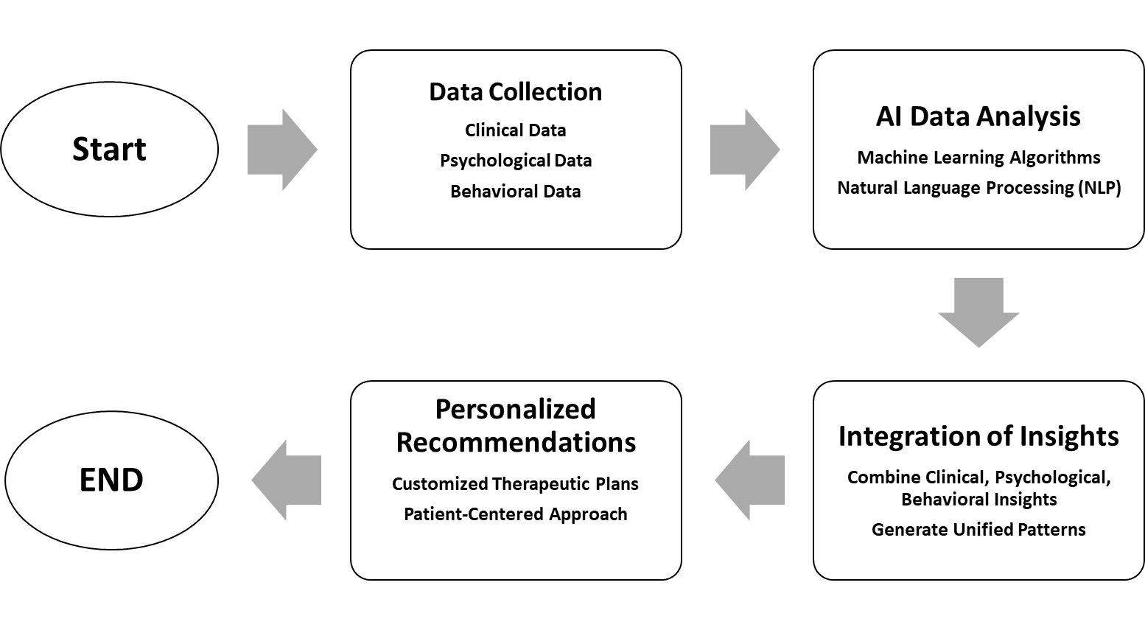
METHODOLOGY
3.1Study Design
This study adopts a multidisciplinary methodology to develop an AI-driven therapeutic recommendation system made for breast cancer patients. The proposed system to cover up gaps in oncology care by integrating biological, psychological, and behavioral data to provide a comprehensive and personalized approach. By making sure the holistic needs of patients, the study revolves around advance therapeutic strategies that prioritize both clinical precision and emotional well being, ensuring enhanced care outcomes.
- Workflow diagram showing key system stages, from data collection to recommendation generation.

3.2 Data Collection
The proposed system relies on a conceptual framework that uses hypothetical data derived from electronic health records (EHRs). These records are envisioned to integrate a wide array of clinical, psychological, and behavioral information, offering a holistic view of patient profiles. Clinical data includes diagnostic histories, therapeutic regimens, and comorbid conditions, providing essential insights into medical factors. Simultaneously, psychological assessments capture critical indicators such as anxiety, depression levels, and emotional resilience, which directly influence treatment adherence. Behavioral data, including self-
reported adherence patterns, lifestyle habits, and daily routines, fills the dataset, ensuring a comprehensive approach to understanding patient needs and optimizing therapeutic recommendations.
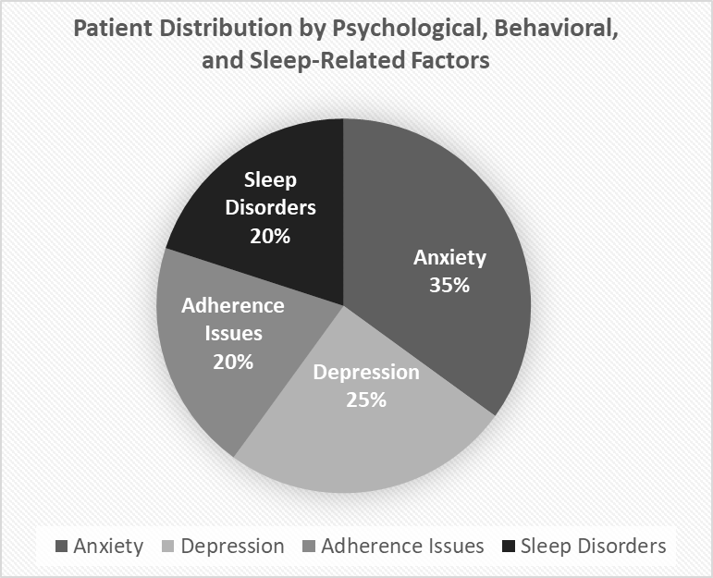
- Hypothetical patient distribution by psychological, behavioral, and sleep-related factors.
3.3 Data Analysis
The suggested methodology leverages advanced machine learning algorithms, with a specific focus on deep learning techniques, to process and analyze multi dimensional patient data. Natural language processing (NLP) plays a central role in extracting meaningful insights from unorganized data, such as psychological assessments and behavioral patterns, which are critical in understanding treatment adherence. By mixing these techniques, the system focus on deliver highly personalized therapeutic recommendations that align with each patient's unique medical and emotional profile. This approach not only enhances predictive accuracy but also supports real time adaptation to improve patient needs, ensuring continuous idealizing of care.

3.4 Integration of Psychological and Behavioral Factors
The system’s idea seeks to easily integrate psychological and behavioral data alongside clinical insights to create personalized therapeutic recommendations uniquely suited to each patient’s context. By incorporating factors such as emotional resilience, adherence patterns, and lifestyle habits, the system ensures that treatment plans are comprehensive and patient centric. This holistic approach not only solving the problem of medical complexities of cancer care but also make sure that the psychological and behavioral dimensions, fostering improved adherence and enhanced overall results.

3.5 Validation and Testing
The validation of the proposed system is centered on simulated case studies representing various patient profiles. These scenarios include early-stage breast cancer patients experiencing psychological challenges, such as anxiety, and advanced-stage patients managing co morbidities like diabetes. By analyzing these cases, the system's ability to align with established clinical guidelines while effectively treatment patient centered considerations is thoroughly assessed. This approach ensures that therapeutic recommendations are both medically sound and especially made to the unique emotional and physiological needs of each patient, demonstrating the system's adaptability and practical applicability.

CASE STUDIES
4.1 Improving Breast Cancer Treatment Using Artificial Intelligence
The first case study focuses on leveraging AI to suggest personalized treatment recommendations for a breast cancer patient diagnosed with early-stage invasive cancer. After reviewing the patient's information, it was found that she suffered from anxiety, which would significantly and directly impact her adherence to treatment guidelines. The AI ​​system would then integrate data from the patient's medical records, behavioral patterns, and psychological assessments, using a multidisciplinary approach, as proposed by Sugiyama et al. [3].
Based on the analysis performed by the proposed AI-based system, the system will propose a treatment plan that combines targeted hormone therapy and cognitive behavioral intervention. This treatment plan is specifically designed to address the anxiety factor. Including psychological support not only improves adherence to treatment but also enhances treatment outcomes, while simultaneously taking into account all clinical and emotional aspects of patient care.

4.2Managing diseases associated with advanced breast cancer
This case study illustrates what AI can do to manage advanced breast cancer, which is inevitably complicated by diabetes. Traditional treatment plans often ignore the balance of cancer treatments and the stability of a patient's metabolism, increasing the likelihood of suboptimal outcomes. Therefore, the use of the comprehensive analytical capabilities described by Liu et al. [13] Important. The proposed AI system collects all diverse patient data, including metabolic features and drug history, to develop treatment strategies specifically designed to work more effectively.
The system proposes an unconventional approach to chemotherapy, strategically reducing factors that may exacerbate high blood sugar, supported by diets tailored to the patient's metabolic needs. This integrated approach marks a turning point in AI-based aspirations to improve cancer treatment journey, reduce risk, and ensure comprehensive and integrated patient care.

DISCUSSION
The integration of artificial intelligence into personalized cancer care introduces a paradigm shift in how treatment decisions are made, emphasizing the need for a more holistic and patient-centered approach. The discussion section explores the broader implications, challenges, and future prospects associated with the proposed system.

5.1Implications of AI-Driven Personalization
The proposed system represents a groundbreaking advancement in oncology care through its seamless integration of psychological and behavioral insights with clinical data. By addressing patient-specific factors such as anxiety, adherence patterns, and lifestyle habits, the system not only optimizes therapeutic effectiveness but also establishes a more compassionate and human-centered approach to cancer care. This aligns with a growing body of research emphasizing the pivotal role of emotional well-being in shaping treatment outcomes [5].
Moreover, the system’s personalized recommendations empower both clinicians and patients in transformative ways. For clinicians, it provides actionable, data-driven insights that refine decision-making processes, ensuring therapies are both evidence-based and patient-aligned. For patients, the system delivers tailored interventions designed to meet their unique medical and emotional needs, promoting better adherence and enhanced satisfaction with care [7]. Such an integrated approach minimizes unnecessary interventions and directly supports global initiatives advocating for sustainable, equitable, and high-quality healthcare practices [6].

Table 2: Summary of Therapeutic Recommendations Tailored to Patient-Specific Factors.
Category | Recommendation | Goal
Psychological Factors | Cognitive Behavioral Therapy (CBT) | Reduce anxiety, improve focus
Behavioral Factors | Lifestyle Interventions | Enhance treatment adherence
Clinical Considerations | Adjusted Chemotherapy Regimens | Align with patient conditions

5.2 Challenges in Implementation
Despite the immense promise of AI-driven therapeutic systems, their successful implementation faces several critical challenges:
- Data Integration: Fragmentation within electronic health records continues to pose a significant barrier to seamless data analysis and decision-making. As highlighted by Sugiyama et al. [3], robust data harmonization frameworks are essential to bridge interdisciplinary gaps and enable comprehensive patient care.
- Ethical Considerations: Data privacy and algorithmic biases remain pivotal challenges that demand careful attention. Transparent governance models and regular auditing processes are necessary to build trust among stakeholders and ensure ethical deployment [8].
- Healthcare Disparities: Limited access to cutting-edge AI technologies in resource-constrained settings risks exacerbating existing inequities in healthcare delivery. Addressing this disparity requires collaborative strategies focused on democratizing access and promoting equitable distribution of AI-driven innovations [4].

5.3Future Prospects
Looking ahead, the proposed system sets the stage for a more collaborative and adaptive healthcare ecosystem. Incorporating emerging technologies such as natural language processing and advanced predictive analytics can further enhance the system's capabilities [9]. Additionally, fostering partnerships between technology developers and healthcare providers is essential to bridge the gap between innovation and practical application [13].
The discussion underscores the transformative potential of integrating AI into cancer care while highlighting the need for thoughtful implementation strategies to maximize benefits and ensure equitable access.

CONCLUSION
This research puts the lights on the transformative role of artificial intelligence in reshaping personalized breast cancer care. By easily integrating clinical insights with psychological and behavioral data, the suggested system offers a holistic and innovative approach to therapeutic recommendations that take a different track from conventional practices. This integration enhances treatment effectiveness and aligns healthcare strategies more closely with patient specific needs, representing a significant milestone in precision medicine.
The practical applications of this system are shown through case studies, which highlight its capacity to improve therapy for patients with complex medical and psychological profiles. For example, fixing anxiety in early stage breast cancer patients or make a special treatment plans for those with co -morbidities, such as diabetes, reflects the system's adaptability and effectiveness.
Nonetheless, if we need the process in progress of such advanced systems, it is not going to work without challenges. Key barriers include data integration complexities, ethical considerations surrounding AI usage, and disparities in access to healthcare technology. Overcoming these challenges is important to ensuring equitable, sustainable, and widespread adoption of AI-driven solutions in clinical practice.
Looking ahead, this research confirms the necessity of fostering interdisciplinary collaborations among technology developers, healthcare professionals, and policymakers. By prioritizing patient centered designs and leveraging advancements in AI, the healthcare sector has the opportunity to redefine its approach to personalized medicine, in the end enhancing the quality of life for countless patients worldwide.

ACKNOWLEDGEMENT
We extend our heartfelt gratitude to Zarqa University for their continuous support and encouragement throughout this research. We also deeply appreciate Abu Dhabi University for providing us with the opportunity to share our ideas and contribute to the academic community.

References

[1] K. V. Ramani, H. Ramani, S. S. Alurkar, B. S. Ajaikumar, and R. G. Trivedi, "Breast Cancer: Medical Treatment, Side Effects, and Complementary Therapies," Momentum Press, New York, 2017.
[2] H.-S. You, C.-X. Gao, H.-B. Wang, S.-S. Luo, S.-Y. Chen, Y.-L. Dong, J. Lyu, and T. Tian, "Concordance of Treatment Recommendations for Metastatic Non-Small-Cell Lung Cancer Between Watson for Oncology System and Medical Team," Cancer Management and Research, vol. 16, pp. 1947–1958, 2020.
[3] A. Sugiyama, H. Okumiya, K. Fujimoto, K. Utsunomiya, Y. Shimomura, M. Sanuki, K. Kume, T. Yano, R. Kagawa, and H. Bando, "Integrated Electronic Health Record of Multidisciplinary Professionals Throughout the Cancer Care Pathway: A Pilot Study Exploring Patient-Centered Information in Breast Cancer Patients," Journal of Multidisciplinary Healthcare, vol. 17, pp. 2069–2081, 2024.
[4] Á. Periáñez, A. F. Del Río, I. Nazarov, E. Jané, M. Hassan, A. Rastogi, and D. Tang, "The Digital Transformation in Health: How AI Can Improve the Performance of Health Systems," Health Systems & Reform, vol. 10, no. 2, article 2387138, pp. 1-15, 2024.
[5] E. Farina, J. J. Nabhen, M. I. Dacoregio, F. Batalini, and F. Y. Moraes, "An Overview of Artificial Intelligence in Oncology," Future Science OA, vol. 8, no. 4, article FSO787, pp. 1-12, 2022.
[6] J. S. Roppelt, A. Jenkins, D. K. Kanbach, S. Kraus, and P. Jones, "Effective Adoption of Artificial Intelligence in Healthcare: A Multiple Case Study," Journal of Decision Systems, vol. 34, no. 1, article 2458883, pp. 1-18, 2025.
[7] S. L. Ackerman, "Promising Precision Medicine: How Patients, Clinicians, and Caregivers Work to Realize the Potential of Genomics-Informed Cancer Care," New Genetics and Society, vol. 41, no. 3, pp. 196-215, 2022.
[8] F. Lysen and S. Wyatt, "Refusing Participation: Hesitations about Designing Responsible Patient Engagement with Artificial Intelligence in Healthcare," Journal of Responsible Innovation, vol. 11, no. 1, article 2300161, pp. 1–15, 2024.
[9] A. Chadwick, A. Frazier, T. W. Khan, and E. Young, "Understanding the Psychological, Physiological, and Genetic Factors Affecting Precision Pain Medicine: A Narrative Review," Journal of Pain Research, vol. 14, pp. 3145–3161, 2021.
[10] L. Zhianfar, H. Nadrian, and A. Shaghaghi, "Enhancement of Adherence to Therapeutic and Lifestyle Recommendations Among Hemodialysis Patients: An Umbrella Review of Interventional Strategies," Therapeutics and Clinical Risk Management, vol. 16, pp. 233–243, 2020.
[11] D. Paulson, N. James, and D. Brush, "Quality of Life Enhancement Research Program: Lessons Learned," Journal of Gerontological Social Work, vol. 62, no. 4, pp. 392–398, 2019.
[12] D. Marti, A. Budathoki, Y. Ding, G. Lucas, and D. Nelson, "How Does Acknowledging Users' Preferences Impact AI's Ability to Make Conflicting Recommendations?" International Journal of Human-Computer Interaction, published online: Nov. 22, 2024.
[13] C. Liu, X. Liu, F. Wu, M. Xie, Y. Feng, and C. Hu, "Using Artificial Intelligence (Watson for Oncology) for Treatment Recommendations Amongst Chinese Patients with Lung Cancer: Feasibility Study," Journal of Medical Internet Research, vol. 20, no. 9, article e11087, 2018.

