Intelligent Android Malware Detection in Real-World Environments Using Machine and Deep Learning Model

Adnan Al-Smadi^{1,2}  College of Information Technology  ¹Zarqa University  ²Yarmouk University  Jordan  a.alsmadi@zu.edu.jo | Haya Al-Hadramy  College of Information Technology  Al alBayet University,  Mafraq, Jordan  haya_ahmad_87@yahoo.com | Ghadeer Sulieman  College of Information Technology  Al al-Bayt University,  Mafraq, Jordan  2220901006@st.aabu.edu.jo

Abstract— The paper develops an algorithm to detect the Android malware. The algorithm implements several models of machine and deep learning. The proposed method uses TUANDROMD dataset to develop and assess these models. Six models were implemented; namely, Gradient Boosting (GB), Random Forest (RF), Support Vector Machine (SVM), XGBoost (XGB), Multi-Layer Perceptron (MLP), and a Custom Deep Learning (CDL) model developed in PyTorch. The Random Forest classifier has the highest performance, with an AUC of 1.00 indicating that the algorithm is able to accurately classify samples with almost no errors, while the other models demonstrated strong predictive capabilities. In addition, the ROC curve indicates excellent performance in distinguishing between malicious and safe applications. These results give a good indication that machine learning and deep learning are robust in detecting malware. This work subscribes in the development of reliable, data-driven security solutions capable of addressing the evolving challenges in mobile threat detection.
Keywords— Android malware, machine learning, malware detection, Mobile security, deep learning, TUANDROMD dataset, cybersecurity

Introduction
Nowadays, almost everyone frequently utilizes the internet [1]. This dependence arises from the reality that without the internet, relationships with others such as online banking, health-related transactions, and marketing would be practically impossible. As the internet has rapidly expanded, criminals have begun to increasingly commit crimes online rather than offline. Hackers had accessed about one billion user accounts in 2013 [2]. In 2014, more than 145 million eBay accounts were accessed by hackers; this is just the beginning of the attacks. As the years pass, this trend continues to rise. One hundred forty-three million Equifax customers' personal information was compromised in 2017 [3]. Cybercriminals typically employ malicious software to infiltrate the computers of their victims [4]. Malware is defined as any software that purposely executes mischievous payloads on affected devices such as computers and smart phones. Malware is defined as any software that is designed to cause damage to any system. Malware exist in various forms such as viruses [5]. Each family and type of malware is engineered to create a specific impact on the victim's computer, which may include damaging the targeted system, enabling remote code execution, or compromising sensitive information [6]. The primary concern of security experts is the security risks that compromise data, which encompasses everything from a projector screen to a car remote control to a straightforward conversation between individuals [7]. A data privacy attack exposes the user’s private data. To protect private information from unauthorized users and malicious attacks that seek to breach the network, numerous researchers have explored this field, providing a variety of cyber security systems and inventing various solutions. Malware samples for IoT expanded from 3216 in 2016 to 121588 in 2018, according to 2020 Kaspersky Lab research [8]. Adware, spyware, and other malicious risks are all popular, making privacy and security measures a significant problem that require close monitoring [9]. To remove the file and restore protection, malware detection is a technique for detecting whether malware has appeared on the device or to determine whether the script, or software, was malicious or benign [10] where has no threat on the user or the system. To recognize network cyber-attacks, analysts utilize machine learning and artificial intelligence (AI) approaches [11]. Malware can seriously harm the machine as is widely known [12]. Malware can limit disk space, increase internet usage, cause browser and pop-up extension issues, and more [13]. Since the output is accurate and reliable, machine learning techniques have attracted attention from several kinds of fields. The recognition of malware, especially 0-day malware, or malware that is undetected, is made achievable by the utilization of machine learning approaches that operate on data pertaining to executable operation. Inference is possibly made at the beginning of direct data generation even before the data is transmitted to the recipient's computer Artificial intelligence techniques. These approaches could operate in almost real-time. However, execution time is a crucial consideration because they are limited by memory availability and processing power constraints. These factors make it significant to identify which solutions are particularly appropriate for use with edge computing devices before developing Edge AI solutions that accurately record hazardous situations and maintain complexity and execution time limitations minimally. In the perspective of such solutions, extracting the calls made by individual executables to Application Programming Interfaces (APIs) could be a compromise. This makes it possible to evaluate the behavior in summary form and determine if the software is malicious or good ware utilizing machine learning analysis [14].

LITERATURE REVIEW

Ali et al. [15] conducted n-grams algorithm to utilize the detection of malware. They used “dynamic analysis technique to extract an Indicator of Compromise (IOC) for malicious files, which are represented using N-grams” [15]. This preprocessing using a Logistic Regression classifier achieved an accuracy of 98.4%. This was the best performance compared with other classifiers used.
Kumar et al. [16] clustered the dataset entries by employing Trend Micro Locality Sensitive Hashing (TLSH) metrics and clustering techniques based on the anomaly detection method. Following the development of feature extraction and feature selection methods, the initial dataset was divided and prepared to enter the training stage. they developed several malware detection classifiers using the Python scikit-learn module. Furthermore, the authors created a dataset specifically to test their method which included malicious and benign software. This dataset is one of the primary components of their study. They found that it was possible to reduce the training time of machine learning algorithms while maintaining the quality of predictions.
Nandagopal et al. [17] employ heuristic decomposition techniques using n-grams. The authors have selected several classifiers such as Random Forest and Random Tree. The data consisted of three thousand files from the non-malware category and three hundred and one malware files from various categories. Among the classifiers, the best one was the RF classifier. Ndibanje et al. [18] developed a machine learning technique to indicate malware. Serpanos et al. [19] proposed a procedure to indicate malware that is adaptable, modular, and has a web interface.
Kim [20] proposed a malware risk index to identify malware and estimate its probability occurrence. A comprehensive review of malware detection in mobiles was done by Alswaina et al. [21]. The literature was divided into features, techniques, and analysis. A method to improve Android malware detection was proposed by Abuthawabeh and Mahmoud [22].
Multiple approaches have been applied to various datasets and under different conditions. Therefore, it is a challenge to make decisive conclusions regarding the most effective strategies for this type of issue.

METHODOLOGY

Dataset Description
A specific dataset created to address the lack of high-quality Android malware datasets, TUANDROMD (Tezpur University Android Malware Dataset) acts as the primary basis for this study. According to the study, 1,000 safe apps from the Google Play Store were collected, along with 24,553 malware samples that were divided into 135 variations across 71 different families for Android Malware Detection in the Wild. The dataset comprises both benign and malicious Android applications collected from real-world environments between 2013 and 2019. Every sample contains comprehensive characteristics, including:
- Permissions
- API calls
- Intent filters
- Activities and services
- Content providers
- File sizes and entropy levels
The CSV file (TUANDROMD.csv) contains a labeled set of these extracted features, where the final label distinguishes between benign (0) and malicious (1) apps. This makes the dataset highly suitable for supervised learning approaches in malware classification tasks. The applications' diverse and real backgrounds guarantee that models developed using this dataset are robust and generalizable to a broad spectrum of Android threats.

Methodology
This study is based on a thorough, multi-stage research methodology that develops and rigorously evaluates machine learning models for a successful detection of Android malware. The first step in this systematic process is the data preparation phase which uses the unique TUANDROMD dataset. The dataset has extensive preprocessing to ensure its quality and integrity. These processes go through meticulous data cleaning, systematically removing rows that lacked valid or logical values to ensure analytical quality. After that, feature transformation was implemented, during which specific attributes were changed into appropriate numerical formats. These attributes include time-related data. Then, a comprehensive feature engineering step with informative features were derived. To improve model performance and reduce bias, the ADASYN (Adaptive Synthetic) sampling technique was used to provide new data for the minority class. This step was crucial in addressing the underlying class imbalance. To normalize the range of numerical attributes, the MinMaxScaler technique was used. This step enhances the model's sensitivity.
The second phase is to systematically partition the available data into training and a testing sets. This partition was made on a percentage bases which was 20% for testing and 80% for training.
The training set used the diverse group of powerful machine learning algorithms. These algorithms are GB, RF, SVM, XGB, MLP, and CDL model developed in PyTorch. To evaluate each model's efficacy, the unseen testing dataset was used to calculate a battery of performance metrics. This set of measures considers comprehensive Classification Report which includes precision (Pr), accuracy (Ac), F1-score (F1), and recall (Rc). It also includes a Confusion Matrix to systematically monitor cType I and Type II errors. Furthermore, the Receiver Operating Characteristic (ROC) curve and AUC-ROC were analyzed to evaluate each model's discriminative power. Here, validation procedures utilized to ensure the robustness of the results and to detect any signs of excessive fitting. Figure 1 shows the flowchart.

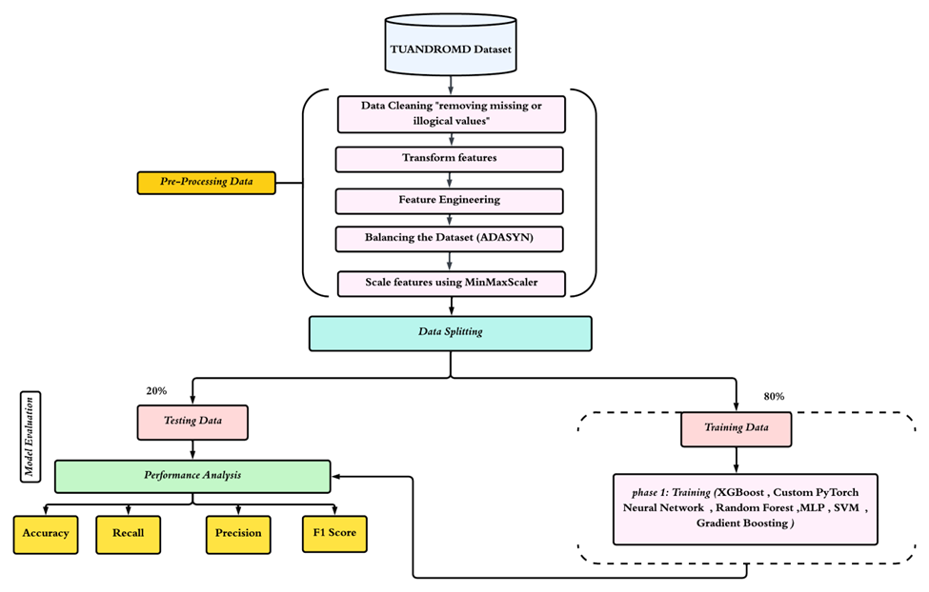

Fig. 1: methodology Flowchart

Methodology Steps for Flowchart

- Data Acquisition
  - Load the TUANDROMD dataset.
- Data Preprocessing
  - Clean data by removing missing or illogical values.
  - Transform features (e.g., convert time to numerical).
  - Perform feature engineering (e.g., derive new features, calculate delta features and standard deviations).
  - Balance data using ADASYN technique.
  - Scale features using MinMaxScaler.
- Data Splitting
  - Training (80%) and testing (20%).
- Model Training
  - Train several classifiers on the prepared training data sets.
  - Algorithms:
    - MLPC
    - Custom PyTorch Neural Network
    - RF
    - GB
    - XGB
    - SVM
- Performance Evaluation
  - Use the testing set to generate predictions.
  - Calculate key metrics: includes Pr, Ac, F1, and Rc.
  - Generate a Confusion Matrix.
  - Analyze the ROC curve and AUC-ROC.
  - Employ cross-validation to test model stability.

RESULTS
The detection process was performed through several steps. The first step was the data-processing and data-segmentation process. The second step was the data training. This step was assessing the performance of each algorithm to ensure the accuracy in a simulated real-world environment. The data was trained to detect malware, classifying it into (1) malicious applications and (0) benign applications. Six algorithms were implemented, including five machine learning algorithms (RF, SVM, MLP, Gradient Boosting, and XGBoost) and one deep learning algorithm (MLP - PyTorch). Confusion matrices were used to construct the performance metrics: Ac, Pr, Rc, and the F1. These metrics were applied in the study to evaluate the classification results. Table 1 shows the results of these algorithms.

Based on the results, all model algorithms achieved very high performance and were close to each other across all performance metrics used, demonstrating the models' ability to generalize and accurately detect malware.
Figure 2 represents ROC curve for the RF algorithm. It shows the relationship between the right and the wrong rates at different thresholds. This curve is an important tool for assessing a model's discriminative ability, as a curve approaching the upper left corner indicates excellent performance in distinguishing between malicious and safe applications. According to the curve in Figure 2, the AUC is equal to 1.00, indicating the algorithm's ability to accurately classify samples with almost no errors in this context. This excellent performance reflects the quality of the data pre-preparation and the algorithm's ability to recognize the distinctive behavioral patterns of malware within the dataset used.

TABLE 1. The results of the algorithms.
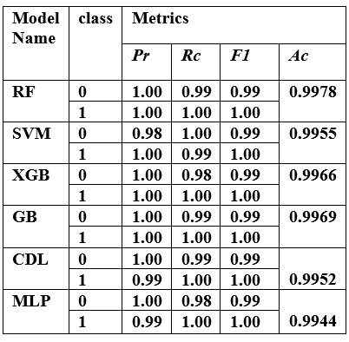

CONCLUSION
In this paper, we implemented machine and deep learning algorithm to detect the Android malware. The method used the TUANDROMD dataset to develop and assess the proposed detection models. The methodology uses six models as described above. The RF classifier has the best performance, with an AUC of 1.00 indicating that the algorithm is able to accurately classify samples with almost no errors, while the other models demonstrated strong predictive capabilities. In addition, the ROC curve indicates excellent performance in distinguishing between malicious and safe applications.

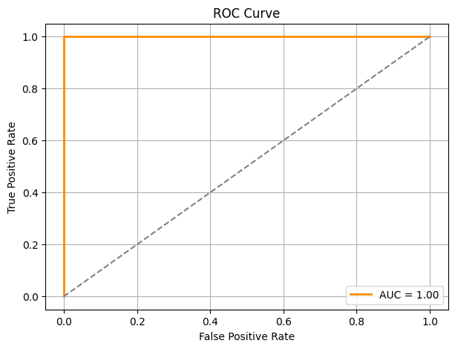
Fig. 2. Receiver Operating Characteristic (ROC) curve for
Random Forest algorithm.

Acknowledgment
“This research is funded partially by Zarqa University-Jordan”

REFERENCES

- Venton Cerf, “The Internet Is for Everyone,” Chapter: The Cambridge Handbook of Cyber Behavior , pp. 5 – 8, Cambridge University Press, 2024.
- Albanese, M., Battista, E., & Jajodia, S., “Deceiving attackers by creating a virtual attack surface,” Cyber Deception: Building the Scientific Foundation. Cham: Springer International Publishing., pp. 167-199, 2016.
- Kouicem, D. E., Bouabdallah, A., & Lakhlef, H., “Internet of things security: A top-down survey,” Computer Networks, 141, 199-221, 2018.
- Choi, K. S., Lee, C. S., & Merizalde, J., “Spreading viruses and malicious codes.,” Handbook on Crime and Technology. Edward Elgar Publishing, pp. 232-250, 2023.
- Triantafyllou, G. P., “Malware analysis,” Master's thesis, Πανεπιστήμιο Πειραιώς, 2024.
- Gunavathi, R., & Bharathi, K. M., “Cybercrimes in the Associated World,” Artificial Intelligence for Cyber Defense and Smart Policing. Chapman and Hall/CRC, pp. 21-31, 2024.
- Ahmadi, S.,”Beyond firewalls: The future of cybersecurity research,” Computer Science and Engineering Research, 2(01), 01-02, 2025‏.
- Saeed, M. A. H., “Malware in computer systems: Problems and solutions,” International Journal on Informatics for Development, 9(1), 1-8, 2020.
- Habeeb, M. A., & Khaleel, Y. L., “ Enhanced Android Malware Detection through Artificial Neural Networks Technique,” Mesopotamian Journal of CyberSecurity, 5(1), 62-77, 2025.
- Berrios, S., Leiva, D., Olivares, B., Allende-Cid, H., & Hermosilla, P., “Systematic Review: Malware Detection and Classification in Cybersecurity,” Applied Sciences, 15(14), 7747, 2025.
- He, Y.,” Preliminary Application of Artificial Intelligence Systems in Computer Science and Technology,” Journal of Theory and Practice of Engineering Science, 5(7), 21-25, 2025.
- Chen, G., Computer Network and Information Security System Establishment and Technical Research. International Journal of Management Science Research, 8(7), 11-16, 2025.‏
- Akhtar, M. S., & Feng, T., “ Malware analysis and detection using machine learning algorithms,” Symmetry, 14(11), 2304, 2022.
- Harahsheh, H., Shraideh, M., & Sharaeh, S., “Performance of malware detection classifier using genetic programming in feature selection,” Informatica, 45(4)., 2025.
- Ali, M., Shiaeles, S., Bendiab, G., & Ghita, B., “MALGRA: Machine learning and N-gram malware feature extraction and detection system,” Electronics, 9(11), 1777, 2020.
- Kumar, R., Sethi, K., Prajapati, N., Rout, R. R., & Bera, P., “Machine learning based malware detection in cloud environment using clustering approach,” 11th International Conference on Computing, Communication and Networking Technologies (ICCCNT), pp. 1-7., 2020.
- Nandagopal, U., & Thirumalaivelu, S., “Classification of Malware with MIST and N-Gram Features Using Machine Learning,” International Journal of Intelligent Engineering & Systems, 14(2), 2021.
- Ndibanje, B., Kim, K. H., Kang, Y. J., Kim, H. H., Kim, T. Y., & Lee, H. J., “Cross-method-based analysis and classification of malicious behavior by api calls extraction,” Applied Sciences, 9(2), 239, 2019.‏
- Serpanos, D., Michalopoulos, P., Xenos, G., & Ieronymakis, V., “Sisyfos: A modular and extendable open malware analysis platform,” Applied Sciences, 11(7), 2980, 2021.‏
- Kim, D., “Decision-making method for estimating malware risk index,” Applied Sciences, 9(22), 4943., 2019.
- Alswaina, F., & Elleithy, K., “Android malware family classification and analysis: Current status and future directions” Electronics, 9(6), 942, 2020.
- Mohammad Kamel Abuthawabeh and Khaled Mahmoud, "Enhanced Android Malware Detection and Family Classification, using Conversation-level Network", The International Arab Journal of Information Technology (IAJIT) ,17(4A), 29 – 36, 2020.

