Temporal and Spatial Analysis of Operational Disruptions in Indian Railways: a Data-Driven Framework

Tushar Sultania
Department of CSE (IOT)
Institute of Engineering and Management, Kolkata, India
sultaniatushar@gmail.com
Mohamed Hafez
Faculty of Engineering FEQS, INTI International University, Nilai, Malaysia mohdahmed.hafez@newinti.edu.my
Sanchita Ghosh
Department of CSE (IOT)
Institute of Engineering and Management, Kolkata, India
sanchita.ghosh@iem.edu.in
Aditya Singh
Department of ECE
Central University of Karnataka, Kalaburagi, India
adityasingh@gmail.com
Amritesh Ojha
Department of ECE,
National Institute of Technology,
Patna, India
amritesho.phd19.ec@nitp.ac.in
Bharat Gupta
Department of ECE,
National Institute of Technology,
Patna, India
bharat@nitp.ac.in
Ayman Amer
Faculty of Engineering, Zarqa Univeristy, Jordan
Aamer@zu.edu.jo
Rahul Deo
Department of ECE,
National Institute of Technology,
Patna, India
rahuld.phd23.ec@nitp.ac.in

Chinmay Chakraborty*
COIR - Medical Technology
KIIT, Bhubneswar, India
drhinmayc@ieee.org

Abstract— This study presents a data-driven framework for analyzing the temporal and spatial patterns of operational disruptions in Indian Railways, with a focus on Alarm Chain Pulling (ACP) incidents. Using a dataset of 20,000 ACP records, events were categorized into two categories of occurrences which are “On Station” and “Out of Station”. The proposed framework combines statistical trend analysis and spatial visualization through a Power BI dashboard to identify key temporal patterns and highlight high-risk zones and vulnerable train numbers. It also compares frequencies of ACP incidence between goods trains and passenger trains. The framework demonstrates how data analytics enhance railway safety operational efficiency and cost effectiveness. Our proposed analysis framework offers a valuable insight as well as propose a way to achieve minimum operational disruptions and optimize resource allocation across the Indian Railways network resulting in improving transportation services significantly, which helps in achieving accessible transportation.
Keywords: —Delays, Data model, temporal, Spatial, Railways, ACP, operational disruption, resource allocation, Rail transportation

Introduction
Indian Railways, run by the Ministry of Railways Government of India, is the second largest railway network in the world and plays an important role in India’s transport system with more than 67,000 routes and with a total track length of over 1,26,000 km. It connects more than 7300 railway stations across India, which include the urban and rural areas, and is a major part of how people and goods move around the country [1]. Every day in India, more than 22,000 trains operate and carry over 23 million passengers and nearly 3 million tonnes of goods. It also has one of the biggest employers in the world, with over 12 lakh employees [2].

*Corresponding Author
It helps in connecting cities, supporting trade, growing tourism, and improving the economy of the country. In recent years, Indian Railways has been working on a new plan for the betterment of the country by adding high-speed routes like the Vande Bharat train, reconstruct the old stations, also replacing the diesel engines by electric engines (over 80% of the routes are electrified), and using digital tools to make services more modern, smooth, and eco-friendly [3].
Alarm Chain Pulling (ACP), facility to equip commuters to stop the train during emergencies in Indian railway is facility but widely misused by passengers. Due to misuse trains get delayed and consequently causes delay in freight trains. [4]. Earlier, Indian Railways used to have the ACP data unstructured because the logs and reports were spread out and unorganized. But due to technological intervention such as use of data analytics tools, it has become easier to analyse and get deeper insights [5] [6].
In this work we propose study new way to look into this issue through the ACP incidents data. The process includes cleaning raw data, finding different types of underlined issues, sub-dividing the ACP events on the basis of where it occurred (at a station or between stations), and its impact on both passenger and freight trains.
The contributions of our proposed work are:
1) Temporal and Spatial Analysis of operational disruption data of railways in the Indian context.
2) Data driven framework: Proposed a data driven framework to get deep insights.
3) Interactive dashboard: cost effective way for enhancing railway safety and operational efficiency in real-time through insights from data analytics
This paper is structured in the following manner. Section II of this paper discusses the related work. Section III provides a description of the datasets, methodology and proposed framework. The results and insights have been discussed in section IV. In conclusion, Section V serves as the final segment of the paper.

Related Work
Indian Railways has been studied for its many data analyses, like operational efficiency, delay management, and the use of data analysis to improve decision-making. However, there is very little research that specifically focuses on Alarm Chain Pulling (ACP) incidents and their systemic impact using modern analytics tools.
Some government reports and the Ministry of Railways' annual reports provide valuable facts on how extensive the railway network is, how it operates, and typical issues it encounters - such as the abuse of ACP [1]. These documents contain valuable data but do not provide the analytical depth needed to turn raw ACP data into useful information.
ACP is known as a life-saving device that allows passengers to stop a train in real emergencies. But it's mostly used for unauthorized deboarding or boarding. Due to this, there are unscheduled stops, train delays, customer irritation, fuel loss, and secondary impacts on freight services using the same corridors. As an example, Central Railway compiled 666 ACP activations in 20 days across both passenger and freight services resulting in 463 fines and unknown delays. The scale and enterprise constraints for this operational abuse are staggering [7].
To solve these issues, several technological solutions have been investigated or tried to solve the problem [8] suggested an IoT- based emergency signalling system that changes physical chain pulls with digital notifications so only authenticated emergencies cause trains to stop. Globally, the MOBILIZE project suggests a multi-sensor safety system, which is able to identify behavioural misuse, sabotage, and environmental deviations in large railway systems in real time, preventing disruptions before any effects emerge [9].
Similarly, different studies investigate how alarm overloading and fault/failure propagation can impact a mission with critical operations. In industrial processes, Authors in [10] suggest a deep-learning–based alarm root-cause analyzer with self-attention BiLSTM-CNN to group alarm sequences, which is used for quick detection of principal fault events in high-alarm rates. Likewise [11] applied Hidden Markov Models to represent alarm signal evolution and detect underlying fault reasons - techniques closely applicable to analyzing unstructured ACP fault and detecting misuse patterns.
Fault detection and delay modeling in rail networks have also been advanced by machine learning (ML). [12] introduced this data augmentation-based deep learning diagnostic approach for identifying signal equipment faults under limited sources of data with the goal of improving the accuracy of predictive models that seek to use data to enhance the timing of pre-emptive maintenance.
A zero-shot Markov delay model has been created in [13] to forecast train delays in extensive networks without labelled training examples, successfully modelling delay propagation - transferable to measuring downstream consequences of ACP abuse.
In [14] authors highlight the importance of data driven framework in complex system. [15] emphasised that the real-time signal reliability and efficiency challenges are critical for resilient and sustainable transportation infrastructure. To enhance predictive maintenance and operational reliabilities real time fault detection data is required [16]. To mitigate operational disruption in transportation system there will be requirement for secure, efficient and resilient communication protocols to handle dynamic and complex transportation system like railways [17].
In spite of a very large quantity of resources, only a few studies have properly put together human behaviour, emergency misuse patterns, and system-level analytics in a combined framework, particularly in ACP in Indian Railways. Most of the literature based on technical faults, delay modelling, or system architecture has not touched upon behavioural misuse of emergency systems (ACP), analysed through data segmentation and visualization.
By using Power BI with Python allows us to pull the structured and cleaned data has allowed for processing and possibly creating a new framework for decision support systems in Indian railways. This study is different from previous experiences of empirical review, which only focused on the manual audit of decisions and the audit of post-incident summaries, because we provide a near real-time framework to assist railway authorities in visualizing, interpreting, and responding to positive and negative trends associated with ACP events.
This study has operationalized an end-to-end analytics pipeline to develop a decision-support framework for Indian Railways so that planning of resources, predictive scheduling, enforcement planning, and passenger awareness can be synthesized into behavioural and operational intelligence not reported or described in peer-reviewed academic media.

Methodology and proposed framework

Dataset description
The dataset used in this study includes alarm chain pulling (ACP) failure records sourced from Indian Railways. It contains over 20,000 rows that have real-time operational disruptions. Each row represents a unique failure and has a mix of structured and unstructured data related to train operations, geographical information, and have details about the operational disruptions. The following key fields were extracted and examined:
- Failure Time and Date: This shows the exact date and time when the ACP incident occurred. This allows for monthly and hourly pattern analysis.
- Zone, Division, and Station (Location): These help to identify the geographical area, which helps to locate where incidents/failures happen.
- Train Number and Train Type: It helps to specify the train types(passenger or goods) that were affected by ACP actions, allowing for specific train analysis.
- Failure Description: A text field that often contains valuable hidden information, such as train numbers, failure causes, and failure type.
- Delay Metrics: This field includes the details like the number of times passenger and goods trains are delayed and their average detention time, which help measure the operational impact of ACP.

Data Preprocessing
To prepare the dataset for visualization and analysis, extensive pre-processing was carried out with Python’s pandas, re, and datetime libraries:
- Datetime Parsing: The ‘Failure Time’ column was standardized using pandas and then, with the help of Power BI, we perform accurate grouping by hour, day, and month.
- Train Number Extraction: Since train numbers were within descriptive text in the failure description column, regular expressions (re.search) were used to extract 4-to-6 digit numbers, which were then cleaned and categorized.
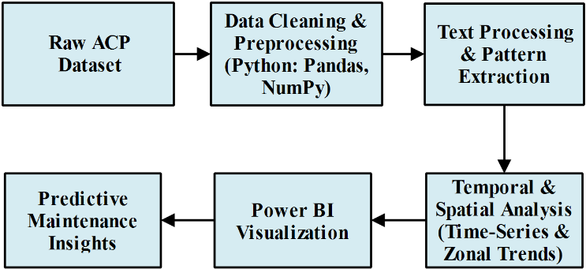
- Location Classification: Based on naming patterns, locations were classified as “On Station” or “Out of Station”. Station codes (e.g., “MGS”, “DNR”) were marked as “On Station” while full section names or undefined labels were marked as “Out of Station”.

Fig.1. Block diagram of proposed data driven framework

Data Cleaning and Standardization:
The raw data usually contains inconsistent headers, missing data, and data that is not in the same format. We used pandas to rename columns that have ambiguous names to enable easier understanding. Rename headers that contained unclear names to make it easier to read. Removed extraneous entries or blanks from the raw data, especially in date/time and failure categories

Failure Type Classification:
Unstructured text fields such as “Failure Description” or “Failure/Obstruction” were handled using pattern recognition and regular expressions.

Train Number Extraction:
As train numbers were presented in an inconsistent format within the description text, Python regex was employed to capture 4 to 6-digit numerical patterns following terms such as Train No. or Train Number. Location Categorization (Station vs Out-of-Station):

Time-Series and Hourly Analysis:
We combined the ACP incidents data in the following categories: A 24-hour hourly data format was taken to find high-risk operational times. Date and Month to analyse seasonal and weekly changes. This time-based analysis helped spot patterns related to timing and month.

Delay and Impact Assessment:
The impact of each ACP event was assessed by totaling the delay counts for passenger and goods trains.

Interactive Dashboard and visualization:
Before importing datasets into Power BI to create interactive dashboards, we need to do data cleaning. We have considered bar charts, stacked column, time series charts to visualize various aspects of analysed ACP data. To get deep insights, we used python libraries and power BI dashboard to get deep insights.
Figure 1 shows the block diagram of proposed data driven framework.

Results and Insights
After conducting the various case study on ACP using Python and Power BI for data analysis and creating visuals. So, we found several key patterns and important points about when, where, and how often the ACP incident happened.

Location-Based Insights
By conducting the Analysis, we found that ACP incidents happen mainly in two places - “On Station” and “Out of Station.” Around 60% of ACP cases happen at stations, especially at busy stations where trains make scheduled stops.

Temporal Distribution
The distribution of ACP incidents, shown in figure 2, reveals the number of incidents that happen on an hourly basis, which follow the daily trends across the network. Hourly Distribution of ACP Incidents
There are two peak times can be seen from the datasets: 1) AM peak (7:00 AM - 11:00 AM): Incidents start to rise from early morning with a peak that occurs around 9:00 AM. This is when the majority of passengers travel to either their offices or schools, correspondingly, during the office/school hours, resulting in crowded trains, particularly trains in suburban and semi-urban places. 2) PM peak (6:00 PM - 9:00 PM): Another large spike occurs in the evening, with peak occurring around 8:00 PM.
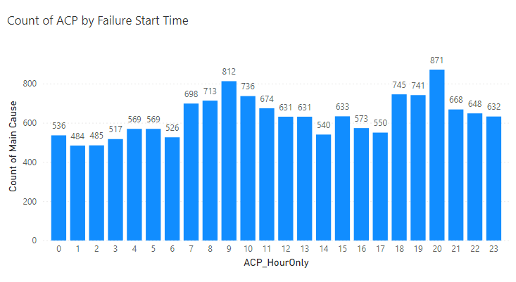
Fig. 2. Hourly distribution of ACP incidents across the dataset
The early morning hour (12:00 AM - 5:00 AM) experiences a very low incidence of ACP, mainly due three reasons: 1) As with the early morning, there are fewer trains run and with lower passenger occupancy. 2) Railway staff and RPF are more alert during the night. 3) lower rush of passengers.
In order to get a better insight into the ACP misuse patterns, we have extracted the data as shown in figure 3 showing the top five specific times in which the ACP incidents happen most often across the whole dataset.
Figure 3 shows that the incidents happen during specific minutes in busy hours which happened during the office and school hours. The identified peak hours in the morning are at 7:35 AM and 9:40 AM. These hours are the morning rush hour.
The incident timestamp and the ACP count were considered and grouped the times and took the monthly data. We filtered the data to discover the top five specific times at
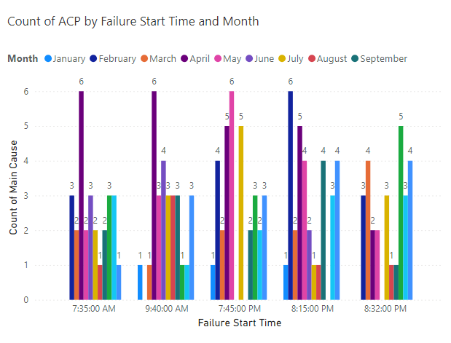Fig. 3. Top five exact time points with highest ACP occurrence
which the most frequent incident happened and charted a bar graph. Overall, both trends (Hourly and high frequency distribution) convey that ACP mostly happens at peak times - or rush hours.
To determine the month with the highest incidence of ACP incidents, we conducted an analysis of ACP trends over time, collecting monthly ACP records. We visualized the data to identify seasonal peaks, thereby facilitating the identification of periods with frequent ACP misuse. Figure 4 shows the total number of ACP incidents for each month. From the graph, it is evident that May exhibits the highest ACP count, followed by April, indicating a seasonal increase in ACP incidents. This rise in May can be attributed to increased travel during summer vacations and local holidays, which generally results in crowded train services. Consequently, there is a higher likelihood of ACP system misuse for unauthorized boarding and de-boarding.
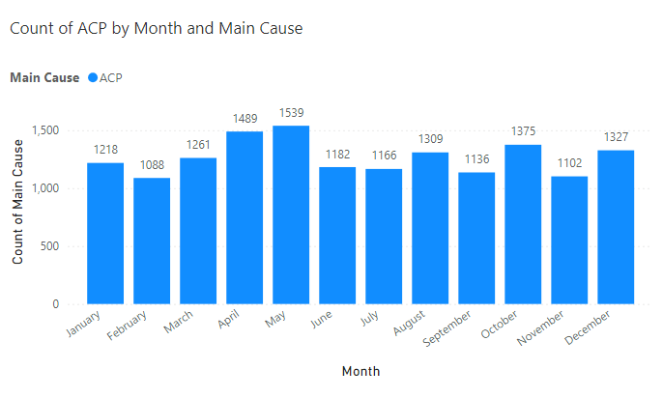Fig. 4. Month-wise distribution of ACP incidents

Day-wise Distribution of ACP Incidents
We tried to look into the day-wise ACP incidents distribution. To analyse this, we converted monthly data to day-wise data and considered only those days that having 60 or more ACP incidents. We found that during the days of festivals i.e. Dussehra i.e. 11th and 12th October in year 2024 highest of the ACP events occurred exceeding than average as shown in figure 5. So, there is strong correlation between festive days and ACP misuses by passengers.
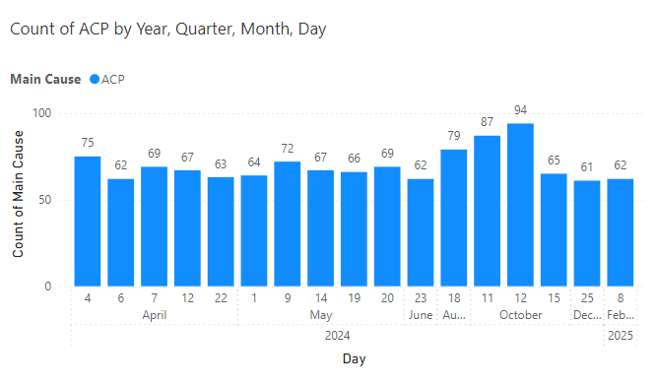
Fig. 5. Day-wise ACP incidents

Effect of ACP misuse on frieght trains
Goods or freight trains are not connected to ACP occurrences directly, but if a passenger train is stopped ahead, it may indirectly affect goods trains, which will also experience delays. Stoppages in front of passenger trains may lead to delays through Indian Railways shared track sections, specifically on congested divisions.

Month-wise Delay Count of Passenger Train
A month-to-month review of the passenger train delays attributed to ACP identified significant increases in disruptions occurring in the month of May. May identified the largest number of delays, with 2,086 occurrences. This number is a considerable quantity when compared to the monthly average caused by misuse of the ACP.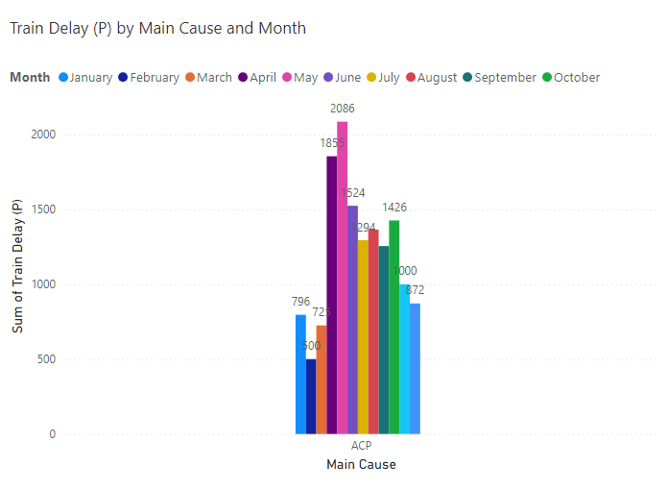
Fig. 6. Monthly delay counts for passenger trains due to ACP- peak in May
There are several potential causes for the increase in delays due to ACP during May: 1) Peak travel season: May coincides with summer vacation in India. 2) Increased unreserved travel: Many passengers will access trains that have not been reserved. 3) Higher frequency of long-distance travel. Overall, the trend of the monthly data shows in figure 6 that how season and passenger behavior converge with infrastructure limitations to contribute to operational delays.

Day-wise delay count of passenger Train
The daily breakdown in ACP-related delays as shown in figure 7 highlights distinct days with higher number of passenger train delays. The 12th of October represented the highest number of delays related to ACP incidents, with 145 delayed trains. It is followed closely by the 11th of October, and two other busy days in regards to delay concentrations.
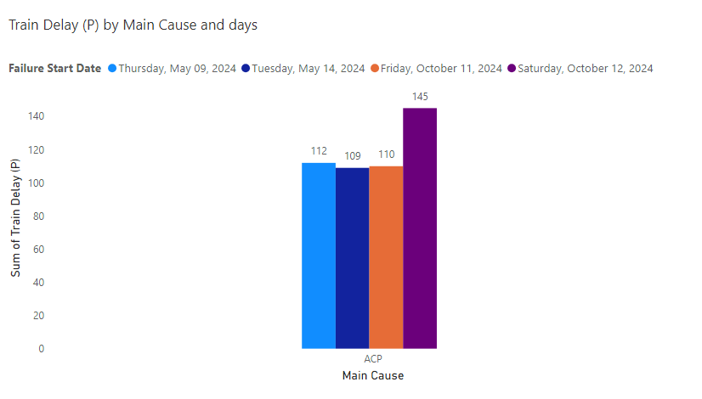
Fig. 7. Top 4 days with maximum passenger train delays due to ACP – peak on 12th october
The following shows the main points from this exploratory analysis: 1) Festival-related crowd: High amount of passenger levels around festival times can lead to crowded train stations and trains. 2) Behavioural patterns: This analysis suggests this is not random by demonstrating that these incidents appear to be heavily correlated with passenger behaviour during busy days. 3) Operational impact: Delays on certain days increased stress levels on the railway network, as one ACP can trigger a series of delays for multiple trains at once in the same area.

Month-wise Delay Count of Goods Train
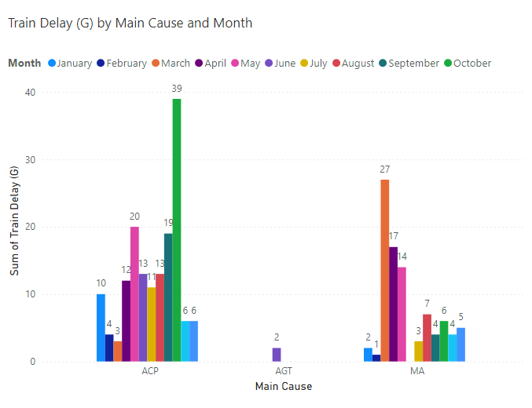

Fig. 8. ACP and MA caused delay counts for goods train (monthwise)
Freight trains got delayed due to two reasons. One is indirect impact of ACP misuse of passenger trains ahead on shared tracks and second one is mechanical attention (MA) in figure 8 shows the most delays in freight trains are happened in October month. Delay in goods train happened in march due to mechanical attention (MA). These findings highlight the specific monitoring techniques: 1) Human-triggered delays (ACP) will require better control systems during busy periods. 2) Technical delays (MA) will require predictive maintenance modelling and improved economic planning to eliminate end-of-cycle backlogs and improve reliable rolling stock.

Train Number Vulnerability
Figure 9 identifies the five long-distance trains that are most often associated with ACP incidents from the database.
The statistics suggest that Train 13350 (Patna–Singrauli Express) has recorded substantially more incidents than all the other trains, with a total of 353 ACP incidents. Other trains with large numbers were 12488 (Seemanchal Express) and 13348 (Palamu Express) as well as two other trains running in congested and diverse areas in India.
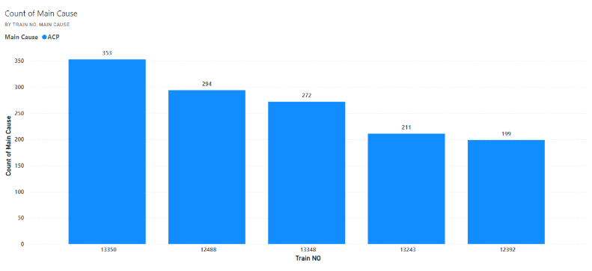
Fig. 9. Top five trains with maximum ACP incidents; Highest: 13350 Patna–Singrauli Express
These trains typically run parallel to busy routes through Bihar, Jharkhand, and Uttar Pradesh. In these regions, specifically identified passengers have consistently used ACP to demand the train pull over at ‘other’ rural or non-designated halts, leading to ongoing ACP issues resulting from 1) There is a lack of adequate halts in the rural or semi-urban areas being served on the route in question. 2) Some passengers are traveling informally or casually by simply boarding a train without planned stops, or using ACP as a way to fill in the gaps where stops have been missed. 3) Overcrowding and a general lack of understanding of the consequences of unauthorized use of ACP. The pattern of similar passengers engaged in repeated ACP abuse across certain train services highlights the need for the necessary enforcement of regulations and passenger awareness on these routes.

Division and COA Section Hotspots
We also studied spatial clustering of incidents of ACP in specific railway divisions and COA (control office application) sections. Figure 10 and 11 show these hotspots.
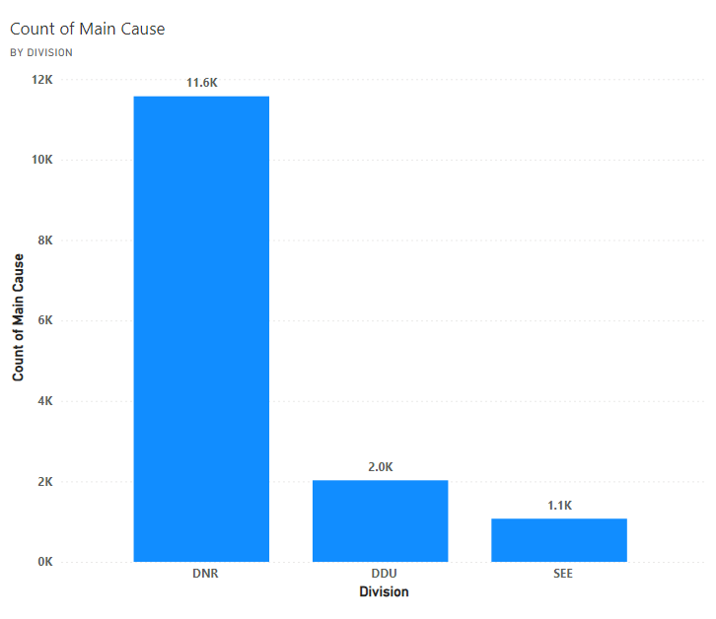
Fig. 10: Top three railway divisions with maximum ACP cases

Division-Level Insights
Figure 10 shows the top three railway divisions with the highest number of reported incidents of ACP. 1) Danapur (DNR), 2) Mughalsarai (DDU) and 3) Sonpur (SEE). These divisions are located in the East Central Railway (ECR) zone, which incorporates a mix of long-distance, express, and passenger trains. The consistently high number of offences likely reflects, high population density makes some authorized boarding and deboarding impossible. Some intermediate stations lack the infrastructure of wider platforms. A mix when operationally shared tracks with goods trains exist. It requires division-specific strategies to prevent ACP misuse.
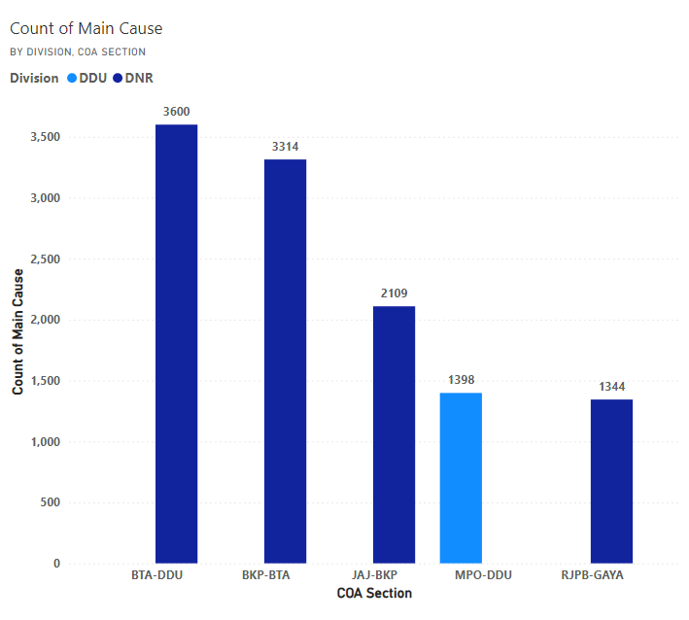
Fig. 11. Top five COA sections reporting highest ACP incident

COA Section-Wise Breakdown
Figure 11 shows the five COA sections that reported the largest number of ACP incidents: 1) Bihta - Pt. Deen Dayal Upadhyaya Junction (BTA -DDU) , 2) Bakhtiyarpur Junction - Bihta (BKP-BTA) 3) Jhajha - Bakhtiyarpur (JAJ - BKP) 4) Manpur - Pt. Deen Dayal Upadhyaya Junction (MPO - DDU) 5) Rajendra Nagar Terminal - Gaya (RJPB - GAYA). The high number of reported ACP events could be due to various reasons such as ppassengers attempting to stop trains, albeit at unscheduled locations, proximity to suburban or semi-urban regions and ooperational bottlenecks during the peak period around major festivals.
These results demonstrate the urgent need for local monitoring and responses, including smart monitoring and geo-tagged incident reporting, improvements to infrastructure, such as fencing or extending platforms, real time incident alerts through the monitoring of the COA system. And identification of division and section-level hot- spots can support Indian Railways in prioritising interventions & resource allocation against mitigating risk.

CONCLUSION
We proposed data-driven framework and developed a dashboard through merging and aligning an extremely large-scale operational dataset to extract deep insights for continual improvement, efficiency, and safety in the rail system for Indian context. We discovered the temporal and spatial patterns associated with ACP incidents occurred. Our analysis outlined that over 90% of ACP incidents occurred within passenger trains, which also had significant delays noted throughout the course of the year. Passenger trains experienced the most delays in May, with the most occurrences of ACP at 2,086 cases. October 12th reported the highest daily incidence of ACP, with 145 delays of train services all involving ACP misuse. Although goods trains do not directly report against an ACP model, they are still indirectly impacted by ACP incidents due to delayed passenger trains, especially since the passenger trains are likely to be held on tracks that also support the movement of goods trains. The major effects of ACP were significantly noticeable in October. The same month was when freight trains had the maximum delays, showing the large impact of ACP incidents.

Acknowledgement
We want to thank Indian Railways for providing the ACP datasets used in this study and National Institute of Technology Patna for making all the necessary support.

References
- Ministry of Railways, “Indian Railways Year Book 2022–23”, Govt. of India. [Online]. Available: https://indianrailways.gov.in
- Directorate of Statistics & Economics, “Railway Statistical Publications,” Ministry of Railways, Govt. of India.
- NITI Aayog, “Indian Railways: Vision 2030,” Govt. of India, 2020. [Online]. Available: https://niti.gov.in
- The Hindu, “Misuse of Alarm Chains Causing Serious Delays,” The Hindu, 2023. [Online]. Available: https://www.thehindu.com
- Popa, Aida-Maria. "Business Intelligence Methods for Sustainable Development of the Railways." Database Systems Journal 6.2 (2015).
- Choudhury, R. (2025). Big Data Analytics for Predictive Modeling of Indian Public Transit Passenger Demand Patterns. Journal of Computational Intelligence, Machine Reasoning, and Decision-Making, 10(2), 1-9.
- Times of India, “666 chain-pulling incidents on CR in 20 days, 463 people penalised”, Jun. 2025.
- Datta, B. S., Ganapathy, R., Vasudevan, S. K., & Abhishek, S. N. (2017). An inventive and innovative alternate for legacy chain pulling system through internet of things. Indonesian Journal of Electrical Engineering and Computer Science, 6(3), 688-694.
- Schreiber, D., Bauer, D., Hubner, M., Litzenberger, M., Opitz, A., Veigl, S., & Biron, B. (2023). MOBILIZE- Maintaining the operational safety and security of large railway systems in emergency situations. e & i Elektrotechnik und Informationstechnik, 140(6), 590-601
- Javanbakht, Negin, Amir Neshastegaran, and Iman Izadi. "Alarm-based root cause analysis in industrial processes using deep learning." arXiv preprint arXiv:2203.11321 (2022).
- Ariamuthu Venkidasalapathy, Joshiba, and Costas Kravaris. "Hidden Markov model based approach for diagnosing cause of alarm signals." AIChE Journal 67.10 (2021): e172
- Yang, N., Zhang, Y., Zuo, J., & Zhao, B. (2024). Fault Diagnosis Method for Railway Signal Equipment Based on Data Enhancement and an Improved Attention Mechanism. Machines, 12(5), 334.
- R. Gaurav and B. Srivastava, "Estimating Train Delays in a Large Rail Network Using a Zero Shot Markov Model," 2018 21st International Conference on Intelligent Transportation Systems (ITSC), Maui, HI, USA, 2018, pp. 1221-1226, doi: 10.1109/ITSC.2018.8570014.
- Mishra, Mihir, Md Habibur Rahman Sobuz, Md Kawsarul Islam Kabbo, M. Jameel, Turki S. Alahmari, Naim Ahmad, and Md Munir Hayet Khan. "Experimental assessment and data-driven hybrid machine learning quantification with parametric optimization of compressive strength of ceramic waste concrete." Case Studies in Construction Materials (2025): e05043.
- Ababneh, J., Attar, H., Muda, Z. C., Colak, I., Deif, M. A., Bendoukha, S., & Solyman, A. (2025). Enhanced nonlinear equalization for OFDM systems in IoT-based intelligent transportation using CGLS algorithms. EURASIP Journal on Wireless Communications and Networking, 2025(1), 61.
- Liu, Jianwei, Hongli Liu, Chinmay Chakraborty, Keping Yu, Xun Shao, and Ziji Ma. "Cascade learning embedded vision inspection of rail fastener by using a fault detection IoT vehicle." IEEE Internet of Things Journal 10, no. 4 (2021): 3006-3017.
- Gupta, Ashi, Rakesh Ranjan, Bharat Gupta, Debasis Das, and Chinmay Chakraborty. "ProBcNet: A Privacy-Preserving Adaptive Route Optimization Protocol for Internet of Consumer Vehicular Networks." IEEE Transactions on Consumer Electronics (2025).

