Molecule Release Probability over Fractional Diffusive Channel

Suman Yadav
Department of ECE
NIT Patna, Bihar, India
sumany.phd20.ec@nitp.ac.in
Mohamed Hafez
Faculty of Engineering FEQS, INTI International University, Nilai, Malaysia mohdahmed.hafez@newinti.edu.my
S. Pratap Singh
Department of ECE
TIET Patiala, Patiala, India
drsprataps@gmail.com

Bharat Gupta
Department of ECE
NIT Patna, Bihar, India
bharat@nitp.ac.in
Chinmay Chakraborty*
COIR - Medical Technology
KIIT, Bhubneswar, India
drchinmayc@ieee.org

Ayman Amer Faculty of Engineering, Zarqa Univeristy, Jordan
Aamer@zu.edu.jo
Sanchita Ghosh
Department of IT
IEM, Kolkata, West Bengal, India
Sanchita.Ghosh@iem.edu.in

Abstract— Recently, Membrane Fusion (MF) based imperfect molecular transmitter (Tx) has been proposed in the literature to transmit the information molecule over diffusive channel which is based on the Fick’s equation of diffusion. Also, it is noteworthy to mention that the MF process is adopted between the vesicles and the MF based transmitter. On the other hand, literatures shows that Fractional Diffusive Channel (FDC) is more general channel model for Diffusive Molecular Communication (DMC). Therefore, this paper presents a closed-form expression of molecule release probability over Fractional Diffusive Channel (FDC). The impact of several physical characteristics such as, forward reaction rate ($k_{f}$), radius of spherical T-BNM ($x_{T}$), the diffusion constant (D_{v}), fractional diffusion exponent 0 ≤ α ≤ 2 on molecule release probability is analyzed. Numerical analysis performed for molecule release probability over the fractional diffusion channel is in perfect alignment with the theoretical background.
Keywords— Molecular communication, Membrane Fusion, Fractional Diffusion

Introduction
These days, developments in nanotechnology result in a new field of research, which is the interaction of nanomachines over a short range in an aqueous environment. This new research area is known as Molecular Communication (MC), which is inspired by nature and molecules are used as information carriers to transfer data amongst the transmitter (TX) and the receiver (RX) [1].
*Corresponding Author
The molecules which are emitted from the TX travels through a fluid medium and finally reaches the RX. Various types of environments and receiving techniques at the RX have been explored in the literature [2]. However, very few research works have considered the effect of signalling channels within the TX and the communicating molecular signals which are on the surface of TX, on the performance of MC system. The various applications of MC consist of controlling diseases and detecting of infectious agents [3], patient monitoring using advanced health diagnostics and decision support to improve patient outcomes [4]-[6], smart drug delivery systems [7].
Moreover, several works have considered the TX as an ideal point source releasing molecule instantaneously [2]. In reality, this is not true as ideal TX overlooks several TX properties, such as signalling routes inside the TX, geometry, and interactions that takes place during releasing. Recently, various works have presented these TX characteristics [8]-[9]. In this paper [8], a TX that uses membrane fusion (MF) for emitting molecules that are confined within the vesicle is considered. In [9] the author developed a spherical TX with a semipermeable border, the permeability of which is utilized to regulate molecule release. Despite the fact that each of these initiatives has advantages of its own, none of them took into account releasing molecules through chemical reactions. This study examines the process of exocytosis, which restricts the molecule's ideal release. During this process, a vesicle—a microscopic, spherical, or oval-shaped molecule-storing container—is moved towards the cell surface, where its contents are released onto the neighbouring atmosphere. The membrane fusion (MF) method, which combines the vesicle and the cell surface, is what produces this discharge. As a result, a TX which employs MF to release molecules requires special consideration.
Furthermore, many recent efforts in DMC have focused on diffusive channels, which are non-Brownian motion in nature and are referred to as fractional diffusion processes [10]. Water diffusion in brain tissue, for example, is seen to be fractional in healthcare applications. Several works include analytical modelling of fractional diffusion are available in [11]-[12]. The first-passage-time-density (FPTD) function for the fractionally diffusive channel was created using the power-law diffusive phenomenon in [11], and the channel's probability of error and throughput were examined. The fractional diffusive channel's stochasticity is examined by the authors in [12]. While critical measures like peak time and peak response of pulse have been studied for normally diffusive channels, there hasn't been any research done on fractionally diffusive channels. Motivated by this, we proposed a fractional diffusion phenomenon that includes various types of diffusion scenarios for molecule propagation under MF.
In this paper, we have presented a unique MF-based TX model in a 3D environment in this research. It expels molecules gathered within the vesicle by combining a vesicle formed within the TX with the TX surface. A fully absorbing RX with a fractionally diffusive channel that absorbs molecules upon contact with the surface has also been taken into consideration. Further, we analysed the impulse response of the channel (CIR) for stationary MC in which both the TX and RX are immobile in relation with molecule release probability which is time-varying.
This is how the remaining paper is structured. Section 2 describes the system model. Section 3 includes the derivation of release probability of the TX membrane. In Section 4, we consider the numerical analysis, and conclusions are discussed in Section 5.

System Model
The suggested MC system is shown in Figure 1 with a fully absorbing R_{X} over fractional diffusion channel and an imperfect spherical T_{X} based on Membrane Fusion (MF). When the vesicles and outer membrane of T-BNM fuse, the molecules are emitted. Additionally, a spherical R_{X} and T_{X} with respective radii of $r_{R}$, and $r_{T}$ is taken into consideration. In this paper, it is assumed the spherical geometry as analytically tractable approximation for various real-world biomedical structures such as liposomes, exosomes, drug-delivery capsules, and spherical tumors. In the stationary case, the core of TX is selected as the starting point of the atmosphere, located at a distance of ‘l’ from the core of RX. It is important to highlight that the propagation environment is a fractional diffusive medium with fixed viscosity and temperature. We have considered the medium as fractionally diffusive as it is a generalized way to include anomalous transport which is observed in biological tissues and nanonetwork environments.
Furthermore, we suppose that after the membrane and vesicles combine, the TX which is spherical emit molecules from its outer surface. The random dispersion of molecules in the propagating environment is also unhindered by TX. Furthermore, the vesicles spread randomly with a diffusion constant D_{v} as soon as they are emitted from the core of the TX. Furthermore, we suppose that the data is packed as a series of binary bits b_{1:K} = [b₁, b₂, ...b_{K}], where K is the length and b_{K} is the k_{th} bit, as it is conveyed from the TX to the RX. Bit b₁ is selected to be broadcast at t = 0 in the static instance.

Probability of Molecule release from TX surface
In this section, we calculate the novel expression of release probability caused by the instant secretion of vesicles from the core of TX. Release probability is calculated as the probability of single molecule emitted by the TX’s surface at time t, as soon as the molecule is emitted from the origin at time t = 0. Moreover, the chance of molecules being discharged from the vesicle and into the communicating environment is identical to that of vesicle fusion because the MF process guarantees this. However, we must first determine the dispersion of vesicle concentration inside the TX before we can calculate the release probability across the TX surface. The concentration of vesicle’s distribution at distance x and time t from the TX’s core in a spherically coordinate system is denoted by G(x, t), 0 ≤ x ≤ $x_{T}$ . The discharge of a vesicle impulse by the TX's core at t = 0, the initially position is determined by [13]

$G\left(x,t→0\right)=\frac{δ(x)}{4πx^{2}}$ (1)

where, $δ(.)$ represents the Dirac delta function. Now, the concentration of particles exhibiting fractional diffusion within the TX is provided as follows by Fick's second law of diffusion [11]

$\frac{∂G\left(x,t\right)}{∂t}=αt^{α-1}D_{v}\frac{∂^{2}G\left(x,t\right)}{∂x^{2}}$ (2)

where D_{v} is the diffusion constant in μm²/s and α is the fractional diffusion exponent with a range, 0 ≤ α ≤ 2. Three forms of diffusion phenomena are expressed by the parameter α : (α = 1) represents normal diffusion; (α ≤ 1) corresponds to sub-diffusion, and (α ≥ 1) represents super-diffusion [14]. The irreversible process provided by (1) now characterizes the boundary condition, denoted by the boundary condition of the third type (Robin) [15]

${\left.D_{v}\frac{∂G\left(x,t\right)}{∂x}\right|}_{x=x_{T}}=-k_{f}G\left(r_{T},t\right)$ (3)

here the negative sign represents the inner boundary condition and $k_{f}$ denotes the forward reaction rate in μm/s of an irreversible reaction [8]. Now, we will calculate the novel expression of release probability by considering the equation (1), equation (2), and equation (3). It is given by [16]

$f_{r}\left(t\right)=4π{r_{T}}^{2}k_{f}G\left(x_{T},t\right)$ (4)

So, we have to first evaluate $G\left(x_{T},t\right)$ from (2). Using separation of variables method [17], we shall replace $G\left(x,t\right)$ as $G\left(x,t\right)=X\left(x\right)T\left(t\right)$ in (2), here X(x) and T(t) are the functions of x and t, respectively. Hence,

$X\left(x\right)T'\left(t\right)= αt^{α-1}D_{v}T\left(t\right)X^{''}\left(x\right)$ (5)
$D_{v}\frac{X^{''}\left(x\right)}{X\left(x\right)}=\frac{1}{αt^{α-1}}\frac{T'\left(t\right)}{T\left(t\right)}=ϵ$ (6)

where $T'\left(t\right)=\frac{∂T(t)}{∂t}$and $X^{''}\left(x\right)=\frac{∂^{2}X\left(x\right)}{∂x^{2}}$. The L.H.S and R.H.S of (6) is a function of x and t respectively, and both add up to a constant $ϵ$. After putting $ϵ={-D}_{v}{λ_{n}}^{2}$, n=1,2,3,… in (6), we get

$X^{''}\left(x\right)+{λ_{n}}^{2}X\left(x\right)=0$ (7)
$T^{'\left(t\right)}+αt^{α-1}D_{v}{λ_{n}}^{2}T\left(t\right)=0$ (8)

For each given $λ_{n}$ and by considering concentration as a symmetric function, the outcome of $X\left(x\right)$ in (7), given through
$X_{n}\left(x\right)$, is specified as

$X_{n}\left(x\right)=A_{n}\cos{(λ_{n}x)}$ (9)

here $A_{n}$ is a constant. Additionally, we need $X_{n}\left(x\right)$ to meet the boundary criteria in (3), so we replace $X_{n}\left(x\right)$ in (3)

$D_{v}λ_{n}\sin\left(λ_{n}x_{T}\right)=k_{f}\cos\left(λ_{n}x_{T}\right)$ (10)

By solving (10), we will get the discrete eigen values of $λ_{n}$. Furthermore, taking consideration of the equation $T_{n}\left(t→∞\right)=0$ in (8), important solution of $T_{n}\left(t\right)$ is

$T_{n}\left(t\right)=B_{n}e^{-D_{v}{λ_{n}}^{2}t^{α}}$ (11)

Considering the superposition’s principle, $X\left(x,t\right)$ is represented by
$$X\left(x,t\right)=\sum_{n=1}^{∞}{X_{n}\left(x\right)T_{n}\left(t\right)}=\sum_{n=1}^{∞}{A_{n}B_{n}\cos{(λ_{n}x)e^{-D_{v}{λ_{n}}^{2}t^{α}}}}$$ (12)
We will next find $A_{n}B_{n}$ considering the initial condition in (1). After substituting (12) into (1), we get

$\sum_{n=1}^{∞}{A_{n}B_{n}\cos\left(λ_{n}x\right)=\frac{δ(x)}{4πx^{2}}}$ (13)
Furthermore, by performing some arithmetic operations and figuring out both sides' integrals around x, we obtain

$\sum_{n=1}^{∞}{A_{n}B_{n}\int_{0}^{x_{T}}{x^{2}}cos\left(λ_{n}x\right)dx=\frac{1}{4π}}\int_{0}^{x_{T}}{δ(x)dx}$ (14)

Furthermore, solving (14), we obtain

$A_{n}B_{n}=\frac{{λ_{n}}^{3}}{4π\left({λ_{n}}^{2}{x_{T}}^{2}\sin\left(λ_{n}x_{T}\right)+2λ_{n}x_{T}\cos\left(λ_{n}x_{T}\right)\right)}$ (15)

Replacing $A_{n}B_{n}$ into (12) we obtained G(x,t) as

$G\left(x,t\right)=\sum_{n=1}^{∞}{\frac{{λ_{n}}^{3}}{4π\left({λ_{n}}^{2}{x_{T}}^{2}\sin\left(λ_{n}x_{T}\right)+2λ_{n}x_{T}\cos\left(λ_{n}x_{T}\right)\right)}}\cos\left(λ_{n}x\right)e^{-D_{v}{λ_{n}}^{2}t^{α}}$
(16)
Finally, substituting expression of $G\left(x_{T},t\right)$ from (16) into (4), the release probability is obtained as

$f_{r}\left(t\right)=\sum_{n=1}^{∞}{\frac{{x_{T}}^{2}k_{f}{λ_{n}}^{3}}{\left({λ_{n}}^{2}{x_{T}}^{2}\sin\left(λ_{n}x_{T}\right)+2λ_{n}x_{T}\cos\left(λ_{n}x_{T}\right)\right)}}\cos\left(λ_{n}x_{T}\right)e^{-D_{v}{λ_{n}}^{2}t^{α}}$
(17)
This is a new expression for fractional diffusive medium and TX based on MF which can further be used to calculate the fraction of molecules absorbed. Since the time-dependent concept fully captures the diffusion channel response, it is a crucial formulation in the nano networking field regarding the number of molecules captured by the R-BNM.

Numerical Analysis
In order to support our theoretical study, we provide numerical findings for the suggested mathematical expressions in this section. To investigate their impact on suggested analytical formulas, we vary the vesicle diffusion coefficient, fractional diffusion exponent, forward reaction rate, and radius of spherical TX.
In Fig. 1, we have shown the release probability of molecules by the TX at time t against time t, while varying parameter k_{f} and remaining parameters constant. It can be observed that when the value of k_{f} is decreased, the time taken by the molecules to achieve the peak of release probability is also increased. This is mostly because as k_{f} decreases, there is less molecular fusion amongst a vesicle and the TX surface. The analytical behavior of the derived release probability agrees with previous studies on anomalous transport [8].
In Fig. 2, the release probability of molecules by the TX at time t against time t is shown, for different values of parameter D_{v} and keeping other parameters constant. We observe that if the value of D_{v} is increased, the time taken by the TX to emit the molecules is very less. This is due to the faster propagation of vesicles when D_{v} is increased.
Further, in Fig. 3, the release probability of molecules against time t, while varying the radius of spherical TX ($x_{T}$) is plotted. It can be clear that as the value of $x_{T}$ is increased, so does the time required to reach the peak of release probability. This is due to the longer time required by a vesicle to diffuse with a larger radius to diffuse through a TX membrane.

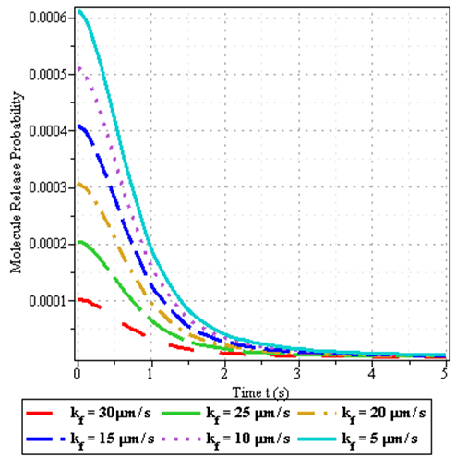
- Release probability from the MF-based TX at time t against time t for parameter (D_{v} = 15 µm²/s, $x_{T}$= 10 µm, α = 1.75).
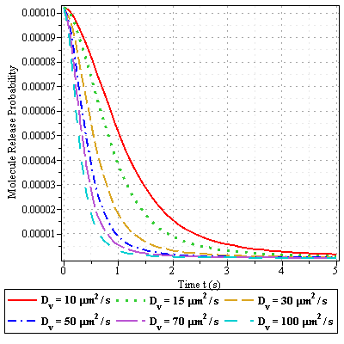
- Release probability from the MF-based TX at time t against time t for parameter (k_{f} = 5 µm/s, $x_{T}$= 10 µm, α = 1.75).
Furthermore, Fig. 4 shows the release probability of molecules given by (17) against time t and shows the comparisons between the features of three different forms of diffusiontoolbar.
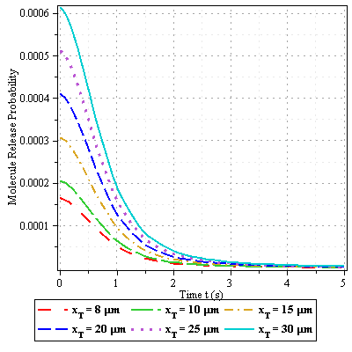
- Release probability from the MF-based TX at time t against time t for parameter (D_{v}= 15 µm²/s, k_{f} = 10 µm/s, α = 1.75).
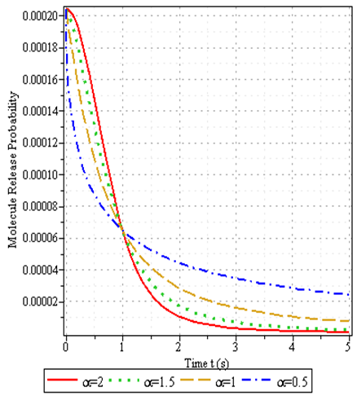
- Release probability from the MF-based TX at time t as a function of time t for parameter (D_{v} = 15 µm²/s, $x_{T}$ = 10 µm, k_{f} = 10 µm/s).

Conclusion
A closed-form expression of molecule release probability over a fractional diffusive channel of a DMC system, considering an MF-based transmitter, has been derived. The effect of various physical parameters has been analysed. Numerical investigations lead to the following observations. As the value of k_{f} is decreased, the time taken by the molecules to attain the peak of release probability is increased. Whereas, as the value of $r_{T}$ is increased the time taken by the molecules to reach the peak of release probability is also increased. Further, as the value of D_{v} is increased, the time taken by the TX to initiate the emission of molecules is also less. Finally, it has been observed that the release probability function is more scattered for sub-diffusion (α ≤ 1) in comparison to normal diffusion (α = 1) and super-diffusion (α ≥ 1). The analytical model presented here will help researchers in designing experiments that analyses anomalous molecule transport in confined biological structures, for example in drug-delivery profiles. To present analysis, followed by presenting the closed-form expression for the number of molecules released by the TX, hitting probability, and error analysis, are different future aspects of the research work.

References
- T. Nakano, Molecular Communication. Cambridge University Press, 2013.
- G. Yaylali, B. C. Akdeniz, T. Tugcu, and A. E. Pusane, “Channel modeling for multi-receiver molecular communication systems,” IEEE Trans. Commun., vol. 71, no. 8, pp. 4499–4512, 2023.
- F. Gulec, and B. Atakan. "A molecular communication perspective on airborne pathogen transmission and reception via droplets generated by coughing and sneezing." IEEE Transactions on Molecular, Biological, and Multi-Scale Communications, vol. 7, no. 3, pp. 175-184, 2021.
- S. Yang, D. Ruan, C. Chakraborty, Z. Guo, O. Alfarraj, and B. O. Soufiane. “Responsible Image Communication-Oriented Federated Impulsive Controlled Synchronization Model for IIoT-Coupled Complex Networks” IEEE Internet of Things Journal (2025).
- I. Vourganas, H. Attar, and A. L. Michala “Accountable, responsible, transparent artificial intelligence in ambient intelligence systems for healthcare.” Intelligent healthcare: infrastructure, algorithms and management. Singapore: Springer Nature Singapore, 2022. 87-111.
- Z. Guo, Y. Shen, C. Chakraborty, F. Alblehai, and K. Yu. Industrial 6G-IoT and machine learning-supported intelligent sensing framework for indicator control strategy in sewage treatment process. IEEE Internet of Things Journal (2024).
- F. M. Ekpan, M. O. Ori, H. S. Samuel, and O. P. Egwuatu “The synergy of AI and Drug delivery: A Revolution in Healthcare.” International Journal of Advanced Biological and Biomedical Research 12, no. 1 (2024): 45-67.
- X. Huang, Y. Fang, A. Noel, and N. Yang, “Membrane Fusion-Based Transmitter Design for Static and Diffusive Mobile Molecular Communication Systems,” IEEE Transactions on Communications, vol. 70, no. 1, pp. 132-148, 2021.
- M. Sch¨afer, W. Wicke, W. Haselmayr, R. Rabenstein, and R. Schober, “Spherical diffusion model with semi-permeable boundary: A transfer function approach,” Proc. IEEE, vol. ICC, p. 2020, 2020.
- L. Chouhan, P. K. Upadhyay, P. K. Sharma, and A. M. Salhab, “On anomalous diffusion of devices in molecular communication systems,” IEEE Trans. Mol. Biol. Multiscale Commun., vol. 8, no. 3, pp. 207–211, 2022.
- L. Chouhan, P. K. Sharma, and A. Noel, “Molecular communication in fractional diffusive channel,” IEEE Commun. Lett., vol. 24, no. 10, pp. 2172–2176, 2020.
- D. P. Trinh, Y. Jeong, H. Shin, and M. Z. Win, “Molecular communication with anomalous diffusion in stochastic nanonetworks,” IEEE Trans. Commun., vol. 67, no. 12, pp. 8378–8393, 2019.
- F. Dinc¸, B. C. Akdeniz, A. E. Pusane, and T. Tugcu, “Impulse response of the molecular diffusion channel with a spherical absorbing receiver and a spherical reflective boundary,” IEEE Trans. Mol. Biol. Multiscale Commun., vol. 4, no. 2, pp. 118–122, 2018.
- J.-H. Jeon, A. V. Chechkin, and R. Metzler, “Scaled Brownian motion: A paradoxical process with a time dependent diffusivity for the description of anomalous diffusion,” Phys. Chem. Chem. Phys., vol. 16, no. 30, pp. 15811–15817, Aug. 14 2014.
- J. Crank, The Mathematics of Diffusion. London, U.K.: Oxford Univ. Press, 1979.
- K. Schulten and I. Kosztin, Lectures in Theoretical Biophysics, vol. 117. Illinois, Champaign, IL, USA: Univ., 2000.
- K. Cole, J. Beck, A. Haji-Sheikh, and B. Litkouhi, Heat Conduction Using Greens Functions. Boca Raton, FL, USA: CRC Press, 2010.

