Deployment of TinyML on THEJAS32 based IoT Platform

Aleena Vinod
Strategic Electronics Group C-DAC
Thiruvananthapuram, India aleena.v@cdac.in
Subina Gafoor A Strategic Electronics Group C-DAC
Thiruvananthapuram, India subina.g@cdac.in

Prem Krishnan N
Bhagyasree V S Strategic Electronics Group C-DAC
Thiruvananthapuram, India bhagyasreevs5@gmail.com

Shibu R M

Strategic Electronics Group C-DAC
Thiruvananthapuram, India premk@cdac.in
Strategic Electronics Group C-DAC
Thiruvananthapuram, India rmshibu@cdac.in

Abstract—THEJAS32 system on a chip(SoC) is based on the VEGA ET1031 processor, a 32-bit single core, in-order, 3-stage pipeline processor developed by C-DAC under the MDP. This work presents the maiden attempt to deploy Tiny Machine Learning (TinyML) on a hardware platform built around the THEJAS32 SoC. A TinyML model was trained and optimized using the TensorFlow framework using Google Colab and de- ployed onto the platform using the VEGA Software Development Kit (SDK). The model was compressed by as much as 97% in comparison with the one developed using TensorFlow. This validates the viability of the TinyML-IoT-THEJAS32 platform for TinyML applications.

Keywords—TinyML, RISC-V, Edge AI, THEJAS32, VEGA SDK

- Introduction
Artificial intelligence is redefining new-era development, making it an indisputable part of everyday life. However, traditional AI deployment requires high computational resources, driving up both cost and energy demands. The exponential increase in energy consumption by AI [1] makes it imperative to introduce devices that require less computational capability.
Edge AI focuses on implementing machine learning algo- rithms on the edge device. This brings the processing and inference-making power to the edge, thereby reducing the frequency of cloud connectivity. Edge AI, however, demands high-power microprocessors and AI accelerators such as neural processing units. Tiny Machine Learning is an innovative step that brings inferencing to the edge. Application-specific machine learning algorithms are trained on platforms such as Google Colab and are optimized for implementation on highly resource-constrained devices such as microcontrollers (MCUs). These optimized algorithms require reduced latency, Power consumption, and memory [2].
The Microprocessor Development Programme (MDP) has been initiated and funded by the Ministry of Electronics and Information Technology (MeitY), Government of India, with
the mission objective to indigenously design and develop a family of microprocessors, related IPs, and the complete ecosystem to enable fully indigenous product development that meets various requirements in the strategic, industrial and commercial sectors. As part of the MDP, the Centre for Development of Advanced Computing (C-DAC), a premier R&D organization under MeitY, has developed the VEGA series of microprocessors, which are based on RISC-V. RISC- V is an open-source Instruction Set Architecture (ISA) that is rapidly developing in the field of embedded microprocessors [3]. We are combining TinyML with RISC-V to provide a methodology to implement machine learning algorithms on the THEJAS32 SoC based on VEGA’s ET1031 processor. The platform integrates multi-communication protocols along with Ethernet, Wi-Fi, SIM, and cryptographic modules allowing secure on-board inferencing.
The primary contributions of this work are:
- The design and implementation of the TinyML-IoT- THEJAS32platform, a novel, multi-protocol platform for secure TinyML on a RISC-V based SoC.
- A validated software methodology for porting and executing TensorFlow Lite for Microcontrollers (TFLM) models using the VEGA SDK on a bare-metal RISC-V core.
- End-to-end development and deployment of the TinyML model from training to on-device inference on the TinyML-IoT-THEJAS32 platform.

- System Architecture
Fig. 1 depicts the block diagram of the TinyML-IoT- THEJAS32 platform designed to execute TinyML algorithms. The platform collects data from end-users via on-board sen- sors, performs computation on the device itself, and can send necessary results to the cloud, if required. This embedded device has low latency, improved privacy, and reduced band- width, and thereby it is more cost-effective and energy efficient

[4]. The system is specifically designed to overcome the drawbacks of conventional AI systems [5].

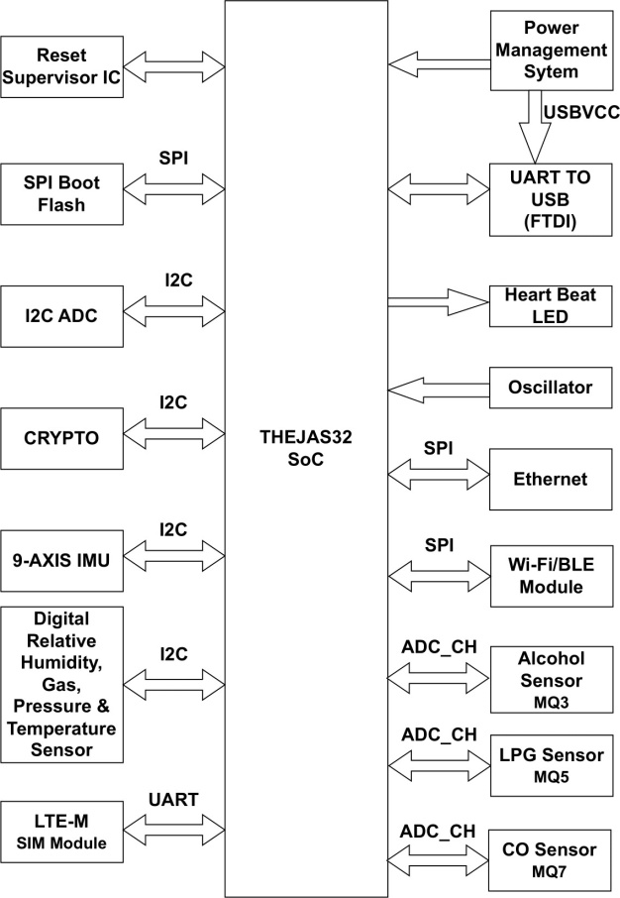

Fig.1. Block Diagram of TinyML-IoT-THEJAS32 Board

- Hardware Implementation
Fig. 2 shows the hardware of the TinyML-IoT-THEJAS32 platform, designed with ET1031, a 32-bit single-core RISC-V based VEGA processor [6]. The main feature of the platform is that it supports multiple network connectivity interfaces: Ethernet, an LTE Cat-M module for 4G connectivity, Wi- Fi/Bluetooth Low Energy, and a cryptographic module for security purposes. The platform features an on-board 9-axis Inertial Measurement Unit (IMU) sensor, a digital relative humidity, gas, pressure and temperature sensor, making it suitable for IoT applications. It has 256 kB of SRAM and 2 MB of flash memory.
Arduino Nano 33 BLE Sense is an existing hardware plat- form designed for the implementation of TinyML applications. In comparison with the Arduino platform, the TinyML-IoT- THEJAS32 platform has a higher clock speed, double the Flash and the same RAM. The core difference, however, lies in the architecture. Arduino Nano 33 BLE Sense is based on ARM Cortex M4 whereas TinyML-IoT-THEJAS32 is based on the RISC-V architecture.
Table I provides a comparison between the two boards highlighting the essential features for TinyML applications.

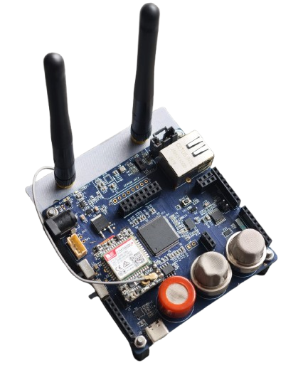

Fig.2. TinyML-IoT-THEJAS32 platform

TABLE I
Comparison of TinyML-IoT THEJAS32 Platform and Arduino
Nano 33 Bluetooth Low Energy Sense Board

Features | TinyML-IoT-THEJAS32 | ArduinoNano33BLESense
Processor | VEGA ET1031 (32-bit) | nRF52840 (32-bit)
Speed | 100 MHz | 64 MHz
SRAM | 256 kB | 256 kB
Flash | 2 MB | 1 MB
Architecture | RISC-V | ARM Cortex M4 with FPU
PWM | 8 | 4×4 channel
Analog Inputs | 4 | 8
SPI | 3 | 1
UART | 3 | 1
I2C | 2 | 1
GPIO | 32 | 48

- Software
The platform uses the VEGA SDK for running machine learning algorithms on-board. The SDK was developed by C- DAC for running C/C++ application programs on VEGA pro- cessors. The SDK runs on Linux machines. In order to compile the C/C++ programs, the appropriate RISC-V toolchain must be installed for the specific processor (32-bit or 64-bit) prior to installing the SDK. This sets up the necessary environment for porting applications and models onto the SoC.
A lightweight C library has been developed to allow the VEGA SDK to run neural network inference directly on the RISC-V MCU. This eliminates the requirement for an operating system or other external dependencies.

TensorFLow was chosen as the framework for model devel- opment. Once the TensorFlow Lite (TFLite)model is obtained, it is converted to TFLM [7] and is used in the application code, which runs in the VEGA SDK for final application deployment. The model development and all conversions were performed in Google Colab.
- Network Interfaces
The TinyML-IoT-THEJAS32 platform supports multiple network interfaces, which include Wi-Fi, Ethernet, and SIM. Each of these modules provides the platform with extensive capabilities.
The use of Wi-Fi for indoor localization applications has been on an increase in recent years [8]. The advantage of using Wi-Fi for tracking and sensing indoor activities is that it can leverage the existing Wi-Fi devices while easily propagating through walls, giving it more coverage than camera-based systems [9]. The on-board NINA-W102-01B module supports Wi-Fi 802.11 b/g/n (2.4 GHz) and can be leveraged for a wide range of TinyML applications, including human activity recognition, environmental monitoring, and smart home.
An Ethernet module can be highly reliable, ensuring fast and secure connectivity. The WIZnet W5500 Ethernet controller supports speeds upto 80MHz and is compatible with standard network protocols such as TCP, IPv4, and ICMP. IoT applications like Industrial IoT, IoT gateways are best suited on the ethernet interface. The SIM7080G cellular module supports NB-IoT and LTE-M, enhancing the IoT capabilities of the module. These features of this module make it suitable for applications such as smart metering, asset tracking, environ- mental monitoring, and industrial automation.
- Applications
The TinyML-IoT-THEJAS32 platform provides a wide range of sensors which can be leveraged for several TinyML applications. We have developed and deployed an alcohol sensor model, trained using the on-board MQ3 sensor. Human activity monitoring models can be developed using the 9-axis IMU sensor. BME680 is a temperature and humidity sensor which can be used for environment monitoring tasks. The network interfacing capability of the board makes it feasible for developing network security applications such as intrusion detection systems.
- Methodology
- Application code development
Google’s TensorFlow Lite, a widely used ML framework, enables the ML programmer to convert TensorFlow models into a quantized and optimized TensorFlow Lite version, portable to edge devices [10]. The TinyML-IoT-THEJAS32 platform is specifically made for IoT applications and supports TensorFlow Lite for microcontrollers. The microprocessor ET1031, supports its own libraries. The library is cross- compiled with the RISC-V VEGA toolchain and is used to build the application code. A model file named with the extension .tflite is integrated into the library.
Application code includes the optimized machine learning model as a header file. The critical point is that the application code size should be less than the RAM capacity of the platform. In this case, it should be less than 256 kB. Binary files of the application code can be uploaded using minicom serial communication with the UART interface.
- Regression model deployment
Fig. 3 illustrates the complete TinyML development pipeline. Starting from data collection, in the context of the experiment mentioned here, data is a one dimensional array of x. In this paper, a sinusoidal function generated using 1000 samples of x, within the range 0 to 2π, is used to train a regression model.
z represents a sequence comprising 1000 samples of random numbers generated from a standard normal distribution. z is scaled by 0.1 and added to sin(x) to create the sequence y. The model is trained to obtain the sinusoidal function of from y.
y = sin(x) + 0.1z (1)
Equation (1) represents the mathematical model where y is the output, x is the input and z is the noise.
The goal is to predict a continuous output for the sinusoidal function, for the given set of x values. In data preprocessing, the dataset is cleaned and labelled, ie, simplified for the train- ing process and is split into training (60%), validation (20%), and testing (20%) data. Model Design involves selecting and structuring an appropriate neural network architecture, which is then trained using TensorFlow. Here, a regression model is chosen because the output is a set of numerical values.
The base model comprises a feed-forward network with one input layer, 2 hidden layers with 16 Rectified Linear Unit (ReLU) activated neurons, and one linear output layer [11]. This model is compiled using the standard ’adam’ optimizer and the mean squared error (mse) loss function for regression. The model is trained for 500 epochs and a batch size of 64. Fig. 4 shows the loss function of predicted and actual values during training and validation. Fig. 5 shows the graph of mean absolute error (MAE), which depicts the amount of error in the prediction.
After training, the model undergoes evaluation and op- timization. This includes quantization, pruning, and perfor- mance tuning done using TFLite. This format reduces memory usage, model size and converts weights and activations to integer 8 quantized values. The optimized model is then converted into an array during model conversion. Table II explains the size at different stages. The initial TensorFlow model has a size of 90.7kB, which was quantized to a mere 2.7 kB (97% smaller than the original model).
In the model deployment phase, an application code is developed which embeds the converted TFLite Micro model, which is integrated into the TinyML-IoT-THEJAS32 platform using the VEGA SDK. The final application code was found to be 88 kB, which was well within the 256 kB RAM of the platform.

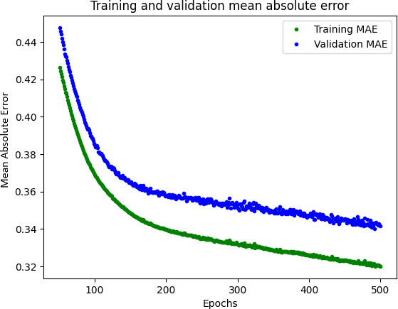

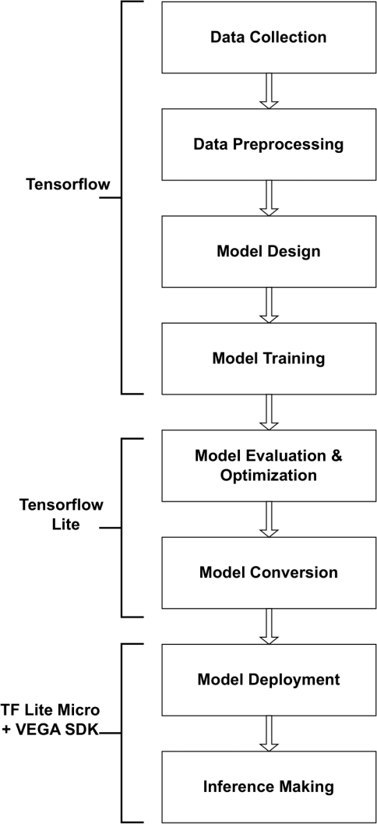
Fig.3. TinyML Flow Diagram

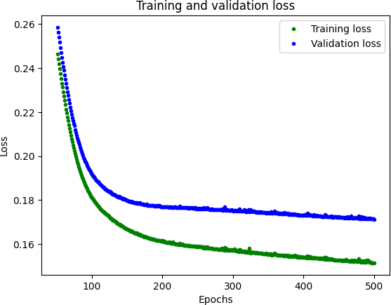

Fig.4. Training and Validation Loss
Fig.5. Training and Validation MAE

TABLE II
Model Size Comparison

Format | Size | Compression
TensorFlow (.pb) | 90.7 kB | -
TensorFlow Lite (float32) | 3.2 kB | 96% smaller
TensorFlowLite (int8) | 2.7 kB | 97% smaller

- Results

A tiny machine learning algorithm, a regression model, is successfully deployed on the TinyML-IoT-THEJAS32 plat- form. A regression model gives prediction of continuous values. So the performance metrics are evaluated by how close the predicted values are to the continuous true value, meant by finding minimum loss and mean absolute error. The model is deployed on the TinyML-IoT-THEJAS32 platform with 8 inference values with mean absolute error of 0.0815and minimum loss of 0.0101 across samples.
Fig.6 depicts the result of the verification made through the development machine by running a Python code. The actual and predicted output are very similar, demonstrating a well- trained model.
This was verified by deploying the 88 kB embedded C code onto the resource constrained TinyML-IoT-THEJAS32 platform. Fig. 7 shows the UART serial monitor depicting memory allocation details of deployment and inference output.
This successful deployment validates the end-to-end work- flow, from model training and optimization to on-device exe- cution on the resource-constrained hardware.
The inference time falls within the latency acceptable for real-time applications, demonstrating the THEJAS32 plat- form’s capability for edge computing. These results confirm the feasibility of deploying TinyML models on this platform.

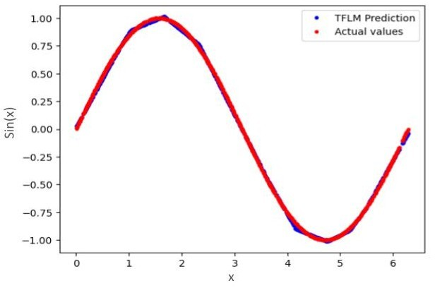

Fig.6. TF Lite Micro prediction with actual values of sin(x)
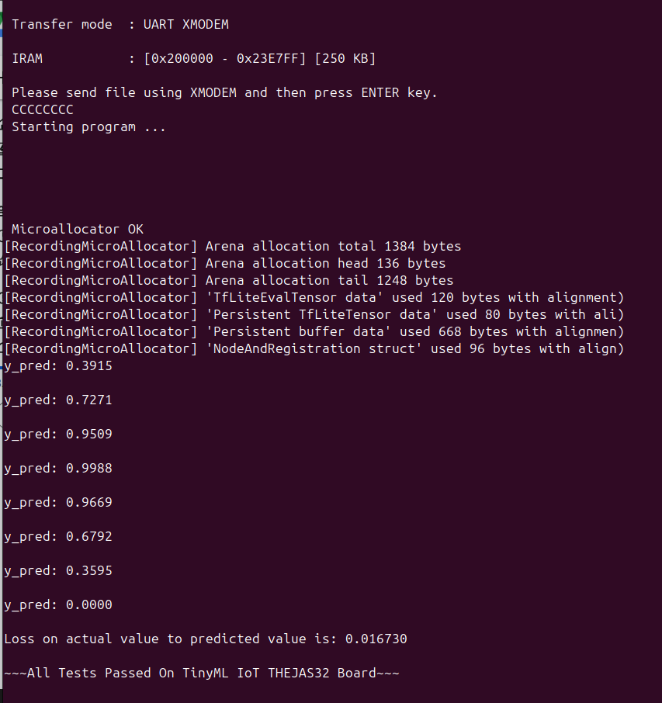

Fig.7. On-board inference result

- Limitations
As discussed, the TinyML-IoT-THEJAS32 platform has been built using ET1031, RISC-V processor core, which is the initial version taped out as part of the MDP project. It is constrained by its single-core architecture, limited computa- tional throughput, and smaller memory address space. These limitations restrict the execution of more complex TinyML models, particularly for those requiring real-time performance such as image, video and audio. In addition, ET1031 does not support parallel task execution.
- Conclusion and Future Work
This work successfully validates the portability of machine learning algorithms on the TinyML-IoT-THEJAS32 platform. The platform can be used for applications like intrusion de- tection system, air quality monitoring, gesture-based controls, and activity tracking. Current development is focused on
enabling Federated Learning and Over-The-Air (OTA), which are crucial features for maintaining models at the edge.
Future work includes the development of an enhanced TinyML platform targeting the 64-bit VEGA processor IP cores, enabling higher computational capability and improved support for advanced edge AI workloads such as image and audio-based IoT applications. C-DAC has successfully developed VEGA series of RISC-V processor core, in soft IP forms of 64-bit single-core (in-order & out-of-order), 64-bit dual-core (out-of-order), and 64-bit quad-core (out-of-order).
Acknowledgment
The authors would like to acknowledge the Cyber Security Section and Hardware Design Group of C-DAC, Thiruvanan- thapuram for constantly supporting us, and Sreenivas Pai K for his contributions to the hardware design of the TinyML- IoT-THEJAS32 platform.
References
- Q. Wang, Y. Li, and R. Li, “Ecological footprints, carbon emissions, and energy transitions: the impact of artificial intelligence (AI),” Humanities and Social Sciences Communications, vol. 11, no. 1, pp. 1–18, 2024.
- Y. W. Hao, C.C. Min, R. M. Sabri, R. L. T. Fat, S. H. Wei, H. Halim,
and S. Y. Fadhlullah, “Implementation Research of Tiny ML on RISC-V Platform Using Efinix Platform for Real Time Person Detection,” in 2025 21st IEEE International Colloquium on Signal Processing & Its Applications (CSPA), pp. 233–238, IEEE, 2025.
- E.Cui,T.Li, and Q. Wei,“Risc-v instruction set architecture extensions: A survey,” IEEE Access, vol. 11, pp. 24696–24711, 2023.
- R. Sanchez-Iborra and A. F. Skarmeta, “Tinyml-enabled frugal smart objects: Challenges and opportunities,” IEEE Circuits and Systems Magazine, vol. 20, no. 3, pp. 4–18, 2020.
- Y. Abadade, A. Temouden, H. Bamoumen, N. Benamar, Y. Chtouki, and A. S. Hafid, “A comprehensive survey on tinyml,” IEEE Access, vol. 11, pp. 96892–96922, 2023.
- Premjith, “ABCs of VEGA.” VEGA processors blog, July7, 2021. [Online]. Available: https://vegaprocessors.in/blog/abcs-of-vega/.
- M. Natraj, “TensorFlow Lite Micro: Embedded Machine Learning on TinyML Systems,” ArXiv, 2020.
- A. Kargar-Barzi, E. Farahmand, N. T. Chatrudi, A.Mahani, and
M. Shafique, “An edge-based wifi fingerprinting indoor localization using convolutional neural network and convolutional auto-encoder,” Ieee Access, vol. 12, pp. 85050–85060, 2024.
- S. M. Hernandez and E. Bulut, “Wifi sensing on the edge: Signal processing techniques and challenges for real-world systems,” IEEE Communications Surveys & Tutorials, vol. 25, no. 1, pp. 46–76, 2022.
- S. S. Saha, S. S. Sandha, and M. Srivastava, “Machine learning for microcontroller-class hardware: A review,” IEEE Sensors Journal, vol. 22, no. 22, pp. 21362–21390, 2022.
- P. Warden and D. Situnayake, TinyML: Machine Learning with Tensor-Flow Lite on Arduino and Ultra-Low-Power Microcontrollers. O’ReillyMedia, Inc., 2019.

