Performance analysis of a hybrid multiplexing-based FSO communication system under rain and fog conditions

Latifa Hacini
elctronics department
Constantine 1 University
Constantine, Algeria
latifa.hacini@umc.edu.dz
Amel Aissaoui
elctronics department
Constantine 1 University
Constantine, Algeria
aissaoui.amel@umc.edu.dz

Abstract— This study investigates a free space optics (FSO) communication system that combines two multiplexing schemes: polarization division multiplexing (PDM) and mode division multiplexing (MDM). This combination multiplies channel capacity while maintaining low hardware complexity. In this configuration, data from eight users are conveyed through four Hermite–Gaussian (HG) modes over two polarization states. These modes are selected mainly for their easier and stable practical implementation. The performance analysis is conducted under various rain and fog conditions to evaluate the system’s robustness. Furthermore, the system performance is compared with that of an MDM multiplexing system. The bit error rate (BER) and eye diagram are used as the main performance evaluation metrics. The BER simulation results demonstrate that PDM-MDM system consistently achieves better performance than MDM system. They also reveal that atmospheric attenuation has a strong adverse impact on the BER, with fog introducing much more degradation than rain.
Keywords— mode division multiplexing, polarization division multiplexing, Hermite gaussian mode.

Introduction
Free-space optics (FSO) is an optical communication technique that enables data transfer through light propagation in open space. To operate correctly, an FSO link requires a clear line of sight (LOS) between the transmitter and the receiver. The performance of such systems is mainly affected by atmospheric turbulence resulting from temperature fluctuations, as well as by adverse weather conditions including fog, rain, and snow [1,2].
To enhance the data-carrying capability of FSO communication systems, several multiplexing strategies have been investigated, including wavelength division multiplexing (WDM) [3,4], orthogonal frequency division multiplexing (OFDM) [5,6], mode division multiplexing (MDM) [7,8], and polarization division multiplexing (PDM) [1,9].
MDM is a multiplexing scheme that exploits the orthogonality of spatial modes, such as Hermite–Gaussian (HG) and Laguerre–Gaussian (LG) modes, to carry independent data channels within the same optical beam [1,7-9]. PDM, on the other hand, utilizes the orthogonality of light polarization states to transmit independent data streams within the same wavelength. This technique effectively doubles the transmission capacity while maintaining robustness against certain channel impairments [1,9-10].
Recently, researchers have combined different multiplexing techniques to further enhance the capacity of FSO communication systems. In [11], a hybrid single-mode fiber (SMF) and FSO communication system was developed by integrating WDM with PDM to improve last-mile connectivity. In [12], the authors introduced a 120 Gbps FSO transmission scheme that combines three multiplexing methods: OFDM, PDM, and optical code division multiple access (OCDMA) to achieve higher capacity. S. A. El-Mottaleb et al. proposed a spectrally efficient 80 Gbps PDM–MDM system for multi-mode fiber (MMF)–FSO transmission [1]. The performance analysis was conducted under various atmospheric turbulence conditions, including rainy weather in three different cities. In [13], a PDM/MDM-FSO architecture based on orbital angular momentum beams was introduced. The proposed system is capable of serving up to 128 users, offering significant improvements in spectral efficiency and overall capacity, even when operating under harsh weather conditions.
Our work falls within this framework. It consists of studying and evaluating the performance of a hybrid PDM–MDM communication system, as proposed in [1], applied to an FSO link under various weather conditions. The complete system configuration is modeled using OptiSystem software. System performance is assessed using two key metrics: the bit error rate (BER) and the eye diagram of the detected signal. The evaluation is performed under various fog and rain scenarios, and the maximum achievable transmission distance, defined at a BER threshold of 10⁻⁶, for the FSO link is subsequently identified.
The structure of the remainder of this paper is as follows: Section 2 outlines the atmospheric scenarios considered in this work. Section 3 details the architecture of the PDM–MDM FSO system. Section 4 discusses the obtained simulation results, and Section 5 provides concluding remarks.

Atmospheric conditions and fso links
In FSO communication, the transmission channel is the atmospheric environment, which is inherently complex and dynamic medium. Atmospheric conditions can significantly alter the characteristics of the propagating laser beam. As a result, FSO links are subject to significant impairments imposed by atmospheric propagation environment, which deviates from an ideal medium due to the spatio-temporal variability of its physical parameters and the heterogeneous nature of its constituents.

Fog attenuation
Fog consists of water droplets suspended in the atmosphere, which can alter the characteristics of light or even block its propagation through a combination of absorption and scattering. One common approach to estimate the attenuation caused by fog is to use visibility as a parameter. The Kim and Kruse models apply this method to predict fog-induced attenuation. The specific attenuation in these models is expressed by the following equation [14]:
$α=\frac{3.912}{ν}{\left(\frac{λ}{550nm}\right)}^{-q}$ (1)
here, ν denotes the visibility measured in km, λ corresponds to the wavelength in nm, and q refers to the parameter associated with the droplet size distribution. According to the Kruse model, the parameter q is selected based on the value of the visibility as [14]:
$q=\left\{\begin{matrix}1.6 \\ 1.3 \\ {0.585ν}^{1/3}\end{matrix}\right.\begin{matrix} ν>50Km \\ 6Km<ν<50Km \\ ν<6Km \end{matrix}$ (2)
According to Kim's model, q is given by [10, 14]:
$q=\left\{\begin{matrix}1.6 \\ 1.3 \\ \begin{matrix}0.16ν+0.34 \\ \begin{matrix}ν-0.5 \\ 0 \end{matrix} \end{matrix}\end{matrix}\right.\begin{matrix} ν>50Km \\ 6Km<ν<50Km \\ \begin{matrix} 1Km<ν<6Km \\ 0.5Km<ν<1Km \\ ν<0.5Km \end{matrix}\end{matrix}$ (3)

Rain attenuation
Rain is a meteorological phenomenon that results from the condensation of atmospheric water vapor into droplets large enough to fall under the influence of gravity. It is typically characterized by a precipitation rate expressed in mm/h [1]. In FSO communication systems, rain induces attenuation of the optical beam primarily through scattering and absorption by water droplets. This attenuation is commonly modeled empirically using the power-law relationship [10,14]:
B_{r}​=αR^{β} (4)
where: B_{r}​ represents the attenuation in dB/km, R is the rainfall rate in mm/h, α and β are empirical coefficients that
depend on the signal wavelength. For FSO links operating in the infrared region (typically between 850 nm and 1550 nm), typical values ​​are: α=1.076, β=0.67. Therefore, (4) becomes [1]:
$B_{r}​=1.076R_{f}^{0.67}$ (5)
This attenuation can become critical during heavy rainfall, making rain an important factor to consider in the design of outdoor optical links, especially in tropical regions.

system description and operating principle
Fig. 1 presents the simulation setup of the investigated FSO system based on hybrid PDM-MDM multiplexing implemented by OptiSystem. At the transmitter level, a laser source operating at a central wavelength of 1550 nm is employed.
Polarization multiplexing is achieved using a polarization rotator component, which changes the polarization state of the optical signal. In this setup, two orthogonal polarizations, X and Y, are employed, with an angle difference of 90° between them. The optical signal is divided into two parts: one maintains the original polarization of the source, while the other is rotated by 90°. Fig. 2 illustrates the optical spectra of the X and Y polarized signals, respectively. Before transmission through the FSO channel, the optical signals with different polarizations are combined using a polarization combiner. At the receiver, a polarization splitter separates the received signals according to their polarization states.
The transmitter section of the system consists of two identical subsystems, each corresponding to MDM multiplexing for one polarization state, using four HG modes: HG₀₀, HG₀₁, HG₁₀, and HG₁₁. As shown in Fig. 3, each HG mode is generated by a Hermite transverse mode generator and carries data produced by a pseudo-random binary sequence generator (PRBSG). These data are

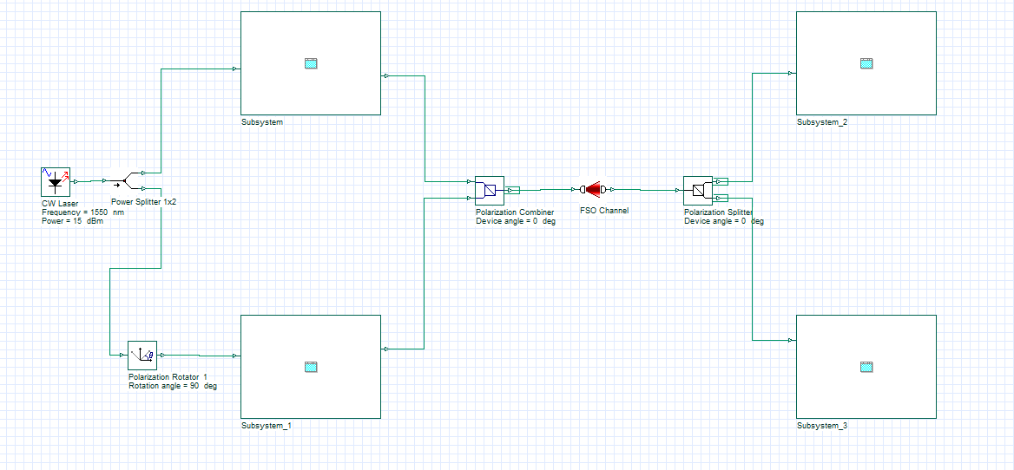

Fig.1. Schematic representation of the hybrid PDM-MDM multiplexing FSO communication system.

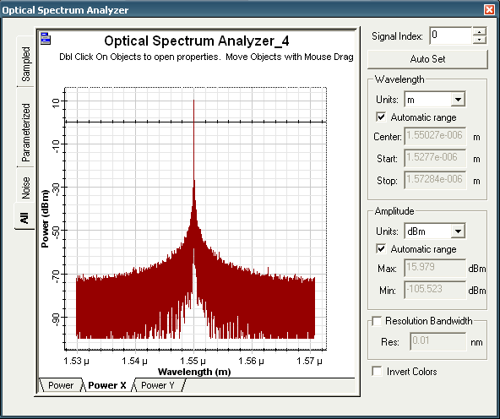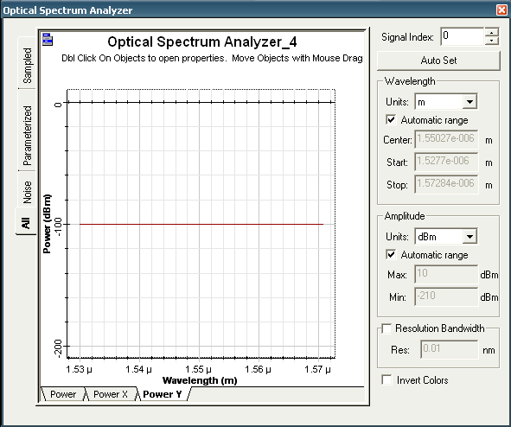
(a)

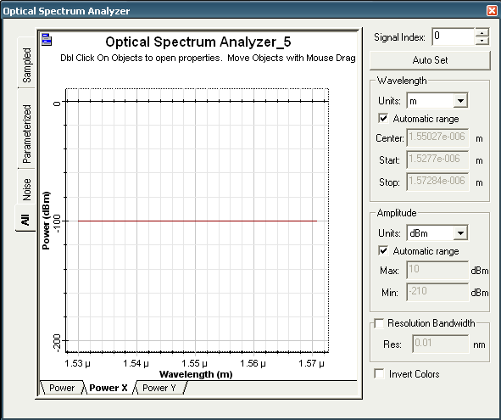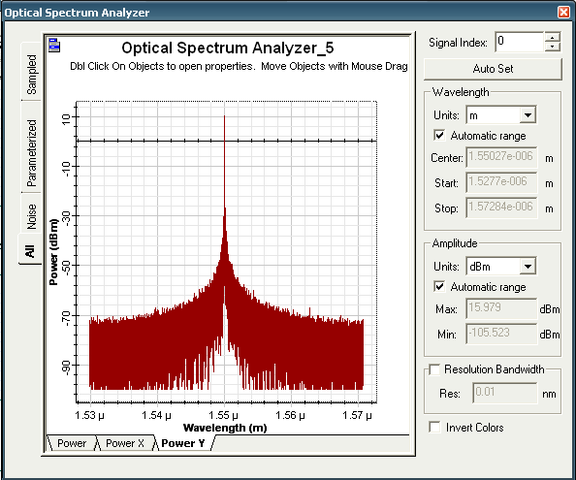
(b)

Fig. 2. Optical spectra of the used signals.
(a) X polarization (b) Y polarization
transmitted to a non-return-to-zero on–off keying (NRZ–OOK) electrical modulator. To enable optical transmission through the corresponding HG mode, the Mach-Zehnder modulator (MZM) is used to generate the modulated optical signal. The data transmitted over the four different HG modes with X or Y polarization is then multiplexed for efficient transmission through the system. For instance, a single HG beam can simultaneously carry two independent data streams; one using X polarization and the other using Y polarization.
Similarly, the receiver side of the system consists of two identical subsystems, each corresponding to the different blocks used for processing the received signals in order to recover the transmitted data. This signal, whether of X or Y polarization, is decomposed into four HG modes using a mode selector component. As presented in Fig. 4, a PIN photodetector is utilized for every mode to perform optical-to-electrical conversion. Following this stage, high-frequency noise is eliminated through a low-pass filter, and the quality of the recovered data is then examined using a BER analyzer.

performance evaluation
The transmission system shown in Fig. 1 was simulated in OptiSystem with the parameters listed in Table I.

Fig.3. generation of the HG mode signal for user data.

Fig. 4. blocks for receiving data.
- Simulation Configuration Parameters
Parameter | Value
Optical power source | 15 dbm
wavelength | 1550 nm
Bit rate per mode | 10 Gbps
Divergence angle | 0.5 mrad
Transmitter aperture diameter | 10 cm
Receiver aperture diameter | 20 cm
Resposivity of PD | 1 A/W
Thermal noise power density | 10⁻²² W/Hz

Rain effect
Fig. 5 shows the logarithm of the BER as a function of different FSO link ranges for two rainfall levels. For the lowest rain attenuation (light rain: LR), the transmitted data propagating through various HG modes and both polarizations, can be successfully received up to a distance of approximately 970 m. This range decreases to about 560 m under heavy rain (HR) conditions. These values correspond to a BER threshold of 10⁻⁶. It is worth noting that an attenuation of 6.27 dB/km was used for light rain and 19.28 dB/km for heavy rain [10].

Fog effect
Fog intensity has a significant impact on the optimal performance of an FSO system. Fig. 6 illustrates how Log(BER) varies with the FSO link distance for three fog levels: light fog (LF), moderate fog (MF), and heavy fog (HF), which correspond to attenuation coefficients of 6 dB/km, 16 dB/km, and 22 dB/km [10], respectively.
(a)
(b)
Fig. 5. Log(BER) vs. distance for light and heavy rain.
(a) X polarization (b) Y polarization
(a)

(b)

Fig. 6. Log(BER) vs. distance for different fog levels.
(a) X polarization (b) Y polarization
Among the three cases, light fog yields the smallest BER values for all users. As the fog becomes denser, the BER progressively increases, and the maximum usable FSO distance reduces, measuring about 950 m for LF, 580 m for MF, and 480 m for HF. Consequently, the communication range is significantly restricted under higher fog densities.
To compare the quality of signal reception under different fog conditions, Fig. 7 presents the eye diagram of user 2 (HG₀₁ mode and X polarization) for the three fog levels at a distance of 500 m. From the eye diagrams, it can be observed that under light fog, the eye exhibit a wide and clear opening, indicating high-quality signal transmission. Under moderate fog, a noticeable reduction in the eye opening is observed. Under heavy fog, the eye diagram show significant closure, indicating severe signal degradation and a higher probability of bit errors.

Performance comparison of PDM-MDM and MDM multiplexing systems
To evaluate the efficiency of the hybrid PDM–MDM multiplexing scheme, its performance was compared with that of MDM multiplexing. The block diagram of this system is similar to that of the hybrid PDM-MDM system in terms of the transmitter and receiver architectures, but without employing polarization multiplexing. The main difference lies in the selection of spatial modes: the same
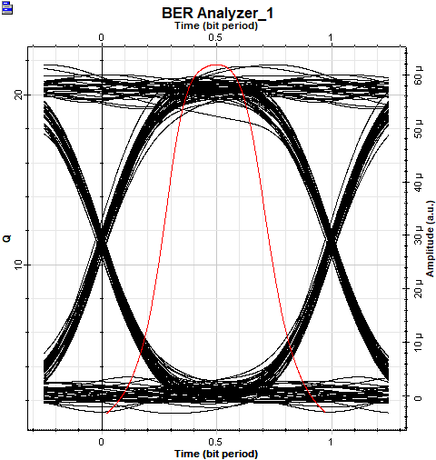
(a)

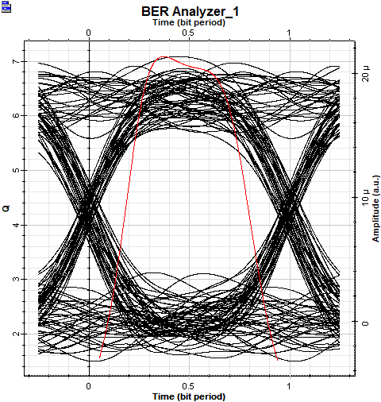
(b)

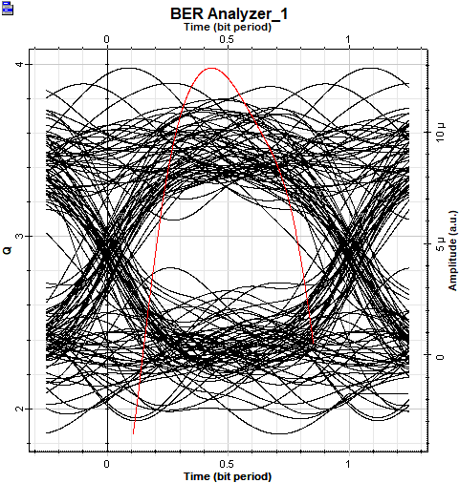
(c)
Fig. 7. Eye diagram for user 2.
(a) light fog, (b) moderate fog, (c) heavy fog.
four modes as those used in the PDM-MDM system were assigned to the first four users, while four additional spatial modes were allocated to the remaining ones. The selected modes are HG₀₂, HG₂₀, HG₁₂, and HG₂₁.
Fig. 8 shows the variation of the logarithm of the BER for all users as a function of distance, for both the hybrid PDM-MDM system and the MDM system. It is evident that the hybrid multiplexing system provides better performance compared to the MDM configuration. According to the presented results, the performance of the MDM-based system is limited by distance. This limitation is clearly observed, as the BER quality degrades with increasing distance. For example, the logarithm of the BER remains approximately constant around -6 when the transmission distance ranges between 900 m and 1000 m. At 1300 m, it rises to about –2, indicating a noticeable deterioration in signal quality. In contrast, for the hybrid PDM-MDM system, particularly for user 4, the BER remains very low at 1000 m (around –48.067), with a gradual degradation observed as the distance increases: –18.036 at 1300 m, –13.489 at 1500 m, and still acceptable at 1800 m with –7.51. This relatively slow variation in the BER demonstrates that the addition of polarization multiplexing significantly improves the stability and robustness of optical transmission over longer distances.
(a)
(b)

Fig. 8. Comparison of Log(BER) of the FSO system with MDM multiplexing and hybrid PDM-MDM multiplexing
(a) users 1 to 4 (b) users 5 to 8
Fig. 9 illustrates the eye diagrams obtained for both systems, generated by the same user 2 under identical transmission conditions: a distance of 1500 m and an attenuation of 0.2 dB/km (clear air). The first diagram, corresponding to the hybrid multiplexing system, exhibit a clear and well-defined eye opening, reflecting high signal quality. In contrast, the diagram generated by the MDM multiplexing system display noticeable eye degradation, indicating significantly lower performance. The analysis of the eye diagrams confirms that the hybrid PDM–MDM multiplexing system achieves substantially better performance than the MDM system.

conclusion
In this work, a hybrid-multiplexing FSO link was simulated using OptiSystem in order to analyze how rain and fog conditions influence overall system performance. A comparison with an MDM multiplexing system was also conducted. The results show that, under similar transmission
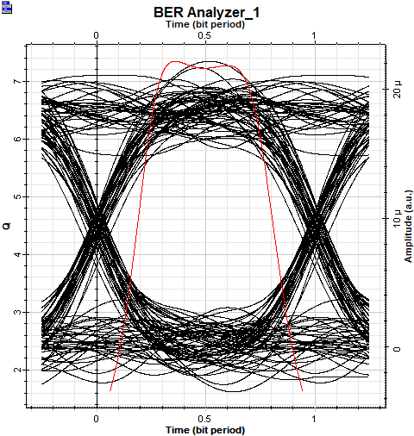
(a)

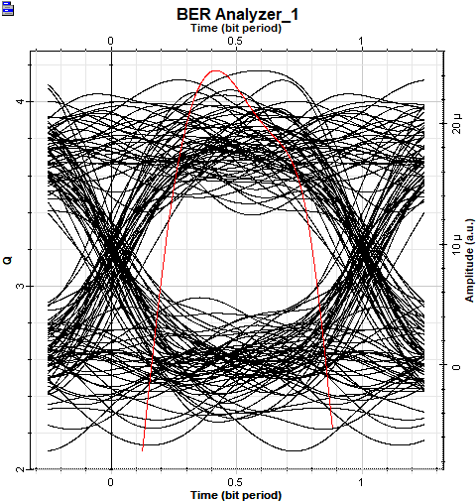
(b)
Fig. 9. Eye diagram for user 2.
(a) hybrid PDM-MDM system (b) MDM system.
conditions, the integration of polarization multiplexing enhances the FSO link performance by extending the transmission range. This improvement demonstrates the effectiveness of combining spatial and polarization multiplexing in mitigating channel impairments and extending communication distance. It was also observed that atmospheric conditions significantly affect transmission quality, as evidenced by a reduction in the eye diagram opening and an increase in the BER, ultimately limiting the effective range of the FSO link.

References
- S. A. Abd El-Mottaleb, M. Singh, H. Y. Ahmed, M. Zeghid and K. S. Nisar, “Performance Analysis of a Spectral-Efficient High-Speed Hybrid PDM-MDM Enabled Integrated MMF-FSO Transmission,” in IEEE Photonics Journal, vol. 15, no. 4, pp. 1-12, Aug. 2023.
- A. Merrouche and A. Aissaoui, “Enhancing performance in hybrid FSO/RF communication systems under atmospheric turbulence and pointing errors,” J Opt, vol. 53, pp. 4238-4248, 2024.
- X. H. Huang, et al, “WDM Free-Space Optical Communication System of High-Speed Hybrid Signals,” in IEEE Photonics Journal, vol. 10, no. 6, pp. 1-7, Dec. 2018.
- D. Shruti, S. Garima, S. Divya and K. Gurjit, “Design and performance analysis of WDM-FSO communication system using Polarization Shift Keying,” Journal of Optical Communications, vol. 45, no. 4, pp. 965-970, 2024.
- B. K. Saw, V. Janyani and G. Singh, “Analysis of coherent-OFDM modulation for FSO communication over distribution with pointing errors,” Optics Communications, vol. 545, 2023.
- N. Kumar and A.L.J. Teixeira, “10 Gbit/s OFDM based FSO communication system using M-QAM modulation with enhanced detection,” Opt. Quant Electron, vol. 48, no. 9, 2016.
- S. Srivastava, K.K. Upadhyay and N. Singh, “Optimization of MDM- FSO system with diferent encoding schemes,” Indian J. Phys, vol. 94, pp. 1803–1809, 2020.
- S. Boobalan, S.A. Prakash, M. Angurala, J. Malhotra and M. Singh, “Performance Enhancement of 3 × 20 Gbit/s MDM-Based OFDM-FSO System,”. Wireless Pers Commun, vol. 122, pp. 3137-3165, 2022.
- D.H. Hani, J.K. Hmood and E.K. Hamed, “Performance investigation of FSO transmission system based on combining MDM and PDM techniques”. J Opt . 2024.
- S. A. Abd El-Mottaleb, et al, “Performance evaluation of PDM/SAC-OCDMA-FSO communication system using DPS code under fog, dust and rain,” Opt Quant Elecron, vol. 54, 2022.
- M. Singh, M.H. Aly, and S.A.A. El-Mottaleb, “Performance analysis of a 448 Gbps PDM/WDM/16-QAM hybrid SMF/FSO system for last mile connectivity,” Opt Quant Electron, vol. 55, no. 231, 2023.
- S.A.A. El-Mottaleb, M. Singh and M.H. Aly. “120 Gbps FSO transmission system based on integrated OFDM-PDM-OCDMA transmission using ICSM code: performance analysis,”. Opt Quant Electron, vol. 56, no. 621, 2024.
- A. Vivek. “Realization of 32 × 4 × 40 Gbps PDM/MDM-FSO system using orbital angular momentum beams,” Journal of Optical Communications, 2025.
- S.Ghoname , H. A. Fayed, A. Abd El Aziz , M. H. Aly .”Performance analysis of FSO communication system: effects of fog, rain and humidity” Sixth International Conference on Digital Information Processing and Communications(ICDIPC), 2016.

