Performance Enhancement of Natural Dye-Sensitized Solar Cells via mathematical and chemical model for imprinting Anthocyanin–Betalain Dyad Photovoltaic Structures

Hamza Karajeh
Jubilee School
Amman, Jordan
hkarajeh@stud.jubilee.edu.jo

Sawsan Jamil Abu Jammaah
Jubilee School
Amman, Jordan
sabujammaah@jubilee.edu.jo
Omar Nofal
Jubilee School
Amman,Jordan
onofal@jubilee.edu.jo
Azhar Sameer Omar Jubilee School
Amman, Jordan
azharsameer@yahoo.com
Mohamed Hafez Faculty of Engineering FEQS, INTI-IU-University, Nilai, Malaysia; mohdahmed.hafez@newinti.edu.my Faculty of Management, Shinawatra University, Pathum Thani, Thailand.

Abstract— As global demand for sustainable energy continues to rise, dye-sensitized solar cells (DSSCs) have gained attention as an attractive alternative to conventional silicon photovoltaics, offering advantages such as low cost, mechanical flexibility, and reliable performance under low-light conditions. This research investigates the application of two natural photosensitisers—anthocyanin extracted from red cabbage and betalain derived from beetroot—in both individual and dyad configurations, produced using a combined mathematical and chemical model for imprinting Anthocyanin–Betalain Dyad Photovoltaic Structures. Spectroscopic characterization techniques such as UV–Vis and ATR–FTIR have proved the dyes’ absorption properties and the presence of functional groups capable of anchoring to the TiO₂ photoanode layer. While single-dye DSSCs exhibited modest power conversion efficiencies (η) of about 0.02%, the dyad-based devices showed a substantial enhancement, achieving η = 0.3%, representing a 15-fold improvement. This increase is linked to the complementary absorption profiles of the dyes, expanded light-harvesting capability, and improved sensitizer coverage on the photoanode surface. The results align with global sustainability priorities, particularly SDG 7 (Affordable and Clean Energy), SDG 12 (Responsible Consumption and Production), and SDG 13 (Climate Action). Nevertheless, the overall efficiencies remain below those of synthetic sensitizers, emphasizing the need for further optimization in dye extraction, deposition methods, and co-sensitization techniques to advance device performance.
Keywords— Dye-sensitized solar cells (DSSCs), natural dyes, dyad structures, Sustainable Development Goals, Affordable and Clean Energy, Climate Action

Introduction
Dye-sensitized solar cells (DSSCs) represent an innovative category of third-generation solar technology that transforms light into electrical energy via the photovoltaic effect, providing a more affordable and scalable option compared to traditional silicon-based solar panels. These cells utilize photosensitizer dyes to capture light and facilitate the transfer of electrons to a semiconductor, most commonly titanium dioxide (TiO₂), which is essential for their operational efficiency [1]. The most effective sensitizers, in terms of both efficiency and durability, are derived from ruthenium (Ru) bipyridyl compounds, which possess remarkable properties, such as high stability, excellent absorption within the visible solar spectrum, effective electron injection, and rapid metal-to-ligand charge transfer rates, which help to mitigate recombination reactions. Although ruthenium-based dyes can achieve conversion efficiencies greater than 10%, their elevated costs, intricate preparation methods, and environmental issues considerably hinder their broader adoption [2] [3] . On the other hand, natural dyes are plentiful, easily sourced, and environmentally friendly, extracted from natural materials like flower petals and leaves [4]. Nevertheless, their comparatively lower efficiency when stacked against synthetic dyes poses a significant obstacle, hence, improving the performance of natural dye-based DSSCs has become crucial for enhancing their competitiveness and realizing their potential as viable, sustainable energy alternatives [5] . Similar simulation and material verification studies have demonstrated the critical influence of dye and semiconductor pairing on DSSC performance [6].
The development of dye-sensitized solar cells (DSSCs) began in 1972, when researchers first investigated chlorophyll-sensitized zinc oxide photoanodes. These early devices exhibited limited efficiency due to insufficient surface area for effective light absorption [[6]. n 1991, Michael Grätzel and Brian O’Regan introduced nanostructured TiO₂ films coated with a ruthenium-based dye, achieving efficiencies of 7.1–7.9%. This advancement marked a pivotal milestone in the progression of DSSC technology [7].
Mathematical modeling of dye-sensitized solar cells (DSSCs) aims to form quantitative and detailed descriptions of the operation of DSSCs, providing a consistent framework to analyze the behavior of DSSCs and detect performance trends. In this way, modeling complements experimental work by detailing underlying mechanisms and directing targeted improvements in the design and efficiency of DSSCs [8] [9]. One of the key objectives of mathematical modeling in DSSCs is to evaluate the efficiency (η) of a DSSC. η is expressed as the ratio of the maximum electrical output power (Pmax)⁡ to the incident solar power (Pin) and is equivalently written in terms of the short-circuit current density (Jsc), open-circuit voltage (Voc), and fill factor (FF) [10].
$Pmax=Vmp Jmp$ (1)
$FF=\frac{Pmax}{Voc Jsc}$ (2)
$η= \frac{Voc Jsc FF}{Pin}$ (3)
$η= \frac{Voc Jsc FF}{Pin}= \frac{V\max{J}max}{Pin}= \frac{Pmax}{Pin}$ (4)

The incident power for the AM1.5 solar spectrum is taken as 1000 W m−21000W m−2, and for computing Pin Fonash [11] provided the following formula:
Pin= $\int_{λ}^{ }{\frac{hc}{λ}φAM1.5\left(λ\right)dλ}$ (5)
The output power is calculated as P=JV_{B}, where the current density (J) is given by the usual diode equation J=Jsc−J0[$e^{\left(\frac{qV_{B}}{m_{I}k_{B}T}\right)}$−1] Substituting this into the power expression yields a voltage‑dependent power function P(VB)= V_{B}J(VB), which is then used to determine the maximum power point. Differentiation of P(VB) with respect to VB provides first and second derivatives that are expressed in terms of Jsc, J0, and the exponential factor $e^{\left(\frac{qV_{B}}{m_{I}k_{B}T}\right)}$.
$\frac{dP}{dV_{B}}=Jsc+J0-J0e^{\left(\frac{qV_{B}}{m_{I}k_{B}T}\right)}\left[\frac{qV_{B}}{m_{I}k_{B}T}+1\right]$ (6)
$$\frac{d^{2}P}{dV_{B}^{2}}=-\frac{qJ0}{mk_{B}T}\left[\frac{qV_{B}}{m_{I}k_{B}T}+2\right]$$ (7)
Introducing the Lambert‑W function W enables an explicit closed‑form expression for the bias voltage at the maximum power point, and an analogous expression for the corresponding current density as in the following formulas:
$$V_{max}=\frac{m_{I}k_{B}T}{q}\left[W\left(e\frac{J0+Jsc}{J0}\right)-1\right]$$
(8)

$$J_{max}=\frac{\left(Jsc+J0\right)\left[W\left(e\frac{J0+Jsc}{J0}\right)-1\right]}{W\left(e\frac{J0+Jsc}{J0}\right)}$$
(9)
Substituting Vmax⁡ into the power expression gives the maximal output power and hence, Pmax of the DSSC is given by the following formula [8]:
$$P_{max}=P\left(V_{max}\right)=\frac{m_{I}k_{B}T\left(Jsc+J0\right)\left[W\left(e\frac{J0+Jsc}{J0}\right)-1\right]}{qW\left(e\frac{J0+Jsc}{J0}\right)}$$
(10)
Alongside efficiency we can also calculate the incident photon to current efficiency (IPCE) which gives an indication of how efficient the DSSC absorbs incident photons. Being a metric to evaluate solar cells by itself, however, the short circuit current density (Jsc) could be calculated using the IPCE as in the following equation [12] where h is Planck’s constant, c is the speed of light, q is the electron charge and φ is the incident photon flux:
$$J_{sc}=\frac{hc}{q}\int_{0}^{∞}{λη_{IPCE}\left(λ\right)ϕ\left(λ\right)dλ}$$
(11)
Investigations into the use of natural dyes for dye-sensitized solar cells (DSSCs) have attracted significant interest, as these pigments offer a sustainable and economical alternative to synthetic options. Plant-based DSSCs are especially appealing due to their affordability, non-toxic nature, and lower environmental footprint when compared to traditional chemical systems. Among these natural pigments, anthocyanin and betalain stand out as effective sensitizers, capable of absorbing sunlight and converting it into electrical energy. Numerous studies have examined the use of these plant-derived dyes in DSSCs, with some examples detailed in TABLE I. Nevertheless, despite some research on mixed dye-based DSSCs, there remains a notable deficiency in studies concentrating on natural dye-based dyad DSSCs. This shortfall underscores the necessity to investigate innovative configurations of natural dyes to enhance the efficiency of DSSCs that utilize natural dyes
Several recent studies have investigated the application of natural dyes and co-sensitization strategies to enhance DSSC efficiency. For example, mixed dye systems combining anthocyanin, betalain, and chlorophyll (with and without silver doping) were examined and achieved enhanced efficiencies in the range of ~0.24-0.74% for the mixtures [13].
U. Mahajan et al. [14] surveyed multiple natural pigment sensitizers, including anthocyanin and tannin, emphasizing the extension of spectral range but noting challenges in dye stability and anchoring. However, despite these efforts, very few works specifically isolate the anthocyanin-betalain dyad (without additional dyes or heavy metal doping) to examine in detail how these two dyes complement each other in spectral absorption, anchoring on TiO₂ surfaces, and charge transfer. This gap motivates the present study, which aims to systematically characterize anthocyanin and betalain, both individually and in dyad form, with a particular focus on functional group interactions, spectral complementarity, and photovoltaic behavior.
However, despite some research on mixed dye-based DSSCs, there is a significant lack of studies focusing on natural dye-based dyad DSSCs. This gap highlights the need to explore innovative natural dye configurations to further optimize the efficiency of natural dye-based DSSCs.
To date, no prior study has systematically analyzed anthocyanin–betalain dyads without the influence of metal doping or additional synthetic sensitizers. This research aims to fill that gap by evaluating the dyad’s spectral complementarity, anchoring behavior, and photovoltaic performance in a controlled, metal-free configuration.
Research on mixed natural dyes in DSSCs has demonstrated their potential to enhance performance by broadening light absorption and improving the interaction between the dye and the semiconductor. Research on mixed natural dyes in DSSCs has demonstrated their potential to enhance performance by broadening light absorption and improving dye interaction with the semiconductor [15]. A study investigating the performance of chlorophyll and xanthophyll pigments extracted from (Cladophora sp.), a type of filamentous freshwater green algae, highlights the value of combining natural pigments for increased efficiency [16]. Another study examined the combination of anthocyanin, betalain, and chlorophyll pigments, showcasing how mixed-dye configurations can improve complementary absorption spectra to improve light-harvesting efficiency and overall DSSC performance [13]. This aligns with broader sustainable energy optimization approaches demonstrated in related solar energy systems research [17].
TABLE I: Photoelectrochemical Properties of Various Reported Natural Plant Dyes Used in DSSCs

Plant source | Dye type | FF | η (%) | Reference
Berberis Integerrima | Berberin | 0.53 | 0.01 | [14]
Punica granatum | Anthocyanin | 0.209 | 0.20 | [15]
Rubus subg. Rubus | Anthocyanin | 0.29 | 0.38 | [18]
Allium cepa | Anthocyanin | 46.63194 | 0.064723 | [19]

The purpose of this study is to investigate the use of natural dyes as sustainable photosensitizers in DSSCs to enhance their performance and commercial viability. Natural dyes extracted from plants—including anthocyanins and betalain from red cabbage (Brassica oleracea L. var. capitata f. rubra) and beetroot (Beta vulgaris)—are analyzed for their affordability, environmental benefits, and interactions with TiO₂ semiconductors. By evaluating the optical properties of both individual and layered dye configurations, alongside key performance parameters. This study aims to advance the development of DSSCs as a cost-efficient and accessible renewable energy technology.
Initially, traditional single-dye DSSCs will be prepared as a control group, while Dyad configurations will be fabricated by sequentially layering two different natural dye sensitizers. These two groups will be analyzed using ATR-IR and UV-Vis Spectroscopy for optical properties, as well as their photoelectrochemical performance, including photocurrent density, open-circuit voltage, fill factor, and power conversion efficiency. Theoretically, dyad configurations can enhance DSSC performance by broadening light absorption and improving the interaction between the dye and the semiconductor. Therefore, it is hypothesized that DSSCs with dyad configurations will exhibit superior overall performance compared to traditional single-dye DSSCs.

METHODOLOGY
This study employed an experimental approach to evaluate the performance of dye-sensitized solar cells (DSSCs) using natural pigments as photosensitizers. The methodology was designed in four stages: (i) preparation of natural dye extracts from red cabbage and beetroot, (ii) fabrication of TiO₂-based photoanodes and carbon counter electrodes, (iii) assembly of DSSCs with single-dye and dyad configurations, and (iv) characterization of the optical and photovoltaic properties of the devices. Spectroscopic techniques (UV–Vis and ATR–FTIR) were used to assess the structural integrity and absorption characteristics of the dyes, while current–voltage (J–V) measurements under simulated sunlight were employed to evaluate the efficiency of the fabricated cells. This systematic approach ensured that both the material properties and device performance could be directly correlated to the use of individual and combined natural dye sensitizers.

Materials
Red cabbage (Brassica oleracea) and beetroot (Beta vulgaris) were used as natural dye sources. Ethanol (95%) served as the solvent for extraction and cleaning. Fluorine-doped tin oxide (FTO) glass substrates (20 mm × 20 mm, 2.2 mm thickness, 6–8 Ω/sq sheet resistance, ≥84% light transmittance) were used as conductive electrodes. Titanium dioxide (TiO₂) nanopowder (AR grade) acted as the photoanode material. The electrolyte was prepared by dissolving 0.5 g of KI and 0.05 g of I₂ in 10 mL of ethanol, yielding an I₂:KI ratio of 1:10 by weight. All chemicals were of analytical grade and used without further purification. Deionized water was employed for cleaning and dilution.

Dye extraction
Two natural dyes were extracted: anthocyanins from red cabbage and betalains from beetroot. Both plants were obtained from a local market and thoroughly rinsed with distilled water to remove impurities.
- Anthocyanin extraction: Red cabbage was chopped and ground into a fine paste using a mortar and pestle. For every 5 g of paste, 10 mL of ethanol was added, and the mixture was stirred at 35 °C for 48 h using a magnetic stirrer (1250 rpm). The extract was filtered, centrifuged to remove solid residues, protected from light with aluminum foil, and stored in dark conditions until use. The molecular structure of anthocyanin is shown in Fig. 1.
- Betalain extraction: Beetroot was peeled, chopped, and boiled in distilled water at 98 °C. The extract was concentrated by partial evaporation to achieve an approximate concentration of 0.2 g/mL, cooled, filtered, and centrifuged multiple times. Both extracts were protected from light to prevent photo-oxidation. The molecular structure of betalain is shown in Fig. 2.
The extracted solutions were later characterized by ATR–FTIR and UV–Vis spectroscopy to confirm their functional groups and light absorption.
  - DSSC fabrication
The fabrication of DSSCs followed a three-step procedure:
- Photoanode preparation:
A TiO₂ paste was prepared by mixing 5 g of TiO₂ powder with 5 mL of ethanol. The paste was applied on cleaned FTO glass using the doctor-blade method, followed by annealing at 190 °C for 30 min and cooling for 10 min. The prepared TiO₂ layer was immersed in the dye solution for 20 min for single-dye cells and 10 min per layer for dyad configurations to enable adsorption. After dye loading, the films were reheated at 190 °C for 30 min to improve dye anchoring.
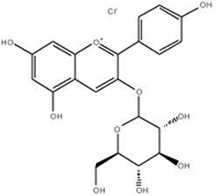
Fig. 1. Molecular structure of anthocyanin [17]
- Counter electrode preparation:
A low-cost carbon counter electrode was fabricated using the candle soot method. The FTO glass was held over a candle flame, forming a thin carbon layer that served as the catalytic surface.
- Cell assembly:
The dye-sensitized photoanode and carbon-coated counter electrode were clamped together with binder clips. The electrolyte solution (0.5 g KI and 0.05 g I₂ in 10 mL ethanol) was introduced between the electrodes by capillary action using a micropipette, ensuring complete filling of the inter-electrode gap.

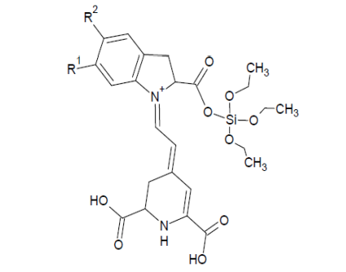
Fig. 2. Molecular structure of betalain [17]

Results and discussion

ATR-IR Spectroscopy
Both anthocyanin and betalain extracts exhibited broad hydroxyl (–OH) stretching vibrations centered around 3300 cm⁻¹, which are characteristic of hydrogen-bonded hydroxyl groups commonly present in polyphenolic compounds. These groups are crucial because they enhance solubility in polar solvents and facilitate strong hydrogen bonding with metal oxide surfaces. Additionally, distinct absorption peaks observed near 1600 cm⁻¹ were attributed to carbonyl (C=O) stretching vibrations, further confirming the presence of conjugated carbonyl functionalities as shown in Fig. 3 for anthocyanin and Fig. 4 for betalain. The coexistence of hydroxyl and carbonyl groups is particularly significant in the context of DSSCs, as both functional groups can coordinate with surface hydroxyl sites on titanium dioxide (TiO₂), promoting effective dye anchoring and electron transfer. This anchoring is a prerequisite for achieving efficient charge injection into the conduction band of TiO₂, thereby directly influencing the photocurrent generation of the cell. Importantly, no abnormal peaks, band broadening, or frequency shifts were detected in the spectra, suggesting that the molecular frameworks of anthocyanin and betalain were preserved during extraction. This structural integrity indicates that the dyes retained their light-harvesting properties and were chemically stable enough for use as sensitizers in DSSC fabrication.

UV-Vis Spectroscopy
The anthocyanin solution exhibited a sharp absorption peak at approximately 535 nm, corresponding to the characteristic π–π* electronic transitions of the conjugated aromatic structures in anthocyanin molecules. Betalain, in contrast, displayed a strong absorption maximum near 485 nm, which arises from the chromophoric betacyanin groups responsible for its deep red-purple coloration. As illustrated in Fig. 5, both absorption peaks fall well within the visible light region (400–700 nm), confirming the suitability of these pigments for solar energy harvesting.
The complementary nature of these absorption bands is particularly significant. Anthocyanin is more strongly absorbed in the green region of the spectrum, while betalain is more effective in the blue-green region. Together, they cover a broader portion of the visible spectrum, reducing spectral “gaps” and improving the probability of photon capture across multiple wavelengths. This broader light-harvesting window is advantageous for maximizing electron excitation and, consequently, photocurrent generation.
In the dyad system, the combined spectral response reveals that both dyes contribute simultaneously to solar absorption without significant spectral overlap or destructive interference. This suggests that the molecular structures of anthocyanin and betalain coexist without competitive adsorption on the TiO₂ surface, allowing each pigment to perform its sensitization function effectively. Enhanced spectral complementarity not only supports higher photocurrent output but also implies more efficient utilization of incident solar energy compared to single-dye systems. Furthermore, the absence of major peak shifts in the UV–Vis spectra indicates that the extraction procedures preserved the chromophoric integrity of both dyes, preventing degradation that might otherwise reduce light absorption efficiency. This spectral stability is critical for ensuring consistent device performance once the dyes are incorporated into DSSCs. Overall, the UV–Vis analysis provides strong evidence that anthocyanin and betalain, when combined, create a dyad system capable of superior solar harvesting compared to individual dye sensitizers.

Photovoltaic Performance
Using a Schottky cell design, the photovoltaic performance of solar cells based on betalain and anthocyanin was tested in simulated sunshine (1 Sun = 1000 W/m2). Furthermore, photocurrent–voltage curves were used to calculate essential characteristics, such as maximum power density (P_{max}), open-circuit voltage (V_{oc}), and short-circuit current density (J_{sc}), as illustrated in TABLE 2. The following equations mentioned previously were used to determine the maximum power, fill factor (FF), and power conversion efficiency (η):
$P_{max}​=V_{mp}​J_{mp}$​
$FF=\frac{P_{max}}{V_{oc}​J_{sc}}$
$η=\frac{V_{oc}​J_{sc}​FF​}{P_{in}}$​
The Maximum power density (Pmax) was calculated by applying the equation mentioned above to find the product of the voltage and current density at maximum power. Which were measured using a solar simulator at 1 Sun (1000W/m²). Pmax was calculated to determine the cells’ peak electricity output under ideal standard test conditions. The calculations are showed as follows:

-Anthocyanin:
Pmax =Vmp ×Jmp
= 250.0000E-3 * 85.2711E-6
= 21.3178E-6

-Betalain:
Pmax =Vmp ×Jmp
= 250.0000E-3 * 760.8415E-6
= 190.2104E-6

-Dyad:
Pmax =Vmp ×Jmp
= 246.0000E-3 * 102.8455E-6
= 25.31E-6

The fill factor (FF) was calculated by applying the equation mentioned above to find the quotient of the maximum power density over the product of the open circuit voltage (Voc) and the short circuit current density (Jsc). FF was calculated to determine how close the cells’ actual maximum power output is to the theoretical maximum. The calculations are showed as follows:

-Anthocyanin:
FF= Pmax / Voc ×Jsc
= 21.3178E-6 / (0.002 * 0.3)
=0.03

-Betalain:
FF= Pmax / Voc ×Jsc
= 190.2104E-6/ (0.001 * 0.2)
=0.95

-Dyad:
FF= Pmax / Voc ×Jsc
= 25.31E-6 / (0.004 * 0.1)
= 0.75

All of the key photovoltaic metrics clearly improved with the dyad-based DSSCs. Better charge separation and reduced recombination were probably facilitated by the dyad's wider absorption and the complementary alignment of the two pigments' energy levels. Furthermore, the TiO₂ surface may have had more consistent dye coverage due to the presence of numerous anchoring groups, which would have enhanced interfacial stability and electron transport. In contrast, narrower absorption spectra restricted the performance of both single-dye systems, even though they demonstrated functional photovoltaic activity. The two pigments in the dyad system, on the other hand, worked in concert to provide stronger and more consistent light harvesting, which increased the total efficiency.

Reasons for Low Voc and Jsc Compared to Literature
The observed Voc (0.004 V) and Jsc (0.1 μA/cm²) values are significantly lower than those reported in similar DSSC studies (typically 0.3–0.7 V and 1–5 mA/cm²). Several factors may explain this discrepancy:

- Low Dye Loading
Short immersion times (10–20 min) and relatively low dye concentrations likely resulted in incomplete TiO₂ surface coverage, reducing photon absorption and electron injection.
- Electrolyte Composition and Conductivity
The use of ethanol-based I₂/KI electrolyte (rather than acetonitrile or ionic liquids) can limit ionic mobility, slowing redox regeneration and lowering photocurrent.
- TiO₂ Film Thickness and Porosity
A single-layer TiO₂ film without scattering layers reduces light trapping and electron transport pathways, limiting Jsc.
- Charge Recombination
Absence of surface treatments (e.g., TiCl₄ post-treatment) and lack of co-adsorbents may have increased recombination at the TiO₂/dye/electrolyte interface, lowering Voc as in Reddy et al., [19].
- Measurement Conditions
If illumination intensity or calibration was below standard AM 1.5G (1000 W/m²), this would also depress current and voltage values.

TABLE II: Photovoltaic Properties of Anthocyanin and Betalain-Based DSSCs

Cell type | V_{oc}  (V) | J_{sc} (μA/cm2) | P_{max}  (μW/cm2) | FF | η  (%)
Anthocyanin | 0.002 | 0.3 | 20.083E-6 | 0.03 | 0.02
Betalain | 0.001 | 0.2 | 190.21E-6 | 0.95 | 0.02
Dyad | 0.004 | 0.1 | 25.31E-6 | 0.75 | 0.3

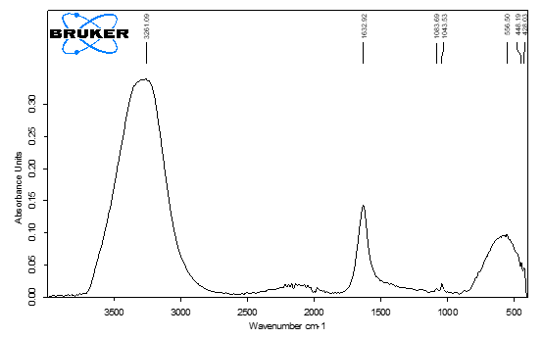
Fig. 3. ATR-IR of anthocyanin solution
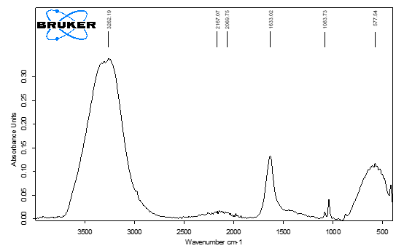
Fig. 4. ATR-IR of betalain solution
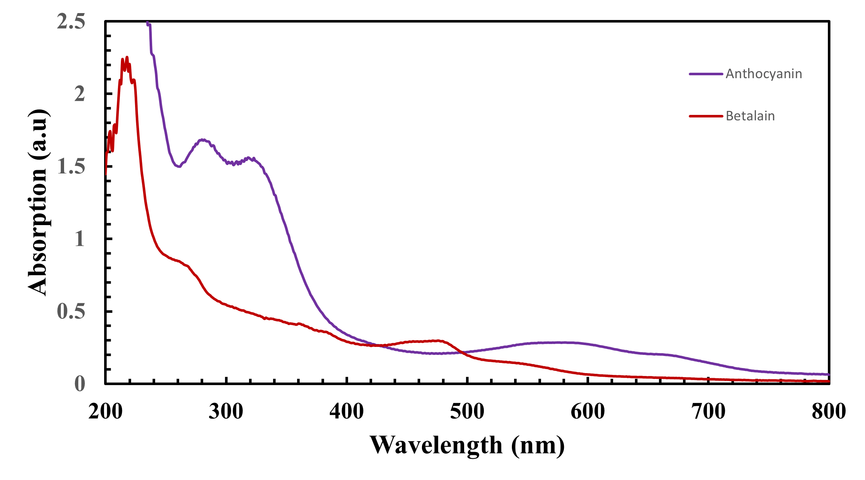
Fig. 5. UV-Vis spectra for anthocyanin and betalain solutions

Conclusion
This study demonstrates that natural dyes such as anthocyanin and betalain can function as effective photosensitizers in DSSCs, particularly when combined in a dyad structure. While single-dye devices exhibited limited performance (η ≈ 0.02%), the dyad configuration achieved a fifteen-fold improvement, reaching η = 0.3%. This enhancement is primarily attributed to the complementary absorption ranges of the two pigments and their effective anchoring on TiO₂, which together broadened the light-harvesting window and reduced recombination losses. Although the overall efficiencies remain lower than those of synthetic ruthenium-based dyes, these findings highlight the potential of natural pigments as sustainable and low-cost alternatives for solar energy conversion.
Future work will focus on refining extraction methods to improve pigment purity, optimizing dye adsorption through pH control, and introducing co-adsorbents to minimize aggregation and enhance electron injection. Additional strategies such as TiCl₄ post-treatment, multi-layer TiO₂ architectures, and alternative electrolytes with higher ionic conductivity will also be explored to boost Voc and Jsc values. Investigating long-term stability under real-world conditions and scaling up fabrication processes will be critical steps toward practical deployment.
From a commercial perspective, natural dye-based DSSCs offer a promising pathway for low-cost, eco-friendly photovoltaic solutions, particularly for niche applications such as indoor energy harvesting for IoT devices, smart sensors, and low-power electronics. Their reliance on abundant, biodegradable materials reduces environmental impact and manufacturing costs, making them attractive for sustainable product design.
This research aligns strongly with the United Nations Sustainable Development Goals (SDGs):
- SDG 7: Affordable and Clean Energy – by promoting renewable energy technologies that are accessible and cost-effective.
- SDG 12: Responsible Consumption and Production – through the use of natural, biodegradable materials and low-impact fabrication methods.
- SDG 13: Climate Action – by reducing dependence on fossil fuels and supporting the transition to low-carbon energy systems.
Natural dye dyads represent a promising direction for advancing solar technologies that are both innovative and closely aligned with global sustainability objectives.

References
[1] M. E. Yeoh and K. Y. Chan, “Recent advances in photo-anode for dye-sensitized solar cells: a review,” Int J Energy Res, vol. 41, no. 15, pp. 2446–2467, Dec. 2017, doi: 10.1002/ER.3764.
[2] S. Shalini, R. Balasundara Prabhu, S. Prasanna, T. K. Mallick, and S. Senthilarasu, “Review on natural dye sensitized solar cells: Operation, materials and methods,” Renewable and Sustainable Energy Reviews, vol. 51, pp. 1306–1325, Nov. 2015, doi: 10.1016/J.RSER.2015.07.052.
[3] S. K. Das, S. Ganguli, H. Kabir, J. I. Khandaker, and F. Ahmed, “Performance of Natural Dyes in Dye-Sensitized Solar Cell as Photosensitizer,” Transactions on Electrical and Electronic Materials, vol. 21, no. 1, pp. 105–116, Feb. 2020, doi: 10.1007/S42341-019-00158-Y/METRICS.
[4] G. Richhariya, A. Kumar, P. Tekasakul, and B. Gupta, “Natural dyes for dye sensitized solar cell: A review,” Renewable and Sustainable Energy Reviews, vol. 69, pp. 705–718, Mar. 2017, doi: 10.1016/J.RSER.2016.11.198.
[5] Green AgNPs for solar panels (directly solar-related, natural/green route):
Palanichamy, P., Krishnasamy, R., Meenakshi Sundaram, U., Thiagamani, S. M. K., Ilyas, R. A., & Hassan, A. M., “A practical green synthesis method of Ag NPs using rosy periwinkle plant leaves for solar panel coating,” Heliyon, vol. 9, no. 12, p. e22893, 2023, doi: 10.1016/j.heliyon.2023.e22893.
[6] H. TRIBUTSCH, “REACTION OF EXCITED CHLOROPHYLL MOLECULES AT ELECTRODES AND IN PHOTOSYNTHESIS*,” Photochem Photobiol, vol. 16, no. 4, pp. 261–269, Oct. 1972, doi: 10.1111/J.1751-1097.1972.TB06297.X.
[7] B. O’Regan and M. Grätzel, “A low-cost, high-efficiency solar cell based on dye-sensitized colloidal TiO2 films,” Nature 1991 353:6346, vol. 353, no. 6346, pp. 737–740, Oct. 1991, doi: 10.1038/353737a0.
[8] B. J. Maldon, “Mathematical modelling of dye-sensitized solar cells,” May 2025, Accessed: Dec. 11, 2025. [Online]. Available: /articles/thesis/Mathematical_modelling_of_dye-sensitized_solar_cells/29032862/1
[9] P. D. Sekaran and R. Marimuthu, “An Extensive Analysis of Dye-Sensitized Solar Cell (DSSC),” Brazilian Journal of Physics 2023 54:1, vol. 54, no. 1, pp. 28-, Dec. 2023, doi: 10.1007/S13538-023-01375-W.
[10] U. Ahmed, M. Alizadeh, N. A. Rahim, S. Shahabuddin, M. S. Ahmed, and A. K. Pandey, “A comprehensive review on counter electrodes for dye sensitized solar cells: A special focus on Pt-TCO free counter electrodes,” Solar Energy, vol. 174, pp. 1097–1125, Nov. 2018, doi: 10.1016/J.SOLENER.2018.10.010.
[11] S. J. Fonash, “Solar Cell Device Physics, Second Edition,” Solar Cell Device Physics, pp. 1–353, Jan. 2010, doi: 10.1016/C2009-0-19749-0.
[12] T. Le Bahers, T. Pauporté, P. P. Lainé, F. Labat, C. Adamo, and I. Ciofini, “Modeling Dye-Sensitized Solar Cells: From Theory to Experiment,” Journal of Physical Chemistry Letters, vol. 4, no. 6, pp. 1044–1050, Mar. 2013, doi: 10.1021/JZ400046P.
[13] N. Patni, S. G. Pillai, and P. Sharma, “Effect of using betalain, anthocyanin and chlorophyll dyes together as a sensitizer on enhancing the efficiency of dye-sensitized solar cell,” Int J Energy Res, vol. 44, no. 13, pp. 10846–10859, Oct. 2020, doi: 10.1002/ER.5752.
[14] M. Hamadanian, J. Safaei-Ghomi, M. Hosseinpour, R. Masoomi, and V. Jabbari, “Uses of new natural dye photosensitizers in fabrication of high potential dye-sensitized solar cells (DSSCs),” Mater Sci Semicond Process, vol. 27, pp. 733–739, Nov. 2014, doi: 10.1016/J.MSSP.2014.08.017.
[15] K. B. Erande et al., “Extraction of natural dye (specifically anthocyanin) from pomegranate fruit source and their subsequent use in DSSC,” Mater Today Proc, vol. 43, pp. 2716–2720, Jan. 2021, doi: 10.1016/J.MATPR.2020.06.357.
[16] A. Lim et al., “Higher Performance of DSSC with Dyes from Cladophora sp. as Mixed Cosensitizer through Synergistic Effect,” Journal of Biophysics, vol. 2015, no. 1, p. 510467, Jan. 2015, doi: 10.1155/2015/510467.
[17] Shati, A. A., Al-dolaimy, F., Alfaifi, M. Y., Sayyed, R. Z., Mansouri, S., Aminov, Z., Alubady, R., Gandla, K., Alawady, A. H. R., & Alsaalamy, A. H., “Recent advances in using nanomaterials for portable biosensing platforms towards marine toxins application: Up-to-date technology and future prospects,” Microchemical Journal, vol. 195, p. 109500, Oct. 2023, doi: 10.1016/j.microc.2023.109500.
[18] A. Sikder et al., “Characterization and Comparison of DSSCs Fabricated with Black Natural Dyes Extracted from Jamun, Black Plum, and Blackberry,” Energies 2023, Vol. 16, Page 7187, vol. 16, no. 20, p. 7187, Oct. 2023, doi: 10.3390/EN16207187.
[19] A. M. Ammar, H. S. H. Mohamed, M. M. K. Yousef, G. M. Abdel-Hafez, A. S. Hassanien, and A. S. G. Khalil, “Dye-Sensitized Solar Cells (DSSCs) Based on Extracted Natural Dyes,” J Nanomater, vol. 2019, no. 1, p. 1867271, Jan. 2019, doi: 10.1155/2019/1867271.

