Intelligent Agriculture Nutrition and Fertilization Monitoring System

Adnan Al-Smadi
Department of Computer
Science
Zarqa University
Zarqa, Jordan
a.alsmadi@zu.edu.jo
Ammar Erjoub
Depatrment of Electronics Engineering
Engineering Faculty YarmoukUniversity
Irbid, Jordan
201792126@ses.yu.edu.jo
Murad Al-Nusairat
Depatrment of Electronics Engineering
Engineering Faculty YarmoukUniversity
Irbid, Jordan
2018972134@ses.yu.edu.jo
Laith Freitekh
Depatrment of Electronics Engineering
Engineering Faculty YarmoukUniversity
Irbid, Jordan
2018972069@ses.yu.edu.jo

Abstract—Agriculture is a key factor for food supply and plays an ultimate role for people to survive worldwide. In recent years, climate changes and weather fluctuations around the world have affected the quality of crops and harvest. Intelligent agriculture is an emerging field of agriculture that employs the Internet of Things (IoT) technology to monitor, optimize, and enhance overall efficiency agricultural process. It can avoid the excess application of fertilizers and enable the farmer to plant his crops correctly. This paper proposes in intelligent agriculture nutrition and fertilization monitoring system. The system aims to remote monitoring, improve resource management, enhance crop quality, and increase efficiency. It uses ESP8266 Node MCU microcontroller connected to the NPK soil sensor to monitor soil conditions. The NPK sensor measures temperature, humidity, the levels of nitrogen, potassium, and phosphorus in soil. The nutrient levels will be adjusted based on sensor readings. The system integrates a mobile interface, enabled by a wireless connection, allowing users to remotely monitor and control the system through a mobile application. This feature offers flexibility and convenience, enabling users to adjust settings, view sensor data, and receive alerts from anywhere at any time.
Keywords—Intelligent agriculture, Blynk platform, IoT, Soil NPK sensor, ESP8266 microcontroller

Introduction
The utilization of the fast development of science and technology in agriculture field has increased in recent years. One area is real-time monitoring of soil condition. This is among the most important and pivotal factors to enhance agriculture. Agriculture is a key factor for food supply and plays an ultimate role for people to survive worldwide. Recently, climate changes and weather fluctuations around the world have affected the quality of crops and products. Due to population growth and food shortage, the need for increasing, controlling, and enhancing the crops quantity and quality became a major factor in human’s lives [1]. However, the majority of rural people still farming based on indigenous agricultural knowledge gained through their experience [2]. There are many challenges that face agriculture production such as soil salinity and arid condition [3]. These challenges lead to decrease in the crops productivity. In addition, the weather affects the quality of produces [4].
Intelligent system has emerged in information technology and become more important in the last decade. It is the answer to the accelerated technological growth of recent years [5, 6, 7, 8].
One important area of focus is the development of intelligent agriculture that integrates automation, sensing and monitoring mechanism to enhance agriculture operations. Intelligent agriculture is an emerging field of agriculture that uses the IoT technology to monitor, optimize, and enhance overall efficiency agricultural process [9].
In this paper we propose to design an intelligent agriculture fertilization system using ESP8266 MCU microcontroller. The objective of this system is to remotely monitor, and thus, enhance crop quality and efficiency. The ESP8266 MCU microcontroller is connected to the Blynk platform. The proposed intelligent agriculture system uses NPK soil sensor to monitor nutrition and soil conditions. The NPK sensor measures temperature, humidity, the levels of nitrogen (N), phosphorus (P), and potassium (K) in soil. Real-time data is displayed on an LCD interface, accompanied by audible and visual alerts. The nutrient levels will be adjusted based on sensor readings. The mobile interface enables users to remotely control the system, adjust schedules, view sensor data, and receive critical event notifications. The system will deliver nutrition and fertilization to plants, enhance growth, and reduce excess fertilizer usage.
Plants require several nutrients during their growth period. They require more N than any other nutrients [10]. However, only a small portion of the nitrogen is available in the soil for the plants. That is because most of the nitrogen in soil is in organic form which cannot be adsorbed by the plant. The best balance of the level of nitrogen in the soil depends on the clay content of soil.
Phosphorus supply is critical and is the second important crop nutrient after nitrogen for plants to complete their growth cycle [11, 12]. In addition, its role in plants growth cannot be ignored nor can be replaced by other nutrients. It is important in seed germination, root, flower and seed development. Potassium is also important nutrient for all kinds of crops. The best balance of the level of potassium in the soil is between (10-20) mg/Kg [13].

PROPOSED SYSTEM
The traditional farming has been relying on manual labor and has been inefficient. In recent years, climate changes and weather fluctuations around the world have affected the quality of crops and products. Due to population growth and food shortage, the need for increasing, controlling, and enhancing the crops quantity and quality became a major factor in human’s lives. One important aspect of intelligent agriculture is the fertilization and soil conditions. However, managing these conditions and environments efficiently requires integration of several factors. Internet of Things (IoT) based intelligent agriculture is important technique in farming which utilizes the fast developing technology to improve agricultural outcome. The IoT technology uses a wide variety of devices, protocols, networks, middleware, applications, systems, and data. When IoT is extended with sensors, actuators, and microcontrollers, farmers can increase demand of food and reduce resource wastage [14].
In this paper, we propose an intelligent agriculture fertilization and nutrition monitoring system based on Node MCU ESP8266 microcontroller. It uses an NPK soil sensor to monitor nutrition and soil conditions. The NPK soil sensor is connected with the ESP8266 microcontroller via RS485 module interface. The ESP8266 Node MCU microcontroller is integrated with the Blynk platform and is used to monitor and manage the conditions of the soil and crops fertilization. The main devices of the proposed intelligent farm integrated system are illustrated as follows.

ESP8266 Node MCU microcontroller
The ESP8266 Node MCU is a modern microcontroller designed by Espressif Systems in China [15]. It is a highly popular, self-contained Wi-Fi microcontroller, with built-in Transmission Control Protocol (TCP)- Internet Protocol (IP) networking software. It is cost effective and widely used in many applications such as Internet of Things (IoT) solutions due to its ease of use and compact size [16, 17].
ESP8266 Node MCU microcontroller comes with powerful processing speed on board. It has a high storage space which allows it to integrate with other devices such as sensors. Some of the key features of ESP8266 Node MCU microcontroller are the Wi-Fi for wireless communication, 32-bit microcontroller processor, central processing unit (clock speed) of 80 MHz, and Low power consumption [15].

RS485 module interface
It is a serial communication protocol. It represents a standard interface of the physical layer of communication. Two components can communicate with each other over a distance up to 1200m using RS485 module interface [18]. It is used in many automation systems and it has several real world applications. For example, it is used in robotics and home appliances

NPK soil sensor
This sensor is used to detect and measure the levels of N, P, and K in soil samples [19]. These nutrients together are referred to as NPK. They typically employ various technologies to monitor soil fertility and analyze the soil samples. Figure 1 shows the NPK sensor. The probe of the NPK soil sensor is inserted into the soil to gather data about the nutrient levels. It may be kept in the soil because of its resistant to acid and corrosion. By knowing the NPK levels, farmers can make good decision about fertilizer application and crop management.

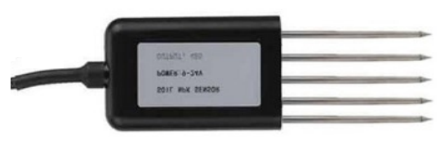
Fig. 1 The NPK soil sensor

Blynk Platform
Blynk is a powerful and comprehensive tool for IoT (Internet of Things) platform. It is designed to help users easily connect, monitor, and control hardware devices through smartphones or web interfaces. Blynk platform supports a wide range of hardware platforms such as ESP8266. Some of the Blynk platform features are as follows [17]:
- Provides user-friendly mobile apps for monitoring and controlling IoT devices.
- Provides cloud services for data storage.
- Real-data visualization through notifications.
- Offers open-source libraries.
- Offers a free tier with limited features.

Blynk platform plays an important role in the application of this IoT-based paper involving ESP8266 and NPK sensor to transmit data to the smartphone's screen.

SYSTEM IMPLEMENTATION
The controller of the proposed system is the ESP8266 Node MCU microcontroller. Through careful hardware connections and software programming, the soil NPK sensor is connected with the ESP8266 microcontroller via RS485 module interface. This setup allows the ESP8266 to communicate with the sensor, retrieve essential NPK sensor data, and send this data over Wi-Fi to a mobile app or web interface. With the Blynk platform, users can access real-time data from the NPK soil sensor and other integrated sensors on their mobile devices. Blynk’s notification features also provide added convenience by sending alerts and notifications when NPK sensor levels deviate from desired ranges, enhancing precision agriculture and enabling farmers to make timely adjustments to optimize crop growth. The circuit diagram of the proposed intelligent agriculture nutrition and fertilization monitoring system is shown in Figure 2. The ESP8266 Node MCU microcontroller is connected to the NPK soil sensor via the RS485 module interface, with pins D2 (RXD) and D3 (TXD). The ESP8266 receives the data from the sensor on pin D2 (RXD) and processes it. It then sends this data to the Blynk cloud platform over Wi-Fi. The data is displayed in the Blynk mobile app, allowing users to monitor real-time soil nutrient levels on their smartphones or other devices. This integration enhances precision agriculture and provides timely information for optimizing crops growth and resource management. A prototype for the proposed intelligent agriculture nutrition and fertilization monitoring system has been implemented and tested. Figure 3 shows a sample reading for the measurement data displayed in the Blynk mobile application. It displayed the readings for the temperature, humidity, the levels of N, P, and K in soil samples. A sample of the ESP8266 code to communicate between the NPK sensor and the ESP8266 microcontroller is shown in Figures 4 and 5.
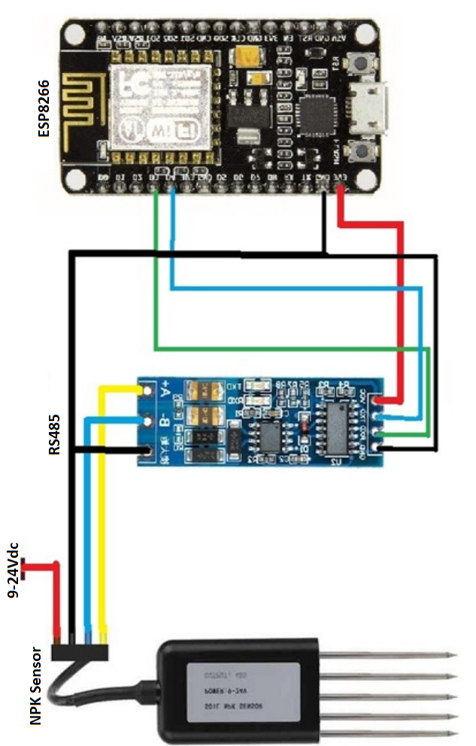
Fig. 2. Circuit diagram and connection for ESP8266 connected to the sensor.
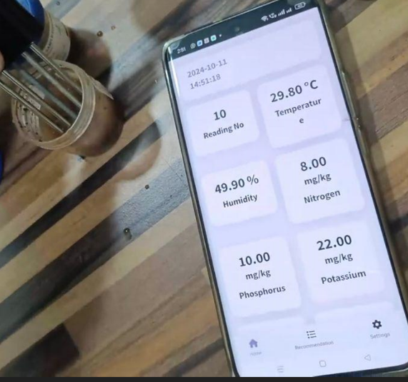
Fig. 3. The data displayed in the Blynk mobile app.

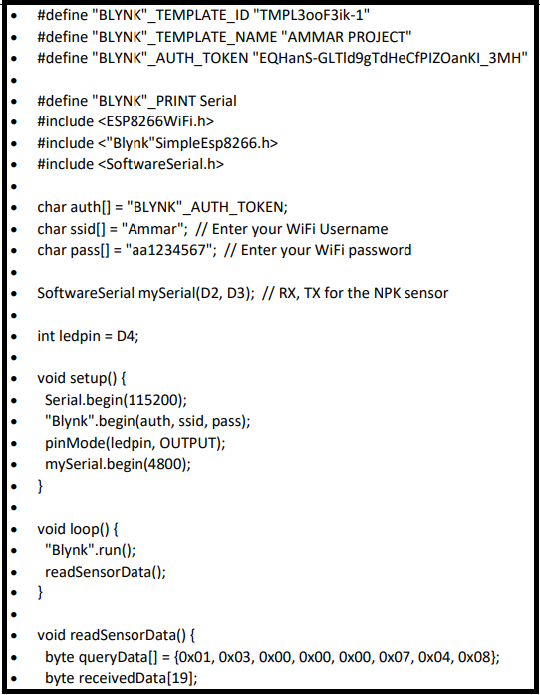
Fig. 4. ESP8266 code for the NPK sensor.
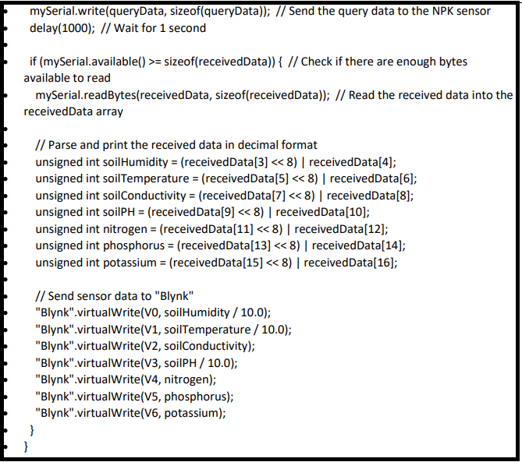
Fig. 5. ESP8266 code for the NPK sensor (continuation).

IV CONCLUSION
This paper presents an intelligent agriculture fertilization monitoring system using ESP8266 Node MCU microcontroller. The system uses NPK soil sensor to monitor important nutrient parameters such N, P, and K in soil samples. In addition, it measures temperature and humidity in the surrounding environment. The ESP8266 controller is connected with the Blynk platform and is used to monitor and manage the conditions of the soil and crops fertilization. The system offers real-time data visualization and immediate alerts, ensuring precise control and peace of mind for users. The incorporation of an efficient nutrient and fertilization system further ensures optimizing plant growth based on sensor feedback. Additionally, the mobile interface introduces an advanced level of convenience, granting users the ability to monitor and control the system remotely while receiving timely event notifications. This combination of sensor technology and wireless connectivity empowers farmers to manage their agricultural environments conveniently and effectively.

Acknowledgment
“This research is funded partially by Zarqa University-Jordan”

References

- Elsayed Mohamed, Abdelaziz Belal, Sameh Abd-Elmabod, Mohammed El-Shirbeny, Abd-Alla Gad, Mohamed Zahran, “Smart farming for improving agricultural management,” The Egyptian Journal of Remote Sensing and Space Science, vol. 24, Issue 3, Part 2, pp. 971-981. December 2021.
- Adithya Vadapalli, Swapna Peravali, and Venkata Rao Dadi, “Smart Agriculture System using IoT Technology,” International Journal of Advance Research in Science and Engineering, vol. 9, no. 9, 2020.
- Adnan Al-Smadi, Murad Al-Nusairat, Ammar Erjoub, Laith Freitekh, and Mohammed Khouj, “Intelligent Farm Irrigation and Safety System” 25th International Arab Conference on Information Technology (ACIT), Zarqa, Jordan, December 10-12, 2024.
- Abdel-Fattah, M.K., Mohamed, E.S., Wagdi, E.M., Shahin, S.A., Aldosari, A.A., Lasaponara, R., Alnaimy, M.A. “Quantitative evaluation of soil quality using Principal Component Analysis: The case study of El-Fayoum depression Egypt,” Sustainability, vol. 13, Issue 4, 2021.
- Martin Molina, “What is an intelligent system?” DOI: 10.48550/arXiv.2009.09083 93 Shapiro, S.C. Encyclopedia of Artificial Intelligence, 2nd ed. USA: John Wiley & Sons, Inc., 2020.
- Adnan Al-Smadi, Wasan Al-Ksasbeh, Mohammad Ababneh, and Manar Al-Nsairat, " Intelligent Automobile Collision Avoidance and Safety System"17th IEEE International Multi-Conference on Systems, Signals & Devices, Sfax, Tunisia, July 20-23, 2020.
- Adnan Al-Smadi, Salam Salah, Areen Al-Moomani, and Majd Al-Bataineh, “Street Lighting Energy-Saving System” 16th IEEE International Multi-Conference on Systems, Signals & Devices, Istanbul, Turkey, pp. 763-766, March 21-24, 2019.
- Shujuan Wang, Haofu Guan,Yuqing Wang, Kanghui Zhang, Yuntao Dai, Shouxu Qiao, and Jihong Shen, "Intelligent Recognition of Gas-Liquid Two-Phase Flow Based on Optical Image", The International Arab Journal of Information Technology (IAJIT) ,Volume 20, Number 04, pp. 609 - 617, July 2023.
- Vishal Uttam Nikam and Aditya Santosh Sawan, “Internet of Things (IoT) based Smart Agriculture System,” International Journal of Advanced Research in Science, Communication and Technology (IJARSC), vol. 3, issue 5, 2023.
- Murphy DV, Osman M, Russell CA, Darmawanto S and Hoyle FC, “Potentially mineralisable nitrogen: relationship to crop production and spatial mapping using infrared reflectance spectroscopy,” Australian Journal of Soil Research, vol. 47, pp.737–741, 2009.
- Johnstown Castle, Tim Sheil, J. Bolger, Agri Merchants “The Efficient Use of Phosphorus in Agricultural Soils,” The Fertilizer Association of Ireland (FAI), Technical Bulletin Series – No. 4, February 2019.
- Esther Mwende Muindi, “Understanding Soil Phosphorus,” International Journal of Plant & Soil Science, vol. 31, no. 2, pp. 1-18, 2019.
- Subhash Mandloi, Shubham Singh, and Sunil Prajapati, “Potassium and its forms in Soil,” The Agriculture Magazine, vol.1, issue 4, 2022.
- Neema S, Vishnumaya Suresh, Vishnupriya Suresh, Kavya Suresh, “IoT Based Smart Agriculture Monitoring and Irrigation System Using Renewable Energy,” International Journal of Progressive Research in Science and Engineering, vol. 5, no. 4., April 2024.
- ESP8266 EX Datasheet, Espressif Systems, Version 7, 2023. https://www.espressif.com/sites/default/files/documentation/0a-esp8266ex_datasheet_en.pdf
- Siddesh G K, R. K. Patel, S. Maitra, S. Bhattacharya, S. Moosa and P. Pavan, "Robotic Car Using NodeMCU ESP8266 Wi-Fi Module," 9th IEEE International Conference on Advanced Computing and Communication Systems, Coimbatore, India, pp. 1439-1443, 2023, doi:10.1109/ICACCS57279.2023.10113098.
- A. Anderies, R. A. Haerudin, V. Aurelia Tan, J. Kanigara and A. Chowanda, "iPlant: Implementation of an Automatic Plant Watering System Using NodeMcu ESP8266 and Blynk," 11th IEEE International Conference on Information and Communication Technology, Melaka, Malaysia, pp. 159-164 2023, doi:10.1109/ICoICT58202.2023.10262470.
- Soltero, Manny; Zhang, Jing; Cockril, Chris; Zhang, Kevin; Kinnaird, Clark; and Kugelstadt, Thomas, “RS-422 and RS-485 Standards Overview and System Configurations, Application Report,” Texas Instruments (Technical report). SLLA070D, June 2002
- Haristian Pratama, Amsar Yunan, Rudi Arif Candra, “Design and Build a Soil Nutrient Measurement Tool for Citrus Plants Using NPK Soil Sensors Based on the Internet of Things“ Brilliance Research of Artificial Intelligence, vol. 1, number 1, November 2021.

