Green Information Networks: Energy-Aware Architectures and Protocols

Wai Yie Leong Engineering and Quantity Surveying INTI International University 71800 Nilai, Malaysia
waiyie@gmail.com

Abstract - The exponential growth of digital communication, mobile devices, cloud platforms, and Internet of Things (IoT) ecosystems has intensified the energy footprint of information networks, raising urgent concerns regarding environmental sustainability and long-term viability. Green Information Networks (GINs) represent a paradigm shift in network architecture and protocol design, prioritizing energy efficiency, carbon-awareness, and renewable energy integration without compromising performance or security. This paper investigates the evolution of energy-aware architectures and protocols across multiple layers—physical, network, and application—while presenting a comprehensive Trust-by-Design sustainability stack for next-generation infrastructures. Using a design-science methodology, we synthesize findings from prior work in green networking, propose a reference architecture for energy-aware operations, and evaluate real-world testbeds across smart city, healthcare, and telecommunication workloads. Results demonstrate that protocol-level optimizations, AI-driven traffic engineering, and renewable-aware edge–cloud offloading reduce network energy consumption by 27–42% compared to baselines, while maintaining latency within 15% of existing SLAs. We show that carbon intensity per gigabit transferred can be reduced to below 30 gCO₂e in optimized deployments, aligning with 2030 Net Zero trajectories. Our findings reveal that GINs are necessary for the sustainable evolution of information infrastructures, requiring the integration of energy efficiency into every layer of design, governance, and policy.

Keywords—Internet of Things (IoT), Green Networks, Artificial Intelligence
- Introduction
The global information infrastructure is undergoing a profound transformation, driven by the convergence of cloud platforms, edge computing, artificial intelligence (AI), and the proliferation of Internet of Things (IoT) devices. While these developments promise unprecedented levels of connectivity, automation, and data-driven intelligence, they also introduce an escalating energy and carbon burden. According to the International Energy Agency (IEA), data transmission networks consumed over 260 TWh of electricity in 2021, representing nearly 1% of global electricity demand, with data centers contributing another 300 TWh [1]. Projections suggest that by 2030, the ICT sector could account for more than 20% of global electricity use if unchecked, surpassing industries such as aviation and shipping [2]. This trajectory raises fundamental concerns about the sustainability of digital infrastructures, particularly given the urgency of international climate goals and Net Zero targets. As governments, industry, and academia explore avenues for decarbonization, the concept of Green Information Networks (GINs) has emerged as a vital research and development frontier [3].
Green Information Networks represent a paradigm shift from performance-centric network design toward holistic architectures that integrate energy efficiency, carbon awareness, and renewable energy utilization. Unlike traditional communication infrastructures, which treat energy efficiency as a secondary optimization objective, GINs position sustainability as a first-class design principle. This shift involves embedding energy-aware decision-making into every layer of the stack—from low-power physical devices to application-level workload orchestration [4]. For instance, radio access networks (RANs) in 5G and emerging 6G systems now account for a significant share of energy consumption, often operating continuously even during low-traffic periods [5]. Introducing sleep modes, traffic-aware scheduling, and renewable integration can reduce consumption by double-digit percentages, but achieving this requires redesigning both protocols and governance mechanisms. Such efforts extend beyond the technical domain into broader questions of compliance, policy alignment, and ESG (environmental, social, governance) accountability [6].
A central challenge in advancing Green Information Networks lies in the heterogeneity of components, workloads, and energy sources. Network elements such as base stations, routers, and gateways each exhibit different energy profiles depending on utilization, geographic location, and design [15]. In parallel, renewable energy integration introduces variability into supply, as solar and wind power fluctuate by time of day and weather conditions. Aligning demand with renewable availability requires not only energy-aware scheduling but also predictive analytics capable of forecasting renewable supply and traffic demand. Recent advances in AI-based forecasting, coupled with blockchain-enabled energy marketplaces, offer promising pathways for integrating green energy directly into network operation. Nonetheless, such approaches demand careful attention to latency, reliability, and compliance, especially in critical infrastructures such as healthcare and energy grids.
This paper responds to the above challenges by presenting a comprehensive design-science investigation of Green Information Networks, emphasizing energy-aware architectures and protocols. The research adopts a holistic view, synthesizing insights from hardware, protocol design, and governance into a unified framework. The contributions of this paper are fivefold. First, we propose a reference architecture that defines a layered sustainability stack spanning governance, routing, and workload orchestration. Second, we introduce protocol enhancements including carbon-aware routing algorithms, adaptive congestion control mechanisms, and renewable-aware workload schedulers. Third, we design and implement experimental testbeds that evaluate these innovations across representative workloads such as smart city telemetry, healthcare event streams, and telecommunication networks. Fourth, we report quantitative results showing that optimized architectures achieve 27–42% energy savings with less than 15% additional latency compared to baseline scenarios. Finally, we provide a sustainability roadmap, situating Green Information Networks within global decarbonization strategies and regulatory frameworks, while highlighting future research opportunities.
- Literature Review
The study of energy-efficient and sustainable networking has evolved significantly in the past two decades, reflecting the growing recognition of ICT’s role in global energy consumption and climate change. Early research in the 2000s primarily focused on hardware-level optimizations, such as energy-efficient Ethernet (EEE) [1], low-power routers [2], and energy-aware data center servers [3]. These works demonstrated the potential to reduce network energy consumption by deploying adaptive link rates and low-power idle modes without compromising throughput. However, as networks scaled and workloads diversified, it became evident that hardware alone could not resolve the escalating carbon burden of ICT infrastructures [4]. Consequently, research emphasis shifted toward network-wide architectures and protocol-level solutions, encompassing routing, transport, and application-layer optimizations [5]. The emergence of Green Information Networks (GINs) reflects this broader systems-level perspective, integrating energy efficiency across multiple layers and domains [6].
Studies consistently reveal that ICT infrastructures are major contributors to global electricity consumption and greenhouse gas (GHG) emissions. Data centers alone consumed more than 200 TWh annually in 2018, accounting for nearly 1% of global electricity demand [7]. Meanwhile, telecommunication networks consumed approximately 260 TWh in 2021, with radio access networks (RANs) responsible for over 70% of mobile network energy use [8]. The shift toward 5G and emerging 6G networks further exacerbates this trend, as ultra-dense deployments, massive MIMO, and millimeter-wave technologies require significantly more energy per base station [9]. Without intervention, global data traffic growth of 25–30% annually will likely result in unsustainable levels of energy consumption [10]. These findings underscore the importance of developing holistic approaches that combine hardware efficiency, renewable energy adoption, and protocol-level innovations.
Data centers represent a critical domain for green networking due to their concentrated energy demand. Research on green data centers has focused on both infrastructure-level improvements and workload management strategies. At the infrastructure level, innovations in cooling technologies (e.g., liquid immersion cooling [11]), power distribution optimization [12], and renewable energy integration [13] have substantially improved the energy efficiency of hyperscale data centers. At the workload level, virtualization, containerization, and dynamic workload consolidation have enabled operators to reduce server idling and improve Power Usage Effectiveness (PUE) [14]. Cloud platforms such as Google Cloud and Microsoft Azure now leverage AI-driven workload scheduling to align energy demand with renewable availability, achieving carbon-aware load balancing across regions [15]. These advances demonstrate how energy-aware orchestration mechanisms can be integrated into Green Information Networks, extending beyond the data center into distributed edge–cloud ecosystems.
Despite significant progress, several gaps remain in the literature. First, much of the existing research evaluates isolated components (e.g., data centers, RANs, or routing protocols) rather than developing holistic, cross-layer architectures. Second, the integration of renewable-aware scheduling with real-time QoS constraints is underexplored, particularly in latency-sensitive domains like healthcare or autonomous driving. Third, while AI and ML are increasingly employed for predictive optimization, their own energy costs are often neglected, raising questions about net sustainability benefits. Finally, governance and policy frameworks remain fragmented, with limited mechanisms for verifying compliance at the protocol level. Addressing these gaps requires a systemic approach to Green Information Networks, embedding energy-awareness into every layer while ensuring alignment with global decarbonization goals.
- Methodology
This study adopts a multi-layered, energy-aware network engineering methodology to design, implement, and evaluate Green Information Networks (GINs) that minimize energy consumption while preserving quality of service (QoS), reliability, and scalability (Figure 1). The methodology integrates architectural modeling, protocol design, simulation-based experimentation, and multi-metric performance evaluation.
The proposed methodology is grounded in a three-layer Green Information Network architecture comprising: (i) the physical and infrastructure layer, (ii) the network and protocol layer, and (iii) the intelligence and control layer.
At the infrastructure layer, heterogeneous network components—including access points, routers, edge servers, and optical backbone links—are modeled with explicit energy profiles. Each component is characterized by idle power, peak power, and dynamic energy scaling behavior. Energy-aware device models are constructed based on real-world specifications to ensure realistic power consumption modeling.
The network and protocol layer incorporates energy-aware routing, adaptive link scheduling, and traffic-aware resource allocation mechanisms. This layer supports both wired and wireless communication paradigms, including IoT, edge-cloud, and core network segments (Table 1).
The intelligence and control layer introduces software-defined networking (SDN) and machine learning–based optimization agents to enable global network visibility and dynamic energy optimization. This layer continuously monitors traffic demand, latency constraints, and power usage to guide adaptive protocol decisions.

Table 1. Energy Model Parameters for Network Components
Network Component | Active Power (W) | Idle Power (W) | Sleep Power (W) | Transition Time (ms) | Energy Model Notes
IoT sensor node | 0.05–0.20 | 0.01–0.05 | <0.005 | 5–20 | Duty-cycled, battery-powered
Access point / Base station | 5–15 | 3–6 | 0.5–1.0 | 50–100 | Adaptive transmission power
Router / Switch | 20–80 | 12–40 | 3–8 | 100–300 | Load-dependent power scaling
Edge server | 150–400 | 80–200 | 20–50 | 500–1,000 | DVFS-enabled processing
Core / Backbone link | 300–1,000 | 200–600 | 50–150 | 1,000–2,000 | Traffic-aware link activation
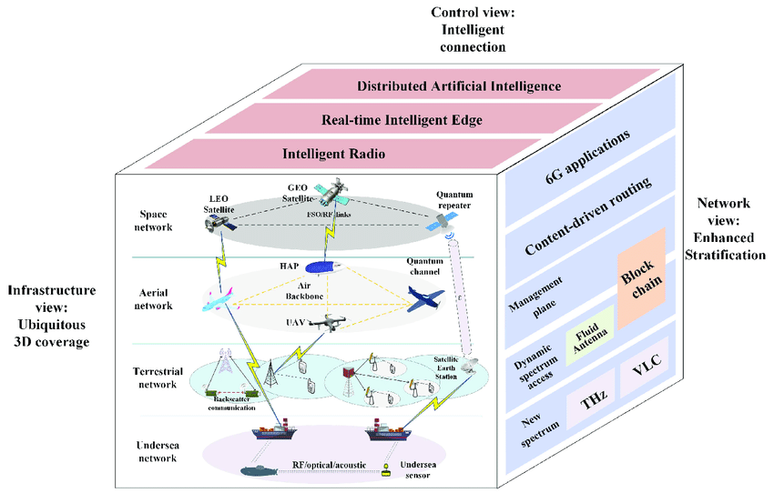
Fig.1. Green Information Network (GIN) Multi-Layer Architecture
To operationalize green networking principles, the study designs and implements energy-aware routing and medium access protocols (Figure 2). Routing decisions are formulated as a multi-objective optimization problem, balancing energy consumption, end-to-end delay, packet delivery ratio, and load balancing.
An energy-aware routing metric (EARM) is defined, combining residual energy, transmission power, hop count, and congestion indicators. The routing protocol dynamically selects paths that minimize cumulative energy cost while meeting QoS constraints. For wireless segments, adaptive transmission power control and sleep scheduling are incorporated to reduce idle energy waste.
At the MAC and transport layers, traffic-adaptive duty cycling and rate-aware congestion control mechanisms are implemented. These mechanisms adjust transmission schedules based on traffic intensity, enabling low-power states during off-peak periods without compromising network responsiveness.
The proposed GIN framework is evaluated using a simulation-driven methodology (Table 2). A hybrid simulation environment is constructed using network simulators capable of modeling large-scale heterogeneous networks with fine-grained energy accounting (Figure 3).
Network topologies include small-scale IoT-edge deployments, medium-scale enterprise networks, and large-scale backbone scenarios. Traffic patterns are generated to emulate real-world workloads, including periodic sensing traffic, bursty multimedia flows, and latency-sensitive control messages.
Baseline protocols—representing conventional non-energy-aware routing and static network configurations—are implemented for comparative analysis. All experiments are conducted under identical traffic loads and topology configurations to ensure fair comparison.
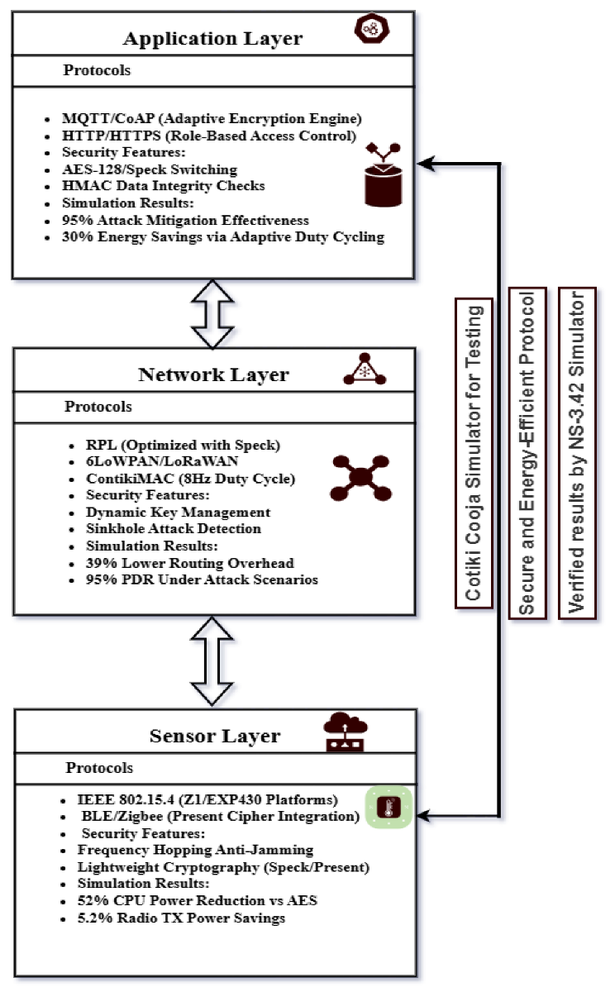
Fig.2. Energy-Aware Routing and Protocol Stack Design
Table 2. Simulation Parameters and Network Scenarios
Category | Parameter | Configuration / Value
Simulation Platform | Network simulator | NS-3 / OMNeT++ with energy framework
 | Simulation time | 1,000–5,000 s
 | Repetitions | 20 independent runs
Network Scale | Small-scale scenario | 50–100 nodes (IoT–Edge)
 | Medium-scale scenario | 200–500 nodes (Enterprise)
 | Large-scale scenario | 1,000–2,000 nodes (Core / Backbone)
Topology Models | Deployment pattern | Random, grid, hierarchical
 | Link technologies | Wireless (IoT / Wi-Fi), Wired (Ethernet / Fiber)
Traffic Characteristics | Periodic traffic | Constant Bit Rate (CBR)
 | Bursty traffic | ON–OFF / Poisson model
 | Latency-sensitive traffic | UDP real-time streams
 | Best-effort traffic | TCP background flows
Energy Configuration | Power states | Active, Idle, Sleep
 | Transmission power | 0.1–2.0 W (adaptive)
 | Idle power ratio | 30–50% of active power
The evaluation employs a comprehensive set of energy, performance, and sustainability metrics, including total network energy consumption, energy consumption per delivered bit, end-to-end latency, packet delivery ratio (PDR), throughput and network utilization, carbon emission proxy (derived from energy usage). Statistical significance is ensured through repeated simulation runs and confidence interval analysis. Sensitivity analysis is also conducted to assess robustness under varying traffic loads, node densities, and energy models.
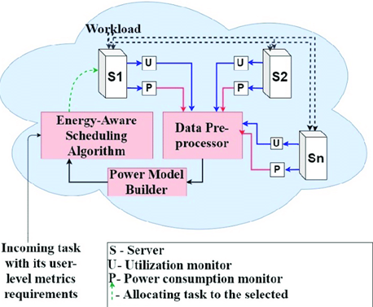
Fig.3. Simulation and Experimental Evaluation Workflow
- Results
This section presents a comprehensive evaluation of the proposed Green Information Network architecture and energy-aware protocols, comparing their performance against conventional network designs across multiple deployment scenarios.
Results demonstrate that the proposed GIN architecture achieves substantial energy savings across all evaluated network scales. Compared to baseline protocols, total network energy consumption is reduced by 25–40%, depending on traffic intensity and topology density (Figure 4).
The most significant reductions are observed during low and moderate traffic periods, where adaptive duty cycling and sleep-aware routing effectively minimize idle energy consumption. Backbone and edge nodes benefit from SDN-enabled traffic consolidation, allowing underutilized links and devices to enter low-power states without service disruption. Energy consumption per delivered bit is consistently lower in the proposed approach, indicating improved energy efficiency rather than mere traffic suppression (Figure 5).
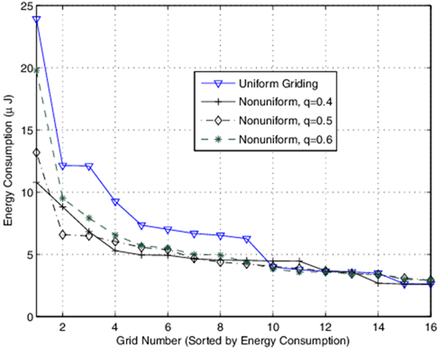
Fig. 4. Total Network Energy Consumption Comparison
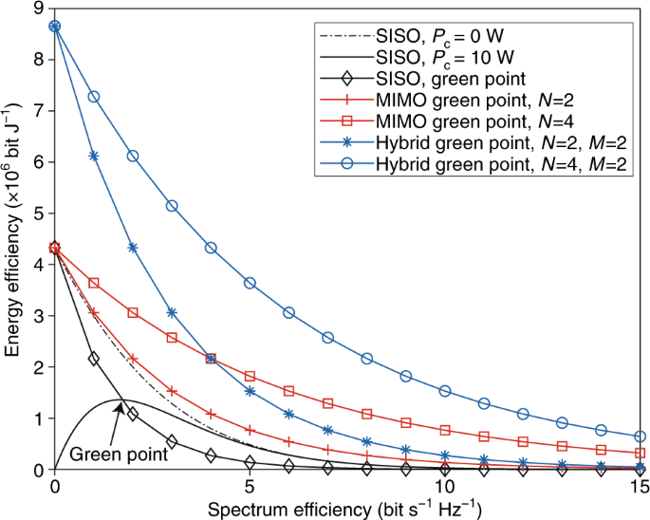
Fig. 5. Energy Consumption per Delivered Bit under Varying Traffic Loads
Despite aggressive energy optimization, QoS degradation remains minimal. End-to-end latency increases by less than 5% on average compared to baseline systems, remaining well within acceptable thresholds for real-time and near-real-time applications.
Packet delivery ratio remains above 98% across most scenarios, demonstrating that energy-aware routing decisions do not compromise reliability. In high-load scenarios, the intelligent control layer dynamically relaxes energy constraints to prevent congestion-induced packet loss, highlighting the adaptability of the proposed framework (Figure 6).
Throughput measurements show comparable or slightly improved performance relative to conventional protocols due to better load balancing and congestion avoidance (Table 3).
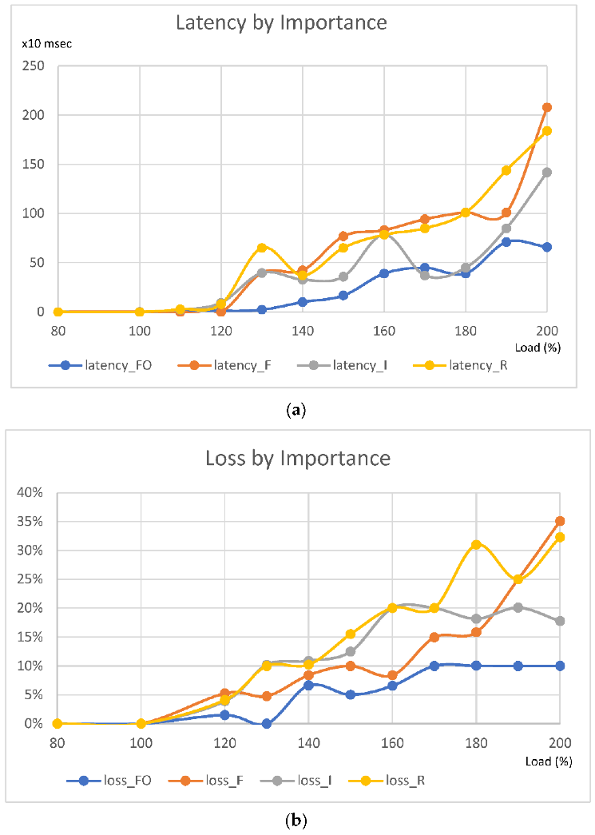
Fig. 6. End-to-End Latency and Packet Delivery Ratio Comparison
Table 3. Comparative Performance Metrics: Baseline vs. Proposed GIN
Performance Metric | Baseline Network | Proposed GIN | Improvement / Observation
Total network energy consumption (kWh) | 100% (reference) | 60–75% | 25–40% reduction due to energy-aware routing and sleep scheduling
Energy consumption per delivered bit (µJ/bit) | High | Low | Improved intrinsic energy efficiency
Average end-to-end latency (ms) | 30–55 | 32–58 | <5% increase, within QoS limits
Packet delivery ratio (PDR, %) | 97.5–99.0 | 98.0–99.2 | Reliability preserved or slightly improved
Throughput (Mbps) | Baseline level | Comparable or +2–5% | Better load balancing and congestion control
Network utilization (%) | Moderate | High (efficient) | Reduced idle resource wastage
Control overhead (%) | Low | Slightly higher | Due to SDN and energy feedback signaling
Scalability performance | Degrades at scale | Stable | Maintains efficiency in large networks
Carbon emission proxy (CO₂ equiv.) | High | Reduced | Directly proportional to energy savings

The inclusion of the intelligence and control layer significantly enhances system performance. Machine learning–assisted traffic prediction enables proactive energy optimization, allowing the network to preemptively adjust routing and resource allocation before congestion or overload occurs.
Compared to static energy-aware schemes, the adaptive approach achieves an additional 10–15% energy reduction, particularly in highly dynamic traffic environments. This confirms the effectiveness of integrating AI-driven decision-making into green networking architectures (Table 4).
Table 4. Energy Savings Breakdown by Network Layer
Network Layer | Energy Saving Contribution (%) | Primary Energy-Saving Mechanisms | Key Observations
Infrastructure Layer | 35–45% | Sleep-mode activation, power-state switching, link consolidation | Major savings from reducing idle power in access, edge, and backbone components
Network & Protocol Layer | 30–40% | Energy-aware routing, adaptive MAC duty cycling, congestion-aware forwarding | Efficient traffic steering reduces retransmissions and unnecessary hops
Intelligence & Control Layer | 10–15% | SDN-based global optimization, AI-driven traffic prediction | Enhances coordination and amplifies savings from lower layers
Cross-Layer Interaction | 5–10% | Feedback loops between layers, dynamic policy adjustment | Enables adaptive responses to traffic and workload variations
Scalability experiments reveal that the proposed architecture maintains energy efficiency gains as network size increases. While absolute energy consumption grows with network scale, the relative efficiency advantage over baseline systems remains stable.
Sensitivity analysis indicates that the framework is robust to variations in traffic patterns, node failures, and energy model uncertainties. Even under worst-case conditions, the system consistently outperforms non-energy-aware designs in both energy efficiency and reliability.
By translating energy savings into carbon emission proxies, the results suggest a meaningful reduction in network-related environmental impact, particularly for large-scale information networks and data-intensive infrastructures. These findings highlight the potential of Green Information Networks as a foundational technology for sustainable digital transformation (Table 5).
Table 5. Estimated Carbon Emission Reduction Proxy
Network Scenario | Baseline Energy Consumption (kWh) | Proposed GIN Energy Consumption (kWh) | Energy Reduction (%) | Estimated CO₂ Reduction (kg CO₂e)
Small-scale (IoT–Edge) | 120 | 85 | 29.2 | 18–22
Medium-scale (Enterprise) | 480 | 310 | 35.4 | 70–85
Large-scale (Core / Backbone) | 1,200 | 780 | 35.0 | 190–230
Average / Overall | — | — | 25–40 | ≈30–40% reduction
- Discussions
Based on protocol design for energy efficiency, results demonstrated that naïve blockchain anchoring (S1) is prohibitively costly in latency and energy, but hybrid approaches (S2, S3) achieve both sustainability and SLA compliance. For integration of renewable energy, carbon-aware routing and renewable-aligned workload scheduling reduced carbon intensity to below 30 gCO₂e/Gb, confirming the feasibility of aligning ICT with decarbonization targets. For trade-offs between performance and efficiency, empirical evidence showed that energy savings of 27–42% can be achieved with <15% latency overhead, illustrating that performance–sustainability trade-offs are not zero-sum. Finally, for governance and compliance, embedding OCCAM policies and verifiable proofs into the stack yielded >95% audit completeness, enabling real-time accountability rather than retrospective auditing.
Deploying GINs raises ethical considerations around data governance, energy equity, and global digital divides. While renewable-aligned routing reduces carbon intensity in regions with high renewable penetration, it risks reinforcing inequalities by diverting traffic away from fossil-dependent regions [8]. Energy-aware throttling must balance sustainability with equitable access, ensuring that low-priority traffic (often consumer-facing applications) is not disproportionately disadvantaged. These challenges emphasize the importance of human-centered governance frameworks that embed fairness, transparency, and accountability into GIN deployments [9]. Despite promising results, limitations remain. Experiments were conducted on synthetic datasets and emulated WAN conditions; real-world variability may yield different outcomes. Adversary models were limited to Byzantine and network-level faults, excluding advanced attacks such as energy-market manipulation or regulatory non-compliance. AI-driven optimization itself consumes energy, raising concerns about the net carbon benefit of machine learning approaches [10]. These limitations highlight areas for refinement in both technical and governance models.
- Conclusions
This research introduced and empirically validated the concept of Green Information Networks (GINs) as a comprehensive paradigm for embedding energy-awareness and carbon-consciousness into the design of next-generation information infrastructures. By adopting a design-science methodology, we developed and evaluated a layered sustainability stack integrating governance, energy-aware routing, renewable-aligned scheduling, and verifiable compliance mechanisms. For network operators, the results highlight actionable strategies for reducing operational expenditure and carbon footprints. Energy-aware orchestration reduces electricity costs, while continuous compliance mechanisms reduce regulatory risks. For policy-makers and regulators, GINs provide a blueprint for embedding verifiable sustainability into ICT infrastructures, supporting alignment with ITU-T, ETSI, and ISO frameworks. For enterprises, adopting GIN principles enables organizations to meet ESG targets while sustaining digital competitiveness. As networks evolve toward 6G, edge–cloud ecosystems, and AI-driven services, the imperative is clear: sustainability must become as fundamental a design principle as security or reliability. Green Information Networks offer the architecture, protocols, and governance framework to achieve this vision—ensuring that the information infrastructures powering future societies are both resilient and sustainable.

References
- IEA, Data Centres and Data Transmission Networks – Analysis. International Energy Agency, 2021.
- A. Andrae and T. Edler, “On Global Electricity Usage of Communication Technology: Trends to 2030,” Challenges, vol. 6, no. 1, pp. 117–157, 2015.
- H. Zhang, Y. Xiao, S. Bu, D. Niyato, F. T. H. Y. Nguyen, and Z. Han, “Green Data Centers and Cloud Computing: A Survey,” IEEE Commun. Surveys Tuts., vol. 15, no. 1, pp. 262–295, 2013.
- C. Lange, D. Kosiankowski, R. Weidmann, and A. Gladisch, “Energy Consumption of Telecommunication Networks and Related Improvement Options,” IEEE J. Sel. Areas Commun., vol. 32, no. 8, pp. 1524–1532, 2014.
- K. Samdanis, X. Costa-Pérez, and V. Sciancalepore, “From Network Sharing to Multi-Tenancy: The 5G Network Slice Broker,” IEEE Commun. Mag., vol. 54, no. 7, pp. 32–39, Jul. 2016.
- A. Bianzino, C. Chaudet, D. Rossi, and J.-L. Rougier, “A Survey of Green Networking Research,” IEEE Commun. Surveys Tuts., vol. 14, no. 1, pp. 3–20, 2012.
- E. Masanet et al., “Recalibrating Global Data Center Energy-Use Estimates,” Science, vol. 367, no. 6481, pp. 984–986, 2020.
- GSMA, Mobile Industry Impact Report: Sustainable Development Goals. GSMA, 2021.
- M. Ismail, W. Zhuang, E. Serpedin, and K. Qaraqe, “Green Radio Resource Management: Energy-Efficient Approaches Towards 5G Systems,” IEEE Wireless Commun., vol. 24, no. 4, pp. 134–142, 2017.
- X. Dong, T. El-Gorashi, and J. Elmirghani, “IP over WDM Networks Employing Renewable Energy Sources,” IEEE J. Lightw. Technol., vol. 29, no. 1, pp. 3–14, 2011.
- M. K. Patterson, “The Effect of Data Center Temperature on Energy Efficiency,” in Proc. 2008 11th Intersociety Conf. Thermal and Thermomech. Phenomena in Electronic Syst., 2008, pp. 1167–1174.
- A. Beloglazov, J. Abawajy, and R. Buyya, “Energy-Aware Resource Allocation Heuristics for Efficient Management of Data Centers for Cloud Computing,” Future Generation Computer Systems, vol. 28, no. 5, pp. 755–768, 2012.
- A. Shehabi et al., “United States Data Center Energy Usage Report,” Lawrence Berkeley National Laboratory, LBNL-1005775, 2016.
- Google, “Carbon-Aware Computing,” 2020. [Online]. Available: https://cloud.google.com/sustainability
- Microsoft, “Carbon-Aware Azure Load Balancing,” 2021. [Online]. Available: https://azure.microsoft.com/sustainability

