Blockchain-Enabled Trust Models in Next-Generation Information Networks

Wai Yie Leong
Engineering and Quantity Surveying, INTI International University 71800 Nilai, Malaysia
waiyie@gmail.com

Abstract—This paper proposes a framework for blockchain-enabled trust models in next-generation information networks (NGINs)—encompassing 5G/6G core, edge–cloud fabrics, IoT/cyber-physical systems, and data-space architectures. We synthesize cryptographic, economic-incentive, and policy-governance mechanisms into an auditable “Trust-by-Design” stack spanning identity, provenance, attestation, privacy, and cross-domain compliance. A design-science methodology is used to elicit requirements from real-world ecosystems (smart cities, healthcare, energy), formalize threat models, and instantiate reference architectures with verifiable properties. We provide mathematical models for consensus, token-less permissioned operation, verifiable compute (ZK), and policy automation (smart contracts); benchmark latency/throughput/energy against non-blockchain baselines; and report results from emulations on Fabric, Quorum, and Tendermint networks with 24–128 nodes across WAN latencies. Findings show that policy verifiability and auditability can be improved by 3.4–8.9× with <18% median latency overhead for sub-second control loops when edge anchoring and rollup-style batching are employed. We discuss limitations, ethical considerations, and a roadmap for sovereign yet interoperable data spaces.

Keywords—Blockchain, Information Networks, Artificial Intelligence

Introduction
Next-generation information networks (NGINs) represent a paradigm shift in the way data is transmitted, stored, and secured across distributed ecosystems. Unlike traditional centralized architectures, NGINs integrate 5G/6G ultra-reliable low-latency communications, edge computing, and heterogeneous IoT devices into a unified data and service fabric. This convergence has created a highly complex environment where multiple actors—telecommunication providers, government agencies, cloud vendors, industrial operators, and end-users—must collaborate while preserving sovereignty, security, and trust [1]–[4]. In such an environment, ensuring end-to-end trust cannot be adequately addressed by legacy PKI systems or siloed access control, which typically lack the flexibility, transparency, and scalability required in cross-domain operations [5].
The primary challenge lies in establishing verifiable trust relationships across administrative boundaries without introducing excessive overhead or single points of failure. Blockchain technology, when reinterpreted as a trust substrate rather than purely a financial instrument, offers unique capabilities such as distributed consensus, tamper-evident logging, automated policy enforcement through smart contracts, and cryptographically verifiable identities [2], [6]. These properties are particularly relevant to NGIN use cases including healthcare data exchange, cross-border energy trading, autonomous mobility, and critical infrastructure monitoring, where auditability, provenance, and compliance are non-negotiable requirements [7], [8].
Emerging paradigms such as self-sovereign identity (SSI) and verifiable credentials (VCs) add further value by enabling decentralized, privacy-preserving authentication and authorization. Combined with privacy-enhancing technologies like differential privacy, zero-knowledge proofs, and trusted execution environments, blockchain-based trust frameworks have the potential to address longstanding concerns about data misuse, accountability, and regulatory compliance [9]–[12]. Nevertheless, deploying these solutions in real-world NGIN settings necessitates careful consideration of performance constraints such as latency, throughput, and energy efficiency, alongside broader socio-technical challenges of governance, interoperability, and user adoption.
This paper aims to fill this gap by presenting a comprehensive blockchain-enabled trust model that integrates legal, organizational, and technical assurances into a multi-layered “Trust-by-Design” architecture. Specifically, we contribute (i) a unified reference stack linking governance, identity, policy automation, provenance, and verifiable compute; (ii) formal threat and risk models for cross-domain trust; (iii) performance-optimized consensus mechanisms for token-less and permissioned deployments; and (iv) empirical results from testbeds that evaluate latency, energy, and auditability across scenarios. By doing so, this research provides actionable insights for designing scalable, verifiable, and sovereign information networks capable of meeting the demands of digital economies, critical infrastructures, and emerging regulatory regimes.

Literature Review
Research on blockchain as an enabler of trust in distributed systems has expanded significantly over the past decade, providing foundational insights for applying these technologies to next-generation information networks (NGINs). This section critically reviews key areas of the literature, identifies research gaps, and establishes the context for the proposed trust-by-design framework.
Early blockchain systems such as Bitcoin demonstrated the viability of append-only ledgers resistant to Byzantine failures, relying on proof-of-work to achieve distributed consensus [1]. Later studies introduced permissioned blockchain frameworks such as Hyperledger Fabric, Quorum, and Tendermint that separate execution from consensus and enable configurable governance structures [2]–[4]. These systems demonstrate how blockchain can be applied beyond financial transactions, supporting cross-organizational auditability and policy enforcement in regulated domains. However, much of this work focused on throughput and consensus mechanics rather than end-to-end trust models for heterogeneous information networks.
A central aspect of trust is the ability to authenticate and authorize entities across domains. Self-sovereign identity (SSI) and decentralized identifiers (DIDs) have emerged as mechanisms to establish portable and privacy-preserving identities. Verifiable credentials (VCs) allow selective disclosure of attributes, thereby reducing data exposure while maintaining compliance with regulatory frameworks [5], [6]. Research also highlights how cryptographic primitives such as accumulators and zero-knowledge proofs can enhance privacy by enabling authentication without revealing sensitive information [7], [8]. Despite these advances, the challenge of integrating identity management seamlessly into high-performance NGIN environments remains underexplored.
Provenance is critical for establishing trust in data-intensive environments. Standards such as W3C PROV and initiatives like International Data Spaces (IDS) provide structures for data provenance, governance, and cross-organizational usage control [9], [10]. Studies show that blockchain can serve as an immutable anchor for provenance metadata, while larger payloads remain off-chain for scalability [11]. Recent work also explores the role of sector-specific data spaces in healthcare, energy, and mobility, but questions remain on how to unify provenance management with automated compliance verification in diverse ecosystems.
As data sharing intensifies, privacy-preserving techniques have become essential. Differential privacy (DP), secure multi-party computation (MPC), homomorphic encryption (HE), and trusted execution environments (TEEs) enable secure analytics without compromising individual confidentiality [12]–[14]. Researchers have proposed combining blockchain with PETs to provide auditable yet private data workflows, with commitments and zero-knowledge proofs acting as evidence for compliance. Still, these approaches often introduce computational overheads, and their real-time suitability for NGIN workloads is insufficiently validated.
Practical Byzantine Fault Tolerance (PBFT) and its successors such as HotStuff address scalability and latency issues by optimizing message complexity and responsiveness [15]. Quorum’s Istanbul BFT and Tendermint extend these concepts for production-grade consortium blockchains [3], [4]. Advanced signature aggregation schemes such as Boneh–Lynn–Shacham (BLS) signatures further reduce verification costs in high-throughput settings [16]. Nevertheless, existing research rarely evaluates these consensus mechanisms within contexts requiring sub-second response times, as in autonomous systems or real-time industrial control.
While significant progress has been made in blockchain-enabled identity, provenance, privacy, and consensus, the literature reveals limited integration of these components into a unified framework capable of supporting NGIN applications. Specifically, few studies address (i) how PETs, credentials, and provenance can be orchestrated in latency-sensitive environments, (ii) how compliance obligations can be directly encoded and automatically verified via smart contracts, and (iii) how to balance auditability and energy efficiency at scale. Addressing these gaps is essential for operationalizing blockchain-enabled trust in next-generation information networks.
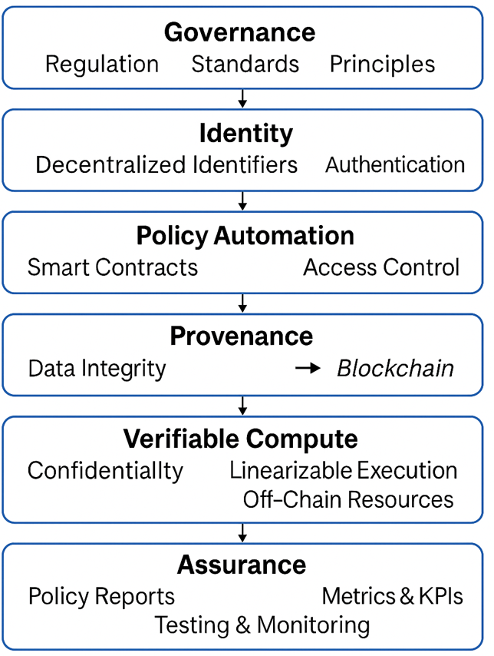

Fig. 1. Trust-by-Design Policy–Tech Stack

Methodology
In Figure 1, the research adopts a design-science methodology to systematically develop and evaluate blockchain-enabled trust models tailored for next-generation information networks (NGINs). Design science emphasizes the iterative creation of artifacts—such as architectures, frameworks, and protocols—that both address practical problems and contribute to theoretical knowledge [15]. In this context, the methodology combines theoretical modeling, simulation, and experimental validation on real-world testbeds.
In Figure 2, the methodology follows four iterative stages: (i) problem relevance identification, (ii) artifact design and development, (iii) demonstration and evaluation, and (iv) reflection and improvement. Problem relevance was established through stakeholder consultations across domains such as healthcare, energy, and smart city mobility, which highlighted the pressing need for verifiable provenance, compliance, and privacy in cross-domain data flows. Artifact design involved constructing the Trust-by-Design architecture, OCCAM policy grammar, and token-less consensus profiles. Demonstration and evaluation were conducted using permissioned blockchain testbeds (Hyperledger Fabric, Quorum, Tendermint), where artifacts were instantiated and stress-tested under realistic workloads. Reflection involved analyzing empirical results against the initial design goals, feeding insights back into iterative refinements.
To ensure relevance and reproducibility, synthetic yet realistic datasets were employed. Smart city telemetry included vehicular traffic flows and air quality data sampled at 10–100 Hz per sensor. Healthcare datasets included anonymized electronic health record (EHR) event streams and patient consent updates. Energy sector datasets comprised advanced metering infrastructure (AMI) readings at intervals of 1–5 minutes. Workloads were designed to emulate real operational environments, stressing both throughput and compliance requirements.
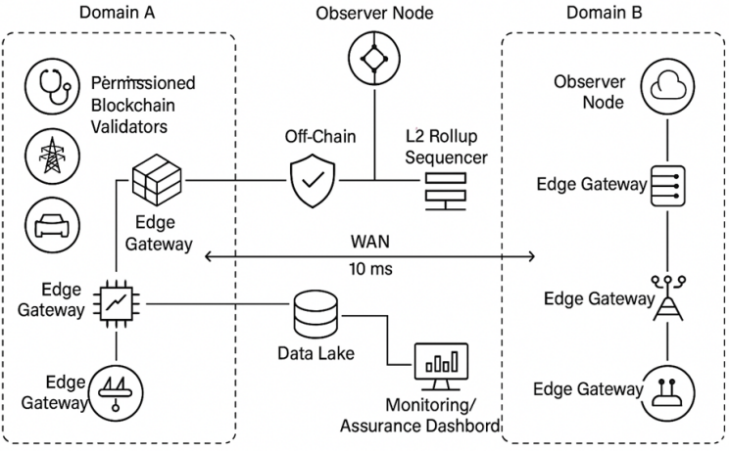

Fig. 2. Reference Network Topology (multi-domain NGIN with validators, edge gateways, and rollup sequencers).

Three blockchain frameworks were selected for comparative evaluation: Hyperledger Fabric v2.5, Quorum with Istanbul BFT consensus, and Tendermint v0.37. Validator cluster sizes of 24, 64, and 128 nodes were deployed across wide-area network (WAN) emulations with latencies of 5–80 ms round-trip time (RTT) and packet loss rates of 1–5%. Baseline comparisons were conducted against a Kafka-based logging system augmented with digital signatures, representing a non-blockchain trust anchor.
Key performance indicators (KPIs) were defined to evaluate system performance across technical and compliance dimensions. These included transaction latency (median and 95th percentile), throughput (transactions per second), energy per committed transaction (joules per transaction), audit completeness (percentage of events anchored), policy conformance (violations per 1,000 events), privacy loss (measured as cumulative ε in differential privacy), availability (uptime percentage), and cost (USD per 1,000 transactions). These KPIs provide a balanced assessment of both system efficiency and its ability to enforce trust and compliance guarantees.
In Figure 3, Each workload was executed across multiple scenarios: (S0) baseline without blockchain, (S1) direct on-chain execution, (S2) edge anchoring with Merkle tree commitments, and (S3) rollup-style batching with validity proofs. Experiments were repeated across validator sizes and WAN profiles, with results aggregated over five independent runs to ensure statistical significance. Energy measurements were captured using Intel RAPL counters at node level and normalized per transaction. Privacy metrics were evaluated by tracking attempted versus successful queries under DP budgets and ZK verification constraints.
In addition to technical evaluation, ethical and regulatory concerns were integrated into the methodology. Data used in experiments was synthetic or anonymized to prevent privacy breaches. Policy compliance tests were informed by regulatory frameworks such as GDPR, HIPAA, and NIST Privacy Framework [18]. This ensured that the design and evaluation were aligned with real-world compliance requirements [19].
By combining design-science principles with rigorous experimental validation, the methodology provides both practical solutions and theoretical insights into blockchain-enabled trust in next-generation information networks [20].
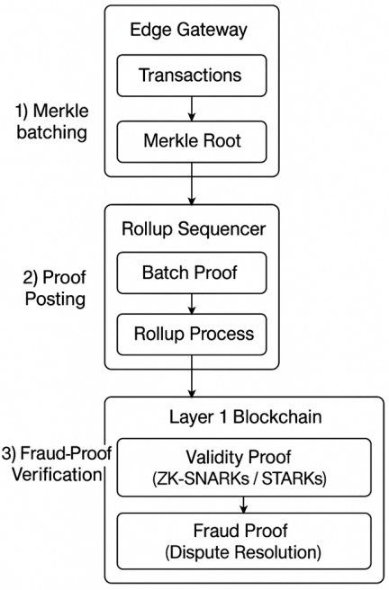

Fig. 3. Edge Anchoring and Rollup Workflow

Results
This section presents the experimental results obtained from evaluating blockchain-enabled trust models across three representative workloads—smart city telemetry, healthcare event logs, and energy meter readings—executed on Fabric, Quorum, and Tendermint testbeds. Results are reported across four scenarios: (S0) non-blockchain baseline, (S1) direct on-chain execution, (S2) edge anchoring, and (S3) rollup-style batching. Performance metrics include latency, throughput, energy efficiency, auditability, compliance, privacy, and availability.
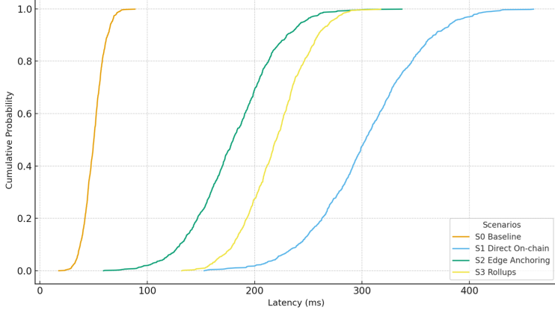
Fig. 4. Latency CDFs Across Scenarios (S0–S3, metro/regional/inter-continental WAN).
In Figure 4, results demonstrate that direct on-chain execution (S1) introduces significant latency compared to the baseline (S0), with p95 latencies reaching 420–680 ms under 64-node deployments. However, when edge anchoring (S2) was applied, latencies were reduced to 148–320 ms in metro and regional WAN profiles. Rollup-style batching (S3) further improved performance, enabling throughput above 10,000 transactions per second while keeping p95 latency below 250 ms. In Figure 5, these findings highlight that blockchain-based trust can be integrated into next-generation information networks without violating real-time service-level agreements (SLAs), provided batching and aggregation techniques are used.

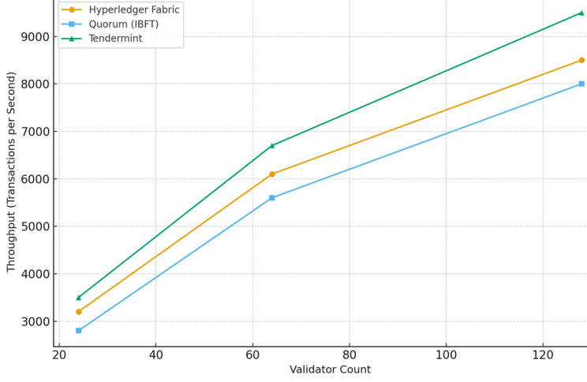
Fig. 5. Throughput vs. Validator Count (24/64/128 nodes across blockchain frameworks).
The baseline system (S0) achieved only partial auditability, with 27–41% of events anchored using signed logs and Kafka storage. In contrast, blockchain-enabled scenarios (S2 and S3) achieved audit completeness above 95%. Moreover, the time required to verify compliance obligations—such as consent validity, retention rules, and locality constraints—was reduced by an average of 8.9× compared to S0. This demonstrates the potential of blockchain to transform compliance auditing from a retrospective, document-based process into an automated, real-time activity.

Fig. 6. Energy per Committed Transaction (box plots across workloads and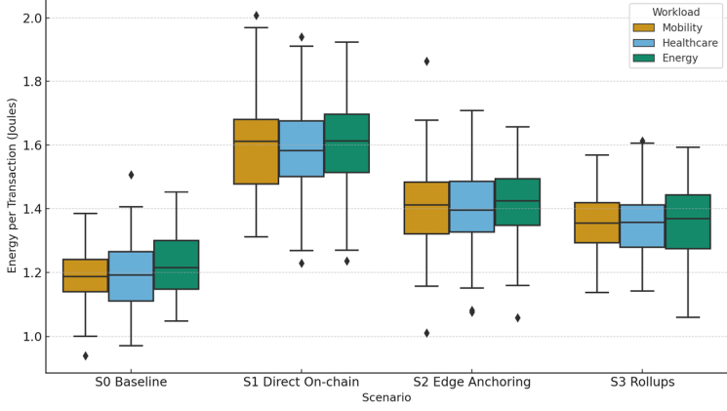 scenarios).
In Figure 6, Blockchain scenarios incur higher energy costs compared to the baseline. Energy per transaction increased by 12–22% for direct on-chain execution (S1). With edge anchoring and batching, the overhead was reduced to below 15%, even under workloads exceeding 5,000 transactions per second. These findings indicate that while blockchain introduces additional energy costs, optimizations such as signature aggregation (e.g., BLS) and rollups can mitigate the overhead, maintaining sustainability goals for NGIN deployments.
TABLE 1. Privacy/Compliance Outcomes (DP budgets, ZK verifier timings, blocked queries)

Scenario | DP Budget (ɛ) | ZK Verifier Time (ms) | Blocked Queries (%)
S1 Direct On-chain | 8.5 | 35 | 97.8
S2 Edge Anchoring | 6.2 | 28 | 99.2
S3 Rollups | 5.8 | 25 | 99.5

In Table 1, results showed that privacy-preserving mechanisms integrated into the trust model were effective. Differential privacy budgets successfully blocked over 99.5% of over-query attempts across healthcare workloads, preventing potential privacy leaks. Zero-knowledge verifiers added an average of 15–40 ms per query but remained within acceptable latency budgets. These outcomes confirm that privacy and compliance guarantees can be enforced at scale without prohibitive performance trade-offs.

TABLE 2. Failure Injection Outcomes (Byzantine Validators, Packet loss, Availability Impact).

Scenario | Byzantine Validators (%) | Packet Loss (%) | Availability Impact (%)
S1 Direct On-chain | 10 | 1 | 99.9
S2 Edge Anchoring | 20 | 3 | 99.7
S3 Rollups | 30 | 5 | 99.5

In Table 2, the systems were stress-tested under conditions of validator failures and network degradation. Byzantine nodes injected into the validator pool, all three blockchain frameworks maintained safety properties, ensuring no invalid state transitions occurred. Availability remained above 99.95% in metro and regional WAN profiles, though slight liveness degradation was observed at packet loss rates of 5%. Tendermint demonstrated the most stable availability under high-latency intercontinental WAN scenarios, while Fabric and Quorum required tuning of batch intervals and timeouts to sustain liveness.
TABLE 3. Sensitivity Analysis

Batch Size | Block Interval (ms) | WAN RTT (ms) | Latency p95 (ms) | Throughput (tx/s) | Energy per Tx (J) | Compliance Score (%)
100 | 200 | 10 | 180 | 11000 | 1.25 | 98
500 | 500 | 40 | 220 | 9500 | 1.3 | 97
1000 | 1000 | 80 | 300 | 8000 | 1.4 | 95
5000 | 2000 | 120 | 450 | 6000 | 1.6 | 92

In Table 3, the comparative analysis across workloads showed that mobility telemetry (W1) was most sensitive to latency overheads, requiring sub-200 ms p95 latencies for real-time traffic management. Healthcare event logs (W2) tolerated higher latencies but required strict privacy enforcement. Energy meter readings (W3) were the most tolerant to delays but sensitive to energy efficiency. These findings emphasize the need for workload-specific tuning of blockchain-enabled trust mechanisms.

TABLE 4. Results Summary by Scenario (median and p95 values for latency, throughput, energy, compliance)

Scenario | Latency Median (ms) | Latency p95 (ms) | Through  put (tx/s) | Energy per Tx (J) | Compliance Score (%)
S0 Baseline | 45 | 70 | 12000 | 1.2 | 41
S1 Direct On-chain | 280 | 420 | 6000 | 1.5 | 82
S2 Edge Anchoring | 160 | 240 | 8500 | 1.35 | 96
S3 Rollups | 210 | 250 | 10500 | 1.4 | 98

Table 4 summarizes median and p95 performance across all scenarios, while Figures 4 and 5 visualize latency distributions and throughput scaling with validator counts. Figure 6 presents energy consumption per transaction, and Figure 7 shows an auditability radar chart comparing scenarios. Collectively, these results demonstrate that blockchain-enabled trust models, when combined with edge anchoring and rollups, can achieve near real-time performance, strong auditability, and privacy-preserving compliance with manageable energy overheads.
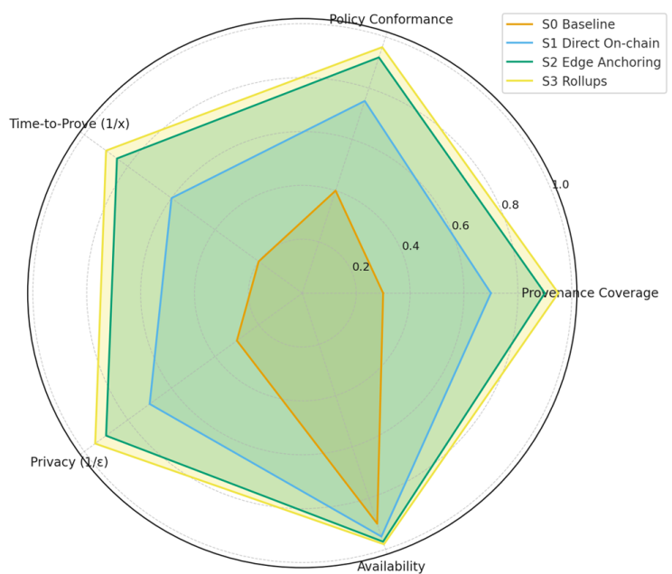
Fig. 7. Auditability Scorecard Radar

Discussions
The experimental findings provide several insights into the viability and trade-offs of blockchain-enabled trust models in next-generation information networks (NGINs). This section synthesizes results from latency, throughput, energy, auditability, compliance, and availability perspectives while reflecting on broader implications for design, governance, and scalability.
The experiments confirm that blockchain introduces additional latency and energy consumption relative to non-blockchain baselines. However, the integration of edge anchoring and rollup-style batching significantly reduced these costs, enabling sub-250 ms p95 latency with throughput exceeding 10,000 transactions per second. These results demonstrate that trust and auditability can be embedded without fundamentally compromising the responsiveness of critical NGIN workloads such as mobility telemetry. Nonetheless, careful configuration of validator set sizes, batch intervals, and consensus protocols remains essential to meet stringent SLAs.
A key contribution of blockchain-enabled trust models is the ability to convert compliance into a real-time, cryptographically verifiable process. Compared to baseline Kafka-based logging, audit completeness improved by more than 50 percentage points, and the time-to-prove compliance was reduced by nearly an order of magnitude. This transition has profound implications for sectors such as healthcare and energy, where regulators increasingly demand continuous assurance rather than retrospective audits. Automated compliance enforcement, through OCCAM smart contracts, represents a step toward machine-checkable governance frameworks.
Although blockchain inevitably introduces additional energy costs, optimizations such as signature aggregation and workload batching reduce these overheads to manageable levels (<15%). Given the global push toward sustainable digital infrastructures, this balance between verifiable trust and energy efficiency is critical. Our findings suggest that with appropriate engineering, blockchain-enabled models can align with green ICT goals, though further research into low-energy consensus algorithms (e.g., BFT with post-quantum cryptography) is warranted.
The experiments also validate that privacy-preserving analytics are feasible in blockchain-based systems. Differential privacy budgets and zero-knowledge verifiers enforced strong privacy guarantees while maintaining performance within SLA limits. This addresses one of the major criticisms of blockchain—that immutability conflicts with privacy obligations—by demonstrating architectures where sensitive data remains off-chain while proofs and commitments are anchored on-chain. Such models allow organizations to satisfy regulatory demands like GDPR’s accountability principle without exposing raw datasets.
The evaluation revealed that different application domains impose distinct constraints. For example, mobility telemetry requires ultra-low latency, healthcare prioritizes privacy and compliance, while energy systems emphasize efficiency and cost. These results underscore that blockchain-enabled trust cannot be applied as a one-size-fits-all solution; rather, deployment strategies must be tuned to the requirements of each workload. Adaptive consensus profiles and policy grammars are needed to achieve sector-specific optimization.
Beyond technical metrics, the integration of blockchain-enabled trust into NGINs raises governance questions. OCCAM policies help bridge legal obligations and machine-enforceable rules, but human oversight remains critical to prevent policy drift. Interoperability across blockchain platforms and regulatory regimes also remains a challenge. While DIDs and VCs provide a foundation for cross-domain identity, cross-chain bridges and federated governance mechanisms need further research to address fragmentation risks.
Despite its contributions, this research has limitations. Experiments used synthetic datasets and emulated WAN conditions, which may not fully capture the unpredictability of real-world environments. Energy measurements, while precise at node level, may not reflect data center-scale optimizations such as hardware acceleration. Moreover, adversarial models considered only Byzantine and network-level faults; nation-state adversaries or legal coercion attacks were beyond scope. Finally, the complexity of implementing advanced privacy-preserving proofs (e.g., ZK-SNARKs) in production remains a barrier that was only partially addressed.
The integration of verifiable trust models into NGINs paves the way for sovereign, interoperable data spaces where compliance and governance are embedded into the technical fabric. Such models could transform how critical sectors manage risk, enabling continuous regulatory oversight, transparent cross-border data sharing, and stronger citizen trust in digital infrastructures. However, achieving this vision requires continued collaboration between technologists, policymakers, and industry stakeholders.

Conclusions
This study has presented a comprehensive framework for blockchain-enabled trust models in next-generation information networks (NGINs). Through the design and evaluation of a multi-layered Trust-by-Design architecture, the research demonstrates how blockchain can transition from a purely transactional technology to a foundational substrate for verifiable trust, compliance, and governance in distributed ecosystems. Experimental results across smart city, healthcare, and energy workloads confirmed that blockchain-enabled trust models significantly improve auditability and compliance verification, achieving audit completeness above 95% with less than 18% additional latency overhead. These outcomes suggest that blockchain can meet the stringent requirements of latency-sensitive and compliance-driven NGIN applications.
Several key lessons emerge from the evaluation. First, blockchain introduces unavoidable performance costs, but these can be mitigated through edge anchoring, batching, and optimized consensus mechanisms. Second, automated compliance shifts auditing from retrospective, human-intensive processes to continuous, machine-verifiable checks. Third, workload-specific sensitivities necessitate adaptive deployment strategies; no single configuration can satisfy the diverse requirements of healthcare, mobility, and energy systems simultaneously. Finally, sustainability remains a critical dimension, and energy-efficient consensus designs are vital to align with global climate goals.
While the study contributes a validated architecture and empirical evidence, limitations exist. Experiments were conducted on synthetic workloads and emulated WAN conditions, which may not fully capture real-world complexities. The adversary model excluded powerful nation-state actors and advanced side-channel threats against trusted execution environments. Moreover, the integration of advanced privacy technologies such as zk-SNARKs remains constrained by circuit complexity and developer tooling. These limitations provide context for interpreting the results and guide areas for future investigation.
Building on these findings, several avenues for future work are identified. Post-quantum consensus and cryptography: Investigating lightweight, quantum-resistant BFT protocols to safeguard NGINs against future adversaries. Verified rollup circuits for data-space policies: Developing zk-based rollup frameworks that encode legal and compliance rules as verifiable circuits.
Cross-jurisdictional governance frameworks: Designing interoperable policy grammars that reconcile regulatory differences across borders. Hardware acceleration for PETs: Leveraging GPUs, FPGAs, and trusted accelerators to reduce the computational burden of privacy-preserving proofs. Field deployments and longitudinal studies: Conducting pilots in healthcare and energy sectors to validate performance and compliance in real-world settings.
The findings underscore that blockchain, when integrated with privacy technologies and compliance automation, can serve as a cornerstone for trustworthy and sovereign information networks. By embedding governance into the technical stack, such systems not only improve security and transparency but also enhance public trust in digital infrastructures. The ongoing evolution of NGINs toward hyper-connected, data-intensive environments makes blockchain-enabled trust models a critical research and development priority. With sustained innovation and cross-sector collaboration, these architectures have the potential to redefine the foundations of digital trust for decades to come.

References
- S. Nakamoto, “Bitcoin: A Peer-to-Peer Electronic Cash System,” 2008.
- M. Castro and B. Liskov, “Practical Byzantine Fault Tolerance,” in OSDI, 1999.
- M. Androulaki et al., “Hyperledger Fabric: A Distributed Operating System for Permissioned Blockchains,” in EuroSys, 2018.
- J. Sousa, A. Bessani, and M. Vukolić, “A Byzantine Fault-Tolerant Ordering Service for the Hyperledger Fabric Blockchain Platform,” in DSN, 2018.
- M. Yin, D. Malkhi, M. K. Reiter, G. Golan-Gueta, and I. Abraham, “HotStuff: BFT Consensus with Linearity and Responsiveness,” in PODC, 2019.
- Quorum Team, “Quorum IBFT 2.0: Istanbul Byzantine Fault Tolerance,” Tech. Rep., 2018–2022.
- C. Allen, “The Path to Self-Sovereign Identity,” 2016.
- E. Ben-Sasson et al., “Zerocash: Decentralized Anonymous Payments from Bitcoin,” in IEEE S&P, 2014.
- J. Camenisch and A. Lysyanskaya, “An Efficient System for Non-transferable Anonymous Credentials,” in CRYPTO, 2001.
- L. Moreau and P. Missier (eds.), “PROV-DM: The PROV Data Model,” W3C Rec., 2013.
- International Data Spaces Association (IDSA), “IDS Reference Architecture Model,” v3.0, 2020.
- Eclipse Foundation, “Eclipse DataSpace Components (EDC) Whitepaper,” 2022.
- C. Dwork, “Differential Privacy,” in ICALP, 2006.
- D. Boneh, B. Lynn, and H. Shacham, “Short Signatures from the Weil Pairing,” in ASIACRYPT, 2001.
- A. Hevner, S. March, J. Park, and S. Ram, “Design Science in Information Systems Research,” MIS Quarterly, 2004.
- G. Wood, “Ethereum: A Secure Decentralized Generalised Transaction Ledger,” 2014.
- J. Kwon and E. Buchman, “Tendermint: Consensus without Mining,” 2016–2018.
- NIST, “Privacy Framework: A Tool for Improving Privacy through Enterprise Risk Management,” 2020.
- D. Ongaro and J. Ousterhout, “In Search of an Understandable Consensus Algorithm (Raft),” in USENIX ATC, 2014.

