Investigate of Blockchain in Management: Jordan Project Management Practice as Case study
Hamed Fawareh  Software Engineering Dept., Faculty of Information Technology, Zarqa University, Jordan  fawareh@zu.edu.jo | Murad Manasrah  Cybersecurity Dept., Faculty of Information Technology, Zarqa University, Jordan  20291116@zu.edu.jo

Abstract-- Blockchain technology has recently been one of the biggest innovations in the project management field, retrospectively opening up a new door towards transparency, security and efficiency during project execution/collaboration. The aim of this study is to investigate the current use of blockchain (if any) within project management practices in Jordan as well as future prospects. We used a quantitative research method with a structured questionnaire that was distributed among project managers, IT professionals, and stakeholders across different sectors. Thus, the goal was to analyze awareness, perceived advantages and disadvantages, and implementation readiness of Blockchain in the project management environment. We analyzed the collected data to find some key trends as well as cultural and practical correlations between blockchain awareness and its use. Results indicate an increasing awareness of use cases, particularly around smart contracts, immutable document tracking, and secure data silo sharing. But there are challenges technical, regulatory, and organizational.

Keywords: Blockchain, supply chain management, Project Management, financial services

I. Introduction
Blockchain technology, initially created for cryptocurrencies, has transformed into a robust instrument for improving transparency, traceability, and security across multiple sectors. The foundational architecture—rooted in cryptographic concepts, distributed ledgers, and consensus algorithms—facilitates immutable and tamper-proof records, rendering it a compelling breakthrough for project management systems [1]. While areas such as finance, insurance and management of the supply chain have detected and integrated large -scale blockchain technologies, the project management domain is relatively underdeveloped in this context [2][3]. Project environment, complexity and characterized by different stakeholders, especially faith, documentation pollution, and are susceptible to the risk associated with the deficiencies of accountability [4] [5]. The decentralized architecture of blockchain provides a novel solution by removing the necessity for a central authority, while guaranteeing that all transactions are securely documented and accessible to all authorized participants [1] [7].
Smart Contracts-Selv Assembly agreements have been coded with specific terms representing one of the most promising applications of blockchain technology in project management. These can automate tasks such as payments of digital contract, progress monitoring and distribution of resources, thus reducing administrative burden and can reduce disagreement between stakeholders [8]. People's ability to verify the dynamics of trust by interacting indicates sufficient changes in project management and execution in verified systems [9].
Amoah and Oh [1] created a blockchain-based project management prototype on the EOSIO platform, which shows tracking and management of project activity through smart contracts. His technology allowed certified stakeholders to log in, validate milestones for project and collect compensation, using all blockchain nodes. The example reported that blockchain can establish a transparent and effective structure from a central authority to manage independently, contract, finance, assets and schedules. In addition, the traceability properties of blockchain streams are of materials and information, which are important for the execution of the project, especially in areas such as construction and logistics. In digital, by digitalization -manual or centralized procedures such as invoice administration and resource before tracking, the blockchain operation increases and provides systems for real -time decisions with certified data. The disruptive potential, despite the implementation of blockchain in project management, faces the desire for technical complexity, integration expenses [1]. In addition, distinguish between permission and permit.
In spite of increasing global attention to blockchain technology and its effective deployment in sectors such as finance, supply chains, and logistics, the implementation of blockchain in the project management domain is still negligible and under-researched, especially in developing countries such as Jordan [10]. The world of project management is frequently filled with complicated exchanges with stakeholders, filing of the manual type, lack of transparency and headaches-causing inefficiencies, all of which are the barriers to achieving our best results. These problems make a strong argument for introducing blockchain solutions to improve trust, transparency, and business process efficiency with capabilities like smart contracts and shared immutable databases. However, there is currently a lack of empirical understanding regarding the level of awareness, perceived benefits, adoption rate, and implementation barriers related to blockchain in project management settings within Jordanian organizations. In addition, little is known about how blockchain usage affects key performance dimensions such as efficiency, transparency, and stakeholder engagement. Without concrete insights into these areas, project-based organizations in Jordan may miss opportunities to leverage blockchain's potential or misallocate resources in its implementation [11] [12]. Therefore, this study seeks to fill the existing knowledge gap by investigating the current state of blockchain awareness, usage, and perceived value among project management professionals in Jordan, while also identifying key obstacles to its effective adoption and evaluating its impact on project performance [13] [14].
This study has significant value at both theoretical and practical levels, especially blockchain continues to develop in a powerful project as finance and supply chain has been studied a lot, its integration in project management - especially in developing countries such as Jordan - was largely inexplicable. By focusing on Jordan's organizations, this study contributes to an emerging technical tendency with the ability to change traditional project management practices [15] [16]. From an academic point of view, the study builds a significant difference in literature by checking awareness, adoption, alleged benefits and obstacles to the implementation of blockchain in the project -based environment. It creates and expands previous research from Amoa and OH [1] by using empirical methods to assess the effect of blockchain in organizational settings for the world. Conclusion will contribute to the growing knowledge body on blockchain competition project management, and offers a local understanding that can inform future models, frameworks and research. For practitioners—especially project managers, IT professionals, and operations officers—this study provides actionable insights into how blockchain can enhance project transparency, streamline workflows, improve stakeholder trust, and reduce inefficiencies through features such as smart contracts and distributed ledgers. Understanding the key enablers and challenges associated with blockchain adoption will assist Jordanian companies in making informed decisions about investing in this technology [17] [18].

II. Literature Review
The study in this paper can inform the national strategies and regulations that support digital changes in the project management sector [19] [20]. It can also guide organizations in construction, logistics and IT industries in building technical and human resources needed to effectively use blockchain technologies [21] [22] [23]. Piccirillo et al. [8] examined the potential applications of blockchain to facilitate collaborative road mapping. Literature research initially performed to ascertain the potential advantages offered by blockchain technologies. The relationships between the deficiencies in collaborative road mapping and the prospective advantages of blockchain were converted into research opportunities. Blockchain inherently addresses two unresolved issues in collaborative road mapping: confidentiality and security. The report identifies three novel potential advantages of blockchain technologies: certification, collective value, and traceability
Das & Cheng [5] introduced a decentralized blockchain system that autonomously enforces the terms and circumstances pertaining to interim payments and transparently and securely shares payment records at the project level without necessitating trust. This paper formalizes a system to automatically originate, validate, and disburse interim payments in accordance with general contract criteria. A blockchain-based data paradigm facilitating selective transparency in payment records is offered. This data architecture enables the confidential exchange of sensitive financial information between two contractual parties while allowing non-sensitive payment-related information to be shared publicly among all project participants. The suggested blockchain framework is underpinned by a core management strategy to enhance many security attributes, including data confidentiality and user authenticity. Given the non-technical background of building project participants, the suggested key management technique aims to dynamically produce cryptographic keys from publicly shareable parameters, hence minimizing storage and administration burdens. This study validates the security aspects of the proposed blockchain framework, including immutability, data confidentiality, user integrity, performance, and deployment costs, and discusses proposals for implementing the system with enhanced security.
Amoah and Oh [1] conducted a survey of various blockchain apps to address this gap and found essential characteristics relevant to the project management domain. This research aimed to develop and evaluate a prototype of a blockchain-based project management tool. The model employed the blockchain proof-of-work idea in targeted aspects of project management. The model implemented a smart contract on a permissionless blockchain testing platform, Electro-Optical System (EOS), to monitor project activity and oversee project resources. The resultant model authenticated and documented each project stakeholder transaction via the smart contract across the blockchain nodes. This study illustrated the viability of creating highly secure decentralized project management solutions that operate without the necessity of a trusted third party. Rejeb and Treiblmaier [9] explores the capabilities of augmented reality (AR) technology in supply chain management (SCM) and logistics. We present a comprehensive overview of the technology's diverse value propositions and its capacity to enhance firms' business processes. The advent of Industry 4.0 has rekindled interest in augmented reality (AR) and its capacity to resolve several challenges facing current business models; yet, comprehensive research examining the potential of AR for supply chain management (SCM) and logistical activities remains limited. To address this knowledge deficiency, we performed a systematic literature review to aggregate previous studies, pinpoint current research voids, and organize augmented reality research in supply chain management and logistics operations. A total of forty-three (43) papers were meticulously examined. This study's findings indicate that augmented reality can enhance value in five primary domains: warehousing, manufacturing, sales and outdoor logistics, planning and design, and human resource management. Furthermore, we examine the problems businesses have in implementing augmented reality in supply chain management and logistics, and suggest avenues for exploratory research for further inquiry. This study emphasizes several practical implications of augmented reality (AR) in supply chain management (SCM) and advises enterprises to regard AR as a viable alternative for optimizing business processes, raising operational efficiencies, and bolstering overall competitiveness. This paper constitutes one of the initial endeavors to synthesize the literature on AR from the perspectives of supply chain management and logistics.
Wamba et al. [11] Blockchain technology have captivated the interest of academics, executives, and professionals around. These participants universally acknowledge that blockchain is not merely a buzzword, but a profoundly disruptive technology that is already reshaping enterprises and their supply chain business models. Notwithstanding significant progress in recent years, blockchain applications in operations and supply chain management (OSCM) remain nascent. There is less knowledge regarding the function of blockchain in operations traceability across several sectors, including e-commerce, agriculture, and public services. This Special Issue aims to enhance our comprehension of blockchain applications in Operations and Supply Chain Management (OSCM) and how companies generate and seize economic value through blockchain technology. This Special Issue will offer a comprehensive and detailed analysis of the role of blockchain in generating value within the field of OSCM. It is anticipated that further insights will be provided regarding the integration of blockchain with new business models, its influence on relationships, and its enhancement of performance and competitive advantage in Operations and Supply Chain Management (OSCM). The evolution of blockchain was examined to furnish readers with a robust foundation. The literature review was conducted from a bibliometric viewpoint on blockchain-related publications. The review underscores the significance of this Special Issue by emphasizing the pressing demands of this subject in this esteemed publication. Ultimately, we offer prospective research avenues and a framework for the articles included in this Special Issue.

Table I Summary For Related Works
Study | Focus Area | Blockchain Application | Key Findings | Methodology | Limitation | Efficiency | Transparency | Stakeholder Engagement
Hunhevicz et al. 2022 [7] | Construction Project Management | Smart contracts & automation | Blockchain enhances transparency and reduces disputes | Case study & empirical analysis | Limited to construction industry | High | High | Moderate
Piccirillo et al. 2022 [8] | Supply Chain & Project Mgmt | Traceability & data security | Improved accountability & efficiency in projects | Literature review & conceptual framework | Lack of  real-world implementation | High | High | High
Das & Cheng2020 [5] | Risk Management in Projects | Decentralized risk mitigation | Blockchain helps in reducing fraud & improving trust | Simulation-based study | Requires more empirical  Validation | Moderate | High | Moderate
Amoah & Oh2021 [1] | Project Collaboration | Smart contracts for task automation | Enhanced collaboration & workflow automation | Survey & qualitative analysis | Focused on  small-scale projects | High | Moderate | High
Rejeb & Treiblmaier2021 [9] | Supply Chain Projects | Data integrity & efficiency | Blockchain enhances supply chain visibility | Theoretical model | No real-world  case studies | High | High | Moderate
Wamba et al. 2020 [10] | Digital Transformation in Projects | Process optimization | Blockchain supports digital transformation in project workflows | Literature review & expert interviews | Limited scope  on project-specific applications | High | High | High
Ahmadishey  khsarmast & Sonmez [7] | Construction Project Governance | Trust & compliance | Blockchain ensures contract compliance & dispute resolution | Case study & framework proposal | Limited industry adoption | Moderate | High | Moderate
Xu et al. 2024 [13] | BIM & Construction Management | Integration with BIM | Improves design collaboration, financial and construction oversight | Mixed-method literature review | Limited guidance on practical implementation | High | High | High
Guilin et al. 2024 | Construction Project Management | Contract automation and tracking | Enhances trust, streamlines workflows, improves financial control | Conceptual framework analysis | Lacks empirical validation | High | High | High
Alkhudary & Gardiner2024 [16] | Project Management Information Systems (PMIS) | Secure data sharing and traceability | Boosts data reliability and decision-making | Case-based study | Focuses only on digital PMIS; scalability concerns | High | High | Moderate
Abdullah et al. 2024 [17] | Supply Chain Finance | Blockchain-enabled financial transparency | Improves supply chain efficiency and visibility | Bibliometric review | Broader focus, not specific to project management | High | High | Low

Wamba et al. [11] seeks to investigate the possible impact of blockchain on supply chain performance. We utilize the literature on technology adoption and supply chain performance, alongside the nascent blockchain literature, to formulate and evaluate a model in two nations, specifically India and the United States. Consequently, we conducted a poll to assess the perspectives and opinions of supply chain professionals. The findings corroborate the model and suggest that blockchain applications can enhance supply chain efficiency. Our findings indicate that knowledge sharing and pressure from trading partners are crucial for blockchain adoption, whereas supply chain performance is notably affected by both supply chain transparency and blockchain transparency. Another conclusion was the absence of evidence for a moderating effect of the industry variable on the outcomes. The research findings possess significant management and theoretical ramifications. Our approach primarily advances the theory of SCM-blockchain, enabling scholars to adapt our verified framework.
khsarmast and Sonmez [2] examined the causes and effects of the payment issue; however, scant research has suggested solutions for its resolution. This study introduces a revolutionary smart contract payment security solution, SMTSEC, designed to mitigate payment difficulties in the construction sector. The SMTSEC guarantees the security of construction contract payments using an automated computerized protocol operating on a decentralized blockchain. The proposed SMTSEC's potential contributions and limits are examined through a genuine construction project. The primary value of the SMTSEC is its provision of a novel way for prompt and transparent payment in construction projects, ensuring payment security for ongoing works without necessitating the administrative expenses and hassles associated with trusted middlemen like lawyers or banks.
Work on recent scholars has quickly discovered the integration of blockchain technology in project management, especially in the design and engineering areas. Underwent a literature with a mixed method, where the convergence of building information modeling (BIM) and blockchain was investigated. His study identified five major management implications at project level: Integration management with design and collaboration, financial management, construction management, information management and other advanced technologies. The authors emphasized the need for a strategic plan to implement blockchain solutions, and highlighted challenges such as stakeholder management, the supervision of the real-time project and data surplus.
In a separate study, Guelin, Maharjan and Mark [14] discovered the application of blockchain technology in Construction Project Management. Their research emphasized Blockchain's ability to increase openness, streamlined execution of contract and improve financial tracking. The authors proposed a framework for integrating blockchain into construction work flows, with the aim of addressing questions related to trust and efficiency between project interests.
Alkhudary and curtains [16] examined how Blockchain Project Management could increase the Information System (PMIS). Their findings suggest that blockchain increases the quality of the information in PMI, which improves better traceability, reliability and security for project data. This reform provides better decision -making and management, gradually contributing the project portfolio to success. In addition, Abdullah et al. [17] conducted a bibliometric review of the blockchain-competent supply chain Finance. In summary of this section the main function and conclusions of previous studies relevant to current research. Table I provides observations of these studies, including their focus region, blockchain application, important conclusions, function, boundaries and efficiency, openness and influence on commitment. The performance columns highlight the findings or conclusions from each study related to specifically used datasets and techniques.

III. Research Methodology
This study employs a quantitative research design using a cross-sectional survey approach. The purpose is to examine the extent, perceptions, and impacts of blockchain applications in project management within companies operating in Jordan, especially in construction, logistics, and related sectors. The goal population includes the project manager, IT manager, operator and other related professionals in companies in Jordan that include construction, logistics, infrastructure and IT areas -the industry where project management is more likely to use Blockchain.
- Sample technique: A targeted sampling method will be used to ensure that respondents have a relevant background in project management and knowledge of digital units.
- Rationale of sample size: Depending on the formula and expected response processes, a minimum test of 150-200 participants will be targeted to ensure generality and strong statistical analysis.
A structured questionnaire will be developed based on constructs identified in the reviewed literature. Items will be rated using a 5-point Likert scale (1 = Strongly Disagree to 5 = Strongly Agree) table II shows the key construction items.
Table II. Key Constructs and Sample Items:
Construct | Source/Justification | Sample Items
Awareness of Blockchain in PM | Wamba et al. (2020) [10]; Amoah & Oh (2021) [1] | "I am aware of how blockchain can be used in project management."
Perceived Benefits | Piccirillo et al. (2022) [8]; Hunhevicz et al. (2022) [7] | "Blockchain enhances trust among project collaborators."
Adoption and Usage | Das & Cheng (2020) [5]; Ahmadisheykhsarmast & Sonmez (2020) [2] | "My organization has implemented blockchain for payment management."
Barriers to Implementation | Wamba et al. (2020) [10]; Rejeb & Treiblmaier (2021) [9] | "The cost of blockchain implementation is a significant barrier."
Project Performance Outcomes | Wamba et al. (2020) [11]; Das & Cheng (2020) [5] | "Blockchain usage has improved the transparency of our project records."

The questionnaire will undergo validation via expert assessment by 2 to 3 specialists in blockchain and project management. In addition, pilot testing with 15–20 participants will be conducted to ensure clarity and reliability.
Data collection: The questionnaire will be disseminated through:
• Digital survey instruments (e.g., Google Forms or Qualtrics)
• Email invites to professional organizations (Jordan Engineers Association, ICT companies, building enterprises)
• LinkedIn and professional networks of individuals in pertinent industries
Data analysis: Data will be examined utilizing SPSS or comparable statistical tools. Analytical processes will encompass:
• Descriptive statistics (means, frequencies) to delineate degrees of awareness and usage.
• Conducting reliability assessment with Cronbach’s Alpha to evaluate internal consistency
• Correlation analysis to examine the correlations among awareness, preparedness, benefits, and performance.
• Multiple regression analysis to evaluate the predictive influence of blockchain adoption on project performance.
Ethical Considerations: Informed consent shall be acquired, confidentiality and anonymity shall be preserved, and ethical approval will be obtained from the associated academic institution, if relevant.

V. Results and Discussion
Based on the survey dimensions and the current state of blockchain adoption in Jordan, the expected results are as follows:
Dimensions 1: Awareness of blockchain in project management (as shown in table III) with high confidentiality between IT professionals and youth project leaders, a moderate level of consciousness is expected among the participants. Some respondents may confuse blockchain with general digital tools, indicating the need for clear education on the subject. Figure 2 shows the project management awareness of blockchain in Jordan.
Table III. Awareness of Blockchain in Project Management
Response | % of Respondents | Count
Very familiar | 20% | 20
Somewhat familiar | 45% | 45
Heard of it but don't understand it | 25% | 25
Never heard of blockchain | 10% | 10
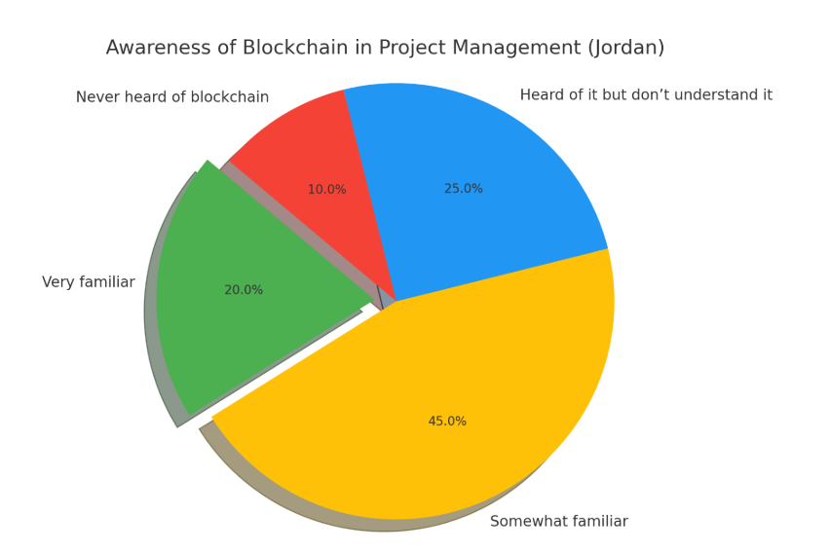
Fig. 2. awareness levels
Dimensions 2: alleged benefits of blockchain response are likely to identify benefits such as data security, openness and better responsibility as shown in table III. Fewer participants may be aware of specific benefits such as smart contract automation or decentralized journal key (Figure 3).
Table III. blockchain benefitsIndication table
Benefit | Strongly Agree | Agree | Neutral | Disagree | Strongly Disagree
Transparency | 35% | 40% | 15% | 5% | 5%
Data Security | 40% | 35% | 15% | 5% | 5%
Smart Contracts | 30% | 30% | 25% | 10% | 5%
Reduced Project Delays | 20% | 30% | 30% | 15% | 5%
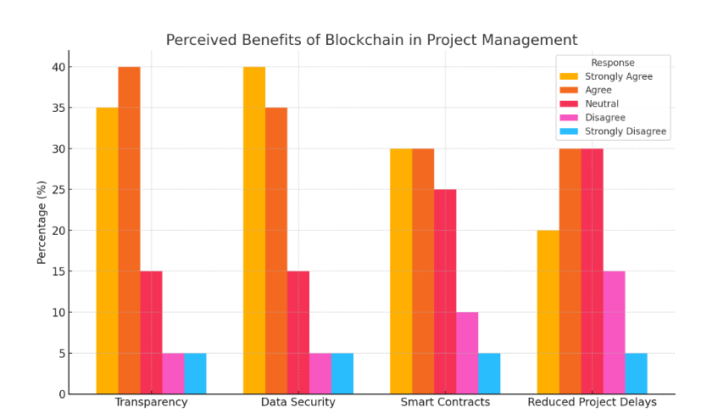
Fig. 2. Benefit for each Grouped
Dimensions 3: Adoption and use, real levels of adoption are expected to decrease, most of the participants stated that blockchain has not yet been implemented in their projects (table V). A small percentage, especially in the private IT region, may report initial stage tests or interest in searching for blockchain solutions. Figure 3 shows the usage of blockchain in project management in Jordan.
Table V. currently using or planning to use blockchain
Response | % Percentage | Count
Yes, already using it | 10% | 10
Planning to use within 1–2 years | 25% | 25
Interested, but no current plans | 45% | 45
Not interested or applicable | 20% | 20
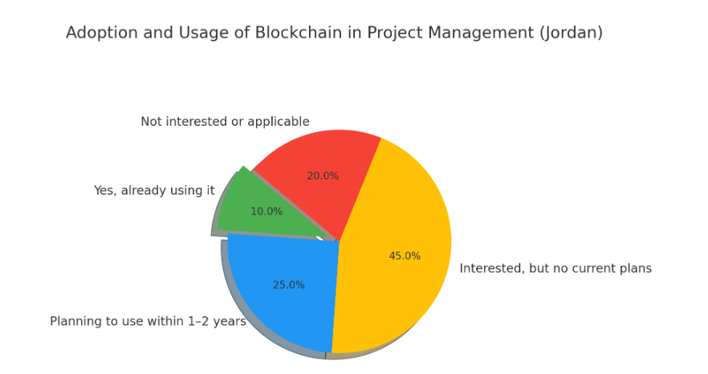
Fig. 3 Adaptation of Usage Blockchain

Dimensions 4: Hinder for implementation of blockchain. Big obstacles are likely to be involved (as in table IV):
- Lack of technical expertise
- High implementation costs
- Limited consciousness
- Government regulation and lack of support
Concerns for integration with existing systems can also be noted. Figure 4 shows the barriers of blockchain in Jordan.
Table IV. Barriers of blockchain
Barrier | % Selected
Lack of technical knowledge | 65%
High cost of implementation | 55%
No government regulation/support | 50%
Difficulty integrating with systems | 45%
Lack of use cases specific to Jordan | 40%
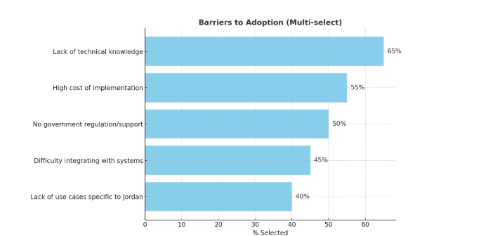Fig. 4. Barriers of Blockchain

Dimensions 5: Project view effect, although real use is limited, respondents can probably agitate that blockchain can improve performance in the areas as (Table VI):
- Work tracking and documentation
- Data integrity
- Stakeholder trust
Evidence of performance effects will be considered most instead of experience as shown in figure 5.
Tavle VI. blockchain can improve project performance
Area of Impact | Yes | No | Not Sure
Task Tracking | 70% | 10% | 20%
Stakeholder Trust | 75% | 5% | 20%
Documentation Accuracy | 65% | 10% | 25%
Budget Management | 50% | 15% | 35%
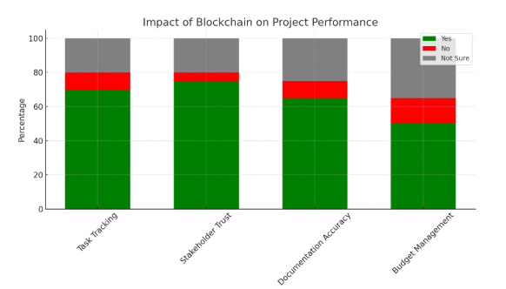
Fig. 5. Performance in Blockchain

VI Conclusion
Studies show that blockchain technology is still in its early stages when it comes to the Jordan Project Management. Especially the awareness and interest between young and technological love persons is increasing, but practically adoption is limited. Recognize the Blockchain opportunity to increase project transparency, data security and collaboration, but many challenges - especially knowledge intervals and lack of infrastructure - draws the implementation of the implementation.

References
- Amoah, E., & Oh, J. Y. (2021). Blockchain adoption in project management. Issues in Information Systems, 22(4), 143-156.
- Ahmadisheykhsarmast, S., & Sonmez, R. (2020). A smart contract system for security of payment of construction contracts. Automation in construction, 120, 103401.
- M. A. Refai, Hamed J. Fawareh, and H. Jawawdeh, “Maximize leader election algorithm performance in bi-directional ring networks with both links down between two nodes,” in Proceedings of the 2023 International Arab Conference on Information Technology, Amman, Jordan, 2024. url: https://acit2k.org/
- Hamed J. Fawareh, Z. Jobair, A. Alswalmh, and A. Suliman, “The evaluation of e-learning system based on the d&m model,” International Journal of Engineering Trends and Technology, 2024, 72(11), pp. 80–90.
- Das, M., Luo, H., & Cheng, J. C. (2020). Securing interim payments in construction projects through a blockchain-based framework. Automation in construction, 118, 103284.
- Hamed J. Fawareh, O. Dahham, H. Aljawawdeh, and A. Daoud, “Evaluation of cloud computing for advancement lms through different environments. International journal of advances in soft computing and its application,” International Journal of Advances in Soft Computing and its Applications, vol. 16, 2024.
- Hunhevicz, J. J., Brasey, P. A., Bonanomi, M. M., Hall, D. M., & Fischer, M. (2022). Applications of blockchain for the governance of integrated project delivery: A crypto commons approach. arXiv preprint arXiv:2207.07002.
- Piccirillo, I. N., Amaral, D. C., & De Oliveira, M. G. (2022). A research agenda for collaborative road mapping supported by blockchain technology. Sustainability, 14(20), 13093.
- Rejeb, A., Keogh, J. G., Wamba, S. F., & Treiblmaier, H. (2020). The potentials of augmented reality in supply chain management: A state-of-the-art review. Management review quarterly, 1-38.
- Wamba, S. F., & Queiroz, M. M. (2020). Blockchain in the operations and supply chain management: Benefits, challenges and future research opportunities. International Journal of Information Management, 52, 102064.
- Wamba, S. F., Queiroz, M. M., & Trinchera, L. (2020). Dynamics between blockchain adoption determinants and supply chain performance: An empirical investigation. International Journal of Production Economics, 229, 107791.
- Hamed J. Fawareh and H. Al-Shdaifat, “Investigating ai-generated code on the impact on software efficiency code quality factor,” Sustainable Data Management, Book Subtitle: Navigating Big Data, Communication Technology, and Business Digital Leadership. Volume 1, chapter 8, ISBN978-3-031-83910-8, 2025.
- Xu, X., Zhao, X., Wu, P., & Cheng, J. C. P. (2024). A mixed-method literature review on the managerial implications of BIM and blockchain convergence in the construction industry. Journal of Civil Engineering and Management, 30(1), 1–17. https://jau.vgtu.lt/index.php/JCEM/article/view/21638
- Guilin, H., Maharjan, R., & Mark, M. (2024). Application of blockchain technology in construction project management. Technik: Journal of Engineering and Applied Sciences, 7(2), 110–125. https://www.journal.ypidathu.or.id/index.php/technik/article/view/828
- Alswalmh, Hamed J. Fawareh, and M. Kanan, “The e-government systems services and its impact on the public jordanians trust from the software quality factors perspective,” in Intelligent Systems, Business, and Innovation Research, Springer Nature Switzerland, 2024, pp. 3–16.
- Alkhudary, D., & Gardiner, P. D. (2024). How can blockchain enhance information quality in project management information systems (PMIS)? International Journal of Managing Projects in Business, 17(1), 89–105. https://www.emerald.com/insight/content/doi/10.1108/IJMPB-01-2024-0021/full/html
- Abdullah, A., Syed, R., Tan, K. H., & Wang, Y. (2024). Blockchain-enabled supply chain finance: A bibliometric review and research agenda. Administrative Sciences, 14(11), 298. https://www.mdpi.com/2076-3387/14/11/298
- S Nithya, D Deepa, Vunnava Dinesh Babu, Hamed J. Fawareh, RD Kayalvizhy, “A Novel Trust Assessment System for Online Social Networking Environment Using Learning Assisted Classification Model”, 2024 International Conference on Innovative Computing, Intelligent Communication and Smart Electrical Systems (ICSES)
- S Sudha Merlin, K Malathy, Hamed J. Fawareh, “ENCL: Empirical Evaluation of Consumer Behaviour Analysis Model Using Internet of Things (IoT) Based Enhanced Neural Classification Logic”, 2024 International Conference on Innovative Computing, Intelligent Communication and Smart Electrical Systems (ICSES)
- Jawawdeh, Hamed J. Fawareh, R. Salman, S. Raed, and H. Alazzeh, “Ethical considerations in ai-driven HCI systems in software engineering,” in Proceedings of the 2023 International Arab Conference on Information Technology, Amman, Jordan, 2024.
- Hamed J. Fawareh and Haya Momani, “The Effect of Using the Scrum Framework in the Design an Stakeholder Reliability”, Book chapter, Artificial Intelligence in the Digital Era, Economic, Legislative and Media Perspectives, volume 159, Springer, 2025
- CG Balaji, Md Imran, S Vamsi Ujwala, Ajinkya P Edlabadkar, Hamed J. Fawareh, “An Improved Neural Classification Logic to Predict Kidney Disease Identification Using Medical Image Processing Principles”, 2024 International Conference on Innovative Computing, Intelligent Communication and Smart Electrical Systems (ICSES).
- M Tamilselvi, R Ashwini, S Ravi, Chadge Rajkumar, Hamed J. Fawareh, “Enhanced Model for Brain Tumor Detection Accuracy Using Inceptionresnetv2 compared to VGG19 and MobileNet Models”, 2024 International Conference on Innovative Computing, Intelligent Communication and Smart Electrical Systems (ICSES)

