Analysis of the Influence of Student Interaction with AI Tools on Academic Performance and Engagement in Digital Learning

FARRAH SETYOPUTRI PRIBADI¹ , GALUH SHAFADILLA ASHA², SEKAR WULAN PRASETYANINGTYAS
¹ Management Department, Binus Business School Master Program, Bina Nusantara University, West Jakarta, 11480, Indonesia
² Management Department, Binus Business School Master Program, Bina Nusantara University, West Jakarta, 11480, Indonesia
³ Management Department, Binus Business School Master Program, Bina Nusantara University, West Jakarta, 11480, Indonesia
E-mail: ¹farrah.pribadi@binus.ac.id, ²galuh.asha@binus.ac.id, ³sekar.prasetyaningtyas@binus.ac.id

Abstract

The emergence of AI (Artificial Intelligence) in the digital era has led to a digital transformation in helping students in their learning process. AI tools Adaptive learning technology, Personalized feedback, and interactive AI tools are some of the AIs most often used by students to better understand the learning that has been done. This study aims to determine the impact of using AI as a tool in the learning process. AI Institute in Indonesia will be the focus of this research as it aims to capture no less than 100 students with its implemented systems. This research seeks to analyze the consequences for students from the implementation of Adaptive learning, Interactive AI tools, Personalized feedback, and other AI technologies. Digital literacy will contribute as a moderator as well where the discussion would revolve on whether its integration makes the process more or less effective for the students when using AI in learning. This will be done through the application of quantitative data.
Keywords: Adaptive learning technology, personalized feedback, interactive AI tools, student in learning, AI (artificial intelligence), digital transformation

- Introduction

Technology has changed education in big ways, changing how people teach and learn (Holmes Wayne et al. 2019). Adaptive learning technologies have become very useful because they can change the way they teach and the materials they use to meet the needs of each student. How to deal with the problems of getting a better educational result and making sure that all of the students, even those from different backgrounds, feel welcome in the classroom. Halkiopoulos et al. (2024) say that to improve each student's learning experience, it is important to think about their individual needs. Personalised feedback is also very important for making the educational experience better. Students get personalized feedback on their work, which helps them learn more and get better at what they do (Kim, 2023; Mahmoud et al., 2023). Interactive AI tools also make learning more interesting and engaging for students by letting them tailor the experience to their own interests and abilities (Rahman et al. 2023).
Technologies are changing the way students are involved in learning process in a great way (Chaudhry et al., 2024). Student engagement is an important factor that affects academic success and achievement. It goes beyond just being present in class and understanding the material (Aljehani, 2024). To be an active part of the learning process, you need to do more than just understand the material. But this link can't be made without using modern technology (Radif, 2024).
A lot of student needed to have enough digital literacy to utilize this technology very well. With this technology can also show how the effect can get them to be more involved (Liang et al., 2023). Digital literacy doesn't just show people how to use the technology but how people know to use them and how they use it to make it even better. Student are better in using technology and more capable in adaptive learning technologies, interactive AI tool, and personalised feedback in a clever way. With those confident can gives student more opportunity to do school excellently (Wang & Guo, 2023; Joseph et al., 2024).
Adaptive learning technologies, like adaptive hypermedia that changes the content based on how students learn, have been shown to help students connect with the material on both a cognitive and emotional level (Rahman & Watanobe, 2023). Additionally, studies on customised feedback have shown that it may support students' motivation and growth mentality (Alrawashdeh et al., 2023). Interactive AI devices have also been shown to create immersive learning environments and encourage people to work together to build knowledge (Eyo-Udo, 2024).
Researchers have looked at individual factors, but not enough at how they all work together to affect student engagement in an integrated theoretical framework. This study fills in the gaps by looking at how these technologies can be used together to get students more involved and by finding out how they are all connected in complicated ways. Students need to be good at using technology for these tools to work and be successful at getting them more involved. According to earlier research, students who struggle with technology may find it difficult to access educational content with adaptive technology and artificial intelligence (AI) tools (Yaseen Husam et al., 2025). In light of this, the purpose of this research is to investigate the relationship among three elements: interactive AI tools, personalised feedback, and adaptive learning technology. It will also look at how digital literacy affects this connection. The researcher wants to find out for sure if students who use AI to help them learn are really effective in their classes.

- Literature review

Adaptive Learning Technologies

One essential component of adaptive learning technology is education. AI technology uses data analytics and algorithms to modify the educational source according to each student's prior performance and the requirements. Adaptive learning system have the capability to transform the content, speed, and the delivery method based on student responses to the system (Halkiopoulos et al., 2024; Khine, 2024). Thats why this system increased the studying process and the result for the student by arranging the system optimally adjusting the needs and how the student study (Sajja et al., 2024). With this technology, instructors can modificate their learning environment to give an suitable assistance for student based on their level of competency (Dutta et al., 2024).

In large educational contexts, adaptive learning offers a practical alternative where traditional methods may fall short in effectiveness. Research by Wang and Lehman (2021) indicates that providing students with tailored, immediate feedback through adaptive systems supports stronger long-term knowledge retention than conventional teaching strategies. Supporting this, Gligorea et al. (2023) observed that such individualized and timely responses help maintain students’ focus on the material and contribute to better support information.

Personalized Feedback

On the modern era of education trends, personalised feedback could support students improvement on their learning and engagement are very important part. This is due to the fact that teachers are able to identify when pupils require specific kinds of written, spoken, or visual support in order to promote optimal learning progress. Personalised feedback, however, has been shown to improve academic performance, control behaviour, and inspire pupils to reach new heights (Kim, 2023). Furthermore, recent research (Wang & Lehman, 2021) demonstrates that tailored feedback enhances students' motivation, self-control, and interest in the course materials. According to (Rahman & Watanobe, 2023), students can gain a deeper grasp of their learning processes by receiving brief, targeted, and useful remarks that assist them identify areas for development and learn how to deal with challenging situations.

Personalized feedback also promotes a growth mindset among students, helping them recognize that their intelligence and skills can improve through dedication and learning (Maier & Klotz, 2022). Rahman and Watanobe (2023) emphasized that the design of feedback is essential—it should be personalized to meet each student’s specific needs to enhance their satisfaction and stimulate active participation in learning. Furthermore, Muthmainnah et al. (2024) discovered that students who received this kind of individualized feedback demonstrated higher engagement, felt more supported during their learning experience, and were motivated to take a proactive role in their education.

Interactive AI Tools

Chatbots, virtual assistants, and intelligent tutoring systems are just a few of the interactive AI tools that are increasingly being employed and installed in educational environments. Through the provision of immediate feedback, such as answers, hints, and explanations, artificial intelligence is utilised to initiate dynamic and customised interactions with pupils. recent research (Mahmoud & Othman, 2023; Kim, 2023). showed that the use of artificial intelligence-driven interventions (neural network-based models) in conjunction with collaborative discourse in computer-mediated conferences enhanced group performance and collaborative knowledge building in educational settings. According to (Ng, D.T.K et al., 2023), AI-based tutoring programs can offer tailored instruction to pique students' interest in learning (Owan et al., 2023; Onesi-Ozigagun et al., 2024). One benefit of these tools is that they can simulate one-on-one tutoring sessions and aid students in engaging with the content to help them retain it.

Because interactive AI tools adapt their training based on student reactions, students learn more effectively. (Mahmoud & Othman, 2023) shown that these tools provide suitable resources to assist students at the right level of knowledge in addition to tasks with varying levels of complexity (Baidoo-Anu & Ansah, 2023). Technology enables personalized and immersive learning by setting goals with adjustable difficulty levels and offering immediate feedback to students (De la Vall & Araya, 2023). Moreover, it supports learners with different skill levels by providing materials suited to their current knowledge, which helps increase engagement and promotes a deeper grasp of the subject matter (Sajja et al., 2024).

Student Engagement

One important determinant of students' accomplishment is their degree of engagement. According to Chaudhry et al. (2024), engagement is the extent to which students are emotionally, behaviourally, and cognitively invested in the learning activities. Feelings of interest and ownership in the learning environment are examples of students' emotional engagement. While cognitive engagement refers to the efforts made to comprehend difficult content, behavioural engagement includes their participation in the class (Skinner & Belmont, 1993). AI technologies, personalised feedback systems, and adaptive learning systems all serve to further pique students' interest in the educational process (Indra et al., 2023). These technologies promote self-directed learning, where learners have more freedom in selecting their learning paths. Through these technologies, educators are able to design an optimal system where instruction is tailored to each learner’s needs and preferences, thereby maximizing the opportunity to engage in almost all facets of the environment.

Customizing learning processes to fit individual students needs and preferences boosts student engagement and is facilitated by adaptive learning systems. The Independence and confidence of students is enhanced when they use these systems, as students are able to learn at their own pace (Alier et al., 2025) . For example, El-Sabagh (2021) notes that adaptive learning platforms increase engagement through lesson alignment and appropriate pacing geared to the specific needs and preferences of each student.

Personalized feedback tends to motivate students more greatly, fostering self-management while encouraging a focus on improvement and growth (Rapaka et al., 2025). The impact of appropriate and positive feedback on students’ emotional and analytical engagement stems from the support and understanding they feel, which during the learning process, makes them feel supported and understood (Radif, 2024; Liang et al., 2023). With the right feedback, students have the chance to engage and succeed. Learning environments that adjust tasks based on each student’s skill level, and provide immediate, relevant feedback, help students engage more deeply and understand the material better (Kim, 2023). For instance, Yuan and Liu (2025) showed that such approaches promote teamwork, knowledge sharing, and improved group outcomes in educational settings.

Digital Literacy

When interacting with information and communication technology, digital literacy refers to the capacity to act with purpose, appropriateness, effectiveness, and critical understanding in order to solve problems, accomplish objectives, and communicate successfully (Veronika et al., 2023; Ervianti et al., 2023). For students to fully benefit from technologies like adaptive learning systems and AI-driven feedback mechanisms, digital literacy is becoming more and more crucial as technology is used in education. Ervianti et al. (2023) demonstrated, for instance, that students who possess high levels of digital literacy are prepared to employ technology in the classroom, which is more likely to lead to improved learning, engagement, and academic performance. Students who lack digital literacy, on the other hand, find these technologies challenging to use, which hinders their participation and prevents them from meeting the required learning goals (Wang & Guo, 2023; Marín & Castaneda, 2023).

The moderating variable in this study is digital literacy. Students are more likely to use and benefit from AI technologies and personalised feedback, which increases student engagement and improves learning outcomes. However, alternative "low-tech" formats were found to be deficient, and students with limited digital literacy may not use these technologies effectively, restricting participation (Obaid et al., 2022). It is clear from moderation by digital literacy that a rise in digital literacy will either boost or decrease the impact of technology on students' involvement (Krajcik et al., 2023). This approach reaffirms multiple existing research studies that claim, besides influencing the acceptance of technology, digital literacy also gaps the utilization of these technologies as devices for meaningful learning (Lu et al., 2025).

3. THEORETICAL UNDERPINNIG & CONCEPTUAL MODEL

Theoretical Underpinning

This research takes a Social Constructivism Theory (Vygotsky, 1978) stance and suggests a conceptual model that emphasises learning's social and collaborative components. According to this theory, learning is a socially mediated activity, such as learning new information alongside instructors, other students, or even robots (Siregar et al., 2024). The main principle of social constructivism is found in adaptive learning technology with respect to gradual support (scaffolding). This type of technology offers assistance with the intention of helping learners overcome specific challenges they face in meeting defined learning goals (Liao et al., 2023). This relates to the framework of the zone of proximal development (ZPD), in which a system that adapts to the learner is said to incrementally enable interaction with the system until the learner reaches a new level (Swastika & Utami, 2025).

As it functions within an individualized support system, feedback caters to personal insights regarding a learner’s strengths and areas requiring additional work by providing responsive, targeted answers at the right moment. This encourages self-regulation, nurtures a growth mindset, promotes advanced levels of cognitive engagement and interaction—all of which are hallmarks of social constructivist theory (Morin, 2023). When carried out appropriately, personalized feedback allows learners to assess their progress, thereby enabling knowledge building together within a supportive and structured learning environment.

Interactive AI programs enhance social collaboration and problem-solving, two critical aspects of social constructivism. The tools create the illusion of real-time interactions and dynamic learning scenarios that actively engage learners while prompting deeper reflection. Together with prompt feedback, these tools foster collaboration, thereby changing learning from an individually performed activity to a socially mediated one (Ouyang et al., 2023).

This framework seeks to close the gap between social constructivism and technology as a facilitator of collaborative learning while examining collaborative learning in the context of digital learning environments (Bjelobaba et al., 2023). Rather, it reframes digital tools as social interaction and understanding conduits rather than as independent learning tools. This study applies these theories by analyzing how these elements interact to further understand the functionality of digital devices and digital literacies and their impact on student participation within current educational contexts.

This framework is further improved by the moderating effect of digital literacy, which contributes to the regulation of these digital instruments in productivity functioning (del Olmo-Muñoz et al., 2023). More advantages are available to students with advanced digital literacy skills, and they demonstrate increased engagement and improved academic achievement when they collaborate and study (Zainuri & Huda, 2023). Conversely, students with lower levels of digital literacy might find it more difficult to use these resources effectively, which could reduce their likelihood of participating in group projects and, in general, lower their level of engagement (Laurillard, 2013).
The degree to which varying degrees of digital literacy influence students' use of digital devices and degree of involvement was then investigated (Hariram et al., 2023). The suggested theoretical framework combines the usage of digital technologies in contemporary learning environments with the social constructivism paradigm. On the other hand, this theoretical paradigm views technology as a tool for interaction, teamwork, and student engagement rather than just a way to convey content. This study understood how students’ technological ability that influence the effectiveness of digital devices in engaging learners.This ensures that the model is relevant to real educational problems while being sound in theory (Laurillard, 2013).

Development of Hypothesis & Conceptual Model

Adaptive learning technologies tailor instruction to the requirements, talents, and progress of students (Sajja et al., 2024; Gligorea et al., 2023). Because students may learn at their own pace, receive quick feedback, and interact with the material at a level that suits them, the introduction of AI technology for personalised learning experiences is anticipated to boost student engagement (Jing et al., 2023). The idea of personalised learning—where suitable learning experiences are provided for particular needs—is introduced by adaptive learning technology. Because the material is more pertinent and suited to the student's learning style, it is anticipated that this personalisation will boost student engagement. The following is the hypothesis based on this input.
H1. “Adaptive learning technologies have a positive effect on student engagement.”
According to Muthmainnah et al. (2024) and Alhalalmeh et al. (2023), personalised feedback entails developing student-centered comments and answers depending on students' performance, strengths, and deficiencies. However, this type of feedback is necessary to sustain student interest and drive. It enables students to make physical progress, which raises their cognitive and emotional engagement and increases their involvement in the learning process. Personalised feedback gives students a clear image of what they are doing, whether it is right or wrong, and helps them feel more emotionally connected to the material. Their behavioural and cognitive involvement in the learning process likely to rise as a result. This concept aids in the development of the following theory.
H2. “Personalized feedback has a positive effect on student engagement.”
In order to increase student engagement with learning materials, interactive AI refers to real-time involvement and support using interactive technologies like chatbots, intelligent tutoring systems, or educational platforms developed around AI (Chen & Ibrahim, 2023). Through a hands-on, individualised learning experience, these tools aid students in learning the content with real-time support while continuing to be actively involved in problem solving. With real-time assistance, interactive AI devices facilitate students' discovery of pertinent content, enabling more engaging content coordination and improving student learning. These gadgets make it possible for students to learn more deeply and become more involved. Thus, the following is the hypothesis.
H3. “Interactive AI has a positive impact on student engagement.”
The ability to correctly comprehend the possible usage and efficacy of digital tools and technologies to function successfully in a digital society is known as digital literacy's moderating role (Arion et al., 2024). According to this study, students' ability to interact with interactive AI tools, personalised feedback systems, and adaptive learning technologies is influenced by their level of digital literacy. By controlling the relationship between the independent variables and student engagement, digital literacy can either increase or decrease the influence of these technologies on student engagement. This supports earlier research showing that any connection with other advanced learning devices requires digital literacy (Eyo-Udo, 2024). Therefore, this study investigates how these tools affect student engagement and how digital literacy might either amplify or lessen their effects. The following theories are developed using this input.
H4a. “Digital literacy moderates the relationship between adaptive learning technologies and student engagement.”
H4b. “Digital literacy moderates the relationship between personalized feedback and student engagement.”
H4c. “Digital literacy moderates the relationship between interactive AI and student engagement.”
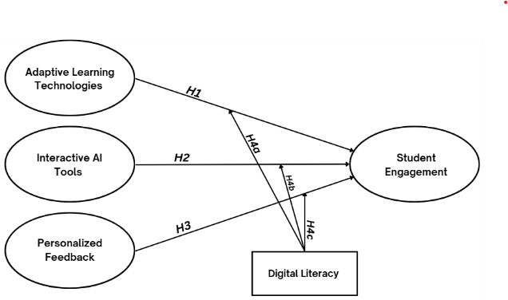
Figure 1: Conceptual of The Study

- Research methodology

Method

This study would use quantitative research methods by collecting data using a numerical system regarding digital learning using AI on student involvement as a learning aid (Yaseen et al., n.d., 2025). Conceptual models and hypotheses must be verified. As a result, the structural equal modelling (SEM)–partial least squares (PLS) approach is recommended. In exploratory research like this one, the PLS-SEM approach aids in producing accurate results (Hair et al., 2018). Furthermore, the survey is not subject to any sampling limitations as a result of this procedure (Willaby et al., 2015). If the data is not normally distributed, analysis cannot be done using covariance-based SEM. However, a normal data distribution is not necessary for the PLS-SEM technique to analyse the supplied data (Khan et al., 2019; Sarstedt et al., 2017).

Researchers will select a sample strategy based on prior experience with digital learning tools, specifically interactive AI tools, personalised feedback, and adaptive learning technologies. The sampling method that the researcher would use is the snowball method, because The snowball method is where researchers would distribute questionnaires and then respondents help distribute them again (Ting et al., 2025).

Data Collection and Analysis

Due to the nature of the study, this study would take a sample of at least 125 Data collection based on the results of respondents answering questions, researchers would determine the number of respondents using Malhotra's theory, namely 5 x n (n = number of question items). The respondents that researchers want to achieve are 5 times the 23 statement items that have been distributed, the total respondents to be achieved are 115 but we would round it up to 120 respondents (Malhotra et al., 2020), male and female students currently studying at a campus that has implemented AI (Yaseen Husam et al., 2025). All participants were chosen by the researcher using inclusion criteria, which include prior familiarity with digital learning tools, such as interactive AI tools, adaptive learning technology, and personalised feedback. In order for the researcher to have access to a variety of educational institutions, respondents come from both public and private universities. The questionnaire platform would be using Google forms to prepare the questionnaire, then distribute the questionnaire link to respondents with different online platforms by social media channels and messaging applications. The language used in the questionnaire is Indonesian.

The suggestions of Armstrong and Overton (1997) are followed in order to ensure that there is a nonresponse bias. The input from the first and last 30 responses would be subjected to an independent t-test after a chi-square test. There were no discernible differences between the two outcomes for either group (p < 0.05). As a result, nonresponse bias is not present in the results. Incomplete and incorrectly filled-out responses would be discovered upon scrutiny. While some responders would return a response sheet that was entirely blank, others would mark each question with multiple checkmarks. As a result, the researcher would not take these respondents into account. Respondents who correctly responded to 23 statements were the subjects of the analysis. According to Deb and David (2014), this is within the acceptable range.

- Result and discussion

Table 1: Demographic Profile of Sample
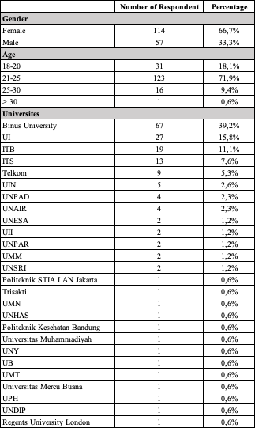

Measurement Model
Checking the validity and reliability of the data obtained from the questionnaires that have been distributed, by conducting reliability and validity tests is a very important factor in conducting research for the measuring tool used. The purpose of this study is to evaluate the validity and reliability of the following instruments: PF (Personalised Feedback), SE (Student Engagement), IAT (Interactive AI Tools), DL (Digital Literacy), and ALT (Adaptive Learning Technologies).
The value limit for each instrument is more than 0.70 in conducting the convergent validity test. Based on the results of the analysis obtained, all instruments found a value greater than 0.70. The results can be said that the ALT1-5, DL 1-4, IAT 1-4, PF 1-4, and SE 1-5 instruments have variables that are tested valid. The metrics used in validity testing are Average Variance Extracted (AVE) the limit set for AVE is 0.50 based on (Buabeng-Andoh & Baah, 2020), Composite Reliability (CR) value should be 0.70 or more is considered acceptable, and Cronbach's alpha value must be above 0.70 so that it can produce high internal reliability.
Continued by conducting a reliability test using the Cronbach alpha value, composite reliability (CR) value, and Average Variance Extracted (AVE) value. Table 2 shows the result of the three values above are 0.70. This value shows that the reliability shows the extent to which the measurement results with the tool can be trusted and the validity results show of the questionnaire reflect well the concept to be measured.

Table 2: Validity & Reliability Test
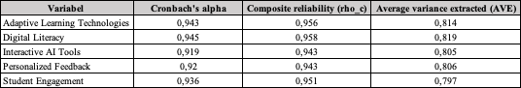

However, the findings of the study utilizing the Heterotrait-Monotrait Ratio (HTMT) values ​​that exceed the threshold. Revealed that a number of construct pairs did not satisfy the discriminant validity criteria during the discriminant validity test stage. The ratio values for a number of constructs pairings, including the Digital Literacy construct pair with Adaptive Learning Technologies and Personalized Feedback with Digital Literacy exceeded the 0.90 threshold and even > 1.00, as indicated in table 2. One such pair had an HTMT = 1.004. Additionally, HTMT = 1.021 for Interactive AI Tools with Personalized Feedback.
These values show that there is overlap between constructs, which may affect the validity of the results of estimating the relationship between variables in the structural model. They also show that respondents are probably unable to distinguish between the concepts of these constructs. Each of the statement items in the constructs has a similar meaning and emphasis.

Table 3: Heterotrait-Monotrait Ratio
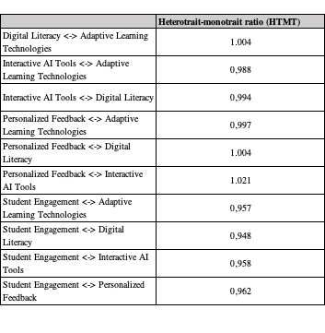

Structural Model
Using the bootstrapping in SmartPLS helps this study to find the Coefficient and R-Square result. The R-Square indicates the relationship between the independent and dependent variables. With a R square value of 0.845, the model reveals that there is a substantial correlation between the variables adaptive learning technologies, personalised feedback, interactive AI tools, and digital literacy, which can account for 84.5% of the student engagement variable.

Table 4: R-Square Value

Figure 2 illustrates the positive correlation between student engagement and interactive AI tools, personalised feedback, and adaptive learning technologies. Hypothesis testing also needs to pay attention to the t-value >1.96 as a limit, this indicator shows that there is no significance in Hypothesis 1 (Adaptive Learning Technologies), Hypothesis 2, (Interactive AI Tools) and Hypothesis 3 (Personalized Feedback), it can be explained that the three hypotheses are rejected. Adaptive learning and personalized feedback have a significant relationship with student engagement, while interactive AI tools do not have a remarkable relationship even though the direction of the arrow shows a positive influence.

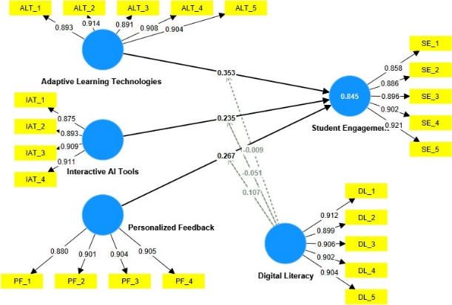
Figure 2: Structural Model
The results obtained show that the use of digital literacy moderating factors is very helpful for students in using AI technology in the learning process. The results obtained in table 2 explain that digital literacy as a moderation weakens the relationship between independent variables (adaptive learning technologies, interactive AI Tools, and Personalized Feedback) with the dependent variable (student engagement). These results show that students do not prioritize the digital literacy aspect in using AI technology. The value of the structural model analysis that the researcher found are Adaptive Learning Technology β = 0.353 & p = 0.007 and Personalized Feedback β = 0.267 & p = 0.026, the value shows that the two variables have a remarkable effect for student engagement. Meanwhile the Interactive AI Tools variable with value of β = 0.235 & p = 0.102 shows that doesnt have a significant effect on student engagement. For the f value indicates a small size effect. The moderating variabel of digital literacy on the independent variables, namely adaptive learning technologies, interactive AI tools, along with personalized feedback, is not significant because p > 0.05 and the f square value is close to 0, so it can be said that the digital literacy moderation variable does not have an effect on the three independent variables.

Table 5: Hypothesis Testing
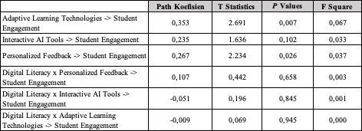

- DISCUSSION
The hypothesis in the previous study was successfully accepted and only 1 hypothesis was rejected, while in this study only two hypotheses were accepted and the others were rejected. The hypothesis obtained in this study obtained significant results for the adaptive learning technology variable and the personalized feedback variable. This could be due to the similarity between the constructs in the questions from the interactive AI tool variable with personalized feedback. Adaptive learning technology is an important factor in the use of AI technology, where students can use the technology adaptively. Many students use AI technology by themselves by starting to get to know the features and buttons they use. According to a study based on (Capuano & Caballé, 2020) that adaptive technology can increase student involvement in the learning process and at the same time can help students too.
personalized feedback is also an important factor in increasing student involvement in the use of AI technology. Personalized feedback is a key factor in student success in higher education learning (Fudge et al., 2019). Personalized feedback can increase students' goal certainty, improve their self-confidence, and increase their engagement in learning (Xu et al., 2025).
Previous research managed to obtain significant results by using digital literacy variables as moderators of interactive AI tool variables and personalized feedback variables. Where the study found that the moderator variable of digital literacy efficiency for students will vary depending on the field of study and its use. The benefits of using AI are also clear, but there are limitations to the use of digital literacy, between ethics and AI literacy having regularity in the lack of training to prepare students in tracking ethical issues on plagiarism, data security, data ownership, data privacy, and algorithm bias (Manganyi, 2025). Students' perceptions of digital literacy in learning with the help of AI technology can be influenced by how well students understand the use of the technology on their own (P et al., 2024).

- conclusion
The objective for this research is to find numerous factors that influence the use of AI technology in the learning process of students in Indonesia. This study conducted quantitative research by distributing online-based questionnaires to obtain data that will then be processed in SmartPLS. This study found that the factors that influence student engagement in the learning process towards the use of AI technology are personalised feedback and adaptive learning technology. Researchers hope to be able to provide output for students who use AI as a learning tool, that students are able to use AI technology by adapting and understanding the use of this technology on their own. In future research, researchers hope to be able to find more respondents, the respondents can be on an international scale, and researchers can get better data analysis results.

Limitations
Checking check This research present several limitations, one of which pertains to the sample size used. Even though the 170 individuals involved meet the basic criteria as established by the rule of ten times the number of indicators in the PLA-SEM framework, GPower analyses suggest that identifying a small moderation effect (small effect size f² = 0.02) would require a larger sample. Consequently, the insignificance of the moderation effect in this study could be due to the lack of statistical power to reveal the relationship. The implication of this limitation is that the results of moderation need to be processed carefully and not immediately conclude that Digital Literacy does not act as a moderator, but rather requires further testing with a larger sample or more comprehensive instruments.

Future Research
Further research could be to improve the instrument by adjusting or filtering statement items on constructs that show HTMT values ​​> 0.90 so that the results of discriminant validity are better. Review the role of moderation by considering the effect size. Preceded by selecting the right sample and supported by the theory that will be used so that it can be generalized. The quality and adequacy of the sample greatly determine the validity of the model built through the PLS-SEM approach.

appendix
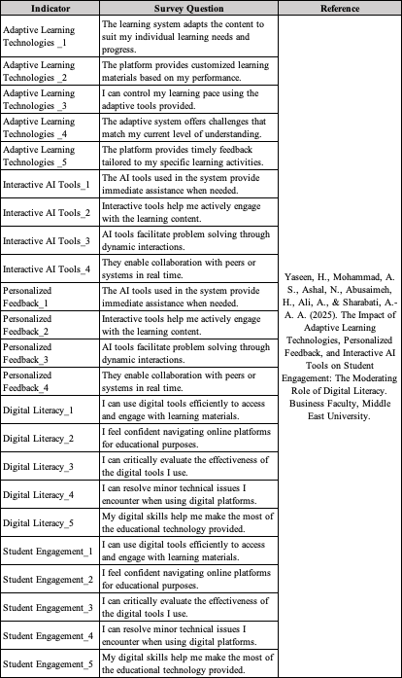

REFERENCEs:
Armstrong, J.S. and Overton, T.S. (1977). “Estimating nonresponse bias in mail surveys”, Journal of Marketing Research, Vol. 14 No. 3, pp. 396-402.
Aldammagh, Z.; Abdaljawad, R.; Obaid, T. Factors. (2021). Driving E-Learning Adoption in Palestine: An Integration of Technology Acceptance Model and Is Success Model. Financ. Internet Quarterly’e-Finans. 17, 41–49.
Chaudhry, S.; Tandon, A.; Shinde, S.; Bhattacharya, A. Student Psychological Well-Being in Higher Education: The Role of Internal Team Environment, Institutional, Friends and Family Support and Academic Engagement. PLoS ONE 2024, 19, e0297508.
Capuano, N., & Caballé, S. (2020). Adaptive Learning Technologies. Association for the Advancement of Artificial Intelligence.
Deb, M. and David, E.L. (2014), “An empirical examination of customers’ adoption of m-banking in India”, Journal of Marketing Intelligence and Planning, Vol. 32 No. 4, pp. 475-494.
DeVellis, R.F. (2012). Scale Development Theory and Applications, 3rd ed., Sage, Thousand Oaks, CA.
Fudge, A., Pardo, A., Iraj, H., Faulkner, M., & Kovanovic, V. (2019). Understanding Students' Engagement with Personalised Feedback Messages. Association for Computing Machinery.
Hair, J.F., Risher, J., Sarstedt, M. and Ringle, C.M. (2018). “When to use and how to report the results of PLS-SEM”, European Business Review, Vol. 31 No. 1, pp. 2-24.
Holmes W., Bialik M. and Fadel Charles. (2019). Artificial Intelligence in Education Promise and Implication for Teaching and Learning, Center for Curriculum Redesign.
Halkiopoulos, C.; Gkintoni, E. Leveraging AI in E-Learning: Personalized Learning and Adaptive Assessment Through Cognitive Neuropsychology—A Systematic Analysis. Electronics 2024, 13, 3762.
Joseph, G.V., Athira, P., Thomas, M.A., Jose, D., Roy, T.V. (2024). Prasad, M. Impact of Digital Literacy, Use of AI Tools and Peer Collaboration on AI Assisted Learning: Perceptions of the University Students. Digit. Educ. Rev.45, 43–49.
Khan, G.F., Sarstedt, M., Shiau, W.-L., Hair, J.F., Ringle, C.M. and Fritze, M.P. (2019). “Methodological research on partial least squares structural equation modeling (PLS-SEM): an analysis based on social network approaches”, Internet Research, Vol. 29 No. 3, pp. 407-429.
Kim, T.W. (2023). Application of Artificial Intelligence Chatbots, Including ChatGPT, in Education, Scholarly Work, Programming, and Content Generation and Its Prospects: A Narrative Review. J. Educ. Eval. Health Prof. 20, 1–8.
Liang, J., Wang, L., Luo, J., Yan, Y., Fan, C. (2023). The Relationship between Student Interaction with Generative Artificial Intelligence and Learning Achievement: Serial Mediating Roles of Self-Efficacy and Cognitive Engagement. Front. Psychol. 14, 1285392.
Mahmoud,M.H., Othman, R. (2024). Effects of New Public Management Reforms on Human Resource Practices: A Case Study in Jordan. Manag. Labour Stud. 49, 149–176.
Malhotra, N. K., Nunan, D., & Birks, D. F. (2020). Marketing Research an Applied Orientation (6th ed.). Pearson UK.
Mahmoud, M.H., Othman, R. (2023). Performance Management System in Developing Countries: A Case Study in Jordan. J. Public Aff. 23, e2864.
Manganyi, I. J. (2025). The Impact of AI and Initiatives on Digital Literacy among Students and Faculty. The Independent Institute of Education (IIE).
P, A., M, A. T., Jose, D., Joseph, G. V., Prasad, M., & Roy, T. V. (2024). Impact of Digital Literacy, Use of AI tools and Peer Collaboration on AI Assisted Learning: Perceptions of the University students. Digital Education Review.
Rahman, M.M., Watanobe, Y. (2023). ChatGPT for Education and Research: Opportunities, Threats, and Strategies. Appl. Sci. 13, 5783.
Radif, M. (2024). Artificial Intelligence in Education: Transforming Learning Environments and Enhancing Student Engagement. Educ. Sci. Theory Pract. 24, 93–103.
Ruel, E.E., Wagner, W.E. and Gillespie, B.J. (2016). The Practice of Survey Research, Sage Publications, Thousand Oaks, CA.
Sajja, R., Sermet, Y., Cikmaz, M., Cwiertny, D., Demir, I. (2024). Artificial Intelligence-Enabled Intelligent Assistant for Personalized and Adaptive Learning in Higher Education. Information. 15, 596.
Ting, H., Memon, M. A., Thurasamy, R., & Cheah, J. (2025). Snowball Sampling: A Review and Guideline for Survey Research. Asian Journal of Business research, 15(1). https://www.researchgate.net/publication/389738207_Snowball_Sampling_A_Review_and_Guidelines_for_Survey_Research
Vygotsky, L.S. (1978). Mind in Society: The Development of Higher Psychological Processes; Harvard University Press: Cambridge, MA, USA,Volume 86.
Worthington, R.L. and Whittaker, T.A. (2006). “Scale development research. A content analysis for recommendations for best practices”, The Counseling Psychologist, Vol. 34 No. 6, pp. 806-838.
Willaby, H.W., Costa, D.S.J., Burns, B.D., McCann, C. and Roberts, R.D. (2015). “Testing complex models with small sample sizes: a historical overview and empirical demonstration of what partial least squares (PLS) can offer differential psychology”, Personality and Individual Differences, Vol. 84, pp. 73-78.
Wang, M. & Guo, W. (2023). ThePotential Impact of ChatGPT on Education: Using History as a Rearview Mirror. ECNU Rev. Educ. 20965311231189824.
Xu, Q., Li, X., & Liu, Y. (2025). Unlocking student potential: How AI-driven personalized feedback shapes goal achievement, self-efficacy, and learning engagement through a self-determination lens. Learning and Motivation, 91.
Yaseen, H., Mohammad, A. S., Ashal, N., Abusaimeh, H., Ali, A., & Sharabati, A.-A. A. (2025). The Impact of Adaptive Learning Technologies, Personalized Feedback, and Interactive AI Tools on Student Engagement: The Moderating Role of Digital Literacy. Business Faculty, Middle East University.

