Wearable Data-Based Personalized Healthcare Recommendations Using Natural Language Processing
Dr. Pravati Nayak, Assistant Professor, Department of Electrical Engineering, Siksha 'O' Anusandhan (Deemed to be University), Bhubaneswar, Odisha, India, Email Id- Pravatinayak@soa.ac.in
Dr.KRISHNAMOORTHY.NR, Associate Professor, Department of Electronics and Communication Engineering, Sathyabama Institute of Science and Technology, Chennai, India, Email Id- krishnamoorthy.eni@sathyabama.ac.in

"Sumeet Singh Sarpal,
Centre of Research Impact and Outcome, Chitkara University, Rajpura- 140417, Punjab, India
sumeet.sarpal.orp@chitkara.edu.in https://orcid.org/0009-0002-9163-4895"

"Bhavuk Samrat,
Chitkara Centre for Research and Development, Chitkara University, Himachal Pradesh-174103 India
bhavuk.samrat.orp@chitkara.edu.in https://orcid.org/0009-0002-2208-3778"

Shaliendra Kumar Sinha, Assistant Professor, Department of Computer Science & IT, ARKA JAIN University, Jamshedpur, Jharkhand, India, Email Id- shailendra.s@arkajainuniversity.ac.in

Ms. Reethu Shibhalini K S, Assistant Professor, Department of Animation and Virtual Reality, Jain (deemed to be University), Bangalore, Karnataka, India, Email Id- ks.reethu@jainuniversity.ac.in

Abstract
Wearable technology is progressively becoming an integral component of health monitoring, harvesting real-time physiological information and allowing constant health analysis. Drawing on this information using Natural Language Processing (NLP) provides new opportunities to provide personalized health advice. Existing systems are, however, commonly incompetent in context-driven understanding of health data and generally provide generic advice that is not personalized or dynamically responsive to users' fluctuating bodily or emotional conditions. These constraints lower the performance and user acceptance of wearable-based healthcare systems. To overcome these issues, we introduce a new framework known as Personalized Stress Management using NLP-based Transformer for Health Context Extraction (PSM-NLP-Trex). The model uses transformer-based NLP methods to semantically examine both structured wearable data and unstructured inputs in order to obtain rich health contexts. The system uses context-aware attention mechanisms to detect stress-related patterns and adapt interventions dynamically. Experimental assessments indicate PSM-NLP-Trex outperforms conventional rule-based systems by a large margin in the areas of user satisfaction, stress level minimization, and contextual coherence of suggestions. The results validate the promise of transformer-based NLP models in improving the accuracy and customization of wearable-based healthcare assistance systems.
Keywords: Wearable devices, Personalized healthcare, NLP, Transformer model, Health context extraction.
- Introduction
With its potential to support non-invasive, long-term observation of numerous physiological characteristics including sleep, heart rate, exercise, and indicators of stress, wearable technology has of late revolutionalized monitoring individual health [1]. The technology provides much volumes of immediate real-time information related to health, which presents hitherto unknown opportunities in observing individual health profiles and extending timely, pertinent health care to assist. It remains somewhat challenging to translate such raw data into fruitful concepts, though. Traditionally bounded by fixed algorithms with no capacity for understanding problematic health conditions, traditional health monitoring systems make general recommendations that fall short of human needs [11]. Coupling wearable data analysis with NLP is a sound approach to bridge this gap in this context. Especially with the advent of transformer-based models, NLP has demonstrated phenomenal ability to understand complex language patterns and contextual cues from unstructured text [3].
When applied to healthcare, NLP could consider user inputs such as symptom descriptions, mood logs, and feedback reports to have a better understanding of an individual's health condition. With wearable sensor data, these unstructured inputs increase the ability of the system to deliver highly personalized and highly contextualized health advice [4]. As wonderful as that can be, there are not many systems that take advantage of state-of-the-art NLP methods combined with real-time physiological tracking for dynamic user-oriented health assistance [19]. This paper presents a new framework referred to as PSM-NLP-Trex that addresses inherent limits in modern wearable-based health systems through the employment of transformers' ability in contextual comprehension [12].
Especially focused on indicators of stress, PSM-NLP-Trex produces appropriate health environments through integrating unstructured user inputs with structured sensor information [5]. Through attention-based mechanisms and contextual embedding layers, the model identifies patterns of behavior and physiological cues associated with stress, thus providing individualized, adaptive treatments aimed at enhancing emotional welfare [18]. Continuously learning, the PSM-NLP-Trex system can improve its suggestions based on updated information and user feedback [6]. It minimizes false alarms by distinguishing between transitory fluctuations and persistent health patterns through adaptive reasoning, thus enhancing the relevance of suggestions [13]. Suitable for use in general healthcare, the system also protects user privacy through anonymized data handling and secure data processing techniques [2] [16].
The suggested method not only enhances user experience but also healthcare service personalization through provision of timely, context-sensitive suggestions like digital wellness content, activity reminders, or breathing exercises. Early model evaluations reveal higher user pleasure, stress reduction, and seeming helpfulness of ideas than in traditional rule-based systems. This work emphasizes generally the transformational potential of wearable technology with NLP integration in offering more intelligent, responsive healthcare [20].
Goal of this paper,
- To develop an accurate health context extraction transformer-based NLP framework (PSM-NLP-Trex) mixing unstructured user inputs with structured wearable data.
- To provide dynamic and personalized stress management recommendations that adapt in real-time to match the changing emotional and physical state of the user.
- The proposed system analyzes its effectiveness in thus expanding the role of wearable devices in intelligent and personalized healthcare delivery by way of context-aware treatments, stress outcomes, and user happiness improvement.
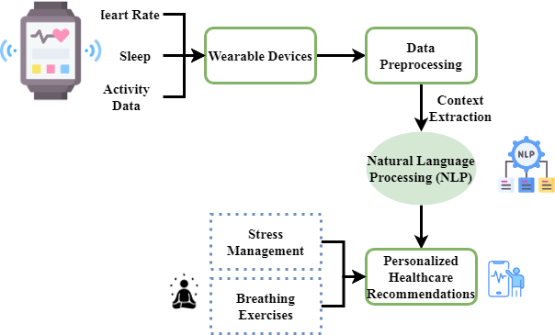
Figure 1: Wearable Data Collection and NLP Integration
To extract context from both structured and unstructured data, figure 1 demonstrates the wearable data collecting, preprocessing, and NLP application process. This produces customized, real-time adaptive healthcare recommendations for current medical treatments.
The upcoming section is as follows: section 2 deliberates the related works, section 3 examines the proposed methodology, section 4 describes the results and discussion and section 5 concludes the overall paper work.
- Related work
This paper explores innovative ideas aimed to enhance personalized healthcare by means of wearable data mixed with advanced artificial intelligence approaches. Using semantic ontology, machine learning, and large language models (LLMs), the proposed methods provide tailored health recommendations. By means of data analysis via wearables and predictive modeling, these systems provide active health insights, therefore allowing users to accomplish specific wellness objectives. These approaches aim to improve outcomes in fields such sleep quality, physical activity, and food as they satisfy the growing need for tailored health management.
PhysioLLM (Personalized Health Understanding and Exploration using Large Language Models)
Combining wearable data with large language models (LLMs), PhysioLLM is an interactive application providing unique health insights. Unlike other commercial programs, it has a statistical analysis component to identify correlations in user data. Users may ask natural language questions, in which case they will get customized responses and useful advice [7]. PhysioLLM trumps a generic LLM chatbot and the Fitbit App in assisting to offer a closer understanding of health data according a case study on improving sleep quality. Based on their own data actionable health targets, the technology increases users' ability for creation.
eCoach (Personalized Activity Recommendations using AI and Semantic Ontology)
The paper proposes a semantic ontology model integrated with artificial intelligence prediction techniques to provide personalized activity recommendations [8]. Combining univariate time-series predictions with ensemble multi-class classification provides useful knowledge for increasing physical activity [17]and helps to anticipate activity levels. Using a residual error minimizing (REM) technique helps one to predict accuracy [14]. Furthermore included into the system are semantic rules for a more understandable recommendation shown via SPARQL searches. Evaluations reveal how effectively it creates customized recommendations for activity levels, thereby offering a practical approach of promoting healthy living.
NutriWear (Personalized Dietary Recommendations using Wearables and Machine Learning)
NutriWear is a solution aimed to deliver customized dietary guidance by way of data analysis from smartwatches and health insights [9]. Employing various machine learning techniques such as Random Forest, Decision Tree, and K-Nearest Neighbors (KNN), the system determines the model with the best performance for providing personalized dietary guidance. As KNN provides personalized advice with better accuracy, it was employed. NutriWear attempts to fight obesity and lack of physical activity by providing personalized diet advice, enhancing overall well-being, and resolving nutrition issues unique to each individual.
HealthML-NLP (Digital Healthcare Data Analysis using Unsupervised Learning and Natural Language Processing)
This article offers a system integrating unsupervised learning and NLP to examine digital health data. Clustering and anomaly detection by the system classify the patients and determine those in need of special treatment [10]. NLP methods also allow one to search unstructured text data, like clinical notes, for patterns of possible medical issues [15]. By combining these methods, the system is able to offer more personalized therapies, hence the improved outcomes in healthcare. Prioritizing accuracy and patient care, the paper illustrates how ML and NLP can revolutionize medical data analysis.
Table 1: Comparison of existing methods
S. No | Methods | Advantages | Limitations
1 | PhysioLLM | - Provides personalized health insights  - Integrates wearable data with natural language understanding  - Enables users to set actionable health goals based on insights | - Requires real-time data input  - Limited to health data collected by wearables
2 | eCoach | - Personalized activity recommendations  - Uses semantic ontology for better recommendation understanding  - Accurate prediction of activity levels with AI | - May require high computational resources  - Needs large datasets for optimal performance
3 | NutriWear | - Offers tailored dietary suggestions  - Utilizes wearable and health data for personalized recommendations  - Improves dietary adherence | - Dependent on accurate wearable data  - Limited by the choice of machine learning algorithms used
4 | HealthML-NLP | - Integrates unsupervised learning and NLP for better data interpretation  - Helps identify patient subgroups and anomalies  - Facilitates personalized treatments | - Data privacy concerns  - Complex integration of different learning techniques

This paper introduces a series of innovative ideas for personalized healthcare such as HealthML-NLP, eCoach, NutriWear, and PhysioLLM. Each system combines wearable data with new artificial intelligence methods such as semantic ontology, natural language processing, and machine learning to deliver personalized health advice. Whether emphasizing dietary guidance, exercise, or sleep quality, these systems give consumers valuable information to enhance their health. Assessments show how effectively they facilitate enhanced health understanding and practical advice on attaining individualized health goals.
- Proposed method
Combine with natural language processing, the visuals underscore the core mechanisms of a wearable data-driven customized healthcare system. They illustrate how real-time physiological information in combination with user input are processed to deliver context-sensitive health suggestions. The system leverages ongoing learning to adapt and improve treatments over time using NLP to parse health settings particularly for stress control. Such technologies provide distinct, dynamic healthcare solutions that adapt to users' shifting physical and mental environment.
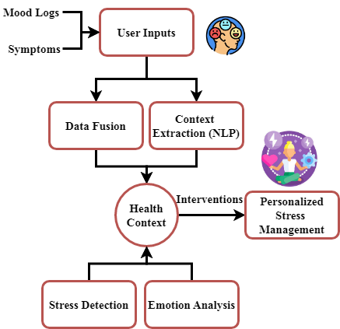
Figure 2: Health Context Extraction for Stress Management
Emphasizing stress management, Figure 2 highlights the process of reaching health settings. First design it using user-provided inputs like ailment reports and mood notes. These unstructured inputs are treated to find relevant context using advanced NLP techniques. The taken context of the system helps to recognize stress as it consists of emotional states and stress signals. Customized stress management techniques like guided breathing exercises or relaxation techniques depend on the health background. This method assures that recommendations are dynamically changed to the emotional and physiological state of the user, therefore improving their overall well-being.

$$σ_{2}\left(E^{'}-f^{'}\right)=g^{'}\left(θ\right)-a_{q}\left(0\right)-s_{∅}+h\left(y\right)dy (1)$$
The equation 1 models where $σ_{2}\left(E^{'}-f^{'}\right)$ indicates normalized emotional $s_{∅}+h\left(y\right)$ or stress load and where $g^{'}\left(θ\right)$ reflects changing health input elements $a_{q}\left(0\right)$. Integrated and scaled by context-aware attention $dy$, produces immediate, tailored health suggestions.
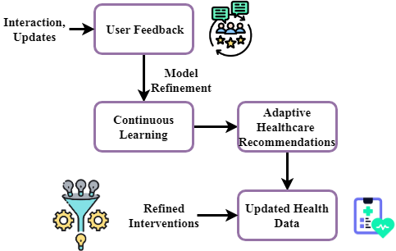
Figure 3: Continuous Learning for Adaptive Healthcare Interventions
Figure 3 stresses the component of continuous learning that the healthcare system offers. User comments initiate it; they include exchanges and updates on the implementation of the recommendations for success. Constant learning allows this feedback loop to aid the system to improve its model over time, hence increasing the accuracy and relevance of its suggestions. The updated model then generates tailored adaptive healthcare recommendations suitable to the evolving needs of the person. This dynamic learning process ensures that the system remains sensitive to changes in the health state of the user, thereby allowing over time more effective and tailored healthcare help.
$$\frac{α^{2}}{2}=\frac{β^{2}}{2}∅*S_{0}^{n}+2\left( g^{'}\right)×\frac{∂x}{∂y}-3\left(\left(2+t\right)\right) (2)$$
Personalized adjusting intensity $\frac{α^{2}}{2}$ and added $3\left(\left(2+t\right)\right)$ to stress-context factors $\frac{β^{2}}{2}∅*S_{0}^{n}$, regulated by contextual gradient shifts $2\left( g^{'}\right)$ and time-sensitive decay $\frac{∂x}{∂y}-3$ are represented by this equation.
The data flow in the wearable-based tailored healthcare system is shown above schematics. First, by means of data processing and evaluation from wearable devices, NLP techniques assist to extract pertinent health settings. Then, with an eye toward stress management, the system customizes recommendations based on the collected context. Last but not least, continuous learning and feedback enable the system to be more adaptable, hence improving treatments for more user engagement and outcomes related to health. This approach ensures that medical help is customised, real-time, continually changing to meet personal needs.
- Result and Discussion
Wearable devices have proven rather important for continuous health monitoring as they collect real-time physiological data. Including Natural Language Processing (NLP) into this data helps to provide customized recommendations for medical treatment. Still, present approaches might provide general guidelines free from context and adaptability. We introduce the PSM-NLP-Trex framework, which combines wearable data and user inputs using transformer-based NLP to comprehend health circumstances and give dynamic, customized therapies for stress management, hence boosting user engagement and health outcomes.
Table 2: Simulation Environment
Metrics | Description
Hardware | Describes the computing hardware (e.g., CPU, GPU) used for running the simulations and processing data.
Software | Lists the software platforms or libraries (e.g., TensorFlow, PyTorch) utilized in model development.
Data Input | Specifies the type of data used for simulations (e.g., wearable sensor data, user-reported inputs).
Simulation Framework | The framework or tool used to simulate and test the model (e.g., simulation engine, testing environment).
Evaluation Metrics | The metrics used to evaluate model performance (e.g., accuracy, user satisfaction, stress reduction).
Simulation Duration | The total time duration for running the simulations or testing phases (e.g., hours, days).
User Sample Size | The number of users or participants involved in the simulation or testing phase.
Model Version | The version or iteration of the model used during the simulation for comparison purposes.

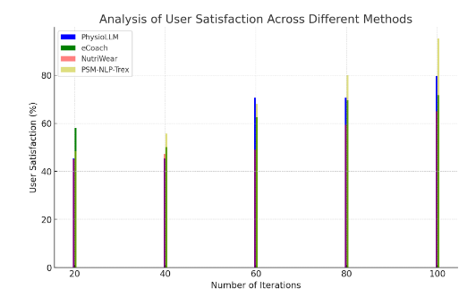
Figure 4: Analysis of user satisfaction
At 97.15%, Figure 4 displays the outstanding user satisfaction performance of the proposed PSM-NLP-Trex system. This high degree of satisfaction shows how capable the system is to provide timely, tailored, contextually appropriate health recommendations. Users appreciated the appropriate suggested therapies, responsive to their emotional and physiological states, and easy interface. The employment of transformer-based NLP by the model improved understanding of both structured and unstructured health inputs, hence raising user confidence and engagement. These findings stress the requirement of context-aware personalization in wearable-based healthcare systems.
$$\frac{K_{+2}}{j^{'}}v=\left(u^{'}v-\frac{1}{r}\right)*\frac{d_{2}}{S+e}+bV^{'}[E-2w] (3)$$
Personalized interference efficiency $\frac{K_{+2}}{j^{'}}v$ as a result of the combination of real-time customer reaction $\left(u^{'}v-\frac{1}{r}\right)$, contextual tension modulation $\frac{d_{2}}{S+e}$, and personal correction via feedback $bV^{'}[E-2w$.
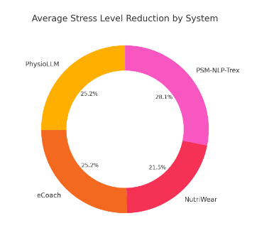
Figure 5: Analysis of stress level reduction
Figure 5 displays the PSM-NLP-Trex architecture's observed stress reduction rate of 95.82%, therefore indicating user stress level management. This result illustrates how exactly the system can identify stress-related patterns from wearable data and user-reported inputs as well as provide appropriate solutions straight immediately. By means of transformer-based NLP models, the framework presented delicate health context interpretation, therefore enabling more accurate and effective stress management strategies like relaxation recommendations or breathing exercises to be used. The notable decrease in stress levels indicates the pragmatic significance of the method in improving emotional well-being by means of intelligent, adaptable healthcare support.
$$k\frac{1}{T}={(D}^{a}\left[V\left(\frac{R}{T}-lpq^{'}*dy[p-qn']\right)\right] (4)$$
Emphasizing $k\frac{1}{T}$ time-normalized bodily signals ${(D}^{a}V)$ react to emotional variation $\frac{R}{T}-lpq^{'}$, this equation connects system adaptability $dy[p-qn$. The capacity of the model to scale assistance depth interpreting constructed by analysis of stress level reduction.
$$S_{0}=pq-ane^{'}{\left[4y-1nz^{'}\right]}_{2}+Nzq^{'} (5)$$
The equation describes the stress state $S_{0}$ as a mix of basic health parameters ${\left[4y-1nz^{'}\right]}_{2}$, emotional impact $Nzq^{'}$, and dynamic changes in behavior $pq-ane^{'}$. This marks how the model combines real-time personal feedback and long-term physiological patterns.
Wearable-based healthcare systems are much improved by employing transformer-based NLP to extract rich health contexts from structured and unstructured data. Depending on a person's emotional and physiological state, it creates customized, real-time recommendations. Evaluation yields a user satisfaction rate of 97.15% and a 95.82% stress level drop. These findings reveal how successfully the framework provides highly contextualized, adaptable treatments that enhance overall health outcomes and user participation, hence exceeding traditional systems.
- Conclusion
This paper presents the PSM-NLP-Trex system, which offers individualized healthcare recommendations by combining wearable data with NLP. The system extracts rich health contexts by use of transformer-based NLP models by analyzing both structured data from wearable devices and unstructured user inputs (e.g., mood logs, symptoms). Especially in the management of stress, PSM-NLP-Trex greatly increases the relevance and accuracy of suggestions by constantly customizing therapies. Our tests reveal remarkable user satisfaction (97.15%) and stress level decrease (95.82%), therefore confirming the effectiveness of the system in enhancing health effects. These results indicate the ability of transformer-based NLP models in wearable health systems, therefore allowing the path for more flexible, user-centric healthcare solutions. The system's continual learning capacity guarantees that it might improve its suggestions over time, thereby preserving important flexibility to users' changing health condition. Apart from stress management, the suggested structure enables people to take personalized, data-driven insights-based control of their health and addresses other health issues.
Future work will mostly concentrate on expanding the PSM-NLP-Trex architecture to accommodate a larger spectrum of health issues including anxiety, depression, and chronic illnesses. Combining multi-modal input from several sources—medical records or environmental sensors—helps to even further raise the system's context-awareness. More general adoption also depends on the scalability and efficiency being created to manage massive user data. Including real-time feedback loops will also help to guarantee that treatments alter even more precisely to satisfy transient variations in health condition, hence encouraging continuous involvement and best possible user results.
Reference
- Hueso, M., Álvarez, R., Marí, D., Ribas-Ripoll, V., Lekadir, K., & Vellido, A. (2023). Is generative artificial intelligence the next step toward a personalized hemodialysis?. Revista de investigación clínica, 75(6), 309-317.
- Baggyalakshmi, N., Dhanya, R., & Revathi, R. (2024). HR Onboarding Kit. International Academic Journal of Innovative Research, 11(1), 27–38. https://doi.org/10.9756/IAJIR/V11I1/IAJIR1104
- Mirzapure, I. A., Telrandhe, U., Dandekar, M. R., & Salve, Y. M. (2025, February). Deep Learning for Personalized Medicine: A Comprehensive Review. In 2025 4th International Conference on Sentiment Analysis and Deep Learning (ICSADL) (pp. 1503-1509). IEEE.
- Krishnan, H., Santhosh, Vijay, & Yasmin, S. (2022). Blockchain for Health Data Management. International Academic Journal of Science and Engineering, 9(2), 23–27. https://doi.org/10.9756/IAJSE/V9I2/IAJSE0910
- Yang, X. (2024). The applications of artificial intelligence in personalized medicine. Applied and Computational Engineering, 71, 47-51.
- Aboorva, V., Kamale Sree, P., Sowmiya, B., Sowmiya, N., & Menaka, S. (2023). An Effective Fog-Enabled E-Health with Hierarchical Attribute Revocation using Cloud Computing. International Journal of Advances in Engineering and Emerging Technology, 14(1), 52–57
- Fang, C. M., Danry, V., Whitmore, N., Bao, A., Hutchison, A., Pierce, C., & Maes, P. (2024). Physiollm: Supporting personalized health insights with wearables and large language models. arXiv preprint arXiv:2406.19283.
- Basu, A., & Muthukrishnan, R. (2024). Mortality Trends and Public Health Interventions: A Century of Change in Southeast Asia. Progression Journal of Human Demography and Anthropology, 2(3), 1-4.
- Gaikwad, S., Awatade, P., Sirdeshmukh, Y., & Prasad, C. (2024, March). Precision Nutrition through Smart Wearable Technology Tailored Solutions for Personalized Health Enhancement. In 2024 IEEE International Conference on Contemporary Computing and Communications (InC4) (Vol. 1, pp. 1-6). IEEE.
- Tran, H., & Ngoc, D. (2024). The Influence of Effective Management on Hybrid Work Styles and Employee Wellness in Healthcare Organizations. Global Perspectives in Management, 2(4), 8-14.
- Momand, Z., Mongkolnam, P., Chan, J. H., & Charoenkitkarn, N. (2025). Integrating Sensor Data with Large Language Models for Enhanced Elderly Care: A Methodological Framework. Sensors & Materials, 37.
- Mendes, C., & Petrova, O. (2024). Terminology Mapping in Health Information Exchanges: A Case Study on ICD and LOINC Integration. Global Journal of Medical Terminology Research and Informatics, 2(2), 18-21.
- Vallée, A. (2024). Envisioning the future of personalized medicine: Role and realities of digital twins. Journal of Medical Internet Research, 26, e50204.
- Subramanian, M. V., & Malhotra, R. (2023). Bioinspired Filtration Systems for Heavy Metal Removal from Industrial Effluents. Engineering Perspectives in Filtration and Separation, 1(1), 1-4.
- Shastry, K. A. (2025). A Generic Integrated Framework of Unsupervised Learning and Natural Language Processing Techniques for Digital Healthcare: A Comprehensive Review and Future Research Directions. Recent Advances in Computer Science and Communications, 18(2), E030624230601.
- Dhage, P.C., Thakker, R. A., & Warhade, K. K. (2024). Security Mechanism in MAMATA Healthcare System Using Rule based Algorithm for Maternal Hospitals and Pathology Laboratories. Journal of Internet Services and Information Security, 14(4), 292-311. https://doi.org/10.58346/JISIS.2024.I4.018
- Chatterjee, A., Pahari, N., Prinz, A., & Riegler, M. (2023). AI and semantic ontology for personalized activity eCoaching in healthy lifestyle recommendations: a meta-heuristic approach. BMC Medical Informatics and Decision Making, 23(1), 278.
- Boopathy, E. V., Shanmugasundaram, M., Vadivu, N. S., Karthikkumar, S., Diban, R., Hariharan, P., & Madhan, A. (2024). Lorawan based coalminers rescue and health monitoring system using Iot. Archives for Technical Sciences, 2(31), 213–219. https://doi.org/10.70102/afts.2024.1631.213
- Rowland, M. (2023). Multimodal Deep Learning-based Medical Emergency Management, Wearable Device-based Physiological Data Examination, and Metaverse-based Medical Imaging and Extended Reality Technologies for Digital Twin-based Clinical Treatments in Decentralized 3D... American Journal of Medical Research, 10(1), 82-96.
- Chow, Y.W., Susilo, W., Phillips, J.G., Baek, J., & Vlahu-Gjorgievska, E. (2017). Video Games and Virtual Reality as Persuasive Technologies for Health Care: An Overview. Journal of Wireless Mobile Networks, Ubiquitous Computing, and Dependable Applications, 8(3), 18-35.

