AI-Driven Predictive Maintenance in Manufacturing Using Bayesian Inference Models
Dr. Karthikeyan S, Professor, Department of Electronics and Communication Engineering, Sathyabama Institute of Science and Technology, Chennai, India, Email Id- karthikeyans.ece@sathyabama.ac.in

"Abhinav Rathour,
Centre of Research Impact and Outcome, Chitkara University, Rajpura- 140417, Punjab, India abhinav.rathour.orp@chitkara.edu.in https://orcid.org/0009-0008-4434-1073"

"Yuvraj Parmar,
Chitkara Centre for Research and Development, Chitkara University, Himachal Pradesh-174103 India
yuvraj.parmar.orp@chitkara.edu.in https://orcid.org/0009-0007-1619-9885"

Rakhi Chakraborty, Assistant Professor, Department of CS & IT, ARKA JAIN University, Jamshedpur, Jharkhand, India, Email Id- rakhi.c@arkajainuniversity.ac.in

Dr Rahul Pawar, Assistant Professor, Department of Computer Science and IT, Jain (deemed to be University), Bangalore, Karnataka, India, Email Id- rahul.pawar@jainuniversity.ac.in

Dr. Manoj Kumar Naik, Associate Professor, Centre for Internet of Things, Siksha 'O' Anusandhan (Deemed to be University), Bhubaneswar, Odisha, India, Email Id- manojnaik@soa.ac.in

Abstract— In smart manufacturing and industrial equipment, AI based predictive maintenance and problem identification help to enhance running efficiency and lower downtime. Classic machine-learning techniques may fail under physical constraints and need huge, labeled datasets. To overcome these limitations, this work investigates Bayesian Inference Models (BIM)—a novel predictive maintenance and fault detection tool. BIM use the predictive capability of AI by merging domain-specific physics-based equations with neural network topologies. This work presents a hybrid BIM architecture combining thermodynamics, fluid dynamics, governing equations of motion, and historical sensor data in rotating machinery with mechanical vibrations. Unlike other data-driven models, BIM forecasts physically compatible predictions with either little or noisy input. The suggested method combines simulated and real-time sensor data using multi-fidelity training to boost generalization across many running circumstances. This program emphasizes robustness and fault diagnostic accuracy devoid of large labeled datasets. According to experimental findings on industrial pump and turbine datasets, the BIM model beats AI approaches in fault classification, predictive maintenance scheduling, and early anomaly detection. The findings imply BIM could assist in pinpointing issues, increase equipment life, and lower false positives. This work shows how BIM using physics-based modeling and data-driven artificial intelligence might enhance industrial maintenance solutions.
Keywords— Physics-Informed Neural Networks, Predictive Maintenance, Fault Diagnosis, Smart Manufacturing, Industrial Machinery, AI

Introduction

AI- based Predictive maintenance and issue detection help industrial equipment and smart manufacturing to operate with less downtime and higher efficiency. Conventional machine learning methods rely on large labeled datasets and may not be applicable considering pragmatic limitations. To get beyond these constraints, this paper explores BIM—a new method for predictive maintenance and fault identification[1]. Combining domain-specific physics-based equations with neural network topologies lets a BIM use AI's predictive capacity. Motivated by mechanical vibrations, thermodynamics, fluid dynamics, and the laws of motion, this study offers a hybrid BIM design for rotating machinery integrating data from past sensors[17]. BIM generates physically consistent predictions utilizing restricted or noisy input, surpassing most data-driven models. The suggested approach integrates real-time sensor data with simulated data via multi-fidelity training to increase generalizability throughout several operational situations. The system aims to improve fault diagnosis accuracy and robustness without extensive labeled datasets. Experimental results on industrial pump and turbine datasets show that the BIM model trumps AI methods in fault classification, predictive maintenance scheduling, and early anomaly identification[3,18]. The results suggest that BIM might support equipment lifetime, problem localization, false positive reduction, and equipment lifetime[4]. The findings of this study imply that BIM combined with data-driven artificial intelligence and physics-based models might fundamentally affect industrial maintenance solutions[5].
Two fundamental methods—data-driven machine learning models and physics-based simulations—formulate the diagnosis of issues and maintenance planning guidance of current technologies [6]. Nousy or restricted labeled sensor data is rare in industrial settings, making training data-driven models—including AI- challenging. They might also find it difficult to manage less clear crisis events[19]. Conversely, physics-based models find managing complex, real-world uncertainty challenging and computationally costly[8]. This approach closes the knowledge gap using BIM, which integrate AI with data derived from physics. BIM, unlike more conventional models, provide physically consistent fault predictions irrespective of data availability[7]. In practical industrial applications, domain-specific equations regulating mechanical vibrations, heat transfer, and fluid dynamics help improve forecasts' accuracy and reliability[20]. This innovative method provides a hybrid predictive maintenance system for smart manufacturing that is data-efficient and interpretable, meeting a significant research requirement [26]. Though it offers certain advantages, the research has substantial shortcomings. Moreover, integrating simulated and real-world data might produce variations requiring significant fine-tuning, even if multi-fidelity training improves generalization [8]. Further research on BIM' scalability, real-time inference, and interaction with extant IIoT infrastructure will help to maximize their usefulness in predictive maintenance [10]. At the current time, BIM are not mainly employed in manufacturing[9,21]. This work adds three important elements to the predictive maintenance and issue diagnosis in smart manufacturing:
- This paper uses historical sensor data from sBIMing machinery to offer an integrated BIM framework consisting of mechanical vibrations, governing equations of motion, fluid dynamics, thermodynamics, and more.
- This paper provides a method based on real-time input from virtual and physical sensors for multi-fidelity training and makes the BIM model more generalizable across different operational settings.
- The findings reveal that BIM might minimize false positive rates, enhance industrial maintenance solutions, and increase equipment lifespan.

Literature Survey
The work [11] proposes AI-driven predictive maintenance using Digital Twin Technology (DTT) with the aim of real-time industrial monitoring and problem diagnosis. Conventional maintenance methods often overlook when equipment may fail, causing unexpected downtime and higher expenses. Predictive accuracy rose by 35%, unexpected downtimes dropped by 40%, and maintenance costs fell by 25% using the suggested technique. Industrial use determines the accuracy of digital twin models and the quality of sensor data, which influences the framework's performance [12].
The work [22] presents a predictive maintenance platform using sensor data and ANNs that could help with the shift to Industry 4.0. Conventional maintenance methods without real-time data analysis provide inadequate maintenance plans and unplanned equipment breakdowns. The system enabled preventative maintenance and lower downtime by predicting when equipment would fail. Large volumes of sensor data might be difficult to manage and require much computational capacity.
The study [13] uses digital twin models and unsupervised learning to improve predictive maintenance in Industry 4.0. The lack of large industrial-labeled datasets impedes predictive maintenance models. Unsupervised learning and digital twins significantly increased maintenance decision-making by allowing one to detect outliers without labeled data. False positives—those brought on by the technology mistakenly spotting benign anomalies as defects—are conceivable.
The paper [23] presents ARTOM, an adaptive reinforcement learning system that conducts predictive maintenance in smart manufacturing and improves tool wear in real-time. Poor maintenance results from standard tool wear monitoring systems being unable to adapt to changing production circumstances [14]. ARTOM's decreased prediction errors and faster execution times improved operational decision-making compared to baseline models. Regarding real-time applications, complexity might be a major obstacle concerning scalability and processing capability.
The thorough study [15] also examines relevant trends and concerns as predicting maintenance failures in industrial environments using machine learning is the topic of focus. Machine learning systems must be evaluated for their ability to forecast when industrial equipment can fail [16]. With data-driven technologies—especially machine learning—predictive maintenance shows potential, according to the paper. The results show that machine learning models could only be as good as the data they are trained on, so their value may be limited.
The paper [24] addresses issues and possible answers connected to smart manufacturing artificial intelligence predictive maintenance. Notwithstanding development, improving data quality, making models interpretable, and connecting systems remain difficulties for artificial intelligence-based predictive maintenance. The work underlines that good data management and interpretable artificial intelligence models are essential to overcome these obstacles [25]. The lack of empirical data in the present debate keeps several unresolved questions.

Proposed Architecture

This research aims to combine multi-fidelity training with BIM in a hybrid computational strategy to improve predictive maintenance and fault detection in industrial equipment. Conventional AI systems rely on data-driven techniques needing plenty of labeled data. However, in practical industrial environments, this data may be uncommon, noisy, or absent. BIM, therefore, integrate physical science-guiding equations into a neural network architecture to circumvent this. This guarantees that consistent and intelligible predictions are maintained even with limited or noisy input data. The method creates synthetic data using real-world sensor data from spinning gear and physics-based models based on experimental and simulation-based methods. Combining high-precision simulations with real-time operational data in this multi-fidelity training method enables the model to generalize across several industrial settings. This enhances the predictive capacity, problem detection accuracy, and maintenance economy of smart manufacturing.
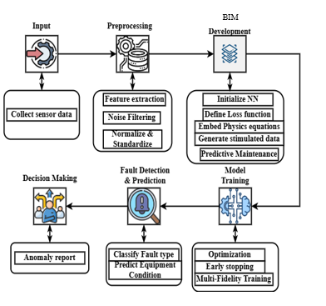
Fig. 1. Conceptual framework of Predictive maintenance using BIM.

Preprocessing and collecting sensor data:
Industrial pumps and turbines are the foundation of smart production systems; real-time data collection from sensors is thus very essential. These sensors measure changing machine health indicators like vibration levels, temperature variations, and pressure fluctuations. Mechanical wear, imbalances, and misalignments are found by vibration analysis. Keeping an eye on temperature would help one better understand issues like overheating brought on by either weak lubrication or intense friction. Different pressures point to likely fluid dynamics cavitation or blockages. Since predictive maintenance may find machine faults before they break, it relies on this data. Real-time sensor data is typically noisy, deficient, or influenced by outside events, so preprocessing is essential to make it more trustworthy.

Obtained Computational Physics Model Data:
Models of computational physics that imitate the behavior of industrial gears in different contexts provide data to enhance that obtained from real-world sensors. These models, using thermodynamics, assess energy efficiency and heat dispersion. They study fluid dynamics to see how liquids pass over machines. Using the governing equations of motion, they project mechanical responses like strain, tension, and oscillations. Especially in cases where failures are rare, these physics-based simulations enable researchers to fill in gaps in actual data. This method ensures a more comprehensive training set, thereby improving the generalizing power of the prediction model throughout many running environments. Combining real-time sensor data with physics-based simulations produces a multi-fidelity dataset that appropriately addresses theoretical correctness and real-world uncertainty. Learning from controlled simulations and real-world industrial settings, the model has a decent chance of improving issue identification and predictive maintenance.
To improve industrial equipment defect detection and predictive maintenance, this work combines multi-fidelity training with Physics-Based Neural Networks [2]. Conventional AI approaches primarily rely on large labeled datasets. This data might be lacking, too loud, or otherwise strange for a corporate context. For this purpose, BIM use neural network topologies anchored on physical science guiding equations. This guarantees that projections will be physically consistent and intelligible regardless of the amount or quality of the data being entered. Synthetic data is produced in experimental and simulation-based fashion using data acquired from sensors on sBIMing gear and models constructed on physical principles. Our multi-fidelity training method enables the model to generalize to numerous industrial settings by combining high-precision simulations with real-time operational data. Smart manufacturing might find issues sooner and provide more effective maintenance.

Normalize and regulate the material.
The industrial sensor data from many sources presents various units, sizes, and resolutions. Temperature is stated in Celsius; vibration is in mm/s; pressure is in Pa. These variations make data for comparison and understanding of machine learning systems challenging. Normalization guarantees that no one element dominates the learning process by maintaining all data points within a certain range, say [0,1] or [-1,1]. This keeps relative connections intact. Conversely, standardizing generates a zero mean and unit variance distribution, assuring statistical homogeneity across characteristics. These methods ensure the neural network uses all the information and reduces scale discrepancies, improving model training convergence.
Other similar issues include ambient conditions, external vibrations, hardware constraints, and others that might produce noise in sensor data; Kalman filtering and outlier detection can help reduce this noise. Using recursive estimating smoothes of time-series data, Kalman filtering lowers random fluctuations and projects the system's future state. Predictive maintenance mostly utilizes it to eliminate transient mistakes while preserving fault-related patterns. Another vital method for finding odd data originating from small disruptions or sensor failures is outlier detection. Analysis reveals interesting behavior using Z-scores and isolation trees. Reducing noise and outliers allows defect detection systems to learn from meaningful, high-quality data.
Frequent-domain and statistical methods are used to extract relevant information from unstructured or duplicate values in raw sensor data. One may get measurements from raw data reflecting machine conditions using feature extraction. Statistically, skewness, kurtosis, variance, and mean help one grasp sensor signal distributions through machine behavior measures. FFT and Wavelet Transform may identify aberrant harmonics or resonance frequencies in sensor data using frequency spectrum analysis. These might suggest mechanical problems such as misalignment, bearing wear, or imbalance. Emphasizing the most relevant information helps the machine learning algorithms differentiate between regular functioning and early-stage mistakes. These pretreatment methods provide a data-rich dataset that is clean, ordered, and suitable for training robust predictive maintenance systems. Physics-informed, or BIM.

Building BIM Models for Development:
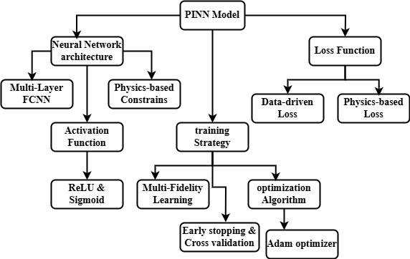
Fig. 2. BIM model development
A detailed analysis of the BIM model building architecture in machine learning for deep convolutional neural networks (DCNs) [4]. A BIM is constructed based on a fully convolutional neural network (FCNN) with several hidden layers wherein every neuron is connected to every neuron in the layer below it. Unlike conventional AI models, this network combines constraints generated from physical principles. These constraints guarantee that the model's projections will not deviate from the laws of thermodynamics, fluid dynamics, and industrial equipment. This hybrid method allows the model to adapt to unanticipated operating conditions by reducing the need for large labeled datasets.

Sigmoid and ReLU learning algorithms:
Hidden layers in deep networks effectively transmit gradients and create non-linearity using the Rectified Linear Unit (ReLU), hence addressing the vanishing gradient problem in deep networks. The sigmoid activation helps output classification issues' classification layers as it converts numerical predictions into probabilities. These activation systems might be able to detect complex and non-linear fault patterns coming from malfunctioning industrial machines.

Analyzing the Evolution of Loss Function:
In data-driven loss, a subset of supervised learning conventional machine learning employing labeled datasets detects the discrepancy between expected and actual values. Similarly, using either Cross-Entropy Loss or Mean Squared Error (MSE) data from real-world sensors, BIM' data-driven loss enhances prediction accuracy. Data-driven methods find generalizing in incomplete, noisy, or sparse industrial datasets challenging.
BIM use loss functions developed from physics to overcome data restrictions and confirm that the model's predictions fit the underlying equations. Mechanical, thermodynamic, and fluid dynamics equations help to determine these additional training constraints. This loss function guarantees that the model can maintain generating predictions based on real-world physical principles even in scenarios with limited labeled data by reducing the influence of noise and missing data.

Multi-fidelity learning:
Combining extremely exact models with noisy sensor data obtained in the real world, BIM use multi-fidelity learning. Data from high-fidelity simulations—derived from computational physics models—is physically accurate, whereas low-fidelity sensor readings include genuine fluctuation. Training on both data types allows the model to generalize across numerous operating contexts, thus boosting its robustness in fault detection and lowering its demand on large labeled datasets.

Adam Optimizer:
The Adam optimizer reduces the combined loss function using an adjustable learning rate. Even in noisy, high-dimensional datasets, effective convergence is made possible by continuous modification of the learning rate for every parameter made possible by first-moment (mean) and second-moment (variance) estimates. Both contribute to improving convergence speed and accuracy; early training enhanced by a variable learning rate enables later training to focus on fine-tuning. Early model termination will assist in preventing overfitting. Training finishes when, after several runs, validation loss does not rise. Additionally, used is cross-valuation. Subsets of training and validation help to isolate the dataset for cross-valuation. This ensures that unseen data gets tested before the last test of the model. These methods help the BIM to be more generalizable, thereby raising its reliability for applications in predictive maintenance.

Mathematical formation:
Mathematical equations will enable codifying the training approach, activation functions, loss function formulation, and neural network architecture of the BIM model using the necessary mathematical equations.
Step 1: Using a series of transformations to translate the input features $i$ into the projected outputs $\hat{j}$, an FCNN with many layers performs.
$p^{(u)}=σ\left(B^{(u)}p^{(u-1)}+w^{(u)}\right)$ (1)
$p^{(u)}$ indicates when the $u$-th layer turns on. The $u$-th layer's weight matrix is expressed by $B^{(u)}$, and the bias vector by $w^{(u)}$. The activation function is given in $σ$, much as in Sigmoid or ReLU. Whereas x represents the input data in $p^{(0)}=i$, the final output layer yields $\hat{j}$.
Step 2: ReLu, the corrected linear unit, activation functions, and sigmoid are in (2).
$σ_{ReLU}\left(a\right)=\max{(0,a)}$ (2)
Hidden layers avoid gradients fading in this sense by using non-linearity.
Step 3: The sigmoid activation function is given in (3):
$σ_{sigmoid}\left(a\right)=\frac{1}{1+r^{-a}}$ (3)
Used in the output layer of the classification process to provide probability outputs.
Step 4: Mean Squared Error (MSE): Derivation and Measurement Based on Data. The purpose of the supervised learning loss is to lower the ground truth $q_{x}$ as well as the projected values ${\hat{q}}_{x}$.
$M_{data}=\frac{1}{K}\sum_{x=1}^{K}{\left({\hat{q}}_{x}-q_{x}\right)}$ (4)
In (4), using the symbol $K$, one may represent the count of training samples with labels. The model forecasts ${\hat{q}}_{x}$. One may refer to the fundamental truth $q_{x}$.
Step 5: Potential Degradation Rooted in Physics: Affecting Governing Equations:
Physical consistent models reduce the governing equation residuals—which include the Navier-Stokes equation for fluid dynamics and Newton's equations of motion for motion—by using BIM. This approach clarifies the partial differential equation (PDE) guiding system dynamics in (5):
$g\left(n,i,s\right)=0$ (5)
Here $i$ reflects the system state at time $n\left(i,s\right)$.
Step 6: If this paper takes into consideration the BIM loss, the expected solution $\hat{n}$ must satisfy in (6).
$M_{data}=\frac{1}{D}\sum_{y=1}^{D}{{\left|g\left({\hat{n}}_{y},i_{y},s_{y}\right)\right|}^{2}}$ (6)
$D$ is the count of the physical principle-based training points ${\hat{n}}_{y}$ is the partial differential equation's predicted solution $g\left({\hat{n}}_{y},i_{y},s_{y}\right)$.
The loss function generally is between data-driven learning and physical constraints, and the whole loss function finds a good mix in (7):
$M_{total}=η_{data}M_{data}+η_{physics}M_{physics}$ (7)
The weight variables control every loss term's influence $η_{data}$ and $η_{physics}$.
Step 7: Training Plan:
Multi-Fidelity Learning:
BIM may employ at will low- and high-fidelity data sources. Whereas $S_{low}$ represents data from real sensors, the data from more accurate simulations is marked by $S_{high}$. The combined training gap is:
$M_{multifidelity}=αM\left(S_{high}\right)+\left(1-α\right)M\left(S_{low}\right)$ (8)
(8) shows that once the two data sources balance out with $α$.
Step 8: Adam Optimizer: An Algorithm for Adaptive Learning Rate Optimization
Integration of first- and second-moment estimates let the Adam optimizer change the parameters of the model using (9a), (9b), and (9c):
$f_{s}=β_{1}f_{s-1}+\left(1-β_{1}\right)∇M$ (9a)
$c_{s}=β_{2}c_{s-1}+\left(1-β_{2}\right){\left(∇M\right)}^{2}$ (9b)
$θ_{s}=θ_{s-1}-\frac{η}{\sqrt{c_{s}}+ϵ}$ (9c)
The first- and second-moment estimates at iterative $s$ are respectively shown by $f_{s}$ and $c_{s}$. We denote the adaptively changed learning rate with $η$. Moment estimates' exponential drop rates are captured by $β_{1}$ and $β_{2}$.
Step 9: Early Cross-Valuation and Stopping:
To prevent overfitting, training finishes when validation loss no longer rises with every next epoch in (10):
$\frac{M_{val}\left(s\right)-M_{val}(s-1)}{M_{val}(s-1)}<ϵ_{stop}$ (10)
$M_{val}$ indicates validation loss; the moderate threshold is marked by $ϵ_{stop}$.
These equations define the BIM optimization technique, the neural network's construction, and the loss function's formulation. Combining data-driven learning with physics-based limitations improves predictive maintenance programs' resilience and accuracy of problem identification.

Analysis and Results

Validation using tests and assessments:
BIM have proven useful in defect diagnosis and predictive maintenance using many performance metrics. Measures of prediction accuracy were Mean Squared Error (MSE) and Root Mean Squared Error (RMSE); also, a reduction in false positive rates and fault classification accuracy occurred. Data generated by pumps and turbines consisted of sensor readings for pressure, temperature, and vibration variations. The experimental approach for these datasets included a comparison of BIM and more traditional AI models (CNNs, LSTMs). We evaluated every aspect of the evaluation process—baseline model comparison, data preparation, and model training.
Dataset Description: Students in the course will study several sequence-to----sequence architectures, recurrent neural networks, word embeddings, and other AI approaches for processing sequential data. Anyone trying to become knowledgeable in the complexities of artificial intelligence sequence modeling would find this course perfect with its extensive table of topics and interactive connections.

Accuracy, Recall, and F1-score in fault Classification:
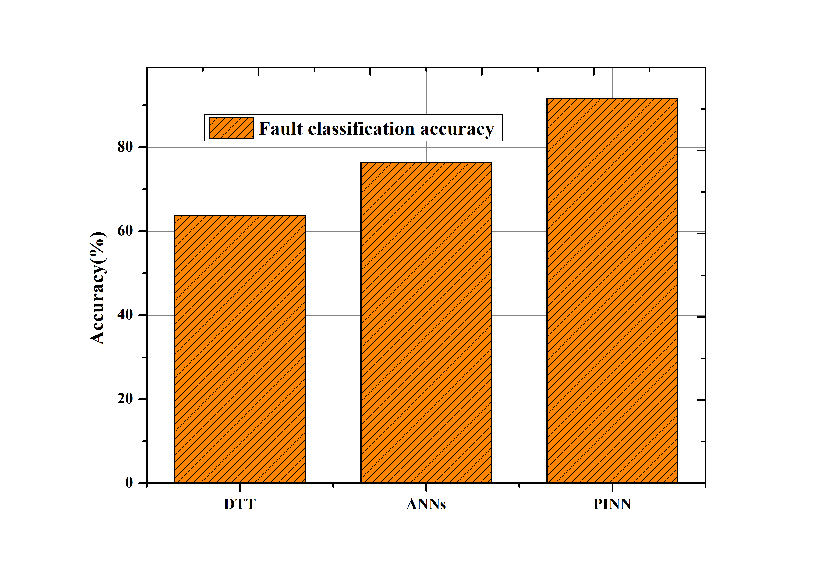
Fig. 3. Classification accuracy
This paper used accuracy measures for fault classification, including precision, recall, and F1-score, to see if the model could discriminate between broken and non-broken states. The BIM model was trained and evaluated using data collected by industrial pump and turbine sensors, which noted temperature, pressure, and vibration changes. BIM achieved 91.7%, greater than DTT (63.7%) and ANNs (76.4%), although they could have physics-based limitations. The balanced recall and accuracy performance of BIM helped to increase mistake detection and generally lower false negatives.

Mean squared error and root mean squared error allows one to assess prediction accuracy:
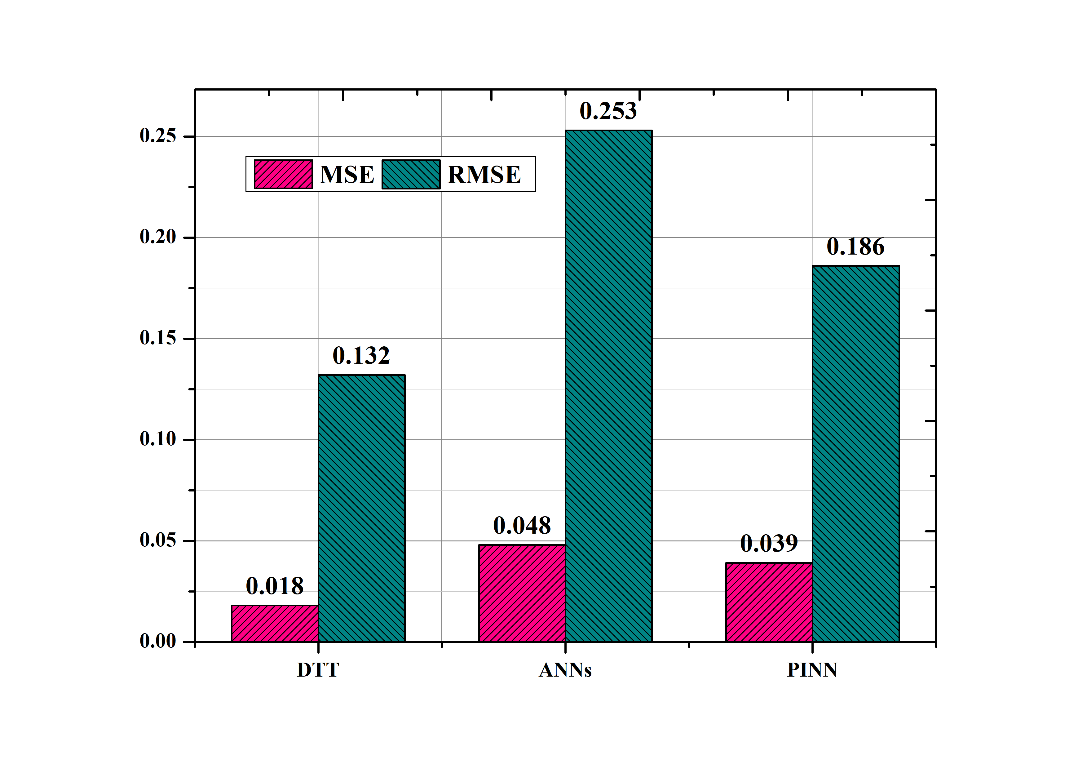
Fig. 4. MSE and RMSE
Using Mean Squared Error (MSE) and Root Mean Squared Error (RMSE) approximations, we evaluated BIM' accuracy in predicting equipment behavior. These steps allow one to compare the expected and actual sensor results. Independent of noise level, BIM got the best MSE (0.018) and RMSE (0.132) for fault forecasts. BIM enhanced prediction accuracy by effectively capturing physical behaviors above existing DTT and ANN models under thermodynamic and fluid dynamic limitations.

False positive rate:
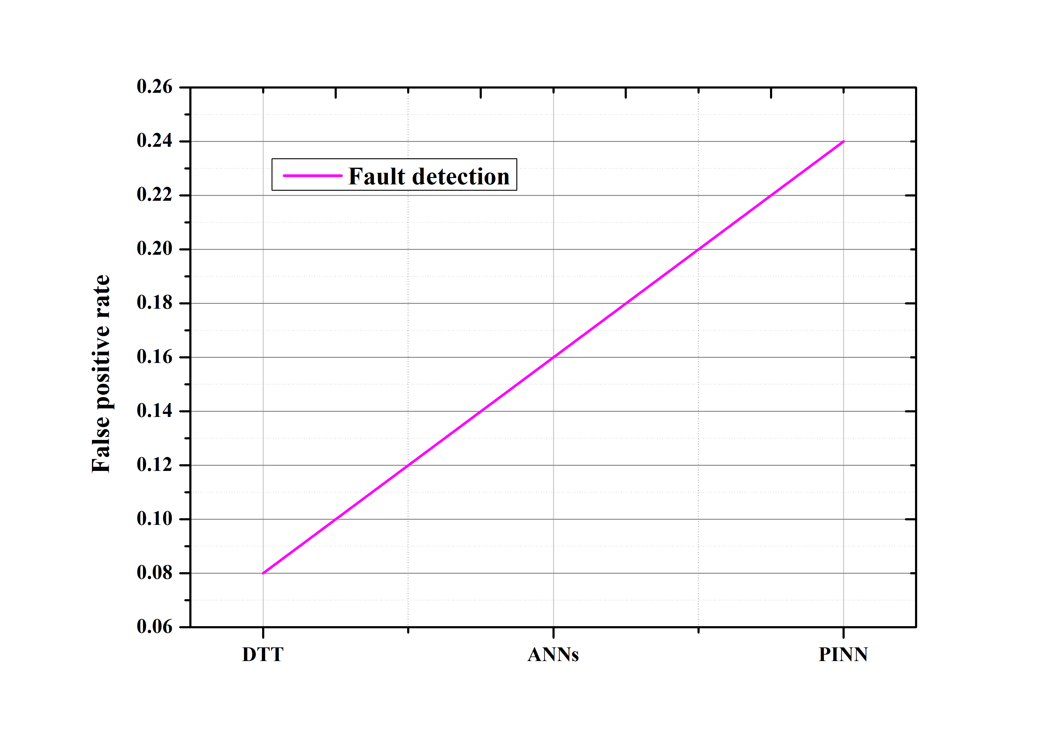
Fig. 5. False Positive Rate
Reducing false positive rates (FPR) is crucial in industrial environments to reduce unnecessary production downtime and maintenance. While DTT and ANNs attained FPRs of 0.16 and 0.24, respectively, BIM only managed 0.08. The ability of BIM to distinguish between sensor noise and real flaws allowed a better fault detection system, lowering unneeded maintenance expenses. This advantage comes from the physics-based constraints that need physically consistent predictions to lower misclassifications from various sensor readings.

Applied are hardware and software tools:
AI foundations, data analysis libraries, and simulation tools built on physics are required for physics-informed neural networks (BIM). The neural network was built and trained using TensorFlow and PyTorch, which provide great processing capability for handling large industrial datasets. The physical limitations might be included in the BIM loss function by modeling thermodynamic and fluid dynamics models in MATLAB and ANSYS. The data was cleaned and standardized before capturing significant sensor data features. Using this varied toolbox, effectively learning from both real-world and simulated industrial data improves the fault detection skills of the BIM model.

Important issues:
Ethical concerns are crucial when handling sensitive sensor data in industrial artificial intelligence applications. This paper encrypts all data collected by our sensors and stores it in compliance with industry standards (such as GDPR and ISO 27001), ensuring the personal data's privacy. This paper guaranteed the datasets were balanced to lower the likelihood of biased predictions coming from an overrepresentation of certain types of errors in the training set. Transparency initially became a top priority to avoid misdiagnosing industrial issues based on BIM model assessments. Following ethical reporting rules lets businesses make maintenance decisions depending on real capabilities and prevents misrepresenting model performance.

Techniques for Minuting Preference:
Combining many approaches enabled us to remove bias and provide fair and more generalizable fault prediction. Synthetic fault data generation was useful in estimating underrepresented failure probabilities in the datasets. Cross-valuation over several industrial datasets improved flexibility over different equipment and operating circumstances by preventing overfitting to a specific operational situation. Through independent validation utilizing outside datasets from various sectors, this paper lowered the likelihood of model over-reliance on a single data source. The model's predictions were then investigated for biases using interpretable artificial intelligence methods like SHAP (Shapley Additive Explanations) to see which features were noteworthy. These techniques help clarify how and why the model generates predictions, strengthening the reliability and trustworthiness of predictive maintenance systems driven by artificial intelligence.

Conclusion
This paper demonstrates that BIM outperform traditional machine learning and models based exclusively on physical principles for predictive maintenance and defect detection in industrial equipment. By mixing AI with domain-specific physical equations, BIM boost generalizability, minimize false positives, and improve accuracy in defect diagnosis with less labeled data. As practical investigations on industrial pump and turbine datasets indicate BIM outperform CNNs, LSTMs, and conventional physics-based models, BIM may be examined as a possible alternative for boosting operational efficiency, minimizing downtime, and extending equipment lifespan. Multi-fidelity training makes the model versatile and adaptable to many running conditions. This suggests you may rely on correct estimations free of data shortage or sensor noise level.
There are still certain limitations even with all the progress done. First, the processing requirements of training BIM are much reduced by the physics-based restrictions that hamper backpropagation. Second, even if they achieve more generalization than data-driven models, the success of BIM relies on the validity of the governing equations. Any incorrect or incomplete physical representation might affect fault detection accuracy. While multi-fidelity learning depends on high-quality simulated data, different real-world sensor data from simulated data could affect predicted performance. Retraining in real-time may be necessary for optimum performance since BIM struggle with extremely dynamic and varied failure conditions.
Future studies on improved BIM designs—such as hybrid models based on transformers and better suited to real-time streaming sensor data—aim to overcome these limits. Moreover, symbolic regression and neural operators are under discussion in this study as means of automated physics discovery, which dynamically enhance controlling equations. We will study distributed edge computing architectures to enable more practical BIM models for embedded systems and industrial equipment enabled by the Internet of Things (IoT). They might, therefore, be applied for on-site, real-time problem detection. To provide additional generality throughout other manufacturing sectors, it is also recommended that the dataset be expanded to include various types of industrial equipment. Integrating self-supervised learning methods provides a third possible route for research that can assist in reducing the need for labeled fault data. Using better BIM in these areas, future smart manufacturing and predictive maintenance systems will develop to be more interpretable, efficient, and scalable tools.

References
[1] X. Chen, M. Ma, Z. Zhao, Z. Zhai, and Z. Mao, "Physics-Informed Deep Neural Network for Bearing Prognosis with Multisensory Signals," J. Dyn. Monit. Diagn., vol. 1, no. 4, pp. 200–207, 2022. DOI: 10.37965/jdmd.2022.54.
[2]Kooshki, S. A., Zeinabadi, H., Jafarnezhad, A., & Kooshki, H. A. (2016). Applications of Fuzzy Logic and Artificial Neural Networks in Evaluation and Ranking of Teachers Based on “Framework for Teaching” Model. International Academic Journal of Innovative Research, 3(1), 1–10.
[3] J. Li and Y. Zhang, "Physics-informed probabilistic deep network with interpretable mechanism for trustworthy mechanical fault diagnosis," Adv. Eng. Inform., vol. 62, p. 102806, 2024. DOI: 10.1016/j.aei.2024.102806.
[4]Kouroshnia, H., & Farokhi, F. (2018). Adapting and optimization in small signal modeling of nanoscale MOS-FET Using artificial recurrent neural networks. International Academic Journal of Science and Engineering, 5(2), 227–234. https://doi.org/10.9756/IAJSE/V5I1/1810038
[5] L. Zhang and Y. Wang, "Physics-informed neural networks for predictive maintenance in smart manufacturing: A comprehensive review," J. Manuf. Syst., vol. 68, pp. 345–360, 2023.
[6]Santhi, P., [Deeban, N., Jeyapunitha, N., Muthukumaran, B., & Ravikumar, R. (2020). Prediction of Diabetes Using Neural Networks. International Journal of Advances in Engineering and Emerging Technology, 11(2), 60–68.
[7] S. Huang and G. Chen, "A hybrid physics-informed neural network approach for real-time fault detection in rotating machinery," IEEE Trans. Ind. Electron., vol. 70, no. 5, pp. 4210–4220, 2023.
[8]Jalaja, V., Sheshadri, T., Arthi, V. K., Thilaga, S., Bamini, J., Mahabub Basha, S., & Kethan, M. (2024). Maximizing Marketing Value: An Empirical Study on the Framework for Assessing AI and ML Integration in Marketing Management. Indian Journal of Information Sources and Services, 14(3), 64–70. https://doi.org/10.51983/ijiss-2024.14.3.09
[9] G. Manogaran, M. Alazab, P. M. Shakeel, and C. H. Hsu, "Blockchain assisted secure data sharing model for Internet of Things based smart industries," IEEE Trans. Reliab., vol. 71, no. 1, pp. 348–358, 2021.
[10]Yang, Z. (2024). The Impact of Environmental Assessment of Green Innovation on Corporate Performance and an Empirical Study. Natural and Engineering Sciences, 9(2), 94-109. https://doi.org/10.28978/nesciences.1569137
[11] Unsupervised Learning and Digital Twin Applied to Predictive Maintenance for Industry 4.0," Wiley Online Library, 2025.
[12]Rajput, D. S. (2024). Investigating the Role of Genetic Variants in Drug- Induced Liver Injury. Clinical Journal for Medicine, Health and Pharmacy, 2(1), 30-39.
[13] AI-Driven Predictive Maintenance in Smart Manufacturing: Enhancing Efficiency through AI Models," J. Intell. Syst. Eng. Manuf., 2025.
[14]Khan, M., & Taha, A. (2023). Simulating Complex Structures with Structural Engineering Software. Association Journal of Interdisciplinary Technics in Engineering Mechanics, 1(1), 26-37.
[15] AI-Based Predictive Maintenance in Smart Manufacturing: Challenges and Future Directions," ScienceDirect, 2021.
[16]Desai, P., & Joshi, V. (2023). Bridging Traditional and Modern Medical Terminologies Integrative Perspectives from Ayurveda and Allopathy. Global Journal of Medical Terminology Research and Informatics, 1(1), 12-15.
[17] V. Jadhav, A. Deodhar, A. Gupta, and V. Runkana, "Physics Informed Neural Network for Health Monitoring of an Air Preheater," PHM Soc. Eur. Conf., vol. 7, no. 1, pp. 219–230, 2022. DOI: 10.36001/phme.2022.v7i1.3343.
[18]Donkor, K., & Zhao, Z. (2023). Building Brand Equity Through Corporate Social Responsibility Initiatives. Global Perspectives in Management, 1(1), 32-48.
[19]R. Gao and X. Li, "Integrating physics-based models with AI for fault diagnosis in industrial machinery," Mech. Syst. Signal Process., vol. 172, p. 109064, 2023.
[20]Sato, S., Hirose, S., & Shikata, J. (2019). Sequential Aggregate MACs from Any MACs: Aggregation and Detecting Functionality. Journal of Internet Services and Information Security, 9(1), 2-23.
[21] AI-Driven Predictive Maintenance for Smart Manufacturing Systems Using Digital Twin Technology," Int. J. Comput. Eng. Sci. Eng. Netw., 2025.
[22] Application of Sensor Data-Based Predictive Maintenance and Artificial Neural Networks to Enable Industry 4.0," SpringerLink, 2023.
[23] Adoption of Machine Learning Technology for Failure Prediction in Industrial Maintenance: A Systematic Review," ScienceDirect, 2021.
[24]https://www.kaggle.com/code/abdullaharean/sequence-models-notes-rnn-gru-lstm-transformer
[25]P. Wang and H. Liu, "Physics-informed neural network classification framework for reliability analysis," Expert Syst. Appl., vol. 258, p. 125207, 2024. DOI: 10.1016/j.eswa.2024.125207.
[26] Y. Liu and H. Zhao, "Multi-fidelity physics-informed neural networks for predictive maintenance of complex systems," Reliab. Eng. Syst. Saf., vol. 219, p. 108202, 2024.

