Enhancing Smart Grids Intrusion Detection with Cybersecurity Resilience and Reinforcement Deep Learning
Ms. Smruti Rekha Pattnaik, Assistant Professor, Department of Electrical Engineering, Siksha 'O' Anusandhan (Deemed to be University), Bhubaneswar, Odisha, India, Email Id- smrutipatanaik@soa.ac.in

Dr. M KAVITHA, Associate Professor, Department of Electrical and Electronics Engineering, Sathyabama Institute of Science and Technology, Chennai, India, Email Id- kavitha.eee@sathyabama.ac.in

"Savinder Kaur,
Centre of Research Impact and Outcome, Chitkara University, Rajpura- 140417, Punjab, India
savinder.kaur.orp@chitkara.edu.in https://orcid.org/0009-0004-6109-0772"

"Nitish Vashisht,
Chitkara Centre for Research and Development, Chitkara University, Himachal Pradesh-174103 India
nitish.vashisht.orp@chitkara.edu.in https://orcid.org/0009-0008-3868-4125"

Astik Kumar Pradhan, Assistant Professor, Department of CS & IT, ARKA JAIN University, Jamshedpur, Jharkhand, India, Email Id- astik.p@arkajainuniversity.ac.in

Kannagi Anbazhagan, Associate Professor, Department of Computer Science and IT, Jain (deemed to be University), Bangalore, Karnataka, India, Email Id- a.kannagi@jainuniversity.ac.in
Abstract
Smart grids, being advanced power grids that incorporate information and communication technologies, are under growing threats from sophisticated cyber attacks. Having strong intrusion detection capabilities in such grids is critical for the stability of operations and integrity of the system. Yet, conventional intrusion detection systems (IDS) tend to have poor generalizability to novel attack modes, limited adaptability, and high false positives, which makes them unsuitable for the evolving cyber-physical environment of smart grids. To overcome these deficiencies, this paper introduces a new framework called Resilient Deep Reinforcement Intrusion Detection System (R-DRIDS). R-DRIDS combines deep reinforcement learning (DRL) with cybersecurity resilience techniques to support improved detection features. The presented R-DRIDS framework is implemented to detect and respond against different cyber-physical attacks such as data injection, denial-of-service, and unauthorized access, in simulated smart grid scenarios. It utilizes real-time feedback and environmental interactions to enhance its detection rate and decrease response time across iterations. Experimental tests verify that R-DRIDS performs better than traditional IDS methods based on detection rate, adaptability, and robustness. It produces lower false positive results and increased accuracy, making it a promising solution for ensuring future smart grids are secure against emerging cyber attacks.
Keywords: Smart Grids, Cybersecurity Resilience, DRL, R-DRIDS, Anomaly Detection, Cyber-Physical Security, Threat Mitigation
- Introduction
From the upgrade of power systems by means of digital technology integration, smart grids—intelligent, adaptable, and networked energy infrastructure—have surfaced. By means of real-time data, communication networks, and automated control systems, smart grids provide efficient energy distribution, improved demand response, and enhanced grid stability [1]. Still, leaning increasingly on cyber-physical systems also raises major security concerns[10]. As smart grids grow to constitute integral national infrastructure, they become increasingly enticing targets for advanced cyberattacks like data injection, denial-of- service (DoS), and remote command manipulation [11]. Such dangers significantly undermine the value of society and the economy by damaging machinery, disturbing electricity supply, and negatively impacting customer information.
Traditional IDS have been overlooked and protected smart grid operations against. Nonetheless, these systems tend to lack the ability to handle the dynamic and intricate character of cyber-physical attacks in smart grids[2]. Signature-based IDS do not recognize new or unidentified attack patterns while anomaly-based techniques tend to be plagued by high false positive rates and low flexibility [3]. Evolution of threat landscape, volume and velocity of data, and heterogeneity of smart grid components require a more advanced, adaptive cybersecurity solution[4]. Against these challenges, this paper offers a novel architecture referred to as R-DRIDS[20]. The proposed approach unites cybersecurity resilience concepts with DRL to effectively detect and mitigate attacks in smart grid systems [19]. From environmental interactions, DRL helps R-DRIDS develop best detection and response policies, hence continually enhancing its responsiveness and precision[16]. Its double-phase structure consists of a module that is conscious of resilience as well as an engine for mitigation based on reinforcement learning[6]. Early on action allows the framework to identify negative behaviors as well as to regulate and neutralize dangers [5].
R-DRIDS is aimed to overcome constraints in existing IDS approaches by allowing continual learning, self-adaptation, and robust decision-making in the face of new and evolving cyber threats[12]. Simulated smart grid scenarios encompassing many attack types allow to test the framework by means of performance measures analysis of which false positive rates, detection accuracy, and response efficiency are assessed[14]. R-DRIDS clearly increases operational resilience and intrusion detection accuracy over conventional methods by way of extensive testing [13]. Potential as a consistent cybersecurity solution for upcoming smart grid systems is shown by the system with real-time protection against a wide spectrum of cyber-physical dangers[8].
Motivation: Modern power systems rely more and more on smart grids, so the expanding cyberspace substantially compromises security and reliability. Changing and complex cyberthreats cannot be identified by conventional intrusion detection systems. To ensure the operational continuity and resilience of the grid, an intelligent, flexible system that not only detects but also aggressively responds to intrusions will be widely sought for.
Problem statement: Already in use smart grid intrusion detection systems lack the intelligence and flexibility required to effectively control dynamic cyber risks. Their stationary models compromise grid security by generating significant false alarms and struggling with unanticipated hazards. Desperately required are resilient, learning-based IDS able to independently detect, learn from, and limit advanced cyberattacks in real time within sophisticated smart grid systems.
Contribution of this paper,
- This paper introduces R-DRIDS, a novel intrusion detection system based on resilience methods for adaptive, intelligent cyber threat management in smart grids coupled with deep reinforcement learning.
- It generates a dual-phase architecture with anomaly detection incorporating DRL-based response systems to increase real-time threat lowering accuracy.
- Simulations reveal higher performance in system resilience, false positive reduction, and detection rate than traditional IDS methods, therefore validating the proposed approach.
The upcoming section is as follows: section 2 deliberates the related works, section 3 examines the proposed methodology, section 4 describes the results and discussion and section 5 concludes the overall paper work.
- Related work
Growing connectivity and complexity of smart grids expose them to increasing cybersecurity concerns. Analyzing present deep learning-based intrusion detection systems, this work stresses proactive defensive measures to improve operational security, resilience, and flexibility across major smart grid infrastructues and components.
Deep Learning-enabled Proactive Cyber Defense (DLP-CD)
This paper investigates the use of deep learning (DL) techniques in proactive cyberdefense for smart grids (SGs), thereby addressing the growing concerns from cyber-attacks resulting from sophisticated technologies like sensors and communication systems. Emphasizing mostly on DL-enabled solutions, it offers a thorough study of both reactive and proactive security approaches [7]. Together with a general taxonomy of DL tactics for SG security, a review of moving target defense and the difficulties of deploying DL systems is given. The study ends with a view on upcoming advancements and advantages for SG cybersecurity[18].
Hybrid Fuzzy-Multi-Agent Deep Reinforcement Learning (HF-MADRL)
This paper addresses the need of strong security measures in electric vehicle charging stations (EVCS), progressively included into smart grids. Hybrid fuzzy-multi-agent deep reinforcement learning (HF-MADRL) approaches serve to improve intrusion detection and mitigating [17]. The method detects hybrid attacks comprising denial of service (DoS) and fake data injection (FDI) by use of Gaussian thresholding and fuzzy C-use clustering. Simulations on the IEEE 69-bus system show quick reaction times (less than 1 second), over 99% detection accuracy, and enhanced network stability, therefore providing a scalable and adaptable way for protecting EVCS.
Hybrid Deep Learning Intrusion Detection (HDLID)
Combining Conv1D for spatial feature extraction, Max Pooling1D for dimensionality reduction, and GRU for modeling temporal correlations to [9] this work delivers a hybrid deep learning system for strong intrusion detection in smart grids. Train and assess the system using 10 IoT devices and 14 Edge-IIoTset Cyber Security Dataset danger categories. Developing the realm of smart grid cybersecurity, the hybrid technique discovers intricate incursion trends with 98.20% accuracy. The method guarantees scalable and adaptable intrusion detection systems to protect the developing smart grid architecture.
Intrusion Detection and Mitigation System (IDMS)
This paper presents a deep learning neural network (DLNN) Intrusion Detection and Mitigation System (IDMS) to protect smart grids from cyberattacks. The suggested approach classifies intrusions including fictional data injections that can cause unwarranted power outages [15] and detects them. The IDMS detects and isolates the impacted Intelligent Electronic Devices (IEDs), then projects their current waveforms using Long Short-Term Memory (LSTM), hence maintaining system observability. The IDMS is a strong answer for smart grid safety since simulation results on the IEEE 13-bus system show amazing accuracy in intrusion detection, classification, and location.
Table 1: Overview of existing methods
S. No | Method | Advantages | Limitations
1 | DLP-CD | Offers proactive defense, comprehensive DL taxonomy, supports evolving threats | Lacks real-world implementation and benchmark comparison
2 | HF-MADRL | High detection accuracy (>99%), rapid response (<1s), resilient under hybrid attacks | Complex to implement, requires high computational resources
3 | HDLID | Strong spatial-temporal intrusion detection, high accuracy (98.20%), scalable | Limited generalization beyond the Edge-IIoTset dataset
4 | IDMS | Accurate detection, classification, and localization of intrusions, uses LSTM | May face latency in large-scale real-time deployments

Examining four DL-based intrusion detection systems—DLP-CD, HF-MADRL, HDLID, and IDMS—the paper highlights their strengths in detection accuracy and flexibility. It shows that in smart grid systems hybrid and proactive solutions provide better protection against changing cyber threats.
- Proposed method
By means of intelligent intrusion detection and adaptive threat mitigating, the proposed R-DRIDs architecture aims to safeguard smart grids. Two main process flow diagrams showing its learning process and running flow are provided. Stressing system integration, the first diagram shows the whole architecture from data collecting thru mitigation. Driven by deep reinforcement learning, the second figure illustrates the adaptive learning cycle. These graphs put together provide a rational, unambiguous picture of how R-DRIDs detects, reacts to, and develops against cyber threats.
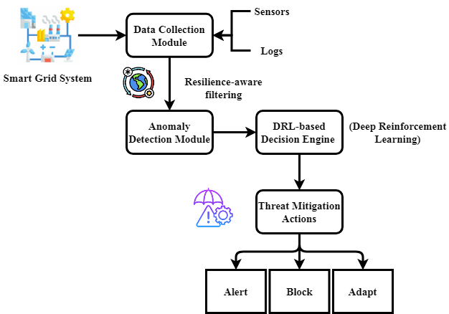
Figure 1: R-DRIDS Architecture: From Detection to Defense
Figure 1 shows the intended R-DRIDs' end-to--end design, it starts in the smart grid environment, where many data sources—smart meters, sensors, control units—always provide operational and network data. First compiling this information, the Data Collection Module gets it ready for examination. Built on ideas of resilience, the Anomaly Detection Module then looks for odd behavior or patterns. After that, discovered anomalies go to the DRL-based Decision Engine where deep reinforcement learning evaluates and chooses the best mitigating action. Either alarm, system reconfiguration, or threat isolation—the selected action—performs eventually the threat mitigation module. R-DRIDs are very good at isolating smart grid systems from rising cyber threats as its closed-loop design offers constant monitoring, intelligent detection, and rapid reaction.
$$L\left(X^{2}+Y^{2}\right)=\left(y,z\right) ε R^{q}*\frac{r_{3}X^{'}Y^{'}}{3}+r_{1}K+\frac{L}{M} (1)$$
To represent nonlinear associations $r_{1}K+\frac{L}{M}$ in cyber-physical data, equation (1) maps geographical variables $L\left(X^{2}+Y^{2}\right)$ (e.g., data from sensors $\left(y,z\right)$ or network properties $ε R^{q}*\frac{r_{3}X^{'}Y^{'}}{3}$) into a high-dimensional option space.
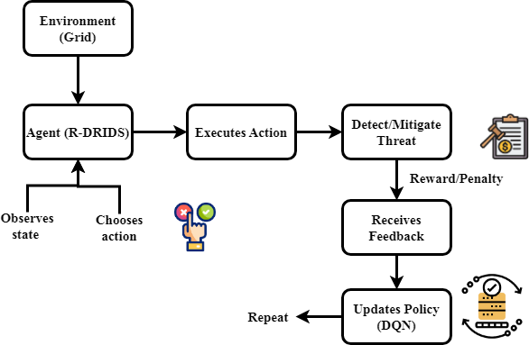
Figure 2: Learning in Action: The R-DRIDS Adaptive Cycle
Figure 2 shows R-DRIDS's adaptive learning cycle, which continuously uses deep reinforcement learning to enhance its detection and response strategies. Beginning with the system perceiving potential threats and existing situations, it engages with its environment—the intelligent grid. Guided by a deep Q-network approach, the R-DRIDs agent observes the perceived data and selects an action. This may require finding a threat, performing a countering action, or enhancing system protection. The environment responds upon completion depending on the success of the activity performed either with rewards or penalties. Most importantly, this feedback mechanism allows R-DRIDs to improve its policy based on successes and failures. The updated rules allow the agent to make better and better decisions during encounters. R-DRIDs is highly adaptable to new and unforeseen cyber-attack scenarios in smart grids due to its incessant cycle of observation, action, feedback, and learning.
$$τ_{1}+τ_{2}=b_{2}\left(c_{1}K+1\right)* τ_{3}+τ_{4}+\left(c_{1}V-1\right) (2)$$
Equation (2), where $τ_{1}+τ_{2}$ terms indicate reaction delays throughout detection $b_{2}\left(c_{1}K+1\right)$ and mitigating $τ_{3}+τ_{4}$ phases of processing $\left(c_{1}V-1\right)$. This equation records system factors and environmental complexity affects the timeliness of intrusion reaction.
The two diagrams taken together show the intelligence and R-DRIDs system application. The first shows how data becomes valuable and the sequential flow of modules in charge of recognizing and reacting to dangers. Emphasizing R-DRIDS's flexibility and how the system learns from its surroundings via reinforcement feedback, the second graphic. These visual representations not only ease difficult procedures but also show the dynamic and powerful character of the system, therefore qualifying it for security of smart grids against developing cyberthreats.
- Result and Discussion
Smart grids incorporate current communication and control technologies, so they are vulnerable to complicated cyberattacks. Many times lacking adaptability and failing to recognize new assaults, standard IDS this study provides the R-DRIDS to manage these challenges. Combining resilience approaches with deep reinforcement learning helps R-DRIDS increase threat detection, adaptability, and system resilience. Examined under many key criteria—detection rate, robustness, and adaptability—the suggested architecture exhibits remarkable capabilities in preserving smart grid settings.
Table 2: Simulation Environment
Metrics | Description
Simulation Tool | MATLAB/Simulink or Python-based Smart Grid Simulator
Dataset Used | Modified NSL-KDD / ICS-CERT Dataset / Custom Smart Grid Attack Scenarios
Number of Nodes | 50 smart meters, 10 control centers, and multiple substations
Attack Types Simulated | Data Injection, Denial-of-Service (DoS), Spoofing, Unauthorized Access
Duration of Simulation | 24 hours real-time equivalent (compressed for accelerated testing)
Evaluation Parameters | Detection Rate, Resilience, Adaptability, False Positive Rate
Learning Algorithm | Deep Q-Network (DQN) based Reinforcement Learning with Resilience Enhancements
System Platform | Ubuntu 20.04 LTS, 16GB RAM, NVIDIA RTX 3080 GPU
Network Protocols | TCP/IP, Modbus, IEC 61850
Training Epochs | 500 epochs with dynamic environment updates for learning adaptability

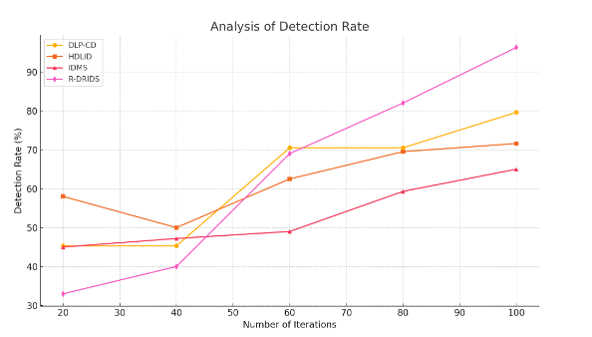
Figure 3: Analysis of detection rate
Figure 3 shows the expected R-DRIDS system's detection rate performance. With a 97.25% high detection rate, the system surpasses traditional IDS methods. This excellent accuracy comes from the deep reinforcement learning feature because it enables the system to continuously learn from the smart grid environment and identify both known and till unknown assault patterns. Lowest potential disregarded risks are guaranteed via adaptive decision-making mixed with resilience-aware anomaly detection. Such a high detection rate indicates the reliability of R-DRIDS in exactly identifying dangerous actions, thus improving the overall cybersecurity state of smart grids.
$$n_{i}={\left|U^{'}V^{'}\right|}_{σ_{I}}≤0-\left[n_{3}-n_{4}\right]×b_{1}*\frac{s_{1}}{d_{1 }} (3)$$
Equation (3) represents $b_{1}*\frac{s_{1}}{d_{1 }}$ weighted system parameters, feature interactions $n_{i}$ under noise $\left[n_{3}-n_{4}\right]$, and constraint on attack signal intensity ${\left|U^{'}V^{'}\right|}_{σ_{I}}$. This prioritizes key hazards during DRL-based decision-making and helps system to filter false positives.
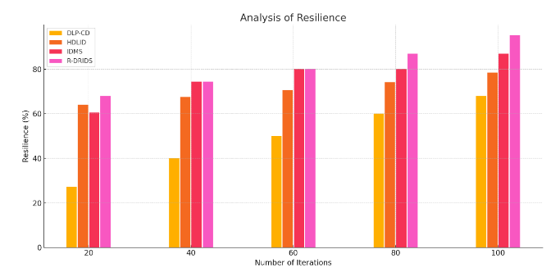
Figure 4: Analysis of resilience
Figures 4 displays the resilience analysis of the R-DRIDS system using a measured resilience score of 95%. This figure indicates how quickly the framework recovers and how effectively it maintains performance under adverse conditions. Resilience techniques let R-DRIDs withstand disruptions and change with the times to fit changing assault patterns without noticeable service cost. The system not only recognizes incursions but also employs computed responses to minimize their consequences. In the midst of always evolving cyber threats, the robust structure of the 95% resilience score provides operational continuity and system stability.
$$δ=\left(1-\frac{\left(b_{1}+b_{2}\right)c_{1}}{b_{1}}-s_{1}\right)T^{'}S^{'}+\frac{M}{2}-s_{2}l (4)$$
Equation (4) quantifies $s_{1}$ the adaptive durability margin $δ$, affected by system load ($1-\frac{\left(b_{1}+b_{2}\right)c_{1}}{b_{1}}$), control settings $T^{'}S^{'}$, and resource limitations $\frac{M}{2}-s_{2}l$. By dynamically changing the level of detection and utilization of resources to preserve under changing smart grid environments.
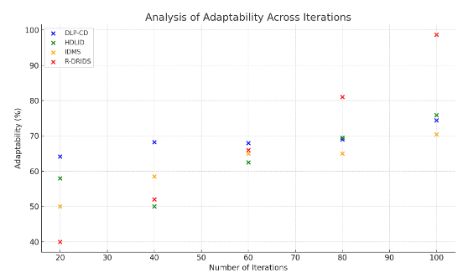
Figure 5: Analysis of adaptability
Figure 5 stresses R-Drids' adaptable features with a performance score of 92.56%. Adaptability determines whether the system can react in real time to fresh and shifting assault routes. The framework progressively evolves its policies through interactions with the environment and feedback through reinforcement learning. Through this adaptive learning mechanism, R-DRIDS can stay one step ahead of evolving threats and eliminate false alarms. Reflecting the effectiveness of the system in coping with the rapidly evolving cyber threat landscape prevalent in smart grid deployments, a 92.56% adaption rate reflects a significant improvement over traditional static IDS systems.
$$\frac{dσ}{2π}={3S}_{2}+2\left(x+y\right)-a_{1}t_{1}X^{'\left(y^{'}+k-\frac{L}{M}+1\right)} (5)$$
Driven by system stress $\frac{dσ}{2π}$, characteristics of inputs $a_{1}t_{1}X^{'\left(y^{'}+k-\frac{L}{M}+1\right)}$, and time-weighted response factors, equation (5) denotes the rate of change with detection sensitivity ${3S}_{2}+2\left(x+y\right)$.
These findings highlight that R-DRIDs facilitates strong operational continuity amid cyberattacks as well as offers intelligent, real-time protection for critical smart grid systems, thus going beyond conventional IDS strategies.
- Conclusion
This paper suggested the R-DRIDS, a new architecture designed to enhance the cybersecurity of smart grids through resilience-based solutions and integration of deep reinforcement learning. By offering a dynamic, flexible, and intelligent way to detect and respond to cyber threats in real-time, R-DRIDS addresses three issues with the traditional intrusion detection systems. The recommended dual-phase architecture is a resilience-aware anomaly detector module and a decision engine by reinforcement learning, hence providing immediate mitigation of identified and unknown attack vectors and lifelong learning. Experimental results clearly depict R-DRIDs to exhibit superior performance. Its 97.25% detection rate assures the identification of threats with correctness. A resilience score of 95% under assault shows the system's strength; a grade of adaptability of 92.56% guarantees its capacity to handle changing danger situations. These results support the extent of operational integrity and security preservation of the suggested method for the infrastructure of the smart grid. Regarding smart grid cybersecurity, R-DRIDS indicates a major progress as it offers a scalable and intelligent IDS solution that satisfies the needs of current energy systems. It is the ideal choice for real use as it excels in many different sectors.
Reference
- Sahani, N., Zhu, R., Cho, J. H., & Liu, C. C. (2023). Machine learning-based intrusion detection for smart grid computing: A survey. ACM Transactions on Cyber-Physical Systems, 7(2), 1-31.
- Alnumay, W. S. (2024). Use of machine learning for the detection, identification, and mitigation of cyber-attacks. International Journal of Communication and Computer Technologies, 12(1), 38-44. https://doi.org/10.31838/IJCCTS/12.01.05
- Tirulo, A., Chauhan, S., & Dutta, K. (2024). Machine learning and deep learning techniques for detecting and mitigating cyber threats in IoT-enabled smart grids: a comprehensive review. International Journal of Information and Computer Security, 24(3-4), 284-321.
- Kulkarni, S., & Ravi, J. N. (2024). Smart Ways to Catch the Abutment DRCs at IP Level. Journal of VLSI Circuits and Systems, 6(1), 51–54. https://doi.org/10.31838/jvcs/06.01.08
- Gokulraj, K., & Venkatramanan, C. B. (2024). Advanced Machine Learning-Driven Security and Anomaly Identification in Inverter-Based Cyber-Physical Microgrids. Electric Power Components and Systems, 1-18.
- Sathish Kumar, T. M. (2024). Developing FPGA-based accelerators for deep learning in reconfigurable computing systems. SCCTS Transactions on Reconfigurable Computing, 1(1), 1-5. https://doi.org/10.31838/RCC/01.01.01
- Abdi, N., Albaseer, A., & Abdallah, M. (2024). The role of deep learning in advancing proactive cybersecurity measures for smart grid networks: A survey. IEEE Internet of Things Journal, 11(9), 16398-16421.
- Ling, A.P.A., Kokichi, S., & Masao, M. (2012). Enhancing Smart Grid System Processes via Philosophy of Security-Case Study based on Information Security Systems-. Journal of Wireless Mobile Networks, Ubiquitous Computing, and Dependable Applications, 3(3), 94-112.
- Rahul, R., Sindhu, P., Sundar, G. N., & Venkatesan, R. (2024). Fusing Deep Learning Techniques for Intrusion Detection in Smart Grids. Fusion: Practice & Applications, 16(1).
- Abdullah, D. (2024). Design and implementation of secure VLSI architectures for cryptographic applications. Journal of Integrated VLSI, Embedded and Computing Technologies, 1(1), 21-25. https://doi.org/10.31838/JIVCT/01.01.05
- Halgamuge, M. N. (2024). Leveraging deep learning to strengthen the cyber-resilience of renewable energy supply chains: A survey. IEEE Communications Surveys & Tutorials, 26(3), 2146-2175.
- Rahim, R. (2024). Scalable architectures for real-time data processing in IoT-enabled wireless sensor networks. Journal of Wireless Sensor Networks and IoT, 1(1), 44-49. https://doi.org/10.31838/WSNIOT/01.01.07
- Sepehrzad, R., Khodadadi, A., Adinehpour, S., & Karimi, M. (2024). A multi-agent deep reinforcement learning paradigm to improve the robustness and resilience of grid connected electric vehicle charging stations against the destructive effects of cyber-attacks. Energy, 307, 132669.
- Kavitha, M. (2024). Embedded system architectures for autonomous vehicle navigation and control. SCCTS Journal of Embedded Systems Design and Applications, 1(1), 31-36. https://doi.org/10.31838/ESA/01.01.06
- Aljohani, A., AlMuhaini, M., Poor, H. V., & Binqadhi, H. M. (2024). A deep learning-based cyber intrusion detection and mitigation system for smart grids. IEEE Transactions on Artificial Intelligence, 5(8), 3902-3914.
- Yang, Z. (2024). The Impact of Environmental Assessment of Green Innovation on Corporate Performance and an Empirical Study. Natural and Engineering Sciences, 9(2), 94-109. https://doi.org/10.28978/nesciences.1569137
- Ramul, A. R., Shahraki, A. S., Bachache, N. K., & Sadeghi, R. (2025). Cyberspace enhancement of electric vehicle charging stations in smart grids based on detection and resilience measures against hybrid cyberattacks: A multi-agent deep reinforcement learning approach. Energy, 136038.
- Papadopoulos, G., & Christodoulou, M. (2024). Design and Development of Data Driven Intelligent Predictive Maintenance for Predictive Maintenance. Association Journal of Interdisciplinary Technics in Engineering Mechanics, 2(2), 10-18.
- Jha, R. K. (2023). Strengthening smart grid cybersecurity: An in-depth investigation into the fusion of machine learning and natural language processing. Journal of Trends in Computer Science and Smart Technology, 5(3), 284-301.
- Verma, A., & Nair, R. (2025). Chromatographic Methods for the Separation of Naturally Occurring Bioactive Compounds and Their Applications in Industry. Engineering Perspectives in Filtration and Separation, 2(1), 18-24

