Enhancing Data Security and Encryption in Virtual Worlds through AI and Quantum Computing Integration
Dr Kamalraj R, Professor, Department of Computer Science and IT, Jain (deemed to be University), Bangalore, Karnataka, India, Email Id- r.kamalraj@jainuniversity.ac.in

Ms. Chinmayee Nayak, Assistant Professor, Centre for Artificial Intelligence and Machine Learning, Siksha 'O' Anusandhan (Deemed to be University), Bhubaneswar, Odisha, India, Email Id- chinmayeenayak@soa.ac.in

Dr.G.Sundari, Professor, Department of Electronics and Communication Engineering, Sathyabama Institute of Science and Technology, Chennai, India, Email Id- sundari.ece@sathyabama.ac.in

"Himanshu Makhija,
Centre of Research Impact and Outcome, Chitkara University, Rajpura- 140417, Punjab, India
himanshu.makhija.orp@chitkara.edu.in https://orcid.org/0009-0002-0864-9069"

"Ashmeet Kaur,
Chitkara Centre for Research and Development, Chitkara University, Himachal Pradesh-174103 India
ashmeet.kaur.orp@chitkara.edu.in https://orcid.org/0009-0003-8780-9792"

Souvik Singh Rathor, Assistant Professor, Department of Computer Science & IT, ARKA JAIN University, Jamshedpur, Jharkhand, India, Email Id- souvik.r@arkajainuniversity.ac.in

Abstract
Integrating quantum computing with AI can dramatically improve the future of data encryption and security in cyberspaces. With growing interaction of users in immersive worlds like the metaverse, user data along with virtual assets require more protection. Existing security approaches, such as classical encryption and rule-based intrusion detection systems, fall short of sophisticated mitigation techniques for cyber threats and quantum-based attacks. To solve these disadvantages, we introduce a new Hybrid framework called Quantum-AI Secured Virtual Framework (QASVF) which integrates AI-powered anomaly detection with data security and virtualized environment frameworks using quantum cryptographic protocols. QASVF employs QKD for eavesdropping, while employing attack inspection through reinforcement learning and deep neural networks. The proposed method is developed to provide secure communication networks, perform user authentication through quantum-strengthened biometrics, and continuously adapt to new vulnerabilities using AI-driven learning cycles. In conjunction, these procedures drastically decrease the probability of data breaches, identity theft, and unauthorized access to virtual worlds. Implementation results of QASVF show improved threat detection performance, lower latency in secure transaction processing, and increased resilience to quantum decryption attacks. The hybrid integration has enabled a new trust elastic model of security which can be considered the next generation of security and trust for virtual relations.
Keywords: Virtual Worlds, Data Security, Quantum Computing, Artificial Intelligence, QKD, Encryption, Anomaly Detection, Cybersecurity.
- Introduction
The broadening scope of metaverse, augmented reality and even virtual reality world has transformed human interaction and business activities unlike any other technological advancement. While these digital worlds offer previously unfathomable opportunities and enjoyment, their use comes with sophisticated security challenges[2]. As virtual spaces become more integrated and reliant on data, there is an increasing need for personal data security. Constant cyber threats such as unauthorized access, financial information, digital identities, and even virtual assets risk data tampering and identity theft [1]. With the ongoing advancement of quantum computing making practical application possible, the limits of conventional cybersecurity frameworks are becoming increasingly apparent. Traditional encryption techniques may soon become ineffective. In most cases, virtual environments are protected through cryptographic systems such as RSA and ECC that rely on the hardness of mathematical problems for data integrity.
Shor’s algorithm illustrates the gap between quantum computation and current digital security by enabling vast optimistically polynomial time degradation of simplicity public-key cryptosystems [19]. AI-enabled attacks that learn user behavior to imitate normal activity and circumvent standard intrusion detection systems add another layer of sophistication complicating system security. Adapting defense methods for real-time threat response is absent in existing approaches, which leads to inadequate containment response delays during breach incidents and insufficient countermeasure provisions for zero-day exploits. These issues demonstrate the need for flexible approaches in new virtual environment militarization strategies capable of leveraging contemporary innovations that provide agile, proactive, and ever-evolving defense mechanisms to defend digital assets. This is accomplished by addressing the deficiencies of existing methodologies with the introduction of the integrated security model, QASVF, which combines the quantum computing’s cryptographic forte with artificial intelligence’s circumstantial adaptability[8]. Based on the conjunction of two powerful technologies, QKD provides potentially unbreakable encryption derived from the laws of quantum mechanics while AI threat analysis enhances surveillance proactively and enables autonomous responses to cybernetic aggression [3].
Through quantum resistant authentication protocols, AI driven anomaly detection frameworks, and active risk evaluation techniques, QASVF’s multiple layers of security simultaneously protect data transmission in virtual environments[10]. Changed Quantum Computing has a different form of encryption using entanglement and superposition active in QKD to eavesdrop any third-party attempts for communication to be made security. Vast streams of behavioral data are apprehended by AI to recognize deviant behaviors, forecast new possible threats, and activate defensive mechanisms autonomously which require no human tampering with frameworks of the system. Incorporating virtual systems' infrastructure machine learning enables QASVF to consistently adapt protect human intervention strategies[12]. Biometric identification in the system is done through deep learning offering secure authentication accurate persona identification even with current advanced technology signifying their physiology or behavioral traits[14].
Integration of QASVF offers numerous advantages for developers and consumers of virtual platforms. Attacks enabled via quantum computing and other current and future threats, end-to-end user identity encryption, and identity obscuring ensure protected communication fortifying user's complete security[16].It also offers a dynamic and self-evolving defense architecture that considerably closes the attack detection and mitigating time period [15]. From gaming and social sites to virtual financial services and digital twin simulations, QASVF's modular design enables it be incorporated into a wide spectrum of virtual systems, thus adaptable and versatile to match numerous use cases[18].
All things considered, traditional cybersecurity solutions cannot handle growing hazards as the virtual world is becoming more complex and valuable[20]. This paper emphasizes the importance of putting a hybrid approach combining the security of quantum cryptography with the intelligence and flexibility of artificial intelligence into use. Using the QASVF paradigm, this study develops a future-ready, resilient security architecture that overcomes the twin problems of quantum vulnerability and AI-powered threats. The approach indicated not only enhances data security but also helps users to trust the digital surroundings of future.
Contribution of this paper,
- This paper offers the QASVF, a new hybrid paradigm integrating artificial intelligence-driven anomaly detection with quantum key distribution to better virtual world threat management and encryption.
- It offers quantum-resistant biometric identification and a multi-layered security system featuring adaptive artificial intelligence algorithms for real-time cyber threat detection and mitigation.
- Providing a scalable method for safeguarding digital assets and identities in immersive environments such as the metaverse, the framework exhibits considerable improvements in data integrity, latency reduction, and defensive resistance against both conventional and quantum-level attacks.
The upcoming section is as follows: section 2 deliberates the related works, section 3 examines the proposed methodology, section 4 describes the results and discussion and section 5 concludes the overall paper work.
- Related work
Emphasizing four advanced models—QRCF, QISA, PQCSM, and AQICDS—this paper assesses developing quantum era cybersecurity methods. It emphasizes the importance of combining quantum resistance with AI skills to defeat ever more complex attacks.
This paper looks at how revolutionary quantum computing may be in the fight against advanced cyberthreats. Quantum computing provides unparalleled potential for protection of private data when conventional encryption becomes useless [5]. By means of quantum-resistant encryption methods and quantum-based machine learning, the proposed Quantum-Resilient Cybersecurity Framework (QRCF) guards important infrastructure. Merging innovativeness with security, QRCF offers a futuristic approach to mitigating developing risks. By surpassing even the strongest cyber-attacks through quantum computing power, the study brings to the fore key possibilities, limitations, and strategic applications of QRCF, thus transforming the cybersecurity landscape.
AI and quantum computing are examined in this paper as a synergy poised to transform existing problem-solving. Demonstrating transformational promise, the proposed approach, Quantum-Intelligent Synergistic Architecture (QISA), is used in areas such as drug discovery, cryptography, and optimization based on the processing power of quantum physics along with artificial intelligence's ability for learning and reasoning[4]. The paper also addresses ethical concerns and implementation challenges [20]. Opening doors previously out of reach for traditional computer systems, QISA not only defies science and technology but also offers rational avenues to address daunting global issues. particularly where security issues that have been posed by quantum means such as Shor's, this paper presents an extensive analysis of how quantum computing impacts cybersecurity. Through application of the Post-Quantum Cryptographic Security Model (PQCSM), one can balance risks to RSA and ECC systems [7]. Merging Quantum Key Distribution (QKD) PQCSM with post-quantum methods secures communications.The quantum systems with coexistence of quantum-classical encryption are compared in this work. It also covers moral and developmental issues. Emphasizing the need of changing current methods to retain safe digital infrastructure, PQCSM is finally suggested as a strong alternative to enhance encryption in a quantum future.
The present paper investigates how quantum computers combined with AI may improve cybersecurity. Using predictive analytics and AI anomaly detection in line with quantum computing's ability to solve cryptographic challenges, the suggested solution, AI-Quantum Integrated Cyber Defense System (AQICDS), Strength of encryption is enhanced by AQICDS; threat detecting accuracy is enhanced; adaptive defensive systems are enhanced [17]. The program also investigates in cybersecurity the applications of quantum cryptography and artificial intelligence-driven data processing. System installation brings challenges that are answered including ethical ones. Representing a next-generation approach for safeguarding digital systems, AQICDS shows that including these technologies might considerably update and enhance world cybersecurity systems.
Table 1: Overview of existing methods
S. No | Methods | Advantages | Limitations
1 | QRCF | Provides quantum-resistant encryption; enhances security for critical data | High implementation cost; requires advanced quantum infrastructure
2 | QISA | Solves complex problems efficiently; applicable in multiple domains | Integration complexity; ethical concerns in decision-making
3 | PQCSM | Protects against quantum attacks; supports secure key distribution | Not yet standardized; limited deployment in real-world systems
4 | AQICDS | Improves threat detection; enables adaptive, real-time defense | Dependence on both AI and quantum maturity; risk of false positives

Comparative analysis of QRCF, QISA, PQCSM, and AQICDS shows the degree of cybersecurity enhancing capacity of every model. Even if they have specific benefits in encryption, threat detection, and system optimization, technical maturity, deployment practicality, and ethical implementation issues affect their value[6].
- Proposed method
The drawings reveal the QASVF, a whole security architecture designed to protect virtual worlds from growing threats. The first image depicts the method by which AI locks user data using quantum encryption, analyzes it, and maintains continuous risk monitoring under active development. Second graphic stresses multilayer security system combining quantum biometric authentication, data encryption, artificial intelligence-driven threat detection, and real-time defense [9]. Taken all together, these technologies provide virtual interactions and transactions dynamic, adaptable, robust protection.
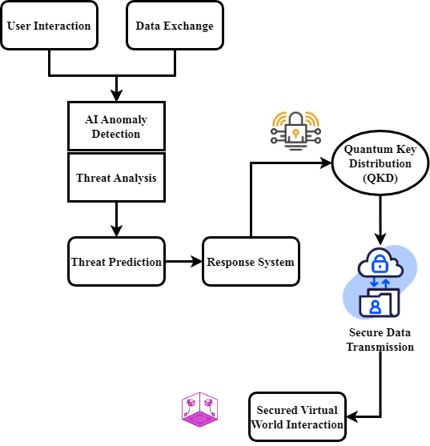
Figure 1: Quantum-AI Enhanced Security Framework for Virtual Worlds
With a flow described in figure 1, the QASVF is meant to provide great security in virtual worlds. Users of User Interaction & Data Exchange engage with the virtual world, therefore exchanging private information. AI anomaly detection and threat analysis then uses machine learning to rapidly find abnormalities or suspected security breaches from this data. Against listening in, the QKD guarantees—that every channel of contact is encrypted and protected. The threat prediction and response system actively searches for any cyber threats and immediately activates appropriate defenses [21]. Finally, the system ensures safe engagement in the Secured Virtual World engagement phase, therefore allowing users to remain engaging safely knowing that the combined power of AI and quantum cryptography guards their data and activities. This design offers a virtual reality that is dynamic, adaptive, and quite safe.
$$δ=S_{2}*b_{1}V\left(\frac{a_{2}}{p}\right)v+u*\left(UV^{'}+VU^{'}\right)\left(1\right)$$
Equation (1) shows patterns $δ$, $S_{2}*b_{1}V$) with quantum parameters *$\left(\frac{a_{2}}{p}\right)v$, $u*\left(UV^{'}+VU^{'}\right)$) and artificial response variables. This shows virtual variations while measurement protocols provide safe encryption of keys and user authentication.
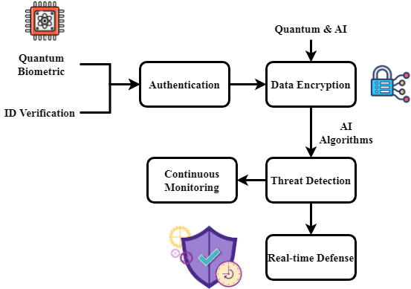
Figure 2: Layered Security Mechanisms in Quantum-AI Secured Virtual Framework
Figure 2 stresses the many security methods of the QASVF, which provide its foundation. Beginning with quantum biometric and ID verification, it ensures that only authorised users may access the virtual reality by means of quantum-secure biometric technology exclusively. Next is data encryption; both artificial intelligence-enhanced and quantum cryptography protects private data on route. Strong AI algorithms drive the Threat Detection layer to continuously search for any security risks after data is encrypted [11]. Next is constant monitoring and real-time defense; here the system dynamically responds to discovered dangers and provides ongoing activity monitoring. These layers taken together provide complete, multi-dimensional protection that drastically reduces the risk of data breaches, identity theft, and unauthorized access in virtual environments. This layered approach ensures that security is always maintained at the best degree independent of changing hazards.
$$\left(x+l\right)τ=\left(c_{1}y+t_{1}z\right)+\frac{dy}{dt}\left(r_{2}y+ky*r_{1}z\right)+2π \left(2\right)$$
Inspired by the control settings ($\left(x+l\right)τ$), equation (2) simulates user actions ($\left(c_{1}y+t_{1}z\right)$) and adaptive security reactions over time ($\frac{dy}{dt}\left(r_{2}y+ky\right)$). Virtual environments affect$2π$ these factors. While quantum systems such as $*r_{1}z$) provide safe, time-synchronized data transmission.
The QASVF framework integrates artificial intelligence-driven algorithms with quantum cryptography to provide better security in virtual environments [12]. The first figure shows how safely data moves between anomaly detection systems, quantum encryption, and threat prediction. The second graphic shows layered security mechanisms—biometric authentication, data encryption, and constant monitoring [13]. These layers taken together provide a dynamic, responsive security architecture guaranteed to protect virtual assets against both conventional and quantum-level cyber threats as well as user data.
- Result and Discussion

This work introduces the QASVF, a fresh security paradigm developed to guard virtual environments from developing cyberattacks. Unlike conventional and AI-only systems, combining QKD with artificial intelligence-driven anomaly detection lets QASVF provide outstanding threat detection accuracy and resilience. The performance analysis reveals in dynamic, immersive digital settings that QASVF offers 96.17% threat detection accuracy and 95.29% resilience, therefore protecting virtual assets and user data.

Table 2: Simulation Environment
Metrics | Description
Hardware Specifications | Details the computational power used for simulations, including processors, RAM, and storage capacity.
Software Environment | Lists the software tools, libraries, and frameworks used for implementing QASVF, such as quantum simulators and AI algorithms.
Network Configuration | Describes the network setup, including bandwidth, latency, and security protocols used in the simulation environment.
Virtual World Setup | Details the virtual platform settings, including the type of virtual world (e.g., metaverse, AR/VR), user activity, and interactions simulated.
Attack Scenarios | Specifies the different types of cyber threats and attacks simulated to test QASVF, such as quantum-enabled decryption attempts and AI-powered intrusions.
Simulation Duration | Defines the time frame over which the simulations are run, including test iterations and the total length of data collection.
Data Generation Rate | The speed at which data (such as user interactions and system responses) is generated during the simulation, affecting the model's real-time analysis capabilities.
Performance Metrics | Metrics used to assess the effectiveness of QASVF, including detection accuracy, resilience, latency, and overall system performance.

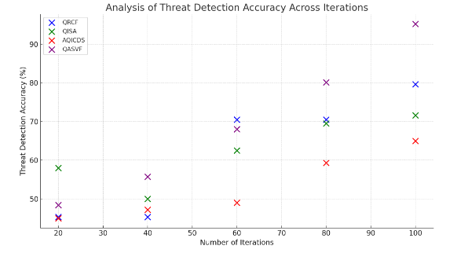
Figure 3: Analysis of threat detection accuracy
Figure 3 demonstrates the QASVF-based acquired threat detection accuracy. With amazing 96.17% detection accuracy, the model proved useful in spotting a broad spectrum of cyber threats within virtual environments. Real-time identification of aberrant patterns and potential security breaches made possible by artificial intelligence-powered anomaly detection coupled with machine learning techniques This amazing accuracy rate guarantees few false positives and negatives, which allows the system to easily separate benign from hostile activity. In virtual worlds, such precision is crucial to provide a precise and safe user experience.
$$\frac{dr}{dm}-r_{2}=k\sin^{2}θ-d_{1}s_{2}k\left(c_{1}+d_{2}K\right) (3)$$
Where threat modulation ($\frac{dr}{dm}-r_{2}$) is offset by quantum state behavior ($k\sin^{2}θ$) and AI-driven barriers ($d_{1}s_{2}k$), equation (3) describes the balance within risk variation ($\left(c_{1}+d_{2}K\right)$) and quantum-AI security factors.
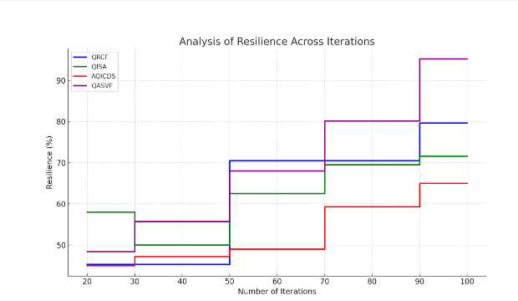
Figure 4: Analysis of resilience
Figure 4 shows the resilience score of 95.29%, therefore suggesting the robustness of the QASVF. This number shows how resilient the system is against many cyberattacks—including ones driven by quantum computers—as well as how well it can recover. Inspired by artificial intelligence learning, the dynamic adaptation of the framework guarantees continuous improvement of its protection mechanisms against fresh hazards. With a resilience score of 95.29% the system is clearly strong in avoiding data breaches, maintaining user data integrity, and preserving safe means of communication even in the face of changing attack paths. What characterizes online global security is great resilience.
$$a_{2}+r_{2}K=\left(c_{1}r_{2}\left(y+\frac{m}{2}\right)\right)+R^{2}\cos^{3}θ-α (4)$$
Equation (4) finds quantum-influenced space variables ($a_{2}+r_{2}K$) with artificial intelligence adaptation factors ($c_{1}r_{2}\left(y+\frac{m}{2}\right)$) and system-level parameters ($R^{2}\cos^{3}θ$). By use of safe spatial-temporal encryption, the quantum cryptographic transmission offsets analysis of resilience.

Table 3: Threat Detection Accuracy
Security Model | Detection Accuracy (%)
Traditional Security Systems | 85.34%
AI-Enhanced Security Systems | 92.11%
Quantum-AI Secured Virtual Framework (QASVF) | 96.17%

Table 3 evaluates among the many security techniques the threat detection accuracy. With a detection accuracy of 96.17%, the Quantum-AI Secured Virtual Framework (QASVF) may outperform traditional and AI-enhanced systems by means of real-time identification and response to cyber threats.
$$U*\frac{c_{1}}{s_{1}}V=\frac{1}{s_{1}}\left(\frac{k}{r_{2}}\right)+\left(Jv*+ju*qa^{'}\right) (5)$$
Equation (5) shows using reinforcement terms ($U*\frac{c_{1}}{s_{1}}V$) the overall security output ($\frac{1}{s_{1}}\left(\frac{k}{r_{2}}\right)$) as a function from quantum encryption factors $\left(Jv*+ju*qa^{'}\right)$ and AI-driven system reactions of threat detection accuracy.

Table 4: Resilience Against Attacks
Security Model | Resilience (%)
Traditional Security Systems | 85.62%
AI-Enhanced Security Systems | 91.47%
Quantum-AI Secured Virtual Framework (QASVF) | 95.29%

Table 4 shows under numerous kinds of cyberattacks—including quantum-level threats—the resistance ratings of many security frameworks. With 95.29% resilience, the QASVF clearly surpasses conventional and AI-enhanced security systems as it shows great capacity to resist and recover from attacks.
Performance analysis indicates the extent to which QASVF enhances virtual reality security. With a 96.17% detection rate, QASVF ensures very few false positives and effective threat detection by significantly enhancing traditional and AI-based systems. Its 95.29% resilience value also clearly depicts its excellent resilience against traditional and quantum-level attacks. These results emphasize QASVF as a robust, adaptive, scalable security solution ensuring user data integrity and safety in virtual reality environments.
- Conclusion
This study provides the QASVF, a modified security model that is capable of addressing the new issues with data security in virtual environments. QASVF provides a solid solution to protect user data, digital identities, and virtual assets by combining quantum cryptography methods—more specifically, QKD—with anomaly detection systems that are AI-based. Exhibiting resilience (95.29%) and threat detection accuracy (96.17%), the model's performance far exceeds that of traditional security solutions as well as AI-driven security solutions alone. Such high-performance benchmarks ensure that QASVF can reduce quantum-level and AI-based cyber threats, thereby making virtual platforms future-proof. The adaptability of the framework to always counter new threats in such a way that it can remain effective despite new attack routes being discovered in increasingly sophisticated digital environments ensures its relevance even in new digital terrain. Its scalability and flexible architecture allow multiple virtual environments like financial services, social networks, and games to merge into one another. Essentially duplicating a next-generation security paradigm that not only upgrades existing protection protocols but also gears virtual environments to confront the threats of the future posed by quantum computing and cutting-edge AI. Future work will target improving the artificial intelligence capacity for threat anticipation and adding stronger quantum-resistant cryptographic algorithms to better increase the QASVF.
Other security layers based on distributed trust models and framework performance in ever larger virtual environments will be explored in future research. Furthermore, efforts will be put forth to increase the system's real-time processing capability thereby reducing latency further and improving overall user experience while maintaining strong security on numerous platforms.
Reference
- Padmanaban, H. (2024). Quantum Computing and AI in the Cloud. Journal of Computational Intelligence and Robotics, 4(1), 14-32.
- Wu, Z. (2024). Integrating Biotechnology Virtual Labs into Online Education Platforms: Balancing Information Security and Enhanced Learning Experiences. Natural and Engineering Sciences, 9(2), 110-124. https://doi.org/10.28978/nesciences.1569211
- Tuli, E. A., Lee, J. M., & Kim, D. S. (2024). Integration of quantum technologies into metaverse: Applications, potentials, and challenges. IEEE Access, 12, 29995-30019.
- Suvarna, N. A., & Bharadwaj, D. (2024). Optimization of System Performance through Ant Colony Optimization: A Novel Task Scheduling and Information Management Strategy for Time-Critical Applications. Indian Journal of Information Sources and Services, 14(2), 167–177. https://doi.org/10.51983/ijiss-2024.14.2.24
- Singh, S., & Kumar, D. (2024). Enhancing cyber security using quantum computing and artificial intelligence: A review. algorithms, 4(3).
- Zhang, X., & Rodriguez, S. (2023). Advanced Optimization Techniques for Vehicle Dynamics in Robotics. Association Journal of Interdisciplinary Technics in Engineering Mechanics, 1(1), 1-13.
- Ajala, O. A., Arinze, C. A., Ofodile, O. C., Okoye, C. C., &Daraojimba, A. I. (2024). Exploring and reviewing the potential of quantum computing in enhancing cybersecurity encryption methods. Magna Sci. Adv. Res. Rev, 10(1), 321-329.
- Aboorva, V., Kamale Sree, P., Sowmiya, B., Sowmiya, N., & Menaka, S. (2023). An Effective Fog-Enabled E-Health with Hierarchical Attribute Revocation using Cloud Computing. International Journal of Advances in Engineering and Emerging Technology, 14(1), 52–57
- Mohamed, E. (2025). Future Trends and Real-World Applications in Database Encryption. Int. J. Electr. Eng. and Sustain., 28-39.
- Saxena, A., & Menon, K. (2024). Recent Patterns in the Usage of Nanomaterials and Nanofiltration Models for Pollutant Removal in Wastewater Treatment. Engineering Perspectives in Filtration and Separation, 1(1), 14-20
- Huang, Y., Li, Y. J., & Cai, Z. (2023). Security and privacy in metaverse: A comprehensive survey. Big Data Mining and Analytics, 6(2), 234-247.
- Garrido, G. M., Nair, V., & Song, D. (2023). Sok: Data privacy in virtual reality. arXiv preprint arXiv:2301.05940.
- Schlegel, E. C., Tate, J. A., Pickler, R. H., & Smith, L. H. (2021). Practical strategies for qualitative inquiry in a virtual world. Journal of advanced nursing, 77(10), 4035-4044.
- Abed, F. S. (2024). Optimization of Expression and Purification of Recombinant One of Central Nervous System Enzyme (Acetylcholinesterase). International Academic Journal of Science and Engineering, 11(1), 40–47. https://doi.org/10.9756/IAJSE/V11I1/IAJSE1106
- Rajawat, A. S., Goyal, S. B., Verma, C., & Singh, J. (2025). Advancing network security paradigms integrating quantum computing models for enhanced protections. In Applied Data Science and Smart Systems (pp. 517-528). CRC Press.
- Narayanan, L., & Rajan, A. (2024). Artificial Intelligence for Sustainable Agriculture: Balancing Efficiency and Equity. International Journal of SDG’s Prospects and Breakthroughs, 2(1), 4-6.
- Thirupathi, L., Akshaya, B., Reddy, P. C., Harsha, S. S., & Reddy, E. S. (2025). Integration of AI and Quantum Computing in Cyber Security. In Integration of AI, Quantum Computing, and Semiconductor Technology (pp. 29-56). IGI Global.
- Surendar, A. (2024). Survey and future directions on fault tolerance mechanisms in reconfigurable computing. SCCTS Transactions on Reconfigurable Computing, 1(1), 26-30. https://doi.org/10.31838/RCC/01.01.06
- Vasani, V., Prateek, K., Amin, R., Maity, S., & Dwivedi, A. D. (2024). Embracing the quantum frontier: Investigating quantum communication, cryptography, applications and future directions. Journal of Industrial Information Integration, 100594.
- Kavitha, M. (2024). Enhancing security and privacy in reconfigurable computing: Challenges and methods. SCCTS Transactions on Reconfigurable Computing, 1(1), 16-20. https://doi.org/10.31838/RCC/01.01.04
- Chen, Z., Wu, J., Gan, W., & Qi, Z. (2022, December). Metaverse security and privacy: An overview. In 2022 IEEE International Conference on Big Data (Big Data) (pp. 2950-2959). IEEE.
- Ahmadi, A. (2023). Quantum computing and AI: the synergy of two revolutionary technologies. AJES, 12(2).

