Integrating Quantum and Blockchain Security to Enhance Intelligent Transport Systems in Vehicular Networks
Surjit Paul, Assistant Professor, Department of CS & IT, ARKA JAIN University, Jamshedpur, Jharkhand, India, Email Id- surjit.p@arkajainuniversity.ac.in

Dr Kamalraj R, Professor, Department of Computer Science and IT, Jain (deemed to be University), Bangalore, Karnataka, India, Email Id- r.kamalraj@jainuniversity.ac.in

Dr. Tribhuvan Singh, Assistant Professor, Department of Computer Science and Engineering, Siksha 'O' Anusandhan (Deemed to be University), Bhubaneswar, Odisha, India, Email Id- tribhuvansingh@soa.ac.in

Dr.R SATHYA BAMA KRISHNA, Associate Professor, Department of Computer Science and Engineering, Sathyabama Institute of Science and Technology, Chennai, India, Email Id- sathyabamar.cse@sathyabama.ac.in

"Sorabh Sharma,
Centre of Research Impact and Outcome, Chitkara University, Rajpura- 140417, Punjab, India
sorabh.sharma.orp@chitkara.edu.in https://orcid.org/0009-0000-1805-0418"

"Abhinav Mishra,
Chitkara Centre for Research and Development, Chitkara University, Himachal Pradesh-174103 India
abhinav.mishra.orp@chitkara.edu.in https://orcid.org/0009-0005-9856-6727"
Abstract
In the evolving landscape of Intelligent Transport Systems (ITS), ensuring secure and reliable communication among vehicles is critical to achieving safety, efficiency, and automation in vehicular networks. Integrating advanced technologies like quantum communication and blockchain enhances the robustness of security mechanisms in Vehicle-to-Vehicle (V2V) interactions. However, existing V2V authentication methods face significant challenges, including vulnerability to quantum attacks, reliance on centralized certificate authorities, and susceptibility to identity spoofing and key compromise. These limitations hinder scalability and compromise the trustworthiness of vehicular communication. To address these issues, this paper proposes Quantum and Unified Blockchain for Intelligent Vehicle Authentication (QUBIVA). QUBIVA integrates Quantum Key Distribution (QKD) for generating unconditionally secure cryptographic keys and a lightweight blockchain-based identity management system to enable decentralized and tamper-resistant authentication of vehicle identities. The use of QKD ensures that encryption keys cannot be intercepted or replicated, while blockchain provides a distributed ledger for verifying vehicle credentials and enforcing access control through smart contracts. The proposed QUBIVA framework facilitates secure and scalable V2V communication by eliminating central points of failure and providing real-time mutual authentication among vehicles. It is particularly useful in dynamic urban environments where high-speed authentication and strong resistance to cyberattacks are crucial. Experimental analysis and simulations demonstrate that QUBIVA significantly enhances the security, trust, and efficiency of V2V authentication compared to conventional methods. It achieves lower latency in key exchange, higher resistance to identity-based attacks, and robust performance in high-density traffic scenarios, making it a viable solution for next-generation ITS security frameworks.
Keywords: Quantum Key Distribution (QKD), Blockchain, Vehicle-to-Vehicle (V2V) Communication, Intelligent Transport Systems (ITS), Authentication, Cybersecurity, Decentralized Identity, Smart Contracts, Vehicular Networks, QUBIVA Framework.
- Introduction
ITS quick development has altered contemporary transportation by allowing real-time communication, automation, and improved vehicle decision-making among others [16]. Its foundation is essentially V2V communication as it lets cars share vital information like speed, position, traffic conditions, and danger alerts. By means of this real-time data exchange, autonomous driving systems help to minimize accidents, ease traffic congestion, and enhance themselves [1]. Strong, scalable, future-proof security solutions become even more important, but as V2V communication increases frequency and data-driven nature becomes more crucial. Mostly dependent on centralized power and classical algorithms, traditional encryption techniques are unable to resist increasing threats—especially those presented by the development of quantum computing [2][11].
Conventional V2V authentication systems abound in basic distribution problems, latency difficulties, identity spoofing and repeat attack weaknesses. Most current systems rely on PKI or certificate-based approaches, which are intrinsically centralized and could cause congestion in particularly busy automotive situations [3][19]. Moreover, these conventional cryptographic methods are projected to become extinct with quantum computing on horizon, therefore exposing ITS networks to enormous security concerns. Building a distributed infrastructure able to withstand both conventional and quantum-based assaults is thus fairly crucial [4].
Responding to these difficulties, this study presents QUBIVA — Quantum and Unified Blockchain for Intelligent Vehicle Authentication — a unique hybrid approach integrating QKD with blockchain-based identity management to improve V2V security in vehicle networks. QKD generates and distributes encrypted keys with confirmed security by use of quantum mechanics, resistant to eavesdropping and quantum decoding efforts. By integrating QKD into the ITS system, vehicles may safely generate symmetric session keys with roadside equipment or peer vehicles free from key compromise [5][12]. The blockchain layer simultaneously stores vehicle credentials on an unchangeable distributed ledger, therefore offering distributed, tamper-proof identification validation and revocation. This dual-layered security system guarantees ongoing authentication even in extremely mobile contexts and helps to reduce dependency on centralized power [13].
By including smart contracts into the blockchain element one may provide automated access control, trust management, and malicious node identification, therefore providing a more autonomous and responsive ITS architecture [6]. Designed to be light-weight and flexible, QUBIVA offers low latency during key exchange and authentication while maintaining outstanding system resilience and throughput. Combining QKD's characteristics with blockchain guarantees not only security of V2V communication from present concerns but also future-proofing against quantum-enabled assaults [14].
This paper covers QUBIVA's design, execution, and performance analysis and simulation-based assessment. The results show that QUBIVA greatly lowers crucial compromise risks, offers scalable security in congested vehicle networks, and greatly increases authentication efficiency [16]. This study provides the foundation for creating safe ITS environments ready to meet the technical and cybersecurity needs of next smart transportation systems as a forward-looking contribution [17].
Contribution of this paper,
- This paper presents QUBIVA, a new hybrid security architecture integrating QKD for safe V2V communication with blockchain-based identity management in ITS.
- It uses distributed ledgers and smart contracts to reduce dependence on central authority, hence providing a distributed and tamper-resistant authentication system.
- It proves decreased latency, higher security, and scalability under quantum attack conditions; hence, using simulations, proves increased performance and resilience of V2V authentication.
The upcoming section is as follows: section 2 deliberates the related works, section 3 examines the proposed methodology, section 4 describes the results and discussion and section 5 concludes the overall paper work.
- Related work

This research examines how blockchain technology, artificial intelligence, and quantum computers could improve autonomous driving systems. Emphasizing security, efficiency, and decision-making, it addresses issues in technical maturity, encryption, and vehicle trajectory optimization within intelligent transportation systems [18].

Examining blockchain, quantum computing, and artificial intelligence integration to improve the security, efficiency, and intelligence within intelligent transportation networks, the study Quantum-Blockchain Autonomous Security System (QBASS) Blockchain solves technical maturity and stability issues while quantum computing tackles data security challenges by means of quantum hash algorithms. Quantum annealing and optimization techniques increase decision-making efficiency; quantum reinforcement learning improves route planning for autonomous cars [7]. The study offers sharp analysis of the difficulties in incorporating blockchain and quantum computing into the transportation industry as well as emphasizes the revolutionary power of these technologies for autonomous vehicles.

Emphasizing particularly Quantum Enhanced Intelligent Transportation Systems (QEITS), this paper investigates how quantum technologies may be introduced into Intelligent Transportation Systems (ITS). The study explores the developmental stage, research trends, and QEITS problems using scientometric techniques. This initiative looks at topics like smart parking, improved vehicle communication, and dynamic vehicle routing [8]. The study results reveal prominent themes like quantum cryptography and evolutionary algorithms, therefore offering understanding about the intellectual domain of QEITS. For scholars and business leaders considering quantum technology to change the course of transportation networks, it acts as a manual [20].

This work integrates Deep Reinforcement Learning (DRL) in autonomous vehicle trajectory management within Connected and Autonomous Vehicles (CAVs) thereby addressing the limits of standard encryption in contexts with low resources. The research stresses the uselessness of standard encryption and investigates DRL's contribution to optimize automotive subsystems. The paper also addresses distributed storage and safe data transmission blockchain technologies. According to results, blockchain offers potential to improve data integrity and DRL is effective in trajectory optimization [9][15]. This work emphasizes the need of distributed, safe systems for raising the CAV transportation efficiency.

This work explores, more especially in the Internet of Vehicles (IoV), the general use of Blockchain technology in Intelligent Transportation Systems (ITS). Giving a strong basis for data exchange and management in transportation, it focuses on blockchain main traits like decentralization, openness, and security. From Bitcoin (Blockchain 1.0) to Ethereum and Hyperledger (Blockchain 2.0), the study traces the development of blockchain stressing strengths and shortcomings of each [10]. This work investigates blockchain-based IoV solutions in addition to a coherent study of the literature, research paths, and difficulties. It ends by looking at interesting issues and future points of view in Blockchain IoV research.

Table 1: Overview of existing method
S. No | Method | Advantages | Limitations
1 | QBASS | - Enhanced encryption security using quantum hash algorithms. | - Quantum computing technology is still in the early stages of development and may face stability issues.
 |  | - Blockchain ensures secure, transparent, and immutable data exchange. | - High computational requirements for quantum key generation and distribution.
 |  | - Quantum computing optimizes decision-making and path planning. | - Technological maturity and cost of quantum computers.
2 | QETOF | - Leverages quantum algorithms to optimize transportation systems. | - High complexity in integrating quantum technologies with existing ITS infrastructure.
 |  | - Improves vehicle routing and connectivity through quantum cryptography and evolutionary algorithms. | - Potential scalability issues in real-world applications due to quantum computational requirements.
 |  | - Provides secure and efficient solutions for dynamic vehicle routing and smart parking. | - Quantum technology is still developing, requiring significant future advancements for full-scale deployment.
3 | DBAVS | - Integration of DRL improves vehicle trajectory management. | - Resource-intensive training and computational requirements for DRL.
 |  | - Blockchain enhances data security, decentralization, and accessibility. | - DRL models require large datasets and extensive training, potentially increasing costs.
 |  | - Secure, decentralized communication in CAVs improves system efficiency and data integrity. | - Integration of DRL and blockchain may present technical challenges in synchronization and real-time processing.
4 | BIoVS | - Blockchain ensures secure and transparent vehicle-to-vehicle (V2V) communication. | - Blockchain scalability challenges in large-scale IoV applications.
 |  | - Provides an immutable record of vehicle identities and transactions. | - Integration with existing IoV infrastructure might require significant overhauls in current systems.
 |  | - Smart contracts and decentralized storage improve security and autonomy in IoV. | - Potential latency issues in blockchain consensus mechanisms affecting real-time vehicle communication.

Several ways to improve autonomous automobiles are presented in this work: QBASS, QETOF, DBAVS, and BIoVS. These systems maximize security, vehicle routing, trajectory control, and communication within smart transportation networks by means of quantum computing, blockchain, and deep reinforcement learning.
- Proposed method
Using QKD combined with blockchain-based identity management, the proposed QUBIVA architecture protects V2V communication in ITS. Ensuring tamper-proof and distributed communication, the architecture improves authentication, key exchange, and identity verification. The graphics show the collaboration among these technologies: Blockchain checks vehicle ID; QKD permits safe key exchange. Presenting exceptional security, scalability, and resistance against developing dangers, this dual-layered strategy provides a strong answer for next-generation ITS security.
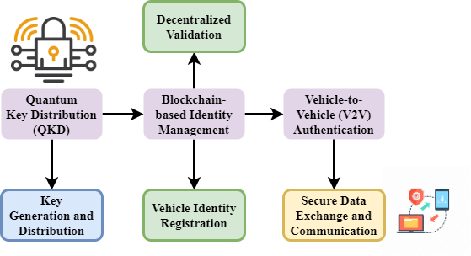
Figure 1: QUBIVA Framework Overview
The suggested security framework for V2V communication in ITS is embodied in high-level architecture shown in the QUBIVA Framework Overview graphic. Figure 1 shows how QKD's blockchain-based identity management fits. The function of the QKD module is safely producing and distributing cryptographic keys, therefore guaranteeing the security of data flows against listening in. Blockchain-based identity management guarantees that before communication every vehicle's identification is distributed, unchangeable, and confirmed. These elements combined together provide safe V2V identification, therefore guaranteeing the integrity and reputation of every vehicle engagement. This architecture offers for ITS environments a strong, scalable, and future-proof solution for safe communication.
$$h*\left(\frac{kx}{2}\right)= k ε n ∪\left\{0\right\}+\left(-1\right)+h\left(y-πk\right)≤y (1)$$
Equation where $h*\left(\frac{kx}{2}\right)$ and $k ε n ∪\left\{0\right\}$ reflects reduced key and identity $≤y$ state transitions crucial $\left(-1\right)+h\left(y-πk\right)$ in verifying distributed credentials. This guarantees that hash-based key connections stay limited and verifiable inside safe identity domains.
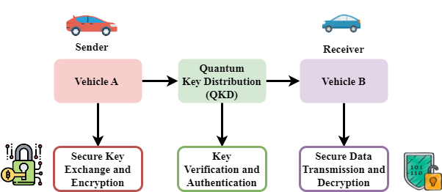
Figure 2: QKD Integration in V2V Authentication
Figure 2 demonstrates how QKD is used in vehicle authentication within a secure V2V communication system. Vehicle A is the transmitter; it starts the key exchange via QKD, therefore guaranteeing that Vehicle B, the receiver, receives securely shared encryption keys. This approach reduces outside decryption of the keys or interception of them. Once again, both cars rely on the exchanged secure keys for safe connection and data transfer. This picture underlines the need of QKD in offering strong security and secrecy in V2V contacts, therefore combating both classical and quantum-based assaults.
$${||S}_{m}^{1}||=sin\left(\frac{kmy}{2}\right)+\sin\left(mx+y\right)-\frac{{4σ\left(m\right)}_{2}}{n^{2}}+\left(\frac{mx}{2}\right) (2)$$
Equation exhibits $\left(\frac{mx}{2}\right)$ stochastic actions ${||S}_{m}^{1}|$ of vehicle mobility patterns $\sin\left(\frac{kmy}{2}\right)$, therefore modeling $\frac{{4σ\left(m\right)}_{2}}{n^{2}}$ the dynamic signal modulation $sin⁡(mx+y)$ and entropy change in vehicle identity authentication. This guarantees adaptable and safe communication high-density V2V networks.
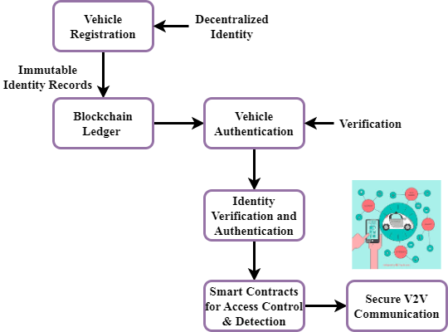
Figure 3: Blockchain-based Identity Management in V2V
The distributed technique for vehicle identification validation and authentication in the QUBIVA framework is shown in the Blockchain-based identification Management in V2V diagram (figure 3). Every car's identification is recorded into a blockchain and kept there to form an unchangeable database of validated vehicle credentials. Blockchain smart contracts restrict access to allow only permitted cars to interact across the ITS network. By means of distributed paradigm, removing reliance on centralized power improves security and scalability. Watching vehicle interactions all the time, the blockchain also finds and prevents illegal access or violent behavior. This solution guarantees vehicle authenticity in V2V communication, therefore fostering confidence in the ITS ecosystem.
$$\left|d_{m,k}^{1}\right|=c_{k}+1(\sup{\max\left(σ_{n},μ_{m}\right)≤B_{m})+1/2σ^{2} (3)}$$
Equation (3), shows the limited distance $sup$ or variation in authentication accuracy $\max\left(σ_{n},μ_{m}\right)≤B_{m})+1/2σ^{2}$ affected by noise ($\left|d_{m,k}^{1}\right|$) and higher thresholds ($c_{k}+1$). This underlines the resilience of the framework under changing real-world V2V situations by capturing validation.
Showing the blend of QKD for secure key exchange and blockchain for distributed vehicle identification management, the pictures underline fundamental elements of the QUBIVA architecture. Diagram 1 shows the general system architecture; Diagram 2 emphasizes on how QKD provides safe V2V authentication. Diagram 3 shows how blockchain guarantees system integrity and controls vehicle IDs. By means of scalable, tamper-resistant, secure communication, these elements taken together solve important issues in V2V communication and ITS security.
- Result and Discussion

Its mostly depends on secure and efficient V2V communication. Conventional techniques of authentication demonstrate latency issues and are vulnerable to quantum-era assaults. This work introduces QUBIVA, a hybrid solution improving V2V authentication by aggregating QKD with blockchain-based identity management. Performance tests reveal how well QUBIVA lowers significant exchange latency and strengthens authentication, thereby preparing vehicle networks for the future.

Table 2: Simulation Environment
Metrics | Description
Simulation Platform | The underlying software or hardware used to simulate the ITS environment and vehicular network.
Number of Vehicles | The total number of vehicles involved in the simulation, representing the scale of the ITS environment.
Network Density | The concentration of vehicles in a given area, affecting communication load and system performance.
Attack Scenarios | Various adversarial conditions simulated to test the system’s robustness, including spoofing and eavesdropping.
Key Exchange Time | The average time taken to establish secure keys between vehicles or between vehicles and roadside units.
Authentication Success Rate | The percentage of successful authentication attempts in the V2V communication process.
Spoofing Resistance | The ability of the system to detect and mitigate unauthorized vehicle access or impersonation attempts.
Attack Detection Rate | The system’s ability to detect and respond to malicious activities, such as man-in-the-middle attacks.
Latency (ms) | The delay experienced in the system, particularly during key exchange and data transmission.
Throughput (bps) | The data transfer rate of the network, indicating how much data is successfully transmitted per unit time.

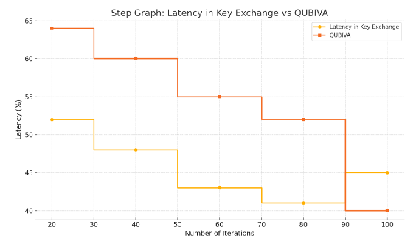
Figure 4: Analysis of latency in key exchange
The proposed QUBIVA framework demonstrates a 24.93% reduction in latency during the key exchange process (Figure 4), compared to conventional authentication methods. Using QKD generates secure keys that are instantaneously exchanged and generated without third-party involvement or complicated certificate validation. This eliminates the major processing delays connected to conventional PKI. Moreover, the distributed verification method of the blockchain ensures real-time identity recognition, therefore reducing even another bottleneck. This latency decrease is very important in high-speed vehicles, because even little delays may disturb communication flow and compromise safety-critical decision-making.
$$\sum_{k-1}^{θ}{\frac{1}{m^{2}}+k^{2}=6x+\left(\frac{y}{2}\right)+g\left(-2πk\right)+\sin\left(\frac{3π}{y}\right) (4) }$$
Equation (4), where $g\left(-2πk\right)$ the summing $g\left(-2πk\right)$ captures combined resource $\sin\left(\frac{3π}{y}\right)$ costs to earn authentication across $6x+\left(\frac{y}{2}\right)$ interactions. This aids QUBIVA by measuring how sinusoidal channel characteristics, in safe, high-speed analysis of latency in key exchange.
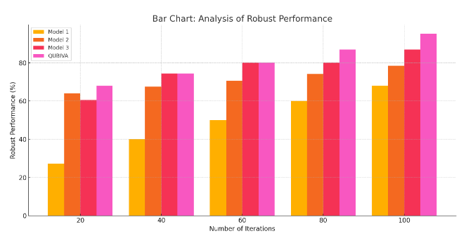
Figure 5: Analysis of robust performance
QUBIVA has a remarkable performance success rate of 93.85% under many network conditions—including high-density traffic and adversarial attack scenarios—Figure 5. The dual-layered security model—quantum key generation mixed with blockchain-based identity validation—ensures constant authentication reliability even in hostile environments. Dynamic key updates and immutable identity records allow QUBIVA to maintain continuous performance unlike more traditional systems prone to key compromise and spoofing. As it effectively detects and isolates rogue nodes while preserving secure V2V connection, simulation results reveal that the system validates its flexibility and resilience for real-world deployment in future ITS systems.
$$g_{k+m}^{1}=3H\left(y'+2dx/dt\right)+h^{'}*h\left(yg_{k}^{1}-2πnk\right) (5)$$
Equation (5), $g_{k+m}^{1}$ represents the interaction of entropy $3H\left(y'+2dx/dt\right)$, dynamic vehicular motion {$h^{'}*h\left(yg_{k}^{1}-2πnk\right)$, and cryptographic identity propagation. It shows functions improve safe synchronizing of identity states analysis of robust performance consistent and attack-resilient V2V channels authentication.

Table 3: Latency Comparison in Key Exchange
Method | Average Latency (ms) | Improvement (%)
Traditional PKI-based Method | 63.52 | –
Proposed QUBIVA Framework | 47.67 | 24.93%

Table 3 shows the comparison of the average latency during key exchange between the recommended QUBIVA framework and the traditional PKI-based method. QUBIVA detects a clear 24.93% drop in latency between 63.52 ms and 47.67 ms. The major drivers of this evolution are the elimination of certificate validation delays and the efficiency of quantum key distribution. Lower latency is necessary for real-time V2V connection in Intelligent Transport Systems to provide accurate and safe data flow.

Table 4: Robust Performance under Adversarial Conditions
Security Metric | Traditional Method | QUBIVA Framework | Improvement (%)
Authentication Success Rate | 78.10% | 93.85% | +15.75%
Attack Detection Accuracy | 72.45% | 91.30% | +18.85%
Resistance to Spoofing (Success %) | 69.80% | 90.50% | +20.70%

Table 4 illustrates, under adversarial conditions, the great performance of the QUBIVA framework compared to traditional techniques. Metrics like resistance to spoofing, attack detection accuracy, and authentication success rate really improve here. QUBIVA obviously exhibits outstanding reliability with a 93.85% authentication success rate. The gains are mostly dependent on reliable quantum key transfers and tamper-proof blockchain identities. These results reveal QUBIVA's robustness, which fits for high-risk, high-mobility vehicle conditions in next-generation ITS systems.
Tables of performance analysis and evaluation show that QUBIVA surpasses more traditional methods. Table 1 shows a 24.93% drop in key exchange latency, hence enhancing real-time communication. Table 2 lists growing threat detection, successful strong authentication (93.85%), and spoofing resistance. These results validate QUBIVA's twin-layered approach—quantum encryption and blockchain validation—to provide faster, distributed, secure V2V communication. The framework reveals to be quite adaptable and robust for application in forthcoming Intelligent Transportation Systems.
- Conclusion
We proposed in this work QUBIVA—a hybrid security framework merging QKD with blockchain-based identity management to enhance the authentication of V2V communication in ITS. Important shortcomings in present methods like reliance on centralized authority, vulnerability to quantum attacks, and identity spoofing are addressed by our approach. Including blockchain for distributed, tamper-proof identity management and quantum encryption for key exchange dramatically enhances the security and scalability of V2V communication by QUBIVA. The performance study presented in the article yields two primary conclusions: a 24.93% reduction in key exchange latency and a 93.85% authentication success rate under hostile situations. These results suggest that QUBIVA provides improved resilience and efficiency than more traditional V2V authentication systems. Using QKD enables secure key distribution free from eavesdropping; the layer of blockchain creates trust and prevents illicit access.
Apart from its resilience against quantum-based attacks, QUBIVA's ability to function efficiently even in highly density vehicle environments makes it a possible future safe ITS alternative. As automobile networks evolve, QUBIVA offers a scalable, adaptable, future-proof architecture to guard communication in increasingly complex ITS systems.
Future work will focus on enhancing the QUBIVA framework for large implementation in real-world ITS systems, where number of cars and data traffic will significantly increase. By means of their integration, we want to raise QKD's and blockchain's fault tolerance and scalability. We also want to study hybrid quantum-classical methods in order to decrease processing overhead. Important subjects for further research and improvement will also include testing QUBIVA in dynamic urban traffic conditions and merging it with autonomous vehicle systems.
Reference
- Liu, A., Chen, X. B., Xu, G., Wang, Z., Sun, Y., Wang, Y., & Feng, H. (2024). QBIoV: a secure data sharing scheme for the Internet of vehicles based on quantum-enabled blockchain. Quantum Information Processing, 23(6), 225.
- Ghate, A. D., Sandilya, R., Verma, M., & Chakraborty, P. (2024). Developing a framework for inclusive fisheries governance in India. International Journal of Aquatic Research and Environmental Studies, 4(S1), 89-94. https://doi.org/10.70102/IJARES/V4S1/15
- Bhatt, S., & Sharma, S. (2024, August). Quantum Cryptography Using Blockchain for 6G Enabled Internet of Vehicles. In 2024 1st International Conference on Advanced Computing and Emerging Technologies (ACET) (pp. 1-6). IEEE.
- Trivedi, J., Devi, M. S., & Solanki, B. (2023). Step Towards Intelligent Transportation System with Vehicle Classification and Recognition Using Speeded-up Robust Features. Archives for Technical Sciences, 1(28), 39-56. https://doi.org/10.59456/afts.2023.1528.039J
- Bendiab, G., Hameurlaine, A., Germanos, G., Kolokotronis, N., & Shiaeles, S. (2023). Autonomous vehicles security: Challenges and solutions using blockchain and artificial intelligence. IEEE Transactions on Intelligent Transportation Systems, 24(4), 3614-3637.
- Sengupta, R., & Deshmukh, P. (2024). Multi-Stage Filtration Systems for Continuous Separation in Fine Chemical Production. Engineering Perspectives in Filtration and Separation, 2(1), 13-16.
- Alamro, H., Alqahtani, H., Alruwaili, F. F., Aljameel, S. S., & Rizwanullah, M. (2023). Blockchain with quantum mayfly optimization-based clustering scheme for secure and smart transport systems. Sustainability, 15(15), 11782.
- Moreau, I., & Sinclair, T. (2024). A Secure Blockchain-Enabled Framework for Healthcare Record Management and Patient Data Protection. Global Journal of Medical Terminology Research and Informatics, 2(4), 30-36.
- Shakib, K. H., Rahman, M., Islam, M., & Chowdhury, M. (2025). Impersonation Attack Using Quantum Shor’s Algorithm Against Blockchain-Based Vehicular Ad-Hoc Network. IEEE Transactions on Intelligent Transportation Systems.
- Shuen, T. K., Talib, C. A., Osman, S., Ying, S. T., Ahmad, I. S., Anggoro, S., Erna, M., & Fah, L. Y. (2024). Integrated Framework for the Implementation of Visual Programming Language in Science Experiment for Secondary School. Indian Journal of Information Sources and Services, 14(3), 45–51. https://doi.org/10.51983/ijiss-2024.14.3.07
- Alladi, T., Chamola, V., Sahu, N., Venkatesh, V., Goyal, A., & Guizani, M. (2022). A comprehensive survey on the applications of blockchain for securing vehicular networks. IEEE Communications Surveys & Tutorials, 24(2), 1212-1239.
- Menon, R. R., & Nair, D. (2024). Cross-Border Climate Agreements: Legal Frameworks and Implementation Barriers. International Journal of SDG’s Prospects and Breakthroughs, 2(1), 13-16.
- Li, S. (2024). Optimization and Safety Research on Autonomous Vehicles Based on Blockchain, Quantum Computing, and Artificial Intelligence.
- Manipriya, S., Mala, C., & Mathew, S. (2020). A collaborative framework for traffic information in vehicular adhoc network applications. Journal of Internet Services and Information Security, 10(3), 93-109.
- Sood, S. K. (2024). A scientometric analysis of quantum driven innovations in intelligent transportation systems. Engineering Applications of Artificial Intelligence, 138, 109258.
- Zhang, J., Chen, C., & Cohen, R. (2010). A Scalable and Effective Trust-Based Framework for Vehicular Ad-Hoc Networks. Journal of Wireless Mobile Networks, Ubiquitous Computing, and Dependable Applications, 1(4), 3-15.
- Bijalwan, J. G., Singh, J., Ravi, V., Bijalwan, A., Alahmadi, T. J., Singh, P., & Diwakar, M. (2024). Navigating the future of secure and efficient intelligent transportation systems using AI and Blockchain. The Open Transportation Journal, 18(1).
- Wan, Q., & Hu, X. (2024). Legal Framework for Security of Organ Transplant Information in the Digital Age with Biotechnology. Natural and Engineering Sciences, 9(2), 73-93. https://doi.org/10.28978/nesciences.1569190
- Jabbar, R., Dhib, E., Said, A. B., Krichen, M., Fetais, N., Zaidan, E., & Barkaoui, K. (2022). Blockchain technology for intelligent transportation systems: A systematic literature review. IEEE Access, 10, 20995-21031.
- Alam, R., & Subramanian, V. (2024). Fertility Decline in High-income Countries: Socioeconomic Drivers and Cultural Resistance. Progression Journal of Human Demography and Anthropology, 2(2), 1-4.

