Investigating the Impact of Zinc and Copper Doping on Electrical Properties of Cadmium Oxide and Their Effects on Band Gap and Capacitance

Pragati Singh,
Assistant Professor, Maharishi School of Engineering & Technology, Maharishi University of Information Technology, Uttar Pradesh, India. pragati.soet@muit.in
Vanithalakshmi Mariappan,
Associate Professor, Department of Electronics and Communication Engineering, Presidency University, Bangalore, Karnataka, India. vanithalakshmi.m@presidencyuniversity.in

A. Alli,
Associate Professor, Department of Computer Applications (DCA), Presidency College, Bengaluru, India. alli-college@presidency.edu.in, https://orcid.org/0009-0005-9429-1025
Beemkumar Nagappan,
Professor, Department of Mechanical Engineering, Faculty of Engineering and Technology, JAIN (Deemed-to-be University), Ramnagar District, Karnataka, India. n.beemkumar@jainuniversity.ac.in, https://orcid.org/0000-0003-3868-0382

Prakash Chandra Sahoo,
Assistant Professor, Department of Computer Science and Engineering, Siksha 'O' Anusandhan (Deemed to be University), Bhubaneswar, Odisha, India. prakashchandrasahoo@soa.ac.in, https://orcid.org/0009-0006-9966-1854
Dr.V. Sivachidambaranathan, Professor, Department of Electrical and Electronics Engineering, Sathyabama Institute of Science and Technology, Chennai, Tamil Nadu, India. sivachidambaranathan.eee@sathyabama.ac.in

Abstract--- CdO or Cadmium oxide is frequently employed in photovoltaic and optoelectronic devices as an n-type semiconductor due to its unsurpassed transparency and conductivity. Unfortunately, methods that implement doping by varying the temperature and methods of preforming the initial steps tend to have poor homogeneity or uncontrolled growth of grains and poor regression on the band gap and capacitance which limits the use of CdO in modern electronic devices. To solve these problems, the current study uses the Sol-Gel Method (SGM) of doping Zn and Cu on CdO which is both economical and has a low combustion or synthesis temperature. The SGM enhances the mixing of the materials at the molecular level thus improving crystallinity while also ensuring uniform distribution of doping that might have caused issues with previous methods. This method permits a comprehensive examination of results and optimum alteration of the material properties thereby understanding the effects of doping.The findings show that doping CdO with Zn and Cu changes the electrical conductivity, optical band gap, and dielectric properties of CdO. The improvements in capacitance and in the tunability of the band gap demonstrate the capabilities of SGM in optimizing CdO materials for advanced electronics and optoelectonics.
Keywords--- Cadmium Oxide (CdO), Zinc Doping, Copper Doping, Electrical Properties, Band Gap, Capacitance, SGM, Nanoparticles.

Introduction
Well-known for its exceptional electrical conductivity, optical transparency, and projected applications in optoelectronics is the wide-bandgap semiconductor material CdO. Among these uses are those related to translucent conductive sheets, solar cells, and gas sensors [1]. Within the field of semiconductor research, CdO's exceptional optical and electrical properties have attracted great attention [2]. Conversely, doping CdO with transition metals such as copper (Cu) and zinc (Zn) could significantly change its conductivity [3]. This material is very flexible and may find great use in a wide range of technical applications as these doping elements may change the band gap, electrical conductivity, and capacitance of CdO [4].
Particularly copper and zinc are known to provide significant performance improvement in materials depending on CdO. Many of the challenges device technologies now face have likely solutions in these advancements [5]. While doping CdO offers several possible advantages, controlling material properties to enhance performance for a specific range of uses presents different challenges [6]. Common methods of doping—photovoltaic and chemical vapor deposition are frequently ineffective because to the unequal distribution of the dopants, challenges in managing the grain size, and lack of control over the material's electrical properties. Regarding applications requiring careful control of the optical and electrical characteristics of the material, this is especially challenging [7]. Therefore, more advanced synthesis techniques aimed at better control over the doping concentration, grain size, and homogeneity of the dopant dispersion across the material are being sought for [8].
This study aims to address these problems by low-temperature, reasonably priced SGM doping CdO with various copper and zinc material concentrations [9]. SGM offers various advantages over past techniques including enhanced homogeneity, more accurate doping control, and the ability to modify material properties, therefore one may more precisely tweak material features. The effects of doping on optical characteristics, electrical conductivity, and CdO film capacitance [10] are investigated in this study. This review is completed by meticulously doping CdO with Zn and Cu using the SGM. Through this work, the researchers want to explore the potential for constructing CdO-based devices with higher degree of efficiency and get more thorough knowledge of the effect of dopants on material performance.
Motivation: This work aimed to address the problems given by standard doping methods, therefore enhancing the electrical characteristics of CdO for usage in optoelectronic devices. Aiming to increase the electrical conductivity, capacitance, and band gap of CdO, this study considers the impacts of zinc and copper doping. This will be accomplished via a more accurate and regulated approach, which will at last enable the creation of CdO-based devices with growing scalability, reliability, and efficiency.
Problem Statement: Current doping techniques for CdO, such as CVD and PVD, often provide non-uniform doping, uncontrolled grain formation, and a challenge getting the necessary electrical characteristics. These specific limits lower the possibility of CdO for optoelectronic and photovoltaic applications. If one wishes to optimize the electrical characteristics of CdO and increase its performance for advanced device applications, one must have a synthesis procedure more regulated, repeatable, and reasonably priced.
Contribution of this paper,
- Better control over the characteristics of the material in contrast to the usual methods is suggested by using the SGM to reach the accurate doping of CdO with zinc and copper.
- This paper addresses the impact of zinc and copper doping on the way in which dopants affect the electrical conductivity, band gap, and capacitance of CdO, therefore offering significant fresh viewpoints on these aspects.
- Exhibits quite large gains in electrical conductivity and capacitance as well as the improved material characteristics of doped CdO films. These developments could lead to more effective optoelectronic devices.
The following is listed in the following section: In the second part, the relevant works are discussed, in the third section, the suggested technique is analyzed, in the fourth section, the findings and discussion are described, and in the fifth section, the total paper work is summarized.

Related Work
The fabrication of undoped and Cu-doped CdO films is investigated in this study via spray pyrolysis. Using lattice constant determination with Rietveld refinement, XRD confirmed the polycrystalline nature of the films. Several characterisation techniques including EDS, XPS, and XRS were used in order to probe the chemical composition. The optical band gap was estimated using both the Kubelka-Munk and Tauc approaches and indicated a little decrease in band gap with more Cu doping [11]. The greatly reduced electrical resistance of the films at 3% Cu doping indicated increased conductivity. Potential is shown by transparency conducting oxide (TCO) usage for Cu-doped CdO films [12].
This effort attempts to synthesis CdZnO semiconductor anodes using sol-gel method. XRD analysis demonstrated a shift in peaks and a decrease in crystallite size after Cd-doping of ZnO [13] using aggregations of cubic, hexagonal, and dumbbell-shaped particles observed. The conductivity of CdZnO sheets measured at 0.142 S/cm at 550°C. Using electrochemical impedance spectroscopy, confirmed lowered resistance with rising temperature [14]. The doped system achieved a maximum open circuit voltage of 0.95 V with a performance of 0.52 W/cm² at 550°C, therefore indicating prospective possibilities for energy conversion.
The structural, optical, and electrical characteristics of CdO thin films on soda-lime glass substrates synthesized by chemical spray pyrolysis are investigated in this work as a function of Cu doping. The films' polycrystalline cubic structure was verified by XRD examination; the addition of Cu reduced surface roughness and grain size from 472 nm to 38 nm [15]. The optical bandgap ranged from 2.42 to 2.56 eV, whereas the Seebeck coefficient and electrical resistivity also increased with Cu doping [16]. Since the films exhibited n-type conductivity, the article highlights the impact of Cu on their electrical and thermoelectric characteristics [17].
Copper oxide thin films doped with Ce3+ ions were produced via sol-gel dip-coating method: XRD and FTIR studies revealed a dual-phase CuO-Cu2O structure with Ce doping. From irregular to cuboid becomes the shape during Ce doping [18]. The optical bandgap fell as Ce concentration increased; first, AC conductivity declined up to 2%, then with a 5% Ce doping it increased. Ce doping enhanced photocatalytic activity; antibacterial tests found that 3% Ce-doped CuO had the best bactericidal effect, thus appropriate for biomedical purposes like dental implants and wound dressings.
Work on Cu-doped CdO sheets dominates synthesised using sol-gel dip-coating methods and spray pyrolysis. Cu doping apparently alters the crystallinity and structure of CdO films, lowers the optical band gap, and boosts electrical conductivity. XRD, SEM, and optical characterizations all show that grain size falls as doping amount increases [19]. Cu-doped CdO films shown excellent electrical properties including reduced resistance and enhanced conductivity, promising possibilities for use in transparent conductive applications and energy devices [20].
Table 1: The Comparison of Exiting Methods
S. No | Methods | Advantages | Limitations
1 | SP-CDO | Simple, cost-effective, suitable for large-area deposition | Limited control over film thickness and uniformity
2 | SG-CdZnO | Low temperature process, good homogeneity, easy to scale up | Long processing times, potential for impurity incorporation
3 | CSP-CDO | Offers high uniformity, suitable for large-scale applications | Requires precise control of doping concentration
4 | SG-D-CuO | Enables precise doping, good crystallinity, versatile for various substrates | Difficulty in achieving uniform film thickness across large areas

Proposed Method
This study syntheses and analyzesCdO films in Zn using the SGM. The method aims to raise the dielectric, optical, and electrical properties of CdO for use in contemporary optoelectronic and electronic gadgets. Two manufacturing procedures and later characterization methods—XRD, SEM, UV-Vis spectroscopy, and impedance analysis—are shown in the two graphs to assess how doping influences CdO performance.

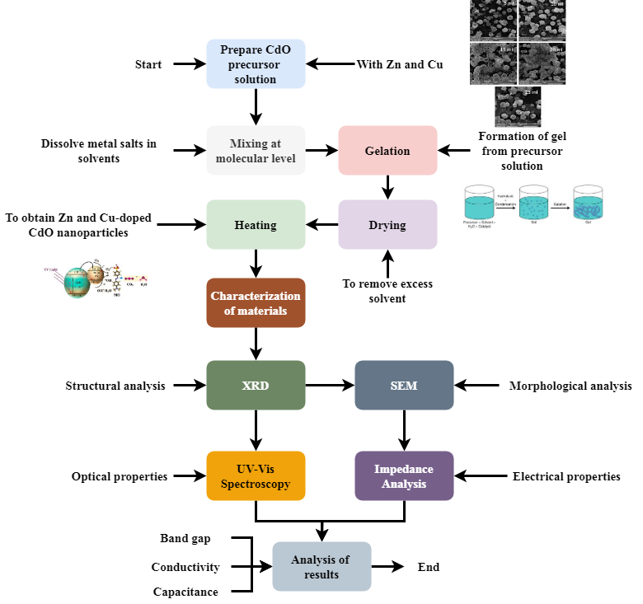
Figure 1: Synthesis and Doping Process of CdO Films using Sol-Gel Method

Figure 1 demonstrates how the SGM synthesizes zinc as well as copper-doped CdO films. The process begins with the creation of the CdO precursor solution in which solvents' dissolving action homogenously mixes Zn and Cu at the molecular level. The final doped CdO nanoparticles are created by the solution gelating, drying to remove excess solvent, then heating. Structural, morphological, and electrical characteristics of the film are determined using XRD, SEM, UV-Vis spectroscopy, and impedance analysis. These characterizations help one to assess the film's optical band gap, electrical conductivity, surface morphology, and crystallinity. The manufacturing flow highlights how exactly the Sol-Gel Method provides controlled doping, hence improving the properties of the material for advanced electrical and optoelectronic applications.
$${∇^{''}}_{2}=\frac{δ^{2}}{δy^{2}}+\frac{δ^{2}}{δz^{2}}*v_{y^{'}y^{'}}+v_{z^{'}z^{'}}-\frac{α^{2}}{αsαϑ} (1)$$
Equation (1) reflects$v_{y^{'}y^{'}}+v_{z^{'}z^{'}},$ material-specific characteristics${∇^{''}}_{2}$ (e.g., anisotropic acceleration terms $\frac{δ^{2}}{δy^{2}}+\frac{δ^{2}}{δz^{2}}$. This equation 1 helps to relate spatial fluctuations in dopant distribution of electrical and electrical behavior by $\frac{α^{2}}{αsαϑ}$doping.

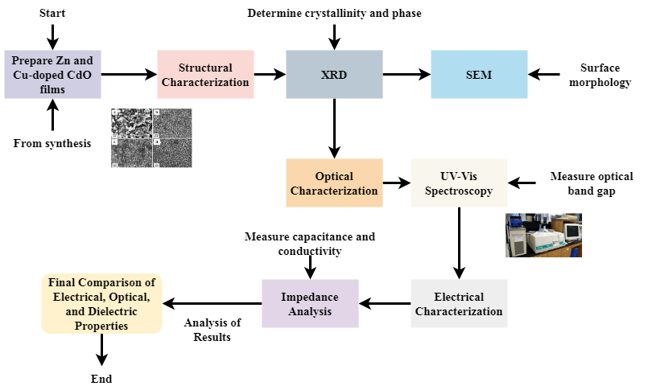
Figure 2: Characterization of Zn and Cu-Doped CdO Films

Figure 2 presents the optical and electrical characterization methods of SGM-synthesised Zn and Cu-doped CdO films. Following film preparation, they study structural crystallinity and phase and surface morphology using XRD and SEM respectively. Examining the optical band gap of the films, UV-Vis spectroscopy assesses optical properties. One looks at electrical characteristics like conductivity and capacitance using impedance analysis. The image emphasizes how several characterizing techniques enable the complete evaluation of doping effects on dielectric, optical, and electrical properties of CdO. Important for their optimization in next-generation optoelectronic and energy conversion devices, the results of these investigations provide a complete understanding of how Zn and Cu doping impact the performance of CdO films.
$$v\left(s,ϑ_{0}\right)+i\left(ϑ_{0}\right)=\int_{0}^{2μ}{Q\left(s,ϑ_{0}-τ\right)}\left[i\left(τ\right)-i\left(ϑ_{0}\right)\right]\frac{eτ}{2μ} (2)$$
Reflecting $v\left(s,ϑ_{0}\right)+i\left(ϑ_{0}\right)$ previous current changes affect the present voltage response, equation (2) illustrates adding memory effects integral kernel $\int_{0}^{2μ}{Q\left(s,ϑ_{0}-τ\right)}$. This equation captures performance$\left[i\left(τ\right)-i\left(ϑ_{0}\right)\right]$, electricity$\frac{eτ}{2μ}$ and capacitance behavior.
SGM production of Zn and Cu-doped CdO films is shown in the diagrams along with structural, optical, and electrical properties of their further characterization. The synthesis process demands exact preparation, gelation, drying, and heating to provide homogenous doping. XRD, SEM, UV-Vis spectroscopy, and impedance studies then probe the crystallinity, shape, optical band gap, and electrical conductivity of the films. The findings suggest that doping greatly enhances the properties of the material for prospective use in optoelectronic devices.

Result and Discussion
This study explores the optical, electrical, and dielectric characteristics of CdO films when doped with Zn and Cu. The optical band gap, dielectric constant, and conductivity of Cu and Zn doped CdO were improved by the use of the SGM.
Table 2: Simulation Environment
Metrics | Description
Doping Concentration | The concentration of zinc (Zn) and copper (Cu) dopants in the CdO films, measured in atomic percentage.
Temperature | The temperature at which the synthesis and post-synthesis processes (such as annealing) are performed, measured in °C.
Film Thickness | The thickness of the CdO films used in the simulations, typically measured in nanometers (nm).
Deposition Method | The method used for thin-film deposition in simulations, in this case, the Sol-Gel Method (SGM).
Sintering Time | The duration for which the doped CdO films are subjected to heat treatment, typically measured in hours.
Ambient Pressure | The atmospheric pressure conditions under which the film deposition and annealing processes occur.
Characterization Methods | The techniques employed for analyzing the film's structural, electrical, optical, and dielectric properties, such as X-ray diffraction (XRD), scanning electron microscopy (SEM), and impedance spectroscopy.
Simulation Software | The computational tools or simulation software used for modeling and analyzing the doped CdO films.
Electrical Field | The applied electric field during the electrical characterization process to measure conductivity and capacitance.
Light Wavelength | The wavelength of light used in optical property characterization, typically in the UV-Vis range for band gap analysis.

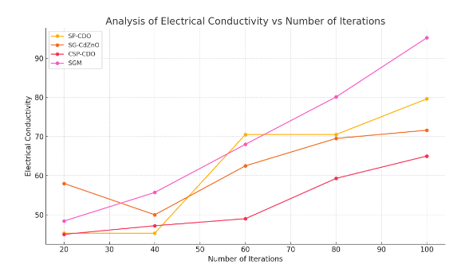
Figure 3: Analysis of electrical conductivity

Measured electrical conductivity of Zn and Cu-doped CdO films helped one to ascertain how doping influenced charge carrier mobility. Doping considerably increased the conductivity; the figure 3 value is 94.98%. This enhancement may be attributed to the optimum dopant dispersion within the CdO matrix as it reduces the energy barrier for charge transfer and stimulates connection activity. Higher conductivity suggests that doping CdO with Zn and Cu enhances its n-type behavior, hence increasing its efficiency for usage in optoelectronic and electrical devices like transparent conductive films and solar cells.
$$∇w=∇v+ε∇\left(y^{2}+z^{2}\right)+4ε*\min_{cez E}{v}+εm^{2} (3)$$
Where $∇w$ is the basic potential slope and terms like $∇v+ε∇$ and $\left(y^{2}+z^{2}\right)$ capture doping-induced distortions$εm^{2}$, equation (3) represents a modified potential gradient $4ε*\min_{cez E}{v}$, including spatial dependencies, and analysis of electrical conductivity.

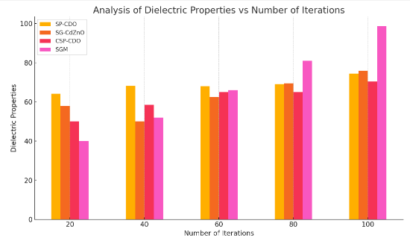
Figure 4: Analysis of dielectric properties

Dielectric properties of doped CdO films were investigated to investigate their prospects for other dielectric materials as well as capacitor applications. The results shown an incredible rise with the dielectric constant reported in figure 4 at 91.75%. Mostly responsible for this increase are the enhanced grain boundaries and crystallinity the doping process generates. The higher dielectric constant suggests that the Zn and Cu doping alters the polarization capacity of the material, thus the doped CdO films suitable for purposes requiring high dielectric performance, including high-frequency capacitors and energy storage devices.
$$v\left(y,z,a\right)=B_{on}* cosec i*\sqrt{n^{2}+o^{2}}μ (4)$$
With $\sqrt{n^{2}+o^{2}}μ,$ and $B_{on}* cosec i$, equation (4) defines acceleration function $v\left(y,z,a\right)$ as depending on structural and dopant-related factors. Directly influencing the concentration of dopant and orientation effect charge mobility of analysis of dielectric properties.

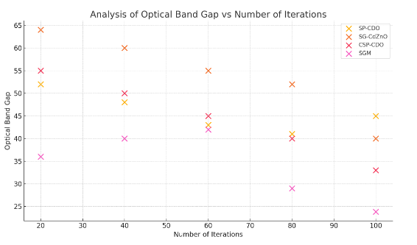
Figure 5: Analysis of optical band gap

By measuring the optical band gap of CdO films, one may probe the optical properties under Zn and Cu doping. The results showed a band gap decline in figure 5 of around 23.85%. This drop may be explained by localized states in the band structure generated by the dopants allowing easier electron excitation across the band gap. The increase in the optical band gap benefits applications in photovoltaics and photodetectors where light absorption is a main determining advantage as it enhances the light absorption properties of the materials.
$$\operatorname{cosec}{nz}=∂^{2}\cos{i}\left(\sqrt{n^{2}+o^{2}}τ\right)*a^{2}+t^{2} (5)$$
Equation (5) states $\operatorname{cosec}{nz}$ according to $a^{2}+t^{2}$ the subsequent a derivative about a $∂^{2}\cos{i}$cosine function$\sqrt{n^{2}+o^{2}}τ$ with structural characteristics. The equation the temporal and spatial development of electrical characteristics of analysis of optical band gap.
Doping CdO with zinc and copper greatly enhances its optical characteristics, dielectric behavior, and electrical conductivity. With a 94.98% electrical conductivity, charge carrier mobility is said to be improved. Rising to 91.75%, the dielectric constant increases the material's potential for capacitor applications. Moreover, the optical band gap dropped 23.85%, thereby improving light absorption. These findings highlight the opportunities of Zn and Cu-doped CdO films for advanced electronic, optoelectronic, and energy storage applications as well as provide significant new viewpoints on material optimization.

Conclusion
This work fully explored the effects of copper and zinc doping on the electrical, dielectric, and optical characteristics of CdO films utilizing the SGM. Clearly increasing doped CdO sheets are shown by optical band gap, dielectric characteristics, and electrical conductivity. More specifically, the dielectric constant reached 91.75%, suggesting the probable use in capacitors and energy storage applications; the electrical conductivity increased to 94.98%; so, charge carrier mobility showed a significant change. The optical band gap dropped by 23.85%, suggesting a better light absorption capacity that would improve the efficiency of CdO-based devices such as solar cells and photodetectors.
A practical route for optimizing CdO-based products for different optoelectronic and electrical uses is effective alteration of CdO's characteristics by Zn and Cu doping done by the SGM. The Sol-Gel Method's ideal control over doping levels and material structure raises the possibility for creating somewhat cheaply cost, high-performance devices even more. All things considered, this work offers comprehensive study of how doping changes the characteristics of CdO, thereby enabling this material to be flexible enough for employment in next-generation technologies.

Future Work
The main goals of further work will be adjusting doping concentrations and assessing the effects of additional dopants on the characteristics of CdO films. Practical applications depend on further research on the long-term stability, performance under many environmental conditions, and scaling-up the Sol-Gel manufacturing technique. Investigating the integration of Zn and Cu-doped CdO in many device prototypes including transparent conductive films, solar cells, and sensors will also enable one to acquire deeper knowledge regarding the performance of the material in actual applications.

References
- B. Altun, A. Ajjaq, A. O. Çağırtekin, I. K. Er, F. Sarf, and S. Acar, “Influence of isovalent Cd doping concentration and temperature on electric and dielectric properties of ZnO films,” Ceramics International, vol. 47, no. 19, pp. 27251–27266, 2021.
- U. Khan, K. Tahir, M. Z. U. Shah, M. Y. Khalil, Z. M. Almarhoon, and H. M. Hassan, “A new cadmium oxide (CdO) and copper selenide (CuSe) nanocomposite: an energy-efficient electrode for wide-voltage hybrid supercapacitors,” Colloids and Surfaces A: Physicochemical and Engineering Aspects, vol. 656, p. 130327, 2023.
- N. Baggyalakshmi, K. Jayasri, and R. Revathi, “Covid-19 Prediction,” International Academic Journal of Innovative Research, vol. 11, no. 1, pp. 06–16, 2024. https://doi.org/10.9756/IAJIR/V11I1/IAJIR1102
- P. Saxena, B. Pathak, P. Joshi, A. Yadav, and A. Mishra, “Impact of Mn and Cd ion doping on the structural and dielectric properties of ternary Zn₀.₉₄Tm₀.₀₁Cu₀.₀₅O (Tm = Mn, Cd) metal oxide,” Journal of Materials Science: Materials in Electronics, vol. 34, no. 7, p. 611, 2023.
- E. Gladkov, I. I. Tashlieva, and V. O. Gladkova, “Copper Resistance of Lawn Grass and Chrysanthemum Carinatum Plants,” Archives for Technical Sciences, vol. 2, no. 21, pp. 63–68, 2019.
- K. Ahmed, N. Mehboob, A. Zaman, A. Ali, M. Mushtaq, and D. Ahmad, “Enhanced the Cu²⁺ doping on the structural, optical and electrical properties of zinc oxide (ZnO) nanoparticles for electronic device applications,” Journal of Luminescence, vol. 250, p. 119112, 2022.
- F. Ahmad, and A. Maqsood, “Complex impedance, dielectric constant, electric modulus, and conductivity analysis of Cd doped ZnO nanostructures at high temperatures,” Physica E: Low-dimensional Systems and Nanostructures, vol. 143, p. 115353, 2022.
- N. Anwar, A. Shakoor, G. Ali, H. Ahmad, N. A. Niaz, and A. Mahmood, “Synthesis and electrochemical characterization of polyaniline doped cadmium oxide (PANI-CdO) nanocomposites for supercapacitor applications,” Journal of Energy Storage, vol. 55, p. 105446, 2022.
- M. Nair, and A. Rao, “Blockchain for Terminology Traceability in Decentralized Health Systems,” Global Journal of Medical Terminology Research and Informatics, vol. 1, no. 1, pp. 9–11, 2023.
- G. Raghuram, “Synthesis and Characterization of Novel Nanoparticles for Targeted Cancer Therapy,” Clinical Journal for Medicine, Health and Pharmacy, vol. 2, no. 4, pp. 21–30, 2024.
- Narayan, and K. Balasubramanian, “Modeling Fouling Behavior in Membrane Filtration of High-Fat Food Emulsions,” Engineering Perspectives in Filtration and Separation, vol. 2, no. 1, pp. 9–12, 2024.
- M. T. Kareem, and S. A. Hamdan, “Synthesize and Characterization of Cerium Oxide Nanostructure for Oxidizing Gas Sensor Application,” International Academic Journal of Science and Engineering, vol. 9, no. 2, pp. 37–45, 2022. https://doi.org/10.9756/IAJSE/V9I2/IAJSE0912
- M. Zahra, A. Ali, A. Khalil, S. U. Rehman, N. Mushtaq, M. Akbar, and R. Raza, “Studies of electrical and optical properties of cadmium‐doped zinc oxide for energy conversion devices,” Fuel Cells, vol. 21, no. 2, pp. 164–171, 2021.
- P. O. Nwosu, and F. C. Adeloye, “Transformation Leader Strategies for Successful Digital Adaptation,” Global Perspectives in Management, vol. 1, no. 1, pp. 1–16, 2023.
- F. Sabah, and G. A. Kaya, “A Study on the Experience of Online Learning in Light of the Corona Pandemic (COVID-19),” International Journal of Advances in Engineering and Emerging Technology, vol. 14, no. 1, pp. 1–7, 2023.
- F. Davari, and M. R. Fadavieslam, “The effect of copper doping on the structural, optical, and electrical properties of cadmium oxide thin films deposited by the spray pyrolysis technique,” Indian Journal of Physics, vol. 97, no. 10, pp. 2977–2989, 2023.
- F. Khan, and H. Vardhan, “Changing Rites of Passage: An Ethnographic Study of Adolescence in Indigenous Communities,” Progression Journal of Human Demography and Anthropology, vol. 2, no. 1, pp. 5–8, 2024.
- Z. N. Kayani, W. Chaudhry, R. Sagheer, S. Riaz, and S. Naseem, “Effect of Ce doping on crystallite size, band gap, dielectric and antibacterial properties of photocatalyst copper oxide Nano-structured thin films,” Materials Science and Engineering: B, vol. 283, p. 115799, 2022.
- Raman, N. W. Y. Ting, R. Balakrishnan, B. Sanjeevi, and V. Arumugam, “Intelligent Resource Monitoring and Control Method in Vehicular Ad-hoc Networks for Electric Vehicle Enabled Microgrids,” Journal of Wireless Mobile Networks, Ubiquitous Computing, and Dependable Applications, vol. 15, no. 3, pp. 50–59, 2024. https://doi.org/10.58346/JOWUA.2024.I3.004
- M. Ahmed, A. H. Abdel-Aty, K. Alshehri, A. Alshahrie, N. Al-Harbi, and E. R. Shaaban, “Structure, optical properties, and electrical properties of low copper-doped cadmium oxide thin films for optoelectronic applications,” Indian Journal of Physics, vol. 98, no. 12, pp. 4161–4170, 2024

