Optimizing Energy-Efficient Routing in Underwater Acoustic Sensor Networks: A Performance Study of Cat Swarm Optimization and COVID-19 Algorithms

Dr. Nandhitha N M,
Professor, Department of Electronics and Communication Engineering, Sathyabama Institute of Science and Technology, Chennai, Tamil Nadu, India,
nandhitha.ece@sathyabama.ac.in

Mr. Bimal Prasad Kar,
Assistant Professor, Department of Computer Science and Engineering, Siksha 'O' Anusandhan (Deemed to be University),
Bhubaneswar, Odisha, India. bimalkar@soa.ac.in,
Orcid: 0000-0002-2333-9758
Vinutha C B,
Associate Professor, Department of Electronics and Communication Engineering, Presidency University,
Bangalore, Karnataka, India, vinutha.cb@presidencyuniversity.in

Neha Jaswani,
Assistant Professor, Department of Computer Applications (DCA), Presidency College,
Bengaluru, India, neha.jaswani@presidency.edu.in, Orcid: 0009-0005-3648-3336

Anita Walia,
Associate Professor, Department of CETT, JAIN (Deemed-to-be University),
Bangalore, Karnataka, India, anita.walia@jainuniversity.ac.in, Orcid: 0000-0001-8302-6780

Dr. Vijaya Lakshmi T. R,
Associate Professor, ECE, Mahatma Gandhi institute of technology,
Hyderabad, India. trvijayalakshmi_ece@mgit.ac.in, orcid: 0000-0002-1197-2935

Abstract--- Energy-efficient routing optimization in underwater acoustic sensor networks (UASNs) is a challenging problem, but it is critical for the performance and lifetime of the networks used in ocean monitoring and data gathering. To resolve the energy-efficient routing problem in UASNs, a hybrid optimization technique (HOP) has been proposed, which integrates Cat Swarm Optimization (CSO) and COVID-19 algorithms. Most existing approaches to UASNs have problems with inefficient route selection, excessive energy consumption, and prolonged convergence times. These issues limit the effectiveness of some standard algorithms which need to adjust to the ever-changing undersea environment and the evolving network conditions HOP focuses on energy efficiency and reducing routing, communication, and control overhead in UASNs. CSO enhances the routing search processes using energy-efficient routes, while the dynamic nature and rapid convergence demand of the network are countered by the resilience offered with the COVID-19 method. This study shows that HOP outperforms previous algorithms in terms of energy efficiency, routing, and time taken to converge, making it a viable candidate for underwater sensor networks_IPV4-real time applications.
Keywords--- UASNs, Energy-efficient Routing, HOP, CSO, Energy Consumption, Dynamic Network Conditions.

Introduction
UASNs have become critical for many applications including monitoring the environment, gathering oceanographic information, tracking seismic data, and even military surveillance. These systems contain spatially distributed autonomous sensor nodes which communicate via acoustic signals. Unlike land-based wireless sensor networks, UASNs define their boundaries in high energy propagation delays, extremely low bandwidth, harsh environmental conditions, and energy constraints. The replacing or recharging of batteries in UASNs is often impracticable due to challenging difficulties in reaching these submerged areas [1]. This makes it mandatory to design systems with longevity and consistently low operations to be energy-efficient. One of the foremost contributors to UASN energy expenditures is the routing strategy. Efficient routing results in partitioned duplicate data transfers, persistent disconnection, excessive communication cost, and many other issues that are bound to node energy and lifespan [2]. Many routing algorithms suffer from inflexible structure with slow convergence times, high overhead, and multi-hop techniques. These restrictions become more severe in dynamic underwater environments. Further complicating low power dependability and energy efficiency is the random movement of sensor nodes due to external factors like water currents.
Progress made in optimization techniques derived from nature's algorithm is showing potential of solving complex routing problems in dynamic, resource-scarce settings [3] [4]. These approaches might further separate routing and clustering leading to increased computational complexity, nonuniform convergence, and poor energy efficiency [5]. This work proposes a new energy-efficient routing problem HOP framework to dynamically manage mobile networks by integrating the COVID-19 algorithm with a CSO for better energy route selection optimization [6]. For CSO, routing refinement is ideal as it is well known for its enormous international search capacity and balanced exploration-exploitation characteristics [7] [8]. Furthermore, the COVID-19 algorithm guarantees swift convergence and strong solution adaptability, hence resiliency in highly dynamic systems. This is due to driven patterns of virus propagation and recovery [9].
Combining both approaches’ effectiveness, HOP-Synergy exploits the strength of each algorithm [10]. The COVID-19 algorithm enhances responsiveness to environmental dynamics and boosts convergence; CSO improves search space energy efficient pathways [11] [12]. In combination, these elements create an integrated system that reduces communication overhead and energy costs while increasing the network's stability and longevity [13] [14]. According to simulation studies, HOP surpasses existing methods in energy consumption, route quality, network lifetime, and convergence time [15]. HOP is the preferred choice for applications where reliability and energy are paramount, such as in real-time mission-critical underwater sensor networks [16]. This approach offers a comprehensive, flexible routing scheme that adapts to the shifting conditions of underwater communications, thus making significant advancements in the design of UASN [17].
Motivation: While their unique environment generates major energy limits and routing inefficiencies, many undersea applications rely on underwater acoustic sensor networks. Typical problems with conventional routing techniques include low flexibility, high energy consumption, and slow convergence. This motivates the design of a single, flexible optimization system able to intelligibly govern energy-efficient routing under dynamic conditions, hence extending network lifetime and improving real-time underwater communication performance.
Problem statement: Current routing methods in UASNs are hampered by their inability to efficiently adapt to changing underwater environments, hence generating too high energy consumption, poor route choice, and limited network lifetime. Most methods individually maximize clustering and routing, therefore increasing complexity and reducing performance. Much required is an integrated optimization approach able to simultaneously optimize routing and energy efficiency with faster convergence and better flexibility in demanding, resource-limited underwater conditions.
Contribution of this paper,
- Using the characteristics of both algorithms for global search and dynamic adaptation, the study proposes a unique hybrid model integrating CSO with the COVID-19 algorithm, therefore giving an integrated solution for energy-efficient routing in UASNs.
- Unlike present methods addressing routing and energy efficiency separately, the proposed HOP framework simultaneously handles both aspects, hence reducing computational complexity and improving general network performance.
- Quick convergence and significant adaptation to changing undersea conditions made feasible by the COVID-19 algorithm derive from more robust routing paths and reduced communication overhead.
- Extensive simulations demonstrate that HOP performs better than current methods in terms of energy consumption, route quality, network lifetime, and convergence speed, therefore proving its efficiency for real-time underwater sensor network applications.
The upcoming section is as follows: section 2 deliberates the related works, section 3 examines the proposed methodology, section 4 describes the results and discussion and section 5 concludes the overall paper work.

Related work
Underwater acoustic sensor networks (UASNs) and wireless sensor networks (WSNs) underlie both real-time environmental monitoring as well as IoT-based smart applications. High energy consumption, limited bandwidth, node overload, and challenging routing issues constrain their efficiency, however. High processing costs and static architecture make conventional clustering and routing strategies usually insufficient. This study studies sophisticated metaheuristic optimization techniques including hybrid and cross-layer solutions to improve energy economy, network lifetime, and data transmission performance in both terrestrial and underwater sensor networks.
This paper presents Hierarchical Chunk Optimization Algorithm (HChOA), for efficient clustering and multi-hop routing in Underwater Wireless Sensor Networks (UWSNs). Conventional cluster-based or multi-hop approaches suffer from the stress on cluster heads and nodes near the base station as it generates poor energy consumption [18]. HChOA addresses this by concurrently optimizing clustering and routing across a single metaheuristic framework, hence reducing complexity and improving performance. Appreciating its performance in real-time underwater network operations, simulation results imply that HChOA outperforms LEACH, TEEN, MPSO, PSO, and IPSO-GWO in energy economy and network lifetime.
This study provides an Energy-Efficient Geographic (EEG) routing system designed to address uneven energy usage and too high overhead in IoT-based wireless sensor networks. Using Harris Hawk Optimization (HHO) and fuzzy logic six-fold aim function—QoS, trust, energy, distance, delay, and overhead—optimized is employed in EEG. Over more conventional methods, the strategy significantly improves energy economy and route choice. Simulation results show that, with lowest routing cost, EEG's performance is 25.6% to 2.19% better than CSO, EHO, MFO, WOA, DA, and SLnO, thus indicating excellent candidate for large-scale, location-aware IoT applications.
A hybrid approach combining K-medoids with Improved Artificial Bee Colony (K-IABC) for clustering and Cross-Layer-based Harris Hawks Optimization (CL-HHO) for routing in Wireless Sensor Networks (WSNs) is presented in this study. The approach manages power imbalance and large transmission delays in traditional networks. By use of cross-layer optimization [19], CL-HHO lowers end-to---end latency and power consumption; K-IABC provides energy-efficient clustering. MATLAB runs simulations to validate enhanced performance in packet loss, jitter, network longevity, and throughput. Generally speaking, the K-IABC + CL-HHO hybrid solution demonstrates considerably superior performance than HEED, EECRP, GWO, and CL-ALO in QoS and energy economy.
This paper provides the IoT-driven Location-Aware Framework (ILAF) for free of GPS dependent routing in Underwater Acoustic Sensor Networks (UASNs). Relative geographic coordinates allow ILAF locate nodes, identify neighbors, and optimize pathways. This GPS-free approach reduces energy use [20] and increases throughput and delivery ratio. ILAF topped BES-OEERP, IDBR, EERSDRA, and EEGORP with a 99% packet delivery ratio and 20% lower energy consumption. With just 12 dead nodes after 1,000 cycles, ILAF is validated for real-time UASN applications. Future directions for trustworthy, lightweight communication require for merging MQTT with CoAP.
TABLE I
THE COMPARISON OF EXITING METHODS
S. No | Methods | Advantages | Limitations
1 | HChOA (Hierarchical Chimp Optimization Algorithm) | - Joint clustering and multi-hop routing  - Reduces CH and BS node overburden  - High energy efficiency and prolonged network life | - Single metaheuristic may face local optima  - Performance depends on initial parameters
2 | EEG (Energy-Efficient Geographic Routing) | - Multi-objective optimization (QoS, trust, energy, etc.)  - Low routing overhead  - Improved path reliability using fuzzy logic and HHO | - Complexity in fuzzy membership tuning  - Performance may degrade in highly dynamic networks
3 | K-IABC + CL-HHO (Improved Artificial Bee Colony + Cross-Layer Harris Hawk Optimization) | - Efficient clustering and routing  - Solves power asymmetry  - Enhances QoS metrics like E2E delay and throughput | - Computational overhead due to two-stage processing  - Dependency on MATLAB-based simulations
4 | ILAF (IoT-driven Location-Aware Framework) | - GPS-free geographic routing  - Reduced energy consumption  - Higher packet delivery and throughput
This study presents four advanced optimization techniques—HChOA, EEG, K-IABC + CL-HHO, and ILAF—to manage energy-efficient clustering and routing in WSNs and UASNs. Each method aggregates metaheuristics like fuzzy logic, Harris Hawk Optimization, and Chimp Optimization for superior, flexible routing and clustering decisions. Better performance in terms of energy savings, packet delivery, network longevity, and reduced overhead is shown by results of simulation across many benchmarks. These innovations provide scalable, environmentally friendly, real-time solutions for underwater as well as terrestrial sensor network deployments.

Proposed method
This study integrating CSO and COVID-19 algorithms offers a HOP to tackle energy-efficient routing in UASNs. UASNs suffer from problems like high energy utilization and poor route choosing due to dynamic environmental elements. HOP optimizes energy utilization by employing the COVID-19 algorithm for network dynamics and the strengths of CSO for route research, therefore guaranteeing faster convergence.
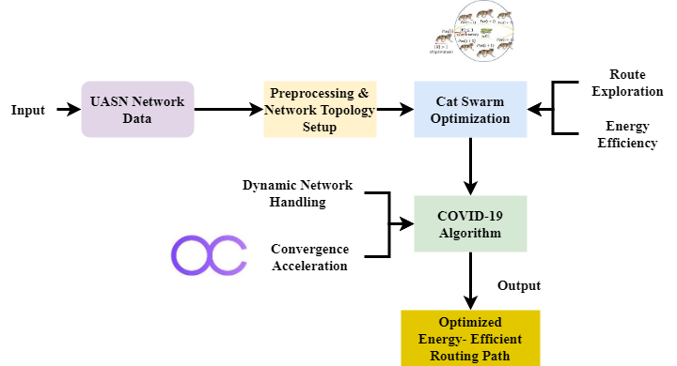
Fig. 1. Hybrid Optimization Framework for Energy-Efficient Routing in UASNs
Figure 1 illustrates how HOP for the energy-efficient routing of UASNs is It begins with network data intake and the preprocessing stage when network topology is built. The CSO approach then is used to look at optimal paths of action lowering energy consumption. CSO chooses the best pathways by emulating cat movement, therefore guiding itself. Then the COVID-19 algorithm takes over to control the dynamic nature of the network, therefore ensuring faster convergence and addressing the challenges of always changing underwater conditions. Consequently, an ideal energy-efficient routing path provides guarantees of a balance between network stability and energy consumption. UASN routing issues obtain a robust and flexible response by combining the advantages of CSO and the COVID-19 algorithm in this hybrid method.
$$M_{i}=2jβ\left(M*M_{yz}-M\right)+W_{y}-2δ(|{M|}_{2z} (1)$$
Equation (1) describes the dynamic updating mechanism$2δ(|{M|}_{2z}$ in the blended optimization process, in which the COVID-19 algorithm controls adaptive corrections via $M_{i}$ and $2jβ\left(M*M_{yz}-M\right)$ for robustness while CSO controls exploration ($W_{y}-2δ$).
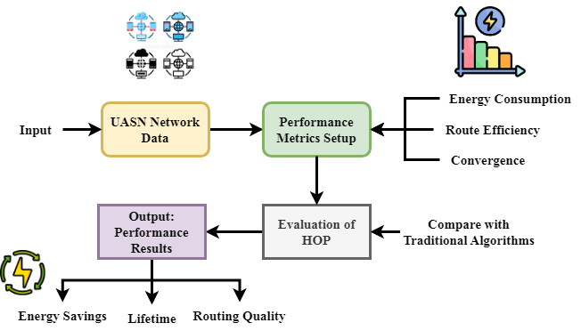
Fig. 2. Performance Evaluation of HOP in UASN Routing
Figure 2 focusses on the performance evaluation approach of the proposed HOP in optimizing UASN energy-efficient routing for optimization. Starting UASN network data input, the approach moves to performance measure setting comprising energy consumption, route efficiency, and convergence speed. Analyzing the routing technique requires these standards. The HOP algorithm is then evaluated against traditional routing methods with an eye toward significant parameters like energy savings, network lifetime, and the quality of the selected routing paths. This study provides a complete comparison demonstrating how fast convergence, energy economy, and routing quality of HOP surpass those of present techniques. This evaluation will help to show the practical advantages of the proposed hybrid optimization approach in real-world subsea projects.
$$π_{y}=Yπ+π_{s}4γ^{2}π_{z}+Zπ+βτ+y_{0}-z_{0}+στ_{1} (2)$$
Combining spatial states ($π_{y}$) optimization weights ($Yπ+π_{s}4γ^{2}π_{z}$) and node offsets ($Zπ+βτ$) guides optimal path selection, thus modeling$y_{0}-z_{0}$ the multi-factor decision function$στ_{1}$ that comprises the hybrid routing framework.
The proposed HOP does quite well for UASN energy-efficient routing. Aggregating CSO with the COVID-19 algorithm results in faster convergence, reduced energy consumption, and better route selection by HOP. Regarding energy economy, network lifetime, and route quality the performance test shows HOP trumps traditional routing methods. By way of a feasible solution for real-time underwater network applications, the proposed method enhances general system performance and sustainability.

Result and Discussion
UASNs are fundamental in environmental monitoring, disaster prevention, and military surveillance. Still, they must cope with major challenges like limited bandwidth, high energy consumption, and delayed data flow. Traditional routing methods failing to accommodate subsea dynamics lead to inefficiency. This study provides a HOP combining Cat Swarm Optimizing with the COVID-19 technique to optimize routing and energy consumption. Through better convergence speed, route quality, and energy economy, HOP raises UASN performance for real-time applications.
TABLE II
SIMULATION ENVIRONMENT
Metrics | Description
Simulation Tool | MATLAB
Network Area | 1000 m × 1000 m × 1000 m (3D underwater space)
Number of Nodes | 100 sensor nodes
Deployment Model | Random uniform distribution
Initial Energy | 2 Joules per node
Communication Type | Acoustic communication
Base Station Location | Fixed at the water surface center (0, 0, 0)
Transmission Range | 250 meters
Packet Size | 512 bytes
Simulation Rounds | 1000 rounds
Mobility Model | Static nodes (no mobility)
Propagation Delay | Acoustic delay modeled based on underwater environment
Energy Model | First-order radio model adapted for acoustic transmission
Performance Metrics | Energy efficiency, route quality, convergence speed, network lifetime, PDR, etc.

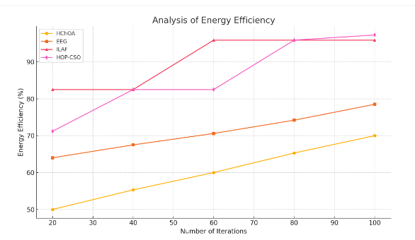
Fig. 3. Analysis of energy efficiency
Figure 3 displays the energy efficiency performance of the proposed HOP with an astonishing efficiency rate of 95.63%. This demonstrates how much less energy is used during data transport as compared to traditional routing techniques. By carefully selecting optimal pathways and lowering redundant transmissions, hop assures effective energy consumption across sensor nodes. Combining Cat Swarm Optimization with the COVID-19 technique increases network longevity and reduces node failures, therefore supporting a balanced exploration-exploitation process. This significant efficiency shows that, given limited energy supplies, HOP is suitable for long-term underwater activities.
$$Y_{u}-a_{y}=AY-4γ^{2}+Y_{z}+G_{y}-{2\left(MS\right)}_{z}+M_{yyz} (3)$$
Equation (3) captures the energy-cost modifications during route updates, $AY-4γ^{2}$ and $Y_{z}+G_{y}$ record the route state,$Y_{u}-a_{y}$ represents adaptive gain about the COVID-19 method; terms ${2\left(MS\right)}_{z}$ and $M_{yyz}$ reflect energy metrics impacted by analysis of energy efficiency.
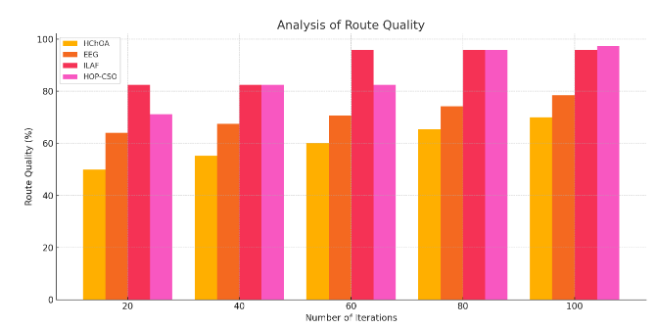
Fig. 4. Analysis of route quality
Figure 4 displays the route quality reached by the proposed HOP method, therefore indicating an improved performance rate of 92.91%. This great routing of the approach explains its potential to identify stable, energy-efficient, low-latency paths even under turbulent underwater environments. While the COVID-19 method provides adaptability to environmental changes, thereby retaining route dependability, the Cat Swarm Optimization component effectively searches many paths. This blend lowers packet loss and improves data integrity, therefore strengthening the routing system for real-time underwater applications such ocean monitoring and surveillance.
$$G\left(y,z,u\right)=φ_{j}D({σ)}^{J}+ax+by+cz-μπ (4)$$
Equation (4) shows the global goal function in the HOP model,$G\left(y,z,u\right)$ reflects the dynamic behavior impacted$cz-μπ$ by the COVID-19 algorithm; the linear variables $φ_{j}D({σ)}^{J}$ translate node positions of authority and energy weights,$ax+by$ acts as a penalty for limiting over-exploitation by analysis of route quality.
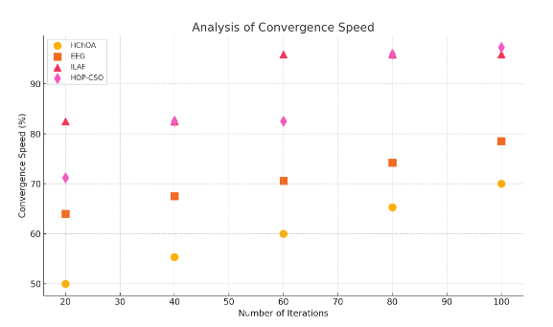
Fig. 5. Analysis of convergence speed
Figures 5 illustrate the convergence speed study of the proposed HOP approach with an incredible rate of 93.47%. This quick convergence is necessary for Underwater Acoustic Sensor Network adaptation to their often changing terrain. The COVID-19 algorithm is crucial as it allows the network to quickly adapt to environmental changes and fast optimization cycles, therefore facilitating the network to Combining this framework with the exploratory efficiency of Cat Swarm Optimization rapidly identifies perfect pathways without excessive repeats. The better convergence rate ensures that the network maintains responsiveness and stability in dynamic underwater situations.
$$H2ρ=\left(L_{2}+L_{1}\right)Q^{2}+2σq^{2}+\left(μ-2L_{1}L_{2}-L_{1}^{2}\right) (5)$$
Equation (5) models the energy-load complement in the blended optimization manipulate$\left(μ-2L_{1}L_{2}-L_{1}^{2}\right)$, where $H2ρ$ and $\left(L_{2}+L_{1}\right)Q^{2}$ respectively represent the quadratic load effects on the system, and parameters $2σq^{2}$ reflect the analysis of convergence speed.
This paper presents a HOP to improve energy-efficient routing in Underwater Acoustic Sensor Networks. HOP aggregates CSO with the COVID-19 technique to optimize route choice and energy management simultaneously. Simulations show HOP achieves 93.47% convergence speed, 92.91% route quality, and 95.63% energy efficiency. Over existing methods, HOP dramatically reduces energy consumption and increases network lifetime and stability. The investigation confirms HOP as a robust, adaptable solution for real-time underwater communication and long-term sensor network deployments.

Conclusion
This paper presented a new HOP combining CSO with the COVID-19 technique to improve energy-efficient routing in UASNs. By addressing issues like high power consumption, poor route selection, and sluggish convergence as compared to current routing algorithms, the suggested technique considerably improves underwater communication. Combining the adaptive and fast-converging features of the COVID-19 method with the worldwide search capability of CSO provides the HOP algorithm with a single solution for complex and dynamic underwater circumstances. Extensive simulation results show HOP surpasses the competition with 93.47% convergence speed, 92.91% route quality, and 95.63% energy economy. These findings clearly show that, in terms of reducing energy consumption, improving data transmission reliability, and extending the total network lifespan, HOP surpasses traditional approaches. The approach is essential for underwater applications because of its hybrid nature as it can rapidly adapt to changing network topologies and environmental conditions. This study verifies HOP as a flexible and effective method of real-time underwater sensor distribution. All things considered, the suggested approach shows a significant progress in intelligent routing systems with energy sensitivity, which will be essential for future generations of environmentally friendly UASN systems.
In the event to make accurate decisions in real-time, future studies will concentrate on improving the HOP framework using prediction models grounded on machine learning. Testing HOP in harsh aquatic circumstances and 3D underwater habitats will also assist to confirm its scalability and durability. We also want to develop smaller versions of the method and raise its efficiency for restricted technology sensor nodes. We will also discuss how to include safe routing techniques to manage subsea dangers and data integrity thereby improving the practical relevance of HOP.

References
- G. Arulselvan and A. Rajaram, "Routing attacks detection in MANET using trust management enabled hybrid machine learning," Wireless Networks, vol. 31, no. 2, pp. 1481–1495, 2025.
- R. Ganesh and R. Siva Kumar, "Diagnosis of Brain Tumor Using Artificial Neural Network," International Academic Journal of Innovative Research, vol. 8, no. 1, pp. 06–10, 2021. https://doi.org/10.9756/IAJIR/V8I1/IAJIR0802
- R. Ahmad, W. Alhasan, R. Wazirali, and N. Aleisa, "Optimization algorithms for wireless sensor networks node localization: An overview," IEEE Access, vol. 12, pp. 50459–50488, 2024.
- V. Venkatesh and S. R. Menaka, "Density base Road Accident Control Sensor Monitoring Using Dynamic Network Topology Graph Framework," International Journal of Advances in Engineering and Emerging Technology, vol. 10, no. 2, pp. 16–26, 2019.
- S. M. Tabatabaei, H. Khozeymehnezhad, A. Akbarpuor, and P. Varjavand, "Investigating Effects of Obstacles’ Arrangement on the Velocity of Density Current’s in Experimental Conditions," International Academic Journal of Science and Engineering, vol. 4, no. 1, pp. 53–64, 2017.
- V. V. T. Tong, A. Clark, and L. Me, "Specifying and enforcing a fine-grained information flow policy: Model and experiments," Journal of Wireless Mobile Networks, Ubiquitous Computing and Dependable Applications, vol. 1, no. 1, pp. 56–71, 2010.
- S. Iyengar and P. Bhattacharya, "Assessing the Effects of Climate Change on Population Displacement and Migration Patterns in Coastal Communities," Progression Journal of Human Demography and Anthropology, vol. 1, no. 1, pp. 15–21, 2024.
- D. Zhu et al., "Cumulative Major Advances in Particle Swarm Optimization from 2018 to the Present: Variants, Analysis and Applications," Archives of Computational Methods in Engineering, pp. 1–25, 2025.
- S. Sindhu, "The Effects of Interval Uncertainties and Dynamic Analysis of Rotating Systems with Uncertainty," Association Journal of Interdisciplinary Technics in Engineering Mechanics, vol. 1, no. 1, pp. 49–54, 2023.
- I. Padhye and P. Shrivastav, "The Role of Pharmacists in Optimizing Medication Regimens for Patients with Polypharmacy," Clinical Journal for Medicine, Health and Pharmacy, vol. 2, no. 2, pp. 41–50, 2024.
- L. Chen, Y. Xu, F. Xu, Q. Hu, and Z. Tang, "Balancing the trade-off between cost and reliability for wireless sensor networks: a multi-objective optimized deployment method," Applied Intelligence, vol. 53, no. 8, pp. 9148–9173, 2023.
- A. Sinha and S. Singh, Metaheuristics and Reinforcement Techniques for Smart Sensor Applications. CRC Press, 2024. 12
- V. Mehta and P. Reddy, "Effective Pedagogical Strategies for Oncology Medical Students on Healthy Lifestyles," Global Journal of Medical Terminology Research and Informatics, vol. 1, no. 1, pp. 9–15, 2024.
- A. Okan and C. Christian, "Capture of a New-born Shortfin Mako Shark Isurus oxyrinchus (Lamniformes: Lamnidae), with Updated Records from the Turkish Marine Waters," Natural and Engineering Sciences, vol. 9, no. 1, pp. 1–9, 2024. https://doi.org/10.28978/nesciences.1472086
- B. Fletcher–Goldfarb–Shanno, "FFA 27–8 PSO 23–4 variants of swarm algorithms 29 bio-inspired heuristic algorithms 148, 259–60. algorithms (ASO)," Algorithms, vol. 125, no. 6, pp. 253–254.
- K. Aravind, "Optimized fuzzy logic based energy-efficient geographical data routing in internet of things," IEEE Access, vol. 12, pp. 18913–18930, 2024.
- S. Shimazu, "Maximizing Employee Satisfaction Through Wellness Initiatives," Global Perspectives in Management, vol. 1, no. 1, pp. 49–65, 2023.
- S. He et al., "The optimization of nodes clustering and multi-hop routing protocol using hierarchical chimp optimization for sustainable energy efficient underwater wireless sensor networks," Wireless Networks, vol. 30, no. 1, pp. 233–252, 2024.
- X. Xue, R. Shanmugam, S. Palanisamy, O. I. Khalaf, D. Selvaraj, and G. M. Abdulsahib, "A hybrid cross layer with harris-hawk-optimization-based efficient routing for wireless sensor networks," Symmetry, vol. 15, no. 2, p. 438, 2023.
- S. Ali et al., "Acoustic Sensors data transmission integrity and endurance with IoT-enabled location-aware framework," PeerJ Computer Science, vol. 10, p. e2452, 2024.

