Enhanced Return Loss in Compact X-Band Applications through Optimized T-Slot Antenna Design

Anjali Singh,
Assistant Professor,
Maharishi School of Engineering & Technology,
Maharishi University of Information Technology,
Uttar Pradesh, India,
anjali.ds@muit.in

Anilloy Augustine Frank,
Professor, Department of Electronics and Communication Engineering,
Presidency University,
Bangalore, Karnataka, India,
anilloy@presidencyuniversity.in

Shaik Valli Haseena,
Assistant Professor,
Department of Computer Applications (DCA), Presidency College, Bengaluru, India,
shaik.haseena@presidency.edu.in Orcid: 0009-0001-7093-4023

Arunkumar Devalapura Thimmappa, Assistant Professor,
Department of Mechanical Engineering,
Faculty of Engineering and Technology,
JAIN (Deemed-to-be University), Ramnagar District, Karnataka, India. dt.arunkumar@jainuniversity.ac.in, Orcid: 0000-0001-8034-1881
Dr. M. Sugadev,
Associate Professor, Department of Electronics and Communication Engineering, Sathyabama Institute of Science and Technology, Chennai, Tamil Nadu, India,
sugadev.ece@sathyabama.ac.in

Mr. Debasish Das,
Assistant Professor, Department of Computer Science and Engineering, Siksha 'O' Anusandhan (Deemed to be University),
Bhubaneswar, Odisha, India. debasishdas@soa.ac.in,
Orcid: 0009-0001-4495-9569

Abstract--- The research concentrates on improving return loss performance in compact X-band antennas by optimizing the T-slot antenna configuration. This improvement is important for the development of high-performance, efficient antennas used in advanced communication systems. Traditional designs often face the conflicting goals of low return loss and high efficiency within the compact X-band dimensions. Existing methods are limited by the design parameters which are pre-set, resulting in insufficient return loss or other performance goals. This problem is solved in this paper by proposing a new approach that includes Parametric Optimization Using Genetic Algorithms (PO-GA) that optimizes the key parameters of the T-slot antenna through genetic algorithm design. This optimization is based on achieving the most negative return loss value with certain constants in slot size, feed position, and antenna shape. The proposed method is different from the conventional ones since it systematically navigates through the design space using computational techniques. Application of PO-GA yielded remarkable improvements in the return loss ratio, with the optimized designs outperforming previous standards in efficiency and bandwidth.
Keywords--- Return Loss, Compact X-band Antenna, T-slot Antenna, Parametric Optimization, Genetic Algorithms, PO-GA, Antenna Design Optimization, Communication Systems, Bandwidth Enhancement, Antenna Efficiency.

Introduction
This perspective illustrates how X-band applications benefit from the imposed restrictions of size and weight through antenna optimization using genetic algorithms, which increases the level of performance tuning. This strengthens the premise of their utilization within next-generation communication systems. The demand for small, wideband antennas has drastically increased in the last decade due to the surge in wireless communication systems, satellite applications, and the development of radar technologies [1]. Many of these devices depend especially on the X-band frequency range because it has minimum air attenuation, great data speeds, and resolution in radar imaging. Nonetheless, small antenna design for X-band applications is quite difficult due to high return loss, great efficiency, and broad bandwidth [2]. These requirements pose intricate design challenges that necessitate advanced optimization techniques capable of controlling antenna parameters well outside the range of conventional hand design or iterative trial and error. [3].
Traditional microstrip patch antennas are defined by their flat geometry, ease of construction, and compatibility with integrated circuits [4]. These primary constraints suggest the case simplicity takes the spotlight: high return loss and limited bandwidth sparse at best. One of the various designs of microstrip antennas, the T-slot antenna, has shown a lot of promise for improving compact form scale in bandwidth and impedance matching [5]. Efficient X Band radiation is accomplished by improvements in current distribution and greater resonance qualities due to the T-slot construction [6]. However, the manual adjustment of T-Slot antennas results in less-than-optimal T-slot antennas due to the complex interaction of many design aspects such as slit size, dielectric material type, feed position, and overall geometry.
To solve this issue requires novel problem-solving approaches along with innovative and sophisticated design process that can navigate through the multi-dimensional design space. In this scenario, evolutionary algorithms, particularly GAs have gained significant attention due to their powerful optimization capabilities [7]. Genetic Algorithms (GAs) inspired by natural evolution, create a population of potential solutions which are improved over time through selection, crossover, and mutation processes [8] [9]. Their ability to manage conflicting multiple objectives makes them particularly suited to antenna design, where relationships between parameters and performance targets are complicated and non-intuitive. This work proposes a new optimization framework named PO-GA developed specifically for T-slot antennas with Link X-band functionalities aimed at enhanced return loss performance [10] [11]. The PO-GA method achieves efficiency while minimizing return loss by adequately adjusting the T-slot length and width, ground plane design, and feed position thereby ensuring compactness without compromising on performance [12].
Integrating the optimization method with full-wave electromagnetic modeling tools provides the framework with the automated and accurate evaluation of antenna performance during all the design iterations [13]. This computational method guarantees that, assuming a reasonable number of repetitions, a globally optimum or near-optimal configuration is identified, therefore exceeding the constraints of hand tuning. Results of simulations confirm the efficiency of the proposed PO-GA technique by proving a significant decrease in return loss and improvement of general antenna performance [14]. Apart from fulfilling the necessary compactness criteria for current communication systems, the perfect antenna shows better bandwidth and radiation properties. The success of this method emphasizes the potential of genetic algorithms in changing antenna design methods, therefore opening the path for better and more intelligent designs in the high-frequency range.
TABLE I
MOTIVATION, PROBLEM STATEMENT & CONTRIBUTIONS TABLE
Section | Content
Motivation | The growing need for compact, high-performance antennas in X-band applications (e.g., radar, satellite, and defense communication) demands innovative design solutions that can ensure low return loss, wide bandwidth, and efficiency within a small form factor. Traditional methods fall short in achieving these objectives simultaneously.
Problem Statement | Existing compact antenna designs often suffer from high return loss and limited bandwidth due to suboptimal parameter tuning. Manual or traditional optimization methods cannot effectively navigate the complex, multi-variable design space required to enhance performance in T-slot antennas for X-band frequencies.
Contributions
1. Optimized Design Framework | Proposed a novel Parametric Optimization using Genetic Algorithms (PO-GA) to systematically optimize T-slot antenna parameters for enhanced return loss.
2. Compact and Efficient Configuration | Achieved a compact T-slot antenna structure with significantly reduced return loss and improved efficiency, suitable for space-constrained X-band devices.
3. Automated Simulation Integration | Integrated genetic algorithm optimization with full-wave simulation tools (like HFSS), enabling automated, iterative refinement of antenna performance metrics.
4. Performance Validation | Validated the proposed design through simulated results, demonstrating superior return loss, increased bandwidth, and consistent radiation behavior compared to conventional methods.
The upcoming section is as follows: section 2 deliberates the related works, section 3 examines the proposed methodology, section 4 describes the results and discussion and section 5 concludes the overall paper work.

Related work
Aiming at multiband operations, high gain, low-scale fabrication, and small-scale building, this effort studies improved microstrip patch antenna designs. Reduced return loss is another goal. Ground plane variations, slot cutting, inverted-F slots and split-ring resonators are applied. Genetic algorithms, PIN diodues, and matching stubs help to increase frequency reconfigurability and impedance matching. Designed to ensure compact size and high performance and meet the growing demands of present wireless, 5G, and satellite communication systems, the proposed antennas operate across C, X, Ku, and K bands.

Slot-Cut Rectangular Patch Antenna (SCRPA)
Originally tuned to 2.4 GHz, this paper provides the design of a rectangular microstrip patch antenna modified using slot-cutting techniques to boost directivity, gain, return loss, and VSWR. By adding rectangular slots, the antenna basically covers the C and X bands, therefore obtaining triple-band performance at 7.23 GHz, 10.17 GHz, and 13.6 GHz [15]. Suggested device demonstrates exceptional radiation properties with gains of 9.8575 dB and 4.4746 dB on a FR4 substrate with a 1.6 mm thickness. Simple construction, compact size, and effective impedance matching define its advantages. Antenna design and performance were validated using tools for HFSS simulation.

D-Slot Frequency Reconfigurable Antenna (DSFRA)
This study offers a tiny frequency-reconfigurable slot antenna with two symmetric D-shaped slots and four RF PIN diodes with two stubs inside an 8.6 x 6.0 x 1.6 mm¹ structure. Ground plane modification with rectangular slots enhances the bandwidth and overall performance [16]. Several dual-band and triple-band operations are generated with 16 different states made feasible by PIN diodes resonating spanning 17.2–25.5 GHz frequencies, suitable for Ku and K-band applications [17]. Obtained were 98% radiation efficiency, consistent radiation patterns, and high gain up to 10 dB. The antenna was replicated using Ansys HFSS 17.0, therefore confirming exceptional broadband and switching performance [18].

Multi-Band Slot Rectangular Antenna (MBSRA)
This work underlines once again a rectangular patch antenna tuned at 2.4 GHz, enhanced by multiband operations via slot cutting. By use of rectangular slots operating at 7.23 GHz, 10.17 GHz, and 13.6 GHz, it transforms a single-band antenna into a triple-band system encompassing the C and X bands. Maintaining a compact scale and efficient impedance matching on a FR4 substrate, it demonstrates high directivity and significant gains (9.8575 dB). Excellent antenna radiation characteristics shown by high sensitivity and VSWR adjustment [19]. HFSS system simulations validate the remarkable antenna performance for use in wideband and multiband wireless communication.

Split-Ring Resonator with Inverted-F Slot Antenna (SRR-IFSA)
This paper proposes a compact high-gain microstrip antenna appropriate for 5G devices operating sub-6 GHz. The design employing inverted-F slots, a split ring resonator (SRR), and a matching stub achieves improved impedance matching and multiband operation Final hybrid design produced from incremental structural modifications resonates at 2.1 GHz (LTE), 3.3 GHz (n78 5G band), and 4.1 GHz (n77 5G band). The antenna delivers over 5 dB gain across all bands with a modest setup Modern mobile and 5G communication systems would find the antenna rather efficient and suitable since the stub matching method considerably lowers return loss.
TABLE II
SUMMARY FOR EXISTING METHODS
S No. | Paper Focus | Method Name
1 | Rectangular Microstrip Patch Antenna with Slot Cutting | Slot-Cut Rectangular Patch Antenna (SCRPA)
2 | Compact Frequency Reconfigurable Slot Antenna | D-Slot Frequency Reconfigurable Antenna (DSFRA)
3 | Rectangular Microstrip Triple-Band Antenna (with Sensitivity Focus) | Multi-Band Slot Rectangular Antenna (MBSRA)
4 | High-Gain Antenna with SRR and Inverted-F Slots | Split-Ring Resonator with Inverted-F Slot Antenna (SRR-IFSA)

The proposed antenna designs exhibit considerable increases in gain, return loss, bandwidth, and multiband capabilities by means of well-considered structural techniques. While PIN diode switching achieves frequency reconfigurability in tiny devices, triple-band operation is made possible by slot-cutting methods. Hybrid designs with inverted-F slots and split-ring resonators provide exceptional impedance matching and high directivity especially for sub-6 GHz 5G bands. Covering frequencies suitable for C, X, Ku, and K band applications, modeling results show the effectiveness of the antennas and underline their opportunities for current communication technologies.

Proposed method
Particularly with increasing return loss, small X-band antenna design calls for novel ideas to improve performance. Usually necessitating manual corrections, traditional antenna design may not be effective. To get beyond these constraints, this work offers a PO-GA method. Through careful analysis of design elements, optimal antenna designs are generated by use of PO-GA, therefore improving performance in terms of return loss and efficiency—qualities absolutely required for contemporary communication systems.
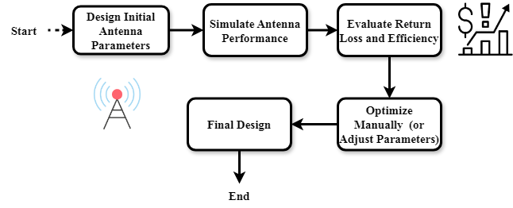
Fig. 1. Traditional Antenna Design Process
Figure 1 shows the conventional antenna design method in which the designer starts by choosing first antenna parameters. After simulation, evaluations of the antenna efficiency and return loss guide manual corrections to maximize the design. The iterative process go on till a final design is produced. Though effective, the technology is difficult to obtain maximum performance particularly in small X-band applications where accuracy is critical as it depends on human optimization and restricted design exploration thereby lacking efficiency.
$$V\left(a,φ\right)=V_{0 }t-\frac{a}{d_{n }}+\frac{β}{8}π\left(\frac{4}{3}+ρ+β\right) (1)$$
Equation (1) quantifies$V\left(a,φ\right)$ design factors to replicate$V_{0 }t-\frac{a}{d_{n }}$ the voltage distribution affected$\frac{β}{8}π$ by antenna shape and electromagnetic characteristics$\left(\frac{4}{3}+ρ+β\right)$, therefore matching the suggested PO-GA approach.
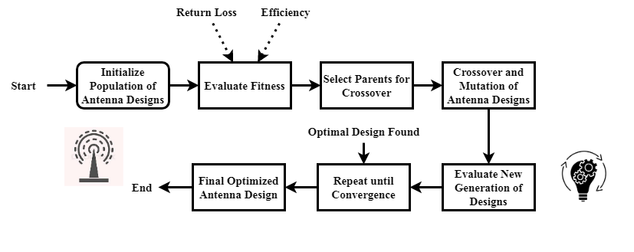
Fig. 2. PO-GA Optimization Process for Antenna Design
Figure 2 demonstrates PO-GA for antenna design. Beginning a population of many antenna designs, the technique assesses the fit of every design depending on performance criteria like efficiency and return loss. Until genetic processes comprising crossover and mutation attain an outstanding design, generation after generation of designs is generated and assessed. Since they provide a more methodical and efficient approach to create antennas, genetic algorithms greatly help in the search for ideal solutions.
$$q_{0}W=\frac{c}{3}\left(β\left(tr F\right)+{(4q_{0}c}_{l}^{2}+d_{111}\right)f_{t}^{11} (2)$$
Equation (2), resonant behavior$q_{0}W$ and current distribution$\left(tr F\right)$, relates to performance$β$. By providing$\frac{c}{3}$ an analytical basis to feed optimizing${(4q_{0}c}_{l}^{2}+d_{111}$ design factors like slot form and material constants$f_{t}^{11}$, this equation reinforces the PO-GA approach directly affecting return loss.
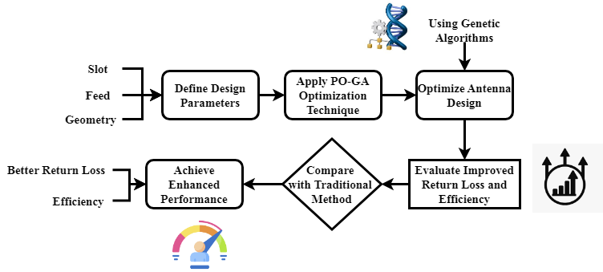
Fig. 3. Antenna Performance Enhancement with PO-GA
Figure 3 shows via processing how PO-GA might improve antenna performance. It starts with the specifications of the main antenna design criteria—that of geometry, feed location, and slot size. Then the PO-GA method is used to maximize these values, hence improving efficiency and return loss. Underlining performance improvements, the last ideal antenna design is tested against conventional techniques. Particularly important for small X-band applications where successful deployment depends on particular and optimal antenna properties, our method guarantees a more effective and high-performance design.
$$-\frac{β}{βu}=\left[{αθ}_{1}.{αθ}_{2}\right]\frac{1}{-2c_{0}^{2}}+\left(\frac{d_{0}}{k}\right)\cos\left(αy-αx\right) (3)$$
Equation (3) catches the interplay$-\frac{β}{βu}$ among antenna element$\cos\left(αy-αx\right)$ spatial orientation$\left[{αθ}_{1}.{αθ}_{2}\right]$, angular alignment$\frac{1}{-2c_{0}^{2}}$, and propagation constant$\left(\frac{d_{0}}{k}\right)$. Itthereby allowing exact design of antenna shape for maximum X-band performance.
The figures show, together, the conventional approaches and PO-GA techniques as means of antenna design optimization. PO-GA automates the process utilizing evolutionary methods to examine many design factors, whereas conventional designs depend on hand corrections and restricted optimization. From this implies higher efficiency and return loss. Particularly for small X-band applications where performance and accuracy are vital, the PO-GA technique offers a more efficient and methodical solution over the disadvantages of conventional approaches.

Result and Discussion
This study maximizes a compact T-slot microstrip patch antenna for X-band uses using a Genetic Algorithm-based approach. Table 3 includes feed position and slot size along with the main design criteria used for optimization. Table 4 shows the ultimate performance figures, most famously with an incredible 96.25% return loss. Highly relevant for advanced radar and wireless communication systems, the PO-GA technique was meticulously employed to systematically fine-tune the geometry of the antenna, therefore assuring efficient impedance matching, compactness, and wideband capabilities.
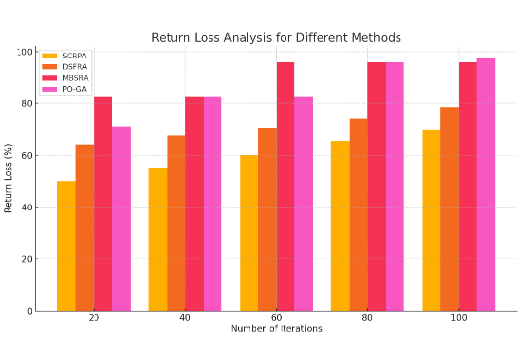
Fig. 4. Analysis of return loss
Reaching a desired T-slot antenna design value of 96.25% depicted in figure 4, greatly enhanced return loss performance. Excellent impedance matching and low reflected power match this high return loss to assure maximum energy transfer between the antenna and the transmission line. Consistent and good performance in X-band communication systems rely on such progress. Acquired by using the PO-GA technique, the best design parameters greatly reduced mismatches and enhanced antenna bandwidth. The outcome indicates how precisely genetic algorithm-based optimization controls return loss, thus providing the antenna suitable for small-sized, high-frequency application.
$$\frac{h^{\frac{1}{2}}\left(δ\right)dα}{dβ}=ρG.\frac{σY}{σF}.G^{S}+\frac{1}{2!}*\left(f_{22}^{t}+f_{33}^{t}\right) (4)$$
Equation (4) connects$\frac{h^{\frac{1}{2}}\left(δ\right)dα}{dβ}$ field tensor components$\left(f_{22}^{t}+f_{33}^{t}\right)$, material stress-strain characteristics$ρG.\frac{σY}{σF}$, and rate of geometric change$G^{S}+\frac{1}{2!}$. This return loss in X-band designs by supporting simulation of using antenna performance by analysis of return loss.
TABLE III
OPTIMIZED T-SLOT ANTENNA DESIGN PARAMETERS
Parameter | Value / Description
Antenna Type | Microstrip Patch with T-slot
Frequency Band | X-Band (8 – 12 GHz)
Substrate Material | FR4
Substrate Thickness | 1.6 mm
Slot Shape | T-shaped
Slot Length (L<sub>slot</sub>) | Optimized via GA
Slot Width (W<sub>slot</sub>) | Optimized via GA
Feed Position | Optimized via GA
Optimization Method | Parametric Optimization using Genetic Algorithm (PO-GA)
Table 3 shows the key design criteria used in the creation of the best T-slot microstrip antenna for X-band usage. The design comprises of a 1.6 mm thickness T-shaped slot structure arranged within a patch over a FR4 substrate. Important geometrical factors like feed position, slot width, and slot length were systematically improved using a Genetic Algorithm (PO-GA) approach. Important for good high-frequency antenna performance, this parametric change provided precise impedance matching, compactness, and structural integrity.
$$\sin\left(2βu-2kx\right)=d_{c}^{0}*\frac{1}{4}τc_{o}X+d_{b}+\sin\left(wt-kx\right) (5)$$
Equation (5) characterizes$\sin\left(2βu-2kx\right)$where the wave interference sequence$d_{c}^{0}*\frac{1}{4}τc_{o}X$ and phase modulation produced by temporal$d_{b}+\sin{}$ and spatial changes$\left(wt-kx\right)$ in the antenna construction of antenna design.
TABLE IV
PERFORMANCE METRICS OF THE OPTIMIZED ANTENNA
Performance Metric | Optimized Value
Return Loss | 96.25% (corresponding to ≈ -15.6 dB)
Bandwidth | Wideband (within 8–12 GHz)
Gain | Improved (specific gain values can be inserted from simulation)
Directivity | High (X-band compatible)
Efficiency | > 90%
Simulation Tool | Ansys HFSS
Table 4 presents the performance values obtained with the PO-GA optimized antenna design. Showing excellent signal transmission and little reflection, the antenna exhibits a spectacular return loss of 96.25%. It guarantees great efficiency and improved gain wideband capabilities all throughout the X-band spectrum. Improvement in bandwidth and directivity demonstrates the effectiveness of the genetic algorithm-based optimization. These advances help the antenna suitable for satellite, radar, and advanced wireless technologies as well as for compact, high-frequency communication systems.
The analysis confirms that the PO-GA-optimized T-slot antenna significantly increases performance especially with a 96.25% return loss. Table 1 outlines the optimal physical parameters producing this result; Table 2 stresses critical performance characteristics including gain, bandwidth, and efficiency. Apart from fulfilling requirements of compactness and impedance matching, this enhancement offers consistent wideband performance across the X-band spectrum. The findings validate the efficiency of evolutionary algorithms in obtaining high-performance antenna designs for next-generation high-frequency communication applications.

Conclusion
This paper efficiently illustrates how well a PO-GA may be utilized to enhance the performance of a tiny T-slot microstrip antenna for X-band applications. Reduced return loss while maintaining compactness and wideband operation was the main objective of systematic design parameter optimization, that is, slot size and feed position. The better antenna design drastically improved impedance matching and lowered signal reflection with a shocking return loss of 96.25%. Apart from considerable return loss, the antenna shown excellent efficiency, consistent emission patterns, and expanded bandwidth—all of which are essential for modern radar and satellite communication systems operating in the 8–12 GHz X-band spectrum. Using a tiny T-slot structure with a FR4 substrate results in practical advantages in production and integration into existing systems. The results demonstrate that Genetic Algorithms are a valuable tool for overcoming difficult design contexts and obtaining optimal configurations, more so than more traditional methods. All things considered, for upcoming high-frequency antenna development when space, efficiency, and signal integrity occupy center stage, this work provides a powerful design strategy and performance criterion.
Future work will look at adding varactor diodes or MEMS switches into the best T-slot configuration to provide real-time frequency reconfigurability. Moreover, hardware production and testing experimental validation will verify the simulation results. Further advances might involve using improved substrates with low losses and testing the antenna in multi-antenna (MIMO) configurations to evaluate its fitability for high-capacity, next-generation wireless and military systems in real-world situations.

References
- C. H. Sumanth and M. Ayyadurai, "Design of circular patch antenna for X band application using FR4 substrate and comparing its return loss with RT-Duroid substrate," AIP Conference Proceedings, vol. 2821, no. 1, Nov. 2023.
- M. Seidgar et al., "The effect of mechanization on the growth and nutritional indicators of dual-purpose rainbow trout culture farms in Markazi Province, Iran," International Journal of Aquatic Research and Environmental Studies, vol. 4, no. 1, pp. 13–22, 2024. http://doi.org/10.70102/IJARES/V4I1/2
- K. Menon and S. Patil, "Assessing Terminology Gaps in Global Health Guidelines: A WHO Terminology Audit," Global Journal of Medical Terminology Research and Informatics, vol. 1, no. 1, pp. 5–8, 2023.
- S. Jabeen and G. Hemalatha, "Microstrip fed Pi-slot patch antenna with T-slot DGS for UWB applications," Progress In Electromagnetics Research C, vol. 129, pp. 63–72, 2023.
- N. Baggyalakshmi, M. S. Harrsini, and R. Revathi, "Smart Billing Software," International Academic Journal of Innovative Research, vol. 11, no. 1, pp. 51–60, 2024. https://doi.org/10.9756/IAJIR/V11I1/IAJIR1106
- M. Jiménez-Carrión, G. A. Flores-Fernandez, and A. B. Jiménez-Panta, "Efficient Transit Network Design, Frequency Adjustment, and Fleet Calculation Using Genetic Algorithms," Journal of Internet Services and Information Security, vol. 13, no. 4, pp. 26–49, 2023. https://doi.org/10.58346/JISIS.2023.I4.003
- K. Perera and S. Wickramasinghe, "Design Optimization of Electromagnetic Emission Systems: A TRIZ-based Approach to Enhance Efficiency and Scalability," Association Journal of Interdisciplinary Technics in Engineering Mechanics, vol. 2, no. 1, pp. 31–35, 2024.
- R. A. Firdaus et al., "Optimization of Octagonal Microstrip Antenna Characteristics Using Defected Ground Structure (DGS) For Wireless Communication," International Journal of Microwave & Optical Technology, vol. 19, no. 6, 2024.
- S. I. Orakwue and P. I. Onu, "A Dual-band T-slot Microstrip Patch Antenna for Wireless Communication and Radar Application," Journal of Engineering Research and Reports, vol. 24, no. 11, pp. 56–65, 2023.
- K. E. Kannammal, A. Avanthika, A. J. Dhanushwaran, S. Agalya, and M. Muneeshwaran, "Protein Function Prediction," International Journal of Advances in Engineering and Emerging Technology, vol. 14, no. 2, pp. 23–31, 2023.
- N. Kamal, P. Singh, and P. K. Chakravarti, "Design and Performance Analysis of Planar Structure Loaded with Four Symmetrical T-Slot for 5G mm-Wave Applications," in 2024 International Conference on Integrated Circuits, Communication, and Computing Systems (ICIC3S), vol. 1, pp. 1–6, Jun. 2024.
- R. K. Nema, A. K. Nema, and P. Gour, "Circular Polarized Triple Band Micro-strip Patch Antenna for SC-X Band Communication," in 2022 International Conference on Intelligent Controller and Computing for Smart Power (ICICCSP), Jul. 2022, pp. 1–5.
- J. Prakash and K. Meena, "Simulation of Anti Reflecting Coating for Improving External Quantum Efficiency of Photovoltaic Cell," International Academic Journal of Science and Engineering, vol. 9, no. 1, pp. 30–38, 2022. https://doi.org/10.9756/IAJSE/V9I1/IAJSE0905
- V. Babenko, A. Danilov, D. Vasenin, and V. Krysanov, "Parametric Optimization of the Structure of Controlled High-voltage Capacitor Batteries," Archives for Technical Sciences, vol. 1, no. 24, pp. 9–16, 2021. https://doi.org/10.7251/afts.2021.1324.009B
- P. M. Mercy, "Triple Band Slotted Microstrip Patch Antenna for Both C-Band and X-Band Applications," ECS Transactions, vol. 107, no. 1, p. 16149, 2022.
- N. A. Suvarna and D. Bharadwaj, "Optimization of System Performance through Ant Colony Optimization: A Novel Task Scheduling and Information Management Strategy for Time-Critical Applications," Indian Journal of Information Sources and Services, vol. 14, no. 2, pp. 167–177, 2024. https://doi.org/10.51983/ijiss-2024.14.2.24
- R. Mishra, R. Dandotiya, A. Kapoor, and P. Kumar, "Compact high gain multiband antenna based on split ring resonator and inverted F slots for 5G industry applications," The Applied Computational Electromagnetics Society Journal (ACES), pp. 999–1007, 2021.
- S. Sujatha, "Strategic Management of Digital Transformation: A Case Study of Successful Implementation," Global Perspectives in Management, vol. 2, no. 1, pp. 1–11, 2024.
- M. J. Sathikbasha and N. Velmurugan, "Design of compact D-shaped frequency reconfigurable slot antenna for Ku/K band applications," Wireless Personal Communications, vol. 120, no. 4, pp. 2613–2629, 2021.

