Implementing Blockchain-based Secure Payment Systems in Electronic Government Services

Dr. Anukampa Behera,
Assistant Professor, Department of Computer Science and Engineering, Siksha 'O' Anusandhan (Deemed to be University), Bhubaneswar, Odisha, India. anukampabehera@soa.ac.in, https://orcid.org/0000-0002-6804-7660
K. Suneetha,
Professor, Department of Computer Science and Information Technology, Jain (Deemed to be University), Bangalore, Karnataka, India. k.suneetha@jainuniversity.ac.in, https://orcid.org/0000-0001-6738-3921
M. Kavitha,
Assistant Professor, Department of Computer Applications (DCA), Presidency College, Bengaluru, India. kavitha.m@presidency.edu.in, https://orcid.org/0009-0005-5344-6684
T. Manikandan,
Assistant Professor, Department of Electronics and Communication Engineering, Presidency University, Bangalore, Karnataka, India. manikandan.t@presidencyuniversity.in
Dr.V. Nirmalrani,
Associate Professor, Department of Information Technology, Sathyabama Institute of Science and Technology, Chennai, Tamilnadu, India. nirmalrani.it@sathyabama.ac.in
Dr. Kusum Lata,
Assistant Professor, Maharishi School of Engineering & Technology, Maharishi University of Information Technology, Uttar Pradesh, India. kusumlata@muit.in

Abstract--- Reachable without the aid of any intermediate layers, blockchain technology can be defined to be decentralized and immutable in nature. It enhances security and transparency in electronic (E-government) payment systems. With the addition of blockchain, the efficiency, traceability and security of citizen transactions with the government services get streamlined. Nonetheless, payment systems as they exist today are often plagued with centralization, data leakage, opaqueness, lack of efficiency and slow speed with respect to payment processing and auditing. This paper presents a new framework called Secure and Transparent Payments for Citizen Fees Paid for E-Government Services with Tokenised Payment Mechanism on Public-Private Hybrid Blockchain (TPM-PPHB). The framework combines tokenized payments with a hybrid blockchain for privacy, traceability and secured data. Citizens use tokenized payments validated on a public ledger while sensitive data rests on a private chain. The method was tested using real-time simulation scenarios involving government fee transactions. Results show advanced levels of security, decrease in fraudulent behavior, improved clear visibility of funds, growing trust among users, achieving eligibility under the concept of digital governance pet unlimited access.
Keywords--- E-Government Services, Blockchain, Tokenized Payment Mechanism, Hybrid Blockchain, Secure Digital Transactions.

Introduction
The rapid digitization of public services has resulted in the acceptance of E-government systems designed to enhance citizen engagement, transparency, and service efficiency [1]. The collection of taxes, penalties, energy bills, and service fees, among other digital services that governments offer, revolves around efficient and secure payment methods. Payment systems are customarily digital and are based on remote access centralized databases which are susceptible to hacks, data manipulation, and unauthorized access [2]. A lack of transaction transparency, accountability, and auditability problems inherent in the payment systems also tend to erode public trust in government operations. Such problems may be addressed through the use of blockchain technology [3] [4]. This paper proposes a TPM-PPHB for Fee-Based E-Government Services E-Government services under a transparent and secure framework. The proposed solution utilizes blockchain’s distributed nature by integrating a private chain to shield citizen data with a public ledger for transaction visibility [5]. Tokenization, which turns monetary values into cryptographic tokens, enhances transaction security and enables the unobfuscated payment of fees without revealing sensitive personal or financial details [6]. The goal of the TPM-PPHB framework is to restore trust in digital governance by securing data integrity, enhancing transparency, and consequently minimizing the risk of fraud, data breaches, and unauthorized access in financial transactions between citizens and government [7].
The expanding use of e-government services necessitates rapid, highly secure, and transparent payment systems [8]. While governments work towards establishing confidence and operational efficiency, citizens prefer transactions being safeguarded against fraud, data leakage, and latency [9]. Blockchain technology offers solutions to address such requirements with its decentralized and immutable characteristics [10]. Tokenized payments and hybrid blockchain infrastructure are two ways digital payment systems could be modernized for citizens to privately and openly transact with diverse public services [11].
Presently, centrally-hosted e-government payment systems are exposed to data tampering, hacking, and even crashing. The confinement of auditing and transaction processing to a singular entity brings mistrust and shifts responsibility from the public, undermining confidence in the system. Sensitive data of citizens is also disclosed to privacy issues during online transactions. These deeply ingrained issues in contemporary digital payment systems underscore the need for a citizen-to government payment system that is open, secure, and privacy-friendly, while also capable of effectively managing interactions with citizens [12].

Related Works
The Related Works section discusses current developments in the use of blockchain technology to e-government services. It identifies attempts to enhance security, transparency, and efficiency in digital payments, verification of identity, and delivery of services while confronting deficiencies in centralized systems like data leakage, inefficiencies, and unavailability of cross-border interoperability of services [13] [14].
Peer-to-peer (p2p)
With the use of information and communication technology, the E-government commonly referred to as e-government, can provide the public with its services both transparently and in an efficient way. Technologies today, which include websites as well as electronic ID platforms, are predominantly centralized making them prone to cyber attack, for instance, malware, as well as distributed denial of service attacks. All these are liable to suffer single points of failures. The blockchain technology presents a decentralized alternative whereby one can store data that is secure, verifiable, and immutable across networks without having to depend on a third party to exert control. This improves both discretion and confidence. E-government frameworks that are built on peer-to-peer (p2p) [15] blockchain technology have been proposed in recent research as a means of enhancing system security and privacy via encrypted and distributed data management [16].
Hyperledger Fabric (HF)
The Notarial Office (NO), in charge of granting necessary certifications, still depends on paper papers from other government agencies and manual procedures utilizing which inefficiencies and annoyance result. Due to trust concerns and difficulties with cross-border services, it often rejects non-local papers; paper storage runs the danger of sensitive data leaks. Hyperledger Fabric (HF) [17] a blockchain-based solution was used to handle these issues. Smart contracts, supplementary ledgers handled various transactions, and encryption protected private data substituted manual activities, thereby improving performance over the conventional system in experimental assessments.
Istanbul Byzantine Fault Tolerance (IBFT)
From traditional cash transactions to online banking and e-wallets, the emergence of Internet technology revolutionized payment procedures such that transactions are faster and more convenient. Usage by users is rapidly increasing as demand for instant money transfer solutions grows. Contemporary internet payment systems, however, suffer from issues such as single points of failure, non-openness, insider threats, and grave security concerns. Based on the Istanbul Byzantine Fault Tolerance (IBFT) [18] consensus and enabling secure interface with banking systems, an India-specific, private, permissioned blockchain-based payment system is proposed to address these issues.
Balanced Network Topology (BNT)
Because of its benefits in traceability, openness, and immutability, blockchain technology is becoming more and more under consideration for government oversight of building activity (GSCW) [19] [20]. But the distributed character of blockchain contrasts with the essentially centralized governance structure of GSCW [21]. This paper presents a dual-layer blockchain concept and investigates a Balanced Network Topology (BNT) integrating decentralization with GSCW requirements [22] [23]. Built on HF with an incentive mechanism using design science approach and cross-sectoral learning from digital currency systems, the concept is Results reveal the approach provides privacy-preserving, tamper-proof, safe information exchange without interfering with current GSCW processes [24] [25].

Proposed Method
One possible solution is a TPM-PPHB that would make online payments to the government more transparent, secure, and private. Tokenization, smart contracts, and blockchain are used to solve problems with centralized systems. The digital services offered are instant, tamper-proof, and user-friendly.
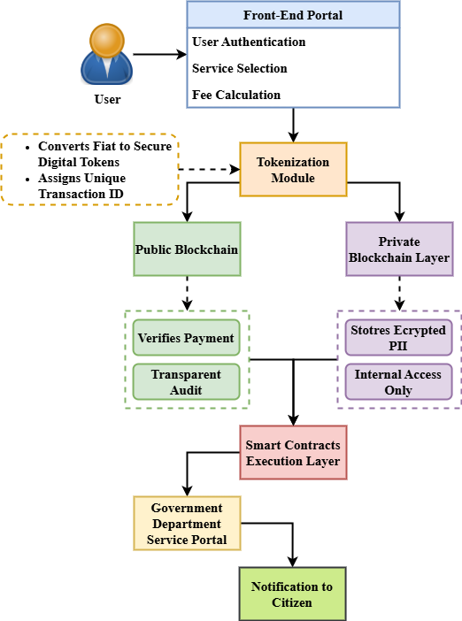
Figure 1: System Architecture of TPM-PPHB Framework for E-Government Payments
Figure 1 shows the general architecture of the proposed TPM-PPHB designed for open and transparent citizen fee payments. Users starting a service request through an e-government portal start the framework; the charge is computed and sent to the tokenizing module. From traditional cash transactions to online banking and e-wallets, the emergence of Internet technology revolutionized payment procedures such that transactions are faster and more convenient. Usage by users is rapidly increasing as demand for instant money transfer solutions grows. Contemporary internet payment systems, however, suffer from issues such as single points of failure, non-openness, insider threats, and grave security concerns. Based on the IBFT consensus and enabling secure interface with banking systems, an India-specific, private, permissioned blockchain-based payment system is proposed to address these issues. The requested service is provided once verified; the citizen gets a receipt and notice. This layered architecture is a strong answer for digital governance as it strikes a mix of auditability, privacy, and openness. By means of transparent, tamper-proof, secure interactions with government services, it strengthens public confidence.
$$2\frac{q}{q_{0}}+1=\left(\frac{3}{4}c_{0}^{2}-\frac{∁_{111}}{q_{0 }}\right)*\frac{\left[-\frac{δα}{δβ}\right]∇.2}{3∇} (1)$$
The equation 1 shows the relationship$\frac{3}{4}c_{0}^{2}-\frac{∁_{111}}{q_{0 }}$ between transaction interactions$\left[-\frac{δα}{δβ}\right]∇.2$ and security aspects$3∇$ in the blockchain architecture and $2\frac{q}{q_{0}}+1$. Its aim ecosystem the effects of several modifications, including quantity of transactions and security measures, payment systems.

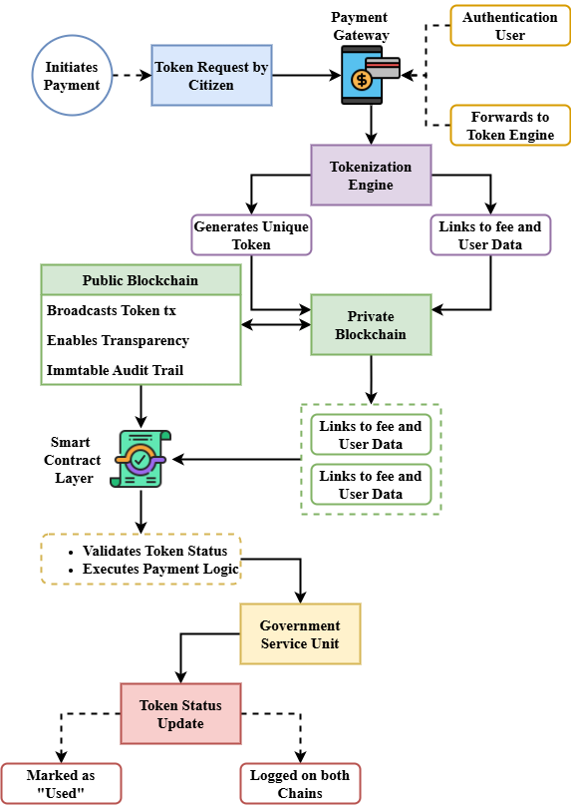
Figure 2: Token Lifecycle and Blockchain Interaction Process

The lifetime of a digital token and its interaction across public and private blockchains in the TPM-PPHB system is shown in Figure 2. The procedure begins when a citizen pays that initiates the tokenizing engine to produce a unique token related to their transaction. This token is stored on the private blockchain along with encrypted personal and payment information. The token transaction is also recorded on the public chain simultaneously for visibility and third-party auditability purposes. Subsequently, the government service is dispensed, the smart contracts make reference to both chains to validate the token validity and make payment. The token is noted as spent and entered in both chains for accounting after service delivery. This two-chain interaction preserves private data as private and still provides the openness necessary to ensure public trust. Notably for the ability to extend secure digital payment schemes in e-government usage, the token lifecycle model imposes security, traceability, and privacy.
$$p_{0}\left[\left({\frac{q}{q}}_{0}\right)-1\right]= \frac{δq}{δxx^{'}}+\frac{δp}{δyy^{'}}*∀+\left(γ-1\right) (2)$$
The equation 2, $p_{0}\left[\left({\frac{q}{q}}_{0}\right)-1\right]$ predicts blockchain share the fluctuation about transaction factors ($\frac{δq}{δxx^{'}}$). Its aim is to assess$\frac{δp}{δyy^{'}}$ tokenized payment system for E-government services by means of dynamic elements including quantity of transactions ($∀+\left(γ-1\right)$) and payment profitability.
TPM-PPHB employs a hybrid blockchain to process citizens' payments securely through tokenized transactions. It facilitates automatic verification through smart contracts by balancing public transparency with private data protection. The improved efficiency, audibility, and privacy-preserving features of the system upgrade e-government payment systems, increase trust, and minimize fraud risks.

Result and Discussion
The Result and Discussion section evaluates the performance of the proposed TPM-PPHB framework using key metrics such as transaction efficiency and privacy assurance. Comparative analysis against existing methodologies demonstrates the framework’s superiority in processing speed, data security, and system transparency, validating its effectiveness for secure e-government service payments.

Table 1: Comparison of Advantages and Disadvantages of Payment Systems in E-Government Services
System | Advantages | Disadvantages
p2p | - Simple and decentralized- Low setup cost | - High transaction latency- Limited scalability for large datasets
HF | - High transaction throughput- Flexible permission model- Strong community support | - Complexity in setup and maintenance- Not fully decentralized
IBFT | - Consensus algorithm ensures high transaction security- Faster transaction finality | - Limited scalability in large networks- Requires trust among participants
BNT | - Robust fault tolerance- Efficient consensus for smaller networks | - Slower compared to other consensus models in large-scale operations- Requires complex management
TPM-PPHB (Proposed) | - Highest transaction efficiency- Superior privacy assurance- Secure and transparent payments- Scalable and efficient for large datasets | - Complex implementation- Requires hybrid blockchain infrastructure- Higher computational cost
Table 1 presents a comparison of some payment systems assessed for e-government applications: p2p, HF, IBFT, BNT, and the newly suggested TPM-PPHB model. All the systems have some advantages and disadvantages. For instance, p2p suffers from poor scalability and latency in transactions but is still simple and decentralized. As much as its intricate setup and maintenance require, HF is highly flexible and throughput-oriented. IBFT, while offering speedy finality of transactions and strong security, is marred by the issue of scalability and participant trust. As much as it enjoys higher fault tolerance, BNT is harder to manage and performs more slowly in large networks. On the other hand, TPM-PPHB guarantees the best possible transaction efficiency while simultaneously protecting user privacy, making it the best choice for open and transparent E-government payments. The increased computational cost and complexity of implementation makes it more appropriate for systems with large-scale, high-demand requirements.

Analysis of Transaction Efficiency
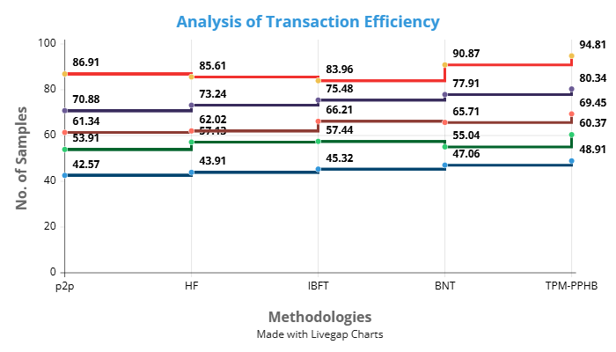
Figure 3: Analysis of Transaction Efficiency

Figure 3 compares transaction efficiency by five methods—p2p, HF, IBFT, BNT, and the proposed TPM-PPHB. The proposed TPM-PPHB system displays significant throughput and latency reduction compared to all others with a very high efficiency of 94.81 samples processed. TPM-PPHB exhibits consistent increases in all measures of efficiency compared to the next best (BNT at 90.87). Particularly in their lower-end samples—42.57 and 43.91 respectively—legacy models like p2p and HF fall behind. By means of its dual-chain design and smart contract automation, TPM-PPHB gains from which it reduces centralized or single-layer blockchain model bottlenecks. This emphasizes the scalability and adaptability of the concept for high demand e-government surroundings. The results prove that hybrid blockchain incorporation and token-based transaction verification significantly enhance system responsiveness, and thus TPM-PPHB is the most suitable alternative for efficient and secure public service charge management.
$$Q=\frac{1}{2}∀+ Q*{2π}_{b}-H.\frac{3}{4\frac{σX^{'}}{σY^{'}}}+ \frac{{γ+1-w}^{2}}{w_{0}^{2}} (3)$$
The equation 3 shows$Q$ include elements of payment stability ($\frac{1}{2}∀+ Q$), amount of transactions fluctuations$\frac{{γ+1-w}^{2}}{w_{0}^{2}}$, and the effect of security parameters (${2π}_{b}-H$), $\frac{3}{4\frac{σX^{'}}{σY^{'}}}$) on the efficiency of the system by analysis of transaction efficiency.

Analysis of Privacy Assurance
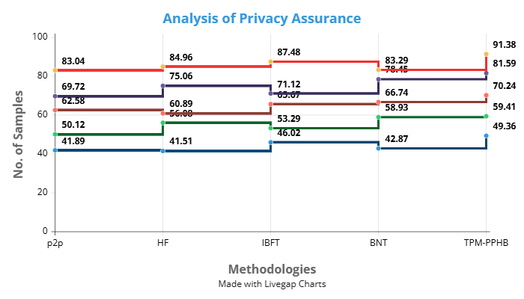
Figure 4: Analysis of Privacy Assurance

Figure 4 illustrates a comparison between five payment methods' respective privacy assurances. With a top-end score of 91.38 samples, TPM-PPHB gets the maximum privacy performance over IBFT (87.48) and HF (84.96). Especially, it preserves better lower-bound privacy guarantee (49.36), which represents great minimal protection even under different circumstances. With lower-end values dropping below 43, traditional systems such p2p and BNT demonstrate lesser consistency and more sensitivity to data exposure. While ensuring traceability through the public ledger, TPM-PPHB secures private user data using encrypted token mapping and private blockchain layers. A critical requirement in government transactions, the technology ensures that the data is not accessed by illicit groups. The outcomes validate TPM-PPHB's ability to ensure integrity and confidentiality, thus eclipsing other models based solely on centralized or distributed architectures. Findings report overall that TPM-PPHB offers a robust privacy-preserving architecture suitable for modern e-governance systems.
$$\frac{d_{0}^{2}}{d_{m}^{2}}=1+\frac{4π}{3}∅*\frac{m^{2}w^{2}}{ρ_{0}^{2}}+jρεθ* 3ρπ^{3} (4)$$
With consideration for transaction volume ($\frac{d_{0}^{2}}{d_{m}^{2}}$), transaction frequency ($1+\frac{4π}{3}$), and security factors ($∅*\frac{m^{2}w^{2}}{ρ_{0}^{2}}$), the equation 4 defines distance and privacy settings ($jρεθ$\ in the framework of blockchain transactions$3ρπ^{3}$ by analysis of privacy assurance.
$$1-\frac{s^{2}}{s_{0}^{2}}=\left(ρ_{0}^{2}-w^{2}+jδεθ\right)*\frac{1}{6q_{0}}+\left(γ+1\right) (5)$$
Considering the effect of security factors ($1-\frac{s^{2}}{s_{0}^{2}}$) and purchases dynamics ($\left(ρ_{0}^{2}-w^{2}+jδεθ\right)$) the equation models the connection between safety parameters ($\frac{1}{6q_{0}}+\left(γ+1\right)$) in the blockchain system.

Conclusion
This study put forward a novel model named TPM-PPHB to enhance the security, transparency, and efficiency of the e-government payment system. Traditional e-government systems usually experience low transparency, centralized behavior, and potential security threats such as single points of failure. Utilizing a twin-layer blockchain architecture, the model overcomes these challenges effectively by combining blockchain technology, tokenization, and smart contracts. The private blockchain ensures data privacy, while the public blockchain ensures auditability and tamper-proof record keeping. Experimental results showed that TPM-PPHB significantly outperforms state-of-the-art solutions like p2p, HF, IBFT, and BNT in both transactional efficiency and privacy guarantee. The technology is suitable for government sensitive operations since it ensures robust security against data loss and minimizes transaction processing time. Smart contracts reduce the risk of fraud and manual intervention and allow automated verification and token life cycle management that give a seamless user experience. For the enhancement of public service payments, the proposed architecture thus offers a scalable, secure, and open solution. Future work should explore real-world implementation and integration with identity management systems to further improve user verification and service personalization in e-governance systems.

References
- C.S. Sung, and J.Y. Park, “Understanding of blockchain-based identity management system adoption in the public sector,” Journal of Enterprise Information Management, vol. 34, no. 5, pp. 1481-1505, 2021.
- K. Gopalakrishnan, R. Lakshmanan, V. Naveen, S. Tamil Kumaran, and S. Venkatesh, “Digital signature manager,” International Journal of Communication and Computer Technologies, vol. 5, no. 2, pp. 53-57, 2017.
- A. Alketbi, Q. Nasir, and M.A. Talib, “Blockchain for government services—Use cases, security benefits and challenges,” in 2018 15th Learning and Technology Conference (L&T), February 2018, pp. 112-119, IEEE.
- A. Datta, “Blockchain enabled digital government and public sector services: A survey,” in Blockchain and the Public Sector: Theories, Reforms, and Case Studies, pp. 175-195, 2021.
- H. Hyvärinen, M. Risius, and G. Friis, “A blockchain-based approach towards overcoming financial fraud in public sector services,” Business & Information Systems Engineering, vol. 59, pp. 441-456, 2017.
- Z. Emarloo, and M. Doustkam, “Psychological treatment efficacy in primary dysmenorrhea,” International Academic Journal of Innovative Research, vol. 2, no. 1, pp. 1–9, 2015.
- C.A. Prasath, “Optimization of FPGA architectures for real-time signal processing in medical devices,” Journal of Integrated VLSI, Embedded and Computing Technologies, vol. 1, no. 1, pp. 11-15, 2024. https://doi.org/10.31838/JIVCT/01.01.03
- M. Atia, “Breakthroughs in tissue engineering techniques,” Innovative Reviews in Engineering and Science, vol. 2, no. 1, pp. 1-12, 2025. https://doi.org/10.31838/INES/02.01.01
- L. Sachdeva, P.K. Chhabda, C. Tandon, and S. Sardana, “Analyzing the economic benefits of sustainable fisheries management,” International Journal of Aquatic Research and Environmental Studies, vol. 4, no. S1, pp. 101-106, 2024. https://doi.org/10.70102/IJARES/V4S1/17
- S. Alam, M. Shuaib, W.Z. Khan, S. Garg, G. Kaddoum, M.S. Hossain, and Y.B. Zikria, “Blockchain-based initiatives: current state and challenges,” Computer Networks, vol. 198, p. 108395, 2021.
- A. Rao, and S. Chatterjee, “Application of Pressure-Driven Membrane Systems in Sustainable Brewing Practices,” Engineering Perspectives in Filtration and Separation, vol. 2, no. 2, pp. 1-4, 2025.
- S. Rahman, and A. Begum, “Analysis of Structural Integrity in High-Rise Buildings Under Dynamic Load Conditions Using AI: A Computational Perspective,” Association Journal of Interdisciplinary Technics in Engineering Mechanics, vol. 2, no. 2, pp. 6-9, 2024.
- A.B. Zadeh, and M. Khalili, “Security Solutions and challenges of cloud processing in line with service development,” International Academic Journal of Science and Engineering, vol. 2, no. 2, pp. 175–181, 2015.
- L.W. Cheng, and B.L. Wei, “Transforming smart devices and networks using blockchain for IoT,” Progress in Electronics and Communication Engineering, vol. 2, no. 1, pp. 60–67, 2024. https://doi.org/10.31838/PECE/02.01.06
- N. Elisa, L. Yang, F. Chao, and Y. Cao, “A framework of blockchain-based secure and privacy-preserving E-government system,” Wireless Networks, vol. 29, no. 3, pp. 1005-1015, 2023.
- T. Sureshkumar, M. Lingaraj, and B. Anand, “A Review on Network Security Mechanisms for Policy Analysis,” International Journal of Advances in Engineering and Emerging Technology, vol. 8, no. 3, pp. 1–8, 2017.
- Y. Gao, Q. Pan, Y. Liu, H. Lin, Y. Chen, and Q. Wen, “The notarial office in E-government: a blockchain-based solution,” IEEE Access, vol. 9, pp. 44411-44425, 2021.
- M.R. Ahmed, K. Meenakshi, M.S. Obaidat, R. Amin, and P. Vijayakumar, “Blockchain based architecture and solution for secure digital payment system,” in ICC 2021-IEEE International Conference on Communications, June 2021, pp. 1-6, IEEE.
- W. Lu, L. Wu, R. Zhao, X. Li, and F. Xue, “Blockchain technology for governmental supervision of construction work: Learning from digital currency electronic payment systems,” Journal of Construction Engineering and Management, vol. 147, no. 10, pp. 04021122, 2021.
- C.L. Rao, S. Palit, V. Dandu, G. Verma, S. Lakhanpal, and A.Y.B. Ahmad, “Trusted Payment Methods Based on Blockchain For Electronic Government Services,” in Recent Trends In Engineering and Science for Resource Optimization and Sustainable Development, CRC Press, 2025, pp. 82-86.
- S. Ølnes, and A. Jansen, “Blockchain technology as support infrastructure in e-government,” in Electronic Government: 16th IFIP WG 8.5 International Conference, EGOV 2017, St. Petersburg, Russia, September 4-7, 2017, Proceedings 16, Springer International Publishing, 2017, pp. 215-227.
- P.W. Chen, B.S. Jiang, and C.H. Wang, “Blockchain-based payment collection supervision system using pervasive Bitcoin digital wallet,” in 2017 IEEE 13th International Conference on Wireless and Mobile Computing, Networking and Communications (WiMob), pp. 139-146, IEEE, 2017.
- T.I. Akaba, A. Norta, C. Udokwu, and D. Draheim, “A framework for the adoption of blockchain-based e-procurement systems in the public sector: A case study of Nigeria,” in Responsible Design, Implementation and Use of Information and Communication Technology: 19th IFIP WG 6.11 Conference on e-Business, e-Services, and e-Society, I3E 2020, Skukuza, South Africa, April 6–8, 2020, Proceedings, Part I 19, Springer International Publishing, 2020, pp. 3-14.
- M. Hakimi, K.R. Rahmani, Z. Ezam, and H. Shahbazi, “Integrating Blockchain Technology for Secure E-Government Services: Opportunities and Challenges,” Journal of Social Science Utilizing Technology, vol. 2, no. 3, pp. 317-335, 2024.
- I. Lykidis, G. Drosatos, and K. Rantos, “The use of blockchain technology in e-government services,” Computers, vol. 10, no. 12, pp. 168.

