Optimizing Predictive Maintenance in the Energy Sector with Machine Learning for Cost Savings and Equipment Reliability

Dr. Gayatri Nayak,
Associate Professor, Department of Computer Science and Engineering, Siksha 'O' Anusandhan (Deemed to be University), Bhubaneswar, Odisha, India. gayatrinayak@soa.ac.in, https://orcid.org/0000-0001-5360-8149
H.S. Annapurna,
Assistant Professor, Department of Electronics and Communication Engineering, Presidency University, Bangalore, Karnataka, India. annapurna.hs@presidencyuniversity.in
N. Raghu,
Associate Professor, Department of Electrical and Electronics Engineering, Faculty of Engineering and Technology, JAIN (Deemed-to-be University), Ramnagar District, Karnataka, India. n.raghu@jainuniversity.ac.in, https://orcid.org/0000-0002-2091-8922
Dr.T. Sasikala,
Professor, Department of Computer Science and Engineering, Sathyabama Institute of Science and Technology, Chennai, Tamilnadu, India. sasikala.cse@sathyabama.ac.in
Dhanasingh B Rathod,
Assistant Professor, Department of Computer Applications (DCA), Presidency College, Bengaluru, India. dhanasingh.rathod@presidency.edu.in, https://orcid.org/0009-0003-6311-9404
Dr. Savita,
Assistant Professor, Maharishi School of Engineering & Technology, Maharishi University of Information Technology, Uttar Pradesh, India. savita@muit.in

Abstract--- Predictive maintenance is a crucial aspect of ensuring the reliability and cost-effectiveness of equipment in the energy sector. By leveraging machine learning techniques, companies can predict equipment failures and optimize maintenance schedules, reducing both downtime and operational costs. However, existing methods often rely on traditional maintenance schedules or basic machine learning models that struggle to effectively handle complex, large-scale datasets with limited labeled data. The proposed method, Anomaly Detection using Unsupervised Learning (AD-UL), addresses these challenges by identifying irregular patterns in equipment behavior without the need for labeled failure data. This technique helps detect potential failures before they occur, providing early warnings of anomalies and enabling proactive maintenance actions. By implementing the AD-UL framework, energy companies can enhance predictive maintenance strategies, improve equipment reliability, and reduce costs. The results indicate that this approach outperforms existing methods by detecting failures more accurately and earlier, leading to significant cost savings and improved asset management.
Keywords--- Predictive Maintenance, Machine Learning, Anomaly Detection, Unsupervised Learning, Energy Sector.

Introduction
Continuous pressure to improve operations, conserve costs, and maintain high equipment reliability propels the energy sector [1]. Adopting advanced technologies such as machine learning (ML), predictive maintenance is a method which predicts potential breakages and allows timely actions to become effective [2] [3]. Predicting equipment failures enables organizations to transition from reactive maintenance to proactive, thus extending assets' life cycles, reducing downtime [4], and thereby reducing running expenses [5]. Conventional methods, though, may struggle to cope with the complexity of real-time data and big systems that would lead to inefficiencies and missed opportunities for cost savings [6]. Promising solutions to these challenges arise from the emergence of anomaly detection techniques and machine learning [7]. But existing predictive maintenance methods [8] largely rely on labeled data that might not always be available or sufficient in most industrial environments [9]. In addition, traditional approaches may not be capable of handling huge amounts of disorganized data generated by numerous energy sources [10]. This paper proposes a novel framework for predictive maintenance in the energy sector using Anomaly Detection with Unsupervised Learning (AD-UL) [11]. This method can identify unusual patterns in equipment behavior without the need for labeled failure data, providing a more effective solution to the limitations of current systems [12].
With the demand for operations that are both reliable and economical in the energy sector continually on the increase, our research was driven by the necessity of fulfilling that requirement. Inefficient traditional maintenance plans tend to be ineffective, leading to a higher downtime, high maintenance costs, and issues that were unforeseen [13]. With the utilization of machine learning techniques, i.e., anomaly detection, firms can opt for moving to predictive maintenance models, which could enhance the reliability of their operations along with the economic viability of their functions [14] [15].
The predictive maintenance strategies currently employed in the energy sector typically face challenges that are related to data labeling and dealing with complex real-time data collected from massive systems [16]. It is very likely that these legacy systems are facing challenges in the detection of initial signs of failure leading to reactive maintenance, unplanned outage, and astronomical costs [17]. It is crucial to overcome such limitations in order to increase operational effectiveness and guarantee the reliability of significant energy technology infrastructure [18].

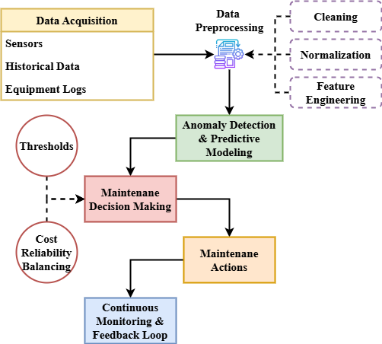
Figure 1: Workflow for Predictive Maintenance Strategy

Figure 1 offers a high-level summary of the suggested predictive maintenance process combining many phases into a single operating cycle. Starting with thorough data collecting from sensors, previous equipment performance records, and IoT-enabled devices, the process moves Data preparation—including noise reduction and feature engineering—after collecting guarantees that the prediction models only get useful information. Anomaly detection and predictive modeling techniques analyze the data to detect early signs of faults and estimate RUL. Based on these insights, decision-making modules create optimized maintenance schedules that prioritize both cost-efficiency and equipment reliability [19]. Proactive maintenance actions are executed accordingly. Once the repair is complete, the tracking system gathers new information and returns it to the model so that it continues to improve and become more precise [20]. This entire process enhances the capacity to predict maintenance requirements and builds a sustainable, intelligent maintenance environment that will help equipment last longer, operations become more reliable, and reduce energy sector expenditure by a significant amount.

Related Works
Related works in predictive maintenance and equipment optimization highlight the role of machine learning, data analytics, and anomaly detection in improving industrial efficiency. These studies explore methods for early failure detection, predictive modeling, and maintenance scheduling, emphasizing the benefits of proactive maintenance strategies for reducing downtime, costs, and enhancing reliability.
Deep Learning (DL)
Artificial intelligence (AI) is transforming the renewable energy sector by enhancing predictive maintenance and energy optimization. Artificial intelligence-based predictive maintenance identifies potential defects with sensor information and past performance, avoiding equipment breakdowns and extending infrastructure lifespan. This approach offers significantly enhanced reliability and cost reduction. AI responds to fluctuating environmental conditions in energy optimization through the application of real-time data and statistics, thus enhancing energy production and resource utilization. Neural networks and Deep Learning (DL) [21] are also being applied on various renewable power systems, such as hydro, solar, and wind, for efficiency and competitiveness relative to traditional sources of energy.
Reinforcement Learning Algorithms (RLA)
Because of its great benefits over corrective and preventive maintenance, predictive maintenance—a proactive approach—has become very popular. Conventional approaches of predictive maintenance, however, have limits in maximizing maintenance and raising dependability. Machine learning has corrected many of these flaws over the last two decades and provides improved prediction powers for maintenance optimization. This study reviews traditional predictive maintenance methods, contrasts corrective, preventive, and predictive maintenance, and points out their shortcomings. Reviewing supervised learning and Reinforcement Learning Algorithms (RLA) [22] in maintenance prediction, and stressing important stages in implementing machine learning for enhanced maintenance planning and equipment dependability, it also addresses the advantages of machine learning over conventional approaches.
Internet of Things (IoT)
Efficiency and sustainability of power generation systems are a function of gas and steam turbine performance. This work examines how the performance of the turbines can be optimized to ensure maximum performance using predictive maintenance and thermal optimization hence enhancing sustainability and economy. Application of data analytics, machine learning, Internet of Things (IoT) [23] technology, and predictive maintenance that allows for early faults and performance issues to be discovered, ensures cost savings on downtime and maintenance. Advanced combustion and cooling technologies alongside other thermal optimization techniques improve efficiency and minimize energy losses. These methods together assist in minimizing carbon emissions, extending lifetime, improving turbine performance, and conserving fuel consumption. Additionally discussed are challenges and their remedies.
Predictive Maintenance Model (PMM)
Maximizing industrial equipment is essential for minimizing maintenance expenses, reducing downtime, and increasing productivity. Predictive Maintenance Model (PMM) [24] that scales preventive maintenance by anticipating equipment failure, is implemented through the application of data analysis and machine learning. This research investigates the application of machine learning to predictive maintenance in the industrial sector, with a focus on data collection, preprocessing, and feature engineering. Examining anomaly detection for preventing early failures, model training methods, and machine learning algorithms, it addresses what needs to be addressed. The paper also discusses setting maintenance criteria to balance cost and reliability as well as residual usable life (RUL) estimation. Though highlighting challenges and future prospects, case studies in real-world applications indicate the effectiveness of PMM [25].

Proposed Method
The proposed method introduces a machine learning-based predictive maintenance framework using anomaly detection. It aims to optimize equipment reliability, minimize downtime, and reduce maintenance costs through real-time monitoring and proactive decision-making.

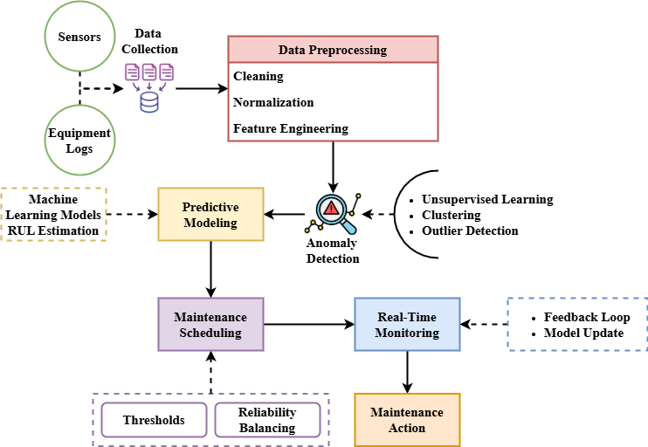
Figure 2: Predictive Maintenance Using Anomaly Detection and Machine Learning

The proposed data-driven predictive maintenance system is schematically illustrated in Figure 2. The initial step is to obtain real-time data from sensors and equipment history in such a way that operations can proceed as normal. Machine learning models are trained on high-quality data using data preparation processes such as cleaning, normalizing, and feature engineering. Unsupervised learning-based anomaly detection approaches are still able to identify when equipment is not performing as well as it ought, even if they don't possess failure data that has been labeled. Following that issues have been discovered, prediction models are able to determine the RUL of the equipment. These kinds of results lead to constant changes in upkeep strategies, which are meant to make interventions more effective in the face of impending disasters. With continuous monitoring and feedback systems, the model's performance is constantly optimized with time. The use of the closed-loop technology in its deployment allows the energy industry to opt for proactive, effective maintenance with a focus on equipment reliability. This enhances the efficiency of performance while reducing downtime.
$${3σ}_{2}Q^{2}=σ_{1}^{2}+\frac{ρ_{3}^{2}}{2\left(A,B\right)}* k_{1}^{2}k_{2}/+{\frac{1}{2J}}_{m+1}(1)$$
Variance in discovered equipment behavior is represented by $σ_{1}^{2}+\frac{ρ_{3}^{2}}{2\left(A,B\right)}$ terms; correlation of broad signals (${3σ}_{2}Q^{2}$) is denoted by $k_{1}^{2}k_{2}/$ corresponds to the prediction index${\frac{1}{2J}}_{m+1}$ patterns over time. This predictions helps measuring departures from typical behavior.

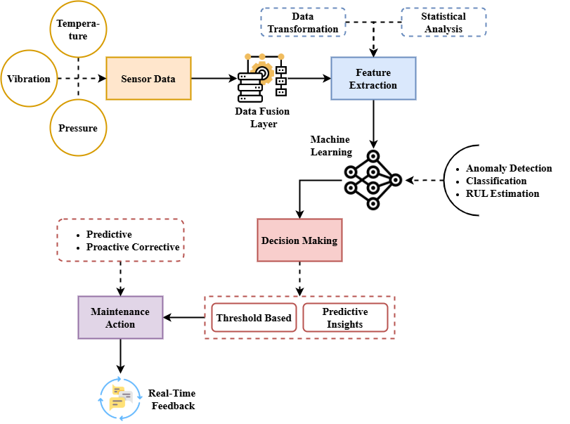
Figure 3: Machine Learning-Driven Closed-Loop System for Equipment Optimization

Figure 3 illustrates how machine learning techniques can be integrated with real-time sensor data in a closed-loop predictive maintenance system. Initially collected and aggregated into a full data stream are sensor data from multiple operating conditions such as temperature, pressure, and vibration. There exist various feature extraction techniques that have been employed for deriving meaningful information regarding the status of the machinery. These extracted features are computed using RUL forecasting models, anomaly detection, and other forms of machine learning algorithms to enable recommendations for maintenance. These projected values are utilized in converting the outcome into recommending maintenance or no maintenance by the decision-making algorithms. These predictions guide the planned proactive maintenance tasks. Moreover, the model is updated and recalibrated continuously by real-time feedback from equipment operation. This dynamic prediction-decision-action-learn cycle ensures the system to learn from dynamic conditions, thus providing highly scalable, smart maintenance techniques that enhance reliability, efficiency, and cost savings in industrial energy operations.
$$Q^{'}=2j+2i\sqrt{\frac{p_{1}\left(S\right)}{2}+ε}\tanh{+\operatorname{sech}\left(vq'\right) (2)}$$
While tanh along with$2j+2i$ sech functions describe transitory$\operatorname{sech}\left(vq'\right)$ anomalous behaviors via hyperbolic transformations$\frac{p_{1}\left(S\right)}{2}$, the equation $Q^{'}$ reflects the fluctuation$εtanh$ of the energy signal. This equation improves failure prediction precision in complicated sensor data.
The proposed approach successfully integrates anomaly detection with machine learning for predictive maintenance. It enables early fault detection, efficient maintenance planning, and continuous model improvement, ensuring enhanced operational efficiency and cost savings.

Result and Discussion
The Result and Discussion section presents a detailed evaluation of the proposed predictive maintenance framework. It highlights the system’s performance in anomaly detection and RUL prediction compared to existing methods. Key improvements in accuracy, cost savings, and downtime reduction are analyzed to validate the effectiveness and practical benefits achieved.

Analysis of Anomaly Detection
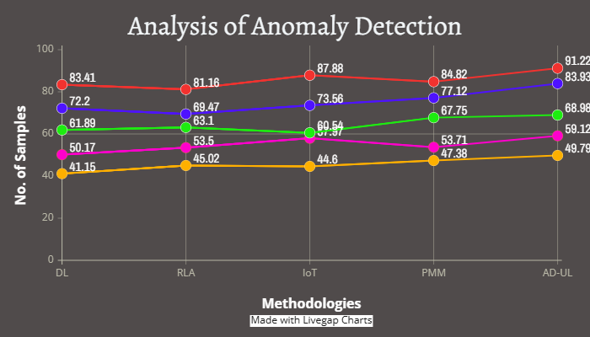
Figure 4: Analysis of Anomaly Detection

Figure 4 displays how effectively various approaches, such as DL, RLA, IoT solutions, PMM, and the proposed AD-UL approach, detect anomalies in industrial equipment data. The graph indicates that AD-UL detects anomalies better and is more stable compared to other approaches. It receives the highest number of correct anomaly detections (91.22 and 83.93 samples). Conventional approaches such as DL and RLA exhibit good performance but are slightly below in reliability and consistency. They fall short of the adaptability of unsupervised learning in variable environments although IoT and PMM-based systems exhibit some success. Combining real-time data monitoring with unsupervised learning shows great efficacy in the continual improvement in sample detection from DL through to AD-UL. The entire outcome verifies that AD-UL significantly enhances the detection of early problems, hence ensuring reduced downtime and enhanced system reliability.
$$β_{1}\left(δ,x,y,u\right){=∆β}_{2}+\left(δ,x,y,u\right)*a_{0},b_{0} (3)$$
Whereas the ($β_{1}\left(δ,x,y,u\right)$) tuple depicts sensor input fluctuations$\left(δ,x,y,u\right)$ modified by coefficients a₀ and b₀, the equation ${∆β}_{2}$ captures baseline drift$a_{0},b_{0}$. This approach to change in response to changes anomaly identification under analysis of anomaly detection.

Analysis of RUL Prediction
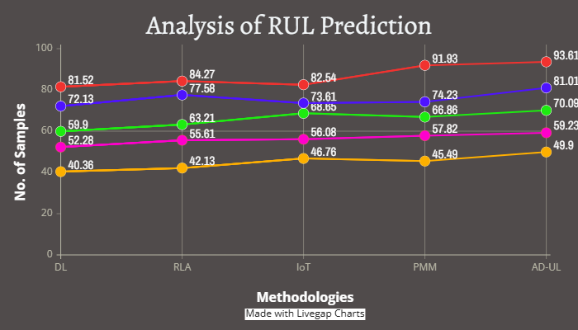
Figure 5: Analysis of RUL Prediction

The comparison of RUL prediction among various predictive maintenance methods is demonstrated in Figure 5 based on various predictive maintenance methods. DL, RLA, IoT-based models, PMM, and proposed AD-UL are tested here. The results indicate 93.61 and 81.01 correct samples with the outcome that AD-UL outperforms other methods in the accuracy of RUL prediction. While with lower precision than AD-UL, conventional methods like DL and RLA exhibit excellent performance. Although useful, IoT and PMM-based systems are relatively poor performers that suggests that while less effective in managing various operating conditions. The seeming performance gap underscores how well unsupervised learning detects intricate patterns without large amounts of labeled data. Better maintenance planning, resource allocation, and avoidance of surprise equipment failures depend on this better RUL estimation. For predictive maintenance applications, AD-UL therefore seems a more robust and scalable solution.
$$Ga'=\frac{dp}{ds}+W\left(\frac{dw}{ds}\right)*\frac{iσ_{2}}{σ_{1}}*4∅±\operatorname{csch}{ (4)}$$
While the complex ratio ($Ga'$) catches signal volatility$\frac{dp}{ds}$, the equation's $W\left(\frac{dw}{ds}\right)$ and $\frac{iσ_{2}}{σ_{1}}$ terms describe pressure $4∅$and waveform changes and csch (hyperbolic cosecant) stresses$csch,$ infrequent, severe deviations. This improves nonlinear data thus allowing analysis of rul prediction.
$$Fa'=\frac{q_{2}^{2}}{16y_{0}^{2}q_{3}}*{2e}^{-ij}+φ_{1}^{2}*\left(\frac{w_{2}}{w_{1}}\right)*\frac{∂x}{∂t} (5)$$
Whereas ratios along$\frac{∂x}{∂t}$ with temporal shifts$\frac{q_{2}^{2}}{16y_{0}^{2}q_{3}}$ on anomaly development${2e}^{-ij}$, the third term describes attenuated$φ_{1}^{2}*\left(\frac{w_{2}}{w_{1}}\right)$ energy of signals with phase shift ($Fa'$). This increases early anomaly detection in predictive maintenance fluctuations in equipment data.

Conclusion
This research presents a robust machine learning-powered predictive maintenance system with a focus on improving equipment reliability, reducing downtime, and minimizing operating expenses in the energy sector. The proposed method effectively addresses limitations in traditional predictive maintenance techniques by incorporating anomaly detection through unsupervised learning (AD-UL). The system offers significant advantages compared to existing methods through real-time monitoring, failure detection at the early stage, and accurate Remaining Useful Life (RUL) predictions. Result and discussion present experimental results validating that, of Deep Learning, Reinforcement Learning Approaches, IoT-based models, and Predictive Maintenance Models, the AD-UL method offers improved detection precision and more accurate RUL prediction. This will make sure that the system is more reliable, that resources are used in the best way possible, and that upkeep is planned ahead of time. The reason for using the suggested method in industrial settings is strengthened by the fact that it reduces downtime and upkeep costs. Aside from increasing energy system efficiency, the suggested solution helps to satisfy environmental goals by lowering emissions and extending equipment life. It takes success in predictive maintenance techniques to merge autonomous learning with anomaly detection, as the positive results show. This study presents a scalable and adaptable green maintenance management approach to numerous various industries.
More research will help us to make the AD-UL system more scalable and intelligible. Combining reinforced learning with supervised and unsupervised learning in blended models can help to improve the flexibility and accuracy even further. If explainable artificial intelligence (XAI) technologies help to make model judgments clearer, automated repair systems might acquire greater trust. It is tested extensively on aircraft, in factories, and in smart infrastructures to ensure it operates in every sector.

References
- S. Bello, I. Wada, O. Ige, E. Chianumba, and S. Adebayo, “AI-driven predictive maintenance and optimization of renewable energy systems for enhanced operational efficiency and longevity,” In International Journal of Science and Research Archive, vol. 13, no. 1, 2024.
- K. Kalaiselvi, K. Niranjana, V. Prithivirajan, K. S. Kumar, and V. Syambabu, “Machine Learning for Predictive Maintenance in Industrial Equipment: Challenges and Application,” In 2024 4th Asian Conference on Innovation in Technology (ASIANCON), pp. 1–6, IEEE, 2024.
- J. Muralidharan, “Machine learning techniques for anomaly detection in smart IoT sensor networks,” Journal of Wireless Sensor Networks and IoT, vol. 1, no. 1, pp. 15–22, 2024. https://doi.org/10.31838/WSNIOT/01.01.03
- G. Arunkumar, “AI-based predictive maintenance strategies for electrical equipment and power networks,” Journal ID, vol. 1727, p. 7536, 2024.
- T. P. Carvalho, F. A. Soares, R. Vita, R. D. P. Francisco, J. P. Basto, and S. G. Alcalá, “A systematic literature review of machine learning methods applied to predictive maintenance,” In Computers & Industrial Engineering, vol. 137, p. 106024, 2019.
- Z. M. Çınar, A. Abdussalam Nuhu, Q. Zeeshan, O. Korhan, M. Asmael, and B. Safaei, “Machine learning in predictive maintenance towards sustainable smart manufacturing in industry 4.0,” In Sustainability, vol. 12, no. 19, p. 8211, 2020.
- M. Molęda, B. Małysiak-Mrozek, W. Ding, V. Sunderam, and D. Mrozek, “From corrective to predictive maintenance—A review of maintenance approaches for the power industry,” In Sensors, vol. 23, no. 13, p. 5970, 2023.
- M. Patel, and E. Reynolds, “Machine Learning Techniques for Predictive Maintenance in Renewable Energy Systems,” In International Journal of Electrical, Electronics and Computer Systems, vol. 13, no. 1, pp. 17–25, 2024.
- M. Yazdi, “Maintenance strategies and optimization techniques,” In Advances in Computational Mathematics for Industrial System Reliability and Maintainability, pp. 43–58, Cham: Springer Nature Switzerland, 2024.
- D. Eswararaj, L. R. Koppada, and R. S. Bodala, “Quantifying the Influence of Artificial Intelligence and Machine Learning in Predictive Maintenance for Vehicle Fleets and Its Impact on Reliability and Cost Savings,” 2025.
- N. Pillai, and I. Panigrahi, “Global Health Security and SDG 3: Strengthening Pandemic Preparedness through South-South Cooperation,” In International Journal of SDG’s Prospects and Breakthroughs, vol. 2, no. 2, pp. 10–13, 2024.
- A. Sayal, N. C., J. Jha, and N. Allagari, “AI-Based Predictive Maintenance Strategies for Improving the Reliability of Green Power Systems,” In Digital Technologies to Implement the UN Sustainable Development Goals, pp. 19–46, Cham: Springer Nature Switzerland, 2024.
- T. M. Sathish Kumar, “Developing FPGA-based accelerators for deep learning in reconfigurable computing systems,” SCCTS Transactions on Reconfigurable Computing, vol. 1, no. 1, pp. 1–5, 2024. https://doi.org/10.31838/RCC/01.01.01.
- J. Muralidharan, “Innovative RF design for high-efficiency wireless power amplifiers,” National Journal of RF Engineering and Wireless Communication, vol. 1, no. 1, pp. 1–9, 2023. https://doi.org/10.31838/RFMW/01.01.01.
- E. M. Barhoumi, Y. Charabi, and S. Farhani, “Detailed guide to machine learning techniques in signal processing,” In Progress in Electronics and Communication Engineering, vol. 2, no. 1, pp. 39–47, 2024. https://doi.org/10.31838/PECE/02.01.04.
- K. Suganthi, and R. Raja, “Optimal Relay Node Placement Algorithm for Energy Balancing in Green Cellular Network,” In International Journal of Advances in Engineering and Emerging Technology, vol. 9, no. 3, pp. 31–43, 2018.
- A. Udhayakumar, K. C. Ramya, P. Vijayakumar, S. Sheeba Rani, A. Balamanikandan, and K. Saranya, “Reversible Vedic Direct Flag Divider in Key Generation of RSA Cryptography,” In Journal of VLSI Circuits and Systems, vol. 6, no. 2, pp. 75–83, 2024. https://doi.org/10.31838/jvcs/06.02.08.
- J. Mayilsamy, and D. P. Rangasamy, “Enhancement of Energy Efficient Routing Scheduling Algorithm based on SDN Using IoT,” In International Academic Journal of Science and Engineering, vol. 8, no. 1, pp. 10–18, 2021. https://doi.org/10.9756/IAJSE/V8I1/IAJSE0802.
- A. Ghosh, and V. Chatterjee, “Electrocoagulation-Assisted Filtration for the Removal of Emerging Pollutants in Wastewater,” In Engineering Perspectives in Filtration and Separation, vol. 1, no. 1, pp. 5–8, 2023.
- A. Farooqi, and S. Sharma, “Marriage Patterns and Household Formation: Insights from Historical Demography,” In Progression Journal of Human Demography and Anthropology, vol. 2, no. 2, pp. 17–21, 2024.
- S. Onwusinkwue, F. Osasona, I. A. I. Ahmad, A. C. Anyanwu, S. O. Dawodu, O. C. Obi, and A. Hamdan, “Artificial intelligence (AI) in renewable energy: A review of predictive maintenance and energy optimization,” In World Journal of Advanced Research and Reviews, vol. 21, no. 1, pp. 2487–2499, 2024.
- Y. Ren, “Optimizing predictive maintenance with machine learning for reliability improvement,” In ASCE-ASME Journal of Risk and Uncertainty in Engineering Systems, Part B: Mechanical Engineering, vol. 7, no. 3, p. 030801, 2021.
- J. Avevor, A. Aikins, and L. Enyejo, “Optimizing Gas and Steam Turbine Performance Through Predictive Maintenance and Thermal Optimization for Sustainable and Cost-Effective Power Generation,” In International Journal of Innovative Science and Research Technology, vol. 10, no. 3, pp. 994–1010, 2025.
- L. K. Narayanan, S. Loganayagi, R. Hemavathi, D. Jayalakshmi, and V. R. Vimal, “Machine Learning-Based Predictive Maintenance for Industrial Equipment Optimization,” In 2024 International Conference on Trends in Quantum Computing and Emerging Business Technologies, pp. 1–5, IEEE, 2024.
- E. Omol, L. Mburu, and D. Onyango, “Anomaly detection in IoT sensor data using machine learning techniques for predictive maintenance in smart grids,” In International Journal of Science, Technology & Management, vol. 5, no. 1, pp. 201–210, 2024.

