Exploring the Impact of Artificial Intelligence on Strategic Decision-Making

Dr. Amit Kumar Bhanja,
Assistant Professor (Senior Grade), Department of Management, School of Management Sciences, Varanasi, India. akbhanja10@gmail.com, https://orcid.org/0000-0001-8908-0374
Vikash Kumar Singh,
Principal Software Engineer, Department of IT, Societe Generale, India. vikashsd@gmail.com
Durga Sivashankar,
Technical Lead, Department of IT, Siemens Healthineers, India. durga.sivashankar@yahoo.com
Dr. Sonal Pundhir,
Assistant Professor, Department of Business Studies, Sharda University, Agra, India. sonalaec@gmail.com

Tanu Marwah,
Assistant Professor, Department of Business Studies, Hindustan college of Science and Technology, Mathura, India. tanumarwah@gmail.com
A. Jagdish Mohan Rao,
Assistant Professor, Commerce, KL (Deemed to be University) Vadeswaram Guntur, India. ajmohanrao@kluniversity.in

Abstract--- AI technologies are helping businesses shift from an information-centered model towards one which relies on deep insights and timely analysis. Such technologies help modern leaders in market monitoring, process control, and competition provisioning. However, decision-making approaches heavily reliant on experience often inadequately capture the predicted phenomena within the time resources available, thus delaying response measures prone to high prediction inefficiency. This paper presents a framework entitled AI-Driven Market Trend Forecasting for Executive Strategy with Predictive Analytics and Machine Learning (PA-ML) aimed at resolving these issues. Integrating real-time data examination, prediction, and insight automation under the PA-ML framework equips organizational leaders with preemptive strategy formulation and rapid decision-making tools. PA-ML allows businesses to adopt new emerging trends, reduce associated risks, and comply faster with changing market realities. The findings suggest that the novel PA-ML framework provides substantial value for optimizing organizational agility while improving dynamically evolving environment adaptability, accelerating strategic planning, and enhancing decision-making efficiency.
Keywords--- Artificial Intelligence, Strategic Decision Making, Predictive Analytics, Machine Learning, Market Trend Forecasting.

Introduction
With the capability of recognizing patterns and providing insights that would otherwise be missed with conventional techniques, AI is changing the world of strategic decision-making by allowing businesses to analyze vast amounts of data [1] [2]. AI-powered tools allow leaders to make decisions swiftly, increasing reliance on data rather than intuition and experience [3] [4]. Strategic decisions in today's world are made with expert precision, splitting nanoseconds due to the increasing dynamism and competition of global markets [5]. Machine Learning (ML) techniques are emerging as fundamental building blocks for predictive capability, assisting businesses in anticipating trends as well as optimizing asset utilization [6]. Even today, some decision models that are mainly based on passive data processing and posteriori judgment, are too slow to keep pace with the rapidly changing market dynamics [7]. This research aims to resolve such problems with the intention to overcome such boundaries with AI-Driven Market Trend Forecasting for Executive Strategy in PA-ML [8]. Utilizing novel ML techniques, this model not only predicts shifts in the market and analyzes growing trends, but also offers real-time strategic recommendations [9].
In addition to improving forecast accuracy, the new approach allows managers to implement appropriate strategies tailored to changing business contexts [10]. The research effort showcased in this study explains, through rigorous evaluation and testing, how the integration of PA-ML into the strategic decision making process helps to gain agility, market competitiveness, and sustainable growth in an economy that relies on data [11].
Conventional strategic decision-making methods are failing to adapt to the rapidly evolving corporate environment characterized by constantly changing market trends and technological changes. Companies must implement systems that provide timely and precise data-driven recommendations to maintain competitiveness [12]. This program seeks to establish a proactive and intelligent decision-making system that employs ML and AI. CEOs can create proactive and reactive growth strategies by identifying trends and gaining knowledge of what's going to occur in the future[13].Such systems for creating strategic decisions may not be effective because they take too long to react, are unable to foresee the future, and rely too heavily on human opinion and past data. The exposure of firms is increased as a result of these deficiencies that also result in missed opportunities, particularly in markets that are unstable [14]. Traditional methods are not only inappropriate but also inflexible that renders them unsuccessful when applied to complex business processes and rapid market fluctuations [15]. It is vital to have an effective AI approach that blends predictive analytics with real-time data analysis to facilitate the development of strategic decisions that are prompt, proactive, and highly accurate [16].

Related Works
Recent studies have explored the integration of AI and ML into strategic decision-making processes [17]. Researchers have focused on enhancing predictive accuracy, trend analysis, and decision support systems. However, gaps remain in achieving real-time forecasting and fully aligning AI-driven insights with executive-level strategic planning needs [18].
Decision Support Systems (DSS)
Emphasizing the formulation job, cognitive studies of planners, and computer-based support systems, and an overview highlights important research questions concerning strategic planning and AI [19]. Reviewing current studies, the author makes the case that modeling the ill-structured early phases of strategic decision-making—especially strategic intelligence analysis and problem diagnosis—will determine future advancement, much as in conventional Decision Support Systems (DSS) [20]. We offer a model-based method of investigating these early phases. More efficient models for strategic decision-making may be developed by means of research in AI domains like diagnosis, scenario assessment, analogical reasoning, plan recognition, nonmonotonic reasoning, and distributed intelligence.
SHapley Additive exPlanations (SHAP)
Hospital management has significantly enhanced patient care, operational effectiveness, and emergency response through AI. This research analyzes the impact of AI on major events such as the COVID-19 pandemic between 2019 and 2023 based on prediction models and extensive research. The paper explores the influence of AI in various areas, such as operations, strategy, and crises, and how this influence changes over time and space. The study examines the advantages of AI in quality management, resource allocation, innovation, and pandemic control while discussing the issues of data privacy and ethics. It applies predictive models such as logistic regression and SHapley Additive exPlanations (SHAP) [21] analysis to derive five broad themes.
Partial Least Squares (PLS)
AI is increasingly impacting so-called personalized content marketing as more individuals are connecting online and decision-making based on data is becoming increasingly crucial. The aim of this paper is to examine the role that AI has played in altering marketing practices through a small random sample of 485 individuals via Partial Least Squares (PLS) [22] analysis. Firms adopting AI perform more effectively in personalizing content, enhancing engagement and customer satisfaction, according to findings. The article highlights the necessity of obtaining solid AI skill as they ensure predictive analysis and better data analysis. In addition, enhancing marketing campaigns and establishing closer, more personalized relationships with customers rely on including AI channels carefully.
Human-Robot Cooperation (HRC)
There needs to be AI in order to have enhanced Human-Robot Cooperation (HRC) [23] of Industry 4.0. ML and deep learning are applied in the AI domain to improve human-robot collaboration in smart industrial environments. By gathering and analyzing data from multiple sensors and equipment, these technologies optimize manufacturing. The traditional methods of production at times lead to inferior quality and efficiency [24]. This is due to the poor coordination and communication that take place during the production process. AI-led accelerated learning encourages greater collaboration in assembly work, operating in a way similar to human touch. With algorithms that are AI-based, the result is the development of a dynamic and productive industrial setup that widely boosts cooperation as well as productivity [25] [26].

Proposed Method
The proposed method utilizes Predictive Analytics and Machine Learning (PA-ML) to forecast market trends, optimize executive strategies, and enhance decision-making through real-time insights, trend analysis, and continuous learning mechanisms.

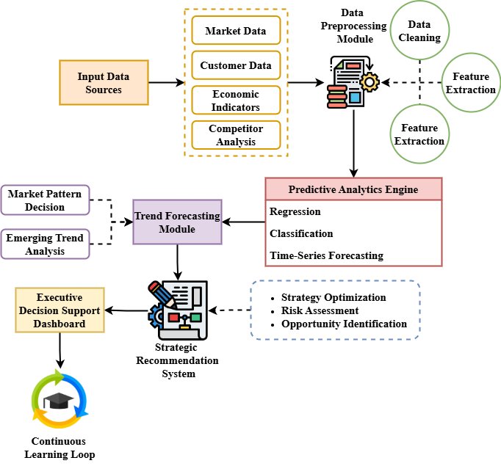
Figure 1: Framework of AI-Driven Market Trend Forecasting for Executive Strategy

The suggested AI-Driven Market Trend Forecasting for Executive Strategy with PA-ML is shown in Figure 1 that provides an overview of the complete architecture. The first step is to gather data from a variety of sources, such as statistics on the market, customer habits, the economy, the competition, etc. Data preparation techniques which provide quality input include cleaning, normalization, and feature extraction. Predictive Analytics Engine processes data and performs regression, classification, and time-series forecasts through ML models. The Trend Forecasting Module employs these forecasting data in forecasting market trends. These notifications are used by the Strategic Recommendation System to quantize risks, maximize strategies, and find new opportunities. The Executive Decision Support Dashboard provides company executives with real-time information and strategic reports. A Continuous Learning Loop ensures that feedback from strategic outcomes is fed in to improve the models owing to its accuracy and adaptability over time.
$$k=∅\frac{A}{∅x}+\frac{∂k^{''}M}{2}+A|∀|^{2}B+\left(1-Mq_{0}\right) (1)$$
Key factors including $k$ affect the prediction$∅\frac{A}{∅x}$ accuracy of the dynamic model$\frac{∂k^{''}M}{2}$ to feed market trend forecasting$A|∀|^{2}B$ that the equation 1 reflects$\left(1-Mq_{0}\right)$. To maximize strategic decision-making alongside market development research, knowledge and predictive elements.

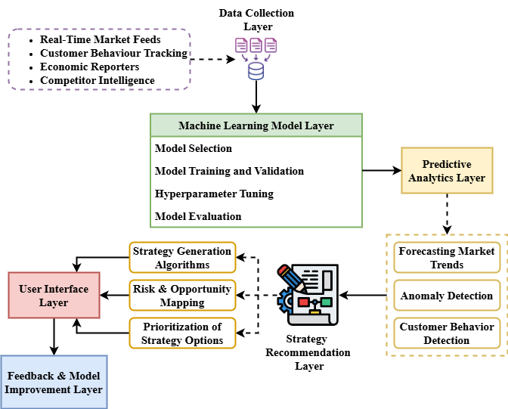
Figure 2: Internal Architecture of PA-ML Framework for Strategic Decision-Making

Figure 2 shows the internal architecture of the PA-ML framework emphasizing the modular design supporting real-time, data-driven strategic decision-making. Starting with the Data Collection Layer, which collects competitor, consumer, market, and financial data, To ready for modeling, the Data Processing Layer engineers, cleans, and transforms features. The ML Modeling Layer chooses the best algorithms, such as Random Forest, XGBoost, or LSTM, after the model is trained, its hyperparameters are adjusted, and its performance is evaluated. The Predictive Analytics Layer builds models of human behavior, finds outliers, and produces patterns connected to forecasts. Strategic suggestions are made in the Strategy Recommendation Layer. They show risks and opportunities in a graph. Using dashboards and reports, then the User Interface Layer presents those actionable findings to the customer. Finally, the Feedback and Model Improvement Layer ensures continuous system development by capturing decision outcomes and re-trains models. More informed and timely strategic decisions are a consequence of this modular approach enhancing flexibility, accuracy, and the ability of the system to adapt with the times for corporate environments.
$$\frac{k_{m}}{2}=p_{10}*\frac{1}{d^{2 }\left(z\right)}\frac{\sin\left[L_{a}-L_{m}\right]}{2xx^{'}}-f^{-j\left(k+\frac{l}{2}\right)x} (2)$$
Including variables$p_{10}$ like separate and phase changes$\frac{k_{m}}{2}$, the equation depicts complicated interactions$f^{-j\left(k+\frac{l}{2}\right)x}$ between many elements$\frac{1}{d^{2 }\left(z\right)}$ influencing market trend dynamics$\frac{\sin\left[L_{a}-L_{m}\right]}{2xx^{'}}$. This equation enables the increasing prediction accuracy for real-time forecasting.
By merging forecasting, ML models, dynamic recommendations, and other data strategies, PA-ML enhances strategic decision planning. With this change, there is improvement in adaptability, risk management, and competition in fast-changing market conditions..

Result and Discussion
This section presents all the outcomes that emerged out of implementing the PA-ML framework. The model's predictive performance diagnostics are taken into account as well as strategic recommendation effectiveness and traditional methods discuss their improvements. Main findings focus on the framework's impact on precision, adaptability, responsiveness, and change in the decision-making process in the rapidly changing market environment.
Table 1: Analysis of Strengths and Limitations of Existing and Proposed Methods
Method | Advantages | Disadvantages
DSS | Simple to implement; suitable for structured decision problems | Limited adaptability; poor performance with large, unstructured data
SHAP | Good interpretability; useful for explaining model outputs | Computationally intensive; less accurate for complex trend forecasting
PLS | Effective with small datasets; strong for linear relationships | Struggles with nonlinear patterns; limited predictive power for dynamic markets
HRC | Improved collaboration models; good for semi-structured environments | Lower prediction accuracy compared to ML-based methods
PA-ML (Proposed) | High predictive accuracy; scalable; adaptive to dynamic market changes | Requires significant computational resources; needs continuous retraining
This table provides both strengths and weaknesses when contrasting the proposed PA-ML and systems SHAP, PLS, HRC, and DSS. While being user-friendly, conventional methods such as DSS do not possess the flexibility to adapt to novel circumstances. SHAP, even with its enormous scale and intricate analyses, is more intuitive than most. PLS, while adept with a limited dataset, does not capture non-linear and intricate patterns of market behavior. HRC, while supporting semi-structured decision making, functions well in human-robot interaction and proves to be reliable; however, like other AI-based models, exhibits reduced compared to other AI frameworks. When it comes to development, prediction accuracy, and dynamics of coping with evolving conditions in the marketplace, the proposed PA-ML architecture possesses significant advantages. There is a great deal of computer power needed and the model needs to be retrained constantly. This comparison study guarantees an unbiased evaluation of the advantages and disadvantages of PA-ML. This promotes further study and highlights its obvious advantages in strategic decision-making to achieve this.

Analysis of Predictive Energy

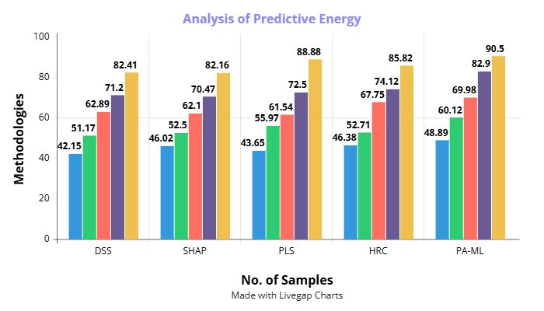
Figure 3: Analysis of Predictive Energy

Five methods—DSS, SHAP, PLS, HRC, and the novel PA-ML approach—are compared in figure 3. Across different sample sizes, the PA-ML approach generally returns better prediction energy values compared to other models. For smaller sample sizes, PA-ML performs better at prediction; its superiority is progressively evident with growing sample sizes. With more data, other techniques like DSS and SHAP show moderate improvement in performance; however, they lag behind to achieve the forecasted consistency and power realized by PA-ML. Even though HRC performs similarly at moderate sample sizes, with larger sizes PA-ML eventually surpasses it. This consistent improvement in performance highlights how well PA-ML creates significant trends and patterns from data, thus providing more accurate forecasts. The findings indicate that the use of predictive analytics and ML has a very significant increase in predictive energy, making PA-ML a quite beneficial strategic tool.
$${jk=q}_{b}^{2}β_{b}^{2}B_{m}*\frac{4vs^{'}}{s}+q_{h}-{\frac{q}{s}}_{0 }+b\left(2vv^{'}+v^{2}\right) (3)$$
Including variables, the equation 3, ${jk=q}_{b}^{2}$ depicts$b\left(2vv^{'}+v^{2}\right)$ complicated interactions$β_{b}^{2}B_{m}$ between many elements influencing market $\frac{4vs^{'}}{s}+q_{h}$trend dynamics${\frac{q}{s}}_{0 }+b$. This equation enables the increasing prediction accuracy for real-time forecasting.

Analysis of Strategic Decision Impact
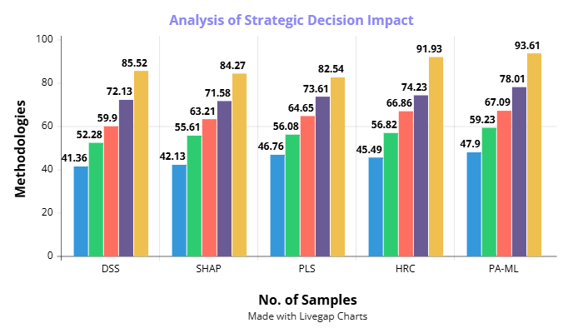
Figure 4: Analysis of Strategic Decision Impact

Figure 4 assesses how different models influence strategic outcomes across increasing sample sizes. The PA-ML framework clearly outperforms other methods such as DSS, SHAP, PLS, and HRC at every data scale. Even with smaller datasets, PA-ML shows a noticeable improvement in decision impact compared to traditional techniques. The performance drawback of PA-ML compared to alternative methods increases with increasing sample sizes, especially as the amount of data increases, leading to much more oscillations in PA-ML's strategic performance. While HRC performs better at times, it fails to provide consistent results and the ultimate peak effectiveness achieved by PA-ML, and it fails to achieve optimum gains until after PA-ML. Prolonged development of DSS and SHAP diminishes their use in critical, dynamic strategic contexts. These findings underscore the PA-ML framework's superiority in executive strategy formulation, as they demonstrate that the predictive insights and strategic recommendations it produces lead to significant enhancements in decision-making efficacy, risk reduction, and opportunity identification.
$$V_{0}=\left(\frac{4π}{3}\right)+R_{0}^{3}+3n+3τp_{0}+\frac{p_{0}}{s_{0}^{2}}*{ρβ}_{0}V+ϑ_{0}^{2}U (4)$$
The equation 4, $V_{0}$ describes in decision-making$\left(\frac{4π}{3}\right)+R_{0}^{3}$ the interaction of many elements including velocity$3n+3τp_{0}$, market circumstances$\frac{p_{0}}{s_{0}^{2}}*{ρβ}_{0}V$, and variable scaling$ϑ_{0}^{2}U$. On incorporating complex system practices and real-time factors to raise the accuracy strategic judgments, this equation corresponds with analysis of strategic decision impact.
$${(Y}^{2}+W^{2})=q_{1}Mw_{2}u^{m}-np1-\frac{np2}{D_{0}^{2}}+μρ_{1}τθ (5)$$
The equation 5, ${(Y}^{2}+W^{2})$ represents the link among many system characteristics$q_{1}Mw_{2}u^{m}$, including mass$\frac{np2}{D_{0}^{2}}$, speed$np1$, and environmental conditions$μρ_{1}τθ .$ This equation combines elements influencing strategic forecasting precision of decision-making.

Conclusion
This study built AI-Driven Market Trend Forecasting, a system for strategic executive decision-making using PA-ML techniques. The recommended technique greatly raised both strategic effect and forecasting accuracy as compared to more conventional approaches such DSS, SHAP, PLS, and HRC. Through integration of real-time data processing, strong ML modeling, and dynamic strategic recommendation systems, the PA-ML architecture significantly improved the market response, risk management, and opportunity discovery capacity of executives. Irrespective of the size of the sample, the anticipated energy and influence of strategic decision tests revealed that PA-ML consistently outperformed all others with comprehensive and meaningful results. The system can increasingly adapt to evolving market scenarios with its high performance rate through its continuous learning capability. This book discusses the revolutionary potential of AI and predictive analytics in revolutionizing strategic decision-making processes. Given PA-ML's faster, more accurate, and data-intensive decision-making backing ongoing executive strategy, it is an intelligent move. The research evidence emphasizes the relevance of integrating ML features within corporate strategic planning processes for superior, faster, and more precise decision-making.
Future study will aim at further developing the PA-ML framework through the application of reinforcement learning methods so as to advance its adaptability in relatively dynamic market environments. In addition, real-time sentiment analysis from social media sites allows the algorithm to identify early market trends. Significant areas of research are large-scale deployment of the system in many industries and proving its scalability and resilience in various corporate environments. Additionally under research will be hybrid AI models that integrate probabilistic reasoning with deep learning to improve strategic decision-making.

References
- M. Rajakrishnan, “Exploring the impact of artificial intelligence in business decision making,” Journal of Data Acquisition and Processing, vol. 38, no. 3, pp. 686, 2023.
- S. Aswathy, “Bibliometric Analysis of Sustainability in Business Management Policies Using Artificial Intelligence,” Global Perspectives in Management, vol. 2, no. 1, pp. 44–54, 2024.
- D. R. Alqurashi, M. Alkhaffaf, M. K. Daoud, J. A. Al-Gasawneh, and M. Alghizzawi, “Exploring the impact of artificial intelligence in personalized content marketing: a contemporary digital marketing,” Migration Letters, vol. 20, no. S8, pp. 548–560, 2023.
- A. Shetty, and K. Nair, “Artificial Intelligence Driven Energy Platforms in Mechanical Engineering,” Association Journal of Interdisciplinary Technics in Engineering Mechanics, vol. 2, no. 1, pp. 23–30, 2024.
- M. A. Khair, R. Mahadasa, F. A. Tuli, and J. R. P. K. Ande, “Beyond human judgment: Exploring the impact of artificial intelligence on HR decision-making efficiency and fairness,” Global Disclosure of Economics and Business, vol. 9, no. 2, pp. 163–176, 2020.
- L. Yesufu, and S. Alajlani, “Enhancing Strategic Decision-Making With AI: Unveiling the Untapped Potential,” In Economic and Political Consequences of AI: Managing Creative Destruction, IGI Global Scientific Publishing, pp. 415–436, 2025.
- T. Lawrence, “Impacts of artificial intelligence on organizational decision making,” Journal of Behavioral Decision Making, vol. 4, no. 3, pp. 195–214, 1991.
- S. Neiroukh, H. Y. Aljuhmani, and S. Alnajdawi, “In the era of emerging technologies: discovering the impact of artificial intelligence capabilities on timely decision-making and business performance,” in 2024 ASU International Conference in Emerging Technologies for Sustainability and Intelligent Systems (ICETSIS), Jan. 2024, pp. 1–6.
- H. Jaiswal, and S. Pradhan, “The Economic Significance of Ecosystem Services in Urban Areas for Developing Nations,” Aquatic Ecosystems and Environmental Frontiers, vol. 1, no. 1, pp. 1–5, 2023.
- I. Hussain, and A. Qureshi, “Gender-Inclusive Energy Transitions: Empowering Women in Renewable Energy Sectors,” International Journal of SDG’s Prospects and Breakthroughs, vol. 2, no. 2, pp. 7–9, 2024.
- A. Trunk, H. Birkel, and E. Hartmann, “On the current state of combining human and artificial intelligence for strategic organizational decision making,” Business Research, vol. 13, no. 3, pp. 875–919, 2020.
- R. Elouidani, and A. Elouidani, “Exploring the Role of Artificial Intelligence in Sustainable Decision-Making: A Systematic Literature Review,” African Journal of Management, Engineering and Technology, vol. 1, no. 2, pp. J-Manag, 2023.
- R. Balaji, V. Logesh, P. Thinakaran, and S. R. Menaka, “E-Learning Platform,” International Academic Journal of Innovative Research, vol. 9, no. 2, pp. 11–17, 2022. https://doi.org/10.9756/IAJIR/V9I2/IAJIR0911
- M. M. Islam, “Exploring the Impact of Artificial Intelligence in Healthcare,” Journal of Artificial Intelligence General Science (JAIGS), vol. 2, no. 1, pp. 228–238, 2024.
- M. Ziwei, L. L. Han, and Z. L. Hua, “Herbal Blends: Uncovering Their Therapeutic Potential for Modern Medicine,” Clinical Journal for Medicine, Health and Pharmacy, vol. 1, no. 1, pp. 32–47, 2023.
- P. Selvam, and N. Stalin, “Power Transfer Efficiency Analysis of Double Intermediate-Resonator for Wireless Power Transfer,” International Journal of Advances in Engineering and Emerging Technology, vol. 9, no. 3, pp. 130–141, 2018.
- V. Mehta, and P. Reddy, “Effective Pedagogical Strategies for Oncology Medical Students on Healthy Lifestyles,” Global Journal of Medical Terminology Research and Informatics, vol. 1, no. 1, pp. 9–15, 2024.
- W. L. Chen, and S. Ramirez, “Solar-Driven Membrane Distillation for Decentralized Water Purification,” Engineering Perspectives in Filtration and Separation, vol. 1, no. 1, pp. 16–19, 2023.
- M. N. Hassooni, “The Impact of Quantum Computing on Artificial Intelligence: An Overview,” International Academic Journal of Science and Engineering, vol. 11, no. 1, pp. 221–228, 2024. https://doi.org/10.9756/IAJSE/V11I1/IAJSE1125
- E. Hawthorne, and I. Fontaine, “An Analysis of the Relationship Between Education and Occupational Attainment,” Progression Journal of Human Demography and Anthropology, vol. 2, no. 4, pp. 22–27, 2024.
- V. Santamato, C. Tricase, N. Faccilongo, M. Iacoviello, and A. Marengo, “Exploring the impact of artificial intelligence on healthcare management: a combined systematic review and machine-learning approach,” Applied Sciences, vol. 14, no. 22, pp. 10144, 2024.
- W. E. Spangler, “The role of artificial intelligence in understanding the strategic decision-making process,” IEEE Transactions on Knowledge and Data Engineering, vol. 3, no. 2, pp. 149–159, 1991.
- H. Asaad, S. Askar, A. Kakamin, and N. Faiq, “Exploring the impact of artificial intelligence on human-robot cooperation in the context of Industry 4.0,” Applied Computer Science, vol. 20, no. 2, pp. 138–156, 2024.
- K. N. Johnson, and C. L. Reyes, “Exploring the implications of artificial intelligence,” Journal of International & Comparative Law, vol. 8, pp. 315, 2021.
- J. Roongta, and J. Roongta, “The Next Frontier: Exploring AI-Driven Business Strategic Decision Making,” Journal of Academic Advancement, vol. 3, no. 01, pp. 50–60, 2024.
- H. S. Putra, J. Badri, and H. Irfani, “Exploring Business Potential Through the Application of Artificial Intelligence: Impact Analysis on Operational Efficiency, Decision Making, and Customer Experience,” Escalate: Economics and Business Journal, vol. 1, no. 02, pp. 72–81, 2023

