Leveraging Blockchain for Enhanced Security and Transparency in Record Keeping

B. Ashwini,
Assistant Professor, Department of Electronics and Communication Engineering, Presidency University, Bangalore, Karnataka, India. ashwini.b@presidencyuniversity.in
Dr. Arun Khatri,
Professor, Mittal School of Business, Lovely Professional University, India. khatriarun@yahoo.com, arun.31886@lpu.co.in, https://orcid.org/0000-0002-5895-7951

Ramkumar Krishnamoorthy,
Assistant Professor, Department of Computer Science and Information Technology, Jain (Deemed to be University), Bangalore, Karnataka, India. ramkumar.k@jainuniversity.ac.in, https://orcid.org/0000-0003-1164-6504
Sheetal,
Assistant Professor, Department of Computer Applications (DCA), Presidency College, Bengaluru, India. sheetal-coll@presidency.edu.in, https://orcid.org/0000-0002-1337-6117
Dr. Ramya G Franklin,
Associate Professor, Department of Computer Science and Engineering, Sathyabama Institute of Science and Technology, Chennai, Tamilnadu, India. ramyagfranklin.cse@sathyabama.ac.in
Dr. Suman Sau,
Associate Professor, Department of Computer Science and Information Technology, Siksha 'O' Anusandhan (Deemed to be University), Bhubaneswar, Odisha, India. sumansau@soa.ac.in, https://orcid.org/0009-0009-9362-347X

Abstract--- The implementation of tamper-proof and decentralized systems such as blockchains have optimized safety and transparency in the data registration domains. Documents and records can be safely stored and kept in a traceable manner due to the blockchain’s immutable nature. Traditional record keeping frameworks which rely on non-transparent systems and redundant dealings result in data manipulation, non-authorization, and lack of trustworthy access. These problems are solved with the Blockchain-based Land Registry System that implements a Decentralized Ledger System (DLS) which uses cryptographic hashing, consensus algorithm, and smart contracts to ensure data accuracy and prevent illegal modifications. Transactions can be instantly validated by stakeholders through secured ownership information that is recorded on the distributed ledger. Also, added trust is provided which decreases fraud as well as simplified registration. The evaluation results indicated that, unlike the traditional procedures, the proposed solution based on the blockchain greatly enhanced the accuracy, ease of access and security of the data making it a reliable and efficient solution for land record maintenance.
Keywords--- Blockchain, Land Registry, Decentralized Ledger System (DLS), Data Security, Transparency.

Introduction
Due to the nature of the modern digital economy, every sector needs to have clear and secure registers [1]. The most powerful reasoning with respect to land registration derives mostly from concern for data and information necessitude which, in this instance, is rather pronounced [2]. The dangers of hacking, unauthorized intrusion, and data breach tarnish all these traditional systems, be they paper-based or computerized and centralized [3]. These limitations diminish trust and increase disputes, misuse, and an inefficient system for property transfers [4]. Blockchains address many of these problems due to their immutably visible and decentralized characteristic [5]. This work develops a Blockchain-based Land Registry System (BLRS), which uses a DLS to enhance security, transparency, and effectiveness in the management of land records [6] [7]. Blockchains guarantee tamper-proof, time-stamped, and verifiable entries in a distributed ledger. Along with the contract verification and caching of properties of interests, the system employs pseudonymous encapsulation of satellite imagery and consensus algorithms [8].
A blockchain system offers all participants instantaneous information access with minimal human and intermediary involvement, unlike traditional systems, which rely heavily on them [9]. This innovative technology, in addition to enhancing operational effectiveness, also promises effective system of land governance that is incorruptible and deceit-proof [10]. The proposed solution seeks to ensure stakeholder confidence and trust in data accuracy while nurturing a protected and easily accessible digital platform for land record management [11]. Traditional land registration systems, owing to their centralized nature, absence of clear delineations, and exposure to tampering, are prone to land disputes and illegal property transactions [12]. Often, these issues result in expensive legal battles. This study examines the potential impact blockchain technology can have in redefining land records administration. It ensures much higher value in the protection, accessibility, and retrievability of data.
The use of blockchain technology presents a viable solution to eradicate corruption, minimize the risk of human error, and simplify record-keeping processes [13]. Such grave issues like tampering with data, lack of transparency, and exposure to unauthorized access are common in current land registration systems [14]. Such centralized practices are generally ineffectual, bribable, and not capable of facilitating equal ownership confirmation [15]. These constraints sabotage effective conveyance of property and raise suspicions among interested parties. Thus, a tamper-free, secure, and transparent mechanism that can foster trustworthiness, guarantee genuineness of data, and facilitate effective property record management using modern digital technology like blockchain is most desirable [16].

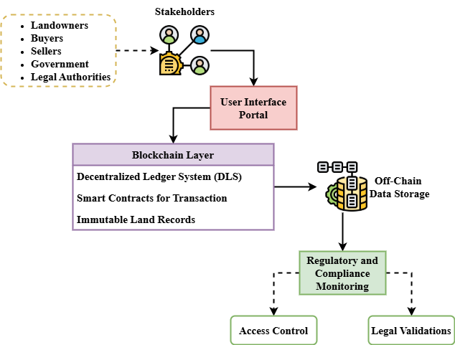
Figure 1: High-Level Overview of Stakeholder Interaction

Figure 1 shows an outline high-level picture of interactions of many stakeholders on the use of the blockchain-based land registration system. Some of these stakeholders include purchasers, sellers, government, attorneys, and landowners. They interact with it through a central user interface—a secure online or mobile application. Authenticated users can initiate or complete land ownership or transfer-based transactions [17]. The building block of the system is the blockchain, on which transactions are irrevocably logged on the distributed ledger and settled through smart contracts. Big documents such as title deeds are stored in encrypted off-chain vaults to manage document storage efficiently; their hashes are stored on the blockchain to check for integrity. As part of its monitoring for compliance, the system verifies that all transactions comply with all relevant laws and regulations [18]. In this overview at the high level, it is pointed out how the system grants safe access to land records in a single location, promotes openness, and minimizes the potential for fraud [19].

Related Works
Emphasizing security, openness, and efficiency, the linked works investigate many ways to improve land record administration. Studies underline the shortcomings of conventional systems and look at new technologies such distributed ledgers, smart contracts, and blockchain that show promise in handling problems with data integrity, access control, and trust.
Innovative Blockchain Model (IBM)
This paper is about blockchain technology, a futuristic tool for sustainable finance, healthcare, and the development of industry and agriculture. It highlights the way blockchains are dispersed, secure, and clear when it is about managing data. The study looks into how it can manage issues such as resource economy, supply chain tracing, and information integrity. An Innovative Blockchain Model (IBM) [20] is suggested, which ensures security and privacy through the integration of public-private components with sophisticated cryptographic technologies, such as Zero-Knowledge Proofs [21]. The challenges of adoption, such as scalability, interoperability, and regulation, are also covered in the report by providing strategic recommendations. It highlights the importance of blockchain across ethical procurement, circular economy, and social inclusion through case studies and theoretical research.
Electronic Data Interchange (EDI)
This article investigates the potential for incorporating blockchain technology into EDI systems to enhance data security, transparency, and trust in company transactions. Conventional Electronic Data Interchange (EDI) [22] is widely used in industries such as logistics and healthcare but suffers from data integrity and unauthorized access issues. The immutable ledger of transactions shown only to a small number of users through blockchain technology, distributed and resistant to tampering, addresses these challenges. Some of the benefits the paper mentions are enhanced auditability, monitoring in real-time, and reduced conflict. Case studies show real-world applications of blockchain technology integrated with electronic data interchange (EDI), thus optimizing processes and improving compliance in modern, secure, open digital environments.
Internet of Things (IoT)
This paper examines how blockchain can improve the transparency and trust in medical data sharing through the Health Internet of Things (IoT) [23]. It proposes a new Temporal Blockchain strategy for tracking the provenance so that data problems of origin, privacy, and compliance are avoided. Emphasizing the further importance of include temporal data, the article examines current systems such Hyperledger Fabric, Ethereum, and Corda. Through robust security and privacy compliance, Temporal Blockchain tracks the origin and history of medical information therefore improving their traceability. The suggested approach shows great potential even if scalability and interoperability still have room for development. Results of evaluation verify strong security, efficient provenance tracking, and regulatory alignment. The study emphasizes the requirement of ongoing research to raise scalability and interoperability, so Temporal Blockchain becomes a strong instrument for open and safe medical data sharing in Healthcare IoT. This cooperative approach helps continuous innovation in blockchain-based medical applications.
Machine-to-Machine (M2M)
The digital world is spreading fast, and the Internet of Things (IoT) is creating new privacy and security issues. Machine-to-Machine (M2M) [24] communication, data security, and user privacy are a requirement in the scenario of IoT devices that run in uncertain and challenging environments. The vulnerabilities of connected, resource-constrained IoT devices may be disregarded by security standards. Peculiar for being decentralized and open, blockchain technology presents a viable solution to such challenges. Speaking about IoT applications in various fields, this paper focuses on security concerns and considers how blockchain can improve IoT security and privacy. Issues with integrating blockchain technologies in IoT systems are also discussed.

Proposed Method
The proposed method introduces a blockchain-based land registry system using a decentralized ledger, aiming to enhance data security, transparency, and efficiency in land record management and ownership transactions [25].

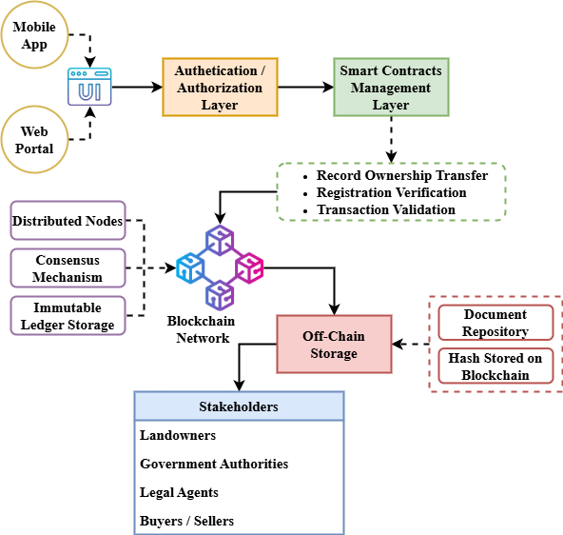
Figure 2: System Architecture of Blockchain-Based Land Registry Using DLS

The DLS's Land Registry System can be seen in Figure 2. Its architectural design serves as a basis for a Blockchain-based implementation which was proposed in this work. The process starts with mobile or online interfaces available to various stakeholders, from government officials and landowners to lawyers. User access control and credential validation is taken care of by the system's authentication and authorization layer. The identification of individuals, validation of the transactions, and transfer of the ownership are automated through the smart contracts layer. This automation is made possible through the Comprising nodes that operate in unison according to a consensus mechanism structure. The network of blockchain guarantees data integrity by writing and enforcing these actions. The effectiveness of the blockchain is maintained as the system provides off-chain storage for large volumes of data such as legal documents and property deeds, retaining only their cryptographic hashes on-chain. A control and compliance policies layer ensures that all actions performed are in accordance with the legal criteria along with the access control policies asserting that all data compliance is maintained. The multi-layered construction guarantees running efficiency, security and transparency.
$${σ_{1}S=(tu)+(k}_{1}k_{2}+k_{1}^{2})Q+Q^{''}{(k}_{1}-k_{2}) (1)$$
Equation (1) represents the stress or trustworthiness state ($σ_{1}S$) of a system as affected by transaction units (${(tu)+(k}_{1}k_{2}+k_{1}^{2}$), secure factors ($Q^{''}{(k}_{1}-k_{2})$), and data searches. The equation shows how integrity and consistency are tamper resistance and openness.
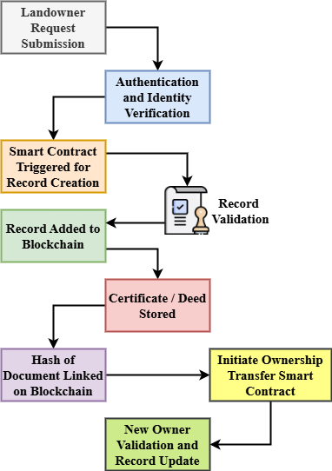
Figure 3: Land Record Workflow in the Blockchain System
Based on the proposed blockchain structure, Figure 3 illustrates the sequential process needed in land production, verification, and record updating. The process begins with a landowner or authorized user utilizing the site to initiate a registration or transfer of ownership request. The system verifies user identification through the layer of authentication. Smart contracts are triggered once authenticated to initiate the validation and recording process. Nodes of designated government authority authenticate and validate the input data. After successful validation, the land record is hashed and stored permanently on the blockchain ledger, ensuring immutability and tamper-resistance. Although their corresponding hashes are stored on-chain for verification, related records—like title deeds or legal certificates—save encrypted form off-chain. Modifications in ownership initiate the same process with updated information. This framework ensures, for legitimate stakeholders, each transaction is visible, verifiable, and securely traceable in real-time.
$$z_{0}=(1-\frac{1}{2}sech⁡(+\tanh\left(\frac{ε1}{2}\right)*q_{1}{sech}^{2}\sqrt{{-2q}_{1}}\left(2\right)$$
Equation (2) generates$\frac{ε1}{2}$ a complicated state of equilibrium$q_{1}{sech}^{2}$ or stability affected$\sqrt{{-2q}_{1}}$ by entropy-like suggestions $z_{0}$ and question dynamics $1-\frac{1}{2}sech$. This safe searches, and cryptographic immunity from manipulation.
The proposed system securely records land transactions on a decentralized blockchain, ensuring transparency, minimizing fraud, and improving operational efficiency through smart contracts, off-chain storage, and strict regulatory compliance measures.

Result and Discussion
The Result and Discussion section presents the evaluation of the proposed blockchain-based land registry system. It analyzes performance in terms of security, transparency, and data integrity. The outcomes are compared with traditional methods, highlighting improvements in transaction efficiency, fraud prevention, and trust among stakeholders through decentralized ledger implementation.

Analysis of Security and Data Integrity

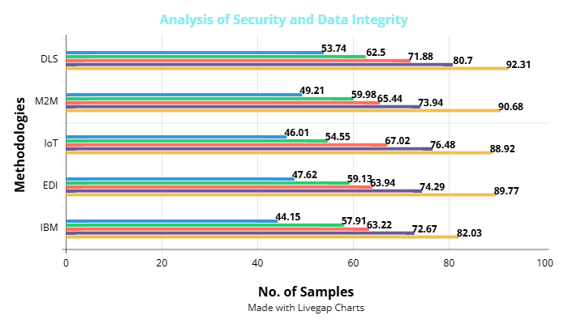
Figure 4: Analysis of Security and Data Integrity

Figure 4 indicates that the distributed ledger system consistently outperforms traditional methods, irrespective of the sample size. In maintaining data private and tamper-free, the distributed system initially indicates a huge improvement compared to IBM, EDI, the Internet of Things, and M2M technologies. The distributed method is predicated on outdated methodologies that improve as samples grow larger. The probability of data breaches and unauthorized alterations decreases as the distributed ledger remains unaltered. The implementation of a decentralized structure and immutable records substantially improves data protection. While traditional approaches improve with more samples, distributed models provide greater transparency and durability. The findings are that distributed ledger technology offers a long-term solution for the challenges of trust problems and security of record of private property. The distributed system is superior to the more conventional centralized record-keeping technique in regards to reliability, scalability, and security.
$${2q}_{3}ρ_{1}=\cosh\left(q_{3}+ρ_{3}\right)* ρ_{1 }\cosh\left(τ_{3}+σ_{4}\right)*ρ_{2}cosh{(τ}_{2}) (3)$$
Equation (3) shows in a secure setting$\cosh\left(q_{3}+ρ_{3}\right)$ the exponential increase of relational force$\cosh\left(q_{3}+ρ_{3}\right)$ and data density. The shows how$ρ_{1 }cosh\left(τ_{3}+σ_{4}\right)$ connected cryptographic and temporal factors (${2q}_{3}ρ_{1}$) increase the robustness and traceability of records$ρ_{2}cosh{(τ}_{2}$, around the distributed ledger on analysis of security and data integrity.

Analysis of Transaction Efficiency and Transparency
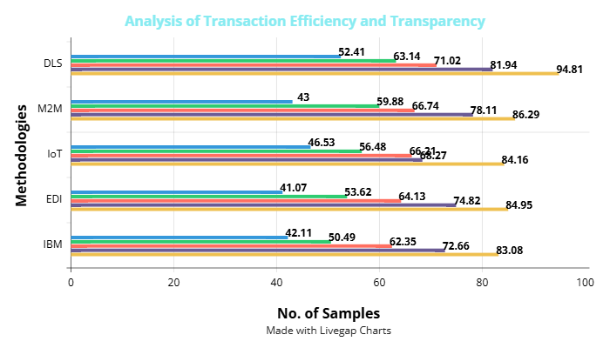
Figure 5: Analysis of Transaction Efficiency and Transparency

Figure 5 illustrates that compared to existing technologies, the distributed ledger system always yields higher results. Even with smaller samples, the distributed structure shows that it is better at managing transactions and being transparent with stakeholders. While classic models such as IBM, EDI, IoT, and M2M still fall short of distributed system performance, they show very little improvement with increasing sample numbers. The distributed method guarantees better clarity at every transaction level, greatly lowers transaction latency, and decreases human verification requirements. This immediately produces more reliable and easier interactions among the people engaged in land ownership procedures. Under the distributed system, transparency also stays always greater, which improves auditability and reduces conflicts. In contrast, traditional systems struggle with delayed updates, opaque processes, and occasional data mismatches. The results clearly support that decentralized ledgers improve not only operational speed but also the credibility and openness of the land registration system.
$${H^{'}K}^{2}={qR}_{1}S{\left(Y\right)}^{2}+{qR}_{2}T{\left(Z\right)}^{3}+{qR}_{3}U{\left(A\right)}^{4} (4)$$
Equation (4) composite security${qR}_{2}T{\left(Z\right)}^{3}$ function wherein stacked transactional components${qR}_{3}U{\left(A\right)}^{4}$ and record system an entropy (${H^{'}K}^{2}$) and cryptographic strength (${qR}_{1}S{\left(Y\right)}^{2}$). This shows increasingly transparent for analysis of transaction efficiency and transparency.
$$2\left(qt_{2}^{2}+{St}_{3}^{2}\right)=\tanh{\frac{q_{2}\left(∆\right)}{2}}*q_{1}\left(∅+1\right)+uqz' (5)$$
Equation (5) expresses$2\left(qt_{2}^{2}+{St}_{3}^{2}\right)$ the link under cryptographic impact $\tanh{\frac{q_{2}\left(∆\right)}{2}}$between information transfer energy$q_{1}\left(∅+1\right)$ and system-level changes$uqz'$. Through cryptographic control, the transactional efficiency and state consistency spontaneously balance.

Conclusion
This paper introduced a DLS-based blockchain-based land registration system to address significant issues with traditional record-keeping systems. In comparison to existing solutions such as IBM, EDI, IoT, and M2M models, the proposed approach unequivocally enhances security, transparency, and efficiency in transactions, as per the research. The use of distributed verification, immutable documents, and smart contracts makes the system ideal for storing land records securely and preventing tampering with transactions. Stakeholder trust is enhanced by open and honest interactions with minimal involvement of middlemen. Off-chain encrypted storage is used to increase system efficiency without sacrificing data integrity. Results of evaluation verified that, across rising sample sizes, the distributed method preserves better security and operational transparency than conventional centralized systems. Apart from simplifying the land registration and transfer procedures, the technology offers real-time auditability and regulatory compliance. The blockchain-based paradigm offers a radical change toward more reliable, efficient, and safe land management practices. This research serves to advance future enhancements that can maximize interoperability, scalability, and broader ecosystem integration to further enhance resilience and transparent governance models for the real estate industry. It further aids in ascertaining the growing uptake of blockchain technologies by public record management.
The planned blockchain architecture will expand by becoming more scalable and interoperable. It will thus be able to handle greater quantities of data without losing compatibility with the existing infrastructure within the government. Research in future-proof consensus algorithms will be carried out so that the feasibility of speeding up transactions without sacrificing security can be explored. The application of artificial intelligence to the detection of fraud and valuation of land will also be examined. Pilot testing will be conducted across several various geographic areas for the purpose of assessing the practical hindrances, regulatory differences, and migration of users existing within several various land administration systems.

References
- L. K. Ramasamy, and F. Khan, “Secure and transparent educational data record-keeping with blockchain,” in Blockchain for Global Education, Cham: Springer Nature Switzerland, 2024, pp. 147–164.
- A. Mohanraj, “Leveraging Blockchain Technology to Enhance,” in Enhancing Security and Regulations in Libraries With Blockchain Technology, 2024, pp. 181.
- A. N. Chitikela, “Secure and Transparent Medical Record Management System Using Python and Blockchain,” arXiv preprint arXiv:2408.02081, 2024.
- M. I. Hossain, T. Steigner, M. I. Hussain, and A. Akther, “Enhancing data integrity and traceability in industry cyber physical systems (ICPS) through Blockchain technology: A comprehensive approach,” arXiv preprint, arXiv:2405.04837, 2024.
- N. Rane, S. Choudhary, and J. Rane, “Blockchain and Artificial Intelligence (AI) integration for revolutionizing security and transparency in finance,” SSRN, 2023.
- J. K. Manda, “Blockchain Applications in Telecom Supply Chain Management: Utilizing Blockchain Technology to Enhance Transparency and Security in Telecom Supply Chain Operations,” unpublished, 2021.
- M. Ojaghloo, and A. Jannesary, “Investigate all attacks on Mobile Wireless Networks and Finding security solutions,” International Academic Journal of Innovative Research, vol. 2, no. 2, pp. 17–27, 2015.
- S. B. Othman, and M. Getahun, “Leveraging blockchain and IoMT for secure and interoperable electronic health records,” Scientific Reports, vol. 15, no. 1, p. 12358, 2025.
- B. Nachiappan, N. Rajkumar, J. Jagannathan, A. Mohanraj, N. Karthikeyan, and C. Viji, “Synergizing Blockchain and Collaborative Networks,” in Leveraging Blockchain for Future-Ready Libraries, IGI Global Scientific Publishing, 2025, pp. 285–318.
- U. V. Ailakhu, “The Future of Recordkeeping: The Legal and Regulatory Considerations of Blockchain Adoption,” Lead City International Journal of Library, Information & Communication Sciences, vol. 2, no. 1, pp. 54–65, 2025.
- D. J. Lemay, R. B. Basnet, and T. Doleck, “Examining the Relationship between Threat and Coping Appraisal in Phishing Detection among College Students,” Journal of Internet Services and Information Security, vol. 10, no. 1, pp. 38–49, 2020.
- M. Utkina, “Leveraging Blockchain Technology for Enhancing Financial Monitoring: Main Challenges and Opportunities,” European Journal of Interdisciplinary Studies, vol. 15, no. 2, pp. 134–151, 2023.
- M. Alharbi, and A. Alabdulatif, “Intelligent Transport System based Blockchain to Preventing Routing Attacks,” Journal of Wireless Mobile Networks, Ubiquitous Computing, and Dependable Applications, vol. 14, no. 1, pp. 126–143, 2023. https://doi.org/10.58346/JOWUA.2023.I1.011
- T. M. Alar, M. Shuaib, I. M. Khormi, S. Alam, I. Aqeel, and S. Ahmad, “Enhancing the trust and transparency of academic records with blockchain-based systems,” in Proc. 2023 Int. Conf. in Advances in Power, Signal, and Information Technology (APSIT), Pune, India, Jun. 2023, pp. 1–7.
- F. Çağıltay, E. Biçer, A. Yıldız, and M. Gökoğlu, “Occurrence of the Scalloped Ribbonfish Zu cristatus (Lampridiformes) in the Gulf of Antalya, Türkiye,” Natural and Engineering Sciences, vol. 8, no. 2, pp. 82–85, 2023, http://doi.org/10.28978/nesciences.1338121.
- S. Dhivya, S. Devashree, A. Kumar, C. Manosigan, and G. H. Kanna, “Fake Product Identification Using Blockchain,” International Journal of Advances in Engineering and Emerging Technology, vol. 14, no. 2, pp. 15–22, 2023.
- T. Jelena, and K. Srđan, “Smart Mining: Joint Model for Parametrization of Coal Excavation Process Based on Artificial Neural Networks,” Archives for Technical Sciences, vol. 2, no. 29, pp. 11–22, 2023, https://doi.org/10.59456/afts.2023.1529.011T.
- P. Sundara Bala Murugan, A. Ganesan, P. Paranthaman, and V. Aruna, “Feasibility Design and Analysis of Process-aware Accounting Information System for Business Management,” Indian Journal of Information Sources and Services, vol. 14, no. 2, pp. 56–62, 2024, https://doi.org/10.51983/ijiss-2024.14.2.09.
- K. Saidova, Y. Muydinova, R. Turakulov, U. Jumanazarov, A. Khudoykulov, O. Kholmurodova, K. Zokirov, and B. Odilov, “Investigating the role of community based conservation in promoting sustainable wildlife management,” International Journal of Aquatic Research and Environmental Studies, vol. 4, no. S1, pp. 95–100, 2024, https://doi.org/10.70102/IJARES/V4S1/16.
- S. Mssassi, and A. A. El Kalam, “Leveraging Blockchain for Enhanced Traceability and Transparency in Sustainable Development,” in Int. Conf. Advanced Intelligent Systems for Sustainable Development, Cham: Springer Nature Switzerland, 2023, pp. 162–177.
- A. Verma, and R. Nair, “Chromatographic Methods for the Separation of Naturally Occurring Bioactive Compounds and Their Applications in Industry,” Engineering Perspectives in Filtration and Separation, vol. 3, no. 1, pp. 18–24, 2025.
- S. K. R. Thumburu, “Integrating Blockchain Technology into EDI for Enhanced Data Security and Transparency”.
- S. V. Kakade, B. Tiple, A. S. Sansuddi, M. D. Kokate, M. M. Alate, and S. Chavan, “Blockchain-Based Medical Record Sharing in Healthcare IoT: Building Trust and Transparency through Secure Provenance Tracking,” Journal of Electrical Systems, vol. 19, no. 3, 2023.
- S. M. Muzammal, and R. K. Murugesan, “A study on leveraging blockchain technology for IoT security enhancement,” in Proc. 2018 Fourth Int. Conf. Advances in Computing, Communication & Automation (ICACCA), 2018, pp. 1–6.
- S. N. Kazemi, and H. S. Zadeh, “Development of Feature Adaptation Models for Proper Registration of Aerial Images,” International Academic Journal of Science and Engineering, vol. 3, no. 2, pp. 176–187, 2016.

