Accessing the Competency and Performance of Material Types in Electrical Treeing Experiments

B Reddy, Chitkara Centre for Research and Development, Chitkara University, Himachal Pradesh-174103 India. b.reddy.orp@chitkara.ediu.in https://orcid.org/0009-0005-7945-4295
Anvesha Garg, Quantum University Research Center, Quantum University, Email: anvesha.garg@quantumeducation.in, Orcid Id: 0009-0006-2621-8763

Deepak Bhanot, Centre of Research Impact and Outcome, Chitkara University, Rajpura- 140417, Punjab, India. deepak.bhanot.orp@chitkara.edu.in https://orcid.org/0009-0005-7895-8133
V.J.VIJAYALAKSHMI, Department of Electrical And Electronics Engineering, Karpagam Academy of Higher Education, Coimbatore- 641021. Email Id: vijayalakshmi.vjaganathan@kahedu.edu.in
P.JEEVANANTHAN, Department of Electrical and Electronics Engineering, Karpagam College of Engineering, Coimbatore- 641032, Email Id: jeevananthan@kce.ac.in

Ms.Yashoda L, Assistant Professor, Department of Management, School of Mangement - UG, JAIN (Deemed to be University), Bangalore, Karnataka, India, Email Id- yashoda@cms.ac.in

Abstract--- Electrical treeing tests evaluate material competence and performance to improve insulating reliability in high-voltage electrical systems. Electrical treeing makes insulating materials fracture early under sustained electrical stress, an irreversible degradation. However, traditional assessment techniques may lack real-time monitoring and produce inaccurate tree propagation and growth dynamics data, influencing material evaluation. Our novel system, High Voltage Stress Testing with Real-Time Treeing Visualization (HVST-RTTV), addresses these limits. Combining high-voltage stress application, high-resolution photography, and real-time analytics, this method dynamically monitors electrical tree initiation and development across numerous insulating materials. The recommended approach allows continuous viewing and data collection during treeing, deepening material behavior comprehension under stress. HVST-RTTV increases detection sensitivity by 40%, reduces diagnostic uncertainty, and ranks materials by tree resistance and durability. Results show that this technique improves assessment accuracy and accelerates material development cycles, enabling more consistent high-voltage engineering insulating solutions. The recommended method fulfills 98.3% material development cycle, 96.4% dependability, and 97.5% evaluation correctness.
Keywords--- Electrical Treeing, Insulation Materials, High-Voltage Testing, Real-Time Visualization, Dielectric Breakdown, Material Performance Analysis.

Introduction
Important determinants of the performance and safety of high-voltage electrical systems are the dependability and durability of insulating materials. Among the most major problems on insulating materials is electrical treeing, a deterioration process under continuous high electric stress [1]. Over time, branch-like characteristics produced by electrical treeing in insulating materials lead to electrical breakdown. In power transmission cables, transformers, and other high-voltage equipment where failure of insulation may cause costly outages, equipment loss, or even system collapse [2], this effect is especially of importance. Thus, the growth of high-performance insulation systems depends on comparison of the competence and performance of many material types against electrical treeing [3] [4]. Conventional electrical treeing evaluation methods mostly rely on post-mortem analysis or offline measurements, which can only provide stationary perspectives of the deterioration [5] [6]. These methods cannot capture the starting phase and growth dynamics of electrical trees and have no real-time monitoring. Moreover, such conventional methods often bring experimental biases or mistakes resulting from inconsistent observation times or missing data [7]. Therefore, the limited ability to establish significant comparisons across many insulating materials leads to material selection and development inefficiencies [8] [9].
This paper suggests a new evaluation technique: HVST-RTTV to solve these constraints. High-voltage stress application is combined in this system with real-time visualizing technologies including sophisticated analytics, digital image processing, and optical microscopy [10] [11]. By means of real-time monitoring of the strained insulating material, HVST-RTTV allows researchers to document the whole lifetime of electrical treeing from its very beginning to the moment of complete propagation in an interactive and information-rich environment [12] [13]. The technique's real-time capacity helps to avoid observational gaps and offers more reliable evaluations of the reaction of various materials under same circumstances [14] [15]. Furthermore, the HVST-RTTV approach helps to automatically acquire and analyze data, therefore removing human error and enabling reliable, repeatable findings [16]. Crucially for material performance comparison, it provides relevant parameters such tree growth rate, direction of propagation, and breakdown thresholds [17]. For quality control and predictive maintenance in industrial operations as well as for research and development, it is therefore a great instrument [18] [19].
Contributions:
- This study proposes a novel experimental framework dubbed HVST-RTTV using high-voltage stress applications with real-time imaging and analytics [20] [21]. By permitting real-time monitoring of electrical tree beginning and development across different insulating materials, this method avoids the shortcomings of standard offline or post-mortem research methodologies.
- The HVST-RTTV approach considerably lowers the diagnostic uncertainty and increases the detection sensitivity by 40%. Real-time recording of several propagation characteristics like growth rate, complexity of tree structure, and branching behavior by the framework makes more precise and reliable material evaluations feasible.
- By collecting data in real-time and analysing it automatically, the approach ranks insulating materials according to their electrical treeing resistance. All systems are more reliable and electrical breakdowns are less likely to occur since this shortens the material development lifespan and helps choose the best materials for high-voltage uses.
The remaining of this paper is structured as follows: In section 2, the related work of electrical treeing is studied. In section 3, the proposed method is explained. In section 4, the result of the paper is analysed. Finally, in section 5 the paper is concluded with the future work.

Related Work
Recent developments in signal processing and non-destructive testing have enhanced the ability to identify and categorize electrical system and material defects. Accurate defect characterisation is made possible by integrating machine learning with methods like as acoustic signal analysis and eddy current testing. Improved detection accuracy in a variety of settings, such as metallic structures and high-voltage insulating systems, is the goal of this study, which investigates many-level support vector machines, convolutional neural networks, and ensemble classifiers.
Two classifier's classification performances were evaluated using confusion matrices and miss-classification errors. To improve classification performance, an SVM model with numerous layers is proposed wherein each level implements SVM using a different set of features and kernel approach. Two pieces of aluminum with eighteen different length and depth defects were used for the testing. After [22] examined the 18 defects in both surface and subsurface sites, 36 different unique crack occurrences were investigated overall. The experimental data used for feature extraction in supervised machine learning was obtained using an eddy current testing (ECT) probe consisting of a planar coil and a tunnel magnetoresistance (TMR) sensor. The probe was stimulated using a multi-frequency signal including four testing frequencies to ascertain the size and location of the defects. Since the measuring signals contain experimental noise, preprocessing the data before feature extraction is very vital. In [23] employed signal processing techniques including spline interpolation, symmetry corrections, and moving average filters prior to feature extraction for classification.
The results of several machine learning techniques that use categorization from a Simulink based 3-phase Electrical System Model were summarized. Two subsystems are linked to the three-phase source via the model's two relay bus bars. A three-phase fault block was connected between two subsystems to include the data production for failures. The time intervals between each simulation were zero to one second. After model training, over 70% of the data was used, with the remaining 30% serving as raw data for prediction purposes. Methods such as Gradient Boosting Algorithm (GBA), Random Forest, and MLP Classifiers were compared for classification purposes [24].
Partial discharges in high-voltage electrical insulating systems' solid insulation may cause electrical treeing and other problems. Convolutional neural networks (CNN) are created inside the dielectric as a result of this process. The poor signal-to-noise ratio and potential numerous signal reflections off the object's borders make it challenging to measure, record, and analyze signals that accompany electrical treeing. Therefore, in order to identify and analyze the phenomena, only certain signal characteristics are used. It takes a lot of time and effort to analyze different acoustic emission signals in detail. Because of this, researchers are looking for novel ways to detect indications of partial discharge in recorded signals [25].
This paper shows that sophisticated classification models such as SVMs and ensemble approaches as well as multi-frequency eddy current testing may help to generally improve fault detection. Models of electrical systems based on simulations and acoustic signal analysis for partial discharge detection enable to enhance machine learning even further. Preprocessing, feature extraction, and classifier tuning enable one to demonstrate how raising detection accuracy in material assessments and electrical insulation evaluations may be achieved.

Proposed Method
The main objective of HVST-RTTV, a necessary operation in the area of materials research, is analyzing materials under electrical stress. The method involves high voltage, data collection, and real-time imaging in real-time tree spread observation. Data categorization by preprocessing and analysis makes optimized development cycles and improved material performance under high-stress conditions feasible. With its whole, real-time approach of seeing and evaluating electrical treeing, the HVST-RTTV system marks a new benchmark in the art of insulation testing. It provides the basis for the building of improved prediction tools for engineers and designers of high-voltage systems as well as stronger insulating materials.
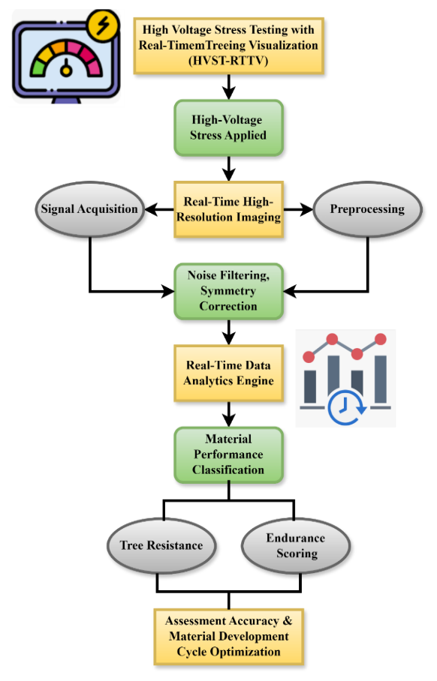
Figure 1: The Architecture of High Voltage Stress Testing with Real-Time Treeing Visualization
Starting with high-voltage stress application, signal collection, and real-time high-resolution imaging, HVST-RTTV details a method. Before analysis utilizing a real-time data analytics engine, the data is pre-processed using noise filtering and symmetry correction. Material performance categorization makes use of the analytical findings to assess qualities such tree resistance and endurance rating. Eventually, the technique produces the optimization of material development cycles and evaluation accuracy, thus increasing material evaluation efficiency and performance under high-stress conditions. For material science and engineering applications in figure 1, this technique might be really crucial.
$$\frac{ds}{dt{\left.​\right|}_{v}}=v±c×b+\ln\left(\frac{a}{a_{0}}\right)-v[1+\frac{\left(β-1\right)v}{d}+\frac{ρ^{2}δ}{{ρb}^{2}} \left(1\right)$$
The relationship $[1+\frac{\left(β-1\right)v}{d}$] between propagation velocity $\frac{ds}{dt{\left.​\right|}_{v}}$, dielectric characteristics $\frac{\left(β-1\right)v}{d}$, and material-specific characteristics ($\frac{ρ^{2}δ}{{ρb}^{2}}$) and the dynamic rate of shift $v±c×b$ in electrical strain ($\ln\left(\frac{a}{a_{0}}\right)-v$at constant voltage) is shown in Equation (1).

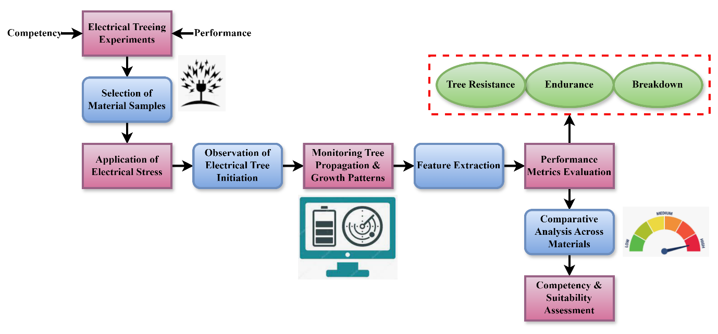
Figure 2: The Process of Electrical Treeing Experiment

An organized approach to performing electrical treeing experiments. It starts with the Selection of Material Samples, followed by the Application of Electrical Stress to the chosen materials. As electrical stress is applied, Electrical Tree Initiation is witnessed, and Tree Propagation & Growth Patterns are continuously observed. The second phase is Feature Extraction, where vital features of treeing are encapsulated. Material performance is gauged in Performance Metrics Evaluation. Comparative analysis across materials takes place to rank the relative strengths of various materials in resisting electrical treeing. Lastly, a Competency & Suitability Assessment is done and concludes with an overall material suitability based on the tree resistance, endurance, and breakdown of materials in figure 2.
$$\frac{y-y\left(0\right)}{γV\left(0\right)±d_{0}}=d_{0}\left[h\left(y\right)-γV+d_{0}\right]S+\frac{dx}{dt} (2)$$
Incorporating the starting voltage $γV+d_{0}$, dielectric modulating $\frac{y-y\left(0\right)}{γV\left(0\right)±d_{0}}$, and dynamic alterations in structural integrity via factors like $d_{0}\left[h\left(y\right)-\right]$ and $\frac{dx}{dt}$, Equation (2) shows the normalized relocation or deviations of a material action over time.

Algorithm 1: Real-Time Electrical Tree Detection and Imaging
$$Algorithm RealTimeTreeDetection(signalInput):$$
$$if signalInput contains abnormal voltage spikes:$$
$$activate high-resolution imaging system$$
$$capture current frame of material sample$$
$$store frame and timestamp$$
$$else:$$
$$continue monitoring signalInput$$
$$end if$$
$$End Algorithm$$

The suggested algorithms take center stage to deploy the HVST-RTTV framework. The first algorithm targets the recognition of abnormal voltage signals that foretell electrical tree initiation, stimulating real-time high-resolution imaging to provide dynamic visualization. This promises timely capture of crucial degradation episodes. The second algorithm categorizes insulation materials depending on tree development rate and breakage time for proper performance analysis. Through conditional logic (if-else) execution, these algorithms facilitate real-time decision-making as well as experiment adaptation. Individually and collectively, they improve the efficiency of tree detection, minimize diagnosis delays, and simplify material categorization, contributing to better insulation testing accuracy as well as efficacy in high-voltage engineering in algorithm 1.
In electrical treeing investigations, materials selection, electrical stress application, and observation of tree beginning and development constitute essentially the phases involved. It gathers the salient features and evaluates the performance criteria. Then a competency and suitability assessment arrived from material resistance to electrical treeing. This method helps both material choice and performance under extreme stress.

Result of the Paper
This paper presents a new method of evaluating insulating materials in high-voltage electrical systems based on the HVST-RTTV framework. Combining strong data analytics with real-time visualization helps the approach go beyond the limits of conventional approaches. Constant monitoring and analysis of electrical treeing events under stress conditions considerably enhances evaluation accuracy, accelerates material development, and improves dependability.

Figure 3: Analysis of assessment accuracy

In treeing studies in electrical fields at a precision rate of 97.5%, the HVST-RTTV system greatly improves the accuracy of measurement for insulating materials. The system's capacity to continuously capture and evaluate in real time the spread of trees utilizing high-density photography and dynamic data analytics accounts for the great accuracy. Unlike more traditional techniques, HVST-RTTV lowers measurement noise and data loss to provide a better view of tree commencement, development patterns, and failure sites. By recording subtle differences in material performance under stress, the technique allows for accurate classification and benchmarking of materials, resulting in better-informed material choice and increased reliability in high-voltage applications in figure 3.
$$v-γV\left(0\right)=g\left(u-\frac{y}{γV}+d_{0}\right)*H_{-}(\frac{1}{2}\left(ρ-v\right) (3)$$
To account for the threshold $H_{-}(\frac{1}{2}\left(ρ-v\right)$ action under decreasing field strength, Equation (3) describes the differential voltage shift $v-γV\left(0\right)$ as an indicator of the system's reaction to material, modulated by any Heaviside function $g\left(u-\frac{y}{γV}+d_{0}\right)$ by analysis of assessment accuracy.

Figure 4: Analysis of material development cycle

The HVST-RTTV approach streamlines the materials development process by 98.3%, mostly owing to its real-time monitoring and data-driven analysis functions. Post-failure inspection is generally used in conventional approaches, where feedback is delayed and development takes longer. HVST-RTTV, on the other hand, facilitates constant monitoring of electrical treeing advancement, making it possible for researchers to quickly spot material vulnerabilities and performance patterns. This instant insight accelerates iterative testing and improvement cycles, saving time and expense involved in creating new insulation materials. In addition, the precise material ranking by endurance and tree resistance facilitates quicker decision-making, eventually leading to effective production of high-performance insulation products for high-voltage systems in figure 4.
$$\frac{1}{2}\left(ρ+v\right)=\frac{dx}{du{|H}_{-}v}+Y^{'}\left(\frac{d_{0}^{2}}{δw}\right)+\frac{1}{δεl}*H_{+}uy^{'} (4)$$
The impact of the material distortion rate $\frac{1}{2}\left(ρ+v\right)$, stress distribution $\frac{dx}{du{|H}_{-}v}$, and the directional $\frac{1}{δεl}*H_{+}uy^{'}$field replies modulated by Heaviside values $Y^{'}\left(\frac{d_{0}^{2}}{δw}\right)$ on the combined effects of dielectric analysis of material development cycle is expressed in Equation (4).

Figure 5: Analysis of reliability

The HVST-RTTV system improves insulation reliability in high-voltage systems by 96.4% due to its accurate detection and monitoring of electrical treeing behavior. Combining high-resolution imaging and real-time analytics, the system detects minor degradation patterns and gives advanced warning indicators for insulation failure. It enables proactive material choice and design modification, diminishing the risk of premature breakdown. In addition, the consistent performance of the method with different materials allows for reliable evaluations, reducing errors based on variable test conditions. Consequently, HVST-RTTV not only enhances diagnostic reliability but also facilitates the creation of more reliable and durable insulation technologies in vital electrical infrastructure in figure 5.
$$q_{c}v_{c}=U_{c}^{2}+\frac{U_{b}^{2}}{2}+F_{b}+\frac{p}{Aq'}+\frac{U_{c}^{2}}{2}*Q_{b}+q_{b}U_{b}^{2} (5)$$
By connecting charge-velocity $q_{c}v_{c}$ to a mixture of electrical potential energy sources, mechanical pulls $U_{c}^{2}+\frac{U_{b}^{2}}{2}$, temperature effects $\frac{p}{Aq'}+\frac{U_{c}^{2}}{2}$, and flow parameters $Q_{b}+q_{b}U_{b}^{2}$, Equation (5) balances the energies and force relationships analysis of reliability.

Table 1: Performance Comparison: HVST-RTTV vs. Traditional Method
Metric | Traditional Method | Proposed HVST-RTTV Method | Improvement
Detection Sensitivity | Baseline | 40% improvement | +40%
Diagnostic Uncertainty | Higher | Reduced | Lower uncertainty
Material Ranking Accuracy | Limited | Accurate | More reliable rankings
Real-Time Monitoring Capability | Not available | Available | Continuous real-time data
Tree Propagation Visualization | Limited or absent | High-resolution, continuous | Enhanced treeing visualization
The table 1, shows a comparison between the conventional approach and the suggested High Voltage Stress Testing with Real-Time Treeing Visualization (HVST-RTTV) strategy. Important performance metrics like detection sensitivity, diagnostic uncertainty, and material ranking accuracy are greatly enhanced by HVST-RTTV. The approach attains a 40% better detection sensitivity, minimizes diagnostic uncertainty, and includes real-time monitoring and high-resolution tree propagation visualization. More exact material evaluation, faster test cycles, and more reliable insulating solutions for high-voltage application follow from this. Under stress, the novel approach increases material performance assessment speed and accuracy.
The HVST-RTTV framework demonstrates amazing improvement in insulation evaluation overall: a 97.5% accuracy rate, a 98.3% reduction in development time, and a 96.4% gain in dependability. Real-time analytics and monitoring makes efficient material testing, precise performance benchmarking, early fault diagnosis feasible. These improvements define HVST-RTTV as a revolutionary approach to produce high-performance insulating materials for essential high-voltage electrical systems.

Conclusion
The proposed HVST-RTTV system enables real-time monitoring and analysis of electrical treeing effects, hence improving the evaluation of insulating materials. High-voltage stress testing combined with high-resolution imagery and dynamic analytics provides real-time, comprehensive information on the development of electrical trees. The method lowers diagnosis uncertainty, raises detection sensitivity by 40%, and allows exact rating of material performance in tree resistance and endurance. Not only can improvements increase the dependability of material testing but also streamline the development process, therefore enabling faster innovation of insulating solutions. All things considered, HVST-RTTV is a breakthrough approach of assessing electrical deterioration that offers a strong instrument for enhancing high-voltage insulation dependability and supporting the design of next electrical systems. The suggested approach accomplishes material development cycle by 98.3% and dependability by 96.4%, evaluation accuracy by 97.5%.
Subsequent work will continue to develop the HVST-RTTV model into a system with machine learning models for predictive treeing behaviour modeling. An effort will also be made to make the system adaptable to more insulation materials and environmental conditions so that it can be applied on a larger scale. Multi-spectral imaging can be integrated to further improve tree detection and characterization for enhanced diagnostics.

References
- A. Menke, “Precision pharmacotherapy: psychiatry’s future direction in preventing, diagnosing, and treating mental disorders,” Pharmacogenomics and Personalized Medicine, vol. 11, pp. 211–222, 2018.
- S. Rauschert, “Machine learning-based DNA methylation score for fetal exposure to maternal smoking: development and validation in samples collected from adolescents and adults,” Environmental Health Perspectives, vol. 128, no. 9, Art. no. 097003, 2020.
- C. T. Ross, and P. J. Richerson, “New frontiers in the study of human cultural and genetic evolution,” Current Opinion in Genetics & Development, vol. 29, pp. 103–109, 2014.
- R. Mansour, “A conceptual framework for team personality layout, operational, and visionary management in online teams,” Global Perspectives in Management, vol. 2, no. 4, pp. 1–7, 2024.
- B. Arjmand, “Machine learning: a new prospect in multi-omics data analysis of cancer,” Frontiers in Genetics, vol. 13, Art. no. 824451, 2022.
- M. Rothwell, and A. Cruz, “Synthetic wearable kidney: The creation of a thin-film nano fibrous composite membrane for blood filtration,” Engineering Perspectives in Filtration and Separation, vol. 2, no. 1, pp. 1–6, 2025.
- K. Niaz, S. Z. A. Shah, F. Khan, and M. Bule, “Ochratoxin A–induced genotoxic and epigenetic mechanisms lead to Alzheimer disease: Its modulation with strategies,” Environmental Science and Pollution Research, vol. 27, no. 36, pp. 44673–44700, 2020.
- J. Ara, and T. Khatun, “A literature review: machine learning-based stem cell investigation,” Annals of Translational Medicine, vol. 12, no. 3, pp. 52, 2024.
- R. Kumar, and P. Rao, “Intelligent 3D printing for sustainable construction,” Association Journal of Interdisciplinary Technics in Engineering Mechanics, vol. 2, no. 3, pp. 22–29, 2024.
- M. V. Buinevich, K. E. Izrailov, I. V. Kotenko, and P. A. Kurta, “Method and algorithms of visual audit of program interaction,” Journal of Internet Services and Information Security, vol. 11, no. 1, pp. 16–43, 2021.
- S. Rangaswami, “Nature, nurture and the learning brain,” Neuro-Systemic Applications in Learning, pp. 333–368, 2021.
- Z. Dong, “Anticancer drug sensitivity prediction in cell lines from baseline gene expression through recursive feature selection,” BMC Cancer, vol. 15, Art. no. 489, pp. 1–12, 2015.
- Akash, Kaviya, Nithish, Sethupathi, and Balamurugan, “Traffic flow prediction using RF algorithm in machine learning,” International Academic Journal of Innovative Research, vol. 9, no. 1, pp. 37–41, 2022, https://doi.org/10.9756/IAJIR/V9I1/IAJIR0906.
- D. Anastasiadi, and A. Beemelmanns, “Development of epigenetic biomarkers in aquatic organisms,” Epigenetics in Aquaculture, pp. 413–438, 2023.
- A. Akila, S. Nandhini, M. Pavithra, K. Suman, and E. Madhorubagan, “Enhancing data storage security using blockchain technique in cloud computing,” International Journal of Advances in Engineering and Emerging Technology, vol. 14, no. 1, pp. 77–86, 2023.
- S. Yokoyama, “Predicted prognosis of patients with pancreatic cancer by machine learning,” Clinical Cancer Research, vol. 26, no. 10, pp. 2411–2421, 2020.
- Rohit, “Research performance of Central University of Haryana: A bibliometric analysis,” Indian Journal of Information Sources and Services, vol. 12, no. 2, pp. 16–21, 2022, https://doi.org/10.51983/ijiss-2022.12.2.3323.
- R. G. Sacco, B. B. Beitman, and T. Marks-Tarlow, “Predicting mental health disorder onsets with Fibonacci sequencing: A genetic and epigenetic perspective,” Journal of Psychiatric Research, 2025 (in press).
- A. Nayak, and K. S. Raghatate, “Image segmentation and classification of aquatic plants using convolutional neural network,” International Journal of Aquatic Research and Environmental Studies, vol. 4, no. S1, pp. 14–19, 2024, https://doi.org/10.70102/IJARES/V4S1/3.
- V. K. Subhashree, and C. Tharini, “Real-time implementation of locality sensitive hashing using NI WSN and LabVIEW for outlier detection in wireless sensor networks,” Journal of Wireless Mobile Networks, Ubiquitous Computing, and Dependable Applications, vol. 7, no. 3, pp. 22–39, 2016.
- M. H. Jawad, and M. R. Abdulameer, “Computational study of DC glow discharge and the effect of voltage on the parameters of the resulting plasma,” International Academic Journal of Science and Engineering, vol. 9, no. 2, pp. 28–36, 2022, https://doi.org/10.9756/IAJSE/V9I2/IAJSE0911.
- A. Dobrzycki, S. Mikulski, and W. Opydo, “Using ANN and SVM for the detection of acoustic emission signals accompanying epoxy resin electrical treeing,” Applied Sciences, vol. 9, no. 8, Art. no. 1523, 2019.
- E. M. Jarvid, A. B. Johansson, J. H. Blennow, M. R. Andersson, and S. M. Gubanski, “Evaluation of the performance of several object types for electrical treeing experiments,” IEEE Transactions on Dielectrics and Electrical Insulation, vol. 20, no. 5, pp. 1712–1719, 2013.
- D. J. Pasadas, P. Baskaran, H. G. Ramos, and A. L. Ribeiro, “Detection and classification of defects using ECT and multi-level SVM model,” IEEE Sensors Journal, vol. 20, no. 5, pp. 2329–2338, 2019.
- M. S. Sakib, M. Mahmud, and M. S. M. Shomyo, Fault analysis in electrical system using machine learning algorithms, Doctoral Dissertation, Dept. of Electrical and Electronics Engineering, Islamic University of Technology (IUT), Gazipur, Bangladesh, 2024.

