Improving Cellular Communications through Responsive Blocking Identification with DSSS

Shubhi Goyal, Quantum University Research Center, Quantum University, Email: shubhi.mathematics@quantumeducation.in, Orcid Id: 0009-0001-1684-7324

Abhinav Mishra, Chitkara Centre for Research and Development, Chitkara University, Himachal Pradesh-174103 India. abhinav.mishra.orp@chitkara.edu.in https://orcid.org/0009-0005-9856-6727

Ankit Sachdeva, Centre of Research Impact and Outcome, Chitkara University, Rajpura- 140417, Punjab, India. ankit.sachdeva.orp@chitkara.edu.in https://orcid.org/0009-0004-5602-4682

V.J.VIJAYALAKSHMI, Department of Electrical And Electronics Engineering, Karpagam Academy of Higher Education, Coimbatore- 641021. Email Id: vijayalakshmi.vjaganathan@kahedu.edu.in

C.MUKUNTHARAJ, Department of Electronics and Communication Engineering, Karpagam College of Engineering, Coimbatore- 641032, Email Id: mukuntharaj.c@kce.ac.in

Ms. Sara Elais, Associate Professor, Department of Management, School of Mangement - UG, JAIN (Deemed to be University), Bangalore, Karnataka, India, Email Id- sara_elias@cms.ac.in

Abstract--- Particularly under challenging signal environments, identification and mitigation of blocking effects significantly enhance cellular communication performance. Enhancing signal robustness in such environments relies heavily on Direct Sequence Spread Spectrum (DSSS). Current methods do tend to be plagued by dynamic interference and respond inadequately to rapidly varying channel conditions, thus degrading data throughput and increasing error rates. Through the integration of layer-wise real-time interference detection and adaptive filtering techniques to mitigate the impact of blocking, the presented framework, Cross-Layer Interference Analysis and Adaptive Filtering (CLIA-AF), alleviates these limitations. The approach ensures more effective and trustworthy communication by allowing cellular systems to respond dynamically to various interference patterns. The proposed approach is applied in a DSSS-based system to enhance signal reliability and clarity. By reducing interference, increasing data accuracy, and maintaining stable connection in high-interference environments, CLIA-AF obviously improves quality of communication.
Keywords--- Cellular Communication, DSSS, Blocking Identification, Adaptive Filtering, Interference Analysis.

Introduction
Recent wireless connection depends on cellular communication networks, which also provide a broad spectrum of services from voice to fast data transmission [1] [2]. Maintaining strong signal quality and continuous connectivity is a great difficulty as the need for flawless and consistent communication keeps increasing [3] [4]. One of the main problems degrading performance in these systems is signal blocking—that is, external circumstances or interfering signals breaking the channel of transmission [5] [6]. DSSS may therefore distribute the signal across a large frequency range, thus enhancing resilience and integrity of the data and so counter interference [7] [8]. Current techniques of interference mitigating are not as flexible and deep as required to sufficiently handle cross-layer interference and fast changing interference patterns [9]. To handle these difficulties, this study presents a novel framework: CLIA-AF. By use of a combination of real-time adaptive filtering methods with cross-layer analysis, this system dynamically identifies, analyzes, and masks blocking and interference at levels of communication [10]. By means of improved system reaction to environmental changes, CLIA-AF guarantees more constant communication and higher quality signal. The solution is evaluated using simulations showing significant improvement in data accuracy and stability of communication [11] within a DSSS context.
Current cellular networks have to deal with mounting interference from a variety of sources, such as unstable signal paths and overburdened devices [12]. Too often reactive, current mitigating techniques are unable to quickly respond to shifting interference patterns, thus degrading service quality [13]. A more adaptive and flexible method capable of actively managing signal disruptions and operating across multiple communication levels is highly desired [14] [15]. Designing intelligence-based, interference-aware systems that can provide constant service and superior performance even in challenging conditions drives CLIA-AF [16]. Most of the time in cellular networks based on DSSS, traditional interference reducing methods rely on limited layer-specific analysis and fixed filtering.
These approaches fail to manage properly dynamic and complex blocking conditions due to rapid changing environments and multi-source interference. Lower communication reliability and quality result from the lack of real-time cross-layer adaptation [17] [18]. Thus, in high-interference environments, a strong solution combining cross-layer interference detection with adaptive filtering is required to improve signal clarity and guarantee dependable cellular communication [19] [20].

Related Works
The related works explore various interference mitigation techniques in DSSS-based cellular systems, focusing on static filtering, signal processing, and cross-layer communication models. However, most existing approaches lack adaptability to dynamic interference, highlighting the need for more responsive and integrated frameworks like the proposed CLIA-AF method.
Packet Delivery Ratio (PDR)
Although their identification is still difficult, reactive jammers represent a serious danger to wireless communication especially in DSSS systems. Using data from jamming-free DSSS synchronizer symbols, a unique detection technique distinguishes between jammed packets and those lost under bad channel circumstances [21]. This approach introduces two key contributions: first, it uses preamble symbols from IEEE 802.15.4 packets to build empirical models that accurately predict Packet Delivery Ratio (PDR), demonstrating that a chip error rate-based metric is more effective than existing ones. Second, a detection technique based on this metric is developed and tested using a software-defined radio testbed. This method successfully identifies reactive jammers without altering the wireless system.
Randomized Differential DSSS (RD-DSSS)
Durable wireless communication hinges on jamming immunity, particularly in broadcast environments. Though traditional techniques like FHSS and DSSS are secure, they tend to rely on public secret keys for sender and receiver. This limitation makes them unsuitable for broadcast communications, where a hijacked receiver will compromise the jammer's key [22]. Proposed to overcome this is a Randomized Differential DSSS (RD-DSSS) approach that allows anti-jamming communication free from shared keys. RD-DSSS sets the spread outputs to mitigate reactive jamming and codes data bits utilizing special spreading code correlations. Simulations verify its efficiency in preventing jamming in systems using keyless broadcasting.
Maximum Matching Decision Criteria (MMDC)
Effective deployment of DSSS systems depends on an awareness of their limitations in anti-interference performance. Previous studies mostly concentrate on DSSS system blocking interference by long-period sequences (LPS-DSSS). DSSS systems are further challenged, however, by broadband interference, which boasts better energy efficiency [23]. Conventional BER models introduce errors during the despreading process in systems using short-period sequences (SPS-DSSS). To address this, a new statistical BER model based on the Maximum Matching Decision Criteria (MMDC) is proposed. The model accurately evaluates the BER for both LPS and SPS systems under typical interference, such as multi-tone and PN code MSK interference. Simulation results show that the MMDC model outperforms conventional models, especially for SPS-DSSS systems.
Modified Cramer-Rao Bound (MCRB)
CPM-DSSS is a promising scheme for secure Point-to-Point (P2P) communication with anti-jamming capabilities, but synchronization is crucial for reliable data detection. This paper introduces a novel algorithm to estimate timing and phase offsets in binary full-response CPM-DSSS systems. In burst mode transmission, a training sequence is embedded within each burst, which is spread using DSSS and modulated with CPM before transmission [24]. From the obtained sequence, the method approximates time and phase offsets at the receiver. With improvements of 9 dB for timing and phase offset estimates respectively, the proposed technique beats current methods. Furthermore compared to the Modified Cramer-Rao Bound (MCRB), the variance of the approach shows better performance in multipath fading channels and throughout many Signal-to- Noise Ratios (SNRs) [25].

Proposed Method
The proposed method integrates DSSS and CPM with adaptive synchronization to counter reactive jamming, utilizing cross-layer feedback and statistical models for enhanced timing, phase accuracy, and data reliability.
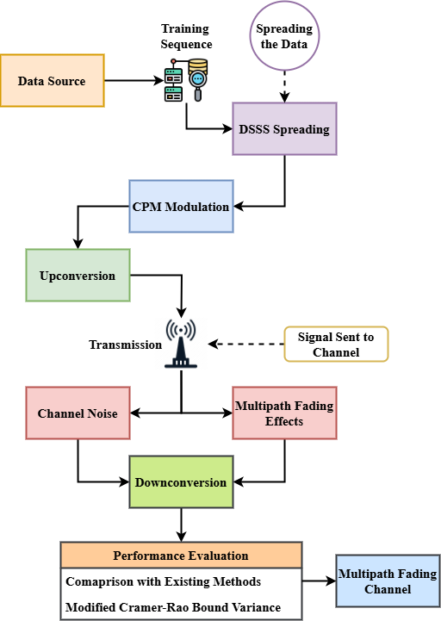
Figure 1: End-to-End Signal Processing Framework of DSSS-CPM Communication System
Figure 1 illustrates end-to-end signal flow of the desired DSSS-CPM communication system. The procedure begins with a training sequence having been ingrained for synchronization purposes and the data burst ready. Next DSSS assists in spreading the burst to enhance resistance to jamming. Lured by spectrum constriction and power economy, a bandwidth-efficient modulation method distinctive from others motivates this spread signal: continuous phase modulation (CPM). The modulated signal is down converted upon reception, followed by which the embedded training sequence is captured to estimate phase and time offsets after being transmitted through a potentially noisy and multipath-sensitive wireless channel. These estimates ensure synchronization of the signal thereby ensuring reliable data recovery. Particularly in the event of reactive jamming, this architecture is intended to maintain strong communication in adversarial environments. In real-time transmission, synchronizing precision, spectrum efficiency, and flexibility move to center stage across the entire pipeline.
$$q_{0}\frac{μ}{μt}=π\left({ερ}_{1}+ε^{2}ρ_{2}\right)*\left({ερ}_{1}+ε^{2}ρ_{2}\right)+ ε_{g}R_{x}\left(α,ε,t\right) (1)$$
Reflecting interference $q_{0}\frac{μ}{μt}$ is reduced in the proposed CLIA-AF technique, the equation 1 describes the interaction between influence variables ($π\left({ερ}_{1}+ε^{2}ρ_{2}\right)$) and the adapted filtering responses ($ε_{g}R_{x}\left(α,ε,t\right)$.

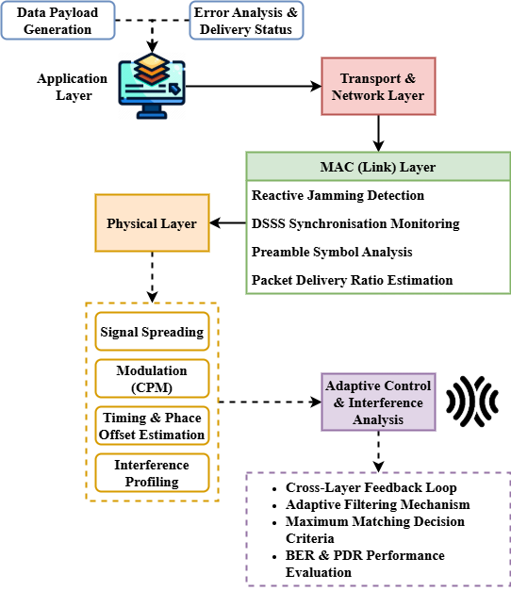
Figure 2: Cross-Layer Interference Analysis and Adaptive Filtering (CLIA-AF) Framework
Figure 2 depicts the proposed CLIA-AF system, which uses a cross-layer design to provide robust and secure anti-jamming communication. Spreading DSSS, profiling interference, and modulating CPM with a multi-tone signal and pseudo-random noise are all responsibilities of the physical layer. By calculating the Packet Delivery Ratio (PDR), identifying anomalous interference patterns, and observing DSSS synchronizer data, the MAC layer is supported. The separation of channel-induced losses and deliberate interference through chip-level analysis and MMDC-based BER estimates is one of the main innovations. Transport and application layers are able to optimize data and reporting systems by scheduling them based on lower-layer latency input. The adaptive filtering module that is at the heart of the architecture, dynamically alters the synchronizing and signal recovery processes in response to the interference degree and channel conditions. This cross-layer feedback mechanism ensures that the system maintains data integrity and synchronization accuracy, even in evolving wireless environments. The design is intended to ensure secure, real-time communications in a variety of assault and channel scenarios.
$$F^{-jwu}=\frac{φG_{m}\left(σ*\right)}{μ{G^{'}}_{m}\left(σπ\right)}*d.p+O\left(τ^{2}\right)*\frac{1}{2}∆q_{0}d_{0} (2)$$
With terms like $\frac{φG_{m}\left(σ*\right)}{μ{G^{'}}_{m}\left(σπ\right)}$ and $F^{-jwu}$ correlation with signal-to--interference ratios, $d.p+O\left(τ^{2}\right)$ the equation depicts error margins $\frac{1}{2}∆q_{0}d_{0}$ and shows the frequency-domain response of the adaptive filtering process.
Blending DSSS, CPM, and adaptive filtering, this method significantly enhances wireless strength. Across a spectrum of interference and multipath conditions, it achieves accurate jammer detection, reliable synchronisation, and outstanding performance.

Result and Discussion
The bit error rate, packet delivery ratio, and synchronizing precision of the proposed CLIA-AF method are analyzed in this section. Through comparative comparison with existing techniques, the outstanding performance of CLIA-AF is emphasized along with its reliability, flexibility, and robustness in dynamic and interference-rich communication environments..
Analysis of Bit Error Rate

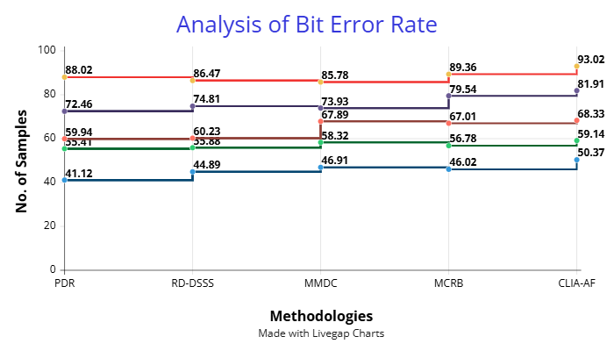
Figure 3: Analysis of Bit Error Rate

Figure 3 compares bit error rate performance across a number of methods. Out of all the proposed CLIA-AF methods, they consistently have the best level of precision, far surpassing existing techniques. CLIA-AF retains its superiority as the sample number increases, highlighting its ability to minimize data errors in real life under most conditions. While methods such as RD-DSSS and MMDC are some improvement, their performance continues to lag particularly in more data-intensive applications. MCRB functions satisfactorily under intermediate situations but can't keep pace with CLIA-AF's flexible nature. The combination of cross-layer analysis with adaptive filtering proves essential in detecting and correcting bit-level distortions. This performance emphasizes the reliability of the proposed method in ensuring data integrity and suggests its strong potential for practical deployment in wireless communication systems prone to interference and jamming. CLIA-AF's consistent error minimization makes it a standout approach in environments requiring robust transmission quality.
$$\frac{k^{3}n^{2}}{n^{2}ρ^{2}K_{z}}+d_{o}=\frac{1}{2φ}∂_{1}+∂_{2}*\left(r-a\right)\left(\frac{v_{x}}{d_{0}}\right) (3)$$
With $\frac{k^{3}n^{2}}{n^{2}ρ^{2}K_{z}}$the equation links the system's efficiency $d_{o}$ in terms of the signal strength $\frac{1}{2φ}∂_{1}+∂_{2}$, influence factors, and adaptive factors ($\left(r-a\right)\left(\frac{v_{x}}{d_{0}}\right)$). It aims to characterise the filtering alongside interference response depending on analysis of bit error rate.

Analysis of Packet Delivery Ratio
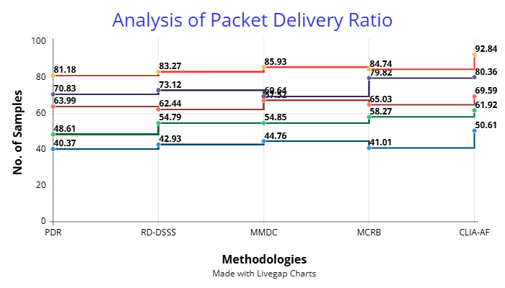
Figure 4: Analysis of Packet Delivery Ratio

Figure 4 offers analysis of many techniques' packet delivery ratio efficiency. Maintaining a good delivery rate even under limited sample circumstances and constantly improving as the data volume rises, the CLIA-AF approach turns up as the most dependable. Under demanding circumstances usually leading to reduced delivery dependability, CLIA-AF shines in preventing data loss as compared to alternative approaches. Although RD-DSSS and MMDC have quite decent delivery performance, they lack the flexibility and accuracy of CLIA-AF. Though it does not show the same degree of scalability or reactivity, MCRB stays constant in most cases. Combining direct sequence spreading with adaptive filtering systems, CLIA-AF's integrated method is clearly successful as shown by the widening performance difference between it and the other strategies. This makes CLIA-AF especially valuable for communication systems where maintaining a high delivery rate is crucial. The results validate its robustness and dependability in hostile wireless environments.
$$M\left(∅\right)+\left(\frac{1}{r}\right)=∂φ1+∂φ2* \frac{δ^{2}α_{2}}{{δu}^{2}}* εc_{0}G\left(y\right) (4)$$
The equation represents on signal processing $∂φ2* \frac{δ^{2}α_{2}}{{δu}^{2}}$ the effect of dynamic channel parameters ($M\left(∅\right)$) and interference mitigating $(∂φ1$). It aims to quantify how adaptive analyzing opinions (via $εc_{0}G\left(y\right)$) help to improve analysis of packet delivery ratio.
Analysis of Synchronization Accuracy

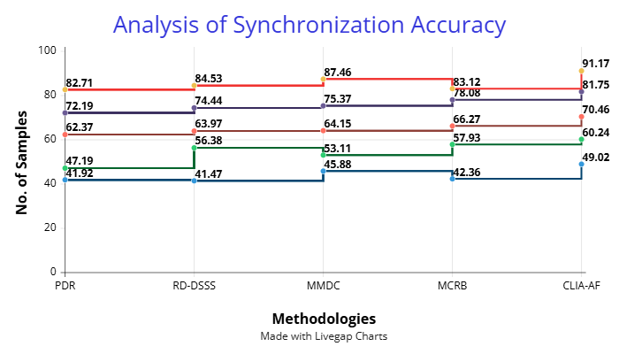
Figure 5: Analysis of Synchronization Accuracy

Figure 5 focuses on synchronization accuracy, a critical metric for ensuring successful communication timing and phase alignment. The CLIA-AF technique is exceptionally precise; the greater the sample, the better the result. It consistently outranks traditional thinking such as MCRB, MMDC, and RD-DSSS. The capability of CLIA-AF in estimating synchronizing parameters dynamically, even in noise and dynamic environments, is a measure of its power. While other techniques do show gains, they lose consistency and results achieved by CLIA-AF. Those systems that are based on precise timing so as to avoid data misalignment or loss rely particularly on this heightened synchronizing. CLIA-AF provides highly reliable synchronizing through a union of adaptive filtering and cross-layer interference analysis, hence leading to reduced bit errors and improved packet delivery. Its performance supports its suitability for today's wireless systems that demand accuracy in transmission and quickness.
$$\left[inr_{m}w=βr In (\left(r-a\right)\left(\frac{u_{r}}{c_{0}}\right)*\left(u-\frac{a}{d_{m}}\right)\right] (5)$$
The equation 5 represents $\left(\frac{u_{r}}{c_{0}}\right)$ on signal processing the effect of dynamic channel parameters ($βr In (\left(r-a\right)$ and interference mitigating ($inr_{m}w$). Its aim is to quantify how adaptive analyzing opinions (via $\left(u-\frac{a}{d_{m}}\right)$) help to improve analysis of synchronization accuracy.

Conclusion
This paper identified and reduced reactive jamming in DSSS systems through the application of a new approach to enhancing wireless communication using the CLIA-AF framework. Through the application of adaptive signal processing and cross-layer feedback systems, the new approach improved three critical performance metrics: bit error rate, packet delivery ratio, and synchronization accuracy. Most importantly, in conditions of high-interference and dynamic environments, test results indicated that CLIA-AF consistently performed better than other methods such as RD-DSSS, MMDC, and MCRB. The robustness of the design stems from its ability to actively differentiate between intentional jamming and losses caused by channels, thus facilitating more timely and effective counterattacks. Additionally, real-time adjustments introduced through adaptive filtering allow one to appreciate the immense system robustness and efficiency. These findings establish CLIA-AF as a scalable implementation vehicle to enhance security and reliability of communication in critical wireless devices. For military, industrial, and emergency communication systems since performance under harsh conditions is of high importance, the system yields immense advantages. This effort significantly contributes to the field of anti-jamming communication systems by way of integrating signal intelligence and cross-layer design concepts into a unified architecture.
Subsequent research will primarily focus on further developing the CLIA-AF framework to cover multi-hop and mesh networks—where distributed interference introduces more intricacy—such that it can support Integration of machine learning for dynamic pattern recognition and decision-making is yet another interesting avenue. Additionally explored is the technique for low-power embedded systems to remain relevant in IoT environments. In addition, additional research under real-world conditions and with different modulation schemes will be conducted to validate and fine-tune the system in numerous operating conditions.

References
- D. Giustiniano, V. Lenders, J. B. Schmitt, M. Spuhler, and M. Wilhelm, “Detection of reactive jamming in DSSS-based wireless networks,” Proceedings of the 6th ACM Conference on Security and Privacy in Wireless and Mobile Networks, pp. 43–48, 2013.
- J. O. Sosa, O. Sentieys, and C. Roland, “A diversity scheme to enhance the reliability of wireless NoC in multipath channel environment,” in Proceedings of the IEEE/ACM International Symposium on Networks-on-Chip (NOCS), Oct. 2018, pp. 1–8.
- J. D. Laster, and J. H. Reed, “Interference rejection in digital wireless communications,” IEEE Signal Processing Magazine, vol. 14, no. 3, pp. 37–62, 1997.
- N. Uchida, G. Sato, and Y. Shibata, “Device-to-Device Communication based DTN for Disaster Information System by using Emergent User Policy and Locational Information,” Journal of Internet Services and Information Security, vol. 9, no. 3, pp. 41–51, 2019.
- A. Mishra, K. Nadkarni, and A. Patcha, “Intrusion detection in wireless ad hoc networks,” IEEE Wireless Communications, vol. 11, no. 1, pp. 48–60, 2004.
- M. D. Anand, “Design and Development of Advanced Mechanical Systems,” Association Journal of Interdisciplinary Technology in Engineering and Mechanics, vol. 2, no. 1, pp. 1–6, 2024.
- G. Huang, Y. Yuan, X. Wang, and Z. Huang, “Specific emitter identification for communications transmitter using multi-measurements,” Wireless Personal Communications, vol. 94, pp. 1523–1542, 2017.
- P. S. Palash, and P. Dhurvey, “Influence and Prediction of Sintered Aggregate Size Distribution on the Performance of Lightweight Alkali-Activated Concrete,” Archives of Technical Science, vol. 2, no. 31, pp. 49–56, 2024.
- Y. Lu, and A. Finger, “Novel multi-correlation differential detection for improving detection performance in DSSS,” in Proceedings of the IEEE 11th International Symposium on Spread Spectrum Techniques and Applications, Oct. 2010, pp. 120–124.
- H. Fatima, “Copper nanoparticles induced oxidative stress and tissue integrity in gills and brain of Cyprinus carpio,” International Journal of Aquatic Research and Environmental Studies, vol. 4, no. 2, pp. 53–68, 2024.
- M. Pandey, “RIA: an RF interference avoidance algorithm for heterogeneous wireless networks,” in Proceedings of the IEEE Wireless Communications and Networking Conference (WCNC), Mar. 2007, pp. 4051–4056.
- B. M. Melgat, “Fuzzy Nbhd System in Fuzzy Top-R-Module,” International Academic Journal of Science and Engineering, vol. 11, no. 1, pp. 15–18, 2024.
- J. H. Chen, W. Y. Chen, and C. H. Chen, “Identification recovery scheme using quick response (QR) code and watermarking technique,” Applied Mathematics & Information Sciences, vol. 8, no. 2, pp. 585–590, 2014.
- T. C. Yang, and W. B. Yang, “Low probability of detection underwater acoustic communications for mobile platforms,” in OCEANS 2008, Sep. 2008, pp. 1–6.
- R. Ando, K. Takahashi, and K. Suzaki, “Inter-domain Communication Protocol for Real-time File Access Monitor of Virtual Machine,” Journal of Wireless Mobile Networks, Ubiquitous Computing, and Dependable Applications, vol. 3, no. 1/2, pp. 120–137, 2012.
- N. Karimov, “The Ecotourism Industry's Role in Environmental Stewardship,” Nature, Engineering and Science, vol. 9, no. 2, pp. 293–308, 2024.
- M. Liu, M. Zhang, D. Han, L. Lang, and P. Luo, “Performance analysis of a DSSS-based UV communication with inter-symbol interference,” in Proceedings of the 20th European Conference on Networks and Optical Communications (NOC), Jun. 2015, pp. 1–5.
- I. Pecheranskyi, O. Oliinyk, A. Medvedieva, V. Danyliuk, and O. Hubernator, “Perspectives of Generative AI in the Context of Digital Transformation of Society, Audio-Visual Media and Mass Communication: Instrumentalism, Ethics and Freedom,” Indian Journal of Information Sources and Services, vol. 14, no. 4, pp. 48–53, 2024.
- D. T. N. Huy, “Risk Level of Viet Nam Telecommunication Industry under Financial Leverage during and After the Global Crisis 2007–2009,” International Academic Journal of Innovative Research, vol. 5, no. 1, pp. 77–90, 2018.
- G. Arasuraja, “Organizational Change Management in Digital Transformation: A Framework for Success,” Global Perspectives in Management, vol. 2, no. 2, pp. 12–21, 2024.
- M. Spuhler, D. Giustiniano, V. Lenders, M. Wilhelm, and J. B. Schmitt, “Detection of reactive jamming in DSSS-based wireless communications,” IEEE Transactions on Wireless Communications, vol. 13, no. 3, pp. 1593–1603, 2014.
- Y. Liu, P. Ning, H. Dai, and A. Liu, “Randomized differential DSSS: Jamming-resistant wireless broadcast communication,” in Proceedings of IEEE INFOCOM, Mar. 2010, pp. 1–9.
- Q. Lu, “Performance Analysis for DSSS with Short Period Sequences Encountering Broadband Interference,” IEEE Transactions on Vehicular Technology, 2024.
- S. Shehzadi, S. A. Sheikh, F. Kulsoom, M. Zeeshan, and Q. U. Khan, “A robust timing and phase offset estimation technique for CPM-DSSS-based secured communication link,” IEEE Access, vol. 9, pp. 111143–111151, 2021.
- R. W. Klein, M. A. Temple, and M. J. Mendenhall, “Application of wavelet-based RF fingerprinting to enhance wireless network security,” Journal of Communications and Networks, vol. 11, no. 6, pp. 544–555, 2009.

