Optimizing Electrical Machines through Effective Stator Insulation Assessment for Maximum Performance

Anvesha Garg, Quantum University Research Center, Quantum University, Email: anvesha.garg@quantumeducation.in, Orcid Id: 0009-0006-2621-8763

Manish Nagpal, Chitkara Centre for Research and Development, Chitkara University, Himachal Pradesh-174103 India. manish.nagpal.orp@chitkara.edu.in https://orcid.org/0009-0000-9823-5251

Vibhor Mahajan, Centre of Research Impact and Outcome, Chitkara University, Rajpura- 140417, Punjab, India. vibhor.mahajan.orp@chitkara.edu.in https://orcid.org/0009-0007-8272-1547

G.RAVIVARMAN, Department of Electrical And Electronics Engineering, Karpagam Academy of Higher Education, Coimbatore- 641021. Email Id: ravivarmanme@gmail.com

S.RAM PRASATH, Department of Electronics And Communication Engineering, Karpagam College of Engineering, Coimbatore- 641032. Email Id: ramprasath.s@kce.ac.in

Dr.Priya Makhija, Associate Professor , Department of Management, School of Mangement - UG, JAIN (Deemed to be University), Bangalore, Karnataka, India, Email Id- priya_m@cms.ac.in

Abstract--- The basis of industrial and power plants are electrical machinery, whose operation mostly depends on the condition of stator insulation. Maintaining dependability, lowering downtime, and maximizing operational efficiency depend on accurate assessment of stator insulation. Current diagnostic techniques are unable of delivering real condition monitoring under various operating settings and lack sensitivity toward early-stage insulation defects. This work proposes a novel method based on Partial Discharge Measurement and Analysis (PDM-A) techniques to get beyond these restrictions. Using advanced signal processing and partial discharge event pattern analysis, the novel method allows one to identify early insulation breakdown. Early intervention made by the method makes predictive maintenance and longer machine lifetime feasible. Experimental validation shows that the approach proposed in this study significantly improves detection accuracy and dependability, thereby improving the evaluation of insulation condition. Usually, this approach increases machine performance and results in more efficient maintenance plans for electrical machine systems.
Keywords--- Stator Insulation, Electrical Machines, Partial Discharge Analysis, Condition Monitoring, Predictive Maintenance

Introduction
In industrial uses, energy generation, and transportation systems—where reliability, safety, and efficiency are critical—electrical equipment is indispensable [1]. Their operating is ecologically benign depending on the reliability of their stator insulation as a protective barrier against mechanical, thermal, and electrical stress [2]. The fast deterioration of insulation resulting from such pressures over time increases the partial discharge (PD) [3], a local dielectric anomaly that might eventually lead to insulation failure [4]. Appropriate monitoring and stator insulation analysis will help to prevent early machine failure and extend the service life of the machine [5] [6] [7]. Particularly when working conditions change [8], regular diagnostic methods include eye testing, tan delta tests, and insulation resistance testing often ignore early damage [9] [10]. These weaknesses lead to delayed issue identification that produces reactive instead of proactive maintenance schedules [11]. Under these constraints, more sophisticated diagnostic instruments are needed to ensure early and accurate problem detection [12]. This work presents a novel PDM-A framework based on signal pattern interpretation of discharge location [13] to improve diagnostic sensitivity [14]. The approach seeks to improve the general assessment of insulation state, therefore enabling predictive maintenance programs [15]. This enables perfect performance and reliability of electrical system.
More comprehensive insulation evaluations are driven by growing dependence on minimal downtime in electrical systems [16]. Still the most frequent machine breakdown causing downtime and costly repairs is stator insulation failure [17]. Preventive maintenance is challenging given the inaccuracy in early identification of existing approaches. The need for a more precise, faster diagnostic device that can contribute to proper maintenance planning and equipment life extension motivates this work [18]. Existing insulation condition assessment methods lack sensitivity in harsh working conditions to detect initial phases of stator deterioration. These techniques are not fit for use in predictive maintenance plans as their possible to provide erroneous or delayed findings [19]. The main emphasis of this work is the inadequacies of contemporary diagnostic instruments in sensitivity and resolution. To solve this, the proposed study presents a PDM-A framework aiming to more accurately identify early defects and enable quick intervention to improve performance.

Related Works
Related works focus on various diagnostic techniques for stator insulation assessment, including thermal analysis, impedance measurement, and conventional partial discharge testing. However, these methods often lack sensitivity and real-time applicability. Recent studies emphasize advanced signal processing and machine learning to enhance fault detection accuracy and enable predictive maintenance strategies.
Six-Sigma Principles (SSP)
Electrical machines are central to various systems and must now meet physical, technological, and environmental demands. As sustainability and efficiency grow in importance, design optimization has become increasingly complex, involving multiple engineering domains like electromagnetics, structural mechanics, and thermal analysis [20] [21]. Important optimization models, methods of analysis, and approaches used in electrical machine design are emphasized in this overview [22]. Two well-known techniques include multi-level optimization based on surrogate-models. Two more advanced approaches—a system-level optimization for electric drive systems and a strong design method using Six-Sigma Principles (SSP)—are also covered. The research also suggests using cloud computing and industrial big data for next intelligent design projects.
Reliability-Oriented Design Approach (RODA)
Rising demand for transportation electrification, particularly in flight, electrical equipment have to reach greater power densities under tight weight limits. Reliability has always been guaranteed by over-engineering, which restricts power density and generates design conflicts. This work presents a Reliability-Oriented Design Approach (RODA) by means of a multi-objective optimization approach including model-based lifespan prediction [23]. Accelerated thermal degradation tests on main-wall and turn insulation inform thermal lifetime models for both continuous and variable duty applications. A reliability-based optimization platform is developed, and a case-study aerospace machine is designed, optimized, and prototyped to validate the improved performance and predictive reliability of the proposed method.
Multilevel Inverters (MLIs)
Because of its low device stress, good power quality, and modular construction—which help to lower device stress—Multilevel Inverters (MLIs) find great use in medium-voltage systems like electric ships, aviation, and renewable energy. Still, the non-sinusoidal waveforms produced by MLIs may hasten motor insulation breakdown [24]. This work investigates insulation stress in stator windings under 3-, 5-, and 7-level inverter outputs as well as the effect of firing angles. Results show that insulation stress is much influenced by PWM waveform forms as well as output level count. Greater dielectric stress resulting from higher voltage RMS and higher firing angle indicates possible optimization possibilities to extend insulation life and power quality.
Physics of Failure (PoF)
Transportation electrification depends on low-voltage electric machines (EMs), which need small size and great power density. But notably in safety-critical industries like aviation, these performance targets may contradict dependability requirements. Though it raises EM size, over-engineering has long been utilized to guarantee safety. Reliability evaluation is therefore included into the design process utilizing the Physics of Failure (PoF) technique to go beyond this [25]. A major failure point in EMs is winding insulation, hence knowledge of its degradation processes is crucial. This article summarizes production techniques, insulating materials, and the main pressures influencing them. Additionally investigated are remaining usable life (RUL) estimates and insulation lifespan models for dependability-oriented design (RoD).

Proposed Method
This method uses Partial Discharge Measurement and Analysis (PDM-A) to assess stator insulation health in electrical machines, enabling early fault detection and improving reliability through predictive maintenance.

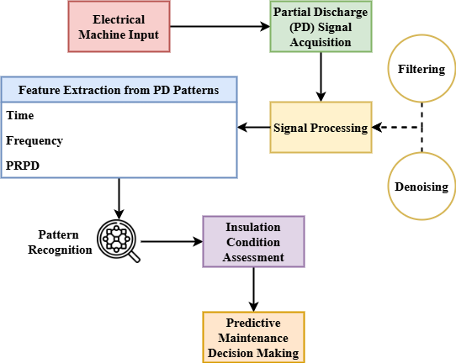
Figure 1: Framework of Stator Insulation Assessment using PDM-A

Figure 1 depicts the assessment of the insulating state of electric machine stators using Partial Discharge Measurement and Study (PDM-A). Under normal operation, the stator windings produce partially discharged signals. Raw data is preprocessed by denoising and filtering to identify relevant discharge events. Subsequent critical features such as frequency-domain and time-domain patterns are recovered and analyzed. The data is subsequently passed through an algorithm for recognizing patterns to sort insulation conditions based on discharge features. This leads to an overall assessment of insulating condition that guides decisions regarding predictive maintenance. The linear yet integrated method of the graphic shows how precisely early-stage insulation breakdown may be found. Combining signal analysis with fault classification improves condition monitoring and guarantees timely maintenance interventions by means of which the framework guarantees dependability and efficiency of medium-voltage electrical devices.
$$2q_{0}d_{0}=\left(\frac{σd}{σq}\right)+\frac{2θτq_{0}d_{0}}{d_{q }}*\frac{q_{0}}{d_{0}^{2 }}(\frac{ρ^{2}q}{{ρQ}^{2}})_{s,0} (1)$$
Modeling how partially $\left(\frac{σd}{σq}\right)$ discharged characteristics $2q_{0}d_{0}$ change under $\frac{2θτq_{0}d_{0}}{d_{q }}$ various stator circumstances, equation (1) shows a complicated interaction $\frac{q_{0}}{d_{0}^{2 }}(\frac{ρ^{2}q}{{ρQ}^{2}})_{s,0}$ between dielectric settings, discharge operation, and insulation stress.

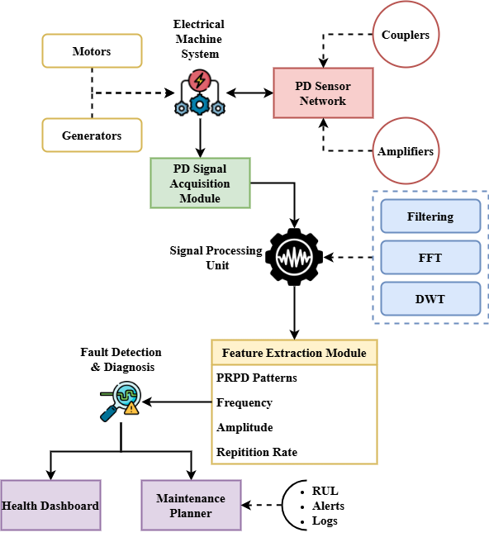
Figure 2: System Architecture for PDM-A Implementation

Figure 2 illustrates the modular system architecture supporting the implementation of the proposed PDM-A method in real-world applications. It begins with the electrical machine and associated partial discharge sensor network, which includes capacitive couplers and amplifiers. Signals collected from the machine are fed into the PD signal acquisition module, which manages real-time data collection and synchronization. The unit processing removes noise and applies sophisticated transformations like FFT or wavelets for enhancing interpretation. The extracted features are sent to a flaw detection diagnostic engine that employs either rule-based classification or machine learning. Results are communicated to a maintenance planning module where RUL forecasting and scheduling are enabled, and results are displayed graphically on a health dashboard to enhance operator awareness. This design helps in the creation of an automated and scalable predictive maintenance system by focusing on the right integration of sensing, processing, diagnostics, and decision-making. It supports dependability-oriented design and continuous monitoring in a range of industrial applications.
$$\frac{τ}{3!}\left(π-1\right)=(π-2)(\frac{p^{'}}{p_{0}})^{3}*\frac{τ}{2!}(π-1)(\frac{p^{'}}{p_{0}})^{2} (2)$$
Equation (2) approximates $\frac{τ}{3!}\left(π-1\right)$ the nonlinear interaction $(π-2)$ between stress-time elements impacting partial discharge $(\frac{p^{'}}{p_{0}})^{3}*\frac{τ}{2!}$ behavior in stator insulation $(π-1)(\frac{p^{'}}{p_{0}})^{2}$ and pressure fluctuations.
$$log*{\frac{\frac{1}{2π}}{Sv_{b}}=a{a^{'}}_{m}+}(p-p_{0})^{2}+\frac{c^{2}}{c_{0}^{2 }}-d_{0}\left[h\left(y\right)-h\left(x\right)\right] (3)$$
Reflecting complicated $\frac{\frac{1}{2π}}{Sv_{b}}$ interactions during partial discharge occurrences $a{a^{'}}_{m}$, equation (3) relates frequency-domain signal behavior $\frac{c^{2}}{c_{0}^{2 }}-d_{0}$ and protection stress change $d_{0}\left[h\left(y\right)-h\left(x\right)\right]$ with entropy-based discharge localization.
The proposed PDM-A framework enhances insulation diagnostics by combining signal processing and fault classification. It ensures timely maintenance, extends machine lifespan, and supports optimized performance in critical applications.

Result and Discussion
This section presents a comparative analysis of the proposed PDM-A method against conventional approaches in assessing insulation health. Key parameters such as Partial Discharge Inception Voltage and Insulation Lifetime Estimation are examined to evaluate performance improvements in fault detection, reliability prediction, and overall machine operational effectiveness.

Table 1: Comparative Evaluation of Insulation Assessment Methods
Methodology | Advantages | Disadvantages
SSP (Six-Sigma Principles) | Simple implementation, low cost | Low sensitivity to early faults, limited diagnostic depth
RODA (Reliability-Oriented Design Approach) | Incorporates reliability considerations, supports robust design | Requires detailed modeling, lacks real-time feedback
MLIs (Multilevel Inverters) | Effective for medium-voltage applications, reduces device stress | High insulation stress due to non-sinusoidal excitation, complex control
PoF (Physics of Failure) | Root-cause analysis, supports lifetime modeling | Complex modeling, not easily adaptable to real-time monitoring
PDM-A (Partial Discharge Measurement and Analysis) | High accuracy, real-time monitoring, early fault detection, lifetime prediction | Requires advanced processing and sensor integration, higher initial setup cost
Methods of insulation testing that can be applied in use on electric equipment with strengths and weaknesses characterized in the comparative table, this new PDM-A technique discussed here is one among the only handful. Six-Sigma Principles (SSP) and Reliability-Oriented Design Approach (RODA) are unsuitable for on-time application and detection of premature failures despite advantages and ease of application. Even though non-sinusoidal waveforms introduce tremendous insulation stress in Multilevel Inverters (MLIs), they find application in medium-voltage. Though its offline nature and complexity limit the Physics of Failure (PoF) approach, it provides excellent understanding of failure processes. The PDM-A technique, in contrast, stands out for excellent diagnostic precision, instantaneous signal monitoring, and ability to predict insulating lifetime. Although it is more advanced in terms of equipment and processing power, its benefits typically outweigh the initial cost. This contrast demonstrates the technical and practical nature of the proposed approach to condition-based maintenance and reliability improvement in contemporary electrical equipment.
Analysis of Partial Discharge Inception Voltage

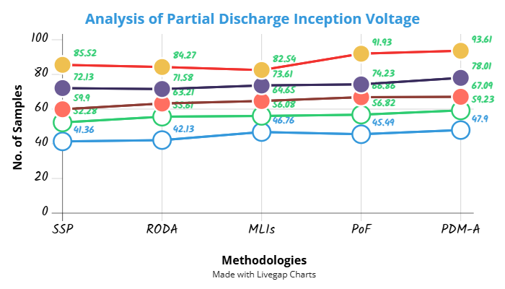
Figure 3: Analysis of Partial Discharge Inception Voltage

Figure 3 shows how several techniques measure partial discharge inception voltage (PDIV). The PDM-A approach outperforms the other methods tested (SSP, RODA, MLIs, PoF, and the suggested PDM-A) in all sample sets. This higher inception voltage suggests that insulating systems evaluated using PDM-A may better tolerate electrical stress prior to partial discharge initiation. Such behavior reflects a more robust and resilient insulation structure. Traditional methods, such as SSP and MLIs, show noticeable variability and lower PDIV values, suggesting reduced sensitivity in early fault detection. The inclusion of signal processing, feature extraction, and fault classification in PDM-A enables more accurate diagnostics. These results illustrate how the method could detect low levels of insulation degradation before it culminates into severe failure. The proposed methodology, involving early insulation measurement and correct maintenance planning, enhances overall electrical equipment reliability.
$$\frac{B}{2A}=(\left(\frac{q^{'}}{q_{0}}\right)+\frac{1}{4} ×\left[\frac{d}{b}\right]*d_{0}+\left(\frac{c}{2A}\right)Uv^{'} (4)$$
Equation (4) characterizes $\frac{B}{2A}$ the interplay of normalized charge fluctuation $\left(\frac{q^{'}}{q_{0}}\right)$, geometric variables $\frac{1}{4} ×\left[\frac{d}{b}\right]$, and voltage-related expelled activity $d_{0}+\left(\frac{c}{2A}\right)$ affecting insulation behavior $Uv^{'}$. It corresponds with the suggested partial discharge, thereby enhancing analysis of partial discharge inception voltage.

Analysis of Insulation Lifetime Estimation
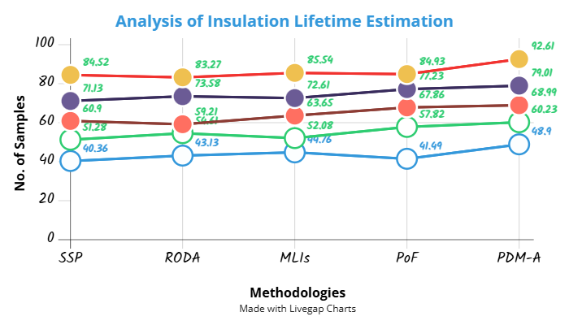
Figure 4: Analysis of Insulation Lifetime Estimation

The performance of most methods of estimating the insulation lifetime based on their ability to predict the Remaining Useful Life (RUL) of stator insulation is indicated by Figure 4. Again better than the conventional techniques like SSP, RODA, MLIs, and PoF is the PDM-A technique. More consistent across the set of samples, the determination of the insulating life by using PDM-A indicates improved health evaluation and longer operational life expectancy. PDM-A takes our understanding of the causes of insulation ageing to a higher level in contrast to earlier systems based on pre-defined safety margins or rudimentary diagnostics utilizing machine learning examination and real-time partial discharge monitoring data. This leads to a more accurate estimation of the insulation's lifetime equivalent to less unplanned downtime and maintenance. The graph shows how precisely and uniformly the method identifies insulating properties in multiple stress profiles. By providing more precise life predictions, the PDM-A model enhances long-term planning along with identifying problems at the beginning stages.
$$\frac{q^{2}}{q_{0}^{2 }}=1+-\frac{1}{2}\left(\frac{q^{'}}{q_{0}})^{2}\right]+…+1+\frac{C}{2A^{'}} *π\left(\frac{p^{'}}{p_{0}}\right) (5)$$
Incorporating for improved sensitivity $\frac{q^{2}}{q_{0}^{2 }}$, equation (5) predicts $\frac{1}{2}\left(\frac{q^{'}}{q_{0}})^{2}\right]$ the development of the partial discharge quantity $1+\frac{C}{2A^{'}}$ as a function of normalized control $π\left(\frac{p^{'}}{p_{0}}\right)$and pressure changes. Recording tiny insulating deterioration patterns helps to analysis of insulation lifetime estimation.

Conclusion
This study proved an entire process to identify the insulation of stator windings using PDM-A so that electrical equipment can operate efficiently and for a longer period. The proposed system can identify early signs of insulation degradation accurately by implementing feature-based fault classification, advanced signal processing, and real-time signal acquisition. When applied under various test conditions, the results indicated that there were dramatic increases in Partial Discharge Inception Voltage (PDIV) and Insulation Lifetime Estimation compared to traditional methods such as SSP, RODA, MLIs, and PoF. Through condition-based maintenance strategies, the PDM-A method does not only enhance sensitivity of problem detection but also enhances the remaining usable life (RUL) of electrical equipment. The method is especially beneficial for safety-critical and high-performance applications in fields such as renewable energy and aviation, as it enables dependability-oriented design (RoD) through enhanced diagnostics and predictive features. Systematic utilization of partial discharge data enhances decision-making for lifespan management and machine operation. The results suggest that the PDM-A approach provides a pragmatic and adaptable solution to guaranteeing the health of insulation that in turn enhances the longevity of machines, minimizes downtime, and facilitates the design of sustainable electric machines in the transportation and industrial sectors.
The PDM-A framework's automation and intelligence will be improved through the implementation of deep learning techniques for adaptive fault classification in future development. The integration with industrial IoT equipment will also enable real-time cloud-based diagnostics and remote monitoring. Experimental verification will be conducted to demonstrate the generalizability and robustness of the system across a diverse array of environmental and workload conditions. A digital doppelganger model will be developed to simulate the degrading behavior of insulation, enabling predictive analytics to be conducted throughout the electrical machine's lifespan.

References
- C. Stone, I. Culbert, E. A. Boulter, and H. Dhirani, “Electrical insulation for rotating machines: design, evaluation, aging, testing, and repair,” John Wiley & Sons, 2014.
- S. B. Lee, K. Younsi, and G. B. Kliman, “An online technique for monitoring the insulation condition of AC machine stator windings,” In IEEE Transactions on Energy Conversion, vol. 20, no. 4, pp. 737–745, 2005.
- G. Bramerdorfer, J. A. Tapia, J. J. Pyrhönen, and A. Cavagnino, “Modern electrical machine design optimization: Techniques, trends, and best practices,” In IEEE Transactions on Industrial Electronics, vol. 65, no. 10, pp. 7672–7684, 2018.
- M. A. Saidel, M. C. E. S. Ramos, and S. S. Alves, “Assessment and optimization of induction electric motors aiming energy efficiency in industrial applications,” In The XIX International Conference on Electrical Machines (ICEM 2010), pp. 1–6, 2010.
- V. Madonna, P. Giangrande, and M. Galea, “Influence of insulation thermal aging on the temperature assessment in electrical machines,” In IEEE Transactions on Energy Conversion, vol. 36, no. 1, pp. 456–467, 2020.
- V. Venkatesh, and S. R. Menaka, “Density base Road Accident Control Sensor Monitoring Using Dynamic Network Topology Graph Framework,” In International Journal of Advances in Engineering and Emerging Technology, vol. 10, no. 2, pp. 16–26, 2019.
- S. Lawa, and R. Krishnan, “Policy Review in Attribute Based Access Control—A Policy Machine Case Study,” In Journal of Internet Services and Information Security, vol. 10, no. 2, pp. 67–81, 2020.
- V. Madonna, A. Walker, P. Giangrande, G. Serra, C. Gerada, and M. Galea, “Improved thermal management and analysis for stator end-windings of electrical machines,” In IEEE Transactions on Industrial Electronics, vol. 66, no. 7, pp. 5057–5069, 2018.
- S. Grubic, J. M. Aller, B. Lu, and T. G. Habetler, “A survey on testing and monitoring methods for stator insulation systems of low-voltage induction machines focusing on turn insulation problems,” In IEEE Transactions on Industrial Electronics, vol. 55, no. 12, pp. 4127–4136, 2008.
- A. A. M. B. Khalek, and M. N. B. Mohamad, “Critical Success Factors for Effective HACCP systems,” In International Academic Journal of Innovative Research, vol. 5, no. 2, pp. 37–46, 2018.
- V. Shrivastava, and M. Ahmed, “The Function of the Blockchain System in Enhancing Financial Integrity and the Confidence of Society,” In Global Perspectives in Management, vol. 2, no. 4, pp. 36–45, 2024.
- C. Dong, Y. Qian, Y. Zhang, and W. Zhuge, “A review of thermal designs for improving power density in electrical machines,” In IEEE Transactions on Transportation Electrification, vol. 6, no. 4, pp. 1386–1400, 2020.
- M. A. Kabir, M. Z. M. Jaffar, Z. Wan, and I. Husain, “Design, optimization, and experimental evaluation of multilayer AC winding for induction machine,” In IEEE Transactions on Industry Applications, vol. 55, no. 4, pp. 3630–3639, 2019.
- A. Kumar, and P. Yadav, “Experimental Investigation on Analysis of Alkaline Treated Natural Fibers Reinforced Hybrid Composites,” In Association Journal of Interdisciplinary Technics in Engineering Mechanics, vol. 2, no. 4, pp. 25–31, 2024.
- P. Vij, and P. M. Prashant, “Predicting aquatic ecosystem health using machine learning algorithms,” In International Journal of Aquatic Research and Environmental Studies, vol. 4, no. S1, pp. 39–44, 2024.
- H. Dewangan, and T. Dewangan, “Sophisticated Design and Integrative Modeling of Sustainable Environmental Practices in Contemporary Pharmacy and Pharmaceutical Industries,” In Natural and Engineering Sciences, vol. 9, no. 2, pp. 395–406, 2024.
- H. Raziq, M. Batool, F. Nawaz, A. Akgül, F. Afzal, and M. K. Hassani, “A review on analysis and modeling of electrical machine insulation system,” In Cogent Engineering, vol. 11, no. 1, 2400614, 2024.
- I. Stevovic, S. Hadrović, and J. Jovanović, “Environmental, social and other non-profit impacts of mountain streams usage as Renewable energy resources,” In Archives for Technical Sciences, vol. 2, no. 29, pp. 57–64, 2023.
- G. Lei, J. Zhu, and Y. Guo, “Multidisciplinary design optimization methods for electrical machines and drive systems,” Springer, Berlin/Heidelberg, vol. 691, 2016.
- J. Sun, Y. Wang, H. Si, J. Yuan, and X. Shan, “Aggregate Human Mobility Modeling Using Principal Component Analysis,” In Journal of Wireless Mobile Networks, Ubiquitous Computing, and Dependable Applications, vol. 1, no. 2/3, pp. 83–95, 2010.
- V. Jayasree, and M. D. Baby, “Scientometrics: Tools, Techniques and Software for Analysis,” In Indian Journal of Information Sources and Services, vol. 9, no. 2, pp. 116–121, 2019.
- G. Lei, J. Zhu, Y. Guo, C. Liu, and B. Ma, “A review of design optimization methods for electrical machines,” In Energies, vol. 10, no. 12, 1962, 2017.
- Z. Chen, X. Huang, A. Liu, Y. Ma, J. Zhang, Q. Zhang, and Z. Li, “Reliability-oriented multiobjective optimization of electrical machines considering insulation thermal lifetime prediction,” In IEEE Transactions on Transportation Electrification, vol. 10, no. 1, pp. 2264–2276, 2023.
- A. Y. Mirza, A. Bazzi, H. H. Nguyen, and Y. Cao, “Motor stator insulation stress due to multilevel inverter voltage output levels and power quality,” In Energies, vol. 15, no. 11, 4091, 2022.
- X. Zhou, P. Giangrande, Y. Ji, W. Zhao, S. Ijaz, and M. Galea, “Insulation for Rotating Low-Voltage Electrical Machines: Degradation, Lifetime Modeling, and Accelerated Aging Tests,” In Energies, vol. 17, no. 9, 1987, 2024.

