Optimizing Big Data for Data-Driven Decision Making with an In-Depth Evaluation
Dr. Maneesh Kumar, School of Engineering and Computer, Dev Bhoomi Uttarakhand University, Uttarakhand 248007, socse.maneesh@dbuu.ac.in
Dr. Dilrajpreet Kaur, Department of Physics, School of Basic & Applied Sciences, K. R. Mangalam University, Gurugram-122103, Haryana, INDIA, dilraj.k@krmangalam.edu.in

Dr. Akash Sanghi, Department of Computer Science & Engineering, Invertis University, Bareilly, Uttar Pradesh 243123, akash.s@invertis.org
K. Yuvaraj, Department of Computer Science, Karpagam Academy of Higher Education, Coimbatore- 641021, Email Id: yuvaraj.k@kahedu.edu.in

C.Mukuntharaj, Department of Electronics and Communication Engineering, Karpagam College of Engineering, Coimbatore- 641032, Email Id: mukuntharaj.c@kce.ac.in

Dr. Hannah Jessie Rani R, Assistant Professor, Department of Electrical and Electronics Engineering, School of Engineering and Technology, JAIN (Deemed to be University), Bangalore, Karnataka, India, Email Id- jr.hannah@jainuniversity.ac.in

Abstract--- The increasing volume, velocity, and variety of data have made Big Data an essential component for enabling data-driven decision-making across industries. This study explores how optimizing Big Data analytics can significantly enhance business intelligence and strategic planning. However, traditional data processing methods often struggle with real-time analysis, lack of scalability, and fragmented data sources, leading to delayed and less accurate decision-making. These limitations hinder organizations from harnessing the full potential of their data assets. To address these challenges, we propose a comprehensive framework integrating real-time data streaming into a centralized data lake, enabling dynamic dashboards powered by Big Data Analytics (BDA). This architecture supports predictive business intelligence by processing structured and unstructured data at scale, delivering insights in real time. The proposed method is applied in various business environments to assess performance metrics, customer behavior, and market trends with greater speed and accuracy. By continuously ingesting and analyzing data from multiple sources, the system facilitates timely and informed decisions. Findings from the implementation reveal a marked improvement in decision accuracy, operational efficiency, and responsiveness to market changes. The framework also demonstrates superior scalability and adaptability compared to traditional systems, making it a robust solution for modern enterprises aiming for competitive advantage through data-driven strategies.
Keywords--- Big Data Analytics, Data-Driven Decision Making, Real-Time Data Streaming, Data Lake, Predictive Business Intelligence, Dynamic Dashboards.

Introduction
Information has emerged as one of the most valuable resources at the disposal of businesses in today's fast-moving digital environment [1]. Businesses are increasingly seeking ways to leverage the exponential growth of information generated from numerous sources ranging from social media which the interactions tends to commercial sensors to inform strategic decisions [2]. It tends to be the driven data for making the decision become absolutely critical to modern-day business operations [3]. Employing Big Data technology is able to enable companies to discover valuable insights, forecast future patterns, and enhance operative efficiency [4]. However, good data optimization methods are needed to transform big, diverse datasets into useful insight.
Despite the excellent advances in data processing, traditional analytics software may not be able to cope with the complexity and volume of contemporary data [5]. Traditionally batch-oriented, traditional methods are not suited to real-time analysis [6]. Additionally challenging to such systems integration of data It end up experiencing delays, mistakes, and dispersed insights that ultimately lead to missed opportunities and inefficient company processes [7]. Such sectors as the logistics, retail, and healthcare where speedy judgments are extremely critical exemplify this inefficiency particularly. This analysis proposes an original scheme blending real-time data relay with lake information that are centralized by the framework to address these limitations [8] [9].
Ongoing data ingestion from numerous sources into one platform where it is cleaned, processed, and warehoused is facilitated through this blended method. Dynamic dashboards offer interactive, real-time images that support predictive business intelligence, thus enhancing the infrastructure [10]. It is fueled by through the Analytics of Big Data, which empowers this method to provide prescriptive and predictive analytics as well as historical and descriptive information, hence helping companies make informed and proactive decisions [11]. The only strength of the proposed method lies in its ability based on the unstructured and structured analysis on real-time thus ensuring always up-to-date and contextually relevant information [12]. With Apache Kafka for online streaming of data, Hadoop and Amazon S3 to remain lake data, and tools that resemble Apache Spark and visualization by the data analytics for power BI, scalability, flexibility, and effectiveness in the setup are assured [13].
It allows businesses to view patterns, identify anomalies, and more accurately forecast outcomes. Additionally, utilization of this setup ensures perfect decision-making by numerous stakeholders and departments [14]. The leaders analytics with the predictive access, consumer behavior analysis, and simple dashboards aggregating key performance indicators (KPIs). It enhances the overall agility of the firm as well as reducing the data-related reaction time required [15].
The platform is also versatile enough for most industries and domains, which assists companies attempting to optimize their Big Data potential [16]. Employing real-time streaming together with technologies and data lake to optimize Big Data depicts a paradigm-breaking method of making decisions [17]. Transcending the deficiencies of traditional methods, the proposed architecture forms the foundation for an additional smart, responsive and data-focused corporate setting. Highlighting its effectiveness in enabling powerful, data-led strategies, this research delves further into the structure, usage, and outcomes of the proposed method [18].
- This article presents a robust structure for real-time data consumption and analysis, hence allowing businesses to develop insights with minimum delay. Minimizing decision latency enables the system to enhance the speed and accuracy of strategic and operational decisions, thus allowing businesses to respond promptly to emerging trends and issues.
- The primary contributions is the seamless combination analytics by streaming the real-process and a data lake is centralized. The blend provides one platform for big data high-volume processing and allows the framework to handle data that is structured and also unorganized at scale. Such efficient transformation and data movement is made possible to a large extent through technologies like the Spark and Apache Kafka.
- Also part of designed with interactive, dynamic and the system to improve predictive business intelligence. With the dashboards, and algorithms which are predictive dashboards allow users to view emerging trends, monitor real-time KPIs, and make decisions based on them. This enables companies to transition from reactive to ready planning, thus improving strategic foresight and overall resource allocation.
The paper discusses the related work in the section 2 followed by the research methodology in the section 3. The section 4 deals with the results and discussion followed by the conclusion and future work in the section 5.

Related Works
The batch processing and traditional data storage methods have been utilized widely, but they typically don't have real-time adaptability and flexibility [19]. Merging data stores and analytical streams together to enhance scalability and reduce latency has recently come into focus. At the core of such breakthroughs have been technologies like the observe and Hadoop. Even then, most present approaches continue to struggle with aggregating numerous sources of data and presenting forecasted insights rendered in real-time. Based on such foundations, our research creates a more nimble and responsive data-driven decision system.
Intelligent Data-Driven Approach (ID-DA)
The combination of optimization methods with intelligent data-driven strategies is investigated in this chapter as a means of addressing the complex problems confronted by companies in the data-rich world of today. The article underlines the need of optimization when making decisions and the part data-driven methods such as artificial intelligence, machines learning, and big data analytics play in improving decision quality via intelligent use of data [20]. Including adaptive algorithms, metaheuristic computational methods, and swarm intelligence approaches, the chapter investigates some frequently used optimization methods in intelligent data-driven decision-making. It addresses their strengths and constraints in many application fields, therefore clarifying their possible advantages for companies. Furthermore discussed in the chapter is the junction of computing techniques and optimization strategies as well as how data-driven methods could solve challenging optimization challenges.
Big Data - Driven Education (BD-DE)
In big data education evaluation, the five main goals are as follows: high-order thinking analysis, performance in learning prediction, learning recognition of emotions, instructional decision-making, and evaluation method optimization [21]. One commonality is the use of text as a data collection tool for high-order thinking investigation. Regardless of the goals of evaluation, the most common object of evaluation is students in higher education. Big data technology is primarily being used in the scientific field to empower teaching evaluation. Lastly, in the field of big data educational institutions evaluation, the current focus is on studying online learning action and environmental participation, designing data mining-based learning analysis frameworks, cognitive medical and high-order thinking skills, and emotional and motivational learning process evaluation.
Data-Driven Transformation (D-DT)
Using examples of how big data has improved decision-making, quality of data, and risk management, this research delves into the revolutionary effects of big data on business financial management [22]. Improved financial reporting, more accurate decision-making, and improved integration of varied data sources are the results of this mixed-methods study's use of meta-analysis, inquiries, interviews, and case studies. Along with real-world advantages like faster data processing and more accurate credit risk assessments, there are also real-world obstacles including a lack of data science talent, cultural pushback, and technological hurdles when trying to integrate new systems with older ones. It will need strategic leadership, ongoing training, and investments in scalable infrastructure to overcome these obstacles.
Data-Driven Decision Making (D-DM)
This study conducts an in-depth investigation of data-driven bridge O&M making decisions in the present day by critically reviewing 485 papers [23]. The investigation covers topics such as common data kinds, data management challenges, and typical application domains that make use of this data. There are a number of obstacles to establishing data-driven bridge O&M decision-making, including inconsistent data requirements, poor data integration, and an absence of defined processes. New avenues for investigation into these problems are suggested for the future. Together, the data and applications identified in this study may assist O & M teams make educated choices that meet their goals, and it can also provide the groundwork for further research in this area [24].
This paper offers a fresh approach for best using Big Data to improve data-driven decision-making. Dealing with the shortcomings of conventional analytics systems, the suggested approach combines dynamic dashboards with real-time data streaming to create a centralized data lake. The framework offers an indicator business intelligence precise conclusions enabled by contemporary Big Data technologies. The way the technology is used in many corporate settings shows better operational efficiency, decision accuracy, and flexibility. This study provides a road map for using scalable and responsive data analytics Facilities in dynamic corporate environments and emphasizes the transforming power of customized Big Data systems in producing agile, insight-driven businesses.

Proposed Method
Using a robust architecture that integrates real-time data streaming with a lake centralized data to enable dynamic, predictive decision-making using the BDA, the proposed solution offers. Essentially, the framework allows you to continuously consume organized and unorganized data from numerous sources such as IoT devices, networking websites, business systems, and so on. This information is and processed and cleaned by data-management platform such as Hadoop or cloud storage. Integrating analytics engines made up of software for the Spark Apache such as Power BI or Tableau builds dynamic dashboards with information which are up-to-date. The intelligence facilitated by this seamless pipeline improves responsiveness, supports stakeholders' ability to make rapid, data-based decisions at numerous organizational tiers.
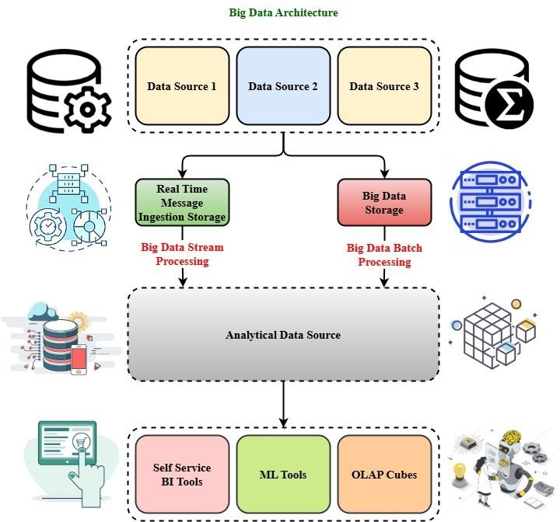
Figure 1: Architecture of Big Data Overview
Demonstrating the well-organized sequence of data from numerous sources to analytical and decision-making tools, Figure 1 presents a full view of architecture by Big Data. This begins with three varied logs unstructured, transaction with data structure with data sources and sensor-created information that collectively portray a variety of inputs. Two concurrent processing streams proceed from these sources. For applications that require real-time insight, like fraud detection or IoT device monitoring, one approach processes real-time data through an intake message system, thus supporting Big Data Stream Processing. Suitable for analyzing historical trends and large datasets at scheduled intervals, the second approach directs the data to Massive Data Storage to supply batch processing.
Processing streams converge into source data common analytics. Aggregated data is ordered, stored, the additional investigation from this entity into a sole repository. With this analytical hub, the information is then filtered into three overall technology tools feeding strategic insights and choice-making. Self-service tech business intelligence technologies allow customers to probe data and develop reports using minimal technological aptitude. Employing this info, machine learning algorithms develop anticipation models and establish patterns. Lastly, the utilization of OLAP cubes assist in performing multidimensional analysis, hence enhancing the ability to examine data from numerous directions. The scalable architecture were efficient way of processing, analyzing, and deriving data in a larger value.
$sinsin σθ\left(\frac{mπy}{M}\right)-coscos \left(φt-L_{a}A\right)+sinsin \left(\frac{mπy}{M}\right)+\frac{d_{0}}{L_{a}} (1)$
Like real-time Big Data systems $\frac{d_{0}}{L_{a}}$, equation (1) depicts the dynamic interplay $sinsin \left(\frac{mπy}{M}\right)$ of many variables by use of analogue s$coscos \left(φt-L_{a}A\right)$. The cosines $sin\left(\frac{mπy}{M}\right)$ and sine components $sinσθ$ describe geographical and temporal variations.

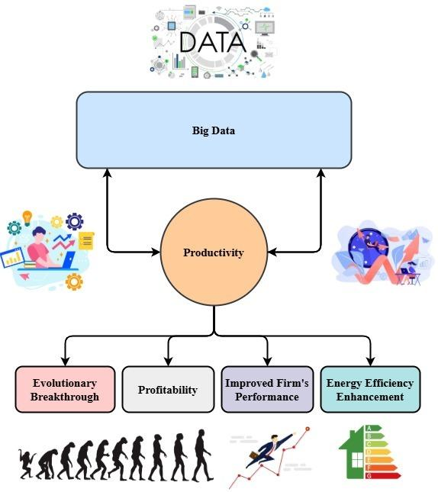
Figure 2: Productivity and Big Data Relationship through Outcomes
Figure 2 illustrates the connection between the big data and productivity of the organization, thus emphasizing how data-driven strategies can enhance overall performance of the company. This was a central to the image and is both influenced by and a product. This two-way relationship emphasizes how when businesses utilize Big Data to enhance in turn efficiency and productivity generates more data, thus creating a constant feedback loop enabling even greater innovation and advancement.
$\frac{{∆β}_{1}}{∆_{A}}=\frac{1}{ρ}+\frac{ρx}{ρu}+d_{0}*{[L}^{2}-\frac{m^{2}δ^{2}}{(M^{2})^{\frac{1}{2}}}]+ {\frac{W}{d}}_{0}*cos⁡(2mαx/L) (2)$
While the proposed Big Data framework $\frac{{∆β}_{1}}{∆_{A}}$ connects many data influences $\frac{1}{ρ}+\frac{ρx}{ρu}$that result in a nonlinear clothing ${[L}^{2}-\frac{m^{2}δ^{2}}{(M^{2})^{\frac{1}{2}}}$, the framework's real-time data combination ${\frac{W}{d}}_{0}$ and processing enable subtle insights into business metrics $cos⁡(2mαx/L)$, so improving the accuracy and depth of business choices.
The diagram also elucidates the prime outcomes of such synergy. Companies may achieve transforming benefits when efficiency rises through judicious big data utilization. The range from capability strides in operations marking significant technological or procedural breakthroughs that are emblematic of large scientific breakthroughs. Coupled with innovation, enhanced profitability arises from decision-making based on data that maximizes utilization of resources and minimizes waste. The performance of the whole company also gets improved in categories such as customer satisfaction, responsiveness, and internal efficiency. Another significant consequence is enhanced energy efficiency as statistics enable firms to monitor consumption patterns and implement plans to reduce environmental impact. The visual story of this number emphasizes the strategic imperative of aggregating Big Data into core business operations to promote development, innovation, and environmentally sustainable success.
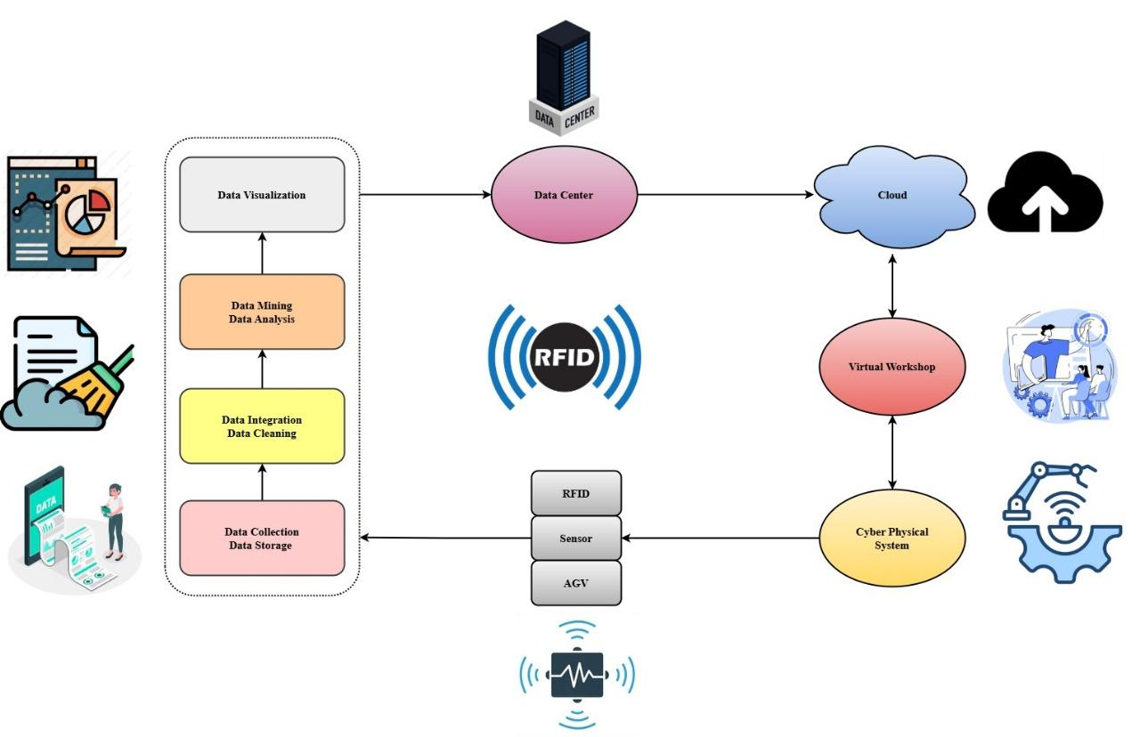
Figure 3: Integration of RFID with the Cyber-Physical Data Flow
Figure 3 illustrates dynamic data flow across and thus illustrates how various used to foster smart manufacturing and digitalization. Essentially, real-time data is collected from the physical environment through observation and broadcasting operating data. The raw data undergoes many crucial stages by the chain processing the data. The information is initially collected and stored before being cleaned and combined to ensure consistency and accuracy. Clean data is then subjected to mining and analysis techniques to discover actionable insights. New data visualization technologies assist one in viewing such insights graphically, thus facilitating decision-making. A central data center receives the processed information and acts as the focal point for data storage and management within the system.
$\frac{ρ^{2}τ_{2}}{{ρu}^{2}}-\frac{{ρw}^{3}}{{2L}_{a}^{2}}=\left(\frac{ρ^{2}τ_{2}}{{ρy}^{2}}+\frac{ρ^{2}τ_{2}}{{ρa}^{2}}\right)-coscos \left(\frac{2nπy}{M}\right)+B\left(a\right) (3)$
Equation (3) reflects $\frac{ρ^{2}τ_{2}}{{ρu}^{2}}$ how the suggested $\frac{{ρw}^{3}}{{2L}_{a}^{2}}$ Big Data architecture harmonizes $\left(\frac{ρ^{2}τ_{2}}{{ρy}^{2}}+\frac{ρ^{2}τ_{2}}{{ρa}^{2}}\right)$ many data inputs provide coherent $coscos \left(\frac{2nπy}{M}\right)+B\left(a\right)$ insights by showing a balance of complicated variables and oscillatory behavior.
Through scalable access and seamless data sharing, the cloud is connected with the data center. The information is fed into a virtual factory environment simultaneously, which mirrors the real workshop within a digital environment, thus providing remote monitoring with simulations. A direct connection with the Cyber-Physical System via this virtual setting makes control over body functions as well as live feedback feasible. Based on the automation and transfer for the wireless, the entire design demonstrates how electronic and physical systems interact to enhance operational agility, data-driven monitoring, and industry 4.0 efficiency environments.
Through a centralized data lake construction streaming data real-time, which proposed method offers a unified framework in big data that enhances decision-making data-driven. This sets to ensure an excellent access to new and relevant information by continuously and the data repository is set during this process. The elastic data lake repository with elastic assists in storing large unstructured and structured amount data. The similar real-time analytics and Apache Spark engines analyze such data to make actionable insights available, which are then displayed on dynamic dashboards via Power BI. Such a process supports predictive intelligence along with increasing precision and speed in decision-making. The structure ensures scalability, flexibility, and effectiveness in the processing of challenging, high-velocity data landscapes and is suited to many industries.

Results and Discussion
Demonstration of the proposed Big Data paradigm reveals drastic boosts in system scalability, predictiveness, and efficiency in decision making. Data were collected and tested from numerous sources in real time across multiple corporate environments, hence demonstrating the versatility and responsiveness of the approach. Performance was benchmarked by utilization of core measures of effectiveness such as system throughput, user participation, and decision lag. The discussion revolves around how quicker, data-informed actions facilitated by real-time analytics and real-time dashboards assisted in reducing operating bottlenecks and strategic planning. Comparative analysis of traditional systems highlights the advantages of adding a centralized repository of data for company information management as well as data streaming.
Analysis of scalability
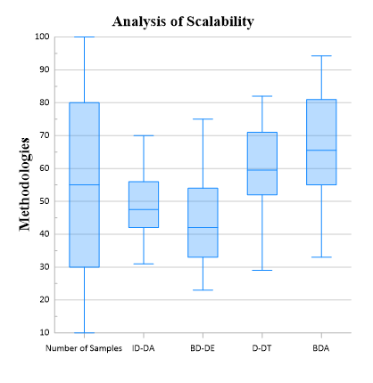
Figure 4: Analysis of Scalability
Four models ID-DA, BD-DE, D-DT, and BDA were tested for scalability over varying sample sizes, as presented in Figure 4. Patterns of performance vary as the sample size is larger. D-DT is not stable, BDA is robust with large samples, whereas ID-DA and BD-DE have varying levels of scalability and stability, as they typically increase and then decrease.
$c_{0}A_{a}=εc_{0}\frac{mγ}{k_{z}M}[coscos ( φu-k_{a}A)coscos \left(\frac{nπy}{L}\right)*(\frac{k}{k_{z}})^{3} (4)$
Equation (4) represents $εc_{0}\frac{mγ}{k_{z}M}$ the interplay of frequencies, amplitude $c_{0}A_{a}$, and phase parallelling how the suggested Big Data platform $coscos ( φu-k_{a}A$ catches real-time oscillations $coscos \left(\frac{nπy}{L}\right)*(\frac{k}{k_{z}})^{3}$ across corporate operations.
Analysis of adaptability
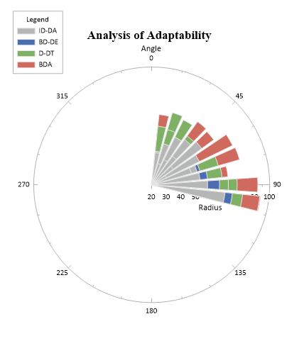
Figure 5: Analysis of Adaptability
Figure 5 illustrates the outcome of an experiment of the four models' flexibility with growing sample sizes for ID-DA, BD-DE, D-DT, while BDA. BDA's consistent outperformance is demonstrated by strong adaptability. ID-DA and BD-DE show significant improvements after 60 samples, while D-DT continues to exhibit steady development. When working with larger datasets, BDA exhibits improved flexibility in general.
$[coscos ( 2φt-{2k}_{z}z)=c_{0}\left(\frac{2m}{k_{a}M}\right)+\frac{1}{2π}*sinsin \left(\frac{2nπx}{L}\right)] (5)$
Equation (5) shows a wave-based interacting $coscos ( 2φt-{2k}_{z}z$of temporal and location variables, much $\frac{1}{2π}*sinsin \left(\frac{2nπx}{L}\right)]$ as the suggested Big Data architecture $c_{0}\left(\frac{2m}{k_{a}M}\right)$ integrates real-time data from many sources.
The findings show that with the ability to provide instantaneous feedback and predictive insights, the proposed architecture significantly enhances decision-making. The combined streaming system and data lake decreased latency, increased data accuracy, and offered dynamic reporting compared to traditional system processing by batch. Users reported being able to access relevant information faster and having their decisions better informed. The system's flexibility was further supported by its effective scaling through various corporate realms. The architecture was shown overall demonstrable improvements on responsiveness strategic and operational efficiency, thus validating its suitability for firms seeking robust, services by the real-time in a bid to remain competitive in a data-driven economy.

Conclusion
Companies must adopt intelligent, scalable, and instant solutions to compete in an era when information is being generated at unprecedented velocities. This paper introduced and evaluated a robust infrastructure for the big data to deliver business intelligence and dynamic dashboards by integrating real-time data streaming with a centrally situated information lake. The proposed solution addresses the inherent limitations of traditional data processing systems such as latency, scalability challenges, and lack of effective communication among data sources.
Through utilization of contemporary Big Data technology such as visualization, Spark, Hadoop, Kafka Apache such as Power BI, the framework facilitates effortless processing, storage, and ingestion which have numerous datasets. Speedier, more precise, context-specific decision-making enabled by it assists businesses in acting swiftly on insights obtained from real-time information. Predictive analytics assists businesses to anticipate and deal with operational risks, consumers' behavior trends, and market dynamics.
Robust accuracy with the responsiveness, term performance and adaptability in a variety of business scenarios is evidenced by the trial results regarding the process of the functions. This facilitates cross-functional collaboration, organizational flexibility, and the entire ecosystem of decision-making improvement. Furthermore, although data volumes continue to grow, its scalable architecture ensures long-term applicability and utilization.
Finally, for organizations attempting to transform raw data into actionable knowledge, optimizing Big Data through this combined approach demonstrates a strategic benefit. A solid foundation for data-driven strategy with an innovation roadmap in predictive intelligence by the business in real-time, the proposed framework exhibits in both dimensions.

Future Works
Future research should focus on enhancing the proposed artificial intelligence and neural network system for automated pattern detection and decision recommendations. Especially in IoT-driven applications, integration with advanced computing can potentially further reduce latency and performance. Additionally crucial for safe and ethical big data usage will be examining data compliance, secrecy, and the governance of data frameworks. Practical applications in various domains will establish the scalability, adaptability, and impact of the framework in a variety of organizational settings.

References
- H. Liao, Y. He, X. Wu, Z. Wu, and R. Bausys, “Reimagining multi-criterion decision making by data-driven methods based on machine learning: A literature review,” Information Fusion, vol. 100, p. 101970, 2023.
- A. F. Skarmeta, M. V. M. Cano, and A. Iera, “Guest editorial: Smart things, big data technology and ubiquitous computing solutions for the future Internet of Things,” Journal of Wireless Mobile Networks, Ubiquitous Computing, and Dependable Applications, vol. 6, no. 1, pp. 1–3, 2015.
- A. C. Ikegwu, H. F. Nweke, C. V. Anikwe, U. R. Alo, and O. R. Okonkwo, “Big data analytics for data-driven industry: a review of data sources, tools, challenges, solutions, and research directions,” Cluster Computing, vol. 25, no. 5, pp. 3343–3387, 2022.
- L. Zigui, F. Caluyo, R. Hernandez, J. Sarmiento, and C. A. Rosales, “Improving communication networks to transfer data in real time for environmental monitoring and data collection,” Natural and Engineering Sciences, vol. 9, no. 2, pp. 198–212, 2024. https://doi.org/10.28978/nesciences.1569561.
- K. Akileswaran, V. Velmurugan, and K. Akshykumar, “IoT based industrial automation for real-time operation control using robust machine supervisory control algorithm,” International Journal of Advances in Engineering and Emerging Technology, vol. 9, no. 4, pp. 13–26, 2018.
- G. Papadopoulos, and M. Christodoulou, “Design and development of data driven intelligent predictive maintenance for predictive maintenance,” Association Journal of Interdisciplinary Technics in Engineering Mechanics, vol. 2, no. 2, pp. 10–18, 2024.
- S. Avancha, and A. Aggarwal, “Data-driven decision making in IT service enhancement,” SSRN, no. 4982779, 2024.
- Z. Karimov, and R. Bobur, “Development of a food safety monitoring system using IoT sensors and data analytics,” Clinical Journal for Medicine, Health and Pharmacy, vol. 2, no. 1, pp. 19–29, 2024.
- C. Wu, P. Wu, J. Wang, R. Jiang, M. Chen, and X. Wang, “Critical review of data-driven decision-making in bridge operation and maintenance,” Structure and Infrastructure Engineering, vol. 18, no. 1, pp. 47–70, 2021.
- L. Li, J. Lin, Y. Ouyang, and X. R. Luo, “Evaluating the impact of big data analytics usage on the decision-making quality of organizations,” Technological Forecasting and Social Change, vol. 175, p. 121355, 2022.
- E. Veera Boopathy, M. A. Y. Peer Mohamed Appa, S. Pragadeswaran, D. Karthick Raja, M. Gowtham, R. Kishore, P. Vimalraj, and K. Vissnuvardhan, “A data driven approach through IOMT based patient healthcare monitoring system,” Archives for Technical Sciences, vol. 2, no. 31, pp. 9–15, 2024, https://doi.org/10.70102/afts.2024.1631.009.
- L. Lin, D. Zhou, J. Wang, and Y. Wang, “A systematic review of big data driven education evaluation,” Sage Open, vol. 14, no. 2, p. 21582440241242180, 2024.
- W. Zhu, “A study of big‐data‐driven data visualization and visual communication design patterns,” Scientific Programming, vol. 2021, p. 6704937, 2021.
- S. Abbasi, and B. Vaziri, “Clustering algorithms in big data,” International Academic Journal of Science and Engineering, vol. 2, no. 2, pp. 182–192, 2015.
- A. Tripathi, T. Bagga, S. Sharma, and S. K. Vishnoi, “Big data-driven marketing enabled business performance: A conceptual framework of information, strategy and customer lifetime value,” in 2021 11th International Conference on Cloud Computing, Data Science & Engineering (Confluence), 2021, pp. 315–320, IEEE.
- N. Ashal and A. Morshed, “Balancing data-driven insights and human judgment in supply chain management: The role of business intelligence, big data analytics, and artificial intelligence,” Journal of Infrastructure, Policy and Development, vol. 8, no. 6, pp. 3941, 2024.
- C. Riley, J. Vrbka, and Z. Rowland, “Internet of things-enabled sustainability, big data-driven decision-making processes, and digitized mass production in industry 4.0-based manufacturing systems,” Journal of Self-Governance and Management Economics, vol. 9, no. 1, pp. 42–52, 2021.
- W. Assegid, and G. Ketema, “Assessing the effects analysis of climate change on aquatic ecosystems,” Aquatic Ecosystems and Environmental Frontiers, vol. 1, no. 1, pp. 6–10, 2023.
- E. Gutierrez-Franco, C. Mejia-Argueta, and L. Rabelo, “Data-driven methodology to support long-lasting logistics and decision making for urban last-mile operations,” Sustainability, vol. 13, no. 11, p. 6230, 2021.
- I. H. Sarker, “Data science and analytics: An overview from data-driven smart computing, decision-making and applications perspective,” SN Computer Science, vol. 2, no. 5, p. 377, 2021.
- S. Rahmani, H. Aghalar, S. Jebreili, and A. Goli, Optimization and computing using intelligent data-driven approaches for decision-making, CRC Press, 2024, pp. 90–176.
- M. A. Al-ma’aitah, “The drivers of big data analytics adoption and its impact on corporate entrepreneurship,” Journal of Internet Services and Information Security, vol. 14, no. 2, pp. 145–168, 2024, https://doi.org/10.58346/JISIS.2024.I2.010.
- M. A. Rauf, S. A. Shorna, Z. H. Joy, and M. M. Rahman, “Data-driven transformation: Optimizing enterprise financial management and decision-making with big data,” Academic Journal on Business Administration, Innovation & Sustainability, vol. 4, no. 2, pp. 94–106, 2024.
- D. Diwakar, and J. Roy, “The role of data analytics in digital transformation: A study of how firms leverage data for insights,” Indian Journal of Information Sources and Services, vol. 14, no. 4, pp. 29–34, 2024, https://doi.org/10.51983/ijiss-2024.14.4.05.

