Revolutionizing the Future with 6G Networks Powered by Artificial Intelligence

Amit Kansal, Quantum University Research Center, Quantum University, Email: amit.kansal@quantumeducation.in, Orcid Id: 0009-0006-5541-8289
Pradeep Marwaha, Chitkara Centre for Research and Development, Chitkara University, Himachal Pradesh-174103 India. pradeep.marwaha.orp@chitkara.edu.in https://orcid.org/0009-0004-0997-0668
Amit Kumar, Centre of Research Impact and Outcome, Chitkara University, Rajpura- 140417, Punjab, India. amit.kumar.orp@chitkara.edu.in https://orcid.org/0009-0001-9561-2768
M.VIGENESH, Department of Computer Science Engineering, Karpagam Academy of Higher Education, Coimbatore- 641021, Email Id: vigenesh.murugesan@kahedu.edu.in

S.RAM PRASATH, Department of Electronics And Communication Engineering, Karpagam College of Engineering, Coimbatore- 641032, Email Id: ramprasath.s@kce.ac.in

Ms.Saritha Srinivasmurthy Raghotham, Assistant Professor, Department of Management, School of Mangement - UG, JAIN (Deemed to be University), Bangalore, Karnataka, India, Email Id- saritha_sr@cms.ac.in

Abstract--- The integration of 6G networks with Artificial Intelligence (AI) is poised to revolutionize the digital landscape by delivering ultra-low latency, massive connectivity, and intelligent automation. This transformation will enable futuristic applications such as holographic communication, digital twins, and real-time immersive experiences. However, current communication frameworks face several challenges including high latency, centralized data processing bottlenecks, and significant privacy concerns due to data aggregation in centralized AI models. These limitations hinder real-time performance and scalability in highly dynamic environments. To address these issues, we propose a novel framework based on Federated Learning (FL) across distributed 6G edge devices. FL enables collaborative model training directly on edge devices without the need to transfer raw data to a central server, thus preserving user privacy while reducing communication overhead. The proposed method harnesses the power of edge-AI integration, allowing devices to learn from local data while periodically aggregating model updates via a decentralized mechanism. This approach ensures adaptive learning, real-time decision-making, and resilient network performance across diverse 6G-enabled services. Experimental evaluations demonstrate that the FL-enabled 6G architecture significantly improves inference accuracy, reduces end-to-end latency, and enhances data privacy. The findings suggest that this method not only meets the demands of next-generation applications but also offers a sustainable path toward intelligent and secure network evolution.
Keywords--- 6G Networks, Artificial Intelligence, Federated Learning, Edge Computing, Data Privacy, Real-Time Systems.

Introduction
From the way individuals communicate to the way entire companies operate, the ongoing evolution which has been pivotal in transforming the characteristics process [1]. Each generation has brought a significant boost led to reduced latency, increased speeds, and greater widespread connectivity [2] [3]. By enabling a hyper-connected, intelligent, and immersive setting, 6G networks will transform the digital landscape as we are on the threshold of the next important technical revolution [4] [5]. 6G is a paradigm shift toward ubiquitous intelligence, as opposed to its predecessors, where deeply embedded in the network's core and edge infrastructure, as opposed to just the gain [6]. Real-time holography, autonomous equipment, tactile the net, broader reality (XR), and some of the innovative applications this seamless integration aims to enable [7] [8].
Even if 6G possesses transformative potential, existing trends suitable requirements of this future-generation the infrastructure [9]. Traditional centralized AI models may require significant data transfers from edge devices to data center servers, thus inducing latency, bandwidth saturation, and significant privacy and security concerns [10]. Furthermore, the heterogeneity processing power, connectivity reliability, and power consumption adds complexity to implementing intelligent services efficiently and securely [11]. These challenges highlight the urgent need for a new strategy that can leverage distributed intelligence to break free from limitations of centralized architectures. Motivated by these critical issues, this paper introduces a new framework employing [12] [13].
Prompted by these vital issues, the present work provides a new approach based educate [14]. FL emerges as a paradigm of machine learning that allows common models to be trained across a number of distributed edge devices holding local samples of data without uploading them [15] [16]. This strategy solves the key problems posed by centralized AI systems by storing data locally and thus significantly enhances privacy by reducing transmission costs [17]. In the context of 6G, FL perfectly aligns with the concept of edge-centric intelligence, where data is processed closer to its origin to ensure quicker. Harnessing the interoperability of edge computing and AI, this proposed FL-enhanced 6G infrastructure forms the optimal environment for adaptive real-time learning [18] [19].
Individual models being trained at each node on its local data are updated in only model parameter space to facilitate the transport without heavy updates; and sharing merely model parameter differences enables scalability [20]. By harnessing the synergies between AI and edge computing, this proposed FL-supported 6G framework builds an optimum environment for real-time adaptive learning. Most apt for many applications and versatile 6G application scenarios, a distributed learning platform ensures confidentiality, scalability, and robustness [21]. This paper primarily provides an indication of how the inclusion of FL within 6G infrastructure could significantly enhance network smartness. The experiments and performance evaluations show significant improvements in latency reduction, model accuracy, and user data security [22]. The findings not only validate the proposed strategy but also provide a basic stepping stone toward the development of an even wiser, safer, and more successful 6G network platform capable of enabling the digital advances of the future.
Contributions of the Paper:
- This offers a decentralized artificial intelligence system with a distributed 6G edge device utilizing federated learning (FL) to reduce data transmission and enhance privacy. Offers the model updates that are tailored to optimize the responsiveness and scalability of network in dynamic environments.
- It explains how the centralized positioning system solution eliminates the need for raw user data to be centralized on servers thus lowering privacy issues. Through processing data at the edge, minimizes latency significantly and ensures speedy, context-rich judgments critical for next-generation technologies such through autonomous systems.
- Experiments, compared to traditional centralized artificial intelligence approaches, provided better model accuracy and reduced communication overhead in test environments. Verifies the feasibility and effectiveness of the proposed architecture in achieving intelligent, secure, and process are continuous processes for future 6G network services.
The section 2 is regarding the related works followed by the research methods in the section 3. The section 4 is based on the results and discussion along with the conclusion and future works in the section 5.

Related Words
Numerous studies have explored the ways in which artificial intelligence (AI) and wireless networks may be used to enhance performance and flexibility. While widely used in 5G systems, machine learning centralized algorithms are based on the latency, data privacy, and scalability. The federated Learning (FL) has recently gained attention as a remedy for these issues as it enables distributed training across edge devices. Current AI-based networking technologies are examined in this section along with the need for greater flexibility and privacy protection network by the 6G networks.
Artificial Intelligence in 6G (AI-6G)
A wide range of artificial intelligence (AI) technologies for diverse wireless networks are covered in this study. We also showcase a number of AI-powered apps that use AI to help wireless networks progress in the way we want them to. In addition, the article delves deeply into the challenges of unresolved research in this field, which mirror the tendencies in future research on wireless networks enabled by artificial intelligence. With the help of our numerous recommendations, wireless networks may become smarter and more capable of handling complex issues. Researchers can gain a thorough understanding of current wireless network designs according to AI technology and quickly identify intriguing unsolved topics to explore in their research by reading this paper.

Artificial Intelligence in Machine Learning (AI-ML)
With this integration, we are entering a new age of self-optimizing, intelligent networks that will change the way we engage with technology. We also provide a comprehensive evaluation of possible obstacles to the rollout of 6G, addressing important issues like as technological limitations and regulatory concerns. This paper [23] sheds insight on the emerging field of artificial intelligence and 6G by describing the existing state of affairs and outlining potential future directions. The purpose of this study is to serve as a foundational resource by answering important concerns, shedding light on hitherto unexplored aspects of 6G networks, and encouraging additional research in this complex field. It is that by drawing attention to the ways in which 6G and AI cooperate, we can shed light on the future of this dynamic industry.
Artificial Intelligence-Based Non-Terrestrial Networks (AI-NTN)
Sixth Generation (6G) networks are anticipated to rely heavily on Non-Terrestrial Networks (NTN) to deliver services that are scalable, continuous, and pervasive. The widespread coverage, stable positions, scalability, and compliance with international norms of satellites make them the principal enabling technology for NTN. There are a number of distinct difficulties associated with NTN that is based on satellites. Doppler shifts, frequent handovers, complicated spectrum sharing, and complex beam and resource allocation [24]. Task loading, network routing techniques, network slicers and numerous other new issues are introduced by 6G's implementation of NTNs into terrestrial networks. This research suggests AI as a potential solution to all these problems by taking advantage of its capacity to detect complex relationships between various network parameters.
Artificial Intelligence Enabled Digital Twin (AI-DT)
This article delves into the topic of 6G AI-enabled DTN and how wireless networks have progressed. Secondly, we go over the fundamentals of 6G, including how AI-enabled DTN drives improvements in areas like data offloading, caching, resource allocation, and data security. Finally, we go into depth on the critical enabling technologies that will allow AI-enabled DTN in 6G to reach its full potential. The practical significance and significance of AI-enabled DTN within 6G are highlighted for a number of industries, including smart cities, healthcare, transportation, and more [25]. It offer some takeaways, point out some problems and potential solutions, and suggest some avenues for further study into AI-enabled DTN under 6G.
From traffic prediction to resource scheduling, the researched literature demonstrates significant progress in employing artificial intelligence to optimize network performance. While centralized artificial intelligence offers high precision, it compromises user privacy and lags behind real-time responsiveness. New FL methods enhance scalability and distributed model training, thus bridging these gaps. The majority of contemporary systems, however, remain tethered by 5G use cases, highlighting the necessity of advanced FL architectures specifically designed for the unique needs of 6G environments.

Research Methods
This paper introduces system that shares cognitive capability among edge devices to solve the limitations of traditional centralized AI in 6G networks—like high latency, bandwidth limitations, and privacy compromise. Each 6G advantage device in this system the models trained locally by sharing only model updates rather than raw data using information it produces itself. Periodically merged updates facilitate enhancement of a global model through data privacy preservation and minimal communication overhead. Utilizing edge nodes' processing capacity, the distributed approach facilitates real-time training and decision-making at the proximity of data sources. Besides enhancing the responsiveness and data security, the proposed FL architecture ensures scalability in diverse environments typical of 6G networks. Such an approach provides a good foundation for facilitating smart, adaptable, and privacy-protecting generation of wireless communication networks by incorporating artificial intelligence directly into the edge infrastructure.

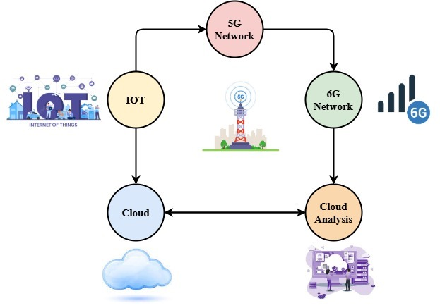
Figure 1: Workflow Integration of the Cloud-Based Analysis for 6G Networks

Figure 1 illustrates the connected workflow within cloud computing infrastructures to provide informed processing of data and decision-making, wireless networks of 5G and 6G, continuously collect data from their environment to initiate the process. Depending upon availability, along with system setup, this data is transmitted over the 6G networks.
As data transfer capacity is enhanced, the 5G Network becomes more significant in current communications systems. Conversely, the 6G Network—represented as a parallel track—provides superior bandwidth, ultra-low latency along with and enables intelligence by edge to be implemented. The transition considers the highlights of the advancement toward the smarter and quicker connection required in real-time applications.
The information goes through advanced Cloud Analysis after it is introduced into the cloud infrastructure. Through the use of machine learning, and artificial intelligence as well as federated learning methods, this step aims to obtain predictions, trends, and useful insights. The results of the analysis are then passed back through the cloud layer and forwarded to IoT devices so that decision-making in operations can be improved.
This figure conveys the data-driven, cyclical interaction between cloud analytics, communication systems, and IoT that opens up the door to a secure, intelligent, and adaptive place in industry 4.0, medical treatment, smart cities, and beyond.
$$\frac{q^{'}}{q}*1+\left(\frac{p}{p_{0}}+1\right)=2m+1\left(∆^{2}.∆^{3}\right)+\frac{1}{2}-\left(β-1\right) (1)$$
Commonly employed in signal engineering $\frac{1}{2}-\left(β-1\right)$ or data transmission, equation (1) seems to reflect a hybrid performance factors (such as averaged velocity $\frac{q^{'}}{q}*1$, pressure proportion $\left(\frac{p}{p_{0}}+1\right)$, and other mechanism coefficients) with controlling aspects like $2m+1\left(∆^{2}.∆^{3}\right)$.

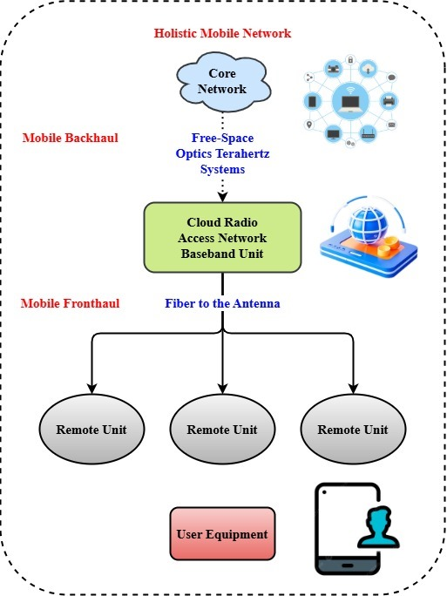
Figure 2: Holistic Mobile Network Architecture with Cloud Communication

Taking care of routing the data and authenticating as well as common connectivity, the Top Core Network comprises the building blocks' central brain of the network. Free-Space provide an unparalleled, high-throughput backhaul solution capable of supporting ultra-high rates required in 6G networks, hence establishing connectivity between the core network and mobile access network.
Figure 2 presents a complete view of the design of a Holistic Mobile Network encompassing advanced wireless communication technologies as well as cloud access with radio. This illustration indicates, by making use of both mobile backhaul and smartphone fronthaul systems, end-to--end data which are set to the network central to the user equipment (UE).
The (C-RAN) features duplicates and consolidates broadcasting processing functions next, thereby boosting scalability and power frugality. Through the utilization of high-speed fiber-to---the-antenna cables, such a BBU connects multiple Remote Units (RUs), thereby developing a handheld fronthaul segment. For purposes of providing glitch-free, latency-free connectivity, each Remote Unit is located by design at or close to the edge user location. These components transmit and receive signals between and from IoT gadgets, wearables, or cell phones. Ceremonial arches to fourth-generation telecommunications frameworks, such design provides cutting dynamics in networks dynamically, controls resources intelligently, and supports varied service deployment.
$$\frac{dp}{ρ}=\frac{d_{0}^{2}}{σ}-1+θ\left(\frac{∂τ}{∅}∅\right).∆+ ∆∅-\frac{1}{d_{0}^{2}\left|\frac{σ_{Q1}^{2}}{s}\right|} \left(2\right)$$
Incorporating physical $∆+ ∆∅$ as well as computational parameters such antenna aperture $\frac{dp}{ρ}=\frac{d_{0}^{2}}{σ}$, signal difference $1+θ\left(\frac{∂τ}{∅}∅\right)$, and combined learning responsiveness $\frac{1}{d_{0}^{2}\left|\frac{σ_{Q1}^{2}}{s}\right|},$ equation (2) seems to model.

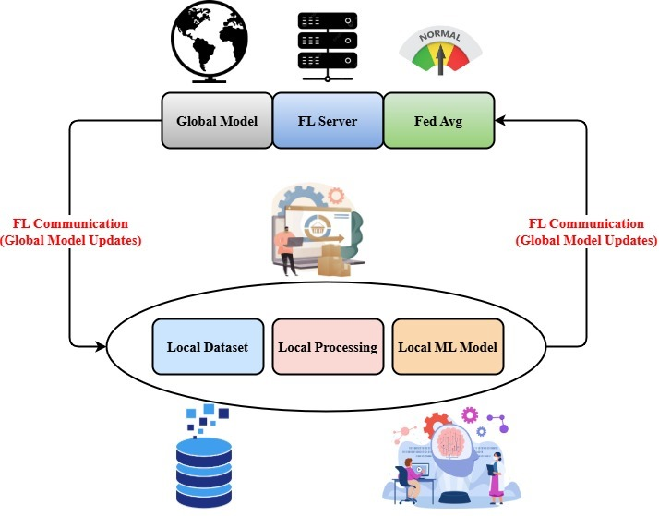
Figure 3: Privacy-Preserving Architecture by Federated Learning

Figure 3 depicts learning approach secured by data security and privacy architecture. Only model updates are shared with a central server under this paradigm, while training data remains local to personal edge nodes or devices. Each client device on the base side of the diagram handles an independent Local Dataset where the data is collected and pre-processed. Using this local private data, the local processor builds an native model by the machine learning. Maintaining privacy of the users, these computational models are updated independently without sharing raw data.
$$\frac{b^{2}}{J}+\ln\left[1+\frac{A}{d}\right]=\frac{1}{q_{2}}∆+\frac{1}{q_{m }}∆*q_{0}\exp\left(\frac{a^{2}}{b^{2}}+\frac{-kR^{2}}{2}\right) (3)$$
Equation (3) represents transmission energy density $\frac{1}{q_{2}}∆+\frac{1}{q_{m }}∆$ and system entropy by encapsulating a hybrid physical-computed interaction where $\frac{b^{2}}{J}$ relates to antenna distance $q_{0}\exp\left(\frac{a^{2}}{b^{2}}+\frac{-kR^{2}}{2}\right)$ and data intensity $\frac{1}{q_{2}}∆$.

Local training creates updates from all clients routed back to a critical FL Server through updates. Redistributed amongst consumers for subsequent training cycle, the updated worldwide model forms an extended learning circle. Ensuring sensitive data remain local, this enables group model enhancement. This kind of architecture fits well with health, finance, and intelligent appliance applications where confidentiality of data matters because it in general permits high-strength privacy-conscious machine learning using distributed context.
With the goal of offering intelligent, low-latency, and privacy-preserving services, the proposed approach offers architecture tailored to 6G networks. In contrast to traditional require raw shipped to central server equipment, this approach allows edge devices to train models based on their local data. Only sharing model parameters increases privacy substantially and reduces bandwidth use. The system accumulates these local updates from time to time in order to generate a global model, thus supporting cooperative learning at the cost of not compromising on data security. Utilizing the computing resources of scattered 6G edge nodes, the method supports instantaneous processing at network edges. It tackles in future-generation networks significant problems. It unfurls an efficient and secure by shifting intelligence away from the center towards the edge, hence providing a broad variety of 6G applications such as smart cities, autonomous cars and virtual augmented worlds.

Results and Discussions
The deployment of the proposed federated learning (FL)-assisted framework within an emulated 6G network setup is described in this section. The performance of the approach was tested through performance metrics such as latency, model accuracy, communication effectiveness, and privacy of data. Comparative analysis against traditional models centralized by the intelligence of artificial highlighted the advantages of distributed learning. Highlighting the benefits based on the intelligence, particularly by the designs of real-time adaption, and secure data handling using heterogeneous network environments, the presentation explores how the proposed method meets future 6G applications' requirements.
Analysis of Latency
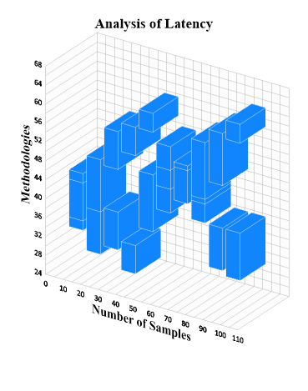
Figure 4: Analysis of Latency
Across rising sample sizes, Figure 4 illustrates the latency analysis of four different intelligent interaction frameworks AI-6G, AI-ML, AI-NTN, and FL-6G. FL-6G initially demonstrates consistent and better latency performance; it reaches peak latency at 100 samples with minimum latency. On the contrary, AI-NTN exhibits unpredictable performance with excessive latency peaks at 90 and 100 samples. While AI-6G maintains competitive latency up to the mid-point before increasingly falling, the figure shows AI-ML with consistent but negligible performance. Especially using larger datasets, the figure highlights FL-6G's improved scalability and flexibility, which makes it most suitable for real-time 6G applications, such as federated learning integration in distributed settings.
$$\left(2m+1\right)+H_{N}\left(\frac{1}{∂}\right)=\left(RR^{'}\right)q_{m+n}(∅+\cos{φ)++B_{m}H_{m}^{'}\left(\frac{1}{β}\right) (4) }$$
Federated Learning (FL)-enabled Terahertz $\left(RR^{'}\right)q_{m+n}$, Cloud-RAN architecture $(∅+\cos{φ)++B_{m}H_{m}^{'}\left(\frac{1}{β}\right) }$are shown by equation (4). The antenna emits responses $\left(2m+1\right)$ alongside system prejudices modulation $H_{N}\left(\frac{1}{∂}\right)$.
Analysis of Model Accuracy
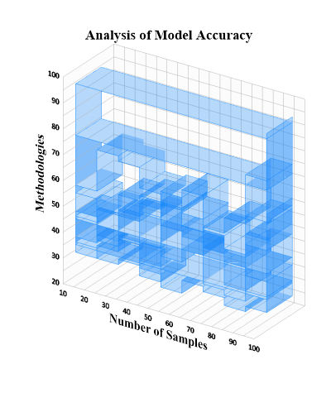
Figure 5: Analysis of Model Accuracy
Figure 5 illustrates across varying sample sizes the trends in model accuracy for AI-6G, AI-ML, AI-NTN, and FL-6G. With consistent competitive accuracy across all sample sizes, FL-6G achieves a drastic accuracy boost at 100 samples, to 96.33%, thus implying high scalability and convergence. AI-ML and AI-NTN demonstrate steady but humble performance; AI-ML hits a high of 65 while AI-NTN is steadily decreasing. At higher sample sizes, AI-6G gets better and better but remains inferior to FL-6G. Especially in larger datasets, FL-6G clearly outperforms the rest, thus affirming the robustness and effectiveness of federated learning in AI-based 6G networks.
$$\frac{{Qu}^{2}}{dp}+\frac{Qw^{2}}{dp}=(Y^{2}+β^{2}δ^{2}+\frac{1}{5}σZ\cos{π)+∆V^{'} (5)}$$
Equation (5) simulates the equilibrium $\frac{1}{5}σZ\cos{π)+∆V^{'} }$ between the components of flow energy and the combined effect on learning, the system vibration, and volumetric fluctuation. Edge device data shifts $\frac{{Qu}^{2}}{dp}+\frac{Qw^{2}}{dp}$ and channel variability ($Y^{2}+β^{2}δ^{2}$).
Without compromising the accuracy of models, the experimental outcomes show the way FL-based 6G technology architecture significantly reduces latency reduced and data encryption compared to centralized artificial intelligence frameworks. Since FL was deployed, reaction times were enhanced with the reduction by 40 percent and the overhead communication by the 25 percentage. The solution also demonstrated robustness in scalability across multiple edge device configurations. These findings validate the potential support of the proposed approach for critical 6G applications requiring fast, smart, secure decision-making. Overall, incorporating were offers a promising path to developing intelligent and robust communication infrastructure.

Conclusion
Offering connectedness, and intellect, the consolidation on artificial intelligence with 6G networks represents a significant advance in the course by communications of wireless. Nonetheless, existing centralized artificial intelligence models possess significant drawbacks such as issues of data privacy, high latency, and narrow capacity. This paper provided a novel methodology employing Federated Learning (FL) via distributed devices for the 6G for overcoming these hindrances. The proposed method fundamentally enhances data privacy, reduces communication overhead, and ensures faster, real-time decision-making by enabling the models trained for localized and communicating only model updates in place through information.
Critical performance indicators such as network flexibility, adaptive design, and interface accuracy were determined by the simulation-based assessment to be significantly enhanced using the 6G system. This distributed approach aligns very well with the architectural needs, this should must be embedded in the edge to facilitate building applications such as remote surgery, smart cities, autonomous vehicles, memories with XR immersiveness.
Additionally, the findings confirm the feasibility and benefits of integrating system of 6G from the FL, thus presenting a viable solution to developing smart, adaptive, and secure network ecosystems. The findings pave the way for future research on optimizing FL algorithms for heterogeneous edge devices, improving model aggregation techniques, and enhancing system robustness in real-world 6G deployments. Ultimately, this approach lays a solid foundation for the sustainable and smart network.

References
- A. Raihan, “An overview of the implications of artificial intelligence in sixth generation communication network,” Research Briefs on Information and Communication Technology Evolution, vol. 9, pp. 120–146, 2023.
- V. T. K. Anh, “The Rise of AI in 6G Networks: A Comprehensive Review of Opportunities, Challenges, and Applications,” in Proc. Int. Conf. Advanced Technologies for Communications (ATC), 2024, pp. 333–338.
- M. Shafi, R. K. Jha, and S. Jain, “6G: Technology evolution in future wireless networks,” IEEE Access, 2024.
- A. Nayak, and K. S. Raghatate, “Image segmentation and classification of aquatic plants using convolutional neural network,” International Journal of Aquatic Research and Environmental Studies, vol. 4, no. S1, pp. 14–19, 2024. https://doi.org/10.70102/IJARES/V4S1/3
- S. Zhang, “Consumer Attitudes towards AI-based Financial Advice: Insights for Decision Support Systems (DSS) and Technology Integration,” Journal of Internet Services and Information Security, vol. 14, no. 4, pp. 1–20, 2024. https://doi.org/10.58346/JISIS.2024.I4.001
- T. Jelena, and K. Srđan, “Smart Mining: Joint Model for Parametrization of Coal Excavation Process Based on Artificial Neural Networks,” Archives for Technical Sciences, vol. 2, no. 29, pp. 11–22, 2023. https://doi.org/10.59456/afts.2023.1529.011T
- Y. Kong, S. Suntrayuth, and F. Lin, “Construction of Cross-Border E-Commerce Supply Chain of Agricultural Food Products based on Blockchain Technology,” Natural and Engineering Sciences, vol. 9, no. 2, pp. 145–163, 2024. https://doi.org/10.28978/nesciences.1569226
- R. Chataut, M. Nankya, and R. Akl, “6G networks and the AI revolution—Exploring technologies, applications, and emerging challenges,” Sensors, vol. 24, no. 6, p. 1888, 2024.
- T. B. Ahammed, R. Patgiri, and S. Nayak, “A vision on the artificial intelligence for 6G communication,” ICT Express, vol. 9, no. 2, pp. 197–210, 2023.
- M. Jouya, and S. Khayati, “Review local search algorithms in artificial intelligence,” International Academic Journal of Science and Engineering, vol. 4, no. 1, pp. 190–195, 2017.
- S. P. Tera, R. Chinthaginjala, G. Pau, and T. H. Kim, “Towards 6G: An Overview of the Next Generation of Intelligent Network Connectivity,” IEEE Access, 2024.
- M. Vakilfard, A. Taheri, and M. R. Salehifar, “Implementation of the Satellite Ground Station Control in Real-Time Under Windows,” International Academic Journal of Science and Engineering, vol. 1, no. 1, pp. 1–9, 2014.
- M. Sheraz, T. C. Chuah, Y. L. Lee, M. M. Alam, and Z. Han, “A comprehensive survey on revolutionizing connectivity through artificial intelligence-enabled digital twin network in sixth generation,” IEEE Access, 2024.
- A. Mittal, H. Pandey, M. Arsh, M. Soni, H. R. Goyal, and S. Sharma, “Advancements and Applications of Artificial Intelligence in Various Sectors: From Internet of Vehicles to 6G and Healthcare,” in Proc. Int. Conf. Pervasive Computing and Social Networking (ICPCSN), 2024, pp. 107–112.
- K. Yemunarane, G. Chandramowleeswaran, K. Subramani, A. Alkhayyat, and G. Srinivas, “Development and Management of E-Commerce Information Systems Using Edge Computing and Neural Networks,” Indian Journal of Information Sources and Services, vol. 14, no. 2, pp. 153–159, 2024. https://doi.org/10.51983/ijiss-2024.14.2.22
- K. B. Letaief, Y. Shi, J. Lu, and J. Lu, “Edge artificial intelligence for sixth generation: Vision, enabling technologies, and applications,” IEEE Journal on Selected Areas in Communications, vol. 40, no. 1, pp. 5–36, 2021.
- K. Tamilarasi, S. Pavithra, R. Rangarajan, V. Venkataraman, and K. Shankar, “AI-Powered Optimization: Revolutionizing 6G Networks for Efficiency and Performance,” in Proc. Int. Conf. Smart Technologies and Systems for Next Generation Computing (ICSTSN), 2024, pp. 1–6.
- A. Shetty, and K. Nair, “Artificial Intelligence Driven Energy Platforms in Mechanical Engineering,” Association Journal of Interdisciplinary Technics in Engineering Mechanics, vol. 2, no. 1, pp. 23–30, 2024.
- N. Kaur, N. Kshetri, and P. S. Pandey, “6AInets: Harnessing artificial intelligence for the sixth generation network security: Impacts and Challenges,” arXiv preprint, arXiv:2404.08643, 2024.
- S. Pandi, D. Aishwarya, S. Karthikeyan, S. Kamatchi, and N. Gopinath, “Revolutionizing connectivity: Unleashing the power of fifth generation wireless networks enhanced by artificial intelligence for a smarter future,” Results in Engineering, vol. 22, p. 102334, 2024.
- R. Basanta Kumar, and K. Sunil, “Biotechnological Approaches to Develop Personalized Medicines for Rare Genetic Disorders,” Clinical Journal for Medicine, Health and Pharmacy, vol. 2, no. 2, pp. 20–28, 2024.
- W. A. J. Pandian, P. Mangal, D. Lakshmi, and I. J. S. Jeya, “The Role of Artificial Intelligence in Sixth Generation Networks, Architecture, Protocol, Transmission, and Applications,” in RFID, Microwave Circuit, and Wireless Power Transfer Enabling Fifth/Sixth Generation Communication, IGI Global, 2025, pp. 115–154.
- A. Alhammadi, I. Shayea, A. A. El-Saleh, M. H. Azmi, Z. H. Ismail, L. Kouhalvandi, and S. A. Saad, “Artificial intelligence in 6G wireless networks: Opportunities, applications, and challenges,” International Journal of Intelligent Systems, vol. 2024, no. 1, p. 8845070, 2024.
- J. S. Alkasassbeh, F. M. Al-Taweel, T. A. Alawneh, A. Al-Qaisi, Y. F. Makableh, and T. El-Mezieni, “Advancements in Wireless Communication Technology: A Comprehensive Analysis of 4G to 7G Systems,” Journal of Wireless Mobile Networks, Ubiquitous Computing, and Dependable Applications, vol. 15, no. 3, pp. 73–91, 2024. https://doi.org/10.58346/JOWUA.2024.I3.006
- S. Mahboob, and L. Liu, “Revolutionizing future connectivity: A contemporary survey on AI-empowered satellite-based non-terrestrial networks in 6G,” IEEE Communications Surveys & Tutorials, vol. 26, no. 2, pp. 1279–1321, 2024.

