Securing Wireless Technology by Identifying and Addressing Duplicitous Programming Risks

Mukul Mishra, Chitkara Centre for Research and Development, Chitkara University, Himachal Pradesh-174103 India. mukul.mishra.orp@chitkara.edu.in https://orcid.org/0009-0002-9297-6299
Sahil Suri, Centre of Research Impact and Outcome, Chitkara University, Rajpura- 140417, Punjab, India. sahil.suri.orp@chitkara.edu.in https://orcid.org/0009-0000-4917-9337

Shitij Goyal, Quantum University Research Center, Quantum University, Email: shitij.qsb@quantumeducation.in, Orcid Id: 0009-0002-5558-8238
N. V. BALAJI, Department of Computer Science, Karpagam Academy of Higher Education, Coimbatore- 641021, Email Id: fashdean@kahedu.edu.in

D.BHANU, Department of Information Technology, Karpagam Institute of Technology, Coimbatore- 641105, Email Id: bhanu.it@karpagamtech.ac.in

Dr.Asha S, Assistant Professor, Department of Management, School of Management - UG, JAIN (Deemed to be University), Bangalore, Karnataka, India, Email Id- asha_s2015@cms.ac.in

Abstract--- Modern communication systems use wireless technology, but their sophistication makes them vulnerable to code alteration that poses security risks. The propagation of hidden dangers requires robust detection and prevention measures. Existing methods often use runtime behavior analysis, which may miss hazardous code that behaves normally. Limited dynamic analysis may also make it hard to detect hidden or entrenched hostile sections. The paper propose a new framework of Detect Malicious using Static Code Analysis (DM-SCA) to solve these gaps. This technique employs static code analysis to inspect source code and binaries without executing them, enabling early and accurate detection of malicious code. DM-SCA evaluates data flow, control flow, and code structures for abnormalities, backdoors, and hidden logic that may indicate security vulnerabilities. Wireless technology security is improved by proactive threat identification during development and integration. It carefully coordinates with wireless firmware updates and secure software development life cycles to provide full coverage without performance overhead. In experiments, DM-SCA outperforms traditional approaches in detecting hidden and dormant dangerous code. It improves analysis speed, accuracy, and applicability across numerous wireless protocols and platforms, making wireless systems safer and more dependable.
Keywords--- Wireless Technology, Duplicitous Programming, Static Code Analysis, Malicious Code Detection, Cybersecurity, Secure Development.

Introduction
Wireless technology has transformed modern communication with billions of devices worldwide linked with before unprecedented simplicity and efficiency. With its fast development and spread, securing wireless networks has become even more important. Deceptive programming created code blocks meant to either leak information, ruin system stability, or create most crucial risks to wireless networks. As wireless systems continue to develop and grow in complexity, cybersecurity education and practice now depend much on determining and regulating [1]. Usually identified as malware or harmful code, deliberate programming seriously compromises wireless networks. These hazards include unauthorized access and data theft as well as the whole disturbance of services. Wireless systems are more susceptible than conventional software systems and perfect targets for attackers wishing to introduce harmful code because of their open and sometimes dispersed character [2]. When wireless technologies are included into the military system, transportation, healthcare, and other main infrastructure, the effects of such attacks might be severe [3]. Ensuring accuracy of information, privacy, and overall system trustworthiness is reliant on the protection of wireless systems against fraudulent programming, and it is therefore no longer discretionary but a needed requirement. Modern approaches to detecting and eliminating dishonesty in codes largely rely on dynamic analysis methods, which monitor program execution to detect malicious behavior [4].
While partially successful, these strategies have significant limitations. A dynamic analysis relies on the code being executed within a controlled environment an example sandbox that could not realistically represent real behavior [5]. Second, experienced attackers generally write code to remain inactive while being analyzed or to function properly while under scrutiny, thus evading detection. Additionally, less conducive to large-scale and real-time applications is dynamic analysis since it demands time and resources [6]. Oftentimes, however, malicious code remains undetected until after damage is done. Universal practices employed by online criminals to mask the true intention of their code, encrypted or obfuscated code cannot be reverse engineered by current techniques, thus another limitation of current techniques [7]. Additionally, integrated firmware and proprietary communication standards render wireless systems frequently infeasible to perform the analysis. The limitations bring into focus the urgent need of a more in-your-face and comprehensive approach to detect fraudulent programming in wireless communication systems [8]. In order to overcome such challenges, this research introduces an innovative system known as DM-SCA.
Through this proactive method, security specialists can detect vulnerabilities and malicious time of development or prior to software implementation, thus significantly reducing the threat of exploitation of the operational environment [9]. In order to detect a wide range of hostile behavior, the DM-SCA framework integrates robust pattern recognition, and rule-based verification. This seeks out anomalies, illicit modifications, and suspicious configurations deviating from standard programming norms in code. In the context by means checking firmware updates, protocol configurations, and driver levels for hidden or illicit capability [10] [11]. Using DM-SCA, programmers and security analysts can identify potential threats in development life cycle, allowing for rapid correction and enhanced security assurance. The proposed method has an excellent practical application in a number of areas [12]. DM-SCA can assist reducing the risk of malware intrusion through over-the-air updates. The smart grids and medical devices, the framework can verify that prior to deployment software components [13]. It even also supports compliance with international security guidelines and standards, thus enabling businesses to meet their legal and ethical obligations towards secure software development. Promising results from initial tests and simulations of the DM-SCA framework have been reported [14].
With high precision and efficacy, the system surpassed traditional dynamic analysis techniques in detection rate of concealed and obfuscated malicious code. It is possible for large-scale deployment demonstrated by its efficacy across numerous platforms and architectures. In addition, DM-SCA's compatibility with existing development tools and CI/CD pipelines ensures seamless acceptance in modern systems. By the findings of DM-SCA, in most cases merely an adequate replacement of dynamic analysis but a superior method of revealing fraudulent programming in wireless technology. Firms can significantly reduce shifting the focus from detection post-deployment to prevention pre-deployment. Through this forward-looking strategy, the overall cybersecurity stance is enhanced and more robust, trustworthy wireless environments are established. One insidious and powerful threat were contemporary dynamic methods struggle to manage is intentional programming. To identify and mitigate risks prior to their manifestation offers a satisfactory solution in the suggested DM-SCA framework. Through early detection, enhanced accuracy, and wide usage, DM-SCA represents a great achievement in the field of wireless security, thus paving the way for safer digital communication in today's wireless world.
Motivation:
This effort is driven by increasing concern with fraudulent programming using wireless communication technology, which is increasingly integrated into daily life and critical systems. Traditional dynamic analysis methods may miss dormant or hidden malicious code, thus leaving systems vulnerable to attack. This gap necessitates proactive, accurate threat discovery. This paper seeks to enhance security at the programming phase with the introduction of the power source DM-SCA framework utilizing static code analysis to locate adversarial code without any form of execution. The aim is to provide an easily scalable, reliable, fast wireless system security solution against evolving cyber threats.
Problem Statement:
From consumer electronics to critical techniques of wireless and infrastructure where organic part of modern communications and control systems. But their increasing interconnectedness and complexity make them more vulnerable to intentional programming of malicious code inserted with the intent to impair operation, leak confidential data, or create backdoors. Since they depend on the execution of code, which can easily be evaded by dormant or camouflaged malware, existing security methods particularly dynamic analysis tend to fail in discovering such threats. Furthermore, these approaches are not suitable for real-time or mass applications. The lack of a useful, active enough, and scalable means for detecting and precluding presents a serious obstacle to wireless systems security and privacy dangerous code patterns ahead of deployment.

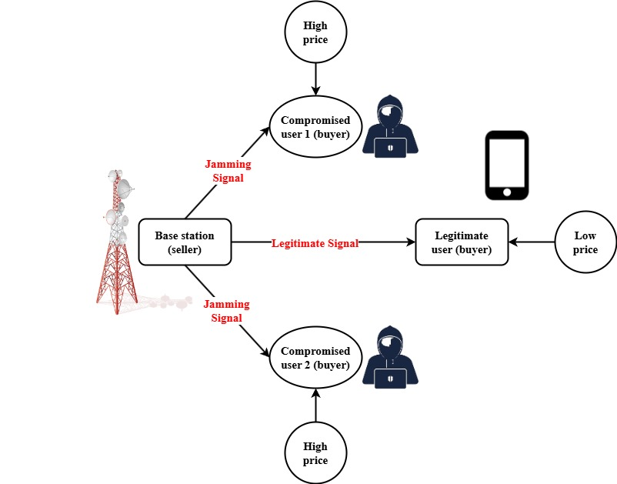
Figure 1: Model for Wireless Secure Communication

Source (buyers), destination, cooperative constitute a secure wireless communication architecture depicted in Figure 1. Through cooperative jamming, the goal is to protect the legitimate transmission from wiretap attacks. When an eavesdropper attempts to capture this information through wiretap channels communicate information to assumed destinations on legitimate line channels. The request power from friendly jammers indicated in exchange for mitigating this risk for a fixed power cost, black dotted arrows.
It produces solid green arrows, or jamming signals, to interfere with the reception of the eavesdropper, thus enhancing concealment. This model depicts a power exchange-based system in which friendly jammers are encouraged to contribute towards security of communication by disrupting the decode intercepted signals without affecting authorized users. The structure ensures selective jamming direction, thus maintaining communication quality to gain destinations at the cost of decreasing it for enemy listeners. The dynamic interaction between all the nodes suggests a game-theoretic as well as market-based approach to optimize consumption. In the face of sophisticated attacks, this collaborative approach is an effective physical-layer security mechanism.
Paper Contribution
- This paper introduces a novel system DM-SCA over rapid detection of duplicitous developing in wireless technologies. It scans code without executing so that concealed dangers could be discovered during development.
- In comparison to traditional dynamic methods, the DM-SCA technique enhances the precision as well as speed of identifying risky code. It detects concealed and camouflaged malware on numerous wireless devices very effectively.
- Architecture provides secure development methodologies and integration into modern CI/CD pipelines. This assists business enterprises in ensuring wireless networks at their premises, ahead of schedule, without interference with their software development processes.
The report consists of the related works in the section 2 followed by the methodology proposed in the section3. The section 4 deals with the discussion and results, and it gets completed by the conclusion in the section 5 along with the future works.

Related Works
The issues regarding the security associated with wireless communications have grown. With more data being stored and sent over the Internet, attackers are actively trying to get their hands on it for malicious purposes. After reviewing the literature on wireless network confidentiality and safety, it has become clear that these networks are vulnerable due to several factors. This paper aims to address these vulnerabilities by illuminating the main security and privacy issues that current wireless networks face, as well as by demonstrating the various techniques that can be used to fix them [15]. Finally, it will wrap up with a thorough examination of cybersecurity measures that can solve the problems in wireless networks.
To eliminate reconnaissance attempts by malicious nodes, the proposed addressing method combines several factors such as the node's physical location, vendor id, and random integers to form IPv6 addresses [16]. Under hostile nodes, the proposed method is subjected to reconnaissance and denial-of-service attacks. The results indicate that the proposed approach considerably minimizes the effect outperforms regarding ASR, energy consumption, and communication overhead [17].
The findings of this assessment indicate that game-theory techniques have been applied to enhance the defensive efficacy of safety measures and anticipate and counter future threats [18]. A number of them have been designed for application the contracts of cyber physical functions. Trends illustrate that game theory provides the ability to analyze and understand intricate security scenarios based on technological advancements, changes in the threat landscape, and the emergence of new trends related to cyber-crime. Emerging opportunities and threats from APTs are explained in this study, such as how defense-bypass tactics and strategies will evolve over time.
With the help of the Internet of Things (IoT), commonplace objects may gain intelligence, commonplace computing can progress towards intelligence, and commonplace communication can get a bit more understanding [19]. In order to provide researchers in this field a comprehensive picture of the (IoT), this article briefly demonstrates the most popular and prevalent features, designs, and protocols of IoT devices. The capabilities of typical Internet of Things devices, including their software and hardware platforms, are detailed in depth. Recently developed and utilized architectures include the three-layer design, SOA-based design, and middleware-based design.
In this paper, examine the (IoT) in depth, covering its framework, its applications, and the cyber security challenges it faces [20]. Since the IoT is integral to modern life, protecting sensitive data is a top priority. On top of that, the article provides a synopsis of case studies detailing instances of security breaches in the IoT that occurred in prior years. In addition, the article delves into the potential future features that might aid in the development of safer and more effective IoT devices. It will go over the many security risks and solutions present in the various IoT network levels.
Table 1: Comparisons of the Methods
S.No | Methods | Advantages | Limitations
1 | Network based Prevention System (NIPS) [6] | Provides comprehensive insight into current threats and available countermeasures in wireless networks | Lacks implementation-specific solutions and real-time threat detection
2 | Stateless Auto Address Scheme (SLAAC) [7] | Reduces the success of reconnaissance and DoS attacks; improves ASR and reduces energy consumption | Still susceptible to advanced adversaries; requires specific network and hardware configurations
3 | Advanced Persistant Threats (APT) [8] | Helps in predicting attacker strategies; improves response planning and defensive effectiveness | Complexity in implementation; dependent on accurate threat modeling and real-time data
4 | Internet of Things in Healthcare Domain (IoT-HD) [9] | Offers a broad understanding of IoT systems including hardware, software, and design principles | Generalized overview; does not focus deeply on specific security vulnerabilities or defenses
5 | Modern Internet of Things [M-IoT] [10] | Highlights real-world IoT security breaches; discusses future trends and mitigation techniques | Primarily descriptive; lacks a proactive detection or prevention mechanism
The table presents a comparative analysis of a number of solutions addressing wireless as well as IoT security issues. Even though they are not deployable in real-time, (NIPS) present a thorough threat awareness. As the efficiency in curbing denial-of-service (DoS) attacks depends on configuration, (SLAAC) can enhance network protection. Though hard to implement, (APT) procedures intensify defensive methods. Without undertaking heavy vulnerability scanning, provides architectural awareness. Although the conversation revolves around trends and past security compromises, lacks proactive detection techniques. There are merits and demerits to every technique the applications in real-world applications.

Proposed Method
There has been a sharp increase in security issues as a result of the explosive growth critical areas. Covert installation of malicious to exploit security vulnerabilities is a serious issue owing to dishonest coding. Conventional security techniques, which rely primarily on dynamic analysis, are at times incapable of detecting these malicious programs because they remain dormant. Wireless networks are susceptible to serious cyber-attacks because existing technologies can not effectively detect these threats in advance. This requires a robust and preventive detect security threats early during the SDLC. A framework for source code and binary analysis without the need to run them is described in this research as (DM-SCA). By providing early, beneficial, and scalable threat identification, the aim is to significantly enhance the security design of wireless communication systems through identification of
$$∂(\frac{w_{j}}{q_{j}d_{j}^{2}})= \frac{w_{j}∂_{j}}{q_{j}^{2}d_{l}^{4}}*\frac{2}{q}[1+\frac{q}{2d}\left(\frac{∂^{2}q}{{∂q}^{2}}\right) (1)$$
Equation (1) illustrates how criteria like as code quality $1+\frac{q}{2d}$ and interdependence depth $\frac{∂^{2}q}{{∂q}^{2}}$ impact overall vulnerability $\frac{w_{j}∂_{j}}{q_{j}^{2}d_{l}^{4}}*\frac{2}{q}$ by modeling the sensitivity of the system's vulnerability $\frac{w_{j}}{q_{j}d_{j}^{2}}$ to fluctuations in these variables. The DM-SCA methodology, which uses statistical analysis of these code metrics to identify harmful trends, is closely related to this and may increase security concerns.

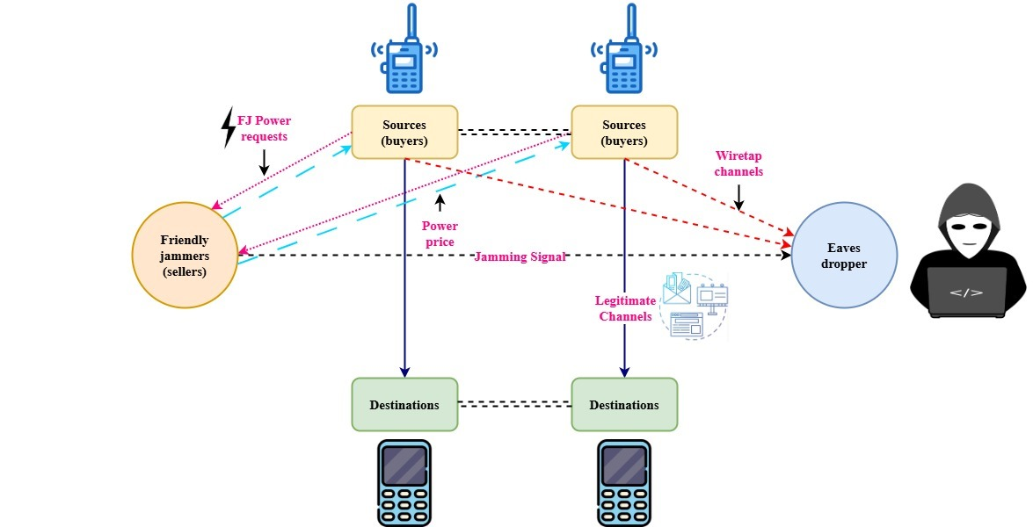
Figure 2: Wireless Resource Compromising Buyers and their Impact

Figure 2 illustrates a wireless communications network where a base station hence the seller assigns spectrum and signal resources to numerous buyers and the users. This can be made tampered with in this setup; one user is legitimate. To disrupt the communication the environment and impact base stations and the process of price allocation, where it compromised users engage in malicious activities such as sending jamming signals.
The base station attempts to serve all consumers but, due to their aggressive behavior, perceived the urgency or demand, actually supplies by higher cost to the tampered customers. The authentic user, indicating a fairer or honest demand, receives the original signal at a lower cost in the meantime.
Either fraudulent bidding or direct jamming, the presence of tampered users upsets policy, hence compromising overall system efficiency. This configuration reveals vulnerabilities, especially in environments where adversaries might manipulate price or signals by acting consumers with high-demand. This figure 1 highlights the importance of designing smart and secure resource allocation methods that can discriminate between good and evil activity within network which is wireless. It was assisted in the detection of malicious behavior.
$$αQ\left(q,t\right)=στ\frac{Et}{Eu}*q\frac{Eq}{Eu}+ρϑ^{2}+ρ(β.V)^{2} \left(2\right)$$
An impact of entropy transfer ratios $q\frac{Eq}{Eu}$, coding efficiency $στ\frac{Et}{Eu}$, and volatility in behavioral vectors $q\frac{Eq}{Eu}$ on a security value function $αQ\left(q,t\right)$ is shown in Equation (2). This framework since it shows how variables such as operation efficiency $ρϑ^{2}+ρ(β.V)^{2}$. This good code quality can improve the accuracy of threat detection when using static analysis.

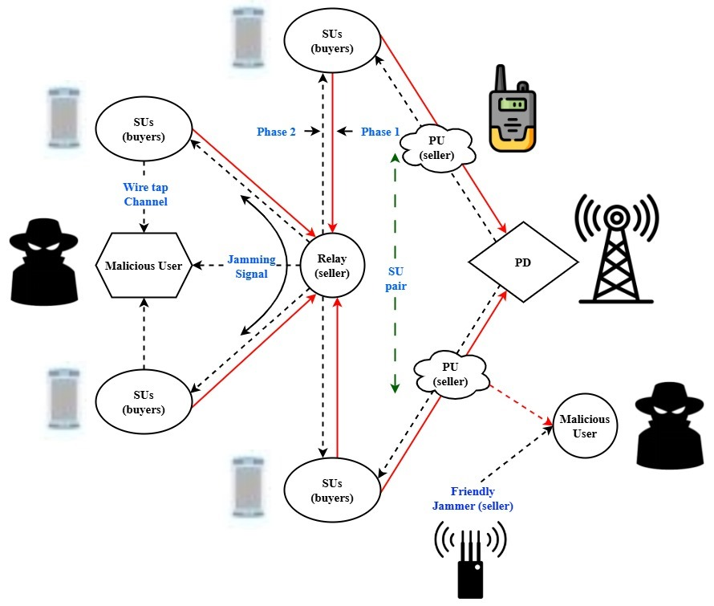
Figure 3: Secure Cooperative Spectrum

The figure 3 demonstrates a secure cooperative spectrum exchange system with numerous sellers and buyers. Secondary users (SUs) act as consumers; primary users (PUs) act as relays and friendly jammer as sellers. Primary users send information to the relay during 1st phase, where it produces interference to protect against the users with eaves dropping. The relay acts as an intermediary salesman and collects the information and is prepared to transfer the pairs of SU. The channel is shown where an eavesdropper attempts to tap the provided transmission.
Phase 2 has the relay transfer the information while the cooperative jammer continues to transmit jamming signals, thus enhancing its capability to conceal itself by blending potential eavesdroppers. The end points to the secure the SU pair connection with consisting of a transmitting SU and a receiving SU. Through application of benevolent interfering with and retransmitting systems, this paradigm emphasizes a secure cooperative design. It offers market-based interaction in which spectrum access is traded under terms of secure data transmission in consideration of eavesdropping threats.
$$\left(ω+\frac{1}{3∆}\right) =\frac{1}{q^{2}d^{2}}\left(\frac{∂^{2}v}{{∂q}^{2}}\right)*\frac{Eq}{Eu}+q∆.v*∆q-ω*v (3)$$
System instability $\frac{1}{q^{2}d^{2}}$ or vulnerability $\left(\frac{∂^{2}v}{{∂q}^{2}}\right)$, represented by $\left(ω+\frac{1}{3∆}\right)$, is represented in Equation (3) as a function $∆q-ω*v$ of second-order fluctuations in behavior $\frac{Eq}{Eu}+q∆.$, quality-to-efficiency ratios, and temporal volatility. This allows for early detection via thorough structural code analysis.
Secure wireless technology is the intention of the planned (DM-SCA) framework, aimed at eliminating malicious programming attacks through early detection by identifying them at the beginning stages of development. Unlike typical dynamic analysis tools, DM-SCA scans for identifying malicious logic or concealed backdoors, also referred analysis by code statistics. It is identified through examination of syntactic and semantic patterns, such as suspicious API calls, buffer overflows, and unauthorized data accesses. The framework is designed to be integrated simply into existing, enabling real-time code auditing without interfering with development workflows. Since it has strong support across many different means for wireless communications as well as platforms, it may be freely designed to fulfill many different customers' requirements. The DM-SCA approach reduces the influence of inoperable or occluded bad code, provides greater detection correctness, and minimizes computational expenses. Ultimately, it offers a reliable, efficient, and preventive measure that enhances the entire cybersecurity environment of wireless systems.

Results and Discussion
New communication systems mostly depend on wireless technology, while its growing intelligence makes them also more vulnerable to security attacks in particular through malicious programming. Due to their fragile nature and lack of runtime indicators, malicious programs insertion often remains undetectable. Largely based on dynamic analysis, new detection methods rely mainly on the latter. We offer (DM-SCA), through static code analysis, thereby filling this gap. This was based on the approach aims to internet security and connectivity in both the deployment and development stages.

Table 2: Environment Simulation
Metrics | Description
Signal-to-Noise Ratio (SNR) | Measures the strength of the desired signal relative to background noise.
Packet Loss Rate | Percentage of data packets lost during transmission, indicating reliability.
Latency | Time delay between sending and receiving a data packet.
Throughput | Amount of data successfully transmitted over the network in a given time.
Interference Level | Degree of signal disruption from external or internal sources.
Bit Error Rate (BER)
  Ratio of bits received in error to total bits sent, reflecting transmission accuracy.
Energy Consumption | Total power used during communication processes, relevant for mobile/wireless devices.
Jamming Resistance | System's ability to maintain performance under intentional jamming attacks.

Analysis of Higher Accuracy

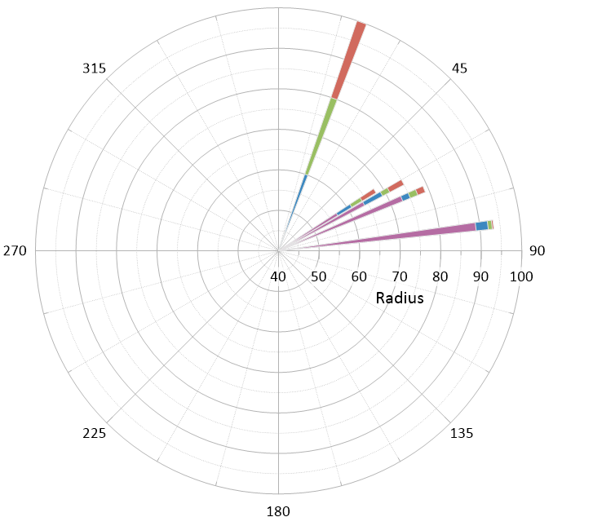
Figure 4: Analysis of Higher Accuracy

Figure 4 illustrates accuracy comparisons in NIPS, SLAAC, IoT-HD, and DM-SCA for various sample sizes. For 100 samples, DM-SCA consistently achieves best accuracy highs of 93.38%. DM-SCA is a highly reliable technique to identify cheating code in wireless networks because its excellent performance translates into powerful detection capabilities.
$$\frac{∂k}{u∂}=\frac{1}{2β}*\left(\frac{{ρV}_{J}}{{ρy}_{k}}+\frac{ρV}{ρY}-{\frac{2}{3ρ}}_{2}\right)+\frac{{ρV}_{l}}{{ρY}_{L}})^{2}*\left(v+d\right) (4)$$
A differential danger gradient $\frac{∂k}{u∂}$ is shown in Equation (4), which is affected $\left(v+d\right)$by behavior-density ratios $\frac{1}{2β}$ as well as volatility $\frac{{ρV}_{l}}{{ρY}_{L}})^{2}$ across many layers $\left(\frac{{ρV}_{J}}{{ρy}_{k}}+\frac{ρV}{ρY}-{\frac{2}{3ρ}}_{2}\right)$, with velocity and depth working as modulators. This aligns multidimensional vulnerability assessment with layered code characteristics to identify deceitful programming.
Faster analysis time
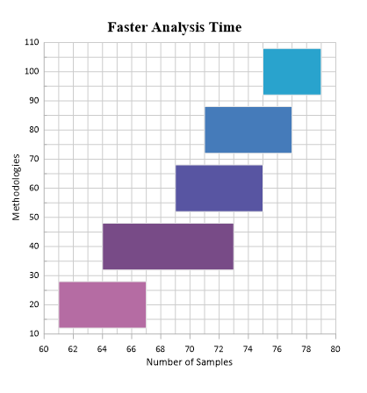
Figure 5: Faster Analysis Time
Figure 5 illustrates, in terms of analysis time over increasing sample sizes, the relative performance of four methods NIPS, SLAAC, IoT-HD, and DM-SCA. DM-SCA consistently outperforms others with quicker and more flexible analysis. Larger datasets serve its efficiency to demonstrate its suitability for real-time safety checks.
$$K+\frac{1}{2}\left(σ+V\right)=\frac{∂K-vw'}{∂u}\left(v-c\right)+vh\left[y-\left(d+v\right)u\right] (5)$$
The dynamic interaction between code variability $\left(v-c\right)$, behavioral changes $\frac{∂K-vw'}{∂u}$, and their influence via differential productivity $vh\left[y-\left(d+v\right)u\right]$ and vulnerability factors are modelled by Equation (5) as the security coefficient $K+\frac{1}{2}\left(σ+V\right)$. This pertains to the DM-SCA framework, which aids in the detection of deceitful programming through static code behavior assessment.
Comparing experimental testing standard dynamic analysis methods demonstrates a significant improvement in identifying fraudulent code. Particularly in detecting latent and obfuscated attacks hidden deep within wireless firmware, DM-SCA achieved superior accuracy detection. Introducing performance overhead, the framework exhibited faster analysis times and scalability over numerous protocols and wireless platforms. Especially in secure development life cycles, these results demonstrate DM-SCA's applicability in real-world scenarios. Its ability to detect threats early on makes it an essential tool for creating more secure wireless communication systems, thus reducing threats security and long-encounters.

Conclusion
Unprecedented convenience and utility have been caused by the rapid proliferation of wireless technology into the consumer and critical facilities markets. Unfortunately, it has also exposed these systems by code of malicious values and other forms of cyber-attack. Malicious malware intentionally placed within wireless firmware or software can lead to severe consequences, including data breach, unauthorized command, and system disruption. Especially in complex and decentralized wireless environments, existing detection techniques, especially depend to a great extent on dynamic analysis, cannot find concealed, camouflaged, or dormant malicious code.
This article presented (DM-SCA) idea as a preventive action to address such problems. DM-SCA uses static code analysis to determine security threats by analyzing binary layouts and source code thoroughly without running the program, unlike traditional practices. Secure development and implementation of software is facilitated by this technology, which identifies nefarious code patterns at an early stage. The framework is flexible and scalable due to its capacity to identify a wide range of malicious activities on numerous wireless platforms. Experimental evaluations showed that DM-SCA provides enhanced accuracy, time analysis reduced as well as enhanced resistance to obfuscation strategies over existing systems.
Finally, the DM-SCA framework significantly enhances the ability to safeguard wireless technologies from malicious programming threats. In an increasingly interconnected world, it assists in building a robust ecosystem, reliable, and secure by shifting the focus from reactive detection to prevention measures.

Future Work
To improve the DM-SCA framework to be more effective in spotting malicious code and withstanding emerging threats, researchers will be adding machine learning techniques in the coming years. Furthermore, we will discuss how to scale the framework so that large deployments over wireless networks can perform real-time statistical analysis. To strengthen security analysis and make it more context-sensitive, we wish to collaborate with industry players to test and include domain-level threat knowledge.

References
- M. Ramaiah, V. Chithanuru, A. Padma, and V. Ravi, “A review of security vulnerabilities in industry 4.0 application and the possible solutions using blockchain,” in Cyber Security Applications for Industry 4.0, pp. 63–95, 2022.
- G. Papadopoulos, and M. Christodoulou, “Design and development of data-driven intelligent predictive maintenance for predictive maintenance,” Association Journal of Interdisciplinary Technics in Engineering Mechanics, vol. 2, no. 2, pp. 10–18, 2024.
- M. M. Islam, S. Nooruddin, F. Karray, and G. Muhammad, “Internet of things: Device capabilities, architectures, protocols, and smart applications in healthcare domain,” IEEE Internet of Things Journal, vol. 10, no. 4, pp. 3611–3641, 2022.
- B. Jeyapragash, and T. Rajkumar, “An analysis of research productivity of Indian Institute of Technology’s (IITs) with special reference to ResearchGate,” Indian Journal of Information Sources and Services, vol. 9, no. 2, pp. 58–62, 2019.
- M. Kang, “A study on the effect of information and communication technology (ICT) on trade in services in the United States,” Journal of Internet Services and Information Security, vol. 14, no. 1, pp. 266–281, 2024.
- C. Akyıldız, “Integration of digitalization into occupational health and safety and its applicability: a literature review,” The European Research Journal, vol. 9, no. 6, pp. 1509–1519, 2023.
- N. Ruzibaeva, S. Makhmaraimova, I. Khaydarov, B. Mukhitdinova, Y. Ne’matova, K. Fayziyeva, Z. Sattorova, and K. Mirzakhmedova, “Application of wireless sensors in the design of smart learning of the English language utilizing Zigbee network technology,” Journal of Wireless Mobile Networks, Ubiquitous Computing, and Dependable Applications, vol. 15, no. 3, pp. 125–135, 2024.
- S. K. Singh, S. Chauhan, A. Alsafrani, M. Islam, H. I. Sherazi, and I. Ullah, “Optimizing healthcare data quality with optimal features driven mutual entropy gain,” Expert Systems, vol. 42, no. 2, p. e13737, 2025.
- H. Azam, M. Tan, L. T. Pin, M. A. Syahmi, A. L. W. Qian, J. H. Jingyan, and S. R. Sindiramutty, “Wireless technology security and privacy: A comprehensive study,” Preprint, vol. 10, 2023.
- M. Carlos, and F. Escobedo, “A case study-based model for sustainable business management through blockchain technology in small and medium-sized enterprises,” Global Perspectives in Management, vol. 2, no. 2, pp. 41–50, 2024.
- H. Jaiswal and S. Pradhan, “The economic significance of ecosystem services in urban areas for developing nations,” Aquatic Ecosystems and Environmental Frontiers, vol. 1, no. 1, pp. 1–5, 2023.
- Y. Kong, S. Suntrayuth, and F. Lin, “Construction of cross-border e-commerce supply chain of agricultural food products based on blockchain technology,” Natural and Engineering Sciences, vol. 9, no. 2, pp. 145–163, 2024.
- P. Mall, R. Amin, A. K. Das, M. T. Leung, and K. K. R. Choo, “PUF-based authentication and key agreement protocols for IoT, WSNs, and smart grids: A comprehensive survey,” IEEE Internet of Things Journal, vol. 9, no. 11, pp. 8205–8228, 2022.
- S. Devliyal, H. R. Goyal, and S. Sharma, “Security techniques in cyber physical system for pharmaceutical care services,” in 2023 IEEE International Conference on Contemporary Computing and Communications (InC4), vol. 1, pp. 1–6, Apr. 2023.
- P. Selvam, and N. Stalin, “Power transfer efficiency analysis of double intermediate-resonator for wireless power transfer,” International Journal of Advances in Engineering and Emerging Technology, vol. 9, no. 3, pp. 130–141, 2018.
- G. Kumar, A. Gankotiya, S. S. Rawat, B. Balusamy, and S. Selvarajan, “IPv6 addressing strategy with improved secure duplicate address detection to overcome denial of service and reconnaissance attacks,” Scientific Reports, vol. 14, no. 1, p. 25148, 2024.
- S. Chopra, G. S. Bains, S. Kaur, R. Sharma, and A. Nayyar, “A review of the various applications and security issues in IoT and its future aspects,” International Journal of Security and Networks, vol. 19, no. 3, pp. 109–127, 2024.
- M. I. Alattas, “The impact of technology on logistics services in Saudi Arabia,” Archives for Technical Sciences, vol. 2, no. 31, pp. 379–392, 2024.
- M. N. A. Khalid, A. A. Al-Kadhimi, and M. M. Singh, “Recent developments in game-theory approaches for the detection and defense against advanced persistent threats (APTs): a systematic review,” Mathematics, vol. 11, no. 6, p. 1353, 2023.
- D. Banumathy, V. Anitha, S. Umamaheswari, and T. Murali, “Discharge prediction for critical patients using machine-learning technology,” International Academic Journal of Science and Engineering, vol. 10, no. 1, pp. 33–38, 2023.

