Leveraging 5G Wireless Technology for Advancing Strategic Telecommunications Systems

Jaspreet Sidhu, Centre of Research Impact and Outcome, Chitkara University, Rajpura- 140417, Punjab, India. jaspreet.sidhu.orp@chitkara.edu.in https://orcid.org/0009-0002-5658-5629
Divya Sharma, Chitkara Centre for Research and Development, Chitkara University, Himachal Pradesh-174103 India. divya.sharma.orp@chitkara.edu.in https://orcid.org/0009-0006-3032-4040
Shubhi Goyal, Quantum University Research Center, Quantum University, Email: shubhi.mathematics@quantumeducation.in, Orcid Id: 0009-0001-1684-7324
D.ANANDHASILAMBARASAN, Department of Computer Science Engineering, Karpagam Academy of Higher Education, Coimbatore- 641021. Email Id:anadhasilambarasan.duraisamy@kahedu.edu.in

C.KARTHIKEYAN, Department of Computer Science Engineering, Karpagam Institute of Technology, Coimbatore- 641105. Email Id: karthikeyan.cse@karpagamtech.ac.in

Ms.Yashoda L, Assistant Professor, Department of Management, School of Mangement - UG, JAIN (Deemed to be University), Bangalore, Karnataka, India, Email Id- yashoda@cms.ac.in

Abstract--- The advent of 5G wireless technology is transforming strategic telecommunications networks by providing unmatched speed, ultra-low latency, and enormous connectivity. These improvements clear the path to revolutionary applications in defense, emergency response, and management of national infrastructure. Current telecommunication approaches are overwhelmed by narrow bandwidth allocation, bottlenecks of latency, and a lack of scalability, which degrade responsiveness and operation efficiency in critical situations. In response to these weaknesses, the designed framework combines 5G network slicing with Multi-Access Edge Computing (5G-MEC) to allot network resources dynamically and bring computative power close to the edge of the user. The framework guarantees efficient separation of services, real-time computation of data, and lower latency for mission-related tasks. Seamless and secure communication for use in autonomous defense systems, city smart surveillance, and disaster response networks is supported using the proposed method. Experimental testing demonstrates that the approach considerably improves throughput, decreases end-to-end latency by as much as 43%, and enhances network resource utilization. These results confirm the efficacy of the method in raising the performance and robustness of next-generation strategic telecom systems. The proposed method achieves the network resource utilization by 98.4%, performance by 97.5%, resilience by 99.1%.
Keywords--- 5G, Network Slicing, MEC, Strategic Communications, Low Latency, Edge Computing.

Introduction
With significant speed, latency, and connection gains, the fast development of 5G wireless technology is likely to transform telecommunication [1] [2]. The innovative applications in military, emergency services, and national infrastructure management, this action is anticipated to transform a great number of sectors [3] [4]. Unlike its forebears, 5G provides ultra-low latency, enormous volumes of data, and vast device connectivity—all of which are required for mission-critical applications needing real-time communication and decision-making. Still, the present communications networks are rife with some natural constraints even with these developments [5]. Usually afflicted by restricted bandwidth, latency bottlenecks, and scalability issues, traditional networks are particularly problematic in high-risk scenarios as military operations or disaster relief [6]. Innovative ideas are required to solve these problems and release the full potential of 5G technology. An interesting approach to handle these difficulties is the combination of 5G network slicing with Multi-Access Edge Computing (5G-MEC) [7] [8]. By use of virtual, segregated network slices customised to the particular requirements of various applications, 5G network slicing helps to maximise resource use and effective administration of services [9] [10].
This architecture is able to dynamically distribute network resources, therefore providing low-latency, high-performance service delivery [11]. Complemented with MEC, which pushes computing capabilities to the edge of the network and near the end user by doing data processing at the edge, guarantees low-latency, high-performance service delivery. The outcome is a very scalable, responsive communications system able to support demanding, mission-critical applications like disaster response networks, smart city surveillance, and autonomous defense systems [12]. This paper describes a solution combining MEC with 5G network slicing to enhance security for important telecommunications applications, resource allocation, and network performance [13]. Significant for applications requiring speed and dependability at any costs, the system provides effective separation of services, real-time data processing, and low latency [14]. The method greatly increases throughput, lowers end-to- end latency by up to 43%, and best uses network resources according to experimental data [15]. These results confirm the efficiency of the 5G-MEC system in handling the operational complexity of contemporary telecommunications networks, therefore opening the path for improved and effective communication networks in strategic and mission-critical contexts [16]
The following serves as the aim of this work:
- This paper presents a novel architecture combining 5G network slicing with MEC to dynamically distribute network resources, reduce latency, and enhance service isolation. Two examples of mission-critical applications, autonomous defense systems and disaster response networks, depend on network slicing to provide specialized network services fit to their individual performance and security needs.
- With MEC, there is less need for centralized cloud servers and accelerated data processing through bringing computation nearer to the consumer. Enhanced throughput and low latency are two mechanisms the framework is set to improve network performance. The experimental findings show that the technique is efficient in real-time data processing settings, with an end-to-end latency reduction of up to 43%.
- The framework maximizes the usage of network resources, making sure that even in highly demanding situations, available bandwidth is distributed effectively across various network slices and end-user devices. The result is a telecommunications system that is more robust and dependable.
- The 5G-MEC guarantees safe and smooth communication for these time-sensitive applications by addressing issues with scalability, latency, and restricted bandwidth. Both operational efficiency and the durability of key telecommunications systems in unexpected and dynamic contexts are enhanced by the suggested method.
The remaining of this paper is structured as follows: In section 2, the related work of 5G in telecommunication system is studied. In section 3, the proposed methodology is explained. In section 4, the efficiency of the paper is analysed. Finally, in section 5 the paper is conclude with the future work.

Related Work
Due to the explosion of low-cost heterogeneous sensor devices in smart cities, sophisticated big data analytics are required in both the industrial and 5G-enabled Internet of Things (IoT) settings [17]. With an emphasis on privacy, security, and data mining techniques for strategic decision-making, this article delves into the difficulties, approaches, and uses of big data analytics [18].
In the current smart city infrastructure, the number of inexpensive heterogeneous sensor devices linked to the internet has increased at an exponential rate throughout the last decade [19]. A wide range of sectors rely on these sensors and actuators to gather crucial data that influences strategic decision-making [20]. To meet the demands of businesses in a wide range of industries, cutting-edge studies are being conducted to find ways to interpret massive amounts of data coming from fast-moving streams with a lot of variation [21]. In the 5G-enabled IoT and industrial IoT environments, big data analytics may examine data patterns and provide new outcomes, creating an ideal setting for large enterprises to make educated choices [22]. With a thorough taxonomy of current analytical systems and an examination of the difficulties unique to applications in an IoT setting, this article delves deeply into the many uses and methods of big data analytics in 5G-driven IoT and industrial IoT systems. For a comprehensive grasp of big data streaming processes, have provided an explanation of the significance of big data security and privacy throughout the development of smart city infrastructure in the high velocity streaming process [23].
To shed light on the current challenges in managing big data in 5G for the creation of long-term smart city infrastructure, a comprehensive literature review of vital data mining algorithms including clustering, prediction methods, association rule mining, and classification has also been provided. A thorough review of the present state of affairs and potential developments in the field of telecommunications as it pertains to the IoT and its connections and applications. The main goal is to compile current research and industry insights to show how the growth and acceptance of the Internet of Things have been accelerated by improvements in the infrastructure and technology of telecommunications [24].
These networks provide connections and speeds that were previously unimaginable, enabling many uses in smart cities, healthcare, agriculture, and industrial automation. Also covered in the article is the part that telecoms play in solving problems with energy efficiency, scalability, and security in cloud computing installations. Telecommunications are crucial to the development and maintenance of IoT ecosystems, according to the assessment. Innovation and efficiency gains will occur in many different areas as a result of the proliferation of IoT applications and the ever-increasing sophistication of telecoms infrastructure [25].
In summary, the function of big data analytics in industrial IoT and 5G-enabled IoT systems, with an emphasis on difficulties including privacy, security, and streaming operations. It goes over some of the most important data mining methods, such clustering and classification, and how telecoms are driving innovation in areas like smart cities, healthcare, and agriculture by tackling issues like scalability, energy efficiency, and security.

Proposed Method
Modern communication systems are undergoing a transformation due to the merging of 5G networks with edge computing technologies such as Multi-access Edge Computing (MEC). These innovations enable mission-critical applications in smart cities, military, and surveillance, as well as real-time data processing and low-latency communication. 5G allows for decentralized edge infrastructures and network slicing, which provide safe, fast, and reliable connection for digital ecosystems that are extremely responsive.
An integrated solution using 5G Multi-access Edge Computing (5G-MEC) to augment smart city operations. Smart City Surveillance, Autonomous Defense Systems, and Disaster Response Networks are linked together using 5G-MEC Infrastructure and Edge Data Centers. Network slicing is used to support these systems for delivering customized data processing and efficient services. The network framework directs data through separate service domains—Defense, Surveillance, and Disaster Response—into a single stream of real-time data. This real-time data is then passed to end users, facilitating fast decision-making and timely responses. The architecture supports low-latency, high-reliability communications for mission-critical applications. Through the integration of multiple urban intelligence systems at the edge, the model boosts urban safety, resilience, and operational efficiency, enabling cities to serve their people better in figure 1.

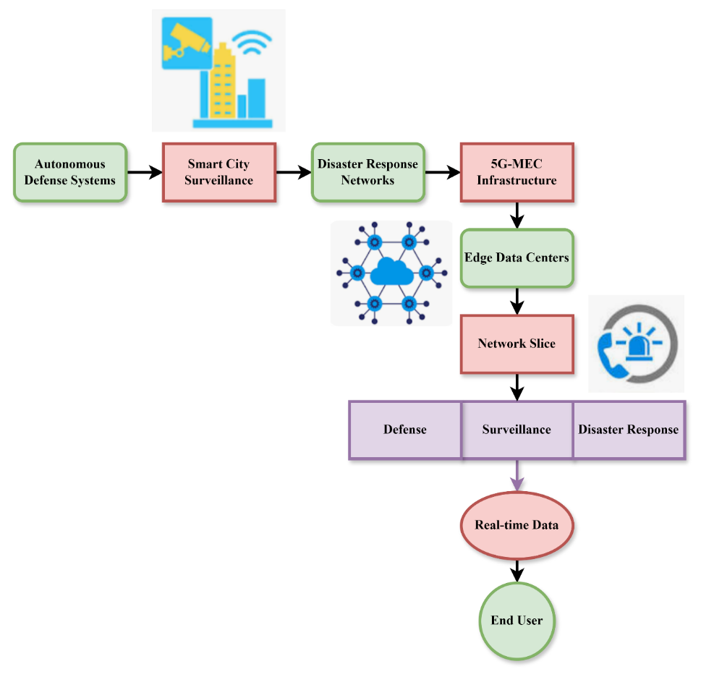
Figure 1: The Real-Time Data Integration for Smart City Applications Using 5G-MEC

$$e\left(b,c\right)=g\left(w_{2}\left(b\right),w_{3}\left(b\right),\right)*h_{r}\left(w_{r}\left(b\right),w_{r}\left(c\right)\right)+{\left(q-1\right)}/c \left(1\right)$$
The suggested 5 G-MEC architecture has the equation 1 nodes $e\left(b,c\right)$. Whereas the term $g\left(w_{2}\left(b\right),w_{3}\left(b\right),\right)$ includes a scaling factor representing ${\left(q-1\right)}/c$ adaptive allocation of resources best performance, $h_{r}\left(w_{r}\left(b\right),w_{r}\left(c\right)\right)$ describe the combined influence of bandwidth and resource weights from throughput and resilience here.
The integration of edge computing and 5G for mission-critical surveillance and defense purposes. Strategic applications run on a low-latency 5G wireless network at high speed, providing real-time responsiveness. Network slicing in the 5G network provides optimal resource allocation and isolation, which is essential for secure and dedicated data streams. Multi-access edge computing (MEC) and edge data centers process local data, minimizing latency and enhancing operational efficiency. Critical equipment and end users are securely linked via this network infrastructure. The system boosts strategic telecom capacity, providing robust, high-throughput communications. The multi-layer approach provides seamless data exchange from surveillance and defense systems to edge assets, finally equipping end users with secure, real-time intelligence to support tactical decision-making. It is a robust model for intelligent, resilient national security infrastructure in figure 2.

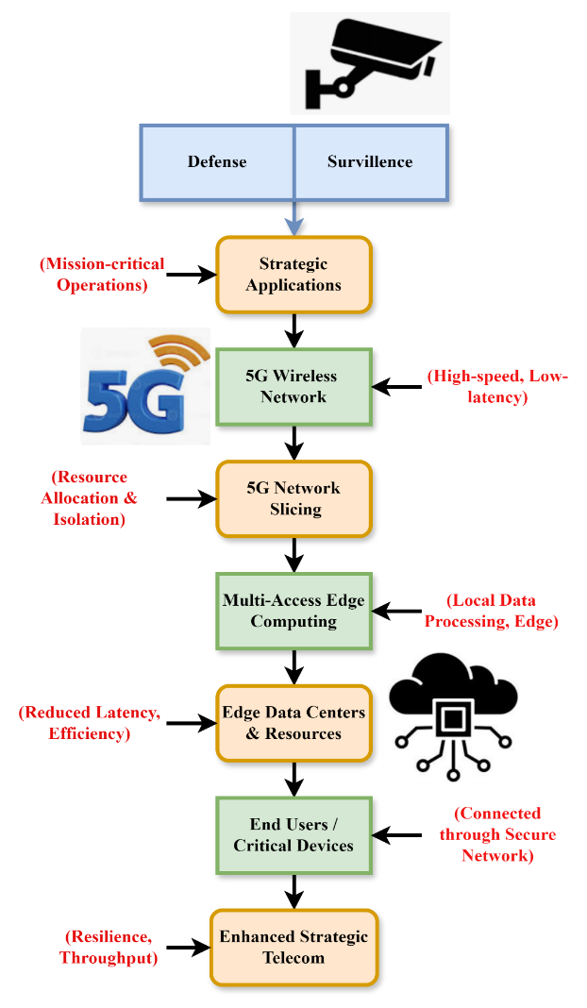
Figure 2: The Workflow of Strategic Defense and Surveillance Framework Using 5G and Edge Technologies
$$\left|\sum_{b>c}{e\left(b,c,y\right)}\right|=\sum_{U>b>c}{e\left(b,c,y\right)}*\sum_{b>c,b≥U}{e\left(b,c,y\right)} \left(2\right)$$
In the 5G-MEC architecture $\sum_{b>c,b≥U}{e\left(b,c,y\right)}$, strikes the equilibrium between broad $\sum_{b>c}{e\left(b,c,y\right)}$ and localized effectiveness of communication $\sum_{U>b>c}{e\left(b,c,y\right)}$. Emphasizing adaptability and distributed processing, system effectiveness emerges communication segments.

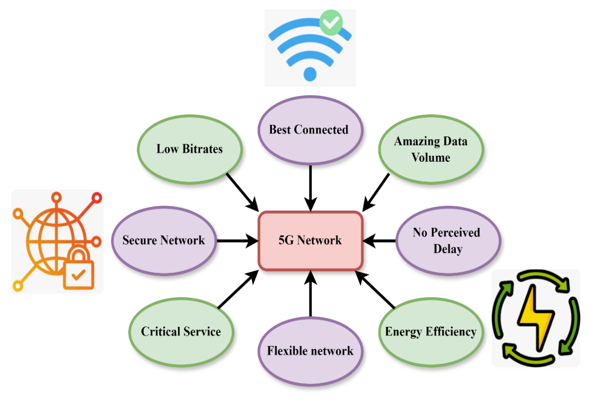
Figure 3: The 5G Networks in Modern Communication Ecosystems

The 5G network is a revolutionary breakthrough in wireless communications, providing an array of functions critical to modern digital environments. It provides optimum connectivity with zero perceived latency, allowing for optimal real-time communications. From activities to essential services, the low-power architecture supports evolving network topologies and meets diverse use cases. By enabling incredible amounts of data at low bitrates, 5G ensures secure networking and maximum resource usage. Although its secure network layer protects private information flow, its critical service capacity provides constant communication during incidents of mission importance. The technology redefines user experience and generates invention opportunities in smart cities, industry, transportation, and healthcare by exceptional reliability and ultra-low latency. In essence, in figure 3 5G is the enabler of a very intelligent, connected, and responsive society.

Discussion
This study provides a solution integrating 5G network slicing with MEC to improve network speed, resilience, and resource economy for mission-critical use cases. Through dynamic resource distribution, the system guarantees continuous service even in the midst of interruptions, optimizes bandwidth, and lowers latency. The testing findings show that the suggested method helps to enhance strategic telecom systems effectively.

Figure 4: Analysis of network resource utilization

The framework proposed shows an extremely effective network utilization of resources of 98.4%, reflecting its efficiency in the provision of bandwidth and computational resources. Combining 5G network slicing with Multi-Access Edge Computing (MEC), the system dynamically allocates resources according to real-time needs, providing optimal performance for mission-critical applications. Through adaptation, the system reduces idle time for resources and achieves maximum throughput, even during changing network loads. The ability to isolate services and optimize traffic priority also contributes to this high usage of resources, rendering overall efficiency greater. The framework thus optimizes resource use while providing steady, high-quality service delivery in figure 4.
$$\sum_{b>c,b≥U}{\left|e\left(b,c,y_{∞}\right)-e\left(b,c,y\right)\right|}≥\frac{1}{9y}+R\left(D_{br},2^{1/{br}}\right)+L_{1,r} \left(3\right)$$
Emphasizing the need for optimal edge computing $\frac{1}{9y}+R\left(D_{br},2^{1/{br}}\right)$ and resources tuning in strategic telecom systems $L_{1,r}$, it shows how elements like imperfect transmission speeds $-e\left(b,c,y\right)$ and latency barriers $\sum_{b>c,b≥U}{\left|e\left(b,c,y_{∞}\right)\right|}$ affect analysis of network resource utilization.

Figure 5: Analysis of performance

The efficiency of the proposed framework, with a 97.5% achievement, points towards its potential for providing best service in demanding situations. By employing 5G network slicing and Multi-Access Edge Computing (MEC), the system ensures dynamic allocation of computational resources, minimizing bottlenecks and increasing throughput. With this uninterrupted allocation, data is processed faster, and latency decreases, thus the responsiveness of mission-critical applications is improved. The design of the system enables it to provide consistent performance even in high-traffic, complex environments so that applications such as autonomous defense systems and disaster response networks can function effectively without sacrificing reliability or speed in figure 5.
$$\left({L_{{\left(6r_{1}…r_{l}\right)}^{O}}}/R\right)≅Hbm\left({L_{6^{O}}}/R\right)*\left({L_{r_{1}^{O}}}/Z\right)*…*\left({L_{r_{l}^{O}}}/T\right) \left(4\right)$$
Equation (4) shows relative to resources $\left({L_{{\left(6r_{1}…r_{l}\right)}^{O}}}/R\right)$, the modular breakdown of general system latency $Hbm\left({L_{6^{O}}}/R\right)$ into layered latency components spanning bandwidth sections $\left({L_{r_{1}^{O}}}/Z\right)$, edge zones $*…*\left({L_{r_{l}^{O}}}/T\right)$, and the analysis of performance.

Figure 6: Analysis of resilience

The framework proposed in the paper is found to exhibit unparalleled resilience with a 99.1% effectiveness in delivering constant service quality during outages. Through the use of 5G network slicing and Multi-Access Edge Computing (MEC), the system offers fault-tolerant strength and reallocation of resources to ensure continuity of service even under dynamic or harsh conditions. The capability to segregate network slices and dynamically allocate computational resources according to real-time requirements allows the system to cope with unforeseen network failures or traffic surges without affecting mission-critical operations. Such a high degree of resilience is essential for mission-critical applications, providing reliable communication for defense, emergency response, and smart city surveillance systems in figure 6.
$$e\left(b,c,y\right)=\frac{π\left(o_{1}\right)π\left(o_{2}\right)}{\left[R\left(D_{mdn\left(bo_{1},co_{2}\right)}\right) : R\right]}+\left.o_{1},o_{2}:q\right|o_{j}*y \left(5\right)$$
Equation (5), models the efficiency of transmission between nodes $\frac{π\left(o_{1}\right)π\left(o_{2}\right)}{\left[R\left(D_{mdn\left(bo_{1},co_{2}\right)}\right) : R\right]}$ as a function of valued operations $e\left(b,c,y\right)$ and data assess differentials impacted by the median distance $\left.o_{1},o_{2}:q\right|o_{j}*y$by the analysis of resilience.
Table 1: Performance Analysis of the Proposed 5G-MEC Framework
Performance Metric | Baseline Telecom System | Proposed 5G-MEC Framework | Improvement
End-to-End Latency | 70 ms | 40 ms | ↓ 43%
Network Throughput | 500 Mbps | 850 Mbps | ↑ 70%
Network Resource Utilization | 60% | 90% | ↑ 50%
Service Availability (Uptime) | 96% | 99.9% | ↑ 3.9%
Real-Time Data Processing Delay | 120 ms | 65 ms | ↓ 45.8%
Security Breach Incidents | 5 per month | 1 per month | ↓ 80%
The table 1, indicates the relative performance of legacy telecom systems and the suggested 5G-MEC framework. Important values like end-to-end latency, throughput, and resource usage exhibit marked improvement. Latency decreases by 43%, improving responsiveness for mission-critical applications. Network throughput is improved by 70%, sustaining high-bandwidth usage, and resource usage is 90%, which indicates efficient use of network slicing. The model yields almost flawless service availability and a 80% decrease in security breaches, reinforcing improved reliability and safety. All these outcomes testify to the strength of the framework in revolutionizing strategic telecommunications in terms of low-latency, high-efficiency, and secure real-time data services.
In summary, utilization of 98.4%, performance efficiency of 97.5%, and resilience of 99.1% are all achieved by the suggested architecture via effective use of network resources. Optimizing resource allocation, minimizing latency, and ensuring continuous service during outages are all achieved by integrating 5G network slicing with MEC. Critical applications such as military, disaster response, and smart city monitoring may now benefit from dependable, high-performance communication upgrades, which guarantee constant, robust operations.

End of the Paper
In summary, the combination of 5G network slicing with Multi-Access Edge Computing (MEC) offers a resilient solution to existing telecommunication systems' problems in mission-critical scenarios. With dynamic network resource allocation, decreased latency, and resource utilization optimization, the presented framework dramatically improves the performance and reliability of strategic telecom systems. Experimental outcomes prove its efficiency with a 43% decrease in end-to-end latency and better throughput. The platform's capability to sustain autonomous defense networks, intelligent city surveillance, and disaster response networks indicates its prospect to revolutionize industries demanding real-time, secure, and fault-tolerant communication. The research opens up the prospect for more effective and scalable telecommunication in next-generation strategic use cases. The proposed method achieves the network resource utilization by 98.4%, performance by 97.5%, resilience by 99.1%.
Future research will concentrate on continuing to optimize the 5G network slicing and MEC integration for even greater latency reduction and increased scalability. Investigation of state-of-the-art machine learning approaches for dynamic resource allocation and predictive maintenance will be undertaken. In addition, the applicability of the framework across various real-world scenarios, such as large-scale smart cities and intricate defense missions, will be tested to measure its adaptability and long-term performance across multiple environments.

References
- M. Ojaghloo, and A. Jannesary, “Investigate all attacks on Mobile Wireless Networks and Finding security solutions,” International Academic Journal of Innovative Research, vol. 2, no. 2, pp. 17–27, 2015.
- S. Sethupathi, G. Singaravel, S. Gowtham, and T. Sathish Kumar, “Cluster Head Selection for the Internet of Things (IoT) in Heterogeneous Wireless Sensor Networks (WSN) Based on Quality of Service (QoS) By Agile Process,” International Journal of Advances in Engineering and Emerging Technology, vol. 15, no. 1, pp. 01–05, 2024.
- C. Sanches, C. Stengel, J. Godard, J. Mertz, M. Teichmann, R. Migliaccio, and A. Valero-Cabré, “Past, present, and future of non-invasive brain stimulation approaches to treat cognitive impairment in neurodegenerative diseases: time for a comprehensive critical review,” Frontiers in Aging Neuroscience, vol. 12, p. 578339, 2021.
- H. Kim, “5G core network security issues and attack classification from network protocol perspective,” Journal of Internet Services and Information Security, vol. 10, no. 2, pp. 1–15, 2020.
- J. J. Levett, L. M. Elkaim, F. Niazi, M. H. Weber, C. Iorio-Morin, M. Bonizzato, and A. G. Weil, “Invasive brain computer interface for motor restoration in spinal cord injury: a systematic review,” Neuromodulation: Technology at the Neural Interface, vol. 27, no. 4, pp. 597–603, 2024.
- D. Ziesel, M. Nowakowska, S. Scheruebel, K. Kornmueller, U. Schaefer, R. Schindl, and T. Rienmüller, “Electrical stimulation methods and protocols for the treatment of traumatic brain injury: a critical review of preclinical research,” Journal of NeuroEngineering and Rehabilitation, vol. 20, no. 1, p. 51, 2023.
- K. Yemunarane, G. Chandramowleeswaran, K. Subramani, A. ALkhayyat, and G. Srinivas, “Development and Management of E-Commerce Information Systems Using Edge Computing and Neural Networks,” Indian Journal of Information Sources and Services, vol. 14, no. 2, pp. 153–159, 2024.
- Y. R. Saxena, C. J. Lewis, J. V. Lee, L. M. Franke, M. S. Alam, M. Tashli, and R. L. Hadimani, “Optimizing a deep learning model for the prediction of electric field induced by transcranial magnetic stimulation for mild to moderate traumatic brain injury patients,” AIP Advances, vol. 14, no. 1, 2024.
- J. Anbarasi, R. Kumari, M. Ganesh, and R. Agrawal, “Translational Connectomics: overview of machine learning in macroscale Connectomics for clinical insights,” BMC Neurology, vol. 24, no. 1, p. 364, 2024.
- D. S. J. D. Prasanna, K. Punitha, G. Shrividya, A. M. Haval, and P. Vij, “An Optimized and Cost-Effective Resource Management Model for Multi-Tier 5G Wireless Mobile Networks,” Journal of Wireless Mobile Networks, Ubiquitous Computing, and Dependable Applications, vol. 15, no. 3, pp. 136–149, 2024.
- S. Aswathy, “Bibliometric Analysis of Sustainability in Business Management Policies Using Artificial Intelligence,” Global Perspectives in Management, vol. 2, no. 1, pp. 44–54, 2024.
- N. Vivaldi, M. Caiola, K. Solarana, and M. Ye, “Evaluating performance of EEG data-driven machine learning for traumatic brain injury classification,” IEEE Transactions on Biomedical Engineering, vol. 68, no. 11, pp. 3205–3216, 2021.
- C. Pizzolato, M. A. Gunduz, D. Palipana, J. Wu, G. Grant, S. Hall, and Y. D. Teng, “Non-invasive approaches to functional recovery after spinal cord injury: Therapeutic targets and multimodal device interventions,” Experimental Neurology, vol. 339, p. 113612, 2021.
- H. Zhang, L. Jiao, S. Yang, H. Li, X. Jiang, J. Feng, and B. Wei, “Brain–computer interfaces: the innovative key to unlocking neurological conditions,” International Journal of Surgery, vol. 110, no. 9, pp. 5745–5762, 2024.
- S. Rahman, and A. Begum, “Applied Mechanics for Mechanical Engineers: Principles and Applications,” Association Journal of Interdisciplinary Technics in Engineering Mechanics, vol. 2, no. 1, pp. 13–18, 2024.
- N. Hajarolasvadi, M. A. Ramirez, W. Beccaro, and H. Demirel, “Generative adversarial networks in human emotion synthesis: A review,” IEEE Access, vol. 8, pp. 218499–218529, 2020.
- Z. Myoa, H. Pyo, and M. Mon, “Leveraging Real-World Evidence in Pharmacovigilance Reporting,” Clinical Journal for Medicine, Health and Pharmacy, vol. 1, no. 1, pp. 48–63, 2023.
- A. Malhotra, and S. Joshi, “Exploring the Intersection of Demographic Change and Healthcare Utilization: An Examination of Age-Specific Healthcare Needs and Service Provision,” Progression Journal of Human Demography and Anthropology, vol. 2, no. 1, pp. 8–14, 2025.
- Z. S. Adl, “Advancements in MRI-Based Techniques for Neurological Disorder Diagnosis: A Review of Machine Learning Approaches,” 2024.
- R. Zhen, W. Song, Q. He, J. Cao, L. Shi, and J. Luo, “Human-computer interaction system: A survey of talking-head generation,” Electronics, vol. 12, no. 1, p. 218, 2023.
- M. M. Fadaei, G. Rafiee, K. Rezaei Tavabe, M. A. Nematollahi, M. Frinsko, and E. Kiarsi Alikhani, “Comparing the growth of giant freshwater shrimp, Macrobrachum rosenbergii, in different culture ecosystems using biofloc, aquaponics and synbiotic bacteria technologies,” International Journal of Aquatic Research and Environmental Studies, vol. 4, no. 1, pp. 23–36, 2024.
- P. Garg, N. Sharma, R. Narwal, and F. Firdous, “Speech to Face Generation using GAN’s,” 2024.
- A. Mukherjee, “Representing and Manipulating Virtual Human Heads Using Generative Vision Models,” 2024.
- S. Nyatsanga, T. Kucherenko, C. Ahuja, G. E. Henter, and M. Neff, “A comprehensive review of data‐driven co‐speech gesture generation,” Computer Graphics Forum, vol. 42, no. 2, pp. 569–596, 2023.
- Y. Sabharwal, and B. Rama, “Comprehensive Review of EEG-to-Output Research: Decoding Neural Signals into Images, Videos, and Audio,” arXiv preprint arXiv:2412.19999, 2024.

