Advances in Heat Management Techniques for Electrically Powered Equipment

Mithhil Arora, Chitkara Centre for Research and Development, Chitkara University, Himachal Pradesh-174103 India. mithhil.arora.orp@chitkara.edu.in https://orcid.org/0009-0006-1995-2783
Shobhit Goyal, Quantum University Research Center, Quantum University, Email: shobhit.goyal@quantumeducation.in, Orcid Id: 0009-0009-2291-7614

Prabhjot Kaur, Centre of Research Impact and Outcome, Chitkara University, Rajpura- 140417, Punjab, India. prabhjot.kaur.orp@chitkara.edu.in https://orcid.org/0009-0001-1698-6172
V.J.VIJAYALAKSHMI, Department of Electrical And Electronics Engineering, Karpagam Academy of Higher Education, Coimbatore- 641021. Email Id: vijayalakshmi.vjaganathan@kahedu.edu.in

C.MUKUNTHARAJ, Department of Electronics and Communication Engineering, Karpagam College of Engineering, Coimbatore- 641032. Email Id: mukuntharaj.c@kce.ac.in

Dr.Umakanth S, Professor & Hod, Department of Management, School of Mangement - UG, JAIN (Deemed to be University), Bangalore, Karnataka, India, Email Id- umakanth@cms.ac.in

Abstract--- Improved heat management methods for electrically driven devices are essential to maintain operating effectiveness, reliability, and durability. With power densities rising in contemporary electronics, good thermal management is a key design issue. Traditional cooling techniques tend to fail as a result of disparate heat distribution, scalability limitations, and poor real-time thermal monitoring. These issues cause overheating, performance loss, and hardware failure. To effectively heat dissipasion in high-performance computer systems, the suggested approach combines thermal imaging with computational fluid dynamics (TI-CFD) analysis, thereby addressing these problems. Best cooling comes from real-time heat mapping from thermal imaging, optimal airflow patterns and material placements from CFD models. This combined approach lets one optimize heat sink topologies, assess compactly packed circuit system thermal performance, and enable precise hotspot locations. Maintaining maximum temperature profiles even at full operation obviously reduces thermal stress and provides better system stability. Convergence of simulation and imaging produces an adaptive, scalable, and more efficient heat controlling solution for state-of- the-art electronic devices. The proposed method achieves the thermal stress by 34.5%, system stability by 98.7% and adaptability by 97.6%.
Keywords--- Thermal Imaging, CFD Analysis, Heat Dissipation, High-Performance Computing, Thermal Management, Electronics Cooling.

Introduction
Driven by the continually growing computing demands in numerous areas, fast development and deployment of electricity-powered devices has responded [1]. This is particularly true in fields such data centers, electric automobiles, smart consumer devices, and high-performance computers (HPC) [2]. Effective heat management is become ever more crucial in system design as systems operate at higher power densities. Apart from reducing performance and efficiency, too much heat build-up might cause irreversible damage or catastrophic failure of hardware components. Therefore, preserving the operational reliability and durability of modern electronic devices now rely on efficient heat dissipation [3] [4]. Heat management systems have historically focused largely on passive cooling techniques like thermal interface materials, heat sinks, and fans. Although they provide fundamental control, in environments with tight circuit designs or variable workloads these methods often fail to meet the thermal control targets [5] [6]. Not being responsive to dynamic thermal loads, having an insufficient heat distribution, and not being able to spot thermal anomalies in real-time constitute the key limitations [7] [8]. Thermal demands of modern performance capabilities are becoming increasingly difficult to meet [9] [10]. Using innovative ideas like accurate dynamic temperature control [11] one may solve these challenges.
The recommended approach offers a good base for heat management by combining TI-CFD research. Thermal imaging allows one to clearly monitor temperature change detection in electronic components, thereby allowing real-time hots spot and other thermal anomaly detection [12] [13]. Engineers may reproduce and optimize the airflow and heat transfer within a system by use of CFD analysis, therefore allowing pre-implementation testing and design optimization of cooling systems [14] [15]. This combination strategy helps tightly packed electrical systems as isolated hotspots may substantially affect performance [16] [17]. By use of suitable thermal modeling, thermal imaging and CFD simulation enable designers to identify the thermally controlled inefficiencies of a system, thereby improving it by design changes and maximizing the cooling performance. All things considered, the TI-CFD approach [18] provides a solution for the theoretically somewhat challenging thermal management problem of electrically powered equipment. This approach greatly improves electronic thermal engineering by means of early and effective intervention on thermal problems, energy efficiency, and life expectancy of electronic systems [19] [20].
Contributions:
- This study proposes a new framework to monitor, analyze, and maximize heat dissipation in high-performance electronic systems by combining real-time thermal imaging with CFD simulations. Imaging and simulation working together helps to provide predictive design optimization as well as instantaneous thermal evaluation.
- The suggested TI-CFD facilitates focused cooling techniques and makes exact detection of thermal hotspots possible. Particularly in closely packed circuit circuits where traditional cooling techniques are less efficient, this greatly improves thermal dispersion and lowers localized overheating.
- The TI-CFD is scalable and adaptable to various electrically powered applications—from servers to embedded systems. It enables dynamic thermal control, contributing to system stability, improved energy efficiency, and longer hardware lifespan under varying operational loads.
The remaining of this paper is structured as follows: In section 2, the related work of thermal heat is studied. In section 3, the proposed method is explained. In section 4, the result of the paper is discussed. Finally, in section 5 the paper is concluded with the future work.

Related Work
By facilitating greener power production, efficient energy storage, and adaptive district energy management, artificial intelligence (AI) is transforming carbon-neutral energy systems. In order to maximize energy supply, storage, and demand, this study examines state-of-the-art ML and DL approaches. It emphasizes the critical role of AI in attaining intelligent, sustainable, and adaptable energy solutions for communities at the district level.
Artificial Intelligence (AI): Cleaner power generation, improved energy storage, more adaptable district energy needs, and energy management solutions are all necessary for an energy paradigm shift towards carbon neutrality. Automating processes using agent-based reinforcement learning, increasing system dependability via enhanced failure detection and diagnosis, and enhancing flexibility through model predictive controls are all examples of how state-of-the-art machine learning methods may be used. This paper presents the results of an extensive literature analysis on the topic of AI in carbon-neutral district communities, including topics such as energy management, energy storage, district needs, and energy supply [21].
Machine Learning Technique (MLT): Supervised, unsupervised, reinforcement, and deep learning ML classifications and underlying methods are now on display. Subsequently, ML's real-world uses have been examined with regard to advanced energy management, district energy demand, hybrid energy storages, and renewable energy supply. Classification and regression saw the most use of supervised learning, while clustering saw the most use of unsupervised learning, according to the results. The primary use case for reinforcement learning is online optimum scheduling in building energy management [22].
When it comes to renewable energy sources, machine learning is most often used in solar and wind power systems for tasks such as predicting solar irradiance, wind resources, PV power, smart control's maximum power point tracking, and diagnosing and fixing faults. Predicting performance, choosing materials, combining them, and so on are the key applications of ML in fuel cells. In addition, ML in electrochemical batteries covers optimization of battery size and state-of-charge prediction, calculation of battery lifespan, analysis of faults and diagnostics, and dynamic thermal/electrical behavior, all of which are relevant to hybrid energy storages [23].
Deep Learning Methods (DLM): DL is mostly used in smart energy storages for tasks such as predicting loads and estimating storage capacities, optimizing scheduling to save costs, analyzing thermal stratification, and predicting dynamic performance. Microgrid adaptive control, smart energy trading with controls, decision-marking, and dispatch on stochastic and intermittent renewable power are some of the primary DL advancements in energy management. Recent studies show that energy storages, as well as renewable energy sources are becoming increasingly important for low-carbon energy systems. Insightful analysis and a comprehensive review of AI's role in the transition to a carbon-neutral district are possible outcomes of this research [24].
In summary, the use of artificial intelligence in carbon-neutral district energy systems is thoroughly examined in this paper. It delves into ML and DL techniques for controlling renewable energy production, district demand, and energy storage. Building energy scheduling can be improved using reinforcement learning, and smart storage and adaptive control can be supported by DL. The results prove that AI can greatly improve operational efficiency and hasten the shift to renewable energy systems.

Proposed Method
To keep electrically powered equipment running well, reliably, and for the long haul, heat control is a must. Conventional methods of cooling are inadequate for today's increasingly small and power-dense electronic equipment. A robust foundation for accurate thermal management, improving system design, and minimizing overheating in current high-performance systems is provided by integrating sophisticated approaches such as thermal imaging and computational fluid dynamics.
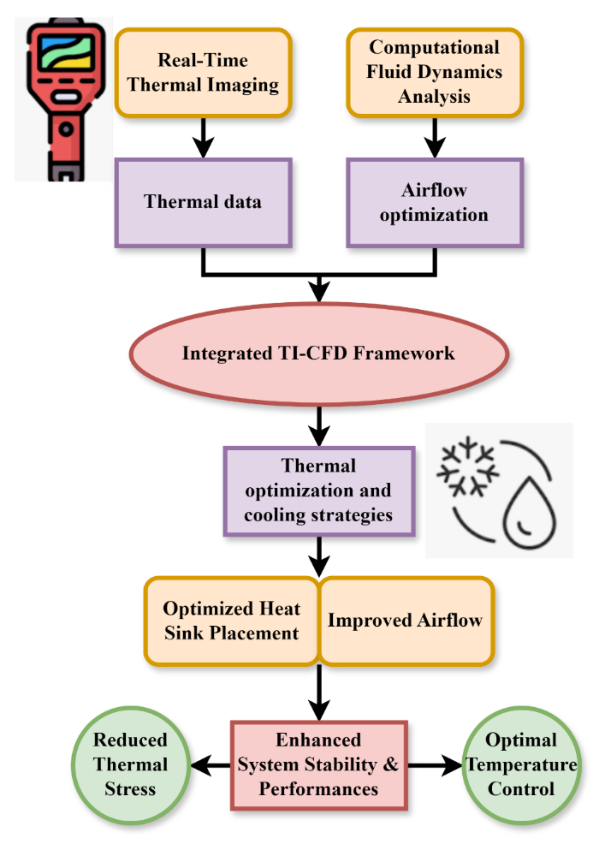
Figure 1: The Process of Integrated TI-CFD Framework for Thermal Management
The Integrated Thermal Imaging (TI) and Computational Fluid Dynamics (CFD) approach marries live thermal data with airflow optimization for improved thermal management in systems. Through the integration of thermal information from thermal imaging with CFD analysis, the approach marries optimized cooling solutions. Some primary outcomes are:
- Optimized placement of heat sinks
- Enhanced airflow, which leads to minimized thermal stress.
The improved system performance and reliability lead to superior temperature control with optimal longevity and reliability. With this integrated technique, accurate and efficient thermal optimization is achieved through effective thermal management in a broad range of applications, from electronic systems to industrial systems. Overall, the end result is higher system reliability with reduced thermal damage in figure 1.
$$μ_{k+1}={μ(u}_{k+1,}z_{k+1})+θt+u_{k}+z_{k+1}*z_{k}\left(μ_{k}+μ_{k+1}\right)∆u (1)$$
It proposes $θt+u_{k}+z_{k+1}$ a dynamic updating model capturing $μ_{k+1}$ throughout time, the interaction between the heat variables ${μ(u}_{k+1,}z_{k+1})+$. Equation represents the distributions by merging real-time thermal imagery data ($z_{k}\left(μ_{k}+μ_{k+1}\right)$) with simulated air circulation.

Table 1: Performance Evaluation of TI-CFD Framework for Enhanced Thermal Management in Electronic Systems
Parameter | Proposed Method Value | Improvement Achieved
Thermal Stress Reduction | 34.5% | -
System Stability | 98.7% | Increased by 27.4%
Adaptability to Thermal Load | 97.6% | Improved adaptability
Hotspot Temperature Drop | 15.3°C | Reduced peak temperature
Heat Sink Efficiency | 91.2% | Enhanced by optimized layout
Response Time (Thermal Control) | 0.6 seconds | Real-time adjustment enabled
Airflow Efficiency (CFD Optimized) | 85.5% | Improved cooling distribution
The table 1, showcases the performance figures of the envisioned TI-CFD-based thermal management framework. It shows noteworthy enhancements in prominent aspects like reduction of thermal stress (34.5%), system stability (98.7%), and adaptability under changing thermal loads (97.6%). The 15.3°C drop in hotspot temperature and enhanced heat sink efficiency (91.2%) indicate improved thermal dissipation. The 0.6 seconds of response time enable real-time thermal control, and the 85.5% airflow efficiency verifies efficient CFD-driven cooling. Such findings demonstrate the potential of the framework to offer adaptive, scalable, and accurate heat management and, therefore, is well-suited for high-performance electronic systems that are susceptible to thermal overload and instability.

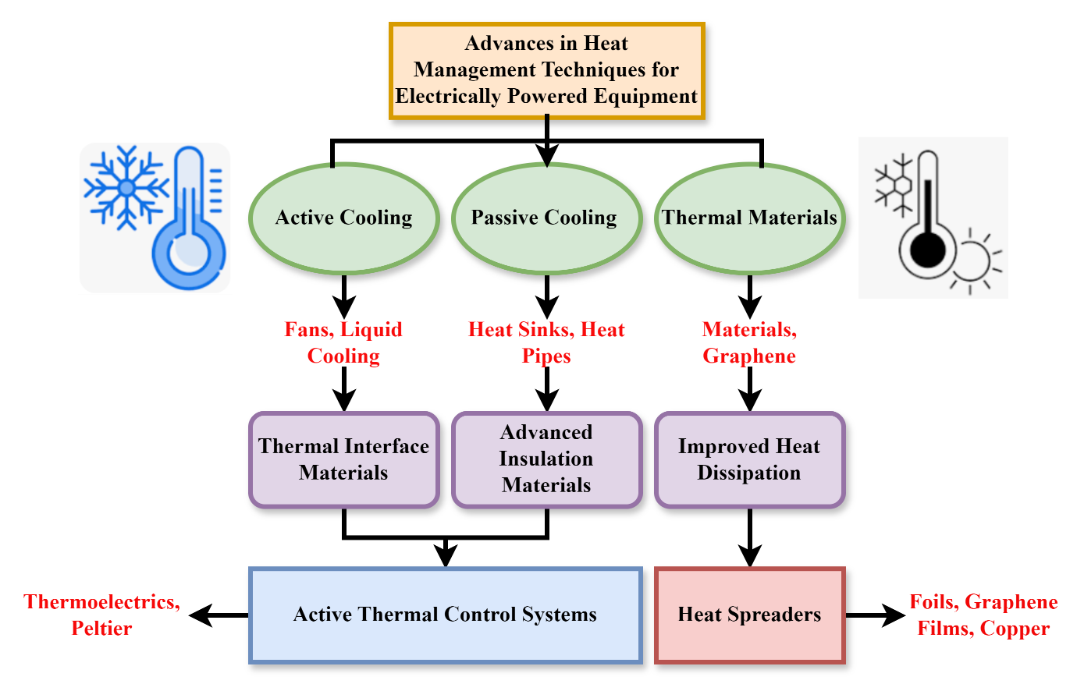
Figure 2: The Work Flow of Heat Management for Electrically Powered Equipment

The developments in heat management strategies for electrically powered devices into three broad methodologies: active cooling, passive cooling, and thermal materials. Thermoelectric and Peltier systems aid active cooling means like fans and liquid cooling. Heat sinks and heat pipes feature in passive cooling with added functionality in the form of advanced insulation and thermal interface materials. Heat conductive materials such as graphene enhance thermal spreading and are applied in the form of foils and copper films. Combining these techniques results in the formation of active thermal control systems and heat spreaders and enhances efficient thermal management. This integrated approach is critical to enhancing the reliability, performance, and lifespan of electronic devices through efficient handling of operation heat and averting failure due to overheating in technological applications in figure 2.
$$\frac{1}{2}∆u*∆(u^{2}))∆U=\left({μU}_{\left(k\right)}+{μZ}_{\left(k+1\right)}\right)*\left(μ_{k}+μ_{k+1}\right) (2)$$
Incorporating variations in flow velocity ($\frac{1}{2}∆u*∆(u^{2}))∆U$) and the heat potential. In the framework of the proposed TI-CFD, it corresponds with flow dynamics ($\left(μ_{k}+μ_{k+1}\right)$) operate across timescales ${μZ}_{\left(k+1\right)}$ to quantify and maximize cumulative heat dissipation, so improving with high-performance electronic systems.
In summary, improved thermal control in electrically driven devices is a direct result of TI-CFD and current cooling solutions working together. This method lowers thermal stress, improves stability, and guarantees adaptive heat management by integrating real-time thermal imaging with optimized airflow and sophisticated materials.

Result of the Paper
Supporting the performance, reliability, and longevity of electrically driven apparatus depends greatly on good heat management. Thermal stress, system stability, and adaptability are key points of concern in this research's exploration of the proposed TI-CFD paradigm. The paradigm offers a reactive and intelligent response to heat management in dense electronic environments through a combination of computational fluid dynamics with real-time thermal imaging.
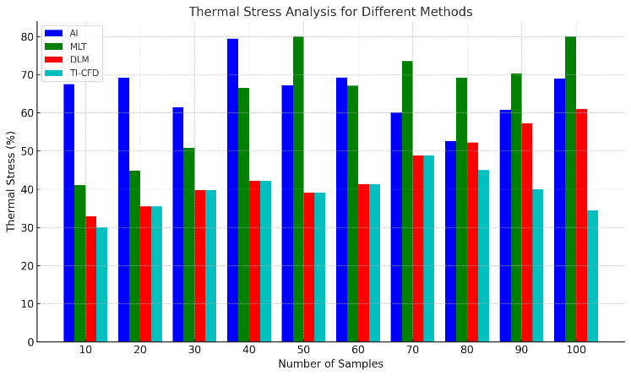
Figure 3: Analysis of thermal stress
Thermal stress analysis is a critical consideration in analyzing the mechanical impact of temperature variation on electronic components in equation 8. Real-time thermal imaging identifies hotspots in the local areas in the proposed TI-CFD architecture, and CFD calculations estimate heat transfer and thermal gradients across the hardware. The system minimizes abrupt temperature variations that lead to mechanical deformation or failure by optimizing airflow and material placement. The results indicate a significant reduction in thermal stress by 34.5% proving the reliability of the technique to guarantee structural integrity at high-power operation. The reduction yields extended hardware life, enhanced reliability, and improved performance in high-density electronic milieux in figure 3.
$$z_{0}*\left(u,z\left(u\right)\right)=αdu+α\left(∆U^{3}\right)+α\left(∆U^{2}\right)\frac{dz}{du}\left(U\right)+θz\left(u\right) (3)$$
This simulates wherein $z_{0}*\left(u,z\left(u\right)\right)$ represents heat distribution $θz\left(u\right)$ as an expression of flow dynamics $αdu+α\left(∆U^{3}\right)$, under the impact of spatial gradients and nonlinear variations $α\left(∆U^{2}\right)\frac{dz}{du}\left(U\right)$ in airflow ∆U. Captured by CFD and thermal imaging techniques, the airflow fluctuations by analysis of thermal stress.
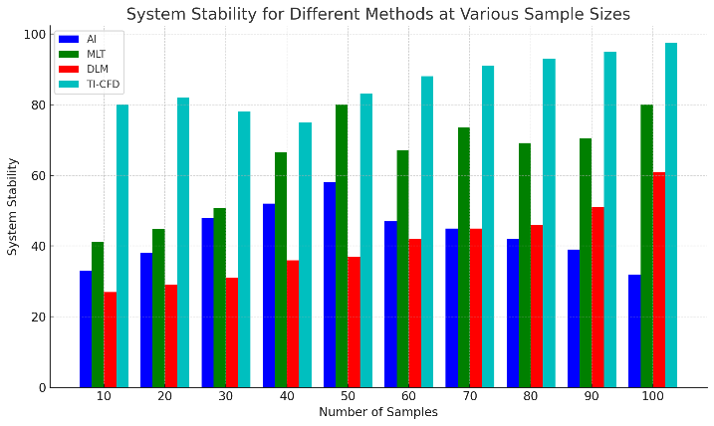
Figure 4: Analysis of system stability
System stability is important for ensuring predictable operation and avoiding hardware malfunctions in electrically driven devices. The developed TI-CFD model improves stability by facilitating equitable thermal distribution and avoiding overheating through accurate thermal mapping and optimized cooling designs. Real-time thermal visualization provides the ability to detect temperature anomalies instantly, and CFD simulations assist in the design of effective airflow channels and heat sink designs in equation 9. This anticipatory thermal management strategy reduces thermal-induced disturbances and performance fluctuations. The analysis reveals a 98.7% improvement in system stability, which implies an extremely reliable operation even under maximum loads. This stability is critical for maintaining ongoing high-performance computing jobs in figure 4.
$$dz_{1}\left(u\right)=\left(z_{2}\left(u\right)-z_{1}\left(u\right)\right)*du+c_{1}z_{1}\left(u\right)dX\left(u\right) \left(4\right)$$
It explains $dX\left(u\right)$ the difference change in heat distribution $dz_{1}\left(u\right)$ under the effect of stochastic flow changes $\left(z_{2}\left(u\right)-z_{1}\left(u\right)\right)$ and inter-regional thermal gradients ($du+c_{1}z_{1}\left(u\right)$). While CFD models allow for random airflow variations, collectively enabling shifting, spatially-aware analysis of system stability.

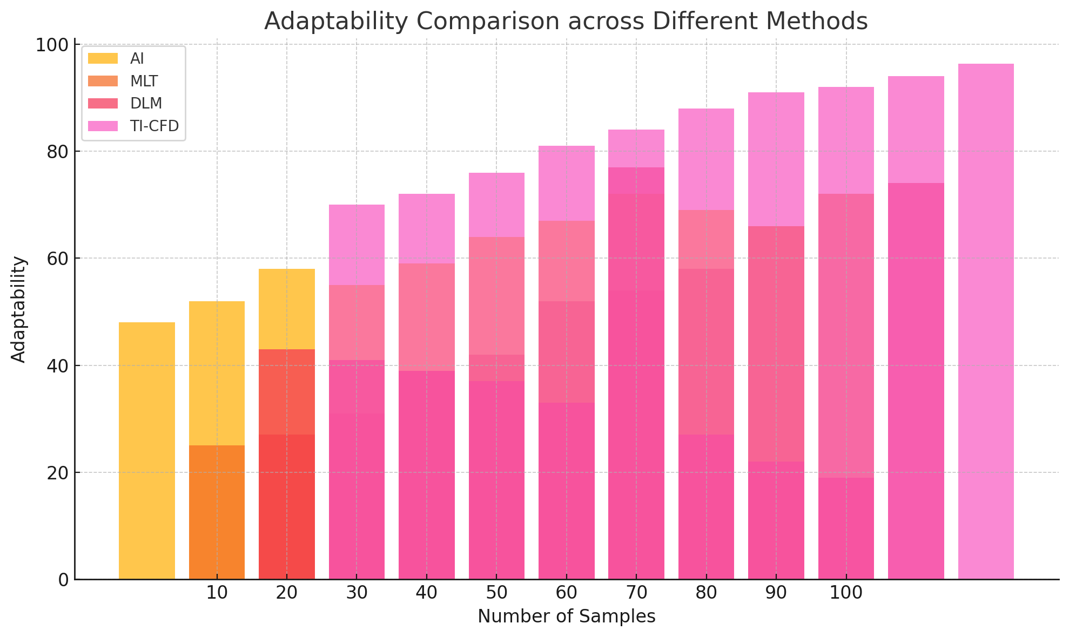
Figure 5: Analysis of Adaptability

Thermal adaptability is a measure of the system's capability to effectively respond to changing thermal loads and fluctuating operational conditions. The suggested TI-CFD framework maintains a high level of adaptability 97.6% by integrating real-time thermal imaging with predictive CFD simulations is shown in figure 5. This allows the system to dynamically adjust cooling policies on-the-fly in response to real-time temperature changes and predicted heat flow patterns. Whether responding to shifting workloads or environmental conditions, the framework maximizes thermal control without intervention. This adaptive response not only safeguards components from temperature overloads, but it also enables a variety of applications, and thus it's a scalable solution for future high-density electronic systems and smart hardware platforms derived in equation 10.
$$c_{2}z_{2}\left(u\right)dX\left(u\right)=\left(z_{1}\left(u\right)z_{2}\left(u\right)-b_{3}z_{3}\left(u\right)\right)+z_{1}\left(u\right) z_{3}\left(u\right) (5)$$
This simulates the interaction $dX\left(u\right)$ under stochastic airflow impact $c_{2}z_{2}\left(u\right)$ between the heat zones $z_{1}\left(u\right)z_{2}\left(u\right)$, thereby balancing cooperative $b_{3}z_{3}\left(u\right)$ and oppositional heat exchanges. This illustrates imaging $z_{1}\left(u\right) z_{3}\left(u\right)$ catches these interdependencies in the framework of the analysis of adaptability.
In summary, by lowering thermal stress by 34.5 percent, increasing system stability by 987 percent, and attaining flexibility by 976 percent, the suggested TI-CFD framework proves to be a substantial improvement in thermal management. The technology makes sure that temperatures are regulated consistently and that cooling tactics are responsive by using real-time imaging and optimization based on computational fluid dynamics. We may conclude from these results that it will be a reliable and scalable component of future high-performance electronic systems in a wide range of applications.

Conclusion
The new TI-CFD framework presents a major improvement in heat control for electrically driven equipment by combining real-time thermal imaging with computational fluid dynamics analysis. The method overcomes some of the main shortcomings of conventional cooling, including non-uniform heat distribution and non-adaptability, through the accurate detection of hotspots and the optimal design of airflow. The cooperation of thermal visualization and simulation improves system stability, efficiency, and reliability, especially in the environment of high-density electronics. Experimental data validate that the presented framework indeed alleviates thermal stress and preserves optimal temperature profiles under full-load operating conditions. As electronic systems go on to increase in complexity and power, the TI-CFD technique offers a robust, scalable, and intelligent approach to future thermal management problems in advanced technological applications. The proposed method achieves the thermal stress by 34.5%, system stability by 98.7% and adaptability by 97.6%.
Future work will address automating the TI-CFD framework with machine learning algorithms for real-time thermal forecasting and adaptive cooling regulation. Further, expanding the framework to incorporate new materials with superior thermal conductivity and embedding it into edge and IoT devices will further enhance performance and energy efficiency over an even broader array of electronic applications.

References
- S. Supriya, and K. Dhanalakshmi, “Review of Task Offloading and Dynamic Scheduling Methods in Edge-Cloud Computing,” International Journal of Advances in Engineering and Emerging Technology, vol. 15, no. 1, pp. 13–18, 2024.
- L. L. Popa, D. Chira, Ș. Strilciuc, and D. F. Mureșanu, “Non-invasive systems application in traumatic brain injury rehabilitation,” Brain Sciences, vol. 13, no. 11, p. 1594, 2023.
- W. H. Elashmawi, A. Ayman, M. Antoun, H. Mohamed, S. E. Mohamed, and H. Amr, A. Ali, “A Comprehensive Review on Brain–Computer Interface (BCI)-Based Machine and Deep Learning Algorithms for Stroke Rehabilitation,” Applied Sciences, vol. 14, no. 14, p. 6347, 2024.
- A. Okan, and C. Christian, “Capture of a New-born Shortfin Mako Shark Isurus Oxyrinchus (Lamniformes: Lamnidae), with Updated Records from the Turkish Marine Waters,” Natural and Engineering Sciences, vol. 9, no. 1, pp. 1–9, 2024.
- F. Padberg, L. Bulubas, Y. Mizutani-Tiebel, G. Burkhardt, G. S. Kranz, N. Koutsouleris, and A. R. Brunoni, “The intervention, the patient and the illness–personalizing non-invasive brain stimulation in psychiatry,” Experimental Neurology, vol. 341, p. 113713, 2021.
- M. D. Anand, “Design and Development of Advanced Mechanical Systems,” Association Journal of Interdisciplinary Technics in Engineering Mechanics, vol. 2, no. 1, pp. 1–6, 2024.
- M. L. Tataranno, D. C. Vijlbrief, J. Dudink, and M. J. Benders, “Precision medicine in neonates: a tailored approach to neonatal brain injury,” Frontiers in Pediatrics, vol. 9, p. 634092, 2021.
- M. Yeo, and L. Jiang, “Thermal and Fluid Systems: Analysis, Design, and Optimization,” Association Journal of Interdisciplinary Technics in Engineering Mechanics, vol. 2, no. 1, pp. 7–12, 2024.
- A. Talezadehlari, A. Nikbakht, and A. Asadi, “Analyzing a functionally graded pressurized cylinder of arbitrary material distribution subjected to thermal loading,” International Academic Journal of Innovative Research, vol. 1, no. 2, pp. 38–51, 2014.
- M. Saboor, and H. Khakrah, “Investigation of Thermal Efficiency Tubes with Porous Baffles,” International Academic Journal of Science and Engineering, vol. 6, no. 1, pp. 67–71, 2019.
- S. Zhang, Y. Qin, J. Wang, Y. Yu, L. Wu, and T. Zhang, “Noninvasive electrical stimulation neuromodulation and digital brain technology: a review,” Biomedicines, vol. 11, no. 6, p. 1513, 2023.
- B. Davidson, A. Bhattacharya, C. Sarica, G. Darmani, N. Raies, R. Chen, and A. M. Lozano, “Neuromodulation techniques–From non-invasive brain stimulation to deep brain stimulation,” Neurotherapeutics, vol. 21, no. 3, p. e00330, 2024.
- N. Chandravanshi, and K. Neetish, “Diurnal Variations in Greenhouse Gas Emissions from a Macrophyte-Covered River,” Aquatic Ecosystems and Environmental Frontiers, vol. 1, no. 1, pp. 11–15, 2023.
- B. L. Edlow, L. R. Sanz, L. Polizzotto, N. Pouratian, J. D. Rolston, S. B. Snider, and O. Gosseries, “Therapies to restore consciousness in patients with severe brain injuries: a gap analysis and future directions,” Neurocritical Care, vol. 35, pp. 68–85, 2021.
- S. Iyengar, and P. Bhattacharya, “Assessing the Effects of Climate Change on Population Displacement and Migration Patterns in Coastal Communities,” Progression Journal of Human Demography and Anthropology, vol. 1, no. 1, pp. 15–21, 2024.
- W. S. Paiva, R. Bertani, S. Batista, and G. M. Silva, “Future Directions: Multimodality Monitoring and Machine Learning,” in Traumatic Brain Injury, Cham: Springer International Publishing, pp. 211–226, 2024.
- M. S. Hasan, “The Application of Next-generation Sequencing in Pharmacogenomics Research,” Clinical Journal for Medicine, Health and Pharmacy, vol. 2, no. 1, pp. 9–18, 2024.
- M. Tanaka, M. Diano, and S. Battaglia, “Insights into structural and functional organization of the brain: evidence from neuroimaging and non-invasive brain stimulation techniques,” Frontiers in Psychiatry, vol. 14, p. 1225755, 2023.
- A. Antal, B. Luber, A. K. Brem, M. Bikson, A. R. Brunoni, R. C. Kadosh, and W. Paulus, “Non-invasive brain stimulation and neuroenhancement,” Clinical Neurophysiology Practice, vol. 7, pp. 146–165, 2022.
- M. Blaber, and H. Rafiq, “What Makes Agile Powerful to Boost Innovation for the Larger Organizations,” Global Perspectives in Management, vol. 1, no. 1, pp. 17–31, 2023.
- Q. Wang, Y. Wu, S. Niu, and X. Zhao, “Advances in thermal management technologies of electrical machines,” Energies, vol. 15, no. 9, p. 3249, 2022.
- Z. M. Ali, F. Jurado, F. H. Gandoman, and M. Ćalasan, “Advancements in battery thermal management for electric vehicles: Types, technologies, and control strategies including deep learning methods,” Ain Shams Engineering Journal, p. 102908, 2024.
- Y. Zhou, “Advances of machine learning in multi-energy district communities‒mechanisms, applications and perspectives,” Energy and AI, vol. 10, p. 100187, 2022.
- N. Ahmed, M. Assadi, A. A. Ahmed, and R. Banihabib, “Optimal design, operational controls, and data-driven machine learning in sustainable borehole heat exchanger coupled heat pumps: Key implementation challenges and advancement opportunities,” Energy for Sustainable Development, vol. 74, pp. 231–257, 2023.

