IoT Applications in Agriculture for Improving Food Quality and Safety

Shubhansh Bansal, Centre of Research Impact and Outcome, Chitkara University, Rajpura- 140417, Punjab, India. subhansh.bansal.orp@chitkara.edu.in https://orcid.org/0009-0009-3402-5365

Gourav Sood, Chitkara Centre for Research and Development, Chitkara University, Himachal Pradesh-174103 India. gourav.sood.orp@chitkara.edu.in https://orcid.org/0009-0009-7365-6645

Udita Goyal, Quantum University Research Center, Quantum University, Email: udita@quantumeducation.in, Orcid Id: 0009-0007-2797-0022

D.ANANDHASILAMBARASAN, Department of Computer Science Engineering, Karpagam Academy of Higher Education, Coimbatore- 641021. Email Id:anadhasilambarasan.duraisamy@kahedu.edu.in

K.S.BHUVANESHWARI, Department of Artificial Intelligence and Data Science, Karpagam College of Engineering, Coimbatore- 641032. Email Id: bhuvaneshwari.k.s@kce.ac.in

Dr.Roopa Traisa, Associate Professor & Hod, Department of Management, School of Mangement - UG, JAIN (Deemed to be University), Bangalore, Karnataka, India, Email Id- roopa@cms.ac.in

Abstract--- Coupling Internet of Things (IoT) technology with agriculture has incredible ways to enhance food safety and quality. Through real-time data gathering and processing, IoT can transform conventional farming practices into smart farming methods. But traditional farming practices can yield lower crop quality and safety hazard at the cost of less precision in monitoring such ingredients as soil moisture and chemical content. With Edge Computing (EC) and Wireless Sensor Networks (WSNs), the proposed system identifies pesticide residues and soil moisture in real-time to solve these issues. This combination provides appropriate, fast data processing at the point of origin, thus enabling fast adjustments. The proposed method assists farmers in keeping optimal soil conditions and minimizing adverse chemical residue buildup. Reduced environmental impact, enhanced food safety, and enhanced agricultural productivity are evidenced by experimental results. Therefore, the system offers a scalable and efficient means of modernizing agriculture using high-end monitoring and control systems.
Keywords--- Internet of Things (IoT), Smart Agriculture, Food Safety, Wireless Sensor Networks (WSNs), Edge Computing.

Introduction
Transforming at a very fast pace all that is modern in agriculture, the Internet of Things [1] presents new opportunities to enhance the amount, quality, and safety of our food supply. Farmers are looking for new, advanced ways of farming because the world needs safe, high-quality food is increasing [2]. Smart sensors, wireless networks, and collective data processing as the Internet of Things (IoT) make monitoring and managing farm activity in real time possible[3]. Precision farming is a style of farming focusing on less waste, less environmental impact, and better crop management possible to leverage this connectivity [4]. Three of the most significant problems facing agriculture are uneven crop surveillance, misuse of pesticides, and erosion of soil. All these problems affect not just personal health but also the type of food bought by consumers [5][6]. Agriculture has usually been dependent on manual surveillance that can be inaccurate and time-consuming [7]. Here, this study provides a means to bypass these constraints and monitor the levels of pesticides and soil content of moisture continuously through Wireless Sensor Networks (WSNs) and Edge Computing (EC). At a faster pace, field level data and decision processing in such a way allow to reduce dependency on centralized systems. While maintaining the farmers in alignment with food safety regulations, the project seeks to reduce negative chemical residues and promote crop quality [8][9]. Technological innovation as highlighted in this study is considered important in fostering environmentally friendly farming.
New issues regarding the safety of food, ecological compatibility in agriculture, and the production of agricultural products require innovative solutions. If soil and pesticide issues are identified early on, conventional methods of agriculture are made ineffective in meeting the quality standards already in existence [10]. To ensure a safer product and enhance real-time decision-making, this requires technology enabled by the internet of things [11]. Existing agricultural practices do not have effective real-time monitoring mechanisms for control of key factors like pesticide residues and soil moisture. Reduced food quality and safety hazards come from manual inspections typically being ineffective, error-prone, reactive rather than preventative. An intelligent, automated system able to continually monitor and control these factors is desperately needed to guarantee ideal crop conditions, reduce environmental damage, and provide customers with safe, premium agricultural goods [12].
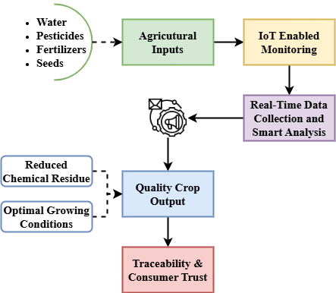
Fig. 1. Overview of IoT for Food Safety
The Internet of Things (IoT) technology enables the safety and hygiene of produce, as illustrated in Figure 1. At the parabola's base, pesticides and agricultural inputs are ranked below fertilizers and water in that order [13]. The inputs are monitored by Internet of Things (IoT) sensors that transmit information regarding the health of the soil, the health of the crop, and the environmental conditions [14]. Real-time data is analyzed locally through edge computing to trigger timely automated actions, such as irrigation control or pesticide application. These automated interventions optimize the use of resources and reduce chemical overuse, resulting in safer and healthier crop outputs. The improved produce is further supported by traceability mechanisms that store and share data with supply chain actors and consumers [15]. The model illustrates the ways in which the Internet of Things (IoT) improves precision farming, reduces health complications, and increases accuracy, thereby bolstering consumer confidence [16][17]. This representation highlights the rationale and benefits of the proposed methodology by establishing a connection between technology and positive health outcomes [18].

Related Works
Recent research in smart agriculture has focused on leveraging IoT technologies to improve crop monitoring, yield prediction, and resource management. Several studies have explored sensor-based systems, data analytics, and machine learning models for enhancing food quality and safety, yet gaps remain in achieving real-time, field-level precision and responsiveness [19].

Food Supply Chains (FSC)
The safety and quality of food were always of significant concern for the health of mankind. The Internet of Things (IoT), with the ability to connect devices at any time and in any place, offers an outstanding opportunity for enhancing Food Supply Chains (FSC). By the use of Internet of Things, one can track the condition of food in real-time and share it with customers as well as managers, thus adding to both transparency and safety [20]. The full application of IoT in FSC is still under development, providing the scope for further improvement[21]. Earlier research has worked on IoT uses in agriculture, such as the creation of a mobile application based on a smartphone camera to measure food freshness and transfer data efficiently[22].

Radio Frequency Identification (RFID)
One area that has found widespread use for the new Internet of Things (IoT) technology is agriculture. Successful applications of core Internet of Things (IoT) components include greenhouse monitoring, product traceability, cold chain tracking, Radio Frequency Identification (RFID), sensors, and wireless sensor networks (WSNs). The internet of things (IoT) improves agricultural safety and quality by lowering labor costs, boosting operational efficiency, and allowing automated detection [23]. New research emphasizes its usefulness in tracking and monitoring agricultural products in real time all the way from production to sales. Agricultural product safety and quality management is another area that this study delves into, along with the advantages and disadvantages of present Internet of Things (IoT) technology.

Bluetooth Low Energy (BLE)
The Internet of Things (IoT) allows cyber-physical systems with communication and sensing capabilities to be seamlessly integrated, hence allowing their collective operation. IoT designs have been investigated in several fields, including food safety that is vital for public health. Examining IoT applications for food monitoring from 2014 to 2019, a literature study turned up 13 papers with poor acceptance in this field. Much of the deployment was carried out in Asia under the watchful eye of Indian specialists [24]. Despite ZigBee, Wi-Fi, RFID, and Bluetooth Low Energy (BLE) being the most popular communication technologies, the most often used sensors were for temperature, humidity, and gas. There is still a lot of limitation, even if there is a lot of promise.

Hazard Analysis and Critical Control Point (HACCP)
Internet of Things (IoT) is transforming the supply chain of beef through real-time monitoring, control, and optimization. With the launch in 2017, the IoF2020 initiative is striving towards the adoption of Internet of Things (IoT) on a large scale across five nations that are engaged in pig farming, poultry tracking, and cow monitoring [25]. Through the use of Internet of Things sensors, farmers can monitor the welfare of their animals, the environment, and the efficiency of their operations. Their alarm systems facilitate the rapid identification of issues, including disease or refuse feed. Transparency from farm to fork is achieved through EPCIS level traceability, which enhances consumer confidence. The microbiological and physical hazards of chicken processing can be identified through the application of IoT technology. This leads to enhanced food hygiene and encourages Hazard Analysis and Critical Control Point (HACCP) compliance. IoF2020 advocates for sustainable agriculture and food safety across Europe.

Proposed Method
The proposed method integrates IoT with wireless sensor networks and edge computing to monitor soil and pesticide levels in real-time, aiming to enhance agricultural food quality and safety.
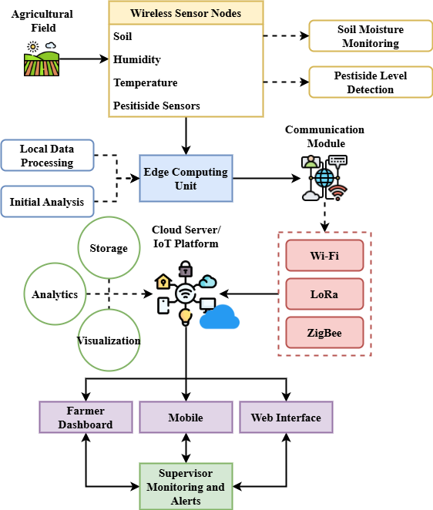
Fig. 2. Architecture of IoT-based Agricultural Monitoring
Figure 2 displays the end-to-end system architecture of the proposed Internet of Things (IoT) system to enhance product health and safety. The initial process of design is the deployment of wireless sensor nodes over the vegetation zones where plants are cultivated to monitor soil moisture, temperature, humidity, and pesticide levels. Initial processing and research on the data are done by an edge computing device, whereas nodes offer it in real time. The results from analysis are transmitted to a cloud service using Wi-Fi or ZigBee. The cloud platform does not support storage for extended periods of time. It also enables to see data and execute smart analytics. Farmers and management can receive advice and useful data via dashboards on mobile or the web. This technology allows data to be collected, decisions to be made at the local level, and monitoring to be carried out from a single location. This makes all parties respond quickly to changes in the environment. The technology increases output, minimizes human labor, and enhances food safety through rapid decision-making based on real-time correct data.
$$\frac{τz}{τs}=\frac{1}{2d}\left[\left(du+s\right)\overline{ω}\left(du+s\right)+\overline{ω}\left(du-s\right)\right]+… \left(1\right)$$
Equation (1) reply of the shear stress $\left(du+s\right)$with fluid-like infrastructure $\frac{τz}{τs}$, and its connection to the proposed IoT-based architecture $\overline{ω}\left(du-s\right)$, resides in its resemblance $\overline{ω}\left(du+s\right)$ to the real-time fluctuation $\frac{1}{2d}$in soil properties.
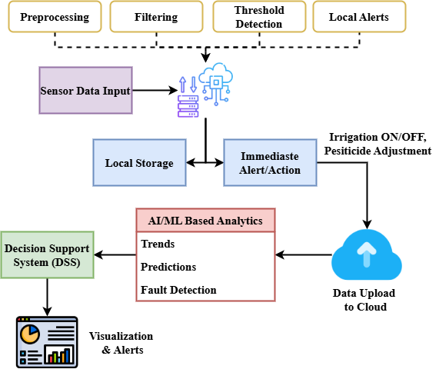
Fig. 3. Data Flow and Decision Making Process
Figure 3 illustrates the detailed data flow and decision-making within the proposed IoT-based monitoring system. The sensor node data is the input that initiates the process. This data is pre-processed and filtered at the periphery computer layer, enabling the system to make rapid, localized decisions such as autonomous irrigation or pesticide adjustments. Local storage of critical data and alarm signals precedes their transmission to the cloud platform. Long-term choices may be made using machine learning and cloud-based statistical modeling; they can assist to identify patterns and project hazards. The results enter a decision support system meant to provide farmers and managers tailored recommendations. Visual dashboards and alarms provide faster planning and action. By means of the elimination of delays and errors related with human inspection, this approach aggressively assures food quality and safety, thus helping to lower environmental impact, increase agricultural productivity, and obey food safety regulations.
$$\left(\frac{1}{2}g_{u}^{2}\right)=\left(\frac{1}{2}ω^{2}+\frac{1}{2}d^{2}{\left|∆ℵ\right|}^{2}\right)+\frac{1}{2}d^{2}{\left|∆g\right|}^{2} (2)$$
Reflecting the complex $\frac{1}{2}d^{2}{\left|∆g\right|}^{2}$ nature of dynamic systems $\left(\frac{1}{2}g_{u}^{2}\right)$, equation (2) offers an energy balance including rotational $\frac{1}{2}ω^{2}+\frac{1}{2}d^{2}$, nodal, and gradient fluctuations ${\left|∆ℵ\right|}^{2}$. This reflects how current sensor information preserve ideal soil conditions, and enhance food safety results.
$$\left(du-s\right)= \left[\frac{1}{2}v_{u}^{2}+\frac{1}{2}d^{2}{\left|∆v\right|}^{2}\right]+\left(-d^{2}v_{u}v_{\left(x,y,z\right)}\right) (3)$$
Equation (3) shows a compromise between spatial interactions $\left(du-s\right)$, kinetic energy $\frac{1}{2}v_{u}^{2}$, and velocity gradients $\frac{1}{2}d^{2}{\left|∆v\right|}^{2}$. This is consistent with $\left(-d^{2}v_{u}v_{\left(x,y,z\right)}\right)$ the suggested IoT approach in which fluctuations preserve steady agricultural inputs, improving reducing safety hazards.
Through smart agriculture techniques and traceability, this method guarantees safer food production by means of precise, real-time monitoring and automatic reactions enabled by IoT technology, therefore boosting crop health and lowering chemical usage.

Result and Discussion
The part on Result and Discussion shows a thorough comparison of many agricultural monitoring techniques used in terms of Emphasizing the better performance of the suggested WSNs-EC framework in improving real-time decision-making and guaranteeing food quality and safety, it concentrates on important performance criteria including soil moisture accuracy and reaction time.
Methodology | Advantages | Disadvantages
FSC | Simple setup; basic tracking of food supply conditions | Low accuracy; slow response; lacks real-time monitoring
RFID | Enables item-level traceability; reliable for supply chain tracking | Expensive tags; limited sensing capabilities; not suitable for soil/pesticide
BLE | Low energy consumption; easy device pairing | Limited range; moderate accuracy; potential data loss
HACCP | Well-established safety framework; helps in hazard prevention | Manual data collection; reactive rather than proactive
WSNs-EC | Real-time monitoring; high accuracy; fast response with edge computing | Initial setup cost; requires technical expertise for deployment
The table provides a comparative overview of existing agricultural monitoring methods, highlighting their strengths and limitations. While traditional systems offer basic functionality, they lack real-time efficiency. The proposed WSNs-EC framework demonstrates significant advantages in accuracy, speed, and automation, making it a more effective solution for modern smart farming applications.

Analysis of Soil Moisture Accuracy
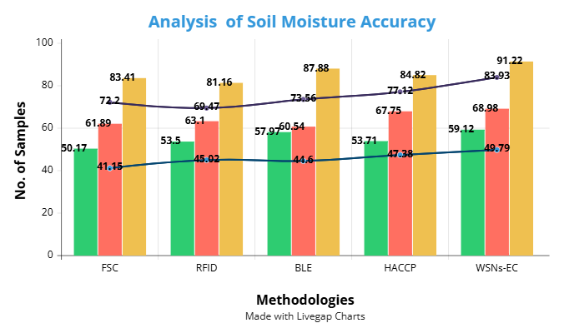
Fig. 4. Analysis of Soil Moisture Accuracy
Figure 4 indicates, in regards to soil moisture precision over a variety of sample sizes, relative performance of some methodologies. The methodologies include FSC, RFID, BLE, HACCP, and proposed WSNs-EC. Of all these, WSNs-EC consistently outscores others with a maximum accuracy of 91.22 at 100 samples, thus exhibiting improved soil condition monitoring precision. Traditional ways, like FSC and RFID, tend to be less accurate. For example, FSC starts at 41.15 and goes up to 83.41. They are not as accurate or reliable as WSNs-EC while BLE and HACCP do some things well. This fully shows how well edge computing works when used with wireless sensor networks and real-time farm tracking. The reason WSNs-EC is more accurate is that it can collect, study, and handle data closer to where it comes from that lowers data loss and delay. The suggested way makes sure accurate control of soil wetness for better farming and food safety, which increases total dependability.
$$2u\overline{∂}\left(2du\right)=\iint_{\left|y\right|=2du}^{ }{∂(y)} eT+\frac{1}{4μd^{2}2u}* ey+eT (4)$$
Equation (4) characterizes $\frac{1}{4μd^{2}2u}$ a complicated $\iint_{\left|y\right|=2du}^{ }{∂(y)}$ interplay of viscosity-driven forces $eT$, temperature effects$ey+eT$, and spatial gradients $2u\overline{∂}\left(2du\right)$. This edge computing and processing o balance and improve crop security by analysis of soil moisture accuracy.

Analysis of Response Time
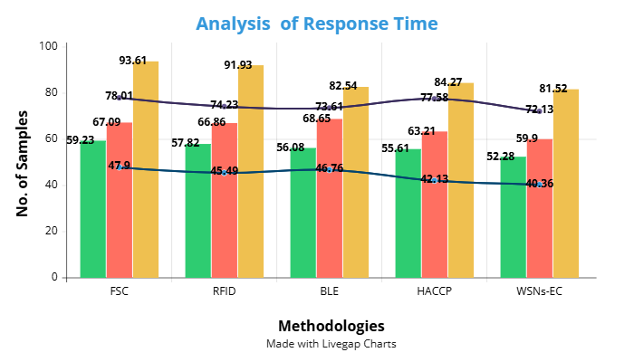
Fig. 5. Analysis of Response Time
Figure 5 illustrates a comparison of the efficacy of various methodologies (FSC, RFID, BLE, HACCP, and WSNs-EC). The response time of WSNs-EC is the fastest among all the processes we evaluated; however, it decreases to 40.36 when 100 samples are included. The response time of conventional procedures, such as FSC and RFID, is prolonged, with initial values of 59.23 and 57.82, respectively, and subsequent values of 93.61 and 91.93. This implies that the refining procedure is time-consuming and there might be inefficiencies. Despite the fact that BLE and HACCP have sluggish response times, they are still lagging behind WSNs-EC.
$$\frac{d}{\sqrt{d^{2}+1}}=\iiint_{L}^{ }{\left[\frac{y-y_{0}}{ds}\right]} eW+ey\left[k-uq^{'}\right] (5)$$
Equation (5) catches $\iiint_{L}^{ }{\left[\frac{y-y_{0}}{ds}\right]}$, distributed system's $k-uq^{'}$ spatial integration $\frac{d}{\sqrt{d^{2}+1}}$ of deviance and corrective forces $eW+ey$. This demonstrates how variations in soil or ambient conditions are dynamically monitored and rectified by analysis of response time.
The faster response time in WSNs-EC is due to edge computing that processes data locally and reduces connection delay and the need for cloud-based services in the center. Food safety and crop health rely on prompt responses such as pesticide alarms or irrigation adjustments that this faster reaction enables. For real-time application in agriculture, WSNs-EC thus exhibits high efficiency and offers instant decision-making ability necessary for today's precision farm systems.

Conclusion
This study developed an efficient IoT-based architecture combining WSNs-EC with Wireless Sensor Network to increase industrial sector food quality and safety. Real-time soil moisture and pesticide concentration monitoring let the system provide a practical and scalable approach for precision farming. Comparative analysis using modern methods like FSC, RFID, BLE, and HACCP shows that the WSNs-EC architecture produces better reaction times and soil moisture accuracy. Edge computing greatly lowers latency by allowing localized data processing—not just speedier decision-making but also the avoidance of data loss and dependency on cloud infrastructure. Tracking overall accuracy, efficiency, and reliability reveals some striking differences in the experiment results. From this results better use of resources, improved agricultural quality, and more safety all across the food chain. Strong rules supported by the framework help to preserve agricultural sustainability and sanitation standards. Therefore, the recommended strategy fairly helps smart agriculture to undergo digital transformation. It provides farmers with supply chain management and practical expertise so that product is safer and ensures yields. The results imply that modernizing food production and tackling growing needs for traceable, high-quality food systems depend critically on real-time, intelligent monitoring utilizing IoT technologies.
Future studies will focus on expanding the WSNs-EC framework to include additional parameters such as air conditions, crop disease prediction, and nutrient content. The ability of AI-based analytics will further improve predictive potential. The flexibility and reliability of the system will be ensured by putting it to use in a range of geographical and climatic settings. Mobile integration, traceability blockchain, and computer-controlled control measures including smart irrigation will be considered. The idea of these advances is to come up with an agriculture platform that is scalable as well as sustainable to ensure guaranteed production of healthy and secure food.

References
- M. A. Khan, R. Khan, and P. Praveen, Eds., Artificial Intelligence Applications in Agriculture and Food Quality Improvement. IGI Global, 2022.
- Yichuan Liu, Weiming Han, Yujie Zhang, Li Li, Jie Wang, and Long Zheng, “An Internet-of-Things Solution for Food Safety and Quality Control: A Pilot Project in China,” Journal of Industrial Information Integration, vol. 3, pp. 1–7, 2016.
- D. Giji Kiruba, J. Benita, and D. Rajesh, “A Proficient Obtrusion Recognition Clustered Mechanism for Malicious Sensor Nodes in a Mobile Wireless Sensor Network,” Indian Journal of Information Sources and Services, vol. 13, no. 2, pp. 53–63, 2023. https://doi.org/10.51983/ijiss-2023.13.2.3793
- S. Balamurugan, N. Divyabharathi, K. Jayashruthi, M. Bowiya, R. P. Shermy, and R. Shanker, “Internet of agriculture: Applying IoT to improve food and farming technology,” International Research Journal of Engineering and Technology (IRJET), vol. 3, no. 10, pp. 713–719, 2016.
- Zhihua Zhu, Yibing Bai, Wenli Dai, Dong Liu, and Yan Hu, “Quality of E-Commerce Agricultural Products and the Safety of the Ecological Environment of the Origin Based on 5G Internet of Things Technology,” Environmental Technology & Innovation, vol. 22, p. 101462, 2021.
- Yevheniia Dziurakh, Iryna Kulyniak, Hayk Sarkisian, Iryna Zhygalo, Bohdan Chepil, and Khrystyna Vaskovych, “Intrusion Detection Systems for Smart Tourism Platforms: Safeguarding Food Safety and User Privacy,” Journal of Internet Services and Information Security, vol. 14, no. 4, pp. 484–498, 2024. https://doi.org/10.58346/JISIS.2024.I4.030
- Narendra N. Misra, Yogesh Dixit, Abdulaziz Al-Mallahi, M. S. Bhullar, Rakesh Upadhyay, and Alexander Martynenko, “IoT, Big Data, and Artificial Intelligence in Agriculture and Food Industry,” IEEE Internet of Things Journal, vol. 9, no. 9, pp. 6305–6324, 2020.
- Mohamed Ben-Daya, Essam Hassini, Zied Bahroun, and B. H. Banimfreg, “The Role of Internet of Things in Food Supply Chain Quality Management: A Review,” Quality Management Journal, vol. 28, no. 1, pp. 17–40, 2020.
- Taimoor Qureshi, Muneeb Saeed, Kamran Ahsan, Aamir A. Malik, Ehtisham S. Muhammad, and Nauman Touheed, “Smart Agriculture for Sustainable Food Security Using Internet of Things (IoT),” Wireless Communications and Mobile Computing, vol. 2022, Article ID 9608394, 2022.
- S. B. Mustapha, A. Alkali, B. A. Zongoma, and D. Mohammed, “Effects of Climatic Factors on Preference for Climate Change Adaptation Strategies among Food Crop Farmers in Borno State, Nigeria,” International Academic Journal of Innovative Research, vol. 4, no. 1, pp. 52–60, 2017.
- Sherry Piramuthu and Weibiao Zhou, RFID and Sensor Network Automation in the Food Industry: Ensuring Quality and Safety Through Supply Chain Visibility. John Wiley & Sons, 2016.
- Sushabhan Satapathy, Debabrata Mishra, and Arturo Realyvásquez Vargas, “Food Safety and IoT-Based Solution,” in Innovation in Agriculture with IoT and AI, pp. 79–98, 2022.
- Vadim Vakhguelt and A. Jianzhong, “Renewable Energy: Wind Turbine Applications in Vibration and Wave Harvesting,” Association Journal of Interdisciplinary Technics in Engineering Mechanics, vol. 1, no. 1, pp. 38–48, 2023.
- Cor Verdouw, Sjaak Wolfert, and Bedir Tekinerdogan, “Internet of Things in Agriculture,” CABI Reviews, 2016, pp. 1–12.
- Noor Abdulhussein Salman, Safa Sabah Al-Noor, and Kareem Ali Khalaf, “Effect of Dose Level of Three Hormones on Egg Production and Thermal Accumulated Period During Induced Spawning of Grass Carp (Ctenopharyngodon idella),” International Journal of Aquatic Research and Environmental Studies, vol. 4, no. 1, pp. 1–11, 2024. http://doi.org/10.70102/IJARES/V4I1/1 15
- Abdelhakim Morchid, Ibrahim Ghaleb Muhammad Alblushi, Hany Mohamed Khalid, Rachid El Alami, Subramaniam Ramasamy Sitaramanan, and Saad Mekhilef Muyeen, “High-Technology Agriculture System to Enhance Food Security: A Concept of Smart Irrigation System Using Internet of Things and Cloud Computing,” 2024.
- Antonio F. Skarmeta, María V. M. Cano, and Antonio Iera, “Guest Editorial: Smart Things, Big Data Technology and Ubiquitous Computing Solutions for the Future Internet of Things,” Journal of Wireless Mobile Networks, Ubiquitous Computing, and Dependable Applications, vol. 6, no. 1, pp. 1–3, 2015.
- Meng Ziwei and L. L. Han, “Scientometric Review of Sustainable Land Use and Management Research,” Aquatic Ecosystems and Environmental Frontiers, vol. 1, no. 1, pp. 21–24, 2023.
- Wondwosen Assegid and Getachew Ketema, “Harnessing AI for Early Cancer Detection Through Imaging and Genetics,” Clinical Journal for Medicine, Health and Pharmacy, vol. 1, no. 1, pp. 1–15, 2023.
- Gede Witjaksono, A. A. Saeed Rabih, Nor Bahiah Yahya, and Shafreen Alva, “IoT for Agriculture: Food Quality and Safety,” in IOP Conference Series: Materials Science and Engineering, vol. 343, p. 012023, Mar. 2018.
- Emily Hawthorne and Isabelle Fontaine, “An Analysis of the Relationship Between Education and Occupational Attainment,” Progression Journal of Human Demography and Anthropology, vol. 1, no. 1, pp. 22–27, 2024.
- Rohit Iyer and Neha Deshpande, “Nanotechnology and Their Applications in Chiral and Achiral Separating Mechanisms,” Engineering Perspectives in Filtration and Separation, vol. 1, no. 1, pp. 7–13, 2024.
- Ping Hou, Jing Wang, Zhen Ma, and Yu Du, “Mini-Review of Application of IoT Technology in Monitoring Agricultural Products Quality and Safety,” International Journal of Agricultural and Biological Engineering, vol. 11, no. 5, pp. 35–45, 2018.
- R. M. Dias, G. Marques, and A. K. Bhoi, “Internet of Things for Enhanced Food Safety and Quality Assurance: A Literature Review,” in International Conference on Emerging Trends and Advances in Electrical Engineering and Renewable Energy, Singapore: Springer Nature Singapore, pp. 653–663, Mar. 2020.
- Ramesh Kolikipogu, Shivaputra Shivaputra, E. Muniyandy, J. P. Maroor, G. V. R. Lakshmi, B. Konduri, and R. Naveenkumar, “Improving Food Safety by IoT-Based Climate Monitoring and Control Systems for Food Processing Plants,” Remote Sensing in Earth Systems Sciences, pp. 1–13, 2025.

