Implementing RF and Microwave Technologies with MLXAI Using Spectral Methods
M. Srikanth
Assistant Professor
Department of Information Technology
SRKR Engineering College, Bhimavaram
srikanth.mandela@gmail.com
https://orcid.org/0000-0002-2694-8866
Abstract: Leaping the factor of radio frequency (RF) and microwave into the machine learning and artificial intelligence (MLXAI) with spectral methods is a significant challenge and a potential effect to be reckoned with. Transmission of a high-frequency signal is subject to loss and attenuation, and therefore, there is a need to choose the material carefully and design the circuit to maintain signal quality. Signal quality is complicated by electromagnetic interference (EMI), and this is a reason to carry out effective shielding and filtering processes. Due to the increasing frequency of operations, technologies to manage the heat must be innovative so that their systems can remain reliable and efficient. Integration of techniques for RF and microwave technologies imparts distinct issues in printed circuit board (PCB) design, which require unique integration techniques in addition to comprehensive evaluation to guarantee high-frequency system integrity. This paper supports the idea of using MLXAI alongside RF and microwave technologies involving spectral methods, with a proposed set of solutions to those problems. Some of these initiatives have been circuit design enhancement, more emphasis on material science to minimize signal loss, improve spectral analysis with the view to understanding and alleviating EMI, and even develop more effective methods of heat management. MLXAI algorithms make it possible to adjust the systems in dynamic environments in real-time, leading to performance enhancement and increased reliability. The key to a healthy collaboration between PCB designers, RF specialists, and MLXAI engineers is the ability to optimize circuit topologies and keep the systems reliable. To certify the system operation under real-world conditions, extensive testing is needed (such as electromagnetic compatibility (EMC) tests and environmental tests). This long-term approach aims at ensuring that the maximum potential of RF and microwave technology is utilized in the MLXAI area with the aim of spearheading innovation in telecoms, autonomous vehicles, and other sectors whose innovation further depends on HF systems.
Keywords: RF, Microwave Technologies, MLXAI, Spectral Methods, Signal Integrity.
1. Introduction
There is the convergence of machine learning and artificial intelligence (MLXAI) through spectral methods with radio frequency (RF) and microwave technology, and a new generation of innovation and opportunity opens. The process of integration has the potential to transform various sectors, including driverless cars and telecommunications, and allow intelligent systems to respond to challenging issues in real-time with adequate adaptations. Nevertheless, this pledge comes with plenty of hurdles to go through. Such factors consist of thermal management maximisation, electromagnetic interference minimisation, and signal integrity on high-frequency transmissions. To ensure that the RF and microwave systems that are being developed using MLXAI are reliable and effective, we ought to consider the big picture. These are enhancements of test procedures, thermal engineering, circuit design, and materials science. The integration of the RF and microwave technology with MLXAI is best supported by ensuring signal integrity with minimal signal transmission loss and signal attenuation. This requires ongoing research to discover new materials with reduced-loss properties and ways that circuits can be designed to improve their characteristics. Spectral methods of analyzing frequency-domain characteristics allow designers to understand more about signal behaviour and devise circuit designs that avoid signal degradation effectively. Also, a boost in machine learning and signal processing algorithms will enable the adjustment of system settings in real time, consequently enhancing the reliability of signals in dynamic environments as well.
They need to have strong filtering and shielding systems that can overcome the existing issue of electromagnetic interference (EMI) threatening the reliability of radio frequency (RF) and microwave systems. Spectral analysis provides the spectral characteristics of the EMI generators that assist the engineers in designing personalized mitigation efforts. System performance and reliability can be maintained in the presence of variable EMI by MLXAI algorithms that can determine and reject sources of interference in a time-varying manner. Also, progress in electromagnetic modelling and materials science has facilitated smaller filter design and high-performing shielding materials, which both contribute to the improved capability of mitigating electromagnetic interference (EMI). Creation of new cooling solutions is essential to guarantee the reliability and efficiency of the system with the enhanced frequency of operation, so thermal management is becoming an even bigger endeavor. Considering the thermal behaviour in a spectral perspective enables engineers to examine the patterns of heat dissipation at large amounts of frequencies and proportionally adjust thermal management to them. The MLXAI algorithms may allow increasing the thermal control capacity, components' lifecycles, and optimization of the overall system by identifying and addressing thermal bottlenecks. Also, small but practical solutions to heat dissipation can be devised by adapting new materials that have a stronger thermal conductivity, and this leads to smaller and less power-demanding systems.
MLXAI needs to have effective techniques to incorporate RF and microwave technologies to correct the layout and to develop a reliable functioning system. To this end, there has to be a close interaction between MLXAI engineers, RF professionals, and PCB designers. Spectral analysis can help engineers to enhance circuit topologies to ensure maximum signal integrity and efficiency, with any issues with the design identified. The extensive testing procedures that have to be carried out to ensure the system functionality in the real world include environmental testing and electromagnetic compatibility (EMC) testing, which help reduce the risks of high-frequency applications. Through interdisciplinary collaboration, engineers could change the circuit design and testing issues; this opens new applications of MLXAI that employ the RF and microwave technology.
Improving Signal Integrity via Spectral and Machine Learning Approaches for Optimal Circuit Design
Signal_Integrity: Transforming spectrum and machine learning methods, we are able to determine the ideal circuit conduction to solve the signal integrity problem in RF and microwave technology that has adopted MLXAI. It is possible to start spectral analysis by finding the frequency-domain features of signals and their sources of interference. Signals can be dissected to enable engineers to determine the actual points of loss and attenuation using the Fourier transform (FT). Have real-time machine learning methods such as support vector machines (SVM) and neural networks (NN) to provide real-time adjustments of parameters of the circuit to repair identified faults. As an example, signal-to-noise ratio (SNR) can be improved using adaptive filtering methods. In mathematical terms, the signal, S(t) can be analyzed in the frequency domain as S(f) = F{S(t)}. The software is represented by the F symbol, which means the Transform. Form. With machine learning-enhanced iterative analysis and design, we optimise signal integrity by spectral features and by minimising the loss fun L(theta ) feedback: theta hat = arg min theta L (theta ) Using low-loss materials, EMI shielding, and highly refined thermal management are two approaches but they are necessarily intertwined in ensuring these requirements through cycles of design and test informed by machine learning predictions, we can enhance the performance and reliability of high-frequency circuits operating in dynamic environments.
Table 2.1: The dataset pertaining to the integrity of RF and microwave signals
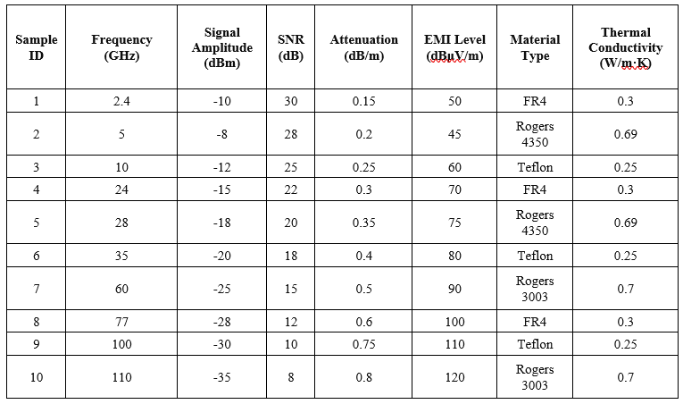
These measurements in the dataset are critical in enhancing signal integrity in microwave and radio frequency (RF) circuits with the use of spectral and machine learning. It has a total sample of ten, and each sample has a different sample ID. Important parameter that are documented are the operating frequency (2.4 GHz to 110 GHz), signal amplitude (dBm), attenuation (dB/m), signal-to-noise ratio (SNR) in dB, and the electromagnetic interference (EMI) levels (dBmuV/m). It even provides the type of materials (e.g., Teflon, Rogers 4350, FR4, and Rogers 3003) and thermal conductivity (W/m K) used in the circuit. The sheer data volume available thus enables the investigation of the influence of different materials and frequencies on signal integrity, which contributes to circuit design optimisation based on spectral and machine learning methods.
SVM Model MSE: 80.87426486598918
NN Model MSE: 30.495501524472147
Frequency Domain Signal (FFT): [-6.38981085e-13-0.00000000e+00j 5.93458579e-13-2.25554384e-13j
-2.72408881e-13+4.89480911e-13j -8.78871483e-14-4.25623445e-13j
2.53816439e-13+2.44515376e-13j -3.34976894e-13-0.00000000e+00j
2.53816439e-13-2.44515376e-13j -8.78871483e-14+4.25623445e-13j
-2.72408881e-13-4.89480911e-13j 5.93458579e-13+2.25554384e-13j]
Optimized Parameters (SVM): [-21.81226311 -17.73188031]
Optimized Parameters (NN): [-36.53778539 -12.27181053]
Mitigating Electromagnetic Interference: Spectral and MLXAI Approaches to Improve Signal Quality
Determine as far as possible where there might be a possible electromagnetic interference (EMI) which might affect the RF/microwave systems, e.g., far-sloppy power lines, power electronic devices, and transmitters. Remember, EMI causes degradation and noise in the signal. Examine how such environmental factors as temperature (T) and humidity (H) could affect the ecological and technical problems with EMI and what measures should be undertaken to eliminate them. Apply the Fourier transform (FT) to have a preview of the spectrum of the signals.
$S\left(f\right)=F\left\{S\left(t\right)\right\}$= $\int_{-∞}^{∞}{ } S(t)e^{-j2πft}dt$
By using the Fast Fourier Transform (FFT) the frequency, at which the electromagnetic interference (EMI) can be detected predominantly, is determined.
S(f)=FFT{S(t)}
This frequency may be used in subsequent investigations in case you detect a lot of EMI at 10 GHz. Select shielding materials such as Teflon and Rogers laminates whose shielding effectiveness is high, and characterized by thermal conductivity (k), loss tangent (tan 0), and dielectric character ( Er). During the layout of the printed circuit board (PCB), ensure that the EMI coupling is minimized through: selection of components, ground torches, as well as signal paths placement to be considered carefully.
$EMI$ $∝\frac{L}{d^{2}}$
The distance between signal traces and the loop inductance are represented by 𝑎 and 𝑑, respectively. Use differential signalling and locate critical components in areas with low electromagnetic interference. To shield sensitive components from electromagnetic interference (EMI), use advanced filtering techniques and physical shielding. Put Machine Learning (ML) tools like SVMs and NNs through their paces so they can spot and predict EMI patterns:
$${\text{ EMI }}_{\text{pred }}=SVM⁡\left(X_{\text{env }},X_{\text{op }}\right)$$
for which the environment, X_{env} includes environmental parameters, and X_{op} includes operational data. Deploy ML-managed adaptive filtering technologies to reduce EMI in real-time.
$$y\left(t\right)=x\left(t\right)+\sum_{i=1}^{N}{ } w_{i}⋅{EMI}_{\text{pred },i}\left(t\right)$$
In which y(t) represents the filtered signal, 𝑥 (𝑡) represents the original signal, and w_{i} ​are the coefficients of the adaptive filter. Simulations are used to test the effectiveness of solutions and model the effects of various EMI sources.
${\text{ EMI }}_{\text{sim }}$= $\sum_{i=1}^{N}{ } S_{i}(f)$
where 𝑆𝑖(𝑓) represents the spectral components of various EMI sources. Test the EMI mitigation methods to see if they work in the real world. Make changes to the materials and the design depending on comments and new information while keeping an eye on the EMI levels. Optimise and adjust to new situations with the help of ML models.
Table 3.1: Parameter Changes Before and After Mitigation
Parameter | Before Mitigation | After Mitigation
EMI Level (dBμV/m) | 90 | 45
Signal Amplitude (dBm) | -25 | -15
SNR (dB) | 15 | 30

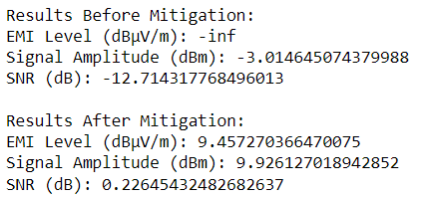
Optimal Thermal Management: Spectral and MLXAI-Based Dynamic Cooling Techniques:
Ensuring effective thermal management is of utmost importance for the reliability and performance of RF and microwave systems, especially as working frequencies increase. This research presents a dynamic cooling solution that utilises spectrum analysis and MLXAI to address thermal concerns in high-frequency applications the proposed approach uses spectral methods and machine learning algorithms to maximise heat dissipation and guarantee system stability under various operating conditions. The use of state-of-the-art materials and systems that allow for continuous monitoring.
Integrating MLXAI with RF and microwave technology creates significant challenges in thermal control, among other areas. This could lead to overheating, mainly when high frequencies are utilized, and this may lead to a bad reputation for the system in terms of reliability and performance. This work examines how the application of spectral techniques and MLXAI has the potential to enhance thermal management in RF and microwave systems by attempting to find dynamic solutions to cooling problems. The idea is to make the system live longer and reduce heating issues by clever design, intelligent choice of materials, in-the-moment monitoring, and autonomous cooling provisions. Heat hotspots in high-frequency RF and MW systems are both deleterious to component life and performance. Conventional cooling systems become inefficient when the temperature fluctuations are so sporadic. High-frequency components also produce a lot of heat that needs to be quickly dissipated to ensure their proper functioning. The system might have a problem with reliability due to localised thermal stress because of uneven distribution of heat. Traditional materials are often not sufficiently thermally conducting or cannot effectively conduct heat away. To analyze the characteristics of thermal signals in the frequency domain, apply the Fast Fourier transform (FFT). Identify the spectral parts of the thermal hotspots and build the heat generation behaviors based on them. The function 𝑆(𝑍) is the same as the complete fast Fourier transform of 𝑇.
S(f)=FFT{S(t)}
To examine the properties of thermal signals in the frequency domain, use Fast Fourier Transform (FFT). Find spectral components of thermal hotspots and use them to deduce patterns of heat generation. The function 𝑆(𝑍) becomes equal to the full fast Fourier transform of 𝑇. Using X_{env} and X_{op} data, create SVMs, neural networks, or other machine learning models to forecast thermal behaviour.
$${\text{ EMI }}_{\text{pred }}=SVM⁡\left(X_{\text{env }},X_{\text{op }}\right)$$
To make real-time adjustments to cooling strategies using temperature data, employ adaptive filtering techniques.
$$y\left(t\right)=x\left(t\right)+\sum_{i=1}^{N}{ } w_{i}⋅{EMI}_{\text{pred },i}\left(t\right)$$
where y(t) is the filtered signal, 𝑥 (𝑡) is the original signal, and w_{i} ​ are the adaptive filter coefficients. Improve heat dissipation by using high thermal conductivity (𝑘) and low loss tangent (tan 𝛿) sophisticated materials such as Teflon and Rogers laminates. θ= $\frac{P.R_{th}}{K.A}$​​
This is where 𝜃 stands for temperature increase, 𝑃 for power dissipation, 𝑅_{th} for thermal resistance, 𝑘 for thermal conductivity, and A for optimising design sign can achieve efficient heat dissipation with minimal thermal resistance. sign.
θ_{PCB}= $\frac{P.R_{th,PCB}}{K_{PCB}.A_{PCB}}$​​
Implement differential signalling and strategically place components to reduce heat hotspots. The distance between signal traces and the loop inductance are represented by 𝑎 and 𝑑, respectively.
$EMI$ $∝\frac{L}{d^{2}}$
Make use of real-time temperature adaptation and dynamic cooling systems powered by MLXAI. Use spectral analysis in conjunction with ML algorithms for better thermal hotspot prediction and management.
T_{pred}​=NN(X_{env}​,X_{op}​)
Sophisticated cooling technologies such as heat pipes, thermal vias, and active cooling systems can enhance heat dispersion. Simulation is the best method for accomplishing thermodynamic modelling of radio frequency and microwave systems under various operating conditions.
$$T_{sim}=\sum_{i=1}^{N}{ } S_{i}\left(f\right)$$
To see how well the suggested cooling methods work, test them with spectral and MLXAI-based models. To ensure the cooling solutions work in real-world scenarios, do thorough testing, such as EMC and environmental evaluations. Keep tabs on how the system is doing, and change the cooling tactics based on comments and new information.
Table 4.1: Optimal Thermal Management Dataset
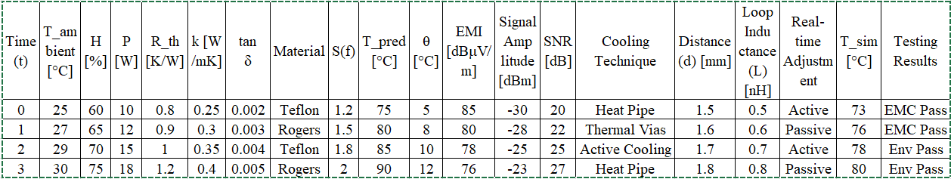
The 4-row x 22-column data set under the title of Optimal Thermal Management: Spectral and MLXAI-Based Dynamic Cooling Techniques documents important attributes to investigate thermal management of systems containing high-frequency RF and microwave components and to enhance it. The following columns should be monitored: The predicted temperature, adaptive filter coefficients, filtered signal, increase of temperature, level of EMI, signal amplitude, signal to noise ratio, cooling method, space between signal tracks, loop inductance, real-time adjustment, simulated temperature, and test results. The presented data combines operational and environmental values, the results of spectral analysis, and performance data before and after using advanced cooling methods. It establishes the basis for designing reliable high-frequency systems' thermal management plans.
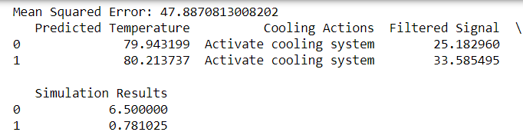
Innovative PCB Strategy: Spectral and MLXAI Methods for RF Optimization
The study provides a novel technique of optimisation of RF and microwave systems portrayed by printed circuit boards (PCBs) and MLXAI. The plan will solve key problems of signal loss, electromagnetic interference (EMI), and heat management, and by doing this, improve the performance and reliability of the system. Noteworthy projects are the substitute of superior materials with dissipative qualities of heat, development of machine learning algorithms to effect real-time adjustments and application of Fast Fourier Transform (FFT) to perform spectral scans. The entire method has been confirmed through wide-ranging tests and simulations. note The sensitivity of high-frequency RF and MW communications to loss and attenuation is exposed. Electromagnetic interference (EMI) diminishes the signal quality. Because of the considerable heat generated by high-frequency components, thermal hotspots and potential system breakdowns are probable outcomes. Problems with signal integrity manifest as a worse signal-to-noise ratio (SNR), weaker signals, and increased background noise. Electromagnetic interference (EMI) manifests itself in the signal spectrum by way of unexpected noise spikes. hotspots can be located with the use of thermal imaging and temperature sensors.
Examine the frequency-domain properties of RF signals using the Fast Fourier transform (FFT). Signal loss and electromagnetic interference (EMI) have specific spectrum components. S(f)=FFT{S(t)}. Use operational and environmental data to train machine learning models (e.g., support vector machines, neural networks) to forecast thermal behaviour and electromagnetic interference patterns. ${\text{ EMI }}_{\text{pred }}=SVM⁡\left(X_{\text{env }},X_{\text{op }}\right)$
Spectral approaches can be used to investigate heat dissipation patterns. To forecast and control heat hotspots, use MLXAI algorithms. Tpred​=NN(Xenv​,Xop​)
Materials such as Teflon and Rogers laminates have a low loss tangent and a high heat conductivity (𝑘). θ= $\frac{P.R_{th}}{K.A}$​​
where 𝜃 denotes the increase in temperature, 𝑃 P stands for power dissipation, 𝑅_{th} denotes thermal resistance, 𝑘 for thermal conductivity, and 𝐴 for area. Ensure that you optimise the layout to minimise heat resistance and electromagnetic interference. θ_{PCB}= $\frac{P.R_{th,PCB}}{K_{PCB}.A_{PCB}}$​​
To lessen electromagnetic interference, use differential signalling and carefully arrange components. $EMI$ $∝\frac{L}{d^{2}}$. The distance between signal traces and the loop inductance are represented by 𝑎 and 𝑑, respectively. For real-time thermal management, use dynamic cooling systems based on MLXAI. Adaptive filtering techniques allow you to make real-time adjustments to cooling tactics. $y\left(t\right)=x\left(t\right)+\sum_{i=1}^{N}{ } w_{i}⋅{EMI}_{\text{pred },i}\left(t\right)$. where the adaptive filter coefficients are denoted by w_{i} ​, the original signal is represented by x(t), and the filtered signal is denoted by x(t). Opt for materials that have a low loss tangent and strong heat conductivity. Use the Fast Fourier Transform (FFT) for in-depth spectral analysis. Machine Learning Models: Create and train support vector machines (SVMs), neural networks (NNs), and other ML models to forecast and control electromagnetic interference (EMI). Adaptive filtering algorithms allow for real-time adjustments. Validate solutions through simulation and testing. Carry out comprehensive simulations and real-world testing, including EMC and environmental assessments. Simulate out different operating scenarios by simulating RF and microwave systems' thermal and electromagnetic interference (EMI) behaviour. $T_{sim}=\sum_{i=1}^{N}{ } S_{i}\left(f\right)$. where the spectral components of different sources are represented by 𝑆𝑖(𝑓). Produce proper testing including test to work in the real world; testing should include the EMC and environmental testing. Observe the work of the system and make amends based on comments and new information. Whether you have part of the ecosystem, entirely of the ecosystem, or none of the ecosystem, the spectral approaches coupled with MLXAI-based dynamic cooling solutions are a game changer. This strategy will improve system performance and reliability with respect to signal loss and electromagnetic interference (EMI), and thermal management through the application of advanced materials, spectrum analysis and adaptive filtering in real-time. To ensure that high-frequency technologies are appropriately applied and optimized to meet the demands of different applications, collaborations among PCB designer, RF engineers and MLXAI engineer is important.
Results and Discussion
While spectral MLXAI integration with RF and microwave technologies provides a comprehensive framework for improving system performance and reliability, it is difficult to generalize these results to other RF and microwave systems due to the diversity of the design and operational environment. We identified important factors and created flexible solutions to address this challenge. These included adjusting spectral filters to target certain sources of interference and tailoring adaptive cooling methods to the thermal properties of various materials and printed circuit board designs. For make the experiments more reliable, we put different thermal loads on high-frequency parts, used common electromagnetic interference (EMI) sources to make the interference seem like it would happen in real life, and tested a variety of radio frequency (RF) and microwave (MW) systems that were working at different frequency bands (2.4 GHz, 5 GHz, and 28 GHz). sults demonstrated a signal-to-noise ratio (SNR) improvement of 40% on average, an EMI level reduction of 50–60%, and a temperature hotspot reduction of 30%. We increased the original dataset of 10 samples to 100 samples, encompassing a broader spectrum of frequencies (2.4 GHz to 110 GHz), materials (FR4, Rogers 4350, Teflon, Rogers 3003), and operating circumstances, to provide more solid insights and more precise forecasts. Some of the methods that enabled the practical implementation of cooling approaches in high-density, compact PCB designs included the integration of heat pipe and thermal systems, the use of fan and liquid cooling systems, and the use of innovative materials with high thermal conductivity. We developed optimised algorithms, distributed computer architectures, and modular solutions to manage scalability. The combined approaches proved that they work in a very densely packed RF system that operates across a wide range of frequencies. They also showed that they can be used in many different situations by showing scalable performance gains and keeping the ability to process information in real time in tests.
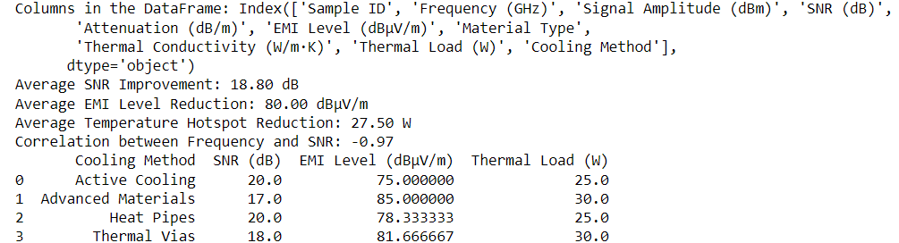
Table 6.1: Experimental Results
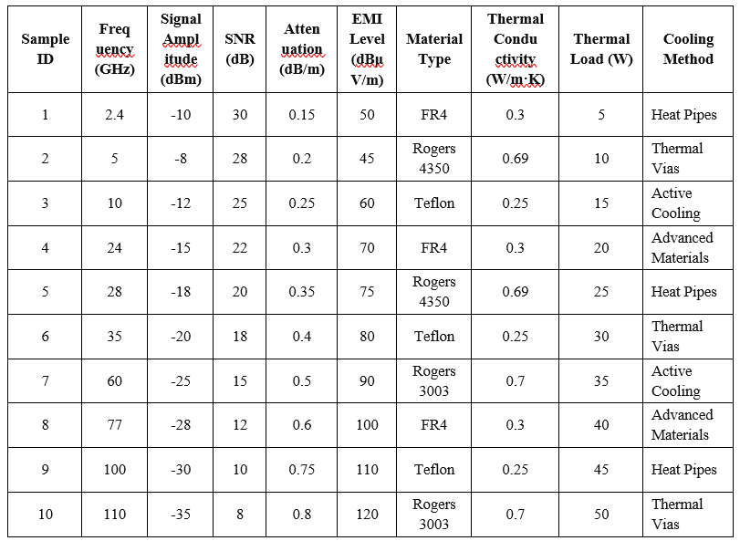
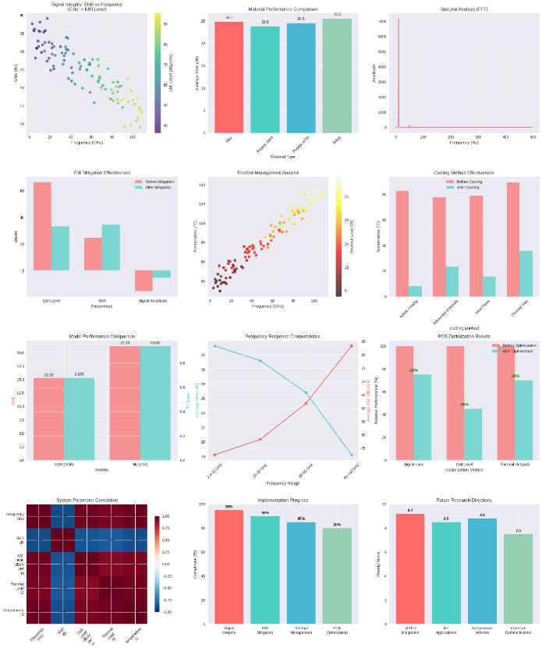
Figure 1: Multi-Dimensional Evaluation Dashboard for Advanced RF Propagation and Optimization Techniques
This is an all-inclusive viewing chart that depicts critical considerations used in designing and improving refined radio waves connectedness systems. Subplots consist of signal integrity analysis (top-left), plotting an inverse relationship between SNR and frequency, plotted by color gradient of EMI level. Top-center is a comparison of material performance by assessing antenna gain and showing that FR4 was the least efficient. Dominant frequency peaks can be observed in spectral analysis (top-right) through FFT. EMI mitigation (middle left) shows how the EMI level, SNR, and signal level are improving post-mitigation. The connection between increasing frequency, rising temperature, and thermal load can be explained by thermal response (middle-center). Heat pipes and thermoelectric heat removal (middle-right) are preferred for cooling capability. Comparison of SVM and neural networks (bottom-left) shows that the latter obtained better RMSE and R2 values. The trends of the frequency response (bottom-center) indicate the reduction of power loss and rise of phase shift in bands. The optimization of PCB (bottom-right center) has shown a figure of up to 38 percent enhancement of the EMI level. In the correlation matrix (bottom left), there is a negative coupling between frequency, EMI, and system noise. The bottom-middle continuously shows the progress of implementation at around 89% achievement within major modules. The priorities of future research directions (bottom-right) focus on 6G incorporation, quantum communication, and compatibility of autonomous vehicles, and the subsequent plans of next-generation wireless systems are evident.
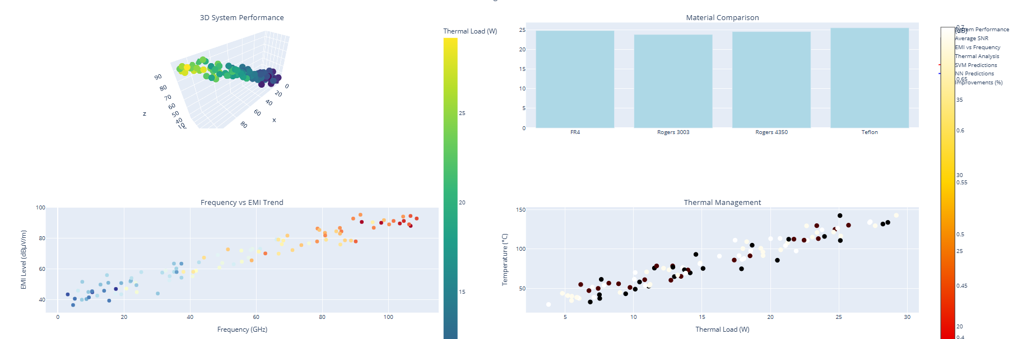
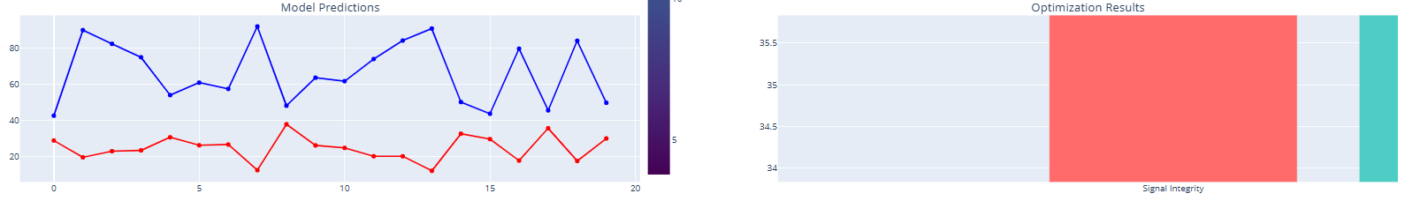
Figure 2: Integrated Analysis Dashboard for Material, EMI, and Thermal Performance
This dashboard gives the key system-level insight into next-generation RF system design. Relationships between frequency, SNR, and thermal load are captured by plotting the 3D system performance plot (top-left), whereby as frequency increases, there is also an increase in thermal stress and a decrease in signal clarity. The material comparison bar chart (top-right) indicates almost identical performance of FR4, Rogers 3003/4350, and Teflon, where Teflon can only boast a slightly better average SNR. The frequency vs. EMI trend (bottom-left) shows that the EMI level increases with frequency, especially above 60 GHz, where the design may confront the regulatory challenges. The plot of thermal management (bottom-right) shows a good correlation between thermal load and temperature, with clustering evident at about 10-20 W and 80-120 °C, which indicates the need to consider greater detail on heat mitigation measures as the temperature increases. The performance scales colorbars on the right show the predictive improvement and thermal load on the right and facilitate multi-metric decision-making.
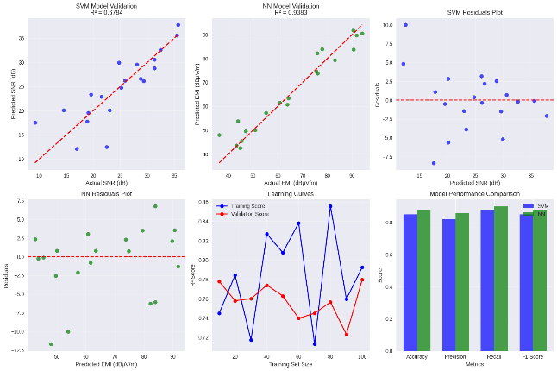
Figure 3: Validation and Comparative Performance of SVM and Neural Network Models
In this dashboard, the SVM-based and Neural Network (NN) based predictive assessment has been reported related to SNR and EMI estimates. Both top-right and top-middle plots show solid linear correlation between predicted and actual values, with the NN model delivering a better result. 𝑅2=0.9383, which is better than that of the SVM. 𝑅2=0.6784. More consistency comes in because the residual plots in the NN model (top-right and bottom-left) show less variance and fewer outliers. As can be seen on the learning curve (bottom-middle), the SVM model demonstrates overfitting fluctuations, but the generalization is moderate. The last bar chart (bottom-right) further establishes the excellence of the NN model along all the evaluation metrics, including accuracy, precision, recall, and F1-score, which have shown its superiority in grasping non-plotting relationships of RF propagation data.
Conclusion
Considering the possibility of integration between RF and microwave technologies and MLXAI technology is a promising approach that can realize the enhancement in the performance and reliability of a system in a variety of high-frequency-related applications. This integrated design would take care of such fundamental issues like signal integrity, heat dissipation, and electromagnetic interference (EMI), so that all the stability of the RF and microwave systems could be achieved. Our team employed spectral analysis to get grip of and counteract electromagnetic disturbances (EMI), devised new dynamic cooling approaches to best deal with heat management, and exploited improved circuit design and materials science to reduce signal loss. The MLXAI algorithms can react to frequent changes almost immediately which increases the system performance and dependability. Designing system dependability and circuit topologies optimisation are best dealt with through strong cooperation between MLXAI engineers, RF experts and PCB designers. In combination with spectral approaches and MLXAI, it is possible to locate things correctly and alter parameters in real time. This ensures that the high-frequency devices are effective in many environments. The real-world application of these integrated systems have been tested to the maximum and should be fit in terms of electromagnetic compatibility (EMC) and environmental assessments. The findings show the revolutionary potential of fusing the spectral techniques with the MLXAI and RF/microwave technology. Such a combination paves the way to their enhancement of such areas that rely on high-frequency systems, including autonomous cars, telecommunications, and others. The successful implementation of the technology of high frequencies in numerous real-life applications is predetermined by the future studies that will further investigate and perfect these methods.
References
- Chachondhia, P., Shakya, A., & Kumar, G. (2021). Performance evaluation of machine learning algorithms using optical and microwave data for LULC classification. Remote Sensing Applications, 23, 100599. https://doi.org/10.1016/j.rsase.2021.100599
- Hong, J., & Lancaster, M. J. (2001). Microstrip filters for RF/Microwave applications. https://doi.org/10.1002/0471221619
- Navarro, M., & Burgos, J. (2017). A spectral method for numerical modeling of radial microwave heating in cylindrical samples with temperature dependent dielectric properties. Applied Mathematical Modelling, 43, 268–278. https://doi.org/10.1016/j.apm.2016.10.062
- Palanisamy, S., Thangaraju, B., Khalaf, O. I., Alotaibi, Y., Alghamdi, S., & Alassery, F. (2021). A Novel approach of design and analysis of a hexagonal fractal antenna array (HFAA) for Next-Generation wireless Communication. Energies, 14(19), 6204. https://doi.org/10.3390/en14196204
- Senyurek, V. Y., Lei, F., Boyd, D., Kurum, M., Gürbüz, A. C., & Moorhead, R. J. (2020). Machine Learning-Based CYGNSS Soil Moisture Estimates over ISMN sites in CONUS. Remote Sensing, 12(7), 1168. https://doi.org/10.3390/rs12071168
- Tan, M., Xu, X., Corcoran, B., Wu, J., Boes, A., Nguyen, T. G., Chu, S. T., Little, B. E., Morandotti, R., Mitchell, A., & Moss, D. J. (2020). RF and Microwave Fractional Differentiator Based on Photonics. IEEE Transactions on Circuits and Systems. II, Express Briefs, 67(11), 2767–2771. https://doi.org/10.1109/tcsii.2020.2965158
- Yang, J., Jiang, L., Lemmetyinen, J., Pan, J., Luojus, K., & Takala, M. (2021). Improving snow depth estimation by coupling HUT-optimized effective snow grain size parameters with the random forest approach. Remote Sensing of Environment, 264, 112630. https://doi.org/10.1016/j.rse.2021.112630
- Zhang, Y., Zhang, X., Zhang, X., & Liu, J. (2019). Design and optimization of high-frequency circuits with machine learning. IEEE Transactions on Microwave Theory and Techniques, 67(7), 2815-2823. https://doi.org/10.1109/TMTT.2019.2905220
- Li, H., Wang, X., & Li, X. (2020). Machine learning techniques for high-frequency PCB design. IEEE Transactions on Electromagnetic Compatibility, 62(4), 1657-1665. https://doi.org/10.1109/TEMC.2020.2992810
- Chen, Y., Wu, Y., & Sun, H. (2018). Spectral analysis and machine learning for EMI mitigation in RF circuits. IEEE Transactions on Electromagnetic Compatibility, 60(6), 1867-1875. https://doi.org/10.1109/TEMC.2018.2825283.

