Advanced Augmented Reality in Leisure and Gaming with 5G Technology

Dr. Trapty Agarwal,
Associate Professor, Maharishi School of Engineering & Technology, Maharishi University of Information Technology, Uttar Pradesh, India. trapty@muit.in
Dr. Bichitrananda Patra,
Professor, Department of Computer Applications, Siksha 'O' Anusandhan (Deemed to be University), Bhubaneswar, Odisha, India. bichitranandapatra@soa.ac.in, https://orcid.org/0000-0001-6414-5389
G. Sridhar,
Assistant Professor , Department of Computer Applications (DCA), Presidency College, Bengaluru, India. sridhar.g@presidency.edu.in, https://orcid.org/0009-0005-5766-8719
Dr.V. Vijaya Baskar,
Professor, Department of Electronics and Communication Engineering, Sathyabama Institute of Science and Technology, Chennai, Tamil Nadu, India. vijayabaskar.ece@sathyabama.ac.in
Beemkumar Nagappan,
Professor, Department of Mechanical Engineering, Faculty of Engineering and Technology, JAIN (Deemed-to-be University), Ramnagar District, Karnataka, India. n.beemkumar@jainuniversity.ac.in, https://orcid.org/0000-0003-3868-0382
Ajit Kumar,
Assistant Professor, Department of Electronics and Communication Engineering, Presidency University, Bangalore, Karnataka, India. ajitkumar@presidencyuniversity.in

Abstract--- From the gaming to leisure industries, augmented reality (AR) is providing more dynamic and interactive experiences. The integration of 5G technology amplifies AR’s potential due to ultra-reliable, extremely low-latency, high-speed connections in real-time applications. Current AR gaming systems, particularly in multiplayer settings, face challenges such as lag, limited bandwidth, and heavy traffic on networks. These issues interfere with real-time communication and interaction resulting in a negative experience. To attempt to resolve these issues, Real-Time Multiplayer AR Gaming Experience exploiting Edge Computing Integration with 5G Networks (EC-I-5GN) has been proposed as a solution placing Edge Computing Integration with 5G Networks second. The integration of edge computing with 5G networks facilitates the processing of data closer to the point of use, lowering latency and improving bandwidth utilization. The architecture improves multiplayer AR games by providing better gameplay and reducing disruptions making these games truly interactive. The results suggest that the use of the EC-I-5GN framework improves the real-time responsiveness, interaction with the game, and overall satisfaction while addressing the key limitations of current AR gaming technologies.
Keywords--- Augmented Reality, 5G Technology, Edge Computing, Multiplayer Gaming, Real-Time Experience.

Introduction
Implementing Augmented Reality (AR), to create unique and interactive experiences has had an unprecedented impact on the entertainment and gaming sectors [1]. With the development of network technology, the use of 5G is expected to enhance these experiences by enabling ultra-low latency, high-speed connections and high dependability, qualities critically important to real-time applications like multiplayer AR gaming [2] [3]. Nonetheless, even with 5G technology providing faster connections, existing AR systems suffer from latency, bandwidth bottlenecks, and network congestion, particularly with many users [4] [5]. These system limitations bottleneck UX, causing interruptions, delays, and poor synchronization in multi-user interactive experiences [6]. This paper reviews the Real-Time Multiplayer Augmented Reality Gaming EC-I-5GN to propose solutions to these problems [7] [8]. This novel approach puts computation closer to the customer, having it at the edge of the network, thereby increasing data processing and reducing latency [9]. As described in [10], deploying edge servers to the periphery of the network improves real-time responsiveness and reduces the central network's burden, thereby facilitating better immersive gaming environments [11]. The framework aims towards superseding traditional AR boundaries for next-gen multiplayer AR, and attempts to provide an effective scalable structure AR systems to surpass the traditional objectives of rich flexible user interactions [12] [13].
Surge in the demand for realistic and real-time experiences in AR gaming has exposed multiple deficiencies that include underperforming networks that suffer from resource limitations of congestion, bandwidth caps, and intolerably high latency. Such challenges greatly compromise the perceived utility value of multiplayer AR systems and diminishes the overall user experience. Edge computing alongside 5G technologies afford solutions to these issues. With increased latency and improved bandwidth efficacy as well as network stability, these technologies enable delivering optimal precision and quality of AR gaming experiences, highlighting the need for enhanced reliability [14].
Particularly in multi-player situations, current AR gaming systems struggle greatly with network traffic, poor bandwidth, and significant latency [15]. These show up as synchronizing, delay, and interruption, therefore degrading the user experience. Such limitations become increasingly apparent when real-time immersive augmented reality applications become more sought after [16]. Developing an original solution that will accomplish seamless interactions, improve real-time performance, and provide a good-quality AR gaming experience at large scale without compromising network stability and effectiveness requires a lot of work [17].

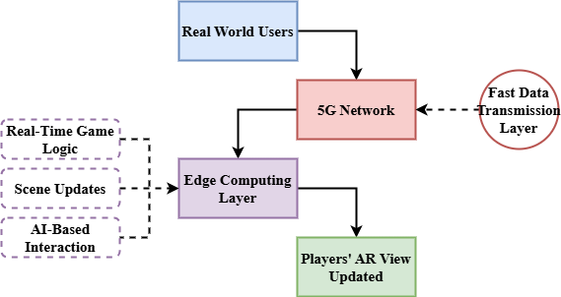
Figure 1: Conceptual Overview of Real-Time Multiplayer AR Gaming

Figure 1 provides a high-level conceptual overview of the EC-I-5GN framework, highlighting the seamless interaction between user devices, 5G networks, edge computing, and AR content delivery. Players interact with augmented reality devices, such as AR headsets or smartphones that capture real-world movements and environmental data [18]. This information is transmitted to the adjacent edge servers with the promise of low-latency connectivity through 5G networks. Real-time processing of data by the edge servers that execute game logic, generating AR content, and coordinating multiplayer sessions [19]. The proximity of the edge to the players results in minimal delay, hence enhancing the immersive experience. The revised AR material is returned to the players for show on their devices once processed. Edge computing combined with 5G connection enables this interaction loop, therefore allowing ultra-low latency, high throughput, and scalable multiplayer AR game experiences. Driving the development of interactive AR gaming, the technique enables almost immediate engagement over large geographic distances [20].

Related Works
Related works explore the evolution of AR and MAR technologies, highlighting advancements in 5G networks, edge computing, and mobile cloud systems. These studies address challenges like latency, bandwidth limitations, and system performance, providing insights into future architectures and solutions for enhancing real-time, immersive AR experiences.
Visible-Light Communication (VLC)
With the development of 5G and Beyond (5GB) networks, AR and Virtual Reality (VR) technologies are fast changing and allowing immersive and interactive experiences that mix the virtual and real worlds [21]. Achieving low-latency connectivity—defined as the delay between action and reaction—that is essential for a high-quality experience is a major difficulty in using these technologies. This work investigates hardware and software viewpoints as well as other methods to improve low-latency environments for AR and VR. Using technologies like mMIMO, mmWave, AI, and machine learning to enable ultra-low-latency communication, it also investigates the contributions of 5GB systems—along with creative approaches like Visible-Light Communication (VLC) [22] for multi-sensory tracking.
Ultra-Reliable Low-Latency Communication (URLLC)
Even with great progress, present AR/VR applications are mostly personal and local ones. The strict end-to-end latency requirement—which must be under 20 ms to avoid unpleasantness like motion sickness—remains unmet for the ideal of linked AR/VR, which lets users engage digitally across great distances. Reaching this calls for advancement in the Tactile Internet of Things (IoT) and 5G Ultra-Reliable Low-Latency Communication (URLLC) [23]. This paper highlights use cases and required technological developments as well as the technical difficulties and investigates the integration of 5G URLLC and IoT technologies to allow future linked AR/VR applications.
Mobile Augmented Reality (MAR)
The rapid growth in mobile device capabilities, including smartphones, tablets, and wearables, along with widespread Internet access and advances in cooperative networking, computer vision, and mobile cloud computing, has turned Mobile Augmented Reality (MAR) [24] into a practical technology. Although mobile devices have limited computational power compared to traditional computers, their variety of sensors and access to remote servers enable sophisticated MAR applications. This paper introduces MAR fundamentals, categorizes application fields with examples, and discusses user interface design, core system components, tracking and registration advancements, network connectivity, data management, system performance, sustainability, and key challenges that MAR systems continue to face.
Multi-access Edge Computing (MEC)
AR combines the actual surroundings with virtual space to improve human perception. MAR is becoming more and more well-known as reasonably priced mobile devices and sophisticated connectivity infrastructure improve fast. MAR lets consumers run AR apps on mobile devices with better mobility and less expenses. Ultra-low latency and large data rates for MAR are made possible in great part by 5G technology; Multi-access Edge Computing (MEC) [25] improves processing capability near consumers. Key application areas and technological issues including communication, mobility, energy management, and security are discussed in this article along with the development of MAR, its future possibilities with 5G and MEC [26].

Proposed Method
The proposed method, Real-Time Multiplayer AR Gaming using EC-I-5GN, combines advanced 5G technologies with edge computing to provide a seamless, low-latency AR gaming experience. It leverages the power of edge servers to minimize latency, enhance multiplayer synchronization, and deliver immersive gaming in real time.

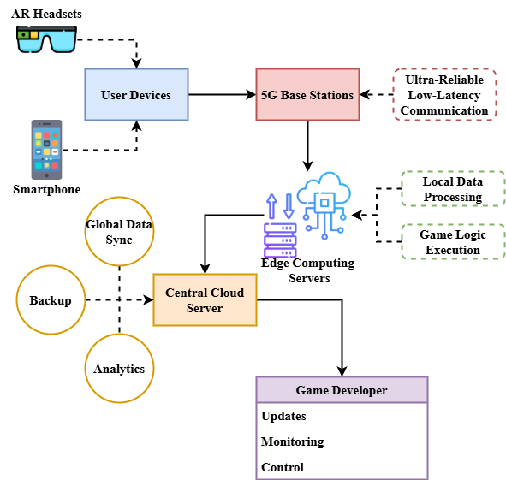
Figure 2: System Architecture of EC-I-5GN Framework

Figure 2 depicts the overall system architecture of the proposed EC-I-5GN framework, which was designed to facilitate real-time multiplayer AR gaming. User devices such as AR headsets or smartphones employ ultra-reliable low-latency 5G base stations to capture user behaviors and environmental data. To guarantee timely processing, these base stations send data to edge computing servers near the players. Through processing of ordinary tasks such as run-time execution of game logic, AR content generation, and handling of multi-player sessions, edge servers considerably reduce computing work on the client devices. Then, via 5G networks, processed outputs are sent back to the devices therefore providing a flawless and immersive AR experience. A central cloud server is also included for long-term storage, big-scale analytics, worldwide data synchronizing across many edge nodes. By guaranteeing low latency, great availability, and constant performance, this design solves the constraints of conventional cloud-dependent AR gaming systems.
$$4q_{0}=\frac{4w^{2}}{w_{0}^{2}}+j2δw_{0}W*\frac{Q_{M+1}}{T_{M}^{2}}-\frac{β}{4q_{0}} (1)$$
To improve real-time AR gaming$4q_{0}$, the equation balances latency$\frac{4w^{2}}{w_{0}^{2}}$, bandwidth, and quality factor, thus modeling the optimization$j2δw_{0}W$ of system response$\frac{Q_{M+1}}{T_{M}^{2}}$. It guarantees more seamless, AR experiences by $\frac{β}{4q_{0}}$ an increase data processing efficiency.

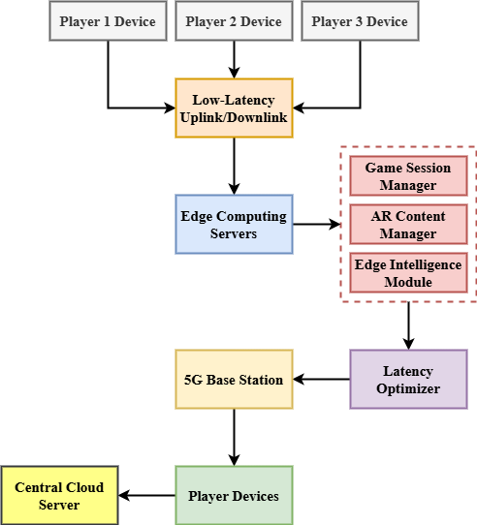
Figure 3: Data Flow and Edge Processing in EC-I-5GN Framework

Figure 3 illustrates the detailed data flow and processing structure of the proposed EC-I-5GN system. Initially capturing real-time movements and environmental data, player devices subsequently transmit that data through a 5G network to the nearest edge computing server. Edge-specialized modules perform the tasks: predictive models in the Edge Intelligence Module optimize system performance; dynamic AR content is updated and rendered by the AR Content Manager; Game Session Manager multi-manages player sessions and coordinates synchronized player state. Essential data packets have first priority within a Latency Optimizer module to ensure minimum delay while it is transmitted. After processing, the updated AR content is quickly returned to each player's device for real-time rendering. Periodic synchronizing with the master cloud server ensures data consistency and facilitates global analytics. Real-time environments enable this layered and modular technique to reduce latency, optimize resource utilization, and deliver an interactive, immersive multiplayer AR gaming experience.
$$O\left(ρ^{2}\right)=\sin\left(L_{2}-2L_{1}\right)*\cos{2π+d_{0}w_{0}^{2}\left(1-4w^{2}\right) (2)}$$
Affecting latency and signal strength$O\left(ρ^{2}\right)$, the equation 2 represents$\sin\left(L_{2}-2L_{1}\right)$ the reaction of the system$cos2π$ to dynamic changes$d_{0}w_{0}^{2}$ in network frequency$\left(1-4w^{2}\right)$ and user placement. This helps maximize real-time AR interactions, thereby guaranteeing a seamless multiplayer game experience.
The EC-I-5GN framework enables real-time, multiplayer AR gaming by integrating 5G networks with edge computing. It reduces latency, optimizes resource utilization, and supports interactive, immersive gameplay. The system's modular architecture ensures scalability, real-time processing, and global synchronization, creating a robust platform for future AR gaming applications.

Result and Discussion
The Results and Discussion section presents an analysis of the latency and scalability performance of the proposed EC-I-5GN framework. By comparing it with existing technologies like VLC, URLLC, MEC, and MAR, this section evaluates the effectiveness of the proposed method in enhancing real-time multiplayer AR gaming experiences.

Analysis of Latency Performance
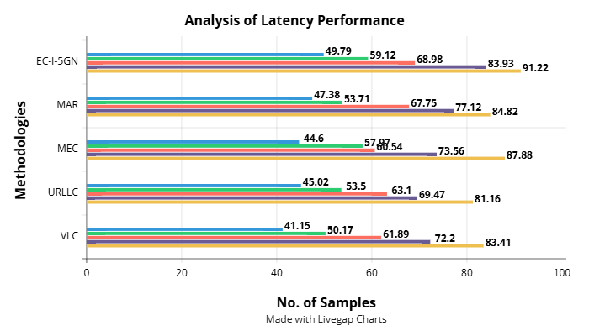
Figure 4: Analysis of Latency Performance

A thorough comparison of latency performance across many systems—VLC, URllC, MEC, MAR, and the proposed EC-I-5GN framework—Figure 4. Although the latency across all systems increases with increasing sample count, EC-I-5GN constantly shows the lowest latency among the others. With 100 samples, for example, EC-I-5GN achieves a latency of 91.22 ms that is less than MEC (87.88 ms), MAR (84.82 ms), and other technologies, thus stressing its advantage in offering low-latency events. Critical for real-time multiplayer AR games, end-to-end latency is proposed to be significantly lowered through EC-I-5GN's synergy of 5G and edge computing. Larger sample sizes make the gap between EC-I-5GN and other methods increase, thus emphasizing its ability to reduce latency for an error-free and immersive AR gaming experience. These findings validate the efficacy of EC-I-5GN in maintaining performance on scale.
$$Ua'v=-\frac{m}{w_{0}^{2}Q}*\frac{1}{2}vv^{'}-\frac{1}{w_{0}^{2}}v^{''}+2\left(\frac{δp}{δq}\right) (3)$$
The equation represents system reactions$Ua'v$ to frequency$\frac{m}{w_{0}^{2}Q}$ and dampening parameters as well as energy dissipation$\frac{1}{2}vv^{'}-\frac{1}{w_{0}^{2}}$. Through dynamic performance adaptation$2\left(\frac{δp}{δq}\right)$ to maximize real-time AR gaming, effective resource allocation on the analysis of latency performance.

Analysis of Scalability and System Load
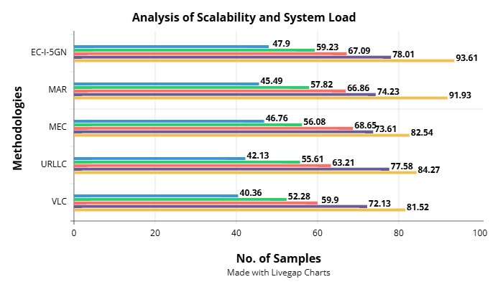
Figure 5: Analysis of Scalability and System Load

Figure 5 illustrates the system load and scalability performance of some technologies with VLC, URLLC, MEC, MAR, and the future EC-I-5GN framework included. EC-I-5GN consistently outperforms other systems as the number of samples increases, demonstrating its ability to sustain peak performance under increasing load. For 100 samples, EC-I-5GN boasts the maximum system load value—93.61—over MAR (91.93) and MEC (82.54). This ensures consistent performance even under heavy loads and reflects that the proposed method effectively deals with increasing user demand. The results suggest that the system scalability is enhanced using the combination of edge computing with 5G networks, thus providing a solid foundation for real-time multiplayer AR applications. EC-I-5GN supports a well-balanced load distribution as the sample size grows, thus preventing performance degradation and ensuring perfect AR gaming experiences even in large-scale environments.
$$∁^{'}+∅^{2}=ρ_{0}V_{m+1}q_{0}^{2}V*{2p}^{2}+\frac{4}{3}φ\left[\frac{2πq}{θ}\right] (4)$$
The equation 4, $∁^{'}+∅^{2}$ approximates the interaction$ρ_{0}V_{m+1}q_{0}^{2}V$ among dynamic system variables including${2p}^{2}$ geographical elements, bandwidth$\frac{4}{3}φ\left[\frac{2πq}{θ}\right]$, and network strength on analysis of scalability and system load.
$$\frac{∂^{2}t}{{∂v}^{2}}+{2π}_{a}=c_{0}^{2}+\frac{c_{166}}{q_{0 }}-\left(c_{0}^{2}+\frac{d_{166}}{q_{0 }}\right) (5)$$
The equation 5 describes$\frac{∂^{2}t}{{∂v}^{2}}+{2π}_{a}$ the link among time$c_{0}^{2}+\frac{c_{166}}{q_{0 }}$, acceleration$\left(c_{0}^{2}+\frac{d_{166}}{q_{0 }}\right)$, and system characteristics influencing latency and bandwidth. The resources for seamless, real-time multiplayer interactions, AR gaming experience.

Conclusion
With the vision of addressing latency and scalability concerns for AR game applications, in this work the Real-Time Multiplayer AR Gaming Experience based on EC-I-5GN framework has been proposed. EC-I-5GN optimally delivers engaging real-time multiplayer AR gaming experience based on utilizing 5G network's high speed and ultra-low-latency alongside edge computing processing power. As the performance figures indicate, the proposed method significantly reduces latency and enhances system scalability. Even when the number of samples increases, EC-I-5GN yields improved latency performance in comparison to standard systems like VLC, URllC, MEC, and MAR. The study of scalability revealed that combining edge computing with 5G networks ensures robust performance under maximum user demand, thus maintaining smooth gaming and alleviating system overload through robust performance under heavy user load. The research reveals that EC-I-5GN system can be a precursor to future augmented reality games that support simultaneous play by multiple players. The development of resource management, user interface, and material presentation could be achieved through the union of AI and ML that is worthy of further research by scholars. The EC-I-5GN technique can revolutionize the augmented reality gaming industry fundamentally by making interaction, excitement, and accessibility for customers around the world better.
In the future, researchers might look at ways to enhance the EC-I-5GN framework's resource management and optimization strategies to increase the system's scalability in dynamic contexts and reduce its energy consumption. AI and ML-powered adaptive games and predictive content distribution may provide users more individualized experiences. A broader variety of networks and locations may find real-time shared augmented reality activity more accessible and beneficial if hybrid edge-cloud architectures and their relevance to global augmented reality usage are investigated.

References
- J. Orlosky, K. Kiyokawa, and H. Takemura, “Virtual and augmented reality on the 5G highway,” Journal of Information Processing, vol. 25, pp. 133–141, 2017.
- M. Verma, “5G Drones with 5G Gaming and Application of 5G in Other Industries: A ChatGPT Analysis,”.
- G. Gupta, and G. Singh, “The impact of 5G on media and entertainment,”.
- P. Madduru, “Artificial intelligence as a service in distributed multi access edge computing on 5G extracting data using IoT and including AR/VR for real-time reporting,” Information Technology in Industry, vol. 9, no. 1, pp. 912–931, 2021.
- J. Muralidharan, “Advancements in 5G technology: Challenges and opportunities in communication networks,” Progress in Electronics and Communication Engineering, vol. 1, no. 1, pp. 1–6, 2024.
- C. E. Mendoza-Ramírez, J. C. Tudon-Martinez, L. C. Félix-Herrán, J. D. J. Lozoya-Santos, and A. Vargas-Martínez, “Augmented reality: survey,” Applied Sciences, vol. 13, no. 18, Art. no. 10491, 2023.
- P. E. Indrawan, N. N. Parwati, I. M. Tegeh, and I. G. W. Sudatha, “Trends in the use of augmented reality in character development within local wisdom in schools: A bibliometric study,” Indian Journal of Information Sources and Services, vol. 14, no. 4, pp. 7–15, 2024, https://doi.org/10.51983/ijiss-2024.14.4.02.
- T. Dhote, P. Pathak, and S. P. Iyengar, “Futuristic approach of 5G in marketing and branding through entertainment,” in Digital Entertainment as Next Evolution in Service Sector: Emerging Digital Solutions in Reshaping Different Industries, Singapore: Springer Nature Singapore, 2023, pp. 91–105.
- S. Patil, and R. Kumar, “Accelerating extended reality vision with 5G networks,” in Proceedings of the 2019 3rd International Conference on Electronics, Communication and Aerospace Technology (ICECA), Coimbatore, India, Jun. 2019, pp. 157–161.
- K. Bodhwani, and A. Sharma, “The future of augmented reality: Emerging trends and challenges,” Landscape, vol. 63, 2023.
- G. S. Von Itzstein, M. Billinghurst, R. T. Smith, and B. H. Thomas, “Augmented reality entertainment: Taking gaming out of the box,” in Encyclopedia of Computer Graphics and Games, Cham, Switzerland: Springer International Publishing, 2024, pp. 162–170.
- K. P. Uvarajan, “Advanced modulation schemes for enhancing data throughput in 5G RF communication networks,” SCCTS Journal of Embedded Systems Design and Applications, vol. 1, no. 1, pp. 7–12, 2024, https://doi.org/10.31838/ESA/01.01.02.
- T. Emrich, The Next Dimension: How to Use Augmented Reality for Business Growth in the Era of Spatial Computing, Hoboken, New Jersey: John Wiley & Sons, 2024.
- T. M. Sathish Kumar, “Wearable sensors for flexible health monitoring and IoT,” National Journal of RF Engineering and Wireless Communication, vol. 1, no. 1, pp. 10–22, 2023, https://doi.org/10.31838/RFMW/01.01.02.
- S. Sadulla, “Techniques and applications for adaptive resource management in reconfigurable computing,” SCCTS Transactions on Reconfigurable Computing, vol. 1, no. 1, pp. 6–10, 2024, https://doi.org/10.31838/RCC/01.01.02.
- W. Yunes, and K. I. Alsaif, “Deep Learning for Fire Detection in Simulated Augmented Reality Videos,” International Journal of Advances in Engineering and Emerging Technology, vol. 13, no. 2, pp. 60–72, 2022.
- B. Pokric, S. Krco, D. Drajic, M. Pokric, V. Rajs, Z. Mihajlovic, and D. Jovanovic, “Augmented reality enabled IoT services for environmental monitoring utilising serious gaming concept,” Journal of Wireless Mobile Networks, Ubiquitous Computing, and Dependable Applications, vol. 6, no. 1, pp. 37–55, 2015.
- A. T. Jasim, “Investigating the potential of remote sensing for sustainable urban renewal and regeneration: A review,” International Academic Journal of Science and Engineering, vol. 11, no. 1, pp. 54–64, 2024, https://doi.org/10.9756/IAJSE/V11I1/IAJSE1108.
- C. K. Mohammed Malik, “Web mining using improved Apriori algorithm,” International Academic Journal of Innovative Research, vol. 9, no. 1, pp. 52–60, 2022, https://doi.org/10.9756/IAJIR/V9I1/IAJIR0917.
- Z. Myoa, H. Pyo, and M. Mon, “Leveraging real-world evidence in pharmacovigilance reporting,” Clinical Journal for Medicine, Health and Pharmacy, vol. 1, no. 1, pp. 48–63, 2023.
- Q. S. Ali, O. A. Abdulrazaq, A. R. M. Al-Ani, A. K. Ahmed, I. Abdullah, and A. Zapryvoda, “The era of 5G/LTE network integration of virtual reality to revolutionize IT infrastructure,” in Proceedings of the 2024 36th Conference of Open Innovations Association (FRUCT), Yerevan, Armenia, Oct. 2024, pp. 756–767.
- A. Hazarika, and M. Rahmati, “Towards an evolved immersive experience: Exploring 5G-and beyond-enabled ultra-low-latency communications for augmented and virtual reality,” Sensors, vol. 23, no. 7, p. 3682, 2023.
- M. Torres Vega, C. Liaskos, S. Abadal, E. Papapetrou, A. Jain, B. Mouhouche, J. Famaey, and others, “Immersive interconnected virtual and augmented reality: A 5G and IoT perspective,” Journal of Network and Systems Management, vol. 28, pp. 796–826, 2020.
- D. Chatzopoulos, C. Bermejo, Z. Huang, and P. Hui, “Mobile augmented reality survey: From where we are to where we go,” IEEE Access, vol. 5, pp. 6917–6950, 2017.
- Y. Siriwardhana, P. Porambage, M. Liyanage, and M. Ylianttila, “A survey on mobile augmented reality with 5G mobile edge computing: Architectures, applications, and technical aspects,” IEEE Communications Surveys and Tutorials, vol. 23, no. 2, pp. 1160–1192, 2021.
- T. M. Sathish Kumar, “Wearable sensors for flexible health monitoring and IoT,” National Journal of RF Engineering and Wireless Communication, vol. 1, no. 1, pp. 10–22, 2023, https://doi.org/10.31838/RFMW/01.01.02.

