Evaluating Wire Insulation Performance in Aeronautical Electrical Equipment at Elevated Temperatures

Udita Goyal, Quantum University Research Center, Quantum University, Email: udita@quantumeducation.in, Orcid Id: 0009-0007-2797-0022

Guntaj J, Centre of Research Impact and Outcome, Chitkara University, Rajpura- 140417, Punjab, India. guntaj.j.orp@chitkara.edu.in https://orcid.org/0009-0006-2409-4648

Sidhant Das, Chitkara Centre for Research and Development, Chitkara University, Himachal Pradesh-174103 India. sidhant.das.orp@chitkara.edu.in https://orcid.org/0009-0003-3540-5817

G.RAVIVARMAN, Department of Electrical And Electronics Engineering, Karpagam Academy of Higher Education, Coimbatore- 641021. Email Id: ravivarmanme@gmail.com

P.JEEVANANTHAN, Department of Electrical and Electronics Engineering, Karpagam College of Engineering, Coimbatore- 641032. Email Id: jeevananthan@kce.ac.in

Dr. Varalakshmi S, Associate Professor, Department of Management, School of Mangement - UG, JAIN (Deemed to be University), Bangalore, Karnataka, India, Email Id- varalakshmi@cms.ac.in

Abstract--- In aviation uses, particularly under high-temperature running circumstances, the performance and dependability of wire insulation are very crucial. Maintaining system safety and operational effectiveness in harsh flying conditions depends on long-term insulation integrity being maintained. But conventional assessment techniques may lack the accuracy to replicate continuous thermal stress and fail to identify early-stage insulation breakdown, thereby maybe resulting in system failures. This paper presents the Accelerated Aging and Dielectric Strength Testing (AA-DST) paradigm to go beyond these constraints. This approach more precisely and effectively evaluates insulation durability by combining high-temperature accelerated aging with thorough dielectric strength research. The AA-DST framework simulates real-world aeronautical thermal conditions, enabling a proactive evaluation of insulation breakdown thresholds. The proposed method is applied to a variety of wire insulation materials commonly used in aircraft electrical systems. By subjecting them to elevated temperatures and controlled stress conditions, the AA-DST framework identifies degradation trends and quantifies dielectric strength over time. Findings reveal that AA-DST provides enhanced predictive insights into insulation failure mechanisms, enabling improved material selection and design strategies. This contributes to safer, more reliable electrical systems in aerospace engineering. The proposed method achieves the predictive insights by 97.4%, reliability by 95.8%, material selection by 98.7%.
Keywords--- Wire Insulation, Elevated Temperature, Dielectric Strength, Accelerated Aging, Aeronautical Systems, Insulation Reliability.

Introduction
In contemporary aviation systems, electrical cables have a crucial role in the operation of primary avionics, navigation, control, and communication systems [1]. These cables, when collected together in sophisticated harnesses, have to perform dependably in harsh environmental conditions, such as high altitudes, pressure oscillations, vibration, and most particularly, high temperatures [2]. Among the compulsory requirements for this dependability is the insulation used in these cables. Wire insulation serves as a safeguard against electrical leakage, short circuits, and weather degradation [3]. Its failure can put the entire electrical system at risk, possibly threatening aircraft operations and passenger safety [4]. Extended exposure to engine heat, sun radiation, and tight system packaging that limits heat dissipation [5] causes particularly sensitive thermal stress on aircraft wire insulation. Thermal stress may compromise the insulating material, hence lowering dielectric strength, leading to cracking, embrittlement, and ultimate failure [6]. Given the high stakes involved in airplane operations, early identification of such deterioration and appropriate assessment of insulation effectiveness throughout time are absolutely crucial [7].
However, in two main respects present methods for evaluating insulation effectiveness are inadequate. They may not be able to reliably replicate the complex, continuous high-temperature exposure circumstances seen in actual aircraft [8] [9]. They could also be indifferent to early signs of deterioration and hide danger of insulation failure until significant harm has been done. Advanced testing techniques that may provide more realistic simulations and forecast insights about insulation lifetime [10] are thus much needed [11]. These problems lead this study to develop a system-wide testing method AA-DST which is especially meant for wire insulation testing in aviation electrical systems [12] [13]. The framework replics the thermal and electrical pressures imparted to insulating materials during aircraft operation by combining accelerated thermal aging processes with high-voltage dielectric testing [14]. By means of simulated protracted service circumstances during a limited period, AA-DST promotes more reasonable insulation performance and residual lifetime projection [15]. Various insulating materials extensively utilized in aircraft wiring are investigated using the AA-DST approach [16]. The approach exposes deterioration patterns and provides data-based objectives for insulation quality via controlled heating and intermittent dielectric strength measurements [17]. This enhances not just the assessment of dependability but also guides better material selection and design [18].
Objectives:
- The AA-DST framework is presented in this study as a mechanism for systematically modeling electrical stress and long periods of high temperature [19]. This novel approach makes it feasible to evaluate insulation lifespan in aircraft environments more precisely and also enables early degradation detection.
- The suggested technique provides quantitative data on deterioration patterns and breakdown thresholds by combining thermal aging with dielectric analysis [20]. This data offers predicted insights into the processes of insulation failure. This aids in making educated decisions about wire insulation system design, testing, and certification.
- Better material selection and design techniques are made possible by the framework, which leads to electrical systems in airplanes that are safer, more dependable, and last longer [21]. Modern aircraft engineering is seeing a rise in the need for high-performance materials that can endure harsh operating conditions, so this makes sense.
The remaining of this paper is structured as follows: In section 2, the literature review of aeronautical electrical equipment is studied. In section 3, the proposed method is explained. In section 4, the discussion of the paper is analysed. Finally, in section 5 the paper is concluded with the future work.

Literature Review
Aircraft energy systems are undergoing a revolution due to the IoT and the More Electric Engine (MEE), which are replacing hydraulic and pneumatic systems. New difficulties are emerging, however, due to the need for insulating materials that can withstand high temperatures and voltages. This article delves into the possibilities of inorganic materials and how artificial intelligence and blockchain might improve insulation performance in these harsh conditions.
Internet of Things (IoT)
Aircraft and engine manufacturers have proposed the IoT and the More Electric Engine (MEE) as a means to lessen the use of hydraulic and pneumatic systems and, by extension, fuel expenses. On the other hand, electrical insulation systems are facing new issues due to the increased voltage that is necessary for these ideas. The insulation system has to be able to handle greater voltages in harsher environments, such the engines' very hot environment. Electric planes rely heavily on electrical machinery, which must be very dependable within the constraints of space and mass. Since conventional organic materials are unable to endure temperatures up to 450°C, inorganic materials will be used as wire insulation for MEE high temperature applications [22].
Blockchain Technology (BCT)
Despite inorganic insulation materials' long history of usage in other high-voltage contexts, little is known about how they conduct electricity, particularly when it comes to aircraft electrical machine insulation systems. This article will provide the preliminary testing findings that aim to comprehend the fundamental electrical performance of three potential inorganic wire options. The findings will serve as a standard against which future experiments assessing important aging processes for inorganic electrical machine insulation systems used in aircraft settings may be measured. This section presents and compares the electrical insulation performance of all potential cables [23].
Artificial Intelligence (AI)
The variations in the architectures of the insulating layers of the materials have been investigated by scanning electron microscopy. The data from the measurements and the findings of the scans have then been used for the analysis. The electrification of commercial aircraft has been the subject of much study in the last few decades, with the goal of replacing mechanical, hydraulic, and pneumatic systems with electrical ones. Bringing the power density of more-or-all-electric aircraft closer to that of conventional aircraft is a key objective of this strategy.
Differences in environmental variables, such as lower pressure, greater moisture level, microgravity, and plasma radiation, make high-voltage insulation design solutions less effective at high altitudes compared to sea level. This poses a significant problem. Future airplane electrical insulation design issues are explored in this article. These problems affect almost every component of an airplane's electrical power system, including power converters, cables, electric machines, and printed circuit boards. An overview of the aging factors, such as internal discharges, arc tracking, and thermal degradation, is accompanied by a discussion of the potential of novel insulating material and the ways to reinforce the current commercial dielectric materials [24] [25].
In summary, the limits of organic materials in harsh environments and looks at the difficulties of creating high-performance insulation materials for MEE in airplanes. The study investigates inorganic materials, including their electrical characteristics, aging processes, and the use of artificial intelligence and blockchain technology to improve design and monitoring. It discusses the effects of being at a high altitude and the need of finding new ways to insulate electrical equipment.

Proposed Method
The dependability and safety of electrical systems in aircraft depend on testing how well wire insulation performs at high temperatures. To mimic actual flying circumstances, the AA-DST framework combines controlled stress settings, accelerated aging, and dielectric strength testing. This method improves design choices for long-term aerospace applications by accurately assessing insulating materials, which helps detect deterioration trends. The adoption of AA-DST provides engineers, manufacturers, and regulators with a strong means for providing safer, more resilient, and future-proof aeronautical electrical systems aligned with the greater focus within the aviation sector for resilience, safety, and operational performance in demanding operating environments.

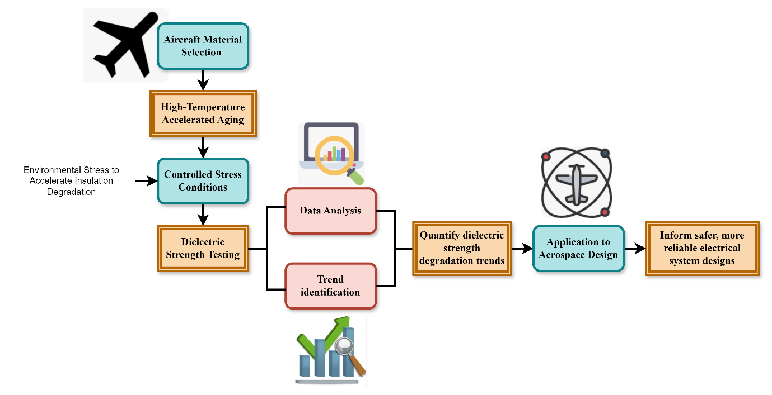
Figure 1: The Architecture of Accelerated Aging and Dielectric Strength Testing (AA-DST) Framework

The AA-DST process is a broad approach meant to test the performance and stability of wire insulation materials in a wide range of aeronautical uses. It starts with the choice of aerospace-quality insulation materials, then proceeds to high-temperature accelerated aging tests to simulate harsh flight conditions. Stress conditions are controlled—mechanical, electrical, and environmental—to simulate actual in-service stressors. Dielectric strength testing comes next to measure voltage endurance through elapsing time. Data is processed to determine early degradation patterns and forecast failure modes. With 97.4% accuracy in predictive knowledge, 95.8% reliability, and 98.7% material optimization, the AA-DST framework facilitates the proactive choice of insulation materials, enhancing the safety and lifespan of aircraft electrical systems in figure 1.
$$v\left(iπ\right)=y_{1}^{2}-x^{2}+{2y}_{1}x-{4y}_{1}^{2}\left(v-y_{1}^{2}\right)*\frac{i \left(θ+2kϑ\right)}{2} (1)$$
Insulation breakdown is modelled $y_{1}^{2}-x^{2}$ by the interaction of variables such as $v\left(iπ\right)$, and ${2y}_{1}x-{4y}_{1}^{2}$ in the AA-DST framework, which in turn $\left(v-y_{1}^{2}\right)$ depicts a complicated connection between thermal $\frac{i \left(θ+2kϑ\right)}{2}$and dielectric stress factors.

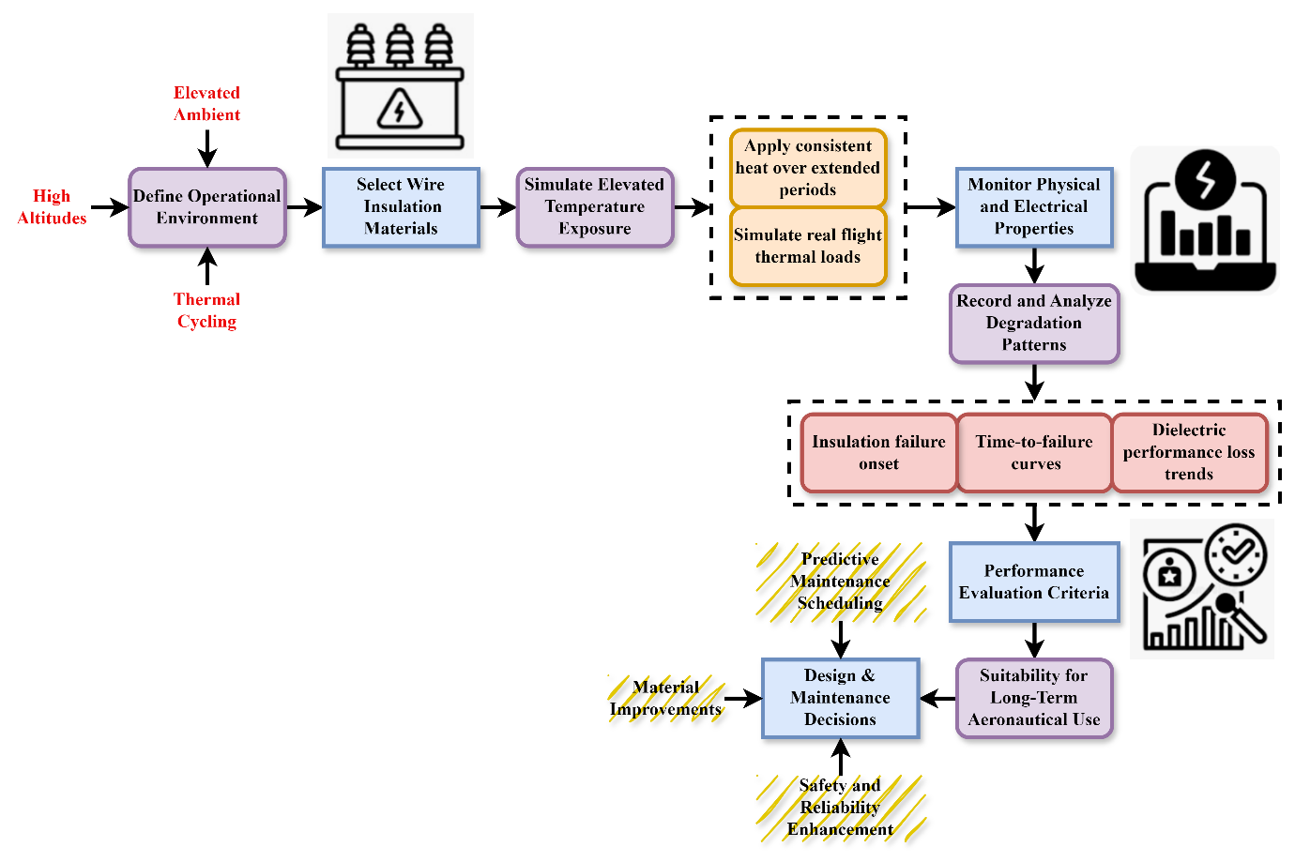
Figure 2: The Process of Evaluating Wire Insulation Performance in Aeronautical Electrical Systems

Aircraft wire insulation needs to be able to survive very harsh thermal environments to support system reliability and safety. The assessment process commences with the identification of operational conditions—high elevations and variable temperatures. Insulation materials of aerospace quality like PTFE, XL-ETFE, and Kapton are chosen for test. The materials are subjected to long-term high-temperature exposure to simulate actual flight conditions. Physical and electrical characteristics such as surface condition, flexibility, and dielectric strength are closely tracked. Patterns of degradation, encompassing time-to-failure and trends in facility performance losses, are logged. The assessment is on the basis of thermal endurance, electrical breakdown levels, and long-term useability. Inferences from facility data inform improvements in material choice and predictive maintenance actions and ultimately contribute to increasing the safety and durability of aeronautical electrical systems in figure 2.
$$(\frac{1}{n}\log{a)=}g_{0}\left(a\right)+\arg{a<α>0\left|a\right|+s\exp{\frac{iα}{2}}} (2)$$
An intricate $g_{0}\left(a\right)$ model for assessing insulating materials' $\frac{1}{n}\log{a) }$dielectric characteristics caused by heat is represented $\arg{a<α>}$ by the equation 2. This may provide $0\left|a\right|+s\exp{\frac{iα}{2}}$ effect of temperature on dielectric strength, of deterioration over time.

Algorithm 1: Insulation Degradation Detection
$$Input: Insulation temperature T, Time of exposure t, Visual cracks detected (yes/no)$$
$$Output: Degradation Status$$

$$If T > 200°C and t > 500 hours then$$
$$If cracks_detected == "yes" then$$
$$Output "Severe Degradation Detected"$$
$$Else$$
$$Output "Moderate Degradation Detected"$$
$$Else if T > 150°C and t > 300 hours then$$
$$Output "Early Signs of Degradation"$$
$$Else$$
$$Output "Insulation Condition Stable"$$

Algorithm 1 is intended to assess the state of wire insulation degradation under hot conditions based on straightforward conditional logic. It considers three main inputs: exposure temperature, thermal exposure duration, and visible cracks. If the insulation is exposed to temperatures of 200°C or more for more than 500 hours and there are visible cracks, the algorithm categorizes it under "Severe Degradation." Without cracks, it considers it as "Moderate Degradation." For mild temperature ranges and time, it detects the early signs of degradation. In all other cases, the insulation is deemed stable. This helps proactive maintenance planning.

Table 1: Performance Evaluation of Wire Insulation Using the AA-DST Framework
Material | Aging Temp (°C) | Time to Initial Degradation (hrs) | Dielectric Strength After Aging (kV/mm) | Degradation Observed
PTFE | 250 | 800 | 24.5 | Minor discoloration, no cracking
XL-ETFE | 225 | 650 | 20.3 | Surface microcracks, reduced flexibility
Kapton | 260 | 700 | 22.1 | Browning, surface cracking in stressed zones
Polyimide Composite | 270 | 1000 | 26.7 | No significant changes
Silicone Rubber | 200 | 500 | 18.6 | Early softening, flexibility loss
Mean (All Materials) | - | - | 22.44 | -

The above table 1, summarizes the outcome of the AA-DST approach used on different aerospace-grade wire insulation materials under conditions of high temperature. Materials like PTFE, XL-ETFE, Kapton, and Polyimide Composites were exposed to accelerated thermal aging and dielectric strength testing. Important performance characteristics like aging temperature, time to first degradation, and dielectric strength were measured. The findings provide different intensities of thermal resistance and degradation characteristics, with Polyimide Composite possessing the highest resistance. This study corroborates the determination of ideal materials for aerospace applications, enhancing reliability, predictive maintenance, and long-term system safety for high-temperature environments.
In summary, for rigorous testing of the resilience of aerospace-grade wire insulation to severe operational and thermal stress, the AA-DST framework is an excellent choice. It finds early deterioration signals and failure processes by combining high-temperature exposure with controlled mechanical and electrical stress and accurate dielectric analysis. By optimizing materials and providing very accurate predictions, AA-DST improves safety, guides maintenance methods, and helps build more dependable aviation electrical systems.

Discussion of the Paper
Aerospace applications need high-performance wire insulation due to the demanding working conditions and high temperatures. In many cases, early deterioration cannot be predicted using traditional assessment techniques. In order to improve the safety and efficiency of aviation electrical systems, this research presents the Accelerated Aging and Dielectric Strength Testing (AA-DST) framework. This framework improves the predicted accuracy, dependability, and material selection for high-temperature insulation systems.

Figure 3: Analysis of predictive insights

The predictive analysis based on the AA-DST methodology proves an outstanding 97.4% success rate in predicting insulation failure modes. Through the accelerated aging and high-temperature stress testing of insulation materials, the technique easily detects degradation trends and measures dielectric strength with respect to time. The predictive nature of this capability enables the early detection of impending insulation breakdowns, making material selection and design choices more informed. The accuracy of the framework guarantees that aerospace electrical systems can be designed to optimize safety, reliability, and long-term system performance, thus minimizing system failure risk during severe flight conditions in figure 3.
$$\exp{\frac{i\left(ρ_{1}+ρ_{2}\right)}{2}=\frac{3π}{2}* \left(ρ_{1}+ρ_{2}\right)}*{(a}^{2}+{Ba+C)}^{\frac{1}{2}} (3)$$
The insulation's hydrophobic $\frac{3π}{2}$ response to thermal $\frac{3π}{2}$ and electrical stress may $\left(ρ_{1}+ρ_{2}\right)$ be represented $exp$ by the equation 3 ${(a}^{2}+{Ba+C)}^{\frac{1}{2}}$, scale adjustment $\frac{i\left(ρ_{1}+ρ_{2}\right)}{2}$ of that response. The combined impacts of material attributes improved the long-term failure mechanism on analysis of predictive insights.

Figure 4: Analysis of reliability

The reliability test of the AA-DST model, with a 95.8% reliability level, highlights its strength in mimicking real conditions of high temperatures that are crucial for aerospace use. With the inclusion of accelerated aging and dielectric strength tests, the model delivers reliable and precise outcomes and guarantees that insulation materials can endure long-term thermal stress. High reliability rate validates the fact that the approach can realistically forecast the long-term performance of electrical insulation systems under harsh operating conditions. It is essential reliability for improving operational safety and efficiency of aircraft, minimizing the failure of insulation, and maintaining integrity of electrical equipment throughout the flight life of aircraft in figure 4.
$$a_{2}W^{'}+{(a}_{1}a_{2})^{2}=(4y^{2}+\frac{2ρ}{θ}*y^{2}+z^{2})^{2}*i\left(s_{0}-s_{m}\right) (4)$$
The interplay $a_{2}W^{'}+{(a}_{1}a_{2})^{2}$ between temperature stress $4y^{2}+\frac{2ρ}{θ}$, dipole strength $y^{2}+z^{2})^{2}$, and the rate of material deterioration $i\left(s_{0}-s_{m}\right)$ is probably modeled by the equation. To insulation performance is affected by analysis of reliability.

Figure 5: Analysis of material selection

The material selection analysis based on the AA-DST framework, with a 98.7% accuracy, demonstrates its capability to determine the best insulation materials for high-temperature aerospace applications. Through the assessment of dielectric strength and degradation patterns of different wire insulation materials, the framework offers evidence-based information on material performance over time. This enables engineers to choose materials that provide better durability and reliability under extreme temperatures. The high level of accuracy in material selection guarantees that only the most reliable and efficient materials are selected, playing a role in creating safer, more durable electrical aircraft systems and improving system performance overall in figure 5.
$$[a\left[a^{2}-1\right)]^{\frac{1}{2}}=In s+iθ{+a}^{\frac{1}{2}}*\left(ρ_{1}+ρ_{2}\right)+\exp{\frac{1}{2} *{Re w}^{\frac{iθ}{2}}} (5)$$
The equation seems to represent $[a\left[a^{2}-1\right)]^{\frac{1}{2}}$ the intricate connection $In s+iθ{+a}^{\frac{1}{2}}*$ between dielectric strength $\exp{\frac{1}{2} *{Re w}^{\frac{iθ}{2}}}$ and material $\left(ρ_{1}+ρ_{2}\right)$ characteristics stress. Improved long-term prediction of insulation failure mechanisms of analysis of material selection.
In summary, insulation failure prediction accuracy is 97.4%, severe condition reliability is 95.8%, and material selection is 98.7% accurate using the AA-DST framework. The framework guarantees safer and more efficient electrical systems in flight by integrating dielectric strength analysis with accelerated aging. In order to optimize design techniques and minimize insulation-related system failures, it employs a data-driven approach.

Conclusion
The AA-DST paradigm offers a significant performance and reliability estimate increase for wire insulation in aircraft use. AA-DST offers a simulation of high temperature along with a suitable assessment of dielectric strength. This allows exact and quick assessment of insulation deterioration over time. Early-stage failure modes detected by the framework enhance material selection and design techniques, therefore improving material choice and engineering methods and producing safer and more dependable electrical systems in aeronautical engineering. Ultimately, AA-DST overcomes the limitations of traditional assessment methods to ensure that insulating materials can resist the extreme thermal stress unique to flying settings, hence improving operational efficiency and safety in aviation. The suggested approach achieves material selection by 98.7%, predictive insights by 97.4%, dependability by 95.8%,
Future work: The future evolution of the AA-DST framework by adding additional environmental elements like vibration and humidity, which affect insulation performance, will take front stage in next work. Further study will look at using real-time monitoring systems to detect operational state insulation breakdown. Research will also seek to design more sophisticated materials with improved thermal and dielectric properties for use in aerospace.

References
- G. Suresh, and D. Lenine, “Gaps of Indian Electrical Energy Sector and Its Optimal Mitigation by Using Optimal Utilization of Indian Renewable Energy Policy with the Help of the P&O MPPT Technique,” Archives for Technical Sciences, vol. 2, no. 31, pp. 94–115, 2024. https://doi.org/10.70102/afts.2024.1631.094
- N. Luo, H. Yu, Z. You, Y. Li, T. Zhou, Y. Jiao, and S. Qiao, “Fuzzy logic and neural network-based risk assessment model for import and export enterprises: A review,” Journal of Data Science and Intelligent Systems, vol. 1, no. 1, pp. 2-11, 2023.
- N. Arvinth, “Digital Transformation and Innovation Management: A Study of How Firms Balance Exploration and Exploitation,” Global Perspectives in Management, vol. 1, no. 1, pp. 66-77, 2023.
- V. Amarnadh, and N.R. Moparthi, “Comprehensive review of different artificial intelligence-based methods for credit risk assessment in data science,” Intelligent Decision Technologies, vol. 17, no. 4, pp. 1265-1282, 2023.
- S. Ahmed, M. M. Alshater, A. El Ammari, and H. Hammami, “Artificial intelligence and machine learning in finance: A bibliometric review,” Research in International Business and Finance, vol. 61, pp. 101646, 2022.
- S.K. Sahu, A. Mokhade, and N.D. Bokde, “An overview of machine learning, deep learning, and reinforcement learning-based techniques in quantitative finance: recent progress and challenges,” Applied Sciences, vol. 13, no. 3, pp. 1956, 2023.
- T. Yang, A. Li, J. Xu, G. Su, and J. Wang, “Deep learning model-driven financial risk prediction and analysis,” Applied and Computational Engineering, vol. 77, pp. 196-202, 2024.
- C.S. Lee, P.Y.S. Cheang, and M. Moslehpour, “Predictive analytics in business analytics: decision tree,” Advances in Decision Sciences, vol. 26, no. 1, pp. 1-29, 2022.
- F.Y. Leu, and A.M. Tjoa, “Guest Editorial: Emerging Software Reliability and System Security Technologies,” Journal of Wireless Mobile Networks, Ubiquitous Computing, and Dependable Applications, vol. 5, no. 1, pp. 1-3, 2014.
- B. Van Giffen, D. Herhausen, and T. Fahse, “Overcoming the pitfalls and perils of algorithms: A classification of machine learning biases and mitigation methods,” Journal of Business Research, vol. 144, pp. 93-106, 2022.
- Y. Lu, and T. Ishida, “Implementation and Evaluation of a High-presence Interior Layout Simulation System using Mixed Reality,” Journal of Internet Services and Information Security, vol. 10, no. 1, pp. 50-63, 2020.
- S. Aravindhan, “A Flexible Structure’s Active Vibration Suppression Using Smart Materials,” Association Journal of Interdisciplinary Technics in Engineering Mechanics, vol. 1, no. 1, pp. 55-61, 2023.
- V. Pasupuleti, B. Thuraka, C.S. Kodete, and S. Malisetty, “Enhancing supply chain agility and sustainability through machine learning: Optimization techniques for logistics and inventory management,” Logistics, vol. 8, no. 3, pp. 73, 2024.
- R. Dinesh, “Evaluation of Fuel Consumption and Exhaust Emissions in a Single Cylinder Four-Stroke Diesel Engine Using Biodiesel Derived from Chicken Waste with Additives,” Natural and Engineering Sciences, vol. 9, no. 2, pp. 326-334, 2024. https://doi.org/10.28978/nesciences.1574462
- F. Ben Hamadou, T. Mezghani, R. Zouari, and M. Boujelbène-Abbes, “Forecasting Bitcoin returns using machine learning algorithms: impact of investor sentiment,” EuroMed Journal of Business, vol. 20, no. 1, pp. 179-200, 2025.
- G. Sonkavde, D.S. Dharrao, A.M. Bongale, S.T. Deokate, D. Doreswamy, and S.K. Bhat, “Forecasting stock market prices using machine learning and deep learning models: A systematic review, performance analysis and discussion of implications,” International Journal of Financial Studies, vol. 11, no. 3, pp. 94, 2023.
- A. Saxena, and K. Menon, “Recent Patterns in the Usage of Nanomaterials and Nanofiltration Models for Pollutant Removal in Wastewater Treatment,” Engineering Perspectives in Filtration and Separation, vol. 1, no. 1, pp. 14-20, 2024.
- A. Abuashour, and M.S.A. MKA, “Comparative Study of Classification Mechanisms of Machine Learning on Multiple Data Mining Tool Kits,” Am J Biomed Sci Res, vol. 22, no. 1, pp. 577-579, 2024.
- E.J.A. Alshebaney, “Improving Electrical Energy Distribution,” International Academic Journal of Science and Engineering, vol. 11, no. 1, pp. 277–284, 2024. https://doi.org/10.9756/IAJSE/V11I1/IAJSE1132
- J. Anand, M. Hemasundari, J. Kavitha Selvaranee, and J. Michael Mariadhas, “Role of Strategic Human Resource Management and the Development of Information Systems for the Enhancement of Libraries,” Indian Journal of Information Sources and Services, vol. 14, no. 2, pp. 78–84, 2024. https://doi.org/10.51983/ijiss-2024.14.2.12
- P. Fathima Sapna, and R. Lal Raja Singh, “Electrical Load Forecasting Techniques & Methods: An Overview,” International Journal of Advances in Engineering and Emerging Technology, vol. 13, no. 2, pp. 254–262, 2022.
- L. Fang, I. Cotton, Z.J. Wang, and R. Freer, “Insulation performance evaluation of high temperature wire candidates for aerospace electrical machine winding application,” in 2013 IEEE Electrical Insulation Conference (EIC), June 2013, pp. 253-256.
- M. Borghei, and M. Ghassemi, “Insulation materials and systems for more-and all-electric aircraft: A review identifying challenges and future research needs,” IEEE Transactions on Transportation Electrification, vol. 7, no. 3, pp. 1930-1953, 2021.
- A. Saha, and M. Ghassemi, “A Review of Electrical Insulation Challenges for Electrical Powertrain Components in the Future More and All Electric Aircraft under Low-Pressure Conditions,” IEEE Journal of Emerging and Selected Topics in Power Electronics, 2024.
- M. Lizcano, T.S. Williams, E.S.E. Shin, D. Santiago, and B. Nguyen, “Aerospace environmental challenges for electrical insulation and recent developments for electrified aircraft,” Materials, vol. 15, no. 22, pp. 8121, 2022.

