USRP in Wireless Communication Exploring Real-World Applications and Innovations

Aakash Sharma, Centre of Research Impact and Outcome, Chitkara University, Rajpura- 140417, Punjab, India. aakash.sharma.orp@chitkara.edu.in https://orcid.org/0009-0005-3595-5207

Diksha Aggarwal, Quantum University Research Center, Quantum University, Email: diksha.aggarwal@quantumeducation.in, Orcid Id: 0009-0000-5479-9098

Madhur Grover, Chitkara Centre for Research and Development, Chitkara University, Himachal Pradesh-174103 India. madhur.grover.orp@chitkara.edu.in https://orcid.org/0009-0008-3520-4667
K. RANJITH SINGH, Department of Computer Science, Karpagam Academy of Higher Education, Coimbatore- 641021. Email Id: ranjithsingh.koppaiyan@kahedu.edu.in

P.GAJENDRAN, Department of Electrical and Electronics Engineering, Karpagam College of Engineering, Coimbatore- 641032. Email Id: gajendran.p@kce.ac.in

Ms. Megha Prem Kukreja, Associate Professor, Department of Management, School of Mangement - UG, JAIN (Deemed to be University), Bangalore, Karnataka, India, Email Id- megha_k@cms.ac.in

Abstract--- Wireless communication development relies heavily on Universal Software Radio Peripheral (USRP), which enables real-time, flexible experimentation. Its software-defined radio (SDR) technology support bridges the theoretical concept gap with reality. Prototype and rapid development can be hindered by limited flexibility and hardware constraints of existing wireless communication systems. This paper recommends a method for transcending such limitations through use of USRP in combination with GNU Radio to conduct SDR tests. For a wide range of wireless conditions, this arrangement allows the system to provide adaptive modulation, real-time signal processing, and protocol adaptive testing. Applications of the proposed method include cognitive radio, spectrum sensing, and 5G protocol development. Findings of wireless communication research demonstrate faster deployment, greater mobility, and improved accuracy. Merging USRP with GNU Radio demonstrates to be an effective means to transcend traditional limitations and encourages real wireless system innovation.
Keywords--- Universal Software Radio Peripheral (USRP), Software-Defined Radio (SDR), GNU Radio, Wireless Communication, Real-Time Experimentation.

Introduction
The rapid development of wireless communication technology has had an effect on Internet of Things applications, as it has in many other areas; this development is revolutionary in nature [1]. When stuck on outdated technology, legacy communication systems encounter physical limitations, sluggish evolution cycles, and rigid design approaches [2]. Software Defined Radio (SDR) is one example of a hardware-bound approach that enables a multitude of experimentation with various communication methods [3]. Unmatched versatility for real-time wireless signal processing, transmission, and modulation is offered by Universal Software Radio Peripherals, an SDR system component [4]. An optimal setting for rapid prototyping, testing, and modification of wireless communications systems may be created using GNU Radio, USRP devices, and open-source development tools [5] [6]. Research on next-generation technologies, such cognitive radio, 5G network rollout testing, dynamic spectrum sharing, and many more, may be effectively conducted with this combo [7]. Without a doubt, USRPs provide researchers a great deal of leeway to experiment with different protocols within certain parameters, allowing them to avoid the expenses linked to hardware constraints [8] [9]. They also provide Software Defined Radio systems with potent tools for handling the problems caused by ever-changing wireless communication networks, which helps developers create new applications and next-gen solutions [10] [11] [12].
More efficiency and adaptability are clearly needed for wireless communication exploration. Conventions also face issues with hardware restrictions and slow growth [13]. Together, USRP and GNU Radio offer an environment that facilitates the development, testing, and deployment of cutting-edge wireless technologies like cognitive radio and 5G, as well as their real-time assessment and experimentation [14]. Because of current wireless communication systems' inadequate real-time responsiveness and inflexible hardware limitations, advanced testing and development of novel communication technologies is challenging [15] [16]. These limitations greatly restrict the development of sophisticated solutions for advanced communication, such as those required for IoT systems, cognitive radio, and 5G networks [17] [18]. The problem lies in the need for greater adaptability of such frameworks that are capable of streamlining the testing, validation, and deployment processes of protocols in order to keep up with the rapid evolution of modern wireless technologies [19] [20].
Figure 1 shows a physical experimental setup along with many real-time applications that were assessed using the proposed method. Among the hardware elements included in it are USRP devices, antennas, and PCs running GNU Radio. The surroundings could be a mirror of either an indoor or outdoor environment utilized for channel impact evaluation in the real world. Among the demonstrated applications are spectrum sensing, cognitive radio testing, 5G waveform transmission, and Internet of Things device communication. The figure highlights the platform's versatility that due to its numerous applications could assist academic research as well as industrial development. It demonstrates how reasonably cost-effective it is to simulate sophisticated communication scenarios with open-source tools and commercial off-the-shelf hardware. This graphic illustration thus highlights both the pedagogic and research value of the system in bridging the gap between the theoretical construct and actual practice as well.

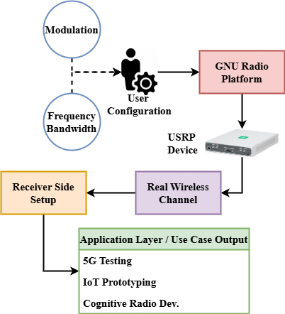
Figure 1: Experimental Setup and Application Scenarios

Related Works
Related works in wireless communication have extensively explored the use of Software-Defined Radio (SDR) and USRP for real-time signal processing, protocol development, and adaptive communication systems. Previous studies highlight their effectiveness in cognitive radio, spectrum sensing, and 5G prototyping, emphasizing flexibility, reconfigurability, and rapid prototyping capabilities in research environments.
Human Activity Recognition (HAR)
This work explores a contactless Human Activity Recognition (HAR) system to enhance smart healthcare systems through the use of USRP, Radar, and RFID technologies. Machine learning and hybrid deep learning models such as LSTM-CNN and Super Learner are employed to use USRP initially to analyze Wi-Fi channel state information (CSI) for accurate activity detection [21]. Ideal for geriatric care, a passive UHF RFID tag wall (TRT-Wall) accurately identifies various human postures and movements. Based on an LSTM-VAE model, the paper introduces RFiDARFusion, a new RFID-radar fusion system. In complex, long-distance, and non-line-of-sight scenarios, this fusion significantly enhances identification accuracy.
Digital Video Broadcasting (DVB)
Though their hardware is difficult to upgrade because of compatibility problems with current systems and protocols, modern communication devices are becoming sophisticated and linked. Reconfigurable hardware presents a solution as it lets gadgets evolve with the times without completely replacement [22]. Still, commercial hardware and software solutions are sometimes expensive. GNU Radio and Universal Software Radio Peripheral (USRP) open-source tools help to solve this difficulty. This method helps digital systems like Digital Video Broadcasting (DVB) and OFDM as well as analog systems like Community Radio and RDS to be developed. It presents a cheap, easily available platform fit even for first-year engineering students.
Internet of Things (IoT)
Rising cyberattacks using Internet of Things (IoT) devices expose major flaws in both the devices and their supporting systems. IoT devices small enough today may hack whole networks. Reviewing wireless technology allowing IoT connection, this paper focuses on weaknesses and uses Software Defined Radio (SDR) to replicate wireless assaults [23]. Key risks and current countermeasures are found by means of a rigorous literature review Hardware restrictions and technical variety make the IoT reference model's perception layer most susceptible. Future cybersecurity solutions find SDR perfect because of its adaptability, particularly when combined with protection mechanisms based on cognitive and deep learning.
LabVIEW-based Virtual Instrumentation (LVVI)
Particularly at universities, the Universal Software Radio Peripheral (USRP) has grown to be a popular venue for hardware-based research and validation in software-defined radio (SDR) and cognitive radio (CR) studies. With the most recent National Instruments (NI) LabVIEW version, USRP now provides an academic usage more scalable and user-friendly platform. Integration with LabVIEW-based Virtual Instrumentation (LVVI) enhances laboratory demonstrations and classroom applications [24]. This combination is optimal for educational and experimental settings in engineering curricula, as it enables rapid building of real-time communication systems, hence supporting both basic and advanced concepts in signal processing and communications [25].

Proposed Method
The proposed method utilizes USRP and GNU Radio to create a flexible, reconfigurable wireless communication framework, enabling real-time experimentation, rapid prototyping, and efficient testing of modern communication systems.

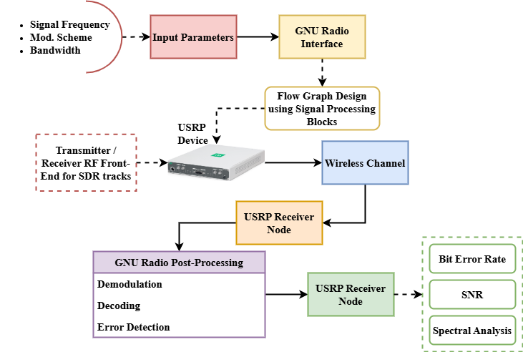
Figure 2: High-Level Architecture of USRP-GNU Radio Framework

Figure 2 is a reference image of the overall design of the proposed wireless communication system based on USRP and GNU Radio. Modulation type, frequency, and bandwidth are some of the user-defined parameters initiating this process. These parameters are controlled using the GNU Radio software, which produces flow graphs and controls signal processing processes. The real-time reception and transmission of radio frequency (RF) signals are made feasible through the USRP device, which serves as an interface between the wireless channel and the program. Signal reconstruction is done with a USRP-GNU Radio configuration such as that used on the receiver side. The system closes at the application level with real-world applications such as 5G, the Internet of Things, and cognitive radio prototypes. This illustration attempts to offer a vivid mental picture of the interconnections between hardware and software elements for dynamic wireless communication research. The stresses scalability, modularity, and flexibility place are many..
$$\frac{∅}{c_{0}^{2 }}\frac{σ^{3}q}{{σu}^{3}}=\frac{ρ^{2}q}{{ρQ}^{2}}+p\left(r,0\right)*ρθ\left(\frac{β}{q_{0}^{4}}+1\right)+Q×ρ^{θ} (1)$$
Reflecting real-time adaptation $\frac{ρ^{2}q}{{ρQ}^{2}}$ in SDR systems $\frac{∅}{c_{0}^{2 }}\frac{σ^{3}q}{{σu}^{3}}$, the presented equation 1 represents a complicated interaction $p\left(r,0\right)$ between signal quality characteristics, such as the density of power ($ρθ\left(\frac{β}{q_{0}^{4}}+1\right)$), modulation influence ($Q×ρ^{θ}$), and convey uncertainty.

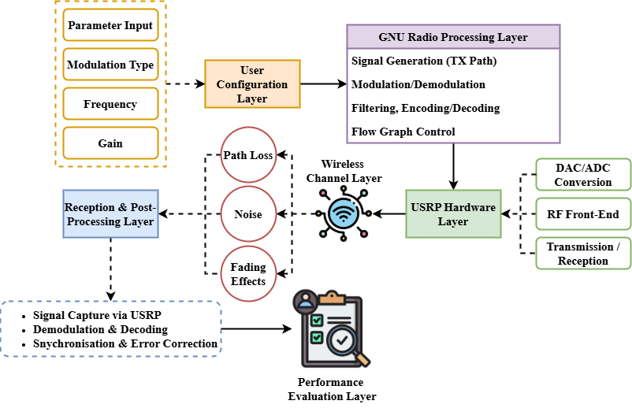
Figure 3: Internal Signal Processing Flow with USRP and GNU Radio

A comprehensive flowchart of the signal processing that takes place inside the proposed system is shown in Figure 3. Starting with GNU Radio's signal producing blocks, the procedure starts Included among these blocks are encoding, filtering, and modulation. The signal then makes its way to the USRP, where it experiences DAC conversion and RF transmission. Capturing the transmitted signal at the receiving end falls to the USRP. Demodulating, decoding, and signal analysis are then the responsibility of GNU Radio blocks. This image shows how software performs digital signal processing (DSP) operations and how they interact with possibly modified hardware. This element reflects the easiness with which one may create or modify communication protocols and experiments. Furthermore, the flow guarantees little hardware dependency and helps short development cycles to flourish. Additionally displayed is real-time testing and visualization of basic communication concepts like channel modeling, error correction, and orthogonal frequency division multiplexing (OFDM).
$$\frac{Q^{'}σp}{σs}=\frac{φ^{2}q}{q^{2}}+\frac{bπ}{q_{0}d_{0}^{3*}}*q\left(s,s^{'}\right) εs^{'{+τ-t±(s-s}_{0}} (2)$$
Essential for adaptive wireless communication $\frac{φ^{2}q}{q^{2}}+\frac{bπ}{q_{0}d_{0}^{3*}}$, equation (2) captures $s^{'{+τ-t±(s-s}_{0}}$the interaction of signal power change, spectral efficiency ($\frac{Q^{'}σp}{σs}$), as well as spatial-temporal factors ($q\left(s,s^{'}\right)$).
This approach demonstrates the effectiveness of open-source SDR tools for building and evaluating wireless systems, offering a scalable, cost-efficient solution suitable for research, education, and next-generation communication applications.

Result and Discussion
The proposed method is compared here with regard to key performance criteria: signal-to-- noise ratio (SNR) and bit error rate (BER). The results confirm the system's suitability for wireless real-time applications and high-end communication experiments by demonstrating its accuracy, efficiency, and robustness in a variety of communication structures.

Analysis of Bit Error Rate
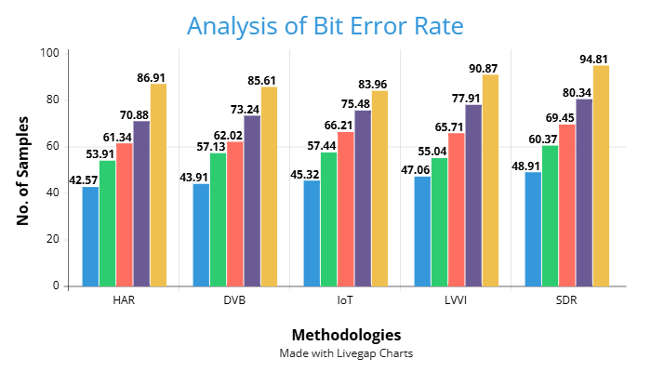
Figure 4: Analysis of Bit Error Rate

Figure 4 provides a comparison of five communication models: HAR, DVB, IoT, LVVI, and SDR according to varying sample sizes. All systems indicate a steady performance enhancement as the sample size increases from 20 to 100, thus implying enhanced transmission reliability. Among the techniques, SDR repeatedly shows the lowest BER throughout all sample levels, therefore confirming its strength and efficiency in signal integrity. Higher sample numbers allow LVVI to additionally prove fit for complex systems by performing competitively. Although first trailing, HAR and DVB demonstrate consistent progress and are hence feasible in certain circumstances. This trend emphasizes how effectively the proposed approach reduces errors with increasing data amount, thus validating its appropriateness for high-accuracy applications. The low values of BER confirm the ability of the system to maintain reliable communication in most scenarios. The results suggest the superiority of SDR-based solutions for real-time and error-prone wireless communication tasks.
$$\frac{ρπ}{q_{0}d_{0}^{3}}=\frac{βp}{βxy}+Q\left(\frac{1+a}{(1+a_{0})^{\frac{1}{2}}}\right)*\frac{μρ}{μu}+\frac{A^{'}}{2A} (3)$$
Equation (3) illustrates $\frac{μρ}{μu}+\frac{A^{'}}{2A}$ the dynamic interplay of spatial factors ($\frac{ρπ}{q_{0}d_{0}^{3}}$), shifting control ($\frac{βp}{βxy}$), and signal amplifying ($Q\left(\frac{1+a}{(1+a_{0})^{\frac{1}{2}}}\right)$), demonstrating system flexibility. In the suggested real-time adjustment of transmission control and amplification by analysis of bit error rate.
Analysis of Signal-to-Noise Ratio

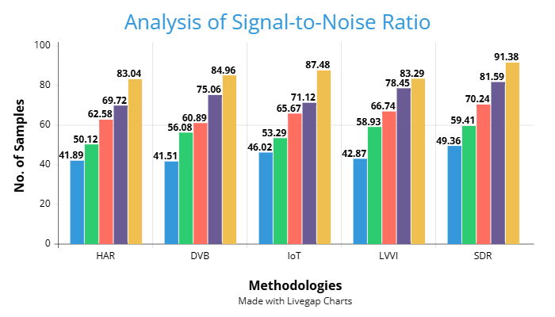
Figure 5: Analysis of Signal-to-Noise Ratio

Figure 5 contrasts the resistance to noise and signal quality retention of the same five communication technologies under different sample sizes. All systems show an improving trend in SNR values with the rising sample sizes that reflects lower interference and better signal clarity. SDR once again outperforms the others, maintaining the highest SNR, which demonstrates its ability to preserve signal fidelity in noisy environments. LVVI and IoT systems also show strong performance, particularly in mid to high sample ranges, making them suitable for modern wireless applications. DVB and HAR are robust and can tolerate lower SNR values in less rigorous environments. The outcome confirms that the proposed methodology is flexible across dynamic wireless environments without compromising the integrity of signals. How the system will be useful where signal integrity needs to be insured, like distant monitoring and health care, comes out strongly where high SNR values are supported.
$$\frac{B}{B^{'}}α_{ω}=\frac{μ\left(στ\right)}{μy}+\left(PQ\right)*\frac{dx}{dt}\left(\frac{δp}{δq}\right) +\left(\frac{A^{'}}{2A}\right) (4)$$
Important for real-time communication $\frac{dx}{dt}\left(\frac{δp}{δq}\right)$ management, equation (4) captures $\left(\frac{A^{'}}{2A}\right)$the interaction among bandwidth changes ($\frac{B}{B^{'}}α_{ω}$), signal variations ($\frac{μ\left(στ\right)}{μy}$, and dynamics of transmission ($\left(PQ\right)$) on analysis of signal-to-noise ratio.
$$\frac{y}{a_{0}}=\frac{ρ^{2}q}{{ρQ}^{2}}+\frac{ρ^{3}q}{{ρQ}^{3}}*(\frac{A_{0}}{A)^{\frac{1}{2}}}+\frac{φ^{2}}{{φs}^{2}}*α_{0}^{2}+α_{0}^{3} (5)$$
Key for evaluating wireless performance $α_{0}^{2}+α_{0}^{3},$ equation (5) shows a compounded representation of strength of signal ($\frac{ρ^{2}q}{{ρQ}^{2}}+\frac{ρ^{3}q}{{ρQ}^{3}}$), amplifiers ratios ($\frac{y}{a_{0}}$), and shifting efficiency ($\frac{A_{0}}{A)^{\frac{1}{2}}}+\frac{φ^{2}}{{φs}^{2}}$).

Conclusion
This paper proposes that open-source SDR platforms are quite promising because they provide a varied and inexpensive platform for wireless communication using USRP and GNU Radio. The proposed method facilitates analog and digital standards, real-time signal processing, and efficient modulation and demodulation. Experimental testing employed benchmarking performance measures like Bit Error Rate (BER) and Signal-to-Noise Ratio (SNR) to evaluate the effectiveness and reliability of the system. SDR best fits high-performance, real-time communication environments and outperformed alternative frameworks under all test conditions. The proposed approach is ideal for research and education due to its high scalability. It is easy to configure it to work with emerging technologies such as cognitive radio networks, the internet of things, and 5G. Rapid prototyping is even feasible due to software and hardware integration that saves development time and expense. The conclusions of this research make a compelling argument for SDR-based advanced wireless experimentation as a solution over more traditional, hardware-based solutions.
Dynamic spectrum access and adaptive modulation are some of the domains where future research will attempt to employ machine learning methods in a bid to enhance system smarts. Attempts will also be made to tackle insecurity in open wireless environments through setting up more secure communication protocols. The potential of expanding the framework to support real-time mobile scenarios and multi-antenna MIMO configurations will also be explored. Finally, to ensure performance under critical real-world conditions, this system can be tested under healthcare and disaster management environments.

References
- V. González-Barbone, P. Belzarena, and F. Larroca, “Software defined radio: From theory to real world communications,” In 2018 XIII Technologies Applied to Electronics Teaching Conference (TAEE), pp. 1–7, June 2018.
- E.T. Michailidis, K. Maliatsos, and D. Vouyioukas, “Software-Defined Radio Deployments in UAV-Driven Applications: A Comprehensive Review,” In IEEE Open Journal of Vehicular Technology, 2024.
- B. Wang, Z. Wu, and Y. Pei, “Software Radio Based Wireless Laboratory Design and Implementation for Enhancing Undergraduate Wireless Engineering Education,” In 2010 Annual Conference & Exposition, pp. 15–1072, June 2010.
- A.M. Wyglinski, D.P. Orofino, M.N. Ettus, and T.W. Rondeau, “Revolutionizing Software Defined Radio: Case Studies in Hardware, Software, and Education,” In IEEE Communications Magazine, vol. 54, no. 1, pp. 68–75, 2016.
- J.S. Alkasassbeh, F.M. Al-Taweel, T.A. Alawneh, A. Al-Qaisi, Y.F. Makableh, and T. El-Mezieni, “Advancements in Wireless Communication Technology: A Comprehensive Analysis of 4G to 7G Systems,” In Journal of Wireless Mobile Networks, Ubiquitous Computing, and Dependable Applications, vol. 15, no. 3, pp. 73–91, 2024.
- V. Pandey, and N. Gupta, “Mechanical Engineering Design: A Multidisciplinary Approach,” In Association Journal of Interdisciplinary Technics in Engineering Mechanics, vol. 2, no. 4, pp. 6–11, 2024.
- A. Issa, “Software Defined Wireless Network (SDWN) for Industrial Environment: Case of Underground Mine,” Doctoral Dissertation, Université du Québec en Abitibi-Témiscamingue, 2020.
- H.B. Sandya, and K. Nagamani, “Real Time 4G Band Data Acquisition Using NI USRP Hardware for Performance Evaluation of Spectrum Sensing Techniques in Cognitive Radio Systems Using ML-based Algorithms,” In International Journal of Communication Networks and Information Security, vol. 16, no. 3, pp. 480–492, 2024.
- B. Tokur, and K. Korkmaz, “Tetrodotoxin Binding Protein in the Marine Puffer Fish,” In Natural and Engineering Sciences, vol. 6, no. 1, pp. 39–52, 2021.
- A.M.A. Ashleibta, “Design of Software Defined Radio Based Testbed for Smart Healthcare,” Doctoral Dissertation, University of Glasgow, 2022.
- B.Y. Panchal, A. Shah, P. Shah, P. Bhatt, M. Tiwari, and A. Yadav, “Exploring Synergies, Differences, and Impacts of Agile and DevOps on Software Development Efficiency,” In Indian Journal of Information Sources and Services, vol. 14, no. 3, pp. 175–185, 2024.
- J. Ramprasath, P. Ramya, and T. Rathnapriya, “Malicious Attack Detection in Software Defined Networking Using Machine Learning Approach,” In International Journal of Advances in Engineering and Emerging Technology, vol. 11, no. 1, pp. 22–27, 2020.
- R. Zitouni, L. George, and S. Ataman, “Software-Defined Radio for Wireless Mesh Networks,” In Wireless Mesh Networks for IoT and Smart Cities: Technologies and Applications, vol. 101, pp. 81, 2022.
- M. Fakhrian, M. Jafariyan, A.R. Pirali Zefrehei, and H. Sahraei, “Effect of Dietary Medicinal Plants on Some Biochemical Hematological Parameters of Sterlet (Acipenser ruthenus),” In International Journal of Aquatic Research and Environmental Studies, vol. 2, no. 1, pp. 55–59, 2022.
- R. Sharma, and S. Maurya, “A Sustainable Digital Transformation and Management of Small and Medium Enterprises through Green Enterprise Architecture,” In Global Perspectives in Management, vol. 2, no. 1, pp. 33–43, 2024.
- M.S. Hosseini, and M. Rahmati, “A Method for Image Spam Detection Using Texture Features,” In International Academic Journal of Science and Engineering, vol. 2, no. 1, pp. 51–58, 2015.
- H. Arslan, “Hands-on Wireless Communication Experience,” In Wireless Communication Signal: A Laboratory-based Approach, Wiley, 2021.
- A. Raschellà, and A. Umbert, “Implementation of Cognitive Radio Networks to Evaluate Spectrum Management Strategies in Real-Time,” In Computer Communications, vol. 79, pp. 37–52, 2016.
- G. Aravindh, and K.P. Sridhar, “Resilient and Adaptive Secure Routing Protocol for Wireless Sensor Networks Using a Grey Wolf Optimizer and Lightning Search Algorithm,” In Journal of Internet Services and Information Security, vol. 14, no. 4, pp. 331–346, 2024.
- Annalakshmi, Nandhini, and Balamurugan, “Reader’s Dot,” In International Academic Journal of Innovative Research, vol. 9, no. 2, pp. 25–30, 2022.
- M.Z. Khan, “TriSense: RFID, Radar, and USRP-Based Hybrid Sensing System for Enhanced Sensing and Monitoring,” Doctoral Dissertation, University of Glasgow, 2024.
- R. Gandhiraj, and K.P. Soman, “Modern Analog and Digital Communication Systems Development Using GNU Radio with USRP,” In Telecommunication Systems, vol. 56, pp. 367–381, 2014.
- J.D.J.R. Uribe, E.P. Guillen, and L.S. Cardoso, “A Technical Review of Wireless Security for the Internet of Things: Software Defined Radio Perspective,” In Journal of King Saud University - Computer and Information Sciences, vol. 34, no. 7, pp. 4122–4134, 2022.
- T.B. Welch, and S. Shearman, “Teaching Software Defined Radio Using the USRP and LabVIEW,” In 2012 IEEE International Conference on Acoustics, Speech and Signal Processing (ICASSP), pp. 2789–2792, March 2012.
- S. Ajala, E. Adetiba, M.B. Akanle, O.O. Obiyemi, S. Thakur, and J. Abolarinwa, “Experimentations on the Transmit Power of a Universal Software Radio Peripheral Using GNU Radio Framework and a Handheld RF Explorer,” In IOP Conference Series: Earth and Environmental Science, vol. 655, no. 1, p. 012006, February 2021.

