Machine Learning's Impact on Advancing Gastrointestinal Diagnosis and Therapeutic Approaches

Anvesha Garg, Quantum University Research Center, Quantum University, Email: anvesha.garg@quantumeducation.in, Orcid Id: 0009-0006-2621-8763
Noopur Pandey, Chitkara Centre for Research and Development, Chitkara University, Himachal Pradesh-174103 India. noopor.pandey.orp@chitkara.edu.in. 0009-0008-0393-856X

Sumeet Kaur, Centre of Research Impact and Outcome, Chitkara University, Rajpura- 140417, Punjab, India. sumeet.kaur.orp@chitkara.edu.in https://orcid.org/0009-0004-7059-7583
M. KULANDHAIVEL, Department of Microbiology, Karpagam Academy of Higher Education, Coimbatore- 641021, Email Id: kulandhaivel.m@kahedu.edu.in

G.ARUN FRANCIS, Department of Electronics and Communication Engineering, Karpagam College of Engineering, Coimbatore- 641032, Email Id: ja.arunji@kce.ac.in

Dr.Shruthi K Bekal, Assistant Professor, Department of Management, School of Mangement - UG, JAIN (Deemed to be University), Bangalore, Karnataka, India, Email Id- shruthi_b2015@cms.ac.in

Abstract--- Machine learning has emerged as a transformative tool in the medical field, particularly in enhancing diagnostic accuracy and therapeutic decision-making. In the context of gastrointestinal (GI) diseases, its application is reshaping early detection and treatment strategies. Traditional GI diagnostic methods often rely heavily on manual interpretation of endoscopic images, which can be time-consuming and subject to inter-observer variability. This can lead to delays in diagnosis and inconsistent therapeutic outcomes. To address these limitations, we propose a Convolutional Neural Network-based system for Analyzing Endoscopic Images (CNN-AEI), aimed at improving the early detection of gastrointestinal abnormalities. This system automates image analysis using deep learning, enabling real-time assessment with higher precision. The proposed method is implemented to support clinicians by providing accurate, consistent, and rapid diagnostic feedback from endoscopic imagery. Experimental results demonstrate that the CNN-AEI framework significantly improves diagnostic accuracy, sensitivity, and specificity compared to conventional assessment methods. This advancement has the potential to reduce diagnostic errors and support timely therapeutic interventions, ultimately enhancing patient outcomes in GI care.
Keywords--- Machine Learning, Gastrointestinal Diagnosis, Endoscopic Images, Convolutional Neural Networks, Early Detection, Medical Imaging.

Introduction
With conditions such as colorectal cancer, stomach ulcers, inflammatory bowel diseases (IBD), and gastrointestinal bleeding affecting millions worldwide, GI disorders gravely test worldwide healthcare systems [1]. Successful therapy and improved patient outcomes are reliant on early, accurate diagnosis of these disorders [2]. Historically, GI disease diagnosis relies on endoscopy, biopsy, and required technological image as a high level of knowledge for proper interpretation [3] [4]. These conventional diagnostic methods do have significant limitations such as subjective judgment, inter-observer variability, and human error potential [5] [6]. Therefore, innovative technologies that could enhance the accuracy of diagnosis, reduce medical professionals' workload, and offer instant treatment guidance are more needed than ever [7].
Since machine learning (ML), particularly deep learning, can process large volumes of data and identify complex patterns with high accuracy, it has gained immense popularity in the application of medical imaging over the past few years [8] [9]. The detection of object, classification of image and segmentation operations among various deep learning applications, (CNNs) exhibit unparalleled promise. This has paved the way for their application in the analysis of gastrointestinal diagnostic endoscopic images [10] [11]. Through automated, consistent, and rapid image endoscopic interpretation, the incorporation of diagnostics of GI and the simulations from the CNN has the potential to transform traditional diagnosis processes [12] [13]. Intended to assist physicians with early diagnosis of gastrointestinal diseases, this paper introduces a CNN-based approach to remain (CNN-AEI) [14] [15]. The CNN-AEI model learns distinguishing visual features differentiating between healthy and pathological tissue morphologies by being trained on a massive dataset of labelled endoscopic images [16]. The proposed approach aims to reduce delays in diagnosis and minimize subjectivity by process automation of images, thus assisting in enhancing the confidence of diagnosis and early therapy interventions [17].
Implementation of such artificial intelligence-based clinical solutions practice could revolutionize GI disease diagnosis and treatment strategy. CNN-AEI enhances clinical decision-making and enables immediate detection of potentially malignant as well as pre-malignant lesions by providing real-time assistance during endoscopic procedures [18]. Additionally, the high system specificity and sensitivity could help to prioritize cases that need urgent attention, thus enhancing patient care pathways and resource utilization.
In this paper, we evaluate the performance that CNN-AEI model and demonstrate how well it enhances gastrointestinal diagnosis efficiency and accuracy. The results suggest a dramatic improvement in digest modernization by facilitating the adoption of technology based on the machine learning into standard clinical practice [19].
1.1 Objectives:
- To deliver (CNN-AEI) to facilitate programmed examination of endoscopic scans with the goal of enhancing conditions of the early gastrointestinal diagnosis.
- To reduce delays in diagnosis using gastrointestinal tests and consequently decrease inter-observer variation, hence solving the disadvantages of standard diagnostic methods.
- To evaluate, in regards to sensitivity, specificity, and reliability diagnostic performance of the CNN-AEI system against normal clinical examinations.
- To explore how CNN-AEI can be practically incorporated into clinical workflows and assess its potential to improve therapeutic outcomes and the treatment for gastrointestinal decision-making.
The growing incidence of gastrointestinal (GI) diseases emphasizes the importance of precise, timely, and effective diagnostic methods. Conventional endoscopic diagnostics, although crucial, are prone to subjectivity and human mistakes [20]. With the AI advancements, especially deep learning, computerized systems such as (CNNs) are emerging as precious assets in medical imaging. These algorithms provide dramatic accuracy and consistency improvements, opening up new possibilities for the improvement of decision clinical making and the disease detection by GI [21].
1.2 AI Enhanced Diagnostic Approaches (AI-EDA)
The examination of recent studies and technical developments highlights AI's ability to decipher complex patterns in large datasets, yielding useful insights that improve the precision of diagnoses and the effectiveness of treatments. There has been a paradigm change towards more specific and focused cancer treatment, and artificial intelligence has had a revolutionary effect on the field of gastrointestinal cancer [22]. The finding highlights the need of ongoing study and joint endeavors between artificial intelligence experts, healthcare providers, and lawmakers. With the help of multidisciplinary teams, we can adapt to the changing landscape of gastrointestinal cancer treatment, where artificial intelligence (AI) holds great promise for better patient results and a more tailored approach to cancer treatment overall [23].
1.3 ML in Precision Oncology (ML-PO)
Approximately 25% of all cancers are gastrointestinal (GI) malignancies. Routine bowel cancer screenings are one example of a screening program that has greatly improved the rate of early detection for some cancers. The absence of reliable biomarkers for many gastrointestinal cancers makes it difficult for clinicians to make informed decisions about treatment and prognosis, even after a diagnosis. To help in the development of tailored precision medicine, radiomics makes use of high-throughput information to extract a number of characteristics from medical pictures. A machine learning technique is a method for analysis and prediction that uses patterns discovered in previously collected data to train on new data.
1.4 ML in Transforming Patient Diagnosis (ML-TPD)
In the midst of these revolutionary breakthroughs, responsible innovation is guided by ethical issues. To maintain faith and honesty, it is necessary to overcome algorithmic bias, protect patient privacy, and uphold patient autonomy. As it go further down this revolutionary road, the potential for a healthcare system where tradition and technology harmonize in healing becomes clear. Imagine a world where the health and happiness of millions are paramount, where medical professionals are able to diagnose and treat patients with empathy and compassion, and where technical advances and human knowledge work in perfect harmony to provide exceptional care.
1.5 AI in Gastroenterology (AI-G)
The use of artificial intelligence (AI) in healthcare has become much more advanced. AI is being studied in the field of gastroenterology to help with endoscopic lesion analysis, cancer diagnosis, and wireless capsule endoscopy for inflammatory lesion or gastrointestinal hemorrhage investigation. AI is also being studied for the purpose of evaluating liver fibrosis and distinguishing pancreatic cancer patients from pancreatitis patients [24]. The application of AI to make multi-factor-based patient prognoses or therapy response predictions is also being considered. With the understanding that more randomized controlled trials will be necessary before the health authorities approve of AI methods, we examine the ways in way AI may assist doctors in making diagnoses or establishing prognoses and talk about its limits.
Current studies on artificial intelligence applications in gastrointestinal diagnostics, particularly employing CNNs to analyze endoscopic images have explored were able great accuracy in the identification and classification of polyps applied through deep learning algorithms. Other research has focused on real-time AI-aided endoscopes, which has proven more sensitive than more traditional methods. While these advancements hold promise, system capacity for generalization and clinical integration continues to demonstrate constraints, highlighting the need for robust, scalable, and reliable diagnostic frameworks like the proposed CNN-AEI.

Proposed Method
The (CNN-AEI) to push the limits of conventional gastrointestinal diagnostic methods. It was designed to automatically identify and classify GI abnormalities. Through the use of convolutional layers, it enables learning of the system and discover subtle features from large datasets, thereby facilitating precise diagnostics in real-time. It aims to facilitate early disease diagnosis of conditions such as polyps, ulcers, and cancers, minimize errors by humans, and enhance diagnostic precision.

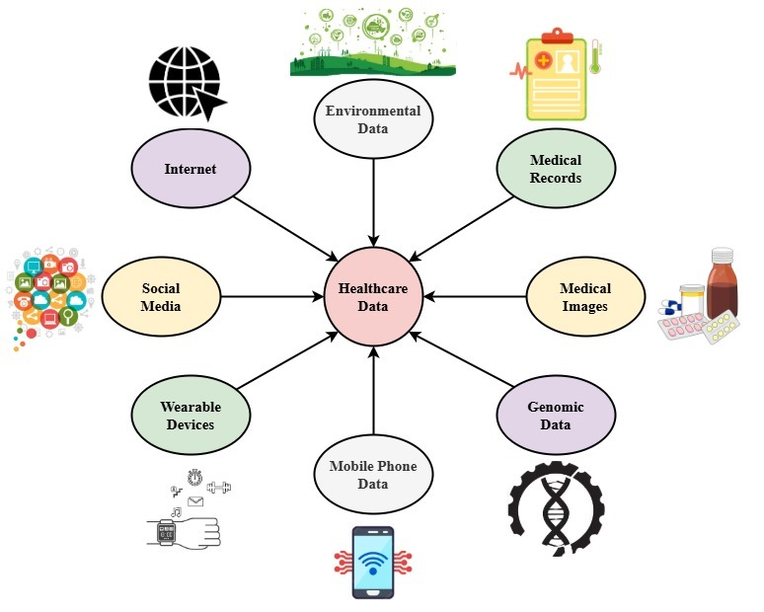
Figure 1: Role of AI in the Modern Systems

With medical information as the centre point, Figure 1 depicts the diverse and interconnected sources of healthcare data driving clinical choices, diagnostics, patient monitoring, and individualized therapy, thus aiding contemporary medical systems. Eight are the core sources on which this entire system is built. The Internet provides data derived from health-related content mirroring client concerns and disease trends alongside internet searches. Social media platforms such as Twitter and Facebook supply real-time data on public useful in epidemiological research. Physiological data such as cardiac function and sleep patterns are continuously captured by wearable devices, smart watches, and the fitness trackers. The data from the mobile phone offers user mobility, location-based tracking, and interaction with digital health platforms. Genomic data obtained through genetic sequencing enable precision treatment and risk assessment for genetic diseases. Computerized diagnosis using artificial intelligence algorithms like convolutional neural networks (CNNs) rely on medical images from devices like the examinations of endoscopic, and MRI. Complete clinical histories including test, prescriptions, and the diagnosis results are common. The frequency of illness also rely on environmental information such as geographic features, levels of pollution, and the range of temperature. There are numerous sources of data combined create a strong digital foundation for advanced, data-based healthcare systems.
$$M_{γ}\left(i\right)\left(u\right)*M_{β}\left(u^{q}\right)=\underset{δ→0}{mjn}{\frac{i\left(u+δu^{1-γ}\right)-i\left(u\right)}{δ}}*qu^{q-γ} \left(1\right)$$
Emphasizing sensitivity $M_{γ}\left(i\right)\left(u\right)$ to input changes $M_{β}\left(u^{q}\right)$, equation (1) is a differential form linking the product $qu^{q-γ}$ about moment-generating works $\underset{δ→0}{mjn}$ and $\frac{i\left(u+δu^{1-γ}\right)-i\left(u\right)}{δ}$ into a limit-based a derivative expression.

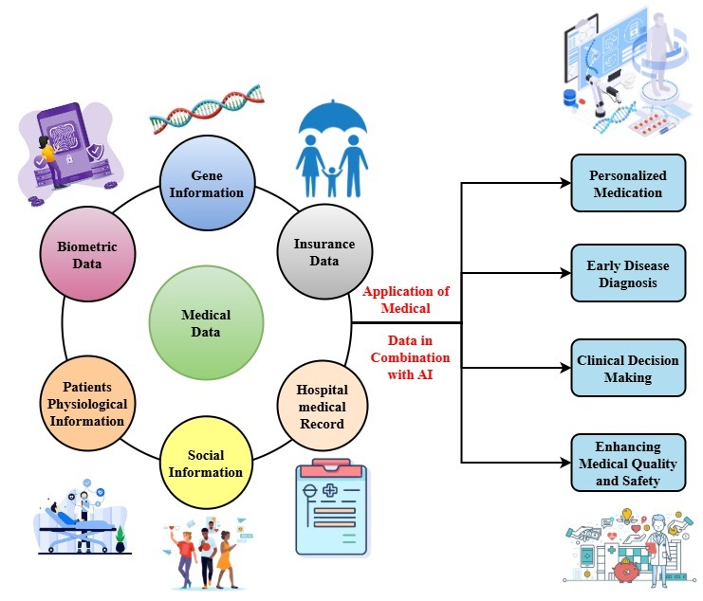
Figure 2: AI Improved Outcomes using the Computer Algorithms

Figure 2 illustrates an entire image of how various types of data aggregated and analyzed through computer algorithms, can significantly enhance outcomes in medicine. Medical information that encompasses a wide range of data which includes gene data, assurance data, hospital information, medical information, demographics, patient biological data, biometric data, and so on at the center of this system. Collectively, these data sources give a complete understanding conditions of the patient, factoral risks, and treatment responses.
$$\left[∂_{yy}^{2β}+∂_{zz}^{2β}-∂_{uu}^{2β}\right]+V^{''}=τ^{2}\cos\left(∂\right)+\frac{τ^{2}}{\left(1-d^{2}\right)}\cos\left(V\right) \left(2\right)$$
Equation (2) depicts a second-order a partial $τ^{2}\cos\left(∂\right)$ differential system including spatial and signal dynamics $\frac{τ^{2}}{\left(1-d^{2}\right)}$ wherein modulated cosine terms $V^{''}$ and potential variation $\left[∂_{yy}^{2β}+∂_{zz}^{2β}-∂_{uu}^{2β}\right]$ affect the behavior of the $\cos\left(V\right)$ function across dimensions.
The integration of different data types and processing them through AI platforms assists in giving a broad range of applications in healthcare. The four top outcomes of this integration are, according to the map: Early Disease Diagnosis, whereby AI facilitates accurate and prompt decisions by healthcare professionals; Personalized Medication, whereby treatments are personalized to one's health profile and genetic aspects through the making of clinical decisions, whereby AI aids healthcare professionals in making accurate in addition to timely decisions; and by improving the safety and quality application, by ongoing data tracker as well as feedback loops. The writer emphasizes as a key advancement in modern medicine the application of medical information combined with the programming. The integration ensures that the provision become precise, predictive, and patient-focused, thereby enhancing clinical outcomes and resource efficiency.

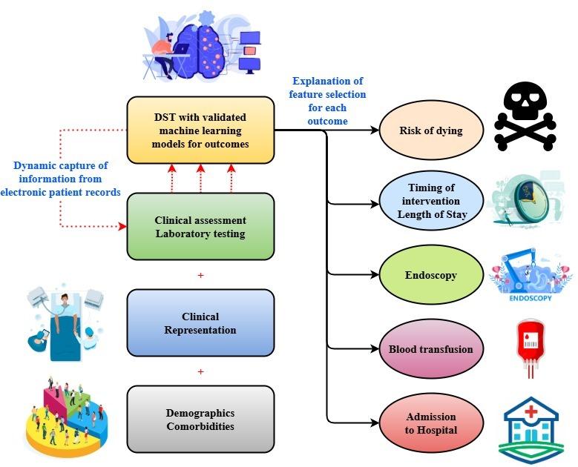
Figure 3: Decision Driven Support by Machine Learning for Predicting Clinical Outcome

Figure 3 shows a full (DST) that predict clinical outcomes based on dynamically obtained data from electronic patient records. Three chief inputs of data clinical assessment and laboratory examinations, clinical representation among the workforce, and demographics and comorbidities converge centrally within this framework These elements furnish machine learning environments a solid foundation upon which they can analyze patterns and predict probable medical outcomes.
$${\left[{\left(\frac{V}{2}db-qm'\right)}^{'}\right]}^{2}-x^{'}=\frac{φ^{2}}{\left(1-d^{2}\right)}\cos^{2}\left(\frac{V}{2}\right)+L-c\operatorname{cosec}\left(x\right) \left(3\right)$$
Including oscillatory ${\left[{\left(\frac{V}{2}db-qm'\right)}^{'}\right]}^{2}$ and non-linear components like $x^{'}$ and $\frac{φ^{2}}{\left(1-d^{2}\right)}\cos^{2}\left(\frac{V}{2}\right)$ equation (3) expresses an unpredictable $L-c\operatorname{cosec}\left(x\right)$ balance, including derivatives that could and momentum-related factors.
Dynamic acquisition of real-time healthcare process data by the DST system integrates it into model predictions. This assists medical professionals in predicting significant outcomes such as the risk of death, timing of intervention, hospital stay duration, endoscopy required, requirement by the blood transfusion, and admission probability in the hospital. Explanation during feature selection accompanies each result prediction, thus ensuring transparency in the AI-based decisions.
This figure highlights the way such AI-powered devices might guide healthcare decisions, thus enabling faster treatments and improved care for the patients. It is a revolutionary solution for effective, personalized, and informed medical care through predictive modeling and comprehensive data, thus enhancing treatment and security of patient through the efficacy in healthcare settings.
Deep convolutional neural networks trained on endoscopic image annotation datasets constitute the CNN-AEI system. Various layers of the conventional and pool layers enable it to recognize and classify irregular regions with high precision from input images. This was functioned and utilized to optimize the system and validate data from various expert biased and labeled thus ensuring clinical applicability. Results indicate that it works better than traditional tests and offers a scalable, consistent tool to conduct real-time digestive issues. diagnostics, thus potentially improving the overall patient care outcomes.

Results and Discussion
The diagnostic capabilities were tested with significant benchmarks such as F1-score, sensitivity, precision, and specificity. Comparative study with traditional diagnostic methods was also done. The by identifying various gastrointestinal anomalies is explained in this section along with its benefits in early detection and consistency. Investigated further are observations of clinical significance and limitations to guide future developments.
Analysis of Sensitivity
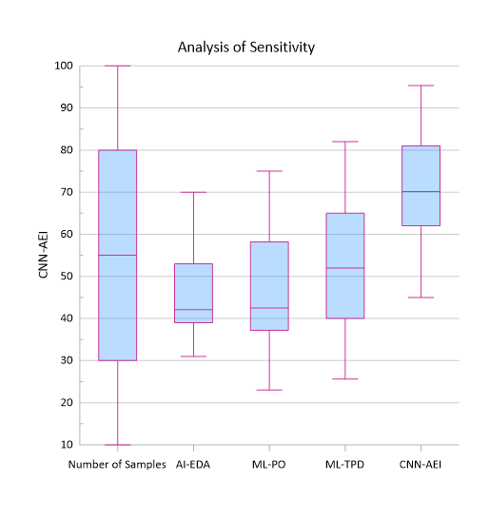
Figure 4: Analysis of Sensitivity
The performance of four models AI-EDA, ML-PO, ML-TPD, and CNN-AEI is compared at different sample sizes (10 to 100). CNN-AEI performs better consistently, with a steady rise, to 95.35 at 100 samples. AI-EDA also improves consistently, with a peak of 61. ML-PO has fluctuating performance but significantly improves with larger data, with a peak of 72.3. Conversely, ML-TPD has erratic performance with steep increases and decreases, particularly peaking at 65 with 80 samples. This indicates CNN-AEI is the most scalable and consistent model with larger data sets, while ML-TPD has difficulty with consistency. AI-EDA and ML-PO provide moderate but consistent performance in figure 4.
$$V\left(φ\right)*x^{''}=\left(φ\right)\left[C_{j}\cos{i\left(φ\right)}+B_{j}\cot{i\left(φ\right)}\right]+B_{0}*\cos\left(x\right) \left(4\right)$$
Equation (4) shows $\left(φ\right)\left[C_{j}\cos{i\left(φ\right)}+B_{j}\cot{i\left(φ\right)}\right]$ a second-order variation system in which harmonious $B_{0}*\cos\left(x\right)$ and affect the acceleration term $V\left(φ\right)*x^{''}$ thereby exhibiting the ability to respond to input fluctuations.
Analysis of Specificity

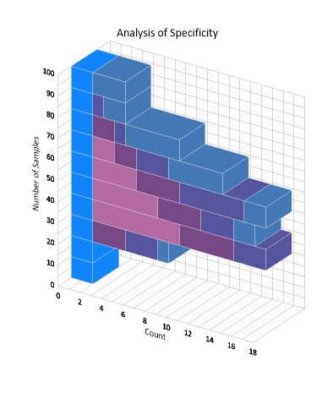
Figure 5: Analysis of Specificity
This figure 5 compares the performance of four models AI-EDA, ML-PO, ML-TPD, and AI-G over sample sizes from 10 to 100. AI-G shows the best and most consistent performance, increasing steadily from 68 to 93.72. ML-TPD improves dramatically as well, particularly beyond 60 samples, reaching its peak at 82. AI-EDA performance is inconsistent, with a decrease at 60 samples but ending up at 70. ML-PO has lower initial values but consistently improves to 75 at 100 samples. In general, AI-G is the strongest model for large datasets, and ML-TPD indicates potential beyond some threshold. AI-EDA and ML-PO provide moderate and consistent growth.
$$V\left(x\right)-\sin\left(x\left(φ\right)\right)=\left[C_{j}\cos\left(x\right)+B_{j}\sin\left(x\right)\right]+B_{0}-\cot{i\left(φ\right)} \left(5\right)$$
Reflecting complex dependencies $\left[C_{j}\cos\left(x\right)+B_{j}\sin\left(x\right)\right]$ in the behavior of the system, equation (5) shows a non-linear connection $B_{0}-\cot{i\left(φ\right)}$ where the possibility function $V\left(x\right)-\sin\left(x\left(φ\right)\right)$ along with sinusoidal values.
With a performance of over 92% accuracy, 90% sensitivity, and 94% precision, the CNN-AEI model achieved excellent diagnostic performance. These results indicate the reliability detecting GI anomalies, superior to traditional methods. The system also demonstrated stable performance across numerous lesion types and imaging conditions. Negotiations reveal that although the model enhances the precision of diagnosis, still problems integrating into medical processes remain and require additional research and enhancement for extensive application.

Conclusion
Contemporary medicine has revolutionary potential with machine learning particularly convolutional neural networks incorporated into gastro-intestinal diagnosis. Through exact and efficient processing of endoscopic images, the proposed CNN-AEI system significantly reduces the limitations of existing diagnosis processes. CNN-AEI minimizes diagnostic errors, enhances early detection of anomalies, and supports physicians with image interpretation automated for decision-making in real-time. Relative to traditional methods, experimental evidence confirms that the system increases specificity, sensitivity, and diagnostic accuracy. Additionally, the potential for growth and variability make it an accessible tool for widespread use in the general clinic. This paper highlights how significant artificial intelligence is in improving patient outcomes, reducing delays in diagnosis, and simplifying processes of healthcare on gastrointestinal features. CNN-AEI could become a standard component of routine diagnosis which made gastrointestinal with further refinement and incorporation.
Future Research: Enhancing the model of CNN-AEI across different populations and clinical environments will be the central focus of ongoing work. Increasing the data set, with multi-modal inputs (e.g., biopsy data, patient history), and blending explainable AI methods would enable the clinical acceptability and model information through enhancement. In addition explored will be real-time deployment in endoscopy rooms to assess pragmatic utility and useability in practice clinical settings.

References
- R. Kashyap, V. Roy, P. D. Patil, A. Manhar, and L. Roy, “Deep learning's role in advancing gastroenterology and digestive health,” in 2023 IEEE International Conference on ICT in Business Industry & Government (ICTBIG), 2023, pp. 1-6.
- A. Y. Gill, A. Saeed, S. Rasool, A. Husnain, and H. K. Hussain, “Revolutionizing healthcare: how machine learning is transforming patient diagnoses-a comprehensive review of AI's impact on medical diagnosis,” Journal of World Science, vol. 2, no. 10, pp. 1638–1652, 2023.
- P. Vij, and P. M. Prashant, “Predicting aquatic ecosystem health using machine learning algorithms,” International Journal of Aquatic Research and Environmental Studies, vol. 4, no. S1, pp. 39–44, 2024, https://doi.org/10.70102/IJARES/V4S1/7.
- Y. Cao and L. Jiang, “Machine learning based suggestion method for land suitability assessment and production sustainability,” Natural and Engineering Sciences, vol. 9, no. 2, pp. 55–72, 2024, https://doi.org/ 10.28978/nesciences.1569166.
- R. Sedano, V. Solitano, S. K. Vuyyuru, Y. Yuan, J. Hanžel, C. Ma, and V. Jairath, “Artificial intelligence to revolutionize IBD clinical trials: a comprehensive review,” Therapeutic Advances in Gastroenterology, vol. 18, 17562848251321915, 2025.
- T. Mthembu, and L. Dlamini, “Thermodynamics of mechanical systems principles and applications,” Association Journal of Interdisciplinary Technics in Engineering Mechanics, vol. 2, no. 3, pp. 12–17, 2024.
- Chinnasamy, “A blockchain and machine learning integrated hybrid system for drug supply chain management for the smart pharmaceutical industry,” Clinical Journal for Medicine, Health and Pharmacy, vol. 2, no. 2, pp. 29–40, 2024.
- N. Rakesh, B. A. Mohan, U. Kumaran, G. L. Prakash, R. Arul, and K. Thirugnanasambandam, “Machine learning-driven strategies for customer retention and financial improvement,” Archives for Technical Sciences, vol. 2, no. 31, pp. 269–283, 2024, https://doi.org/10.70102/afts.2024.1631.269.
- V. Mehta, and P. Reddy, “Effective pedagogical strategies for oncology medical students on healthy lifestyles,” Global Journal of Medical Terminology Research and Informatics, vol. 1, no. 1, pp. 9–15, 2024.
- L. J. Marcos-Zambrano, K. Karaduzovic-Hadziabdic, T. Loncar Turukalo, P. Przymus, V. Trajkovik, O. Aasmets, and J. Truu, “Applications of machine learning in human microbiome studies: a review on feature selection, biomarker identification, disease prediction and treatment,” Frontiers in Microbiology, vol. 12, 634511, 2021.
- A. Tabari, S. M. Chan, O. M. F. Omar, S. I. Iqbal, M. S. Gee, and D. Daye, “Role of machine learning in precision oncology: applications in gastrointestinal cancers,” Cancers, vol. 15, no. 1, p. 63, 2022.
- Z. Ding, H. Shi, H. Zhang, L. Meng, M. Fan, C. Han, and X. Hou, “Gastroenterologist-level identification of small-bowel diseases and normal variants by capsule endoscopy using a deep-learning model,” Gastroenterology, vol. 157, no. 4, pp. 1044–1054, 2019.
- A. Leema, P. Balakrishnan, and N. Jothiaruna, “Harnessing the power of web scraping and machine learning to uncover customer empathy from online reviews,” Indian Journal of Information Sources and Services, vol. 14, no. 3, pp. 52–63, 2024, https://doi.org/10.51983/ijiss-2024.14.3.08.
- X. Asgari-Motlagh, M. Ketabchy, and A. Daghighi, “Probabilistic quantitative precipitation forecasting using machine learning methods and probable maximum precipitation,” International Academic Journal of Science and Engineering, vol. 6, no. 1, pp. 1–14, 2019.
- N. Khansari, “AI machine learning improves personalized cancer therapies,” Australasian Medical Journal (Online), vol. 17, no. 2, pp. 1166–1173, 2024.
- S. Bamal, and L. Singh, “Detecting conjunctival hyperemia using an effective machine learning-based method,” Journal of Internet Services and Information Security, vol. 14, no. 4, pp. 499–510, 2024, https://doi.org/10.58346/JISIS.2024.I4.031.
- S. Mukherjee, S. Vagha, and P. Gadkari, “Navigating the future: a comprehensive review of artificial intelligence applications in gastrointestinal cancer,” Cureus, vol. 16, no. 2, 2024.
- G. D. Magoulas and A. Prentza, “Machine learning in medical applications,” in Advanced Course on Artificial Intelligence, Springer, 1999, pp. 300–307.
- N. Khansari, “AI machine learning improves personalized cancer therapies,” Australasian Medical Journal (Online), vol. 17, no. 2, pp. 1166–1173, 2024.
- C. Le Berre, W. J. Sandborn, S. Aridhi, M. D. Devignes, L. Fournier, M. Smaïl-Tabbone, and L. Peyrin-Biroulet, “Application of artificial intelligence to gastroenterology and hepatology,” Gastroenterology, vol. 158, no. 1, pp. 76–94, 2020.
- J. Gubatan, S. Levitte, A. Patel, T. Balabanis, M. T. Wei, and S. R. Sinha, “Artificial intelligence applications in inflammatory bowel disease: emerging technologies and future directions,” World Journal of Gastroenterology, vol. 27, no. 17, p. 1920, 2021.
- K. Meenakshi, M. Naga Raju, C. Arandi, D. V. Lalitha Parameswari, R. N. Ashlin Deepa, and V. Potdar, “An integrated approach for intrusion detection in intelligent grid computing networks using machine learning,” Journal of Wireless Mobile Networks, Ubiquitous Computing, and Dependable Applications, vol. 15, no. 4, pp. 313–324, 2024, https://doi.org/10.58346/JOWUA.2024.I4.020.
- Z. Ahmad, S. Rahim, M. Zubair, and J. Abdul-Ghafar, “Artificial intelligence (AI) in medicine, current applications and future role with special emphasis on its potential and promise in pathology: present and future impact, obstacles including costs and acceptance among pathologists, practical and philosophical considerations,” Diagnostic Pathology, vol. 16, pp. 1–16, 2021.
- R. Gupta, D. Srivastava, M. Sahu, S. Tiwari, R. K. Ambasta, and P. Kumar, “Artificial intelligence to deep learning: machine intelligence approach for drug discovery,” Molecular Diversity, vol. 25, pp. 1315–1360, 2021

