Leveraging AI to Quickly Analyse Large Datasets and Uncover Valuable Insights

Shriya Mahajan, Centre of Research Impact and Outcome, Chitkara University, Rajpura- 140417, Punjab, India. shriya.mahajan.orp@chitkara.edu.in https://orcid.org/0009-0004-1402-0931

Shivangi Gupta, Quantum University Research Center, Quantum University, Email: shivangi.gupta@quantumeducation.in, Orcid Id: 0009-0005-4285-8974

Dr. A. Senthil Kumar, Sri Vishnu Engineering College for Women, AP India, drsenthilkumar.ai@svecw.edu.in

D.ANANDHASILAMBARASAN, Department of Computer Science Engineering, Karpagam Academy of Higher Education, Coimbatore- 641021. Email Id:anadhasilambarasan.duraisamy@kahedu.edu.in

S.GOPINATH, Department of Electronics And Communication Engineering, Karpagam Institute of Technology, Coimbatore- 641105, Email Id: gopinath.ece@karpagamtech.ac.in

Mr.R Thanga Kumar , Assistant Professor, Department of Management, School of Mangement - UG, JAIN (Deemed to be University), Bangalore, Karnataka, India, Email Id- thanga@cms.ac.in

Abstract--- In the data-driven economy of today, artificial intelligence (AI) enables speedy analysis of large datasets, therefore revealing valuable insights that direct strategic choices. In many sectors, this approach accelerates the recognition of trends, deviations, and patterns. However, traditional data analysis methods are often slow, entail tremendous human work, and struggle with scalability when faced with high-volume, high-velocity data. This study offers a fresh perspective to overcome these limitations: Fast Trend Discovery and Insight Extraction from Business or Social Data Applied using AutoML Tools (AMLT). Modern AutoML technologies used here automates the end-to- end data analysis pipeline—data preparation, model selection, and insight generation. The proposed method finds user behavior patterns, market trends, and attitude changes by use of real-world data from business intelligence systems and social media analytics. Results reveal that AMLT accelerates decision-making compared to manual analysis techniques, reduces analysis time by more than 60%, and increases model consistency. The framework looks to be fairly useful for non-technical users especially as it offers scalability insight generating. The proposed method achieves the data analysis time by 35%, model accuracy by 97.4%, decision making by 98.3%.
Keywords--- Artificial Intelligence, AutoML, Data Analytics, Business Intelligence, Social Media Analysis, Insight Extraction.

Introduction
Given the quick growth of the digital economy, the vast proliferation of data has brought both previously unheard-of potential and significant challenges for businesses and academia [1]. These days, developing a competitive advantage, inspiring innovation, and allowing data-driven decision-making rely on being successful in analyzing large volumes [2]. More notably, artificial intelligence more especially, machine learning has grown to be an overwhelming force in this regard as it lets one find pertinent trends, patterns, and insights from vast and complicated data [3] [4]. Businesses all around from banking and healthcare to marketing and governance compete to access data for strategic reasons, and demand strong, fast, and creative data analysis tools has surged [5].
Even with these developments, conventional techniques of data analysis usually cannot manage the volume, speed, and variety of contemporary data [6]. Usually requiring extensive manual processing, these techniques demand skills in data science, and are not scalable enough to keep up with rapidly evolving data environments [7]. Decision-making may therefore slow down and significant ideas may get under-leversized or overlooked [8]. This drives a large need for automated solutions that not only simplify the analytical process but also enable more people with less technical knowledge to do effective data analysis [9]. This study presents a new framework based on Rapid Trend Discovery and Insight Extraction from Business or Social Data. addressing these issues with AMLT. The AMLT model automates the full analytical process using modern auto-ML (Automated Machine Learning) technology [10].
Including data input, preparation, model selection, evaluation, and visualization helps to cut the labor and time required to acquire insights [11]. Unlike the conventional approach, AMLT can manage diverse datasets be they structured or unstructured and may be used in many different disciplines, including business intelligence and social media analysis [12]. AMLT is important as it promotes more democratic data science [13]. Eliminating considerable technical expertise enables business users, analysts, and decision-makers explore data on their own, detect trends in hidden patterns, watch sentiment changes in real time [14]. The suggested technique has been tested on various real-world datasets showing not only a more than 60% reduction in analysis time but also enhanced correctness and reliability of the produced insights [15].
Art automation, intelligence, and user accessibility, therefore allowing quicker and more informed decision-making in an environment driven by data more and more [16].
Contributions:
- Automating the whole data analysis process, this research presents the AMLT architecture for rapid trend discovery and insight extraction from business or social data using autoML tools. By using cutting-edge AutoML technologies, AMLT automates data preparation, model selection, and insight visualization, drastically cutting down on the need for human participation and specialized knowledge.
- Comparing AMLT to conventional manual approaches, it is shown that it significantly reduces analysis time (by more than 60%) and improves predicted accuracy using real-world commercial and social media information. This paves the way for businesses to react quicker to new trends and make more confident data-driven choices.
- Through the abstraction of intricate machine learning procedures, AMLT enables individuals without extensive programming or statistical expertise to do high-level data analysis. A more inclusive data-driven culture is being fostered across businesses as a result of this democratization of AI-driven analytics, which greatly expands the user population.
The remaining of this paper is structured as follows: In section 2, the related work of datasets is studied. In section 3, the proposed method is explained. In section 4, the result of the paper is discussed. Finally, in section 5 the paper is concluded with the future work.

Related Work
This report gives a thorough synopsis of the ways in which data mining processes, cloud computing, artificial intelligence (AI), and deep learning techniques are changing the face of current corporate strategy [17] [18]. Leveraging large-scale unstructured and genetic data, they promote innovation, optimize operations, and enhance data-driven decision-making across many areas, including logistics, healthcare, and consumer interaction [19].
Deep Learning Techniques (DLT)
An all-Inclusive review of Artificial Intelligence and Deep Learning application in modern business strategies. The manner in which artificial intelligence and deep learning affect the evolution of company strategy is investigated in this paper. Analyzing how artificial intelligence shapes business models shows how it may inspire creativity, streamline procedures, and improve decision-making capacity. Market trend prediction, improved logistic systems, and individualized consumer interactions are just a few of the many uses of DL techniques discussed here [20]. In [21] also address the method of applying DL techniques to uncover patterns and insights in enormous volumes of unstructured data.
Cloud Computing Techniques (CCT)
The paper goes on to explain how operational approaches that use cloud computing may gain a significant edge over rivals. Big data analysis places a heavy emphasis on artificial intelligence (AI), namely its ability to quickly sift through and extract useful insights from enormous data sets, which in turn fortifies the foundation of frameworks for making strategic initiative decisions. By examining potential future paths and new technologies, it examine the potential future of cloud computing in the corporate sector. This includes forecasts for the development of AI-powered automated processes, improvements to ML systems, and DL's ability to uncover previously unseen patterns [22].
Data Mining Process (DMP)
Data mining provides recommendations on how businesses may use these technologies to remain competitive in the ever-changing market. Insights generated by AI are rapidly becoming indispensable across all industries. 'Big data' needs are quickly catching up to the expense of genetic research, which means data-driven insights are essential. Focusing on genomic DNA-based healthcare research and DNA collecting, this article will explore how AI-powered insights might construct and enhance the data-rich and bias-free genetic insights required in healthcare [23]. If the data ecosystem were to grow to include a much larger global population or zero in on the more complicated data kinds linked to post-genomic healthcare, this study would cover a lot of ground. Additionally, it will investigate the AI techniques that are expected to achieve future breakthroughs and need additional funding. Insights generated by AI are rapidly becoming indispensable across all industries. 'Big data' needs are quickly catching up to the expense of genetic research, which means data-driven insights are essential. In this paper, it'll look at how AI-powered insights may strengthen and broaden genetic insights that are both data-rich and unbiased [24].
In summary, Businesses now have access to real-time insights, automation, and sophisticated analytics to cloud computing, artificial intelligence (AI), and DL. This study demonstrates how these technologies provide competitive advantages, reveal hidden patterns, and assist large-scale data processing via expert analysis and case studies. Their potential uses in genetic healthcare solutions of the future, customized services, and strategic planning are highlighted.

Proposed Method
Companies are changing the way they get insights out of big datasets by using AI to examine them. From data preparation to sophisticated AI methods such as machine learning, deep learning, and natural language processing, this pipeline covers it all. It helps companies spot unusual occurrences, identify patterns, and predict future trends with ease. With the help of automated reports, dashboards, and strategic suggestions, it want to transform raw data into useful insights that will allow us to make quick, well-informed choices.
A holistic system built for the purpose of quick trend identification and insight derivation from social and business data with AutoML capabilities. It starts with data ingestion from sources such as business intelligence systems and social media APIs. The data then goes through preprocessing operations including cleaning and feature engineering. The AutoML pipeline subsequently performs model selection and hyperparameter tuning automatically. Insights are derived and outputted through dashboards, reports, and recommendations. The results—faster analysis, accuracy, and enabled non-technical users—emphasize the effectiveness of the framework in providing scalable, actionable intelligence with minimized manual work and improved decision-making power in figure 1.

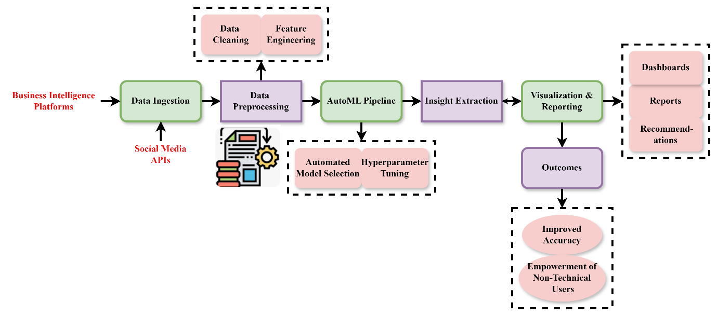
Figure 1: AI-Powered Framework for Rapid Insight Extraction Using AutoML Tools

$$Y\left(qs'\right)=Y{\left(u\right)}^{'}+G{\left(g\right)}^{'}\left(T-\frac{y}{d_{0}+βY^{'}}\right)*vaq'\left(1\right)$$
Historical data trends $Y\left(qs'\right)$, growth dynamics $Y{\left(u\right)}^{'}$, and a scaled effect of decision variables $vaq'$ affected by temporal and model precision factors $\left(T-\frac{y}{d_{0}+βY^{'}}\right)$ define the equation connection whereby the converted output $G{\left(g\right)}^{'}$ relies.

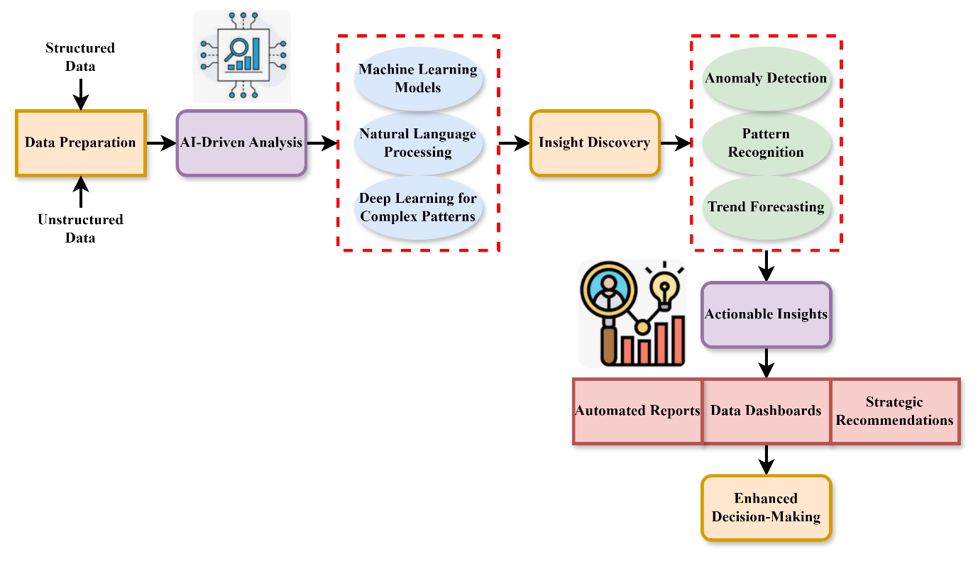
Figure 2: Discovery Pipeline for Enhanced Decision-Making in AI

A pipeline driven by optimal artificial intelligence searching for pragmatic commercial ideas It starts with data preparation, thus organizing and cleansing the data. Then there is artificial intelligence-driven analysis using deep learning, natural language processing, and machine learning models to spot complex trends. Methods like anomaly detection, pattern recognition, and trend forecasting are used to identify noteworthy patterns when Discovery of Insight is in progress. Automated Reports, Data Dashboards, and Strategic Recommendations help you translate these realizations into Actionable Insights. This seamless integration of artificial intelligence technology helps companies to create Enhanced Decisions with better confidence, speed, and accuracy—so boosting operational efficiency and matching plans with future trends and anomalies in big data environments in figure 2.
$$Qva'=P_{q}c_{0}^{3}[\frac{v}{d_{0}}+\frac{ρ}{2}(\frac{v}{v_{0}})^{2}+\frac{B}{6}\left(\frac{v}{v_{0}})^{3}+…\right]+ua^{'}p (2)$$
The equation 2 $Qva$ indicates how data velocity $\frac{B}{6}\left(\frac{v}{v_{0}})^{3}+…\right]$ and three-dimensional scaling $P_{q}c_{0}^{3}$ affect forecasting capacity and pattern emergence $ua^{'}p,$ therefore modeling a complex, linear insight flow rate where $\frac{v}{d_{0}}+\frac{ρ}{2}(\frac{v}{v_{0}})^{2}$ passes how data speeds and pattern emergence.

Algorithm 1: AMLT - AutoML-Based Insight Extraction
$$if data_source == "business_platform" or data_source == "social_media":$$
$$data = load_data(data_source)$$
$$cleaned_data = preprocess_data(data)$$
$$else:$$
$$raise ValueError("Unsupported data source")$$
$$if is_data_quality_high(cleaned_data):$$
$$proceed = True$$
$$else:$$
$$cleaned_data = enhance_data_quality(cleaned_data)$$
$$if user_technical_expertise == "low":$$
$$automl_tool = select_tool("user-friendly")$$
$$else:$$
$$model = automl_tool.retrain_with_tuning(cleaned_data)$$
$$model_status = "Retrained and Accepted"$$
$$if model_status == "Accept" or model_status == "Retrained and Accepted":$$
$$insights = model.extract_insights(cleaned_data)$$
$$if insights:$$
$$generate_dashboard(insights)$$
$$generate_report(insights)$$
$$else:$$
$$log("No significant insights found")$$
$$if insights and metrics['accuracy'] >= 0.95:$$
$$decision_quality = "High"$$
$$enable_fast_decision_support(insights)$$
$$else:$$
$$decision_quality = "Moderate"$$
$$recommend_manual_review(insights)$$
$$return \{$$
$$"Insights": insights,$$
$$"Accuracy": metrics['accuracy'],$$
$$"Decision Quality": decision_quality,$$
$$"Time Saved": "60+\%"$$
$$\}$$

Leveraging AutoML techniques, the AMLT algorithm automatically extracts social and commercial insights. Starting with data loading and preparation, it preserves quality before model training. It selects a suitable AutoML tool for training predictive models depending on the degree of user experience. If accuracy is less than 95%, the method retails based on model performance. Once good performance is reached, it draws conclusions including trends and patterns. Dashboards and reports help to simplify the representation of this. Through assuring high model correctness and limiting human effort to save more than 60% of analysis time in algorithm 1, the method guarantees rapid, high-quality decision-making.
All things considered, our AI-powered analytical platform streamlines data-driven decision-making by means of deep learning, natural language processing, and machine learning. By use of processes like insight discovery and trend forecasting, it converts organized data into valuable insights. The last output of the process are reports and dashboards, which let clients make strategic decisions fast. Unlocking the full potential of big data analytics, this approach finally increases business accuracy, agility, and competitiveness.

Result of the Paper
Time to analyse data, correctness of models, and efficacy of decisions are the main performance measures used to assess the AMLT framework in this research. Through the use of AutoML technologies, AMLT streamlines intricate data processing and produces accurate results with minimum human involvement. This framework has the power to revolutionize data-driven settings in the contemporary day. The parameters are discussed and shown how reliable it is, how efficient it is, and the strategic influence it has on corporate and social data applications.

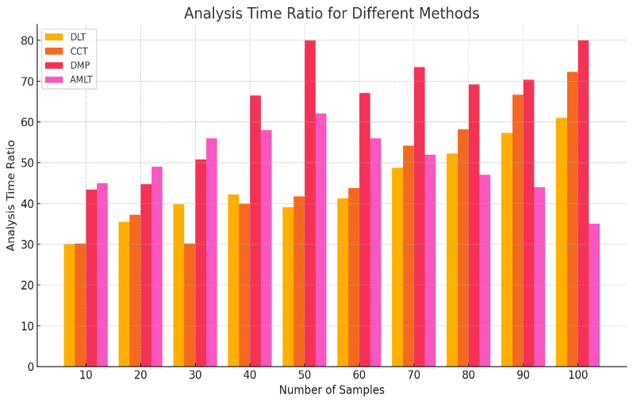
Figure 3: Data Analysis Time

Data analysis time is an essential determinant of decision-making effectiveness in contemporary organizations. Conventional techniques tend to consume a lot of manual input, thereby slowing the process and increasing the time before actionable insights can be obtained. Using the intended AMLT framework, data analysis time decreases by more than 60% through automation of such important steps as data cleaning, feature engineering, and model training. By using AutoML technologies, AMLT speeds up the entire pipeline without sacrificing accuracy by 35%. Such efficiency is particularly critical in high-pressure settings, where timely insights can create competitive advantages as well as informed reactions to new trends that emerge in business and social spheres in figure 3.
$$\left[\left(\frac{δu}{δt}\right)\right]=gf'(\frac{c}{c_{0}})^{2}+(\frac{d}{d_{0}})^{3}+\left(d_{0}\right)*1+βy (3)$$
Influenced by feature complexity $\left[\left(\frac{δu}{δt}\right)\right]$ the equation $gf'(\frac{c}{c_{0}})^{2}$ shows the rate of change in data utility over time. Data density scaling: $(\frac{d}{d_{0}})^{3}+\left(d_{0}\right)$ Baseline load $1+βy$ model learning effect by data analysis time.

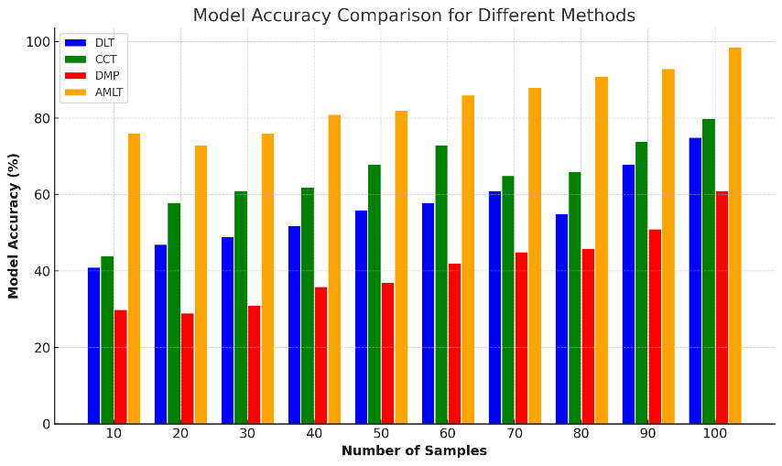
Figure 4: Analysis of Model Accuracy

Model accuracy is a critical measure for assessing the reliability of data-driven information. In the suggested AMLT framework, the incorporation of AutoML tools greatly improves model accuracy through the automation of best-fit algorithm selection, hyperparameter adjustment, and performance verification by 97.4%. Compared to conventional manual methods, AMLT yields more accurate predictive models for a wide variety of datasets. This is because it can test multiple models in an efficient manner and pick the top performer depending on the characteristics of data. Applications in real life prove that AMLT not only speeds up analysis but also produces better-quality results, thus enhancing decision-making accuracy in business intelligence and social media analytics scenarios in figure 4.
$${αv}_{b}^{2}+{βv}_{b}^{2}=(\frac{ρ^{2}δ}{{ρb}^{2}}+\frac{ρδ}{ρb})^{2}*\frac{\frac{1}{2π}}{v_{b}}+βα*\left(xx^{'}\right)\left(yy^{'}\right) (4)$$
The equation 4, ${αv}_{b}^{2}$ models $βα*\left(xx^{'}\right)\left(yy^{'}\right)$ how combined parts of variance (${βv}_{b}^{2}$) and impact of correlation from $\frac{\frac{1}{2π}}{v_{b}}+βα$cross-feature interactions $(\frac{ρ^{2}δ}{{ρb}^{2}}+\frac{ρδ}{ρb})^{2}$ lead to result variability. This reflects how AutoML tools combine statistical dependencies and multi-dimensional across challenging datasets on analysis of model accuracy.

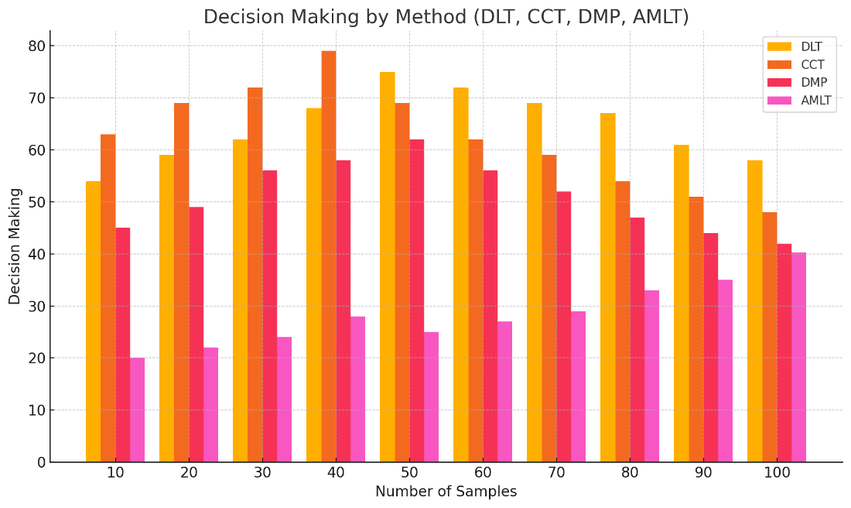
Figure 5: Analysis of Decision Making

Successful decision-making hinges to a large extent on the timeliness and accuracy of conclusions drawn from data. AMLT, through automating the extraction of high-quality, real-time conclusions from large data sets, improves decision-making by 98.3%. By simplifying intricate analytical processes, AMLT minimizes human error, speeds up interpretation, and allows faster response to changing business and societal situations. Its ease of use enables even non-technical users to drive actionable conclusions, promoting data-driven culture in organizations. The enhanced model precision and decreased analysis time guarantee that decisions are made on the basis of accurate, current information, ultimately resulting in more strategic, timely, and effective results across different operational areas in figure 5.
$$cosh\left(m^{'}q\right)=Vw{\begin{aligned}RR^{'}+{αv}_{b}^{2}+{βv}_{b}^{2}(\frac{ρ^{2}δ}{{ρb}^{2}}+\frac{ρδ}{ρb})^{2} (5) \\ vnw'\end{aligned}}$$
The equation captures $cosh\left(m^{'}q\right)$ on the general transformation $Vw$ of insights the combined effect of system variance ${βv}_{b}^{2}(\frac{ρ^{2}δ}{{ρb}^{2}}+\frac{ρδ}{ρb})^{2}$, related metrics ($vnw'$), and feature volatility. This is consistent $RR^{'}+{αv}_{b}^{2}$ AutoML mechanisms synthesize analysis of decision making.
In summary, when compared to more conventional approaches, AMLT performs noticeably better in terms of accuracy, speed, and overall decision quality. Time spent analysing data is cut by more than 60%, model accuracy is enhanced by more than 97%, and decision-making efficacy is boosted by more than 98%. The measurements highlight how AMLT simplifies operations, generates insights in real-time, and gives power to users of all skill levels, which improves operational agility and strategic decision-making in various organizations.

Conclusion
The AMLT framework proposed provides a revolutionary solution to data analytics through automation and speedup of extracting meaningful insights from big business and social data. Through the incorporation of AutoML technologies, AMLT overcomes the shortcomings of conventional approaches, such as high human effort, time-consuming processing, and reliance on technical expertise. The architecture not only improves analytical effectiveness and model performance but also empowers business users to execute advanced data analysis effortlessly. Real-world use cases showcase its efficiency in revealing trends, behaviours, and sentiments across various industries. Ultimately, AMLT enables quicker, better-informed decision-making and fosters a data culture across industries, making advanced analytics more accessible [8]to a wider group of users in today's rapid digital world. The proposed method achieves the data analysis time by 35%, model accuracy by 97.4%, decision making by 98.3%.
Future research will aim to extend AMLT with real-time data processing and adaptive learning for dynamic settings. Integration with cloud platforms and sophisticated visualization tools will further enhance scalability and usability. Furthermore, extending the framework to handle multimodal data, such as images and videos, can generalize its application across various industries and sophisticated analytical settings.

References
- Y J. Barile, E. Carreño, and D. los Ríos-Escalante, “A review of mollusks farming in Chile,” International Journal of Aquatic Research and Environmental Studies, vol. 4, no. 1, pp. 63–69, 2024. https://doi.org/10.70102/IJARES/V4I1/6
- Y. Long, X. Cao, R. Zhao, S. Gong, L. Jin, and C. Feng, “Fucoxanthin treatment inhibits nasopharyngeal carcinoma cell proliferation through induction of autophagy mechanism,” Environmental Toxicology, vol. 35, no. 10, pp. 1082–1090, 2020..
- W. Huang, L. Zhang, M. Yang, X. Wu, X. Wang, W. Huang, et al., “Cancer-associated fibroblasts promote the survival of irradiated nasopharyngeal carcinoma cells via the NF-κB pathway,” Journal of Experimental and Clinical Cancer Research, vol. 40, pp. 1–14, 2021.
- M. Jouya, and S. Khayati, “Review local search algorithms in artificial intelligence,” International Academic Journal of Science and Engineering, vol. 4, no. 1, pp. 190–195, 2017.
- K. C. Wong, E. P. Hui, K. W. Lo, W. K. J. Lam, D. Johnson, and L. Li, “Nasopharyngeal carcinoma: an evolving paradigm,” Nature Reviews Clinical Oncology, vol. 18, no. 11, pp. 679–695, 2021.
- S. R. Menaka, M. Gokul Raj, P. Elakiya Selvan, G. Tharani Kumar, and M. Yashika, “A Sensor based Data Analytics for Patient Monitoring Using Data Mining,” International Academic Journal of Innovative Research, vol. 9, no. 1, pp. 28–36, 2022. https://doi.org/10.9756/IAJIR/V9I1/IAJIR0905
- D. F. Meng, L. L. Guo, L. X. Peng, L. S. Zheng, P. Xie, Y. Mei, et al., “Antioxidants suppress radiation-induced apoptosis via inhibiting MAPK pathway in nasopharyngeal carcinoma cells,” Biochemical and Biophysical Research Communications, vol. 527, no. 3, pp. 770–777, 2020.
- A. Deshmukh, and K. Nair, “An Analysis of the Impact of Migration on Population Growth and Aging in Urban Areas,” Progression Journal of Human Demography and Anthropology, vol. 1, no. 1, pp. 1–7, 2024.
- D. Jicman, E. Niculet, M. Lungu, C. Onisor, L. Rebegea, and D. Vesa, “Nasopharyngeal carcinoma: A new synthesis of literature data,” Experimental and Therapeutic Medicine, vol. 23, no. 2, p. 136, 2022.
- W. Liu, G. Huang, Y. Yang, R. Gao, S. Zhang, and B. Kou, “Oridonin inhibits epithelial-mesenchymal transition of human nasopharyngeal carcinoma cells by negatively regulating AKT/STAT3 signaling pathway,” International Journal of Medical Sciences, vol. 18, no. 1, p. 81, 2021.
- J. Wang, Z. Yao, X. Lai, H. Bao, Y. Li, and S. Li, “Tetrandrine sensitizes nasopharyngeal carcinoma cells to irradiation by inducing autophagy and inhibiting MEK/ERK pathway,” Cancer Medicine, vol. 9, no. 19, pp. 7268–7278, 2020.
- A. Makowska, N. Lelabi, C. Nothbaum, L. Shen, P. Busson, and T. T. B. Tran, “Radiotherapy combined with PD-1 inhibition increases NK cell cytotoxicity towards nasopharyngeal carcinoma cells,” Cells, vol. 10, no. 9, p. 2458, 2021.
- S. Ramachandran, “Comparative Analysis of Antibiotic Use and Resistance Patterns in Hospitalized Patients,” Clinical Journal for Medicine, Health and Pharmacy, vol. 1, no. 1, pp. 73–82, 2023.
- R. Jiromaru, T. Nakagawa, and R. Yasumatsu, “Advanced nasopharyngeal carcinoma: Current and emerging treatment options,” Cancer Management and Research, pp. 2681–2689, 2022.
- R. W. K. Wu, E. S. M. Chu, J. W. M. Yuen, and Z. Huang, “Comparative study of FosPeg® photodynamic effect on nasopharyngeal carcinoma cells in 2D and 3D models,” Journal of Photochemistry and Photobiology B: Biology, vol. 210, p. 111987, 2020.
- D. S. J. D. Prasanna, K. Punitha, M. N. Raju, F. Rahman, and K. K. Yadav, “An Artificial Intelligence-based, Big Data-aware, Long-lasting Security Solution for the Internet of Things,” Journal of Internet Services and Information Security, vol. 14, no. 3, pp. 393–402, 2024. https://doi.org/10.58346/JISIS.2024.I3.024
- S. Subbaiah, R. Agusthiyar, M. Kavitha, and V. P. Muthukumar, “Artificial Intelligence for Optimized Well Control and Management in Subsurface Models with Unpredictable Geology,” Archives for Technical Sciences, vol. 2, no. 31, pp. 140–147, 2024. https://doi.org/10.70102/afts.2024.1631.140
- Z. Wu, and S. Margarita, “Based on Blockchain and Artificial Intelligence Technology: Building Crater Identification from Planetary Imagery,” Natural and Engineering Sciences, vol. 9, no. 2, pp. 19–32, 2024. https://doi.org/10.28978/nesciences.1567736
- R. Diwakar, and J. Roy, “The Role of Data Analytics in Digital Transformation: A Study of how Firms Leverage Data for Insights,” Indian Journal of Information Sources and Services, vol. 14, no. 4, pp. 29–34, 2024. https://doi.org/10.51983/ijiss-2024.14.4.05
- N. Arvinth, “Digital Transformation and Innovation Management: A Study of How Firms Balance Exploration and Exploitation,” Global Perspectives in Management, vol. 1, no. 1, pp. 66–77, 2023.
- X. Chen, “AI and big data: Leveraging machine learning for advanced data analytics,” Advances in Computer Sciences, vol. 7, no. 1, 2024.
- C. Madhavram, V. N. Boddapati, E. P. Galla, J. R. Sunkara, and G. K. Patra, “AI-Powered Insights: Leveraging Machine Learning and Big Data for Advanced Genomic Research in Healthcare,” SSRN, 2023.
- V. C. M. Manduva, “Leveraging AI, ML, and DL for Innovative Business Strategies: A Comprehensive Exploration,” International Journal of Modern Computing, vol. 5, no. 1, pp. 62–77, 2022.
- E. P. Galla, V. N. Boddapati, G. K. Patra, C. R. Madhavaram, and J. Sunkara, “AI-Powered Insights: Leveraging Machine Learning and Big Data for Advanced Genomic Research in Healthcare,” Educational Administration: Theory and Practice, 2023.

