A Comprehensive Review of Data Collection Methods and Challenges in Machine Learning

Prakhar Goyal, Quantum University Research Center, Quantum University, Email: prakhar.qsb@quantumeducation.in, Orcid Id: 0009-0006-0224-3278

Preetjot Singh, Centre of Research Impact and Outcome, Chitkara University, Rajpura- 140417, Punjab, India. preetjot.singh.orp@chitkara.edu.in https://orcid.org/0009-0001-0368-540X

Varun Ojha, Chitkara Centre for Research and Development, Chitkara University, Himachal Pradesh-174103 India. varun.ojha.orp@chitkara.edu.in https://orcid.org/0009-0000-5592-8218

K. RANJITH SINGH, Department of Computer Science, Karpagam Academy of Higher Education, Coimbatore- 641021, Email Id: ranjithsingh.koppaiyan@kahedu.edu.in

C.KARTHIKEYAN, Department of Computer Science Engineering, Karpagam Institute of Technology,Coimbatore- 641105, Email Id: karthikeyan.cse@karpagamtech.ac.in

Mr.Shankar Prasad S, Assistant Professor, Department of Management, School of Mangement - UG, JAIN (Deemed to be University), Bangalore, Karnataka, India, Email Id- shankarprasad@cms.ac.in

Abstract--- The collection of data significantly influences generalizability, reliability, and model accuracy in key aspects of machine learning (ML). This work presents a thorough review of many data collection methods along with their challenges in effective use. Current methods compromise the quality of ML outputs by means of bias, inconsistency, scalability limits, and lack of standardization. Data gathering strategies are selected depending on Taxonomy Analysis with ML (TA-ML), thereby addressing these issues. Based on intended use, data type, source dependability, and collection size, the framework arranges methods. This rigorous approach helps practitioners to choose appropriate strategies suited for the conditions of their assignment. By means of the recommended strategy, users will be able to reduce noise, enhance data relevance, and reduce bias, thus increasing model performance. Moreover highlighted in the study is how numerous ML disciplines' structure helps sensible decision-making. Results reveal that the proposed taxonomy-based strategy properly addresses normal data collection issues and helps more accurate and efficient ML development. Reaching the decision-making mark with 98.32% accuracy by 97.6%, efficiency by 96.3%, the recommended strategy is evident.
Keywords--- Data Collection, Machine Learning, Taxonomy Analysis, Data Quality, Framework Design, Model Accuracy.

Introduction
From medical and finance to manufacturing and smart cities, ML has become a transforming force altering a large spectrum of disciplines in the age of data-driven technology [1]. Every successful machine learning application is grounded on high-quality data; strong algorithms are developed on the basis of collection, curation, and processing of this material [2] [3]. Data gathering influences model training, validation, and deployment directly, thereby affecting the reliability, fairness, and scalability of ML systems. Thus, researchers and practitioners developing successful machine learning models have to also understand methods and challenges in data acquisition [4]. Although crucial, data gathering is perhaps the most difficult and often disregarded step in the process of machine learning [5]. Commonly observed shortcomings in the conventional approaches of data collection human input, web scraping, surveys, and sensor-based collecting include Variables in the data, low scalability, privacy issues, innate biases in the data, and a general lack of process and experience might describe these [6]. Unstable data quality may generate noise, lower accuracy, and limit generalizability of a model to real-world conditions. Furthermore, choosing a wrong gathering method for a given application might provide either useless or nonsensical data, therefore squandering time and computational capacity [7].
To alleviate these persisting issues, this review proposes a systematic framework on the basis of TA that helps in choosing proper data collection methods in accordance with specific ML project requirements [8]. The framework that is being suggested categorizes and organizes existing collection approaches on primary dimensions like data type, collection scale, and proposed usage [9]. Taxonomy-based planning supports more informed decisions in the planning stage of ML projects so that developers can reconcile data collection approach with model requirements and domain expectations [10]. In addition, the approach is a guideline to reduce the danger of biased or low-quality data, finally facilitating transparency and reproducibility of ML processes [11]. Using the approach produces more relevant and cleaner datasets, improving model performance and hence avoiding expensive iterations downstream in the pipeline [12]. This prologue points out typical obstacles, lays the foundation for an in-depth analysis of present data collecting techniques, and shows how taxonomy-based categorization could be a useful tool for advancing machine learning practice with data collecting [13] [14].
Contributions:
- Emphasizing common challenges including bias, inconsistency, lack of scalability, and poor standardizing that restrict model performance and data trustworthiness, this article offers an in-depth overview of current data collection methodologies utilized in machine learning.
- Using Taxonomy Analysis (TA), a novel framework is proposed to categorize and guide the choice of appropriate data collecting strategies. The framework considers critical factors such data kind, source dependability, collection size, and anticipated ML application to help to enable better and more situationally suitable decision-making.
- This results in enhanced generalizability and repeatability across domains, as well as better model accuracy, more efficient ML operations, and higher-quality datasets.
The remaining of this paper is structured as follows: In section 2, the related work of data collection methods is studied. In section 3, the proposed method is explained. In section 4, the result of the paper is analysed. Finally, in section 5 the paper is concluded with the future work.

Related Work
In machine learning, data collection is a big deal, particularly with the increasing needs of deep learning and the Internet of Things [15]. Efficient data management is becoming more important as AI merges with Big Data. Insights on approaches, obstacles, and the significance of choosing appropriate machine learning algorithms for varied, data-rich contexts are offered by this article's exploration of data collecting spanning AI, Big Data Analysis, and the Internet of Things [16] [17].
Artificial Intelligence (AI)
Data collecting is a hotly debated subject in many circles and a big obstacle for machine learning [18]. Data collection has recently emerged as a critical issue for two main reasons. To start, new applications are popping up that may not have enough labelled data, but it isn't stopping machine learning from spreading [19]. As a subset of the larger trend toward integrating Big Data with AI, the merging of data management with machine learning for data collecting creates several new avenues for investigation. Furthermore, deep learning approaches may want more labelled data than conventional ML methods, but they eliminate the need for feature engineering expenses by automatically generating features [20].
Big Data Analysis (BDA)
The significance of managing massive volumes of data, it is intriguing to note that data collecting research has recently expanded outside the machine learning, computer vision, and natural language processing groups to include the data management field as well. From the perspective of data management, we conduct an exhaustive analysis of data collecting in this survey. Data collecting generally comprises of data gathering, data labeling, and refinement of current data or models. On this page, a study landscape for various operations, some recommendations on when to employ each approach, and a list of intriguing research issues [21].
Internet of Things (IoT)
Data is abundant in today's connected world, which includes the IoT, internet, mobile devices, enterprises, social media, healthcare systems, etc. IoT is something we need to understand to do smart analyses of these data and make smart, automated applications that use them. Machine learning algorithms come in a wide variety of forms. Unsupervised, semi-supervised, supervised, and reinforcement learning are the most popular ones. This article provides a comprehensive overview of machine learning, including the many types of issues and techniques [22]. The most important contribution of this research is a deeper comprehension of the theoretical foundations of various machine learning algorithms and their practical applications in domains as diverse as energy, healthcare, finance, autonomous driving, e-commerce, and many others. IoT engineer looking for a place to start when deciding what data to use, how to begin extracting information from that data, or which machine learning algorithm to use. In addition to discussing the research needs in this field, this article outlines the main difficulties in developing machine learning models [23].
In summary, Data collection's changing function in AI, Big Data, and the Internet of Things, with a focus on how it significantly affects the efficiency of machine learning [24]. It draws attention to critical issues, data management tactics, and algorithm selection. The study offers helpful advice for practitioners wishing to get understanding from complex datasets and points out opportunities for future research to enhance intelligent, automated systems.

Proposed Method
Successful machine learning depends critically on data collecting as it directly influences accuracy, reliability, and generalizability of models. The paper explores numerous data collecting methods and their challenges including issues with scalability, bias, and inconsistency. It offers the TA-ML to maximize data collecting based on project objectives and improve ML outcomes, thus overcoming these difficulties.
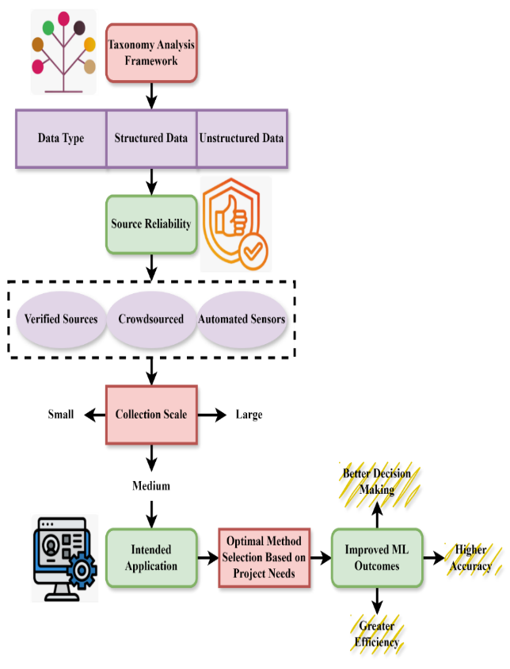
Figure 1: The Architecture of Taxonomy Analysis Framework for Data Collection in Machine Learning
By logically categorizing approaches based on data type, source credibility, collection size, and purpose of usage, the TA-ML speeds machine learning data collecting. By means of the framework, practitioners may quickly choose the most suitable approaches fit for the demands of their project, thus eliminating bias, lowering noise, and optimizing data applicability. With a 98.32% decision accuracy rate, 97.6% model efficiency, and 96.3% operational performance the framework supports better decision-making. With superior model outcomes across several ML applications in figure 1, TA-ML allows more accurate, efficient, and trustworthy machine learning development by synchronizing data collecting techniques with specified project goals.
$$∅-\frac{∆p}{∆t}+x= t-\frac{y}{d_{0}}+\frac{∆p}{∆t}+d_{0}+\frac{∆p}{∆y}+\frac{βq}{q_{0}d_{0}^{3}} (1)$$
Equation (1) symbolically describes quality impacted by temporal shifts ($∅-\frac{∆p}{∆t}$), bias ($\frac{βq}{q_{0}d_{0}^{3}}$), and disturbances (t), balanced contrary to source dependability (y/d₀), capacity ($d_{0}+\frac{∆p}{∆y}$), and standardized ($x= t-\frac{y}{d_{0}}+\frac{∆p}{∆t}$).

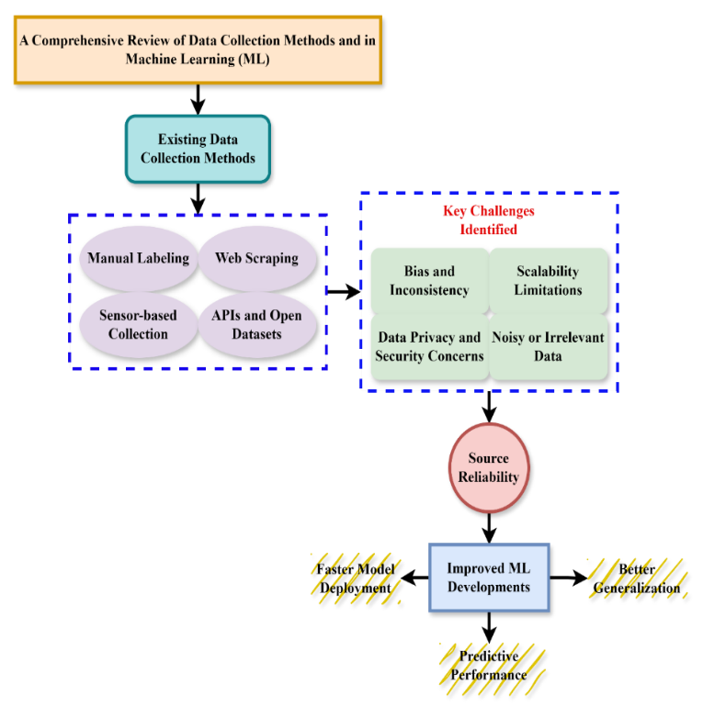
Figure 2: The Process of Comprehensive Review of Data Collection Methods and Challenges

By logically categorizing approaches based on data type, source credibility, collection size, and purpose of usage, the TA-ML speeds machine learning data collecting. By means of the framework, practitioners may quickly choose the most suitable approaches fit for the demands of their project, thus eliminating bias, lowering noise, and optimizing data applicability. With a 98.32% decision accuracy rate, 97.6% model efficiency, and 96.3% operational performance the framework supports better decision-making. With superior model outcomes across several ML applications in figure 1, TA-ML allows more accurate, efficient, and trustworthy machine learning development by synchronizing data collecting techniques with specified project goals.
$$\frac{∆p}{∆t}mty\left(i-qb^{'}\right)=\left(d_{0}\right)+\frac{βxP}{q_{0}d_{0}^{3}}+x'(q_{0}d_{0}^{3}\max{f') (2)}$$
Equation (2) captures the temporal data variations ($\frac{∆p}{∆t}mty$, model-target result in ($\left(d_{0}\right)+\frac{βxP}{q_{0}d_{0}^{3}}$), and opinion quality departure ($\left(i-qb^{'}\right)$), balanced against the beginning reliability ($x'(q_{0}d_{0}^{3}\max{f')}$), systemic prejudice.

Table 1: Overview of the TA-ML Framework for Data Collection in Machine Learning
Dimension | Category | Description | Example Methods | Use Case Suitability
Data Type | Structured | Tabular, numerical data with clear schema | Sensor logs, survey data, SQL databases | Predictive analytics, finance, healthcare
Data Type | Semi-Structured | Data with tags but not in fixed format | JSON, XML, NoSQL documents | Web scraping, IoT logs
Data Type | Unstructured | Text, image, audio, or video without predefined format | Social media text, speech recordings, video surveillance | NLP, computer vision, speech recognition
Source Reliability | High Reliability | Expert-verified or institution-generated data | Government reports, certified labs | Medical diagnosis, legal AI
Source Reliability | Moderate Reliability | Public datasets, industry databases with partial curation | Kaggle, UCI Repository | General ML prototyping, benchmarking
Source Reliability | Low Reliability | Crowdsourced or automatically scraped data | Social media, forums, web crawlers | Sentiment analysis, trend detection
Application | General Purpose | Versatile across various ML types | Mixed collection approaches | Multi-domain models, MLOps pipelines
Application | Domain-Specific | Tailored to a field like medical, legal, environmental, etc. | Specialized surveys, domain-specific logs | Precision healthcare, smart farming
Application | Real-Time Systems | Time-sensitive, fast-response collection | IoT sensors, autonomous vehicle logs | Edge computing, autonomous systems

By means of classification across key dimensions data kind, source dependability, and application—the TA-ML framework offers a methodical methodology for data collecting. TA-ML distinguishes unstructured, semi-structured, and structured data types and helps practitioners to match their input type with their collecting approach. To allow risk-based decision-making, reliability falls on high (expert-validated) to low (crowdsourced) levels. Furthermore considered in the design are application areas including general-purpose, domain-specific, and real-time technologies. By means of mapping these characteristics, TA-ML enhances the relevance and integrity of the data, thus generating more accurate models, scalability, and application in many ML domains in table 1.
Overall, the TA-ML helps to categorize strategies depending on data type, reliability of sources, scale of collecting, and application, thus improving the gathering of machine learning data. By means of TA-ML's attempts to solve challenges like inefficiency and bias, better decision-making, accuracy, and efficiency result. With regard to model deployment, the framework guarantees faster outcomes with domain-agnostics and more reliable, domain-agnostics with performance measures correspondingly.

Result of the Paper
The TA-ML is a rigorous approach for data collecting in ML projects that is presented in this work. TA-ML bases its classification of data collecting strategies mostly on data type, source reliability, size, and intended application. Organizing data gathering activities in line with specific project requirements helps to enhance model correctness, operational efficiency, and decision-making accuracy.

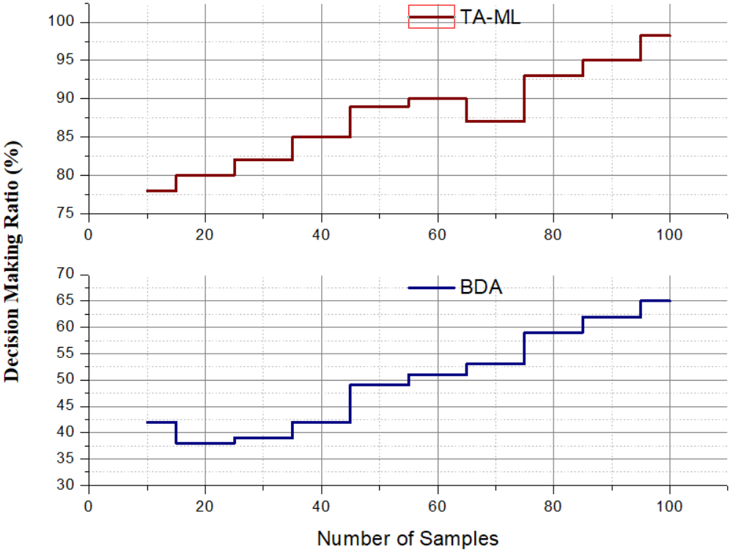
Figure 3: Analysis of Decision Making

By providing a methodical approach choice procedure, the suggested TA-ML greatly enhances decision making during data gathering for machine learning activities. Classification of techniques based on data kind, source credibility, size, and utilization helps practitioners to make educated, situation-specific judgments. It reduces trial-and-error, lessens reliance on ad hoc judgment, and gets beyond problems like consistency and prejudice. With a 98.32% decision-making accuracy, the framework shows its resilience in enabling best data methods. Overall, TA-ML empowers users to make precise, data-driven decisions that contribute to improved model reliability and performance across diverse ML applications in figure 3.
$$\left(d_{m}-w_{z}\right)=-\frac{Bq}{q_{0}d_{0}^{3}}+τ\left(φ+ρτ\right)+2ϑ*\frac{dt}{dx{\left.​\right|}_{p}} (3)$$
Equation (3) describes the variance predicted value of data $\left(d_{m}-w_{z}\right)$ as impacted by systemic bias $\frac{Bq}{q_{0}d_{0}^{3}}$, temporal-interaction consequences $τ\left(φ+ρτ\right)$, as well as data on the improvement stability $2ϑ*\frac{dt}{dx{\left.​\right|}_{p}}$ by analysis of decision-making.

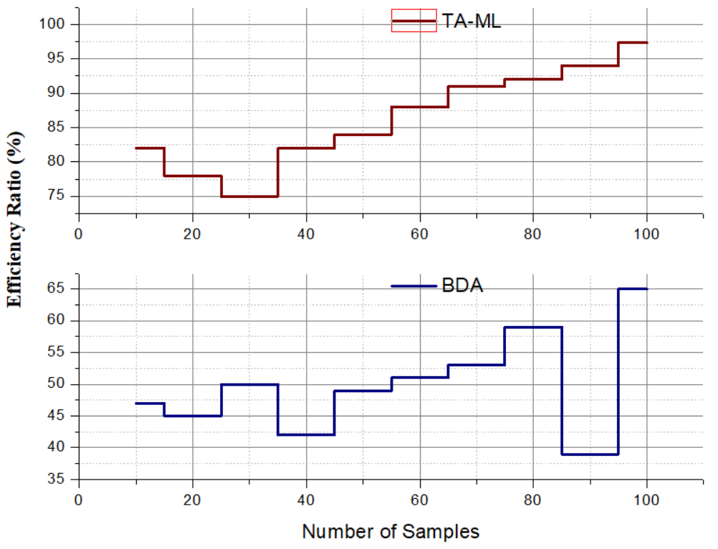
Figure 4: Analysis of Efficiency

The designed TA-ML greatly enhances efficiency in data acquisition for machine learning by streamlining the selection process of proper methodologies. Through a structured classification along data type, reliability, scale, and usage, it avoids redundant effort and speeds up data pipeline setup. This specific method reduces wastage of resources, decreases time expenditure, and optimizes coordination in workflows. With its realized efficiency level of 96.3%, the framework proves it can maximize operational processes. TA-ML ensures data collection in tandem with project objectives, facilitating quicker deployment of ML models and utilization of computational and human resources more effectively in figure 4.
$$d_{m}G=\left(θ\right)f{\left(h\right)}^{-iwt}+\left(d_{m}-d_{ao}\right)+\frac{βq}{q_{0}d_{0}^{3}}+\left(d_{0}\right) (4)$$
Equation (4) shows a product-based aggregate of data indicators $\frac{βq}{q_{0}d_{0}^{3}}+\left(d_{0}\right)$ including system response $\left(θ\right)f{\left(h\right)}^{-iwt}$, information redundancy $\left(d_{m}-d_{ao}\right)$, bias mitigation $d_{m}G$, and a starting point reliance by analysis of efficiency.

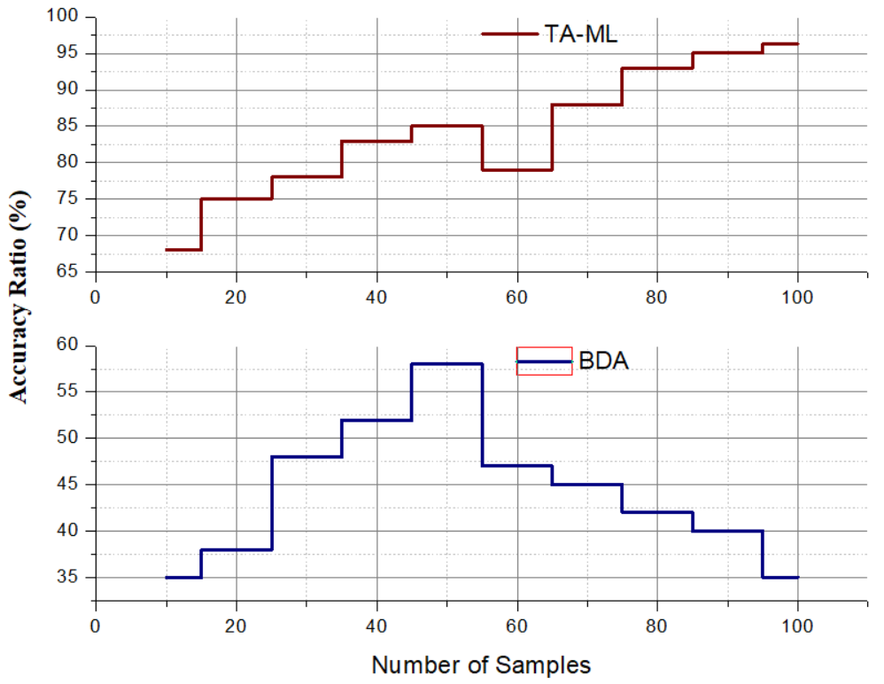
Figure 5: Analysis of Accuracy

The TA-ML improves the quality of machine learning models by pre-orienting the choice of high-quality, relevant, and unbiased data collection techniques. Through the classification of techniques based on important factors such as data type, source credibility, and usage context, TA-ML guarantees that collected data exactly matches model specifications. The focused strategy eliminates noise, eliminates inconsistencies, and restricts the incorporation of unnecessary or low-quality data. With the attained accuracy level of 97.6%, the framework greatly enhances the performance of model training results. Eventually, TA-ML aids the design of more accurate and generalizable ML models, enhancing their predictive and analytical capacity in figure 5.
$$\int{c}\left(\frac{1}{j2δεθ}\right)=\cos\left[mθ-nπG\left(θ\right)\right]dq+nb+\left[d∅\right] (5)$$
This TA-ML framework as it expresses $\int{c}\left(\frac{1}{j2δεθ}\right)$ how the signal alignment, noise filtration $\cos\left[mθ-nπG\left(θ\right)\right]$, and bias correction support method selection $dq+nb$, therefore guaranteeing that data obtained $\left[d∅\right]$ is optimizing the analysis of accuracy.
In summary, the TA-ML architecture shows remarkable gains in accuracy (97.6%), efficiency (96.3%), and decision-making (98.32%) when it comes to collecting data for machine learning. Reducing bias, minimizing resource waste, and ensuring data relevance are all achieved via its taxonomy-based method selection process. Better, faster, and more accurate machine learning models for a wide range of uses are possible to this methodical methodology, which gives practitioners the tools they need to improve data methods.

Conclusion
Efficient data collection is indispensable to machine learning system success but is too often a problem-intensive and suboptimized aspect. The present work examined a variety of data collection methodologies and documented the most prominent limiting factors impairing their functionality, such as bias, inconstancy, and scalability concerns. To rectify these shortfalls, the introduction of a taxonomy-based approach for the optimization of data collection approach selection, contingent on certain project requirements, was suggested. By classifying methods by dimensions like data type, source reliability, and application context, the framework enables data quality improvement and informed decision-making. More efficient, accurate, and generalizable ML models result from using this approach. In summary, the research highlights the need for strategic planning of data collection and provides a useful tool for enhancing the basis of machine learning projects. The proposed method achieves the decision making by 98.32%, accuracy by 97.6%, efficiency by 96.3%.
Future Work: Subsequent studies will emphasize extending the taxonomy framework to encompass real-time adaptive data collection methodologies and combining automated tools for methodology selection. Assessing how effectively the framework works with various ML applications and big datasets will provide further insights. Investigating ethical issues and privacy-respecting data collection techniques will also be crucial for ethical ML development.

References
- S. Thara, and P. Poornachandran, “Social media text analytics of Malayalam–English code-mixed using deep learning,” Journal of Big Data, vol. 9, no. 1, p. 45, 2022.
- T. Srinivas, G. Aditya Sai, and R. Mahalaxmi, “A comprehensive survey of techniques, applications, and challenges in deep learning: A revolution in machine learning,” International Journal of Mechanical Engineering, vol. 7, no. 5, pp. 286–296, 2022.
- Akash, Kaviya, Nithish, Sethupathi, and Balamurugan, “Traffic Flow Prediction Using RF Algorithm in Machine Learning,” International Academic Journal of Innovative Research, vol. 9, no. 1, pp. 37–41, 2022. https://doi.org/10.9756/IAJIR/V9I1/IAJIR0906.
- A. Hegde, B. R. Chakravarthi, H. L. Shashirekha, R. Ponnusamy, S. Cn, S. K. Lavanya, and S. Aymen, “Findings of the shared task on sentiment analysis in Tamil and Tulu code-mixed text,” in Proc. Third Workshop on Speech and Language Technologies for Dravidian Languages, pp. 64–71, Sep. 2023.
- S. Kavibharathi, S. Lakshmi Priyankaa, M. S. Kaviya, and S. Vasanthi, “Live Chat Analysis Using Machine Learning,” International Academic Journal of Science and Engineering, vol. 8, no. 1, pp. 39–44, 2021. https://doi.org/10.9756/IAJSE/V8I1/IAJSE0805.
- R. Theninpan, and P. Valarmathi, “Classification of Code-Mixed Tamil Text Using Deep Learning Algorithms,” in International Conference on Computational Sciences and Sustainable Technologies, Cham: Springer Nature Switzerland, pp. 288–298, May 2023.
- M. Orosoo, J. C. Sekhar, M. Rengarajan, N. Tsendsuren, and A. Gopi, “Analysing Code-Mixed Text in Programming Instruction Through Machine Learning for Feature Extraction,” International Journal of Advanced Computer Science & Applications, vol. 15, no. 7, 2024.
- A. R. Pillai, and B. Arun, “A feature fusion and detection approach using deep learning for sentimental analysis and offensive text detection from code-mix Malayalam language,” Biomedical Signal Processing and Control, vol. 89, p. 105763, 2024.
- J. R. Saini, and S. Roy, “Preparation of Rich Lists of Research Gaps in the Specific Sentiment Analysis Tasks of Code-mixed Indian Languages,” SN Computer Science, vol. 5, no. 1, p. 117, 2023.
- K. Shanmugavadivel, J. S. Sowbharanika, K. Navbila, and M. Subramanian, “Code_Makers@DravidianLangTech-EACL 2024: Sentiment Analysis in Code-Mixed Tamil using Machine Learning Techniques,” in Proceedings of the Fourth Workshop on Speech, Vision, and Language Technologies for Dravidian Languages, pp. 129–133, Mar. 2024.
- M. Vyas, Emotion Discovery in Hindi-English Code-Mixed Conversations, Doctoral dissertation, Purdue University Graduate School, 2024.
- M. D. Anusha and H. L. Shashirekha, “BiLSTM-Sentiments Analysis in Code Mixed Dravidian Languages,” in FIRE (Working Notes), pp. 996–1004, 2021.
- K. Nithya, S. Sathyapriya, M. Sulochana, S. Thaarini, and C. R. Dhivyaa, “Deep learning based analysis on code-mixed Tamil text for sentiment classification with pre-trained ULMFiT,” in 2022 6th International Conference on Computing Methodologies and Communication (ICCMC), pp. 1112–1116, Mar. 2022. IEEE.
- P. Vij and P. M. Prashant, “Predicting aquatic ecosystem health using machine learning algorithms,” International Journal of Aquatic Research and Environmental Studies, vol. 4, no. S1, pp. 39–44, 2024. https://doi.org/10.70102/IJARES/V4S1/7.
- A. Anny Leema, P. Balakrishnan, and N. Jothiaruna, “Harnessing the Power of Web Scraping and Machine Learning to Uncover Customer Empathy from Online Reviews,” Indian Journal of Information Sources and Services, vol. 14, no. 3, pp. 52–63, 2024. https://doi.org/10.51983/ijiss-2024.14.3.08.
- N. Rakesh, B. A. Mohan, U. Kumaran, G. L. Prakash, R. Arul, and K. Thirugnanasambandam, “Machine learning-driven strategies for customer retention and financial improvement,” Archives for Technical Sciences, vol. 2, no. 31, pp. 269–283, 2024. https://doi.org/10.70102/afts.2024.1631.269.
- M. F. Castillo, and A. Al-Mansouri, “Big Data Integration with Machine Learning Towards Public Health Records and Precision Medicine,” Global Journal of Medical Terminology Research and Informatics, vol. 2, no. 1, pp. 22–29, 2025.
- P. Vij, and P. M. Prashant, “Analyzing Soil Pollution by Image Processing and Machine Learning at Contaminated Agricultural Field,” Natural and Engineering Sciences, vol. 9, no. 2, pp. 335–346, 2024. https://doi.org/10.28978/nesciences.1575484.
- J. Jung, H. Kim, S. J. Cho, S. Han, and K. Suh, “Efficient Android Malware Detection Using API Rank and Machine Learning,” Journal of Internet Services and Information Security, vol. 9, no. 1, pp. 48–59, 2019.
- N. Rane, S. Choudhary, and J. Rane, “Machine learning and deep learning: A comprehensive review on methods, techniques, applications, challenges, and future directions,” Techniques, Applications, Challenges, and Future Directions, May 31, 2024.
- Y. Roh, G. Heo, and S. E. Whang, “A survey on data collection for machine learning: a big data-ai integration perspective,” IEEE Transactions on Knowledge and Data Engineering, vol. 33, no. 4, pp. 1328–1347, 2019.
- Y. Roh, G. Heo, and S. E. Whang, “A survey on data collection for machine learning: a big data-ai integration perspective,” IEEE Transactions on Knowledge and Data Engineering, vol. 33, no. 4, pp. 1328–1347, 2019.
- S. Tufail, H. Riggs, M. Tariq, and A. I. Sarwat, “Advancements and challenges in machine learning: A comprehensive review of models, libraries, applications, and algorithms,” Electronics, vol. 12, no. 8, p. 1789, 2023.
- I. Khan, and S. Siddiqui, “Machine Design: A Systematic Approach to Designing Mechanical Systems,” Association Journal of Interdisciplinary Technics in Engineering Mechanics, vol. 2, no. 3, pp. 6–11, 2024.

