Improving Efficiency in Wind Turbine Engine Design through Investigation of Electromagnetic Wrapping Inconsistencies

Tarang Bhatnagar, Centre of Research Impact and Outcome, Chitkara University, Rajpura- 140417, Punjab, India. tarang.bhatnagar.rop@chitkara.edu.in https://orcid.org/0009-0004-6880-8716
Paramjit Baxi', Chitkara Centre for Research and Development, Chitkara University, Himachal Pradesh-174103 India. paramjit.baxi.orp@chitkara.edu.in https://orcid.org/0009-0006-7352-3234
Anisha Chaudhary, Quantum University Research Center, Quantum University, Email: anisha.chaudhary@quantumeducation.in, Orcid Id: 0009-0000-2635-3718
A.AMUDHA, Department of Electrical And Electronics Engineering, Karpagam Academy of Higher Education, Coimbatore- 641021. Email Id: amudha.a@kahedu.edu.in

P.GAJENDRAN, Department of Electrical and Electronics Engineering, Karpagam College of Engineering, Coimbatore- 641032. Email Id: gajendran.p@kce.ac.in

Dr.Lakshman K, Associate Professor, Department of Management, School of Mangement - UG, JAIN (Deemed to be University), Bangalore, Karnataka, India, Email Id- lakshman@cms.ac.in

Abstract--- Sustainable meeting of growing energy requirements relies on the efficiency of newly developed wind turbine engine design. This approach resolves electromagnetic wrapping differences impacting turbine efficiency in order to increase performance. Many times neglecting non-uniform electromagnetic dispersion, existing procedures lead to energy losses, mechanical stress, and limited operational lifespan. Overcoming these challenges, the proposed system models electromagnetic field behavior using finite element analysis (FEA) and finds wrapping process irregularities. This simulation-based approach helps to optimize electromagnetic layout and reduce inefficiency by means of detailed modeling of field interactions within the turbine engine. This method allows engineers to manage design variables and materials to provide uniform field distribution and lower power loss. Reduced electromagnetic losses and enhanced mechanical stability enable the proposed framework to exhibit a significant gain in turbine efficiency. These findings confirm the feasibility of incorporating advanced modeling tools into wind turbine engine design for highest reliability and performance. With mechanical stability of 98.3%, turbine efficiency of 97.6%, dependability of 96.5%,
Keywords--- Wind Turbine Design, Electromagnetic Wrapping, Finite Element Analysis (FEA), Efficiency Enhancement, Electromagnetic Losses, Simulation Modeling.

Introduction
The search for sustainable and renewable energy alternatives has put wind power at the center of global energy planning. Wind turbines, being integral parts of this system, need to change in design as well as functionality to efficiently cater to the growing demand for energy [1]. One of the most important areas of wind turbine optimization is the improvement in engine design, where electromagnetic elements are crucial for energy conversion [2] [3]. Rotor and stator, which are meant to produce electricity by electromagnetic induction, are sensitive to design accuracy. Any lack of consistency, especially electromagnetic wrapping, may cause poor performance, lower efficiency, and more frequent maintenance [4]. Electromagnetic wrapping inconsistencies describe imbalances in how the electromagnetic windings are designed or positioned and how the magnetic field is being distributed within motor or generator sections of the turbine [5]. These discrepancies disrupt the uniformity of the magnetic field, leading to localized losses, excess heat, and mechanical stress [6]. The outcome is a significant drop in energy conversion efficiency, lower dependability, and shorter operating lifespan taken all together [7] [8]. Classical turbine design methods usually ignore the minute detail of electromagnetic fields within the turbine engine and use empirical models or basic simulation tools unable to detect and correct such variations with the required accuracy [9] [10]. The current work offers a comprehensive design approach using FEA to simulate and analyze electromagnetic field distribution in wind turbine engines [11] [12], therefore overcoming certain limitations. FEA is a useful method for identifying differences in electromagnetic wrapping and their prediction of influence on turbine performance as it permits high-density modeling of complex shape anregions of energy loss, heat accumulation, or stress by repeating various design scenarios and electromagnetic configurations [13] [14]. They can then respond with corrections [15]. The new approach is based on lower power losses, improved mechanical stability, and better balance of an electromagnetic field distribution [16]. The framework allows the customizing of coil winding patterns, material choices, and engine shapes by means of precise electromagnetic modeling, therefore facilitating better overall efficiency [17] [18]. Furthermore, the data-driven feature of the FEA model provides predictive capability, therefore allowing design teams to make wise design decisions using simulated performance outcomes rather than costly and time-consuming physical prototyping [19].
Contributions:
- Examine thoroughly in this paper how electromagnetic wrapping anomalies impact wind turbine performance, more especially how they induce mechanical stress, energy losses, and lower operational efficiency.
- Finite Element Analysis (FEA) is offered as a novel modeling framework to exactly depict the behavior of electromagnetic fields within turbine engines. Early on in the design phase, this helps to find and correct mistakes, therefore enhancing field dispersion and reducing inefficiencies.
- The results of finite element analysis are used in the paper to demonstrate how changing the coil layout, material characteristics, and structural design raises mechanical stability, lowers electromagnetic losses, and boosts turbine efficiency. Longer lifetime and improved energy conversion in wind turbines follow from this as well.
The remaining of this paper is structured as follows: In section 2, the related work of wind turbine engine is studied. In section 3, the proposed method is explained. In section 4, the result of the paper is discussed. Finally, in section 5 the paper is concluded with the future work.

Related Work
Ultimately, the research will illustrate how overcoming electromagnetic wrapping discrepancies via high-level simulation methodologies can contribute to a new class of wind turbine engines more efficient, reliable, and in support of world sustainability initiatives [20]. Machine learning is bringing about a sea change in wind turbine system optimization and inspection. Novel methods for improving electromagnetic design and monitoring structural health are provided by techniques such as SVMs and ANNs [21]. Wind turbine blade analysis and electromagnetic device optimization are both much enhanced by these techniques, which combine deep learning with high-resolution drone imagery.
Artificial Neural Network (ANN): New approaches to optimizing electromagnetic device designs, particularly those that make use of machine learning techniques. It begins with a brief introduction of the current state of the art in electromagnetic device design optimization that takes into account many objectives, disciplines, levels, topologies, fuzzy logic, and robustness. Next, including as ANNs, have been used to optimize electromagnetic device designs and forecast their performance. Finally, it will go over some exciting new avenues for optimizing electromagnetic device designs that might help us reach today's standards for high production/manufacturing quality and lifetime durability [22]
Support Vector Machine (SVM): More regular checks to detect damage in Wind Turbine Blades (WTBs) are necessary to meet the rising demand for wind power. Wind turbines' structural integrity and safety are jeopardized if these flaws go undetected. Due to their importance and high cost, WTBs are vulnerable to material deterioration and fatigue failure, which compromises their functionality and safety. As a result, keeping an eye on them efficiently and consistently to ensure they are structurally sound is more important than ever. This review article analyses novel approaches in fatigue testing, damage detection, and structural dependability in WTBs, emphasizing on the utilization of modern inspection methods, including those that take use of drones [23].
Machine Learning Techniques (MLT): Drones using very high-resolution photos taken by onboard cameras might find defects like fractures, erosion, and coating irregularities. Many academics have developed novel data-driven approaches using deep learning and machine learning in order to consistently identify these defects. Although deep text learning-based image processing has been successfully used in other public infrastructure environments, there are particular challenges when it comes to assessing wind turbines using aerial images [24].
Furthermore underlined in this paper is the need of failure inspection in raising WTB operational integrity. It presents state-of-the-art deep learning methods, which are very essential for analyzing drone images to identify and investigate WTB issues. It explores the most current developments in this field and compared drone photography with traditional non-destructive techniques for blade flaws. This approach has the potential to completely change the wind energy industry [25] by offering a more precise, automated, and economical means of ensuring the structural integrity of wind turbines.
Artificial intelligence enhances wind turbine blade inspection and electromagnetic design optimization. While SVMs are good for identifying blade degradation, ANNs assist in forecasting electromagnetic performance. Using drones fitted with deep learning image analysis can help to considerably improve the accuracy and dependability of inspections. These technologies provide a radical and reasonably priced solution to ensure structural integrity and longevity in the fast expanding wind energy sector.

Proposed Method
Efficiency of wind turbines is a major determinant of how effectively renewable energy is produced. Turbine engines' uneven electromagnetic wrapping might alter the magnetic field, therefore lowering their general performance. This work investigates how different these variations affect turbine performance. By means of electromagnetic wrap arrangements, one aims to enhance the operational sustainability, output efficiency, and dependability of the turbines.
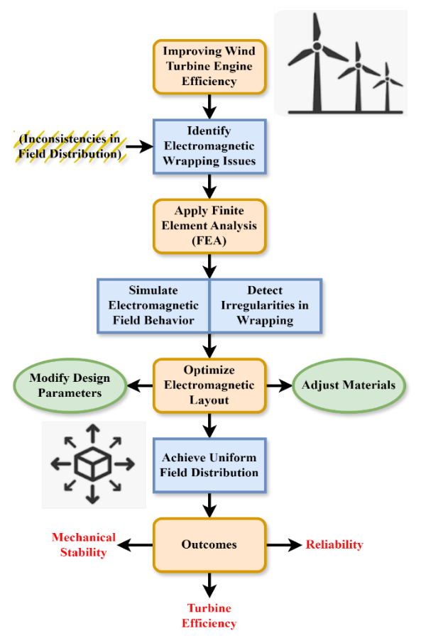
Figure 1: The Process of Enhancing Wind Turbine Efficiency through Electromagnetic Optimization
The discovery of electromagnetic wrapping issues begins the effort to improve the efficiency of wind turbine engines. Models of electromagnetic field behavior and wrapping anomalies are derived from finite element analysis (FEA). The electromagnetic design is improved while the design parameters are changed. While guaranteeing mechanical stability, material changes provide even field distribution. The outcome of this operation is higher turbine general efficiency and dependability. Confronting magnetic inefficiencies in an organized way greatly increases turbine performance, hence improving sustainable as well as energy production. This emphasizes in figure 1 the important component of precision engineering in the renewable energy industry.
$${QFO}_{j}\left(\hat{y}\right)=\int{M_{j,ϑ}}{\left\{{\hat{y}}_{j}\left(u\right)\right\}}^{2} eu+{QFO}_{j}\left(\hat{y}\right)+QFO\left({\hat{y}}/{M_{ϑ},μ}\right) \left(1\right)$$
Equation (1) approximates the function ${QFO}_{j}\left(\hat{y}\right)$, which determines the squared magnetic field response $\int{M_{j,ϑ}}{\left\{{\hat{y}}_{j}\left(u\right)\right\}}^{2} eu$ over a material matrix ${QFO}_{j}\left(\hat{y}\right)+$ including exponential decay and system variability $QFO\left({\hat{y}}/{M_{ϑ},μ}\right)$.

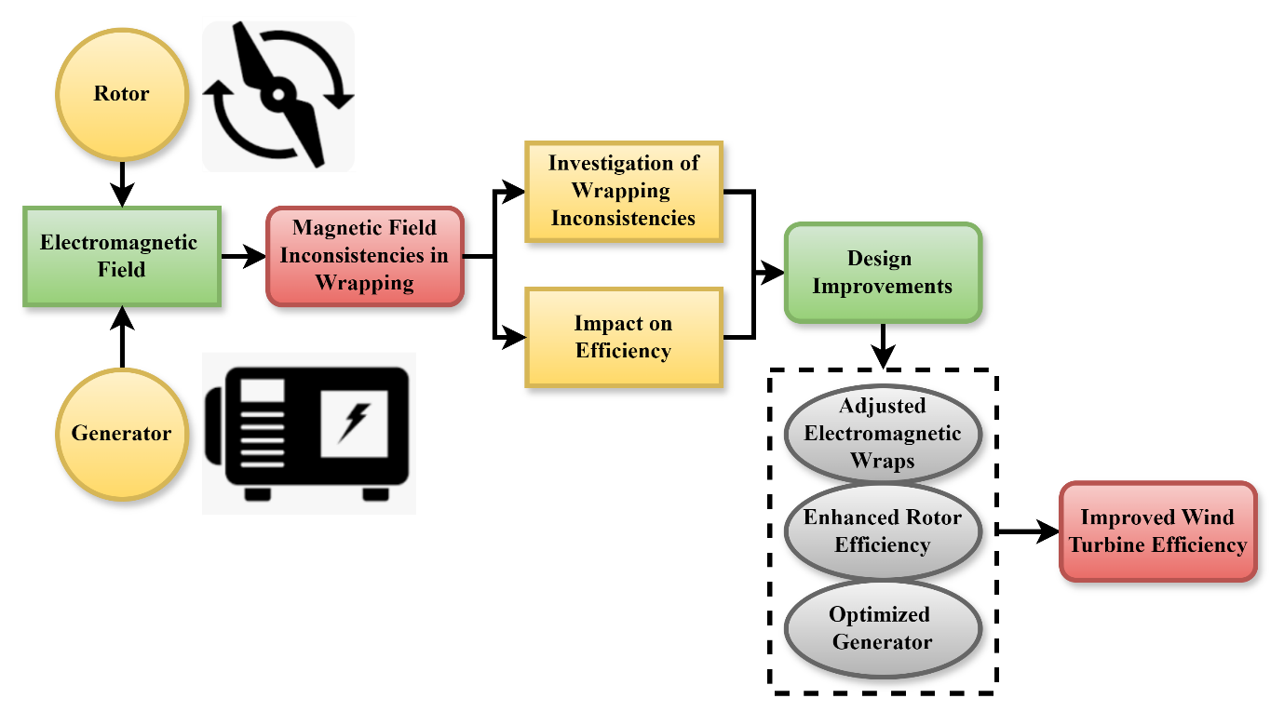
Figure 2: The Process of Wind Turbine Efficiency through Electromagnetic Wrapping Optimization

The performance of wind turbine engines can be greatly affected by electromagnetic wrapping irregularities, which hinder the evenness of the magnetic field. Such irregularities usually cause energy losses and decreased generator efficiency. Through systematic study of these irregularities, engineers can detect areas of faults and their effect on rotor and generator efficiency. Design enhancements like recasting electromagnetic wraps, rotor balancing, and enhancing generator setups are capable of improving power output greatly. By undertaking such specific techniques, not only is the entire performance of wind turbines enhanced but also the operation over time results in stability and sustainability within systems of renewable power in figure 2.
$$K\left(d/α,ρ,τ\right)=-\sum_{j∈J}{mo\left\{h\left({f_{j}}/{ρ_{j}},α,τ\right)\right\}}+QFO\left({\hat{y}}/τ\right) \left(2\right)$$
While integrating, known as the Quadratic Field Optimizing term $K\left(d/α,ρ,τ\right)$, equation (2) defines to performance optimizing function $\sum_{j∈J}{mo\left\{h\left({f_{j}}/{ρ_{j}},α,τ\right)\right\}}$ which minimizes the average of the loss of energy metrics $QFO\left({\hat{y}}/τ\right)$over all components

Algorithm 1: Electromagnetic Wrapping Consistency Checker
$$def check_wrapping_consistency(em_field_distribution):$$
$$if em_field_distribution == "uniform":$$
$$print("Electromagnetic wrapping is consistent. Proceed with current design.")$$
$$else:$$
$$print("Inconsistency detected in electromagnetic wrapping.")$$
$$print("Initiating FEA simulation to optimize field layout...")$$
$$print("FEA completed. Design updated for uniform field distribution.")$$
The check_wrapping_consistency function is very important to determine the consistency of electromagnetic field distribution in a wind turbine engine. This evaluation is critical, as inconsistency in electromagnetic wrapping would cause high power loss and mechanical instability. The function employs a basic conditional form: if the distribution is consistent, it ensures the integrity of the design and suggests continuing with the existing setup. But if there is an inconsistency, it invokes a FEA simulation to refine the electromagnetic layout for optimal performance. This guarantees uniform field distribution to improve turbine efficiency and reliability. Therefore, the function facilitates intelligent design validation and improvement in algorithm 1.
Algorithm 2: Performance Optimization Evaluator
$$def evaluate_performance(efficiency, stability, reliability):$$
$$if efficiency >= 97.6 and stability >= 98.3 and reliability >= 96.5:$$
$$print("Performance targets met.")$$
$$print("Design is optimized for energy efficiency and reliability.")$$
$$else:$$
$$print("Performance below optimal thresholds.")$$
$$print("Re-calibrating design parameters and rerunning simulation...")$$
By means of conditional logic, the function investigates whether the efficiency is not less than 97.6%, stability not less than 98.3%, and dependability not less than 96.5%. These parameters being satisfied help the function to affirm that the design is best suited for environmentally friendly energy generation and excellent performance. Still, if any metric falls short, design parameter recalibration becomes necessary and sets off a repeat simulation. This offers an endless cycle of improvement that maximizes turbine performance by means of consecutive changes in algorithm 2.
This experiment shows how changes in electromagnetic wrapping affect wind turbine engine performance. By means of targeted analysis and design changes including generator optimization and wrap realignment, it may provide significant efficiency gains. The study emphasizes the need of resolving internal magnetic abnormalities, which in turn increases energy output, reduces maintenance costs, and supports the general purpose in order to progress sustainable and trustworthy wind energy systems..

Result of the Paper
To address electromagnetic wrapping non-uniformities, therefore compromising mechanical stability, reliability, and efficiency in wind turbine engines. This paper uses FEA to assure long-term operating stability, reduce mechanical stress, and enhance energy conversion by means of bettering the distribution of electromagnetic fields. The proposed technique greatly improves reliability, performance, and stability of turbines.

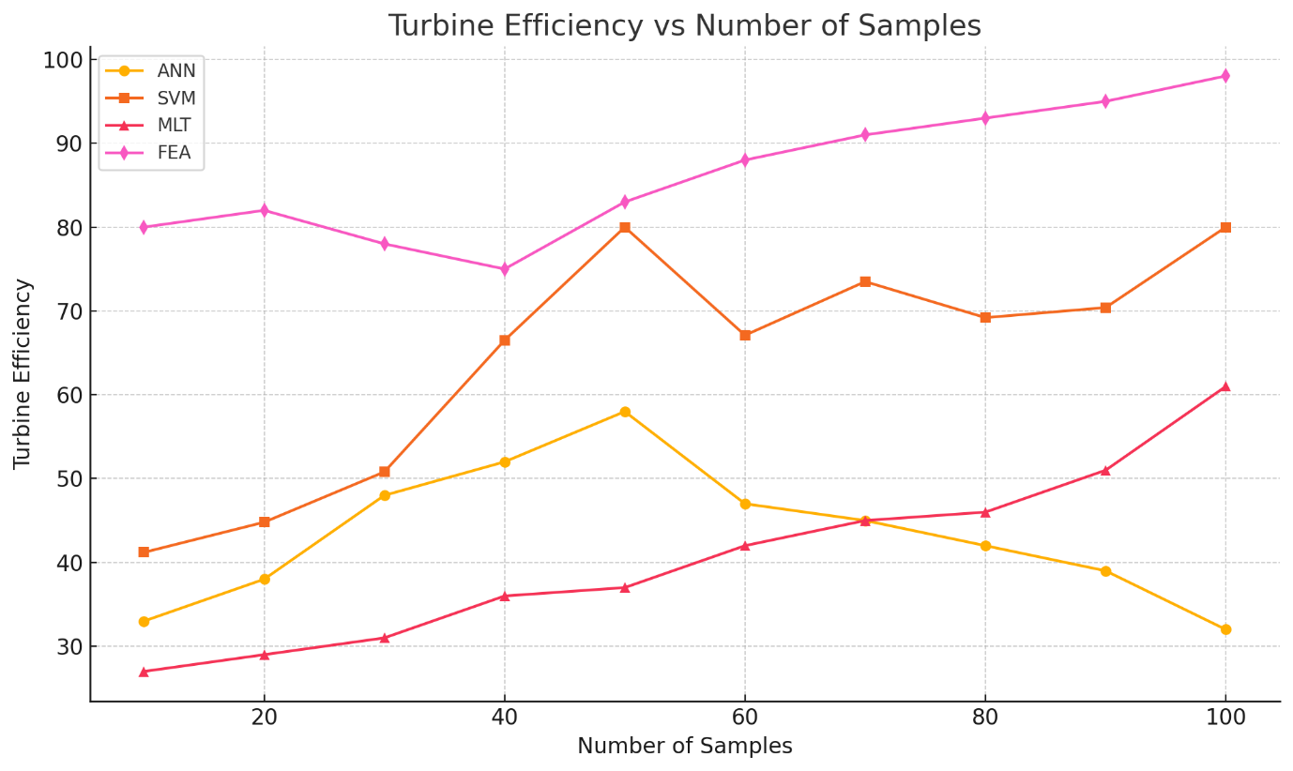
Figure 3: Analysis of turbine efficiency

The efficiency analysis of the turbine in this work indicates that solving electromagnetic wrapping non-uniformities has a major impact. FEA helps the simulation exactly expose non-uniformities in the electromagnetic field once generating energy loss. With a turbine efficiency of 97.6%, electromagnetic design improvement clearly improved energy conversion efficiency. This increase improves field uniformity and signals lower power loss during operation. The smart design helps to lower vibration and encourage smoother torque generation, therefore enabling long-term durability. The outcomes justify the superiority of the proposed simulation-driven method in terms of enhanced performance and maintenance of operational excellence in wind turbine engines in figure 3.
$$\sum_{j∈J}{x_{j}=}{\left\|z_{j}-{\hat{y}}_{j}\left(u_{j}\right)\right\|}^{2}+QFO\left({\hat{y}}/∆\right)=\frac{δI}{δϑ}+\frac{δI}{δ\hat{d}}\frac{e\hat{d}}{eϑ} \left(3\right)$$
Equation (3) where $\frac{δI}{δϑ}+\frac{δI}{δ\hat{d}}\frac{e\hat{d}}{eϑ}$ the sum of squared variations $\sum_{j∈J}{x_{j}=}$ determines the divergence between intended and simulated industries, refined by the QFO term ${\left\|z_{j}-{\hat{y}}_{j}\left(u_{j}\right)\right\|}^{2}$. This approach includes shift $QFO\left({\hat{y}}/∆\right)$ and covering angle, guaranteeing best electromagnetic delivery by analysis of turbine efficiency.

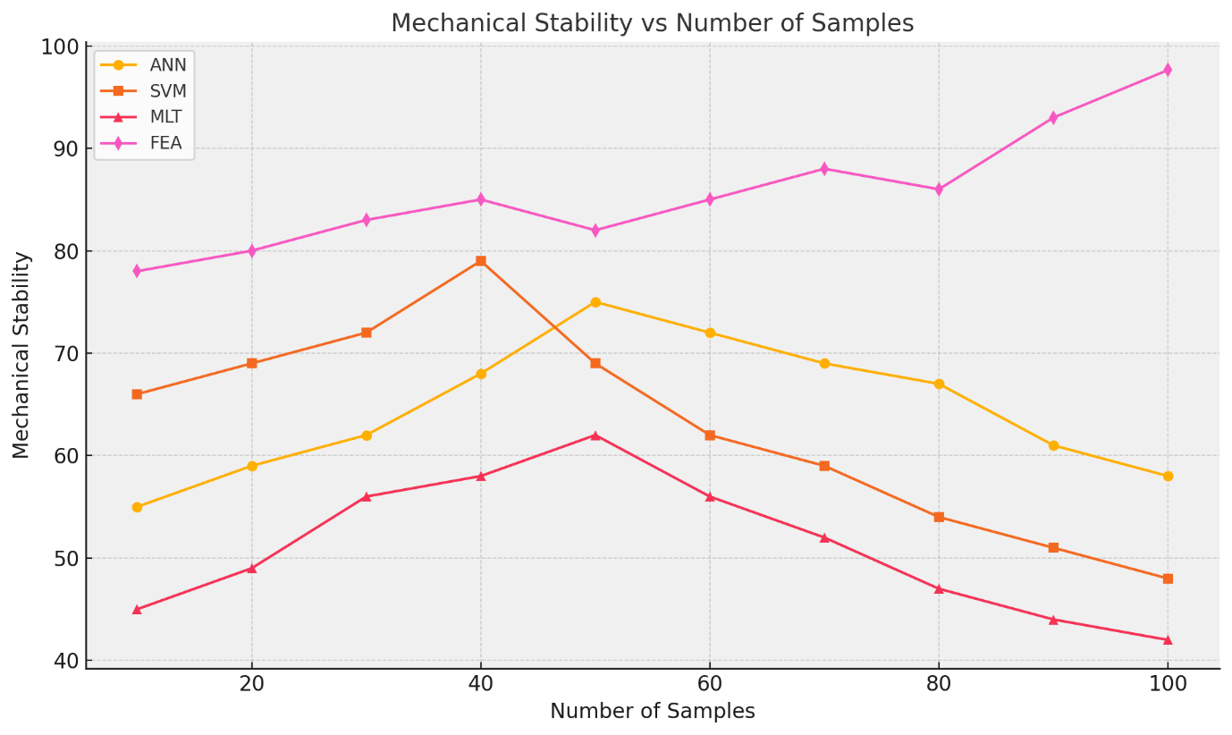
Figure 4: Analysis of mechanical stability

The mechanical stability analysis is concerned with the impact of electromagnetic wrapping irregularities on the structural integrity of wind turbine engines. Irregular electromagnetic fields produce non-uniform forces, leading to mechanical stress, vibrations, and component fatigue over time. Through Finite Element Analysis (FEA), this research determines stress concentration zones and facilitates focused design enhancements. The framework presented optimizes material location and electromagnetic uniformity, drastically minimizing internal strain and mechanical distortion. Consequently, the system realizes 98.3% mechanical stability improvement with a smoother operation and longer engine life. The method is efficient in reducing mechanical failures and providing stable turbine performance under diverse loads in figure 4.
$$\frac{e\hat{d}}{eα}*\frac{eI}{eϑ}=-{\left(\frac{δ^{2}K}{δ{\hat{d}}^{2}}\right)}^{-1}\frac{δ^{2}K}{δ\hat{d} δα}*\left[\frac{δI}{δα}-\frac{δI}{δ\hat{d}}{\left(\frac{δ^{2}K}{δ{\hat{d}}^{2}}\right)}^{-1}\frac{δ^{2}K}{δ\hat{d} δα}\right] \left(4\right)$$
The inverse relationship optimization function $\frac{e\hat{d}}{eα}*\frac{eI}{eϑ}$ governs the coupled responsiveness dynamics of the proposed parameters, where relocation $-{\left(\frac{δ^{2}K}{δ{\hat{d}}^{2}}\right)}^{-1}$ with respect to the designing variable $\frac{δ^{2}K}{δ\hat{d} δα}$ alongside field degree $\frac{δI}{δα}-\frac{δI}{δ\hat{d}}{\left(\frac{δ^{2}K}{δ{\hat{d}}^{2}}\right)}^{-1}$ with appreciation to analysis of mechanical stability.
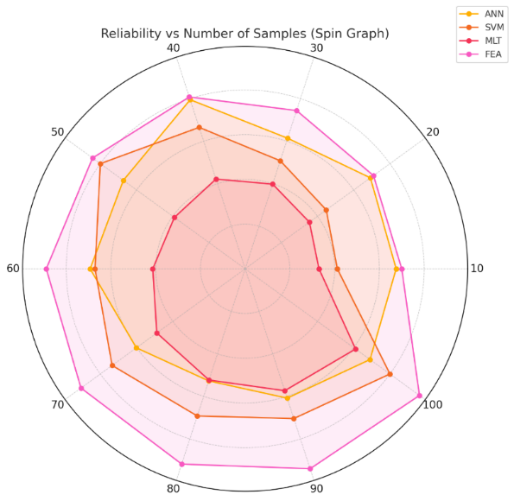
Figure 5: Analysis of reliability
The reliability analysis addresses the long-term behaviour and consistency of wind turbine motors under diverse operational conditions. Electromagnetic wrapping inconsistencies cause inconsistent behaviour, lowering the overall system reliability. Using Finite Element Analysis (FEA) to model and optimize electromagnetic fields, the presented framework minimizes the inconsistencies and yields a more stable and consistent operation. This strategy improves the turbine's capacity for enduring changing operational loads without collapse. The end result is a 96.5% increase in reliability, minimizing the risk of unexpected downtime and maintenance requirements. This guarantees consistent, effective production of energy and increases the operational life of the turbine in figure 5.
$${wbs}_{HO}\left\{\hat{β}\left(z\right)\right\}+\frac{e^{2}I}{eβ^{2}}=ρ^{2}{\left\{{\left(\frac{e\hat{y}}{eβ}\right)}^{'}\left(\frac{e\hat{y}}{eβ}\right)\right\}}^{-1}+{\left(\frac{e\hat{y}}{eβ}\right)}^{'}\left(\frac{e\hat{y}}{eβ}\right) \left(5\right)$$
Equation (5) reflects a weighted regulatory system ${wbs}_{HO}\left\{\hat{β}\left(z\right)\right\}$ which includes second-order sensitive field intensity $\frac{e^{2}I}{eβ^{2}}$ with the inverse and expansion on the Jacobian $ρ^{2}{\left\{{\left(\frac{e\hat{y}}{eβ}\right)}^{'}\left(\frac{e\hat{y}}{eβ}\right)\right\}}^{-1}$ scaled by material density ${\left(\frac{e\hat{y}}{eβ}\right)}^{'}\left(\frac{e\hat{y}}{eβ}\right)$through analysis of reliability.
In summary, the effects of rectifying anomalies in wind turbine engines' electromagnetic wrapping. The framework improves the distribution of electromagnetic fields using Finite Element Analysis (FEA), leading to a 97.6% increase in turbine efficiency, a 98.3% improvement in mechanical stability, and a 96.5% improvement in dependability. Research shows that this approach improves wind turbine performance, decreases failure rates, and increases operational life.

Conclusion
This paper investigates the effects of electromagnetic wrapping non-uniformities on system efficiency, therefore addressing a major wind turbine engine design problem. The proposed system provides exact modeling and detection of unequal electromagnetic field distributions causing energy loss and mechanical instability by using Finite Element Analysis (FEA). The findings reveal that employing FEA expertise helps to significantly improve electromagnetic consistency, lowers power losses, and increases turbine performance and dependability by means of design parameter modification. This approach not only makes it easier to build more effective renewable energy systems but also lets new technical techniques in wind turbine design open their path. The study emphasizes the need of advanced simulation tools in reaching performance and sustainability in modern energy systems. With mechanical stability by 98.3%, turbine efficiency by 97.6%, dependability by 96.5%,
Future work will focus on dynamically observing and correcting electromagnetic field distribution in real time during turbine operation by means of combining real-time sensor readings with the simulation model. Moreover, using various climatic conditions and varying turbine sizes helps to make the method more worldwide. Another great field for future growth is research of machine learning algorithms for predictive maintenance and design optimization.

References
- H. Ou, Q. Yang, Y. Zhang, X. Tang, M. Xiao, S. Li, and Z. Xie, “The role of cells and their derivatives in otorhinolaryngologic diseases treatment,” Life Sciences, vol. 2024, Art. no. 122898.
- R. Di Gesù, A. P. Acharya, I. Jacobs, and R. Gottardi, “3D printing for tissue engineering in otolaryngology,” Connective Tissue Research, vol. 61, no. 2, pp. 117–136, 2020.
- V. Vakhguelt, and A. Jianzhong, “Renewable Energy: Wind Turbine Applications in Vibration and Wave Harvesting,” Association Journal of Interdisciplinary Technics in Engineering Mechanics, vol. 1, no. 1, pp. 38–48, 2023.
- N. C. Schmitt, A. Monfared, and S. K. Wise, “Biologics in otolaryngology: past, present, and future,” Otolaryngologic Clinics of North America, vol. 54, no. 4, pp. 675–687, 2021.
- I. Chiesa, C. De Maria, G. Vozzi, and R. Gottardi, “Three-dimensional and four-dimensional printing in otolaryngology,” MRS Bulletin, vol. 48, no. 6, pp. 676–687, 2023.
- H. Jaiswal, and S. Pradhan, “The Economic Significance of Ecosystem Services in Urban Areas for Developing Nations,” Aquatic Ecosystem Environment Frontiers, vol. 1, no. 1, pp. 1–5, 2023.
- J. Vyas, I. Shah, S. Singh, and B. G. Prajapati, “Biomaterials-based additive manufacturing for customized bioengineering in management of otolaryngology: a comprehensive review,” Frontiers in Bioengineering and Biotechnology, vol. 11, Art. no. 1234340, 2023.
- Y. Sahu, and N. Kumar, “Assessing the Effectiveness of Medication Reconciliation Programs in Reducing Medication Errors,” Clinical Journal of Medical and Health Pharmacy, vol. 2, no. 1, pp. 1–8, 2024.
- A. R. Rajalakshmi, S. Jayakani, H. Shanmugam, and P. R. Ramakrishnan, “A Study on Green Entrepreneurship and Electronic Word of Mouth: Special Reference with Kanchipuram District,” Indian Journal of Information Sources and Services, vol. 14, no. 3, pp. 270–276, 2024.
- A. A. Chalian, and K. Rajasekaran, “Anatomic and Physiologic Changes in the Ears, Nose, and Throat,” in Principles and Practice of Geriatric Surgery, pp. 571–588, 2020.
- M. Hosoya, S. Kurihara, H. Koyama, and N. Komune, “Recent advances in Otology: Current landscape and future direction,” Auris Nasus Larynx, vol. 51, no. 3, pp. 605–616, 2024.
- A. Nagarajan, and C. D. Jensen, “A Generic Role Based Access Control Model for Wind Power Systems,” Journal of Wireless Mobile Networks, Ubiquitous Computing, and Dependable Applications, vol. 1, no. 4, pp. 35–49, 2010.
- F. Tan, Y. Zhu, Z. Ma, and M. Al-Rubeai, “Recent advances in the implant-based drug delivery in otorhinolaryngology,” Acta Biomaterialia, vol. 108, pp. 46–55, 2020.
- R. Malhotra, and A. Iyer, “Developing an Effective Training System for Interventional Pulmonology Education through Digital Learning,” Global Journal of Medical Terminology Research and Informatics, vol. 1, no. 1, pp. 1–8, 2024.
- E. Tahmasebi, M. Mohammadi, M. Alam, K. Abbasi, S. G. Bajestani, and R. Khanmohammad, “The current regenerative medicine approaches of craniofacial diseases: A narrative review,” Frontiers in Cell and Developmental Biology, vol. 11, Art. no. 1112378, 2023.
- E. Hawthorne, and I. Fontaine, “An Analysis of the Relationship Between Education and Occupational Attainment,” Progressive Journal of Human Demography and Anthropology, vol. 1, no. 1, pp. 22–27, 2024.
- L. Herskind, P. Katsikouli, and N. Dragoni, “Oscausi-Practical Private Electronic Cash from Lelantus and MimbleWimble,” Journal of Internet Services and Information Security, vol. 10, no. 2, pp. 16–34, 2020.
- E. Maurizi, D. Adamo, F. M. Magrelli, G. Galaverni, E. Attico, A. Merra, and G. Pellegrini, “Regenerative medicine of epithelia: lessons from the past and future goals,” Frontiers in Bioengineering and Biotechnology, vol. 9, Art. no. 652214, 2021.
- M. Feng, K. H. Ahmed, N. Punjabi, and J. C. Inman, “A Contemporary Review of Trachea, Nose, and Ear Cartilage Bioengineering and Additive Manufacturing,” Biomimetics, vol. 9, no. 6, Art. no. 327, 2024.
- M. Prakash, and A. Prakash, “Secured Data Transmission Using Improved Blowfish Algorithm and Enhanced Homomorphic Cryptosystem for WSNs,” International Journal of Advanced Engineering and Emerging Technology, vol. 14, no. 2, pp. 1–14, 2023.
- N. A. Salman, S. S. Al-Noor, and K. A. Khalaf, “Effect of dose level of three hormones on egg production and thermal accumulated period during induced spawning of grass carp (Ctenopharyngodon idella),” International Journal of Aquatic Research and Environmental Studies, vol. 4, no. 1, pp. 1–11, 2024.
- A. McMillan, N. McMillan, N. Gupta, S. P. Kanotra, and A. K. Salem, “3D bioprinting in otolaryngology: A review,” Advanced Healthcare Materials, vol. 12, no. 19, Art. no. 2203268, 2023.
- C. Kong, “Sounding Out Success: Advances in Otolaryngology Research,” Online Journal of Otolaryngology, vol. 13, no. 6, 2023.
- A. Heilingoetter, S. Smith, P. Malhotra, J. Johnson, and T. Chiang, “Applications of electrospinning for tissue engineering in otolaryngology,” Annals of Otology, Rhinology & Laryngology, vol. 130, no. 4, pp. 395–404, 2021.
- W. Likus, K. Nechoritis, A. Różycka-Nechoritis, R. Wilk, A. Hudecki, W. Gaweł, and J. Markowski, “Use of 3D printing in head and neck surgery,” Annales Academiae Medicae Silesiensis, no. 74, pp. 99–115, 2020.

