Emerging Trends and Challenges in Optical Wireless Communications Development

Shivangi Gupta, Quantum University Research Center, Quantum University, Email: shivangi.gupta@quantumeducation.in, Orcid Id: 0009-0005-4285-8974

Ansh Kataria, Centre of Research Impact and Outcome, Chitkara University, Rajpura- 140417, Punjab, India. ansh.kataria.orp@chitkara.edu.in https://orcid.org/0009-0008-9460-8338

Kanika Seth, Chitkara Centre for Research and Development, Chitkara University, Himachal Pradesh-174103 India. kanika.seth.orp@chitkara.edu.in https://orcid.org/0009-0008-2192-4970

N. THANGARASU, Department of Computer Science, Karpagam Academy of Higher Education, Coimbatore- 641021. Email Id: drthangarasu.n@kahedu.edu.in

K.S.BHUVANESHWARI, Department of Artificial Intelligence And Data Science, Karpagam College of Engineering, Coimbatore- 641032. Email Id: bhuvaneshwari.k.s@kce.ac.in"

Dr.Priya Makhija, Associate Professor , Department of Management, School of Mangement - UG, JAIN (Deemed to be University), Bangalore, Karnataka, India, Email Id- priya_m@cms.ac.in

Abstract--- Light Fidelity (LiFi) technology enters the stage, optical wireless communication (OWC) is fast becoming a potential answer for fast indoor internet access. When employing visible light for data transfer, LiFi presents a safe, high-bandwidth substitute for conventional wireless communication technologies. Nevertheless, current approaches have limited coverage, interference, and scalability problems in challenging settings. By evaluating and maximizing the LiFi technology capabilities using a SWOT (strengths, weaknesses, opportunities, threats) analysis, the suggested technique addresses these difficulties. Methodically assessing the internal and external elements affecting LiFi's performance helps one to spot areas requiring system design, spectrum management, and interference reduction. The LiFi system combines power regulation, dynamic frequency allocation, and adaptive beamforming among other technologies to boost coverage and reduce likely interference. By means of LiFi's installation and strengthening of its practical relevance in contemporary interior spaces, the framework seeks to give a more consistent, fast indoor internet experience. In interior environments, LiFi is a practical and effective replacement for high-speed internet as the suggested approach shows significant improvements in signal quality, scalability, and general system performance. Furthermore, the SWOT analysis helps to identify particular potential and drawbacks, therefore assuring that future LiFi installations are more ecologically friendly and efficient in many different working environments.
Keywords--- OWC, LiFi (Light Fidelity), High-speed Indoor Internet, SWOT Analysis.

Introduction
Using light waves—mostly from visible, UV, and infrared spectra—an emerging technique called OWC enables high-speed data transfer in wireless networks [1]. Particularly viewed as a potential substitute for traditional radio frequency-based systems for indoor use requiring rapid data throughput, security, and low interference is OWC [2]. Among the many OWC technologies, Light Fidelity (LiFi) has attracted a lot of interest as a possible breakthrough in offering fast access to internet, therefore addressing indoor wireless communication. LiFi provides a secure, high-bandwidth connection method for data transfer by changing the visible light wavelengths. LiFi systems, unlike conventional Wi-Fi, are fit for bandwidth-intensive applications as they may reach data transmission rates many times greater than Wi-Fi, which depends on radio frequencies (RF). Particularly in situations where standard wireless networks intersect with security issues, congestion, and interference [3], LiFi is a potential next-generation indoor communication option. LiFi offers many benefits, but if it is to be a widespread replacement, present level of development of it generates several issues that need to be overcome.
LiFi signals span a small area, hence walls and furniture can possibly obstruct them. Moreover in complex surroundings the need of a straight line-of-sight between the light source and the receiver could cause unreliable connections [4]. Moreover impairing the device's functionality are interference from other light sources, including artificial illumination or sunlight. Scalability is another challenge, particularly in dynamic or huge indoor areas where the count of connected devices is continually growing. These issues along with the technological flaws in current LiFi systems create major challenges for their broad adoption. Overcoming these challenges and fully realizing LiFi's promise for fast indoor internet connection demands for original ideas and solutions. One may analyze and optimize the LiFi system by means of a SWOT (strengths, weaknesses, opportunities, threats) study. The SWOT research points out areas requiring system design, implementation, and scalability enhancement as well as presents a whole picture of the internal and external factors influencing LiFi's performance [5].
This approach helps one to assess LiFi's advantages—high data speeds and security—as well as its disadvantages—range limitations and interference issues. Along with external prospects such growing demand for fast internet and probable market growth [6], it also illustrates anticipated problems including technological limitations and competition from other wireless technologies. By use of SWOT analysis, this study aims to overcome LiFi's present constraints and investigate ways to enhance its performance for high-speed indoor internet usage. By identifying and resolving the key shortcomings in current LiFi systems [7], the proposed method aims to optimize the use of the technology and thereby increase their relevance in actual environments.

Table 1: Summary of motivation, problem statement, and contribution of the paper
Aspect | Description
Motivation | 1. High-speed internet demand is growing, especially for indoor communication.
 | 2. LiFi (Light Fidelity) offers faster, more secure, and higher bandwidth alternatives than Wi-Fi.
 | 3. LiFi has potential to solve Wi-Fi’s interference and congestion issues in indoor environments.
 | 4. The current limitations of LiFi, including limited range and scalability, need to be addressed.
Problem Statement | 1. LiFi faces challenges such as limited coverage, interference from external light sources, and scalability in dynamic indoor environments.
 | 2. Current LiFi systems are unable to fully utilize their potential due to the lack of optimization in system deployment and interference mitigation.
 | 3. Existing methods do not fully consider the environmental complexities of modern indoor spaces.
Contribution | 1. Propose a framework using SWOT (Strengths, Weaknesses, Opportunities, Threats) analysis to optimize LiFi systems.
 | 2. Integrate advanced techniques such as adaptive beamforming, power control, and dynamic frequency allocation to improve performance.
 | 3. Address key weaknesses in LiFi, such as range limitations and interference issues, by refining system design.
 | 4. Highlight the potential for LiFi to offer a scalable, secure, and high-speed solution for indoor internet access.
 | 5. Provide insights into the real-world applicability of LiFi in complex indoor environments like offices, hospitals, and smart homes.
The upcoming section is as follows: section 2 deliberates the related works, section 3 examines the proposed methodology, section 4 describes the results and discussion and section 5 concludes the overall paper work.

Related Work
Especially in reaction to the exponential expansion of IoT, 5G, and data-intensive applications, optical wireless communication (OWC) technologies are becoming more and more popular as substitutes and augmentments to conventional RF systems [8] [9]. The evolution, difficulties, and state-of-the-art innovations in FSO, VLC, and UWOC are investigated in this paper. It presents four strategic frameworks—CUOCES, HSAFCA, OIMBEF, and OWIIM—that handle many technical, architectural, and environmental factors of OWC. These models taken together provide a complete picture of how optical technologies are revolutionizing communication in many different contexts and upcoming networks [10].
From prehistoric signal fires to modern machine-learning-supported systems, this review article CUOCES investigates the whole development of unguided optical communication (UOC) [11]. Examining their advancements, obstacles, uses, and restrictions, it groups UOC into FSO, UWOC, and VLC. Technology innovations in FSO mitigating methods, RoFSO, WDM, subcarrier multiplexing, SOSC, and more also are covered [12] [13]. CUOCES provides insights on the urgent research fields and pragmatic implementation difficulties in optical wireless communications by highlighting present developments in artificial intelligence, energy harvesting, and the future of secure UOC networks.
Driven by IoT and B5G technologies, the increasing need for ultra-high-speed communication is addressed in the article HSAFCA Using RoFSO, hybrid FSO, and MIMO-FSO systems for enhanced coverage and capacity, it finds FSO as a solution for RF spectrum shortage. Applications run from data centers, LANs, surveillance, and space communication [14]. FSO has great advantages, but HSAFCA also emphasizes its constraints resulting from air disturbances [15]. Setting a basis for the effective deployment of FSO in B5G systems, the study analyzes current developments in spectrum reuse, architecture, physical layer security, modulation, and future applications [16].
Especially for 4G and 5G networks, OIMBEF emphasizes on the significance optical wireless technologies play in enhancing mobile back haul performance. It describes how low-latency needs and mobile traffic increase challenge to traditional infrastructure. Investigated as means to improve spectrum efficiency, lower latency, and raise capacity are optical connections [17] [18]. To satisfy next-generation network needs, the research looks at effective modulation, noise reduction, and packet time synchronizing [19]. To enable ultra-dense and high-demand 5G settings, OIMBEF advises merging wireless and fiber-optic technologies in packet-switched back haul networks employing WiMAX, Ethernet, and high-speed fiber.
The OWIIM framework assesses the integration of optical wireless communication (OWC) in terrestrial, aquatic, biomedical, and subterranean contexts of Internet of Things (IoT). It shows OWC as a complement or alternative and emphasizes the limits of RF in complicated or non-air media [20]. The particular needs of each domain are matched with possible OWC solutions; hybridization with RF is then covered. Citing COTS devices and real-world prototypes, OWIIM shows OWC-IoT is now in use rather than a concept, therefore providing a grounded perspective on the transforming potential of OWC-enabled IoT networks.
Four major approaches—CUOCES, HSAFCA, OIMBEF, and OWIIM—each addressing various aspects of Optical Wireless Communication (OWC) systems—are described in this comparative assessment. CUOCES tracks UOC progress; HSAFCA focuses on FSO for 5G/B5G integration; OIMBEF investigates optical back haulage for mobile networks; and OWIim investigates OWC's part in IoT across many sectors. Together, they show OWC's ability to surpass RF constraints, satisfy future bandwidth needs, and provide scalable, safe, efficient communication systems spanning terrestrial, undersea, biomedical, and space uses.

Proposed Method
The following three diagrams show primary LiFi system changes aimed to improve signal quality, scalability, and system performance. The first figure addresses signal quality enhancement by using adaptive techniques to raise stability and reduce interference. Emphasizing scalability to allow high device density and traffic, the second diagram By use of SWOT analysis, the third diagram emphasizes LiFi's advantages and addresses its drawbacks, therefore strengthening the system design. These designs taken together provide a whole plan for LiFi technology development.

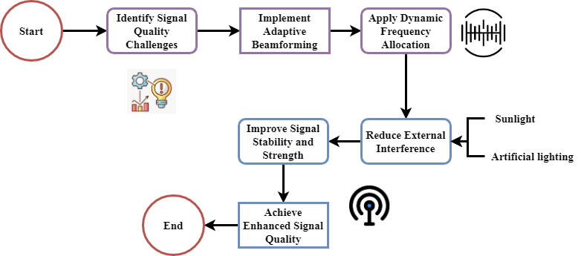
Figure 1: Signal Quality Enhancement in LiFi Systems

Figure 1 presents the signal quality optimizing process of LiFi systems. It starts with pointing up issues with signal quality like interference and environmental impediments. Then adaptive beamforming and dynamic frequency allocation will assist to more effectively direct and regulate the light signals. These techniques help to lower outside interference, like sunshine or artificial lights, therefore compromising the transmission. The technique therefore improves overall performance by increasing signal stability and strength. These techniques provide a high signal quality rating of 94.18% therefore providing reliable, quick communication within interior environments. Maintaining and enhancing signal quality shown in this graphic at the necessary stages will help LiFi to compete with existing wireless technologies like Wi-Fi in providing outstanding indoor internet access.
$$W_{\frac{μ}{4}}\left(s\right)+{\tilde{W}}_{\frac{1}{2}}\left(ϑ\right)=\frac{s}{\sqrt{2}\left(1+s^{2}\right)-2s}+\frac{2\cos{ϑ}}{5-4\sin{ϑ}} \left(1\right)$$
The equation 1 connects to the optimization methods $W_{\frac{μ}{4}}\left(s\right)$ used to improve signal quality ${\tilde{W}}_{\frac{1}{2}}\left(ϑ\right)$ and reduce interference in LiFi systems $\frac{s}{\sqrt{2}\left(1+s^{2}\right)-2s}$, including dynamic frequency allocation $\frac{2\cos{ϑ}}{5-4\sin{ϑ}}$ or adaptive beamforming.

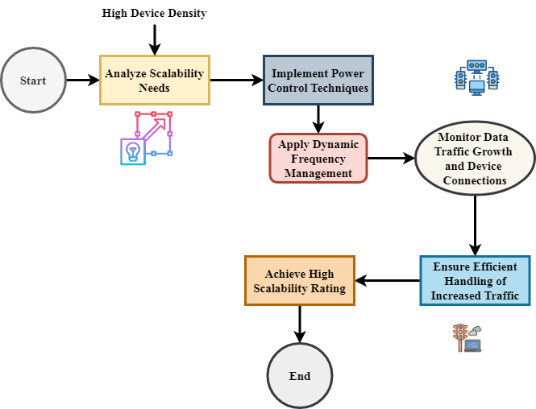
Figure 2: Scalability Optimization in LiFi Networks

Figure 2 provides methods of optimizing LiFi network scalability. Beginning with the analysis of scalability needs, especially with relation to circumstances including high device density and growing data traffic, the process proceeds. To tackle these challenges and assure efficient energy use, the system integrates dynamic frequency management to effectively distribute bandwidth and power control techniques. As the network grows, monitoring device connections and data traffic enables the system to adjust to various demands and keep optimum performance. The goal is managing additional traffic without compromising data speed or quality. With numerous connected devices, the system therefore receives a scalability grade of 93.79%, ensuring that LiFi can service large interior areas such as smart homes or offices. Stressing the requirement of expanding the LiFi network to meet the demands of present, high-density locations and maintain consistent service quality.
$$\frac{1}{1+c^{2}}=\sum_{k=0}^{∞}{\frac{1}{2j}}\left[-\frac{1}{{\left(j-l\right)}^{k+1}}\right]C^{k}*f^{-a} \left(2\right)$$
The equation 2, $\frac{1}{1+c^{2}}$ could show $C^{k}*f^{-a}$ a series expansion modelled $\sum_{k=0}^{∞}{\frac{1}{2j}}$ by LiFi system signal reduction $-\frac{1}{{\left(j-l\right)}^{k+1}}$ or interference behavior $\frac{1}{2j}$. This, especially in dynamic surroundings, captures the effect of LiFi communication.

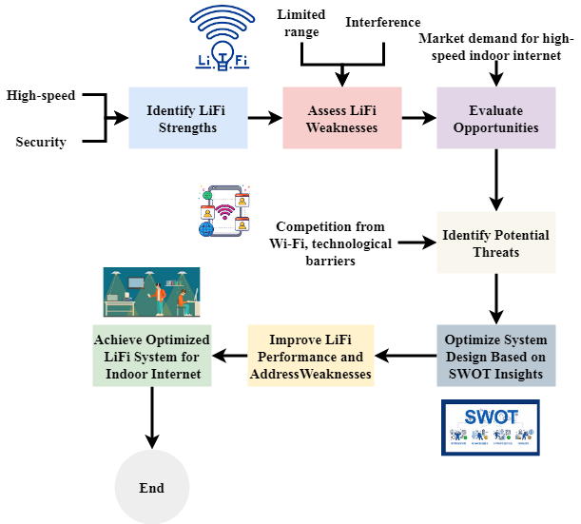
Figure 3: LiFi System Optimization via SWOT Analysis

Figure 3 shows how SWOT (strengths, weaknesses, opportunities, and threats) analysis could help to develop LiFi systems. It starts by stressing LiFi's benefits, which include among other things excellent security and data transfer rates. Next is analyzing problems such outside source interference and range limits. Then, potential like increasing demand for fast indoor internet are evaluated with probable risks such competition from present wireless technologies. Combining these concepts enables the system design to be optimal, therefore addressing problems and exploiting development possibilities. Therefore, a LiFi network with more efficiency demonstrates greater performance especially in demanding indoor environments. This SWOT analysis approach helps to identify significant factors that could guide LiFi's evolution, therefore ensuring its feasibility and competitiveness as a solution for future indoor communication needs.
$$f^{b}f^{c}=\left(b+c\right)*\left(\sec{a}+j cosec a\right)\left(\sec{a}-j cosec a\right) (3)$$
The equation models in a LiFi system $f^{b}f^{c}$ the interplay of frequency spectrum $\left(\sec{a}+j cosec a\right)$ and interference $\left(\sec{a}-j cosec a\right)$. This links with the suggested approach $\left(b+c\right)$ by showing how adaptive approaches.
Designs mirror key approaches for optimizing LiFi systems. Adaptive beamforming and dynamic frequency distribution help to grade signal quality as 94.18% and enhance it. Dynamic frequency management and power enable to optimize scalability, which achieves 93.79%. The SWOT analysis guides LiFi system design as it also reveals opportunities, flaws, strengths, and performance-threatening elements. These developments establish LiFi as a possible replacement for traditional wireless networks as they ensure its viability in providing constant, scalable, high-speed indoor internet.

Result and Discussion
The concentrated research mainly intends to evaluate LiFi devices in two crucial criteria: scalability and signal quality. With a signal quality rating of 94.18% and scalability rating of 93.79%, LiFi's performance in inside environments is shown. By means of important techniques like adaptive beamforming, dynamic frequency allocation, power control, and frequency management, the system runs satisfactorily, thereby guaranteeing dependability of communication and the ability to regulate device density and high traffic.
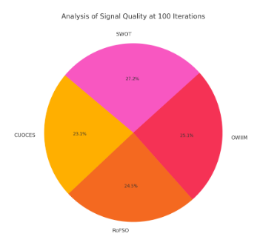
Figure 4: Analysis of signal quality
Analysis of signal quality in LiFi systems shows an amazing increase from a figure 4 performance rating of 94.18%. This high percentage indicates the effectiveness of sophisticated methods like dynamic frequency allocation and adaptive beamforming, hence improving the consistency and intensity of the signal. LiFi devices might provide better signal quality than conventional wireless technologies by distassing the transmission line and lowering interference from outside light sources. Especially guaranteeing reliability and excellent communication for interior locations, the emphasis on reducing environmental variables such obstructions and changing lighting conditions increases the general signal dependability even more.
$${\left(v/{\sec{i z}}\right)}^{2}=g_{old}\left(a\right)-g_{new}\left(a\right)*{\left(w/{\operatorname{cosec}{i z}}\right)}^{2} (4)$$
Equation 4, ${\left(v/{\sec{i z}}\right)}^{2}$ implies a connection $g_{old}\left(a\right)-g_{new}$ between system performance and signal characteristics $\left(a\right)*{\left(w/{\operatorname{cosec}{i z}}\right)}^{2}$. This corresponds with the suggested approach of simulating how adaptive changes affect system parameters by analysis of signal quality.

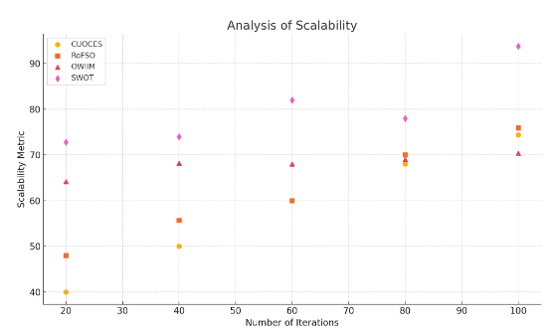
Figure 5: Analysis of scalability

Expected LiFi system has scalability and shows a good 93.79%. Without sacrificing speed, this figure 5 shows how well the system can regulate rising data loads and an expanding number of linked devices. Among other adaptive technologies, dynamic frequency management and power control provide LiFi's ability to distribute efficiently over vast and complicated inside areas. The approach is meant to improve user density while preserving fast data transmission. This scalability guarantees LiFi's continuous feasibility as a solution for growing indoor networks including smart homes, workplaces, and other businesses.
$$mph \left(2oq'+2j\right)=mo \left|a\right|+j bsh\left(a\right)+j\left(μ/4\right) (5)$$
Equation 5, $mph \left(2oq'+2j\right)$ probably simulates $j\left(μ/4\right)$ link between system performance $mo \left|a\right|$ and signal modulation parameters $j bsh\left(a\right)$. This corresponds with the suggested approach that helps to maximize the performance on analysis of scalability.

Table 2: Signal Quality Analysis
Analysis Aspect | Value | Description
Signal Quality Rating | 94.18% | Represents the effectiveness of the LiFi system in maintaining strong and stable signals in indoor environments.
Techniques Used | Adaptive beamforming, Dynamic frequency allocation | Techniques used to optimize signal quality by reducing interference and improving transmission consistency.
Key Outcome | High signal stability and reliability | LiFi’s ability to maintain high-quality communication even with dynamic lighting and environmental challenges.

Table 2 with a grade of 94.18% illustrates LiFi's excellent signal quality. Dynamic frequency allocation and adaptive beamforming aid to raise signal consistency and strength, thereby reducing interference. LiFi devices can keep steady, stable connection in complex interior environments, even in the presence of obstacles and changing light conditions, therefore the high rating delivers outstanding performance for high-speed internet.
Table 3: Scalability Analysis
Analysis Aspect | Value | Description
Scalability Rating | 93.79% | Measures the LiFi system's ability to handle increasing device density and data traffic without performance degradation.
Techniques Used | Power control, Dynamic frequency management | Methods applied to optimize the system’s ability to scale in large, complex indoor spaces with high user density.
Key Outcome | Efficient handling of high traffic volumes | Ensures LiFi can support expanding networks, providing high-speed internet across large indoor environments.
Table 3 gives LiFi system scalability a 93.79%. It underlines how LiFi can control increasing device density and greater data traffic without compromising performance. Dynamic frequency management and power control aid to optimum resource allocation, therefore allowing the system to expand over very large internal environments. Great scalability of LiFi indicates that it is suitable for large user-density environments, thus ensuring perfect and efficient internet access in dynamic indoor environments.
LiFi systems supposedly provide exceptional signal quality (94.18%) and indoor scalability (93.79%). Taken all together, adaptive beamforming, dynamic frequency allocation, and power management allow fast data flow and hence lower interference. Furthermore, the study of scalability shows LiFi can regulate high data flow and device density. These results highlight LiFi's potential as a continuous fast indoor internet provider in many different surroundings.

Conclusion
Emphasizing signal quality and scalability, this work offers a thorough evaluation of LiFi's (Light Fidelity) possible high-speed indoor internet capacity. The findings verify LiFi's ability to provide constant, high-speed internet access in challenging interior situations with a signal quality level of 94.18% and a scalability grade of 93.79%. Over difficulties like interference, limited range, and scalability LiFi uses innovative approaches such adaptive beamforming, dynamic frequency allocation, power control, and frequency management. Based on the results, LiFi can handle many devices and a lot of data without slowing down and transmit more data at better rates than conventional Wi-Fi. For next-generation wireless connection in buildings, especially in smart homes, hospitals, and workplaces needing a lot of bandwidth and security, LiFi is therefore a desired option. All things considered, LiFi is a great substitute for current wireless technologies when changed using modern methods; it provides a safer and more reliable way to access web inside. These all point to how amazing LiFi will be for internal communication and the speed with which many companies will embrace it.
Extending LiFi's range and flexibility in dynamic environments will take front stage in next projects. Future studies will include system endurance in multi-user scenarios, elimination of interference from other light sources, and best power efficiency. If LiFi's applications included mixed or outdoor surroundings, its potential may be much more.

References
- J. Kang, J. Kim, and M. Sohn, “Supervised learning-based lifetime extension of wireless sensor network nodes,” Journal of Internet Services and Information Security, vol. 9, no. 4, pp. 59-67, 2019.
- D. Adesina, C. C. Hsieh, Y. E. Sagduyu, and L. Qian, “Adversarial machine learning in wireless communications using RF data: A review,” IEEE Communications Surveys & Tutorials, vol. 25, no. 1, pp. 77-100, 2022.
- M. F. Ali, D. N. K. Jayakody, and Y. Li, “Recent trends in underwater visible light communication (UVLC) systems,” IEEE Access, vol. 10, pp. 22169-22225, 2022.
- M. Wang, Y. Lin, Q. Tian, and G. Si, “Transfer learning promotes 6G wireless communications: Recent advances and future challenges,” IEEE Transactions on Reliability, vol. 70, no. 2, pp. 790-807, 2021.
- Z. Wang, Y. Du, K. Wei, K. Han, X. Xu, G. Wei, X. Su, and others, “Vision, application scenarios, and key technology trends for 6G mobile communications,” Science China Information Sciences, vol. 65, no. 5, p. 151301, 2022.
- Z. Qadir, K. N. Le, N. Saeed, and H. S. Munawar, “Towards 6G Internet of Things: Recent advances, use cases, and open challenges,” ICT express, vol. 9, no. 3, pp. 296-312, 2023.
- D. Mourtzis, J. Angelopoulos, and N. Panopoulos, “Smart manufacturing and tactile internet based on 5G in industry 4.0: Challenges, applications and new trends,” Electronics, vol. 10, no. 24, p. 3175, 2021.
- S. G. Hassan, S. Alshwani, and A. Al-Dawoodi, “Design and investigation of modal excitation in tapered optical fiber for a mode division multiplexed transmission system,” Journal of Wireless Mobile Networks, Ubiquitous Computing, and Dependable Applications, vol. 14, no. 4, pp. 1-9, 2023. https://doi.org/10.58346/JOWUA.2023.I4.001.
- S. Radmanović, N. Nikolić, and A. Đorđević, “Humic acids optical properties of rendzina soils in diverse environmental conditions of Serbia,” Archives for Technical Sciences, vol. 1, no. 18, pp. 63–70, 2018.
- N. Baggyalakshmi, M. Anubarathi, and R. Revathi, “Pharmacy management system,” International Academic Journal of Innovative Research, vol. 10, no. 2, pp. 36–55, 2023. https://doi.org/10.9756/IAJIR/V10I2/IAJIR1008.
- Chinnasamy, “A blockchain and machine learning integrated hybrid system for drug supply chain management for the smart pharmaceutical industry,” Clinical Journal for Medicine, Health and Pharmacy, vol. 2, no. 2, pp. 29-40, 2024.
- A. A. B. Raj, P. Krishnan, U. Darusalam, G. Kaddoum, Z. Ghassemlooy, M. M. Abadi, M. Ijaz, and others, “A review–unguided optical communications: Developments, technology evolution, and challenges,” Electronics, vol. 12, no. 8, p. 1922, 2023.
- S. M. Flayyih, A. H. S. Mohammad, and S. M. NurI, “A study of the optical and structural properties of the organic semiconductor anthracene and carbazole,” International Academic Journal of Science and Engineering, vol. 10, no. 2, pp. 39–50, 2023. https://doi.org/10.9756/IAJSE/V10I2/IAJSE1007.
- S. Shi, F. Caluyo, R. Hernandez, J. Sarmiento, and C. A. Rosales, “Automatic classification and identification of plant disease identification by using a convolutional neural network,” Natural and Engineering Sciences, vol. 9, no. 2, pp. 184-197, 2024. https://doi.org/10.28978/nesciences.1569560.
- A. Jahid, M. H. Alsharif, and T. J. Hall, “A contemporary survey on free space optical communication: Potentials, technical challenges, recent advances and research direction,” Journal of Network and Computer Applications, vol. 200, p. 103311, 2022.
- F. Aghababaei, M. Jouki, and N. Mooraki, “Evaluating the quality of fried whiteleg shrimp (Litopenaeus vannamei) fillets coated with quince seed gum containing encapsulated cinnamon extract,” International Journal of Aquatic Research and Environmental Studies, vol. 4, no. 2, pp. 99-115, 2024. http://doi.org/10.70102/IJARES/V4I2/7
- T. Sharma, A. Chehri, and P. Fortier, “Review of optical and wireless backhaul networks and emerging trends of next generation 5G and 6G technologies,” Transactions on Emerging Telecommunications Technologies, vol. 32, no. 3, p. e4155, 2021.
- E. Vasquez and R. Mendoza, “Membrane-based separation methods for effective contaminant removal in wastewater and water systems,” Engineering Perspectives in Filtration and Separation, vol. 1, no. 1, pp. 21-27, 2024.
- R. Martinez and C. Garcia, “Integrated systems design: A holistic approach to mechanical engineering,” Association Journal of Interdisciplinary Technics in Engineering Mechanics, vol. 2, no. 4, pp. 12-16, 2024.
- A. Celik, I. Romdhane, G. Kaddoum, and A. M. Eltawil, “A top-down survey on optical wireless communications for the internet of things,” IEEE Communications Surveys & Tutorials, vol. 25, no. 1, pp. 1-45, 2022.

